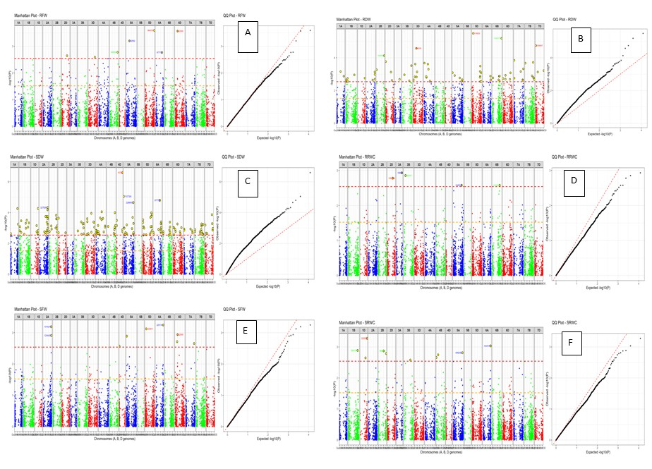
Figure S2.Manhattan and QQ plots for salt tolerance germination related traits in bread wheat. Each dot represents a SNP. In the Manhattan plots the X-axis displays the genomic position of the SNPs across chromosomes 1-7 for sub- genomes A,B,and D with alternatin colours for clarity,while the Y-axis displays the negative logarithm of the P- values (-log₁₀P) indicating the strength of association between the SNPs and the traits. Significance association were determined using multiple testing corrections, including Bonferroni and false discovery rate (FDR), with the red horizontal line representing the significance threshold. Traits analysed include SFW, RFW, SDW, RDW, SRWC, and RRWC. The QQ plots on the right compare observed −log₁₀P values (Y-axis) with expected values under the null hypothesis (X-axis), where each black dot represents a SNP and the red line indicates the expected distribution under no association. Figure S2 .A )Root fresh weight ,B) Root dry weight, C)Shoot dry weight, D)Root relative water content, E) Shoot fresh weight, F) Shoot relative water content

