Supplementary Figures

Supplementary Fig. S1A–S1F | Model-specific feature importance rankings.
Feature importance was quantified using model-specific metrics and normalized to a 0–100 scale to facilitate comparison.

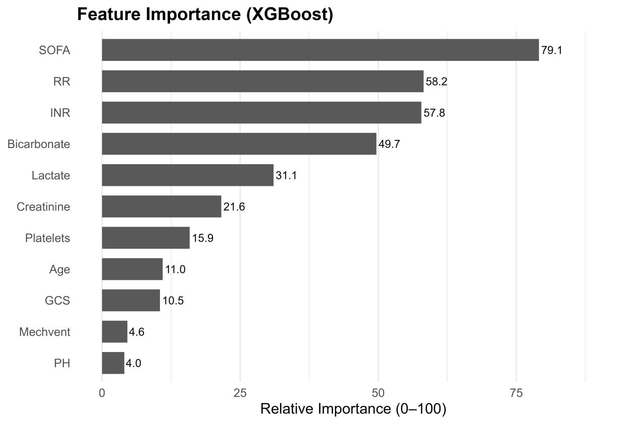

Supplementary Figure S1A | Feature importance derived from the XGBoost model.
This bar chart shows the relative importance of predictors in the XGBoost model for estimating the risk of MODS. Higher values indicate greater contributions of individual features to the model’s predictive performance.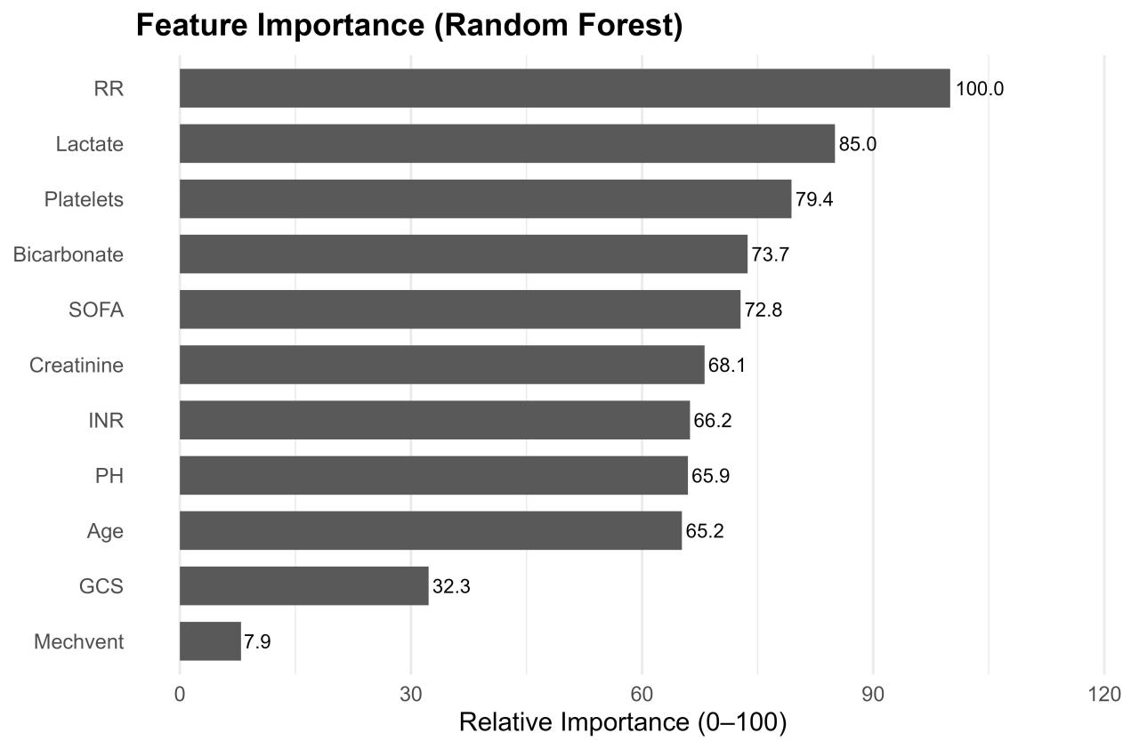

Supplementary Figure S1B | Feature importance derived from the Random Forest model.
This figure presents the relative importance ranking of predictors included in the Random Forest model for estimating the risk of MODS. Higher scores indicate a greater contribution of individual features to the model’s predictive performance, reflecting the influence of key physiological and laboratory variables captured by the ensemble tree-based approach.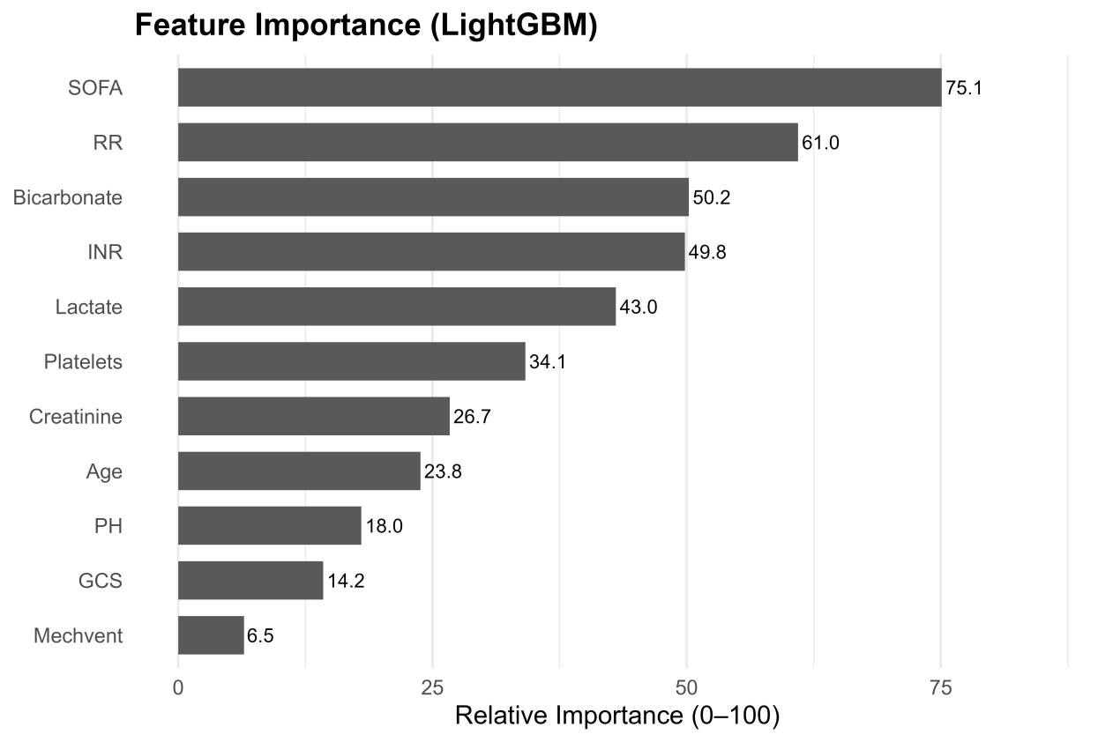

Supplementary Figure S1C | Feature importance derived from the LightGBM model.
This figure shows the relative importance ranking of predictors in the LightGBM model for predicting MODS. Higher values indicate greater contributions to model performance, with organ dysfunction severity (SOFA score), respiratory dynamics (RR), metabolic derangements (bicarbonate, lactate), and coagulation abnormalities (INR) emerging as the most influential features captured by the gradient-boosting framework.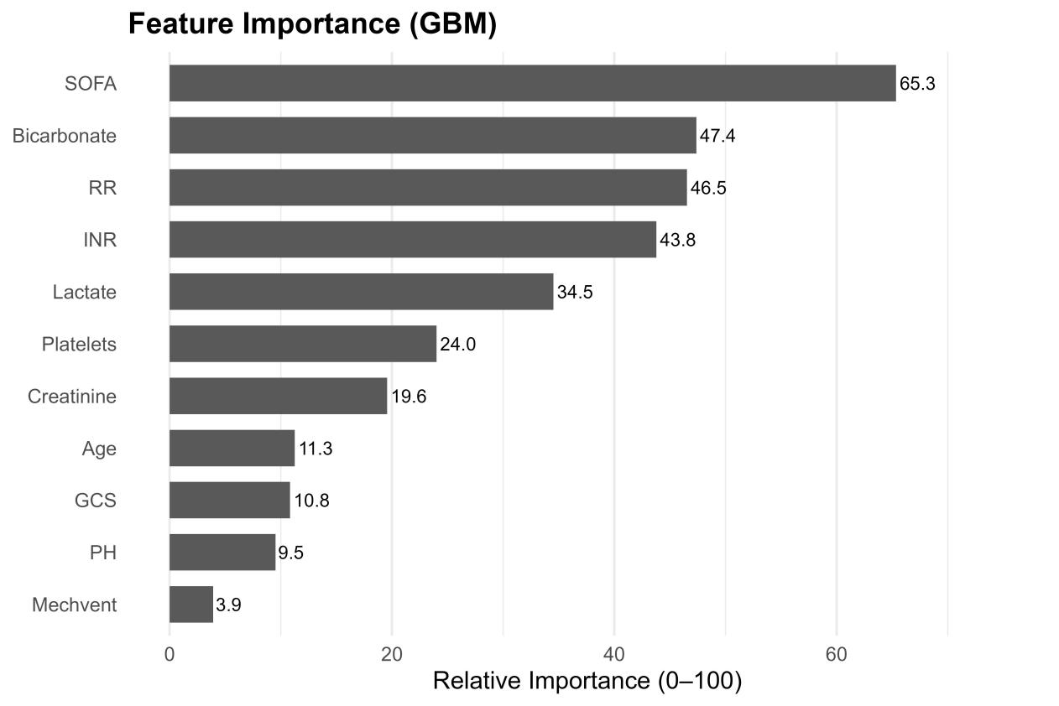
Supplementary Fig. S1D | Feature importance derived from GBM model.
This figure shows the relative importance ranking of predictors in the GBM model for predicting MODS. Higher values indicate greater contributions to model performance, with organ dysfunction severity (SOFA score), metabolic disturbances (bicarbonate and lactate), respiratory dynamics (RR), and coagulation abnormalities (INR) emerging as the most influential features within the GBM framework.
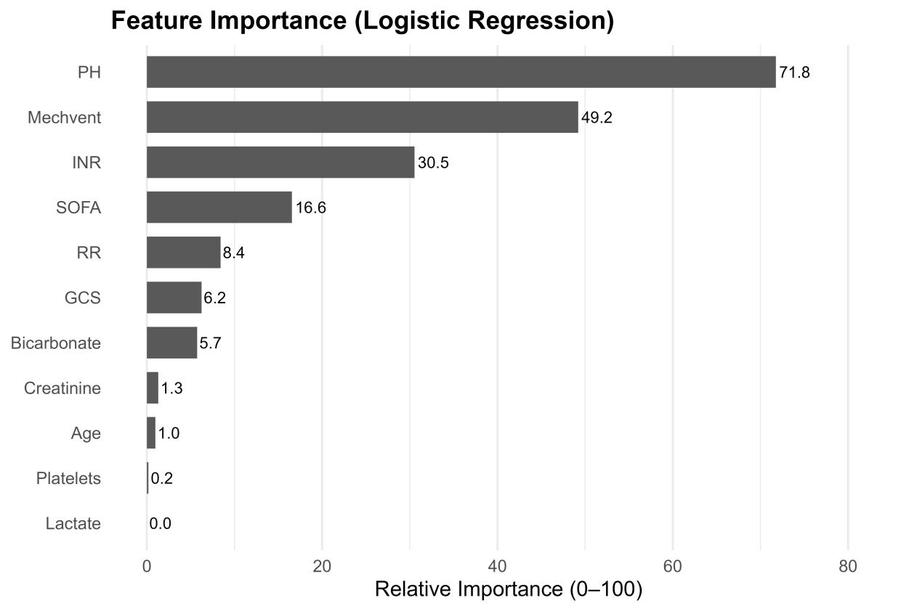

Supplementary Fig. S1E | Feature importance derived from the logistic regression model.
This figure shows the relative importance ranking of predictors in the multivariable logistic regression model for MODS. Importance was based on the magnitude of standardised regression coefficients, with larger values indicating stronger associations with MODS risk. Acid–base status (pH), mechanical ventilation, coagulation abnormalities (INR), and overall organ dysfunction burden (SOFA score) emerged as the most influential predictors, reflecting the linear model’s emphasis on variables with direct, additive effects.
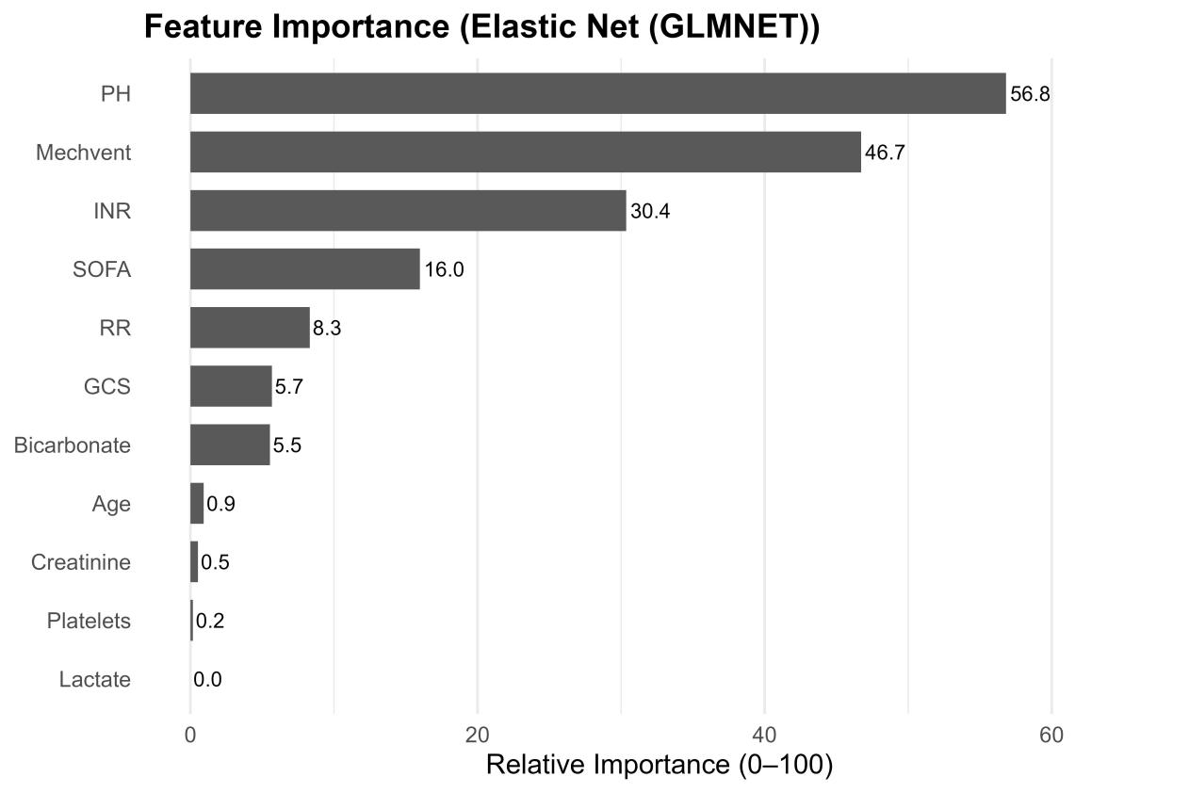

Supplementary Fig. S1F | Feature importance derived from the Elastic Net (GLMNET) model.
This figure presents the relative importance ranking of predictors in the Elastic Net–regularised logistic regression model for predicting MODS. Importance reflects the magnitude of penalised regression coefficients after variable selection and shrinkage. Acid–base status (pH), mechanical ventilation, coagulation abnormalities (INR), and overall organ dysfunction burden (SOFA score) emerged as the dominant contributors, illustrating how regularisation prioritises a parsimonious set of clinically salient predictors while attenuating less informative variables.

Supplementary Fig. S2A–S2E | External validation of the models in the eICU cohort.

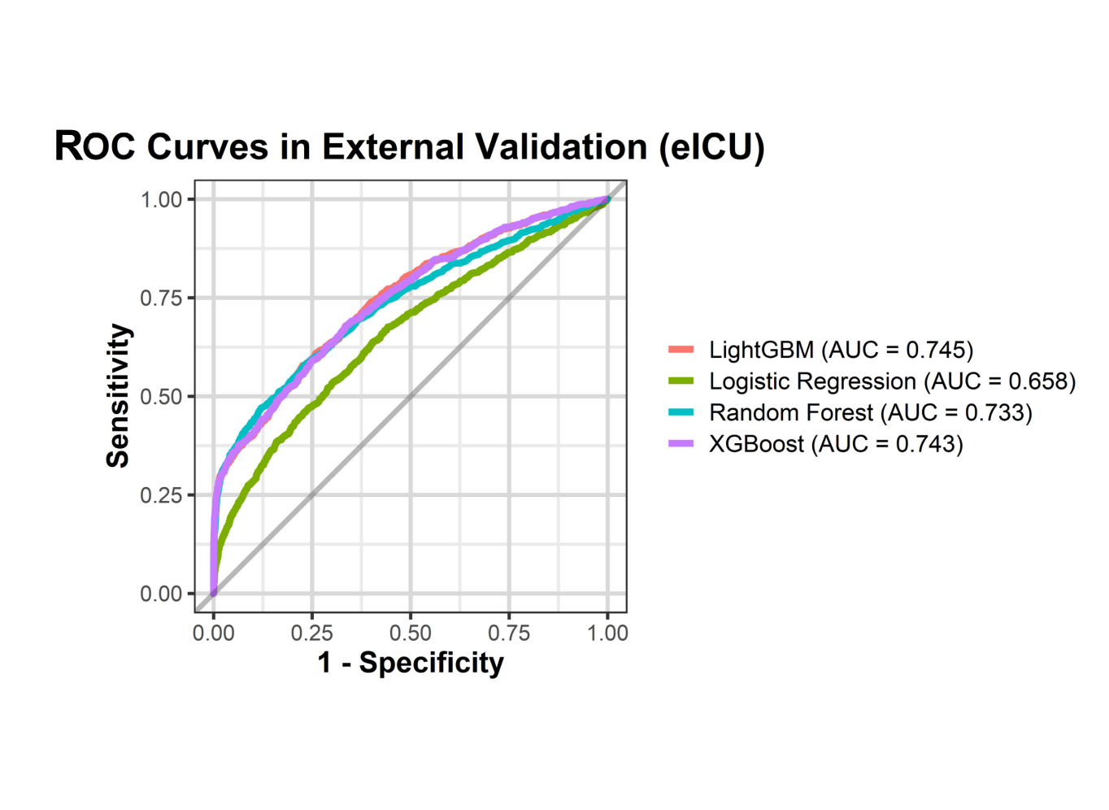

Supplementary Fig. S2A | Discriminative performance in external validation.
ROC curves comparing the discriminative performance of the final LightGBM model with baseline models, including logistic regression, random forest, and XGBoost, in the external eICU validation cohort.

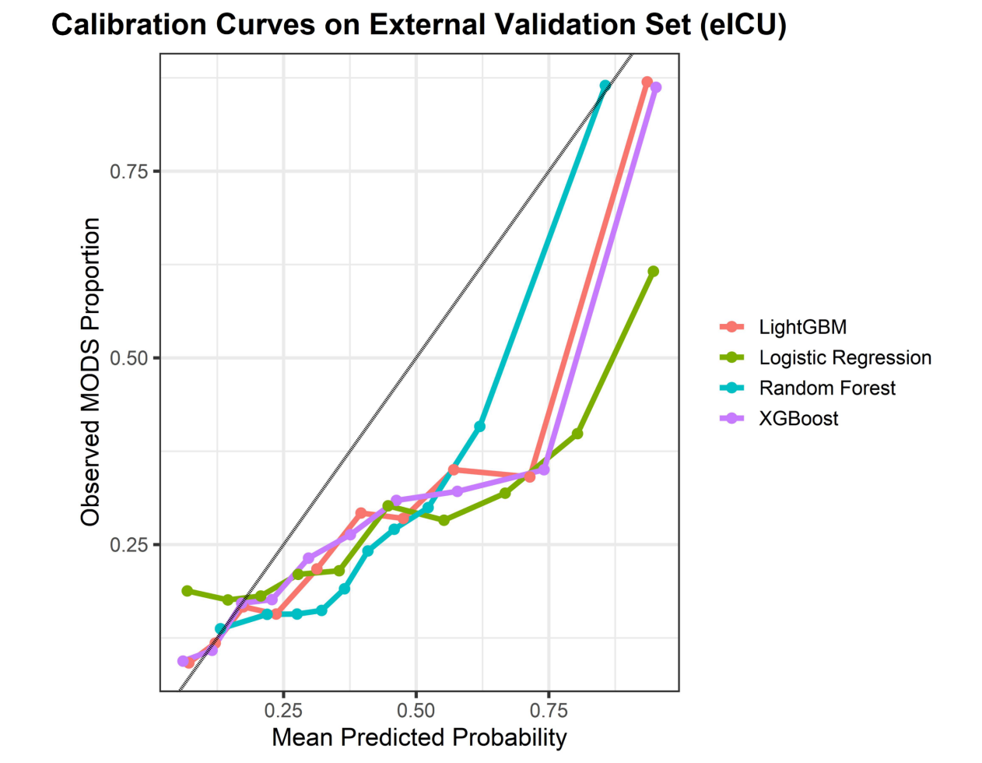

Supplementary Fig. S2B | Calibration performance in external validation.

Calibration curves for all candidate models in the eICU cohort. Predicted probabilities were grouped into deciles, and the mean predicted risk within each decile was plotted against the observed proportion of MODS. The dashed diagonal line represents perfect calibration.

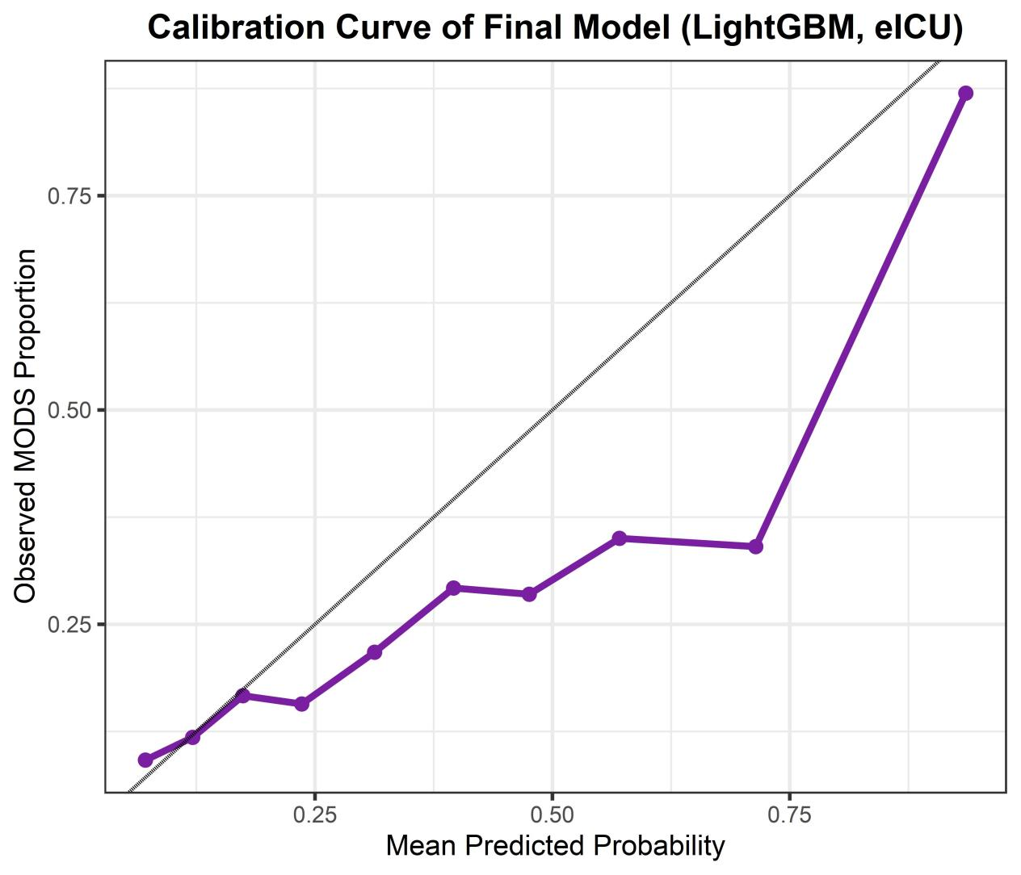
Supplementary Fig. S2C | Calibration of the final model in external validation.

Calibration curve of the final LightGBM model in the external eICU cohort, illustrating the agreement between predicted and observed MODS risk across probability ranges.

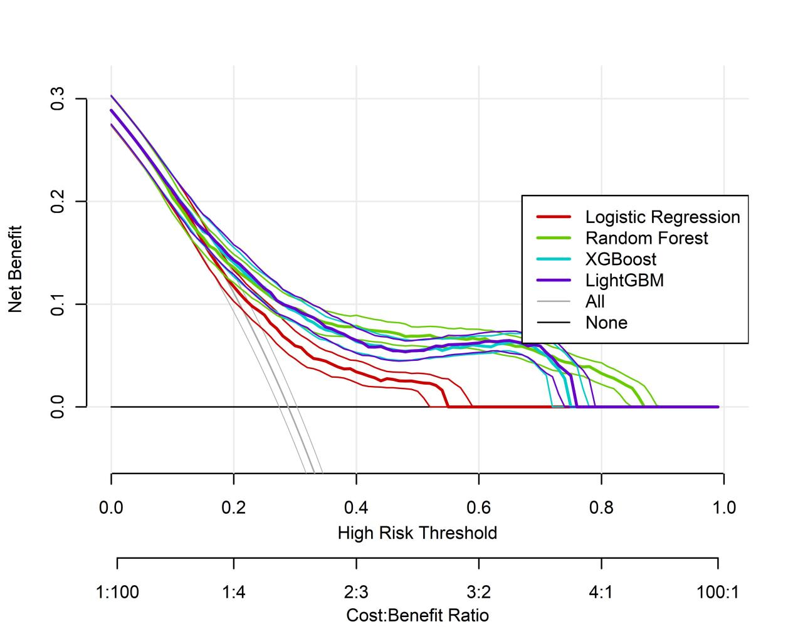

Supplementary Fig. S2D | Decision curve analysis in external validation.

DCA comparing the net clinical benefit of the final LightGBM model and baseline models across a range of threshold probabilities in the external eICU cohort. The horizontal line represents the strategy of treating no patients, whereas the oblique line represents treating all patients.

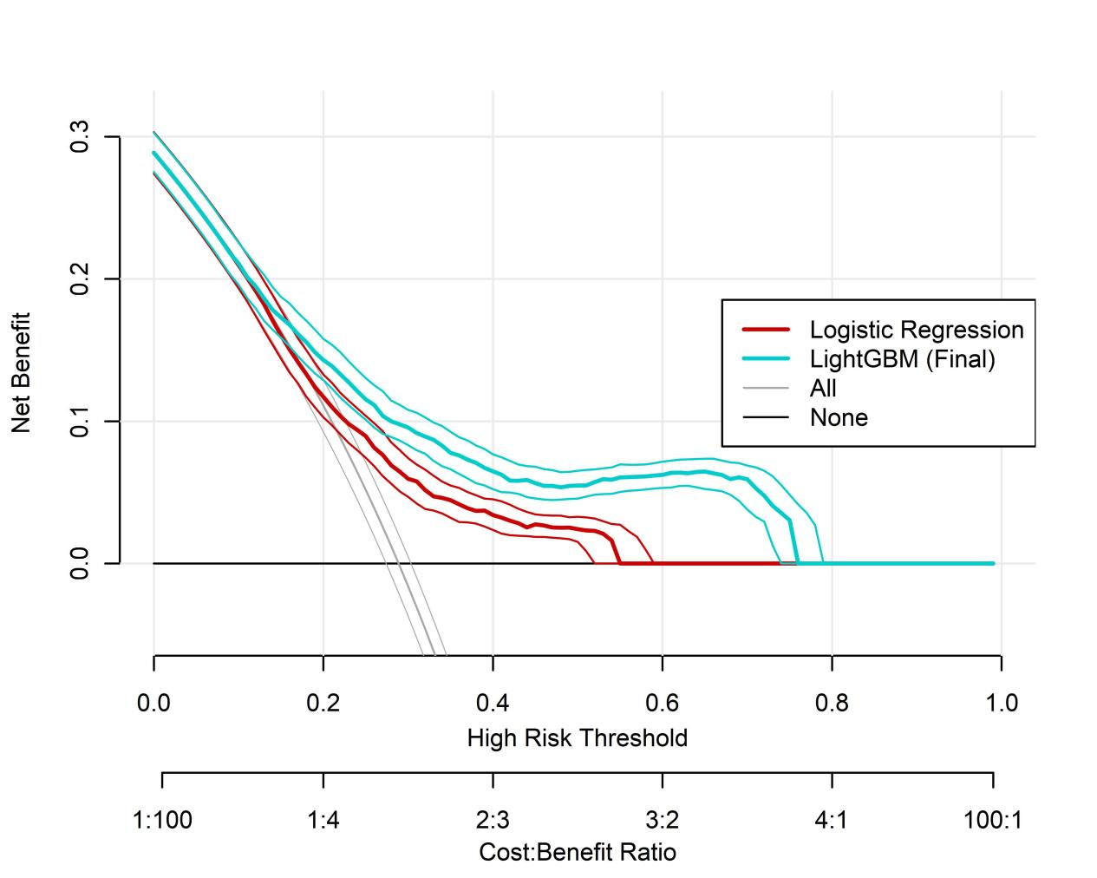

Supplementary Fig. S2E | Decision curve analysis comparing the final model with logistic regression.

Net clinical benefit of the final LightGBM model relative to logistic regression across clinically relevant threshold probabilities in the external eICU validation cohort.

