Additional file 1.


TRIPOD Checklist: Prediction Model Development

Section/Topic | Item | Checklist Item | Page
Title and abstract
Title | 1 | Identify the study as developing and/or validating a multivariable prediction model, the target population, and the outcome to be predicted. | 1
Abstract | 2 | Provide a summary of objectives, study design, setting, participants, sample size, predictors, outcome, statistical analysis, results, and conclusions. | 2-3
Introduction
Background and objectives | 3a | Explain the medical context (including whether diagnostic or prognostic) and rationale for developing or validating the multivariable prediction model, including references to existing models. | 4-5
Background and objectives | 3b | Specify the objectives, including whether the study describes the development or validation of the model or both. | 5
Methods
Source of data | 4a | Describe the study design or source of data (e.g., randomized trial, cohort, or registry data), separately for the development and validation data sets, if applicable. | 6
Source of data | 4b | Specify the key study dates, including start of accrual; end of accrual; and, if applicable, end of follow-up. | 6
Participants | 5a | Specify key elements of the study setting (e.g., primary care, secondary care, general population) including number and location of centres. | 6
Participants | 5b | Describe eligibility criteria for participants. | 6
Participants | 5c | Give details of treatments received, if relevant. | -
Outcome | 6a | Clearly define the outcome that is predicted by the prediction model, including how and when assessed. | 6-7
Outcome | 6b | Report any actions to blind assessment of the outcome to be predicted. | 6
Predictors | 7a | Clearly define all predictors used in developing or validating the multivariable prediction model, including how and when they were measured. | 7
Predictors | 7b | Report any actions to blind assessment of predictors for the outcome and other predictors. | -
Sample size | 8 | Explain how the study size was arrived at. | 8
Missing data | 9 | Describe how missing data were handled (e.g., complete-case analysis, single imputation, multiple imputation) with details of any imputation method. | 8
Statistical analysis methods | 10a | Describe how predictors were handled in the analyses. | 8-9
Statistical analysis methods | 10b | Specify type of model, all model-building procedures (including any predictor selection), and method for internal validation. | 8-10
Statistical analysis methods | 10d | Specify all measures used to assess model performance and, if relevant, to compare multiple models. | 9
Risk groups | 11 | Provide details on how risk groups were created, if done. | -
Results
Participants | 13a | Describe the flow of participants through the study, including the number of participants with and without the outcome and, if applicable, a summary of the follow-up time. A diagram may be helpful. | 10
Participants | 13b | Describe the characteristics of the participants (basic demographics, clinical features, available predictors), including the number of participants with missing data for predictors and outcome. | 10-12
Model development | 14a | Specify the number of participants and outcome events in each analysis. | 10
Model development | 14b | If done, report the unadjusted association between each candidate predictor and outcome. | -
Model specification | 15a | Present the full prediction model to allow predictions for individuals (i.e., all regression coefficients, and model intercept or baseline survival at a given time point). | 15
Model specification | 15b | Explain how to the use the prediction model. | -
Model performance | 16 | Report performance measures (with CIs) for the prediction model. | 12-13, 14-16
Discussion
Limitations | 18 | Discuss any limitations of the study (such as nonrepresentative sample, few events per predictor, missing data). | 20-21
Interpretation | 19b | Give an overall interpretation of the results, considering objectives, limitations, and results from similar studies, and other relevant evidence. | 16-20
Implications | 20 | Discuss the potential clinical use of the model and implications for future research. | 17-21
Other information
Supplementary information | 21 | Provide information about the availability of supplementary resources, such as study protocol, Web calculator, and data sets. | 6
Funding | 22 | Give the source of funding and the role of the funders for the present study. | 22

Additional file 2: Table S1. Candidate predictors and operational definitions

No. | Candidate predictor variable | Obtained through:  T = in-person physical assessment; Q = telephone-administered self-report questionnaire | Assessment name | Operationalization | Variable type | Degrees of freedom | Response options / units | Expected effect on absolute risk  “+” = increases risk; “–” = decreases risk; “?” = unclear or bidirectional.
BIOLOGICAL
1 | Age | Q | INITIATE Survey | Self-reported age in completed years at baseline. | Continuous | 1 | Years | +
2 | Sex | Q | INITIATE Survey | Sex assigned at birth. | Categorical | 1 | 0 = female  1 = male | + for female
3 | Frailty | Q | Clinical Frailty Scale (CFS) (48) | 1-item global rating (1–9). Frailty was defined as CFS ≥5 (49, 50). Higher scores indicate greater frailty. | Categorical | 1 | 0 = non-frail  1 = frail | +
4 | Multimorbidity | Q | INITIATE Survey | Presence of ≥3 chronic conditions (51). | Categorical | 1 | 0 = no  1 = yes | +
5 | Mobility limitation | Q | Preclinical mobility limitation (PCML) Scale (52) | Score (1–5) for 5 tasks. Each item is scored individually. The maximum score for any item was used for each participant. A higher score indicates greater mobility difficulty. | Continuous | 1 | 1–5 | +
6 | Timed Up and Go (TUG) - fast | T | TUG - fast pace (53) | Time to complete TUG at a fast pace. Longer times reflect poorer performance. | Continuous | 1 | Seconds | +
7 | Balance | T | Brief-BESTest (54) | Eight items scored 0–3. Higher scores indicate better balance. | Continuous | 1 | Score (0–24) | –
8 | Grip strength | T | Grip Strength Test (55) | Mean of three maximal efforts (dominant hand), using a Tracker Freedom Wireless Grip dynamometer. Higher values reflect better strength. | Continuous | 1 | Kilograms | –
9 | Visual acuity | Q | ETDRS logMAR (56) | Binocular visual acuity using an ETDRS Chart. Score was calculated using the ETDRS Acuity Log Score. Higher values indicate poorer acuity. | Continuous | 1 | logMAR score | +
10 | Hearing handicap | Q | Hearing Handicap Inventory for the Elderly-Screening (HHIE-S) (57) | Ten items (0–4). Higher scores indicate greater perceived hearing handicap. | Continuous | 1 | Score (0–40) | +
11 | Foot sensation loss | T | Semmes-Weinstein Monofilament Test (58) | Sensation assessed at 10 plantar/ventral foot sites, per foot, with a Neuropen peripheral neuropathy screening device (5.07/10g). Loss defined as >7 insensate sites on either foot (58). | Categorical | 1 | 0 = no  1 = yes | +
12 | Global cognition | T | Montreal Cognitive Assessment (MoCA) (59) | Total score 0–30. Education-adjusted (+1 point added for <12 years). Higher scores indicate better cognition. | Continuous | 1 | Score (0–30) | –
13 | Executive function | T | Trail Making Test (TMT) (60) | The TMT difference score (TMT-B minus TMT-A). Larger values reflect poorer executive functioning and mental flexibility. | Continuous | 1 | Seconds difference | +
14 | Fall risk–increasing drugs (FRIDs) count | Q | INITIATE Survey | Count of FRID categories per Seppälä et al. classification (psychotropic, cardiovascular, other). “Other” included anti-Parkinson agents, antiepileptics, analgesics (opioids, non-opioids, NSAIDs) (61-63). Classification followed the ATC system, except analgesics grouped under “analgesics” and therefore classified as “other” FRIDs (63). | Continuous | 1 | Count (0-3) | +
15 | Pain interference | Q | Brief Pain Inventory (BPI) – Pain interference subscale (64) | Mean of seven interference items (0–10). Higher scores indicate greater pain-related interference. | Continuous | 1 | Score (0–10) | ?
16 | Fear of falling | Q | Falls Efficacy Scale–International (FES-I) (65) | Sixteen items (1–4). Higher scores indicate greater fear of falling. | Continuous | 1 | Score (16–64) | +
17 | Depression | Q | Center for Epidemiologic Studies Depression Scale – 10 item (CES-D-10) (66) | Ten items (0–3). Higher scores indicate more depressive symptoms. CES-D-10 ≥10 indicated clinically relevant depressive symptoms (67). | Categorical | 1 | 0 = no  1 = yes | +
SOCIAL, BEHAVIORAL, ENVIRONMENTAL
18 | Education | Q | INITIATE Survey | Highest completed education categorized as ≤12 years vs >12 years. | Categorical | 1 | 0 = lower  1 = higher | –
19 | Living alone | Q | INITIATE Survey | Lives alone vs not. | Categorical | 1 | 0 = no  1 = yes | +
20 | Social support | Q | Medical Outcomes Study–Social Support Survey (MOS-SSS) (68) | Average of 19 items transformed to 0–100. Higher scores indicate greater perceived support. | Continuous | 1 | Score (0–100) | –
21 | Strengthening exercise | Q | Physical Activity Scale for the Elderly (PASE) (69, 70), Item 6 | Engagement in strengthening exercise (seldom/sometimes/often) vs none. Item 6 was selected because the type of activity, may be more relevant to fall risk than duration alone (7). | Categorical | 1 | 0 = no  1 = yes | –
22 | Nutrition risk | Q | Seniors in the Community: Risk Evaluation for Eating and Nutrition, Version II (SCREEN II) (71) | Eight items. Higher scores indicate lower nutrition risk. | Continuous | 1 | Score (0–48) | –
23 | Neighborhood walkability | Q | Neighborhood Environment Walkability Scale (NEWS) – Access to Destinations (72) | Seven items scored 1–4. Higher scores indicate more activity-supportive environments. The Access to Destinations subscale was used because it captures the most mobility-relevant environmental features and is substantially shorter and more feasible to administer than the full NEWS instrument (73). | Continuous | 1 | Score (7–28) | –
Notes: Total number of degrees of freedom = 23.

Additional file 3: Figure S1. Missing data across candidate predictors (N = 514)
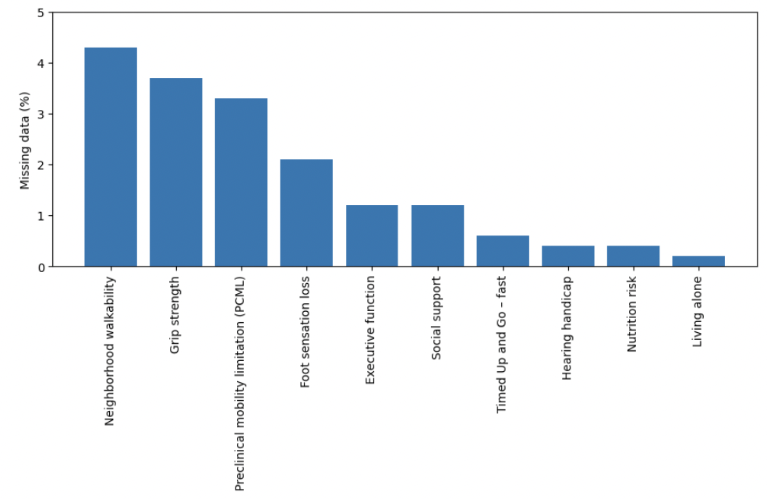
Notes: Only variables with ≥1 missing observation are shown. Percentages were calculated using the full sample (N = 514). No candidate predictor exceeded 5% missingness.

Additional file 4: Table S2. Area under the curve (AUC) values for sequentially expanded fall risk prediction models
Model | Domains | Any falls AUC (95% CI) | Injurious falls AUC (95% CI)
Model 1 | Biological base model (age and sex forced) | 0.64 (0.58–0.69) | 0.73 (0.64–0.82)
Model 2 | Model 1 + Sociodemographic factors | 0.65 (0.60–0.71) | 0.73 (0.65–0.82)
Model 3 | Model 2 + Behavioral factors | 0.65 (0.60–0.71) | 0.77 (0.69–0.86)
Model 4 | Model 3 + Environmental factors | 0.65 (0.60–0.71) | 0.78 (0.69–0.86)
Notes: AUC = area under the receiver operating characteristic curve; CI = confidence interval.
Model development was based on sequential inclusion of predictor domains using logistic regression models.

Additional file 5: Table S3. Regression coefficients for the final prediction models
Predictor | Any Falls |  |  |  | Injurious Falls
 | Coefficient | SE | OR | 95% CI | Coefficient | SE | OR | 95% CI
Constant | 0.41 | 1.59 | 1.51 | 0.07–34.23 | -2.18 | 3.96 | 0.11 | 0.00–262.92
Age | -0.01 | 0.02 | 0.99 | 0.95–1.02 | 0.03 | 0.04 | 1.03 | 0.95–1.12
Female sex (ref = male) | 0.20 | 0.21 | 1.23 | 0.81–1.86 | -0.29 | 0.59 | 0.75 | 0.23–2.38
Preclinical mobility limitation | 0.07 | 0.10 | 1.07 | 0.87–1.31 | — | — | — | —
Balance | -0.02 | 0.03 | 0.98 | 0.93–1.03 | — | — | — | —
Better-eye acuity-logMAR | 1.89 | 0.80 | 6.64 | 1.40–31.56 | — | — | — | —
Fear of falling | 0.04 | 0.02 | 1.04 | 1.01–1.08 | — | — | — | —
TUG (s) | — | — | — | — | 0.12 | 0.07 | 1.12 | 0.99–1.28
Grip strength (kg) | — | — | — | — | -0.05 | 0.03 | 0.95 | 0.89–1.01
Global cognition | — | — | — | — | -0.03 | 0.07 | 0.97 | 0.84–1.13
Executive function | — | — | — | — | 0.01 | 0.01 | 1.01 | 0.99–1.02
Pain interference | — | — | — | — | -0.30 | 0.13 | 0.74 | 0.57–0.96
Abbreviations: TUG = Timed Up and Go; PASE = Physical Activity Scale for the Elderly; OR = odds ratio; SE = standard error; CI = confidence interval.
Dash (—) = variable not included in that model.
Additional file 6: Table S4. Internal validation of predictive models for any falls and injurious falls using bootstrap resampling (1000 iterations)
Outcome | Model | Brier score | Bootstrap SE | 95% CI
Any falls | Model 1 (Biological base model) | 0.23 | 0.0059 | 0.22–0.24
 | Model 4 | 0.23 | 0.0065 | 0.22–0.24
Injurious falls | Model 1 (Biological base model) | 0.17 | 0.0167 | 0.14–0.21
 | Model 4 | 0.16 | 0.0168 | 0.13–0.20
Notes: Lower Brier scores indicate better model calibration.
Abbreviations: SE = standard error; CI = confidence interval.

