Supplementary Materials for Extremophiles
Halorubrum salipaludis sp. nov., isolated from the saline–alkaline soil
Qi Gong¹, Pu Zhao², Shaohua Miao¹, Keke Yi¹, Chunhong Ma^{2*}, Guishan Zhang^{1*}
¹ Key Laboratory of Microbial Resources and Preservation, Ministry of Agriculture and Rural Affair, Institute of Agricultural Resources and Regional Planning, Chinese Academy of Agricultural Sciences, Beijing 100081, P. R. China.
² The Institute of Genetics and Physiology, Hebei Academy of Agricultural and Forestry Science / Hebei Plant Gene Transformation Center, Shijiazhuang 050051, P. R. China.
*Corresponding author:
Chunhong Ma
Tel: 0311-87652128; E-Mail: mch0609@126.com
Guishan Zhang
Tel: +86-10-82108634; E-mail: zhangguishan@caas.cn
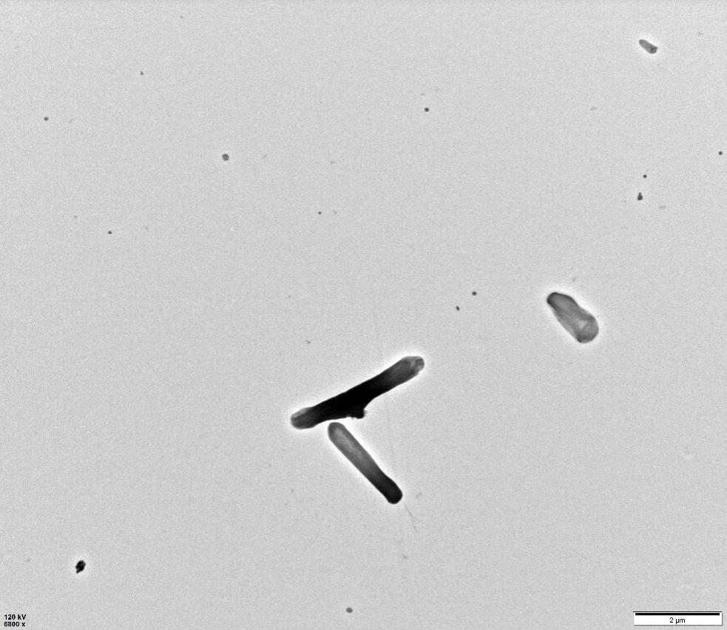
Supplementary Fig. S1. Transmission electron micrographs (TEM) of cells of strain WN019T after 24 h of incubation on MR2A agar plate at 37 ℃. Scale bar is shown on the image.
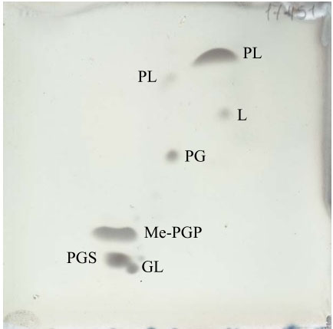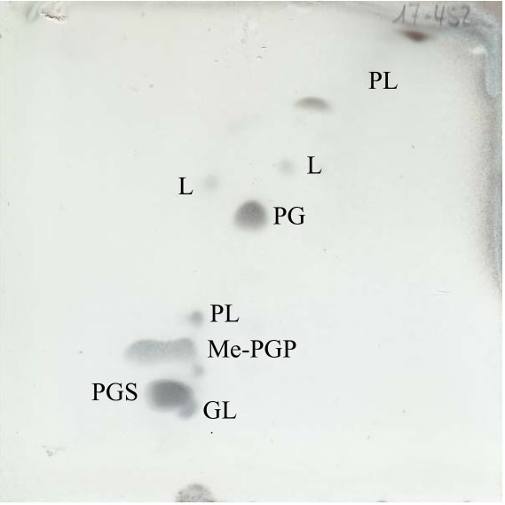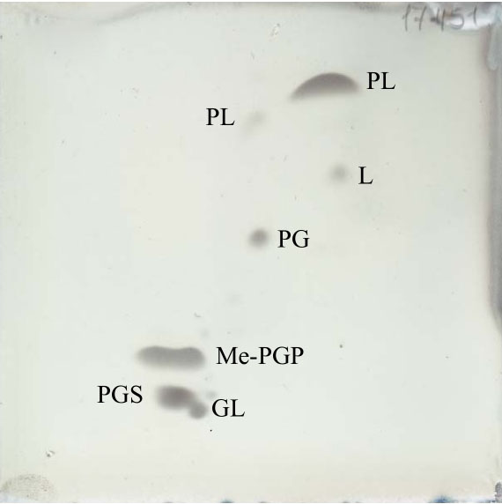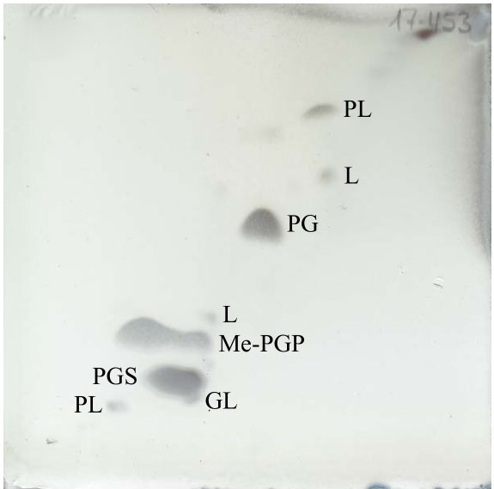
S
F
S
F
S
F
S
F
a
b
c
d
Supplementary Fig. S2. Polar lipids profiles of strains WN019^{T} (a), Halorubrum saccharovorum JCM 8865^{T} (b), Halorubrum persicum JCM 30541^{T} (c) and Halorubrum kocurii JCM 14978^{T} (d). All the polar lipids from 4 strains mentioned above were determined in this study, and the TLC plates were stained by 10 % phosphomolybdic acid in 95 % ethanol for detection of total lipids (Shown above), 0.2 % ninhydrin in 1-butanol for aminolipids (not shown), molybdenum blue reagent (Sigma) for phospholipids (not shown) and Dragendorff's reagent (Sigma) for cholines (not shown).
Abbreviations: L, Lipid; GL, Glycolipid; PL, Phospholipid; PG, phosphatidylglycerol; GL, glycolipid; PGS, Phosphatidylglycerol-Sulfate; Me-PGP, Phosphatidylglycerol-Phosphate-Methyl Ester; F, first dimension of TLC; S, second dimension of TLC.
Halorubrum xinjiangense BD-1^{T} (AY510707)
Halorubrum litoreum Fa-1^{T} (EF028067)
Halorubrum trapanicum NRC 34021^{T} (X82168)
Halorubrum californiense SF3-213^{T} (EF139654)
Halorubrum chaoviator Halo-G^{T} (AM048786)
Halorubrum tebenquichense DSM 14210^{T} (AOJD01000002)
Halorubrum arcis AJ201^{T} (DQ355793)
Halorubrum pallidum PJ61^{T} (KJ644242)
Halorubrum salinum GX71^{T} (HM063951)
Halorubrum laminariae R60^{T} (KF680551)
Halorubrum saccharovorum JCM 8865^{T} (U17364)
Halorubrum salipaludis WN019^{T}(MF782426)
Halorubrum persicum C49^{T} (HG421000)
Halorubrum trueperi Y73^{T} (KX376707)
Halorubrum orientale EJ-52^{T} (AM235786)
Halorubrum aquaticum CGMCC 1.6377^{T} (jgi.1057974)
Halorubrum alkaliphilum DZ-1^{T} (AY510708)
Halorubrum tibetense 8W8^{T} (AY149598)
Halorubrum luteum CGSA15^{T} (DQ987877)
Halorubrum rubrum YC87^{T} (JQ237124)
Halorubrum cibi B31^{T} (EF077639)
Halorubrum halodurans Cb34^{T} (HG421007)
Halobacterium salinarum DSM 3754^{T} (AJ496185)
67
53
26
26
99
98
39
91
72
75
50
71
85
52
59
15
41
51
55
87
0.01
Supplementary Fig. S3. Maximum likelihood (ML) phylogenetic tree based on 16S rRNA gene sequences showing the relationships between strain WN019^{T} and related taxa. Bootstrap values > 50 % (1000 replicates) are shown. Scale bar, 0.01 substitutions per nucleotide position. Halobacterium salinarum DSM 3754^{T} (AJ496185) was used as an outgroup. GenBank accession numbers are indicated for each strain.
Supplementary Fig. S4. Maximum parsimony (MP) phylogenetic tree based on 16S rRNA gene sequences showing the relationships between strain WN019T and related taxa. Bootstrap values > 50 % (1000 replicates) are shown. GenBank accession numbers are indicated for each strain in parentheses.
Halorubrum cibi B31^{T} (EF077639)
Halorubrum halodurans Cb34^{T} (HG421007)
Halorubrum rubrum YC87^{T} (JQ237124)
Halorubrum aquaticum CGMCC 1.6377^{T} (jgi.1057974)
Halorubrum luteum CGSA15^{T} (DQ987877)
Halorubrum alkaliphilum DZ-1^{T} (AY510708)
Halorubrum tibetense 8W8^{T} (AY149598)
Halobacterium salinarum DSM 3754T^{T} (AJ496185)
Halorubrum orientale EJ-52^{T} (AM235786)
Halorubrum trueperi Y73^{T} (KX376707)
Halorubrum arcis AJ201^{T} (DQ355793)
Halorubrum saccharovorum JCM 8865^{T} (U17364)
Halorubrum salipaludis WN019^{T}(MF782426)
Halorubrum persicum C49 ^{T} (HG421000)
Halorubrum salinum GX71 ^{T} (HM063951)
Halorubrum pallidum PJ61^{T} (KJ644242)
Halorubrum laminariae R60^{T} (KF680551)
Halorubrum tebenquichense DSM 14210^{T} (AOJD01000002)
Halorubrum californiense SF3-213^{T} (EF139654)
Halorubrum chaoviator Halo-G^{T} (AM048786)
Halorubrum trapanicum NRC 34021^{T} (X82168)
Halorubrum xinjiangense BD-1^{T} (AY510707)
Halorubrum litoreum Fa-1^{T} (EF028067)
57
54
76
92
75
67
100
67
98
47
85
51
60
72
50
Supplementary Table. S1. The average nucleotide identity (ANI) and dDDH values (%) between the genomes of strain WN019^{T}, and closely related genomes in GenBank.
Most closely related genomes in GenBank | Accession number | ANIb value [%] | ANIm value [%] | dDDH value [%]
Halorubrum salsamenti JCM 31270^{T} | GCA_007671685.1 | 88.06 | 90.33 | 36.4
Halorubrum amylolyticum ZC67^{T} | GCA_004114995.1 | 88.05 | 90.41 | 36.3
Halorubrum halophilum JCM 18963^{T} | GCA_000739595.1 | 87.56 | 90.04 | 35.7
Halorubrum saccharovorum JCM 8865^{T} | GCA_000337915.1 | 87.52 | 89.94 | 35.4
Halorubrum lipolyticum JCM 13559^{T} | GCA_000337375.1 | 87.22 | 89.81 | 34.9
Halorubrum persicum JCM 30541^{T} | GCA_002727125.1 | 87.03 | 89.57 | 34.2
Halorubrum kocurii JCM 14978^{T} | GCA_000337355.1 | 86.76 | 89.41 | 33.8
Halorubrum lacusprofundi ATCC 49239^{T} | GCA_000022205.1 | 86.18 | 88.95 | 33.1
Halorubrum depositum JCM 31272^{T} | GCA_007671725.1 | 84.82 | 88.32 | 29.1
Halorubrum aidingense JCM 13560^{T} | GCA_000336995.1 | 83.26 | 87.37 | 27.5
Halorubrum tebenquichense DSM 14210^{T} | GCA_000337415.1 | 83.03 | 87.42 | 26.9
Halorubrum xinjiangense JCM 12388^{T} | jgi.1057946.1 | 82.86 | 87.29 | 26.9
Halorubrum distributum JCM 9100^{T} | GCA_000337055.1 | 82.86 | 87.4 | 26.8
Halorubrum coriense DSM 10284^{T} | GCA_000337035.1 | 82.55 | 87.16 | 26.2
Halorubrum sodomense DSM 3755^{T} | jgi.1055354.1 | 82.52 | 87.31 | 26.4
Halorubrum californiense DSM 19288^{T} | GCA_000336875.1 | 82.41 | 87.30 | 26.5
Halorubrum halodurans Cb34^{T} | GCA_002252985.1 | 81.47 | 86.93 | 26.1
Halorubrum glutamatedens ZY8^{T} | GCA_003697845.1 | 81.14 | 86.84 | 25.8
Halorubrum aethiopicum JCM 31519^{T} | GCA_001542905.1 | 80.90 | 86.46 | 25.4
Halorubrum aquaticum CGMCC 1.6377^{T} | jgi.1057974.1 | 80.85 | 86.45 | 25.4
Halorubrum cibi DSM 19504^{T} | GCA_900182635.1 | 80.65 | 86.32 | 25.1
Haloparvum sediment JCM 30891^{T} | GCA_001462205.1 | 78.73 | 85.75 | 24.2

