Supplementary Information
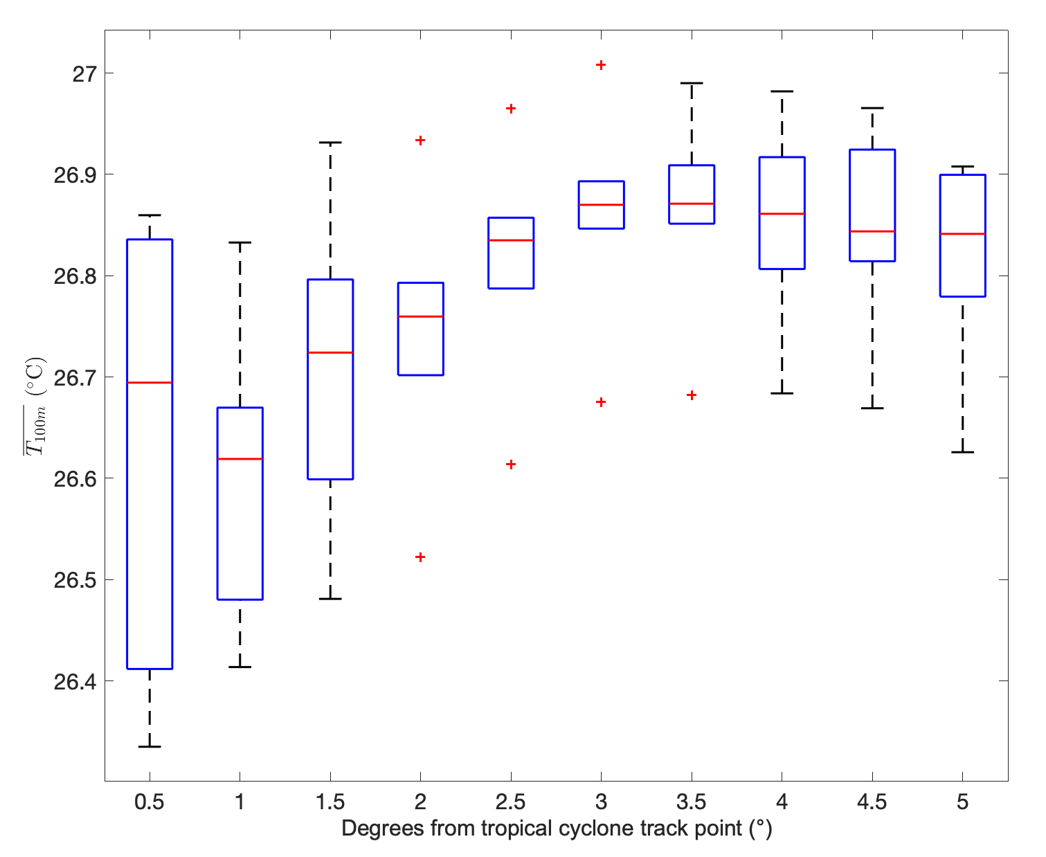
Supplementary Figure 1 Ocean temperature variability 1980-2023 up to 5 degrees from the TC track point and up to 30 days in advance.
Supplementary Table 1 Caribbean TC wind pressure relationship examples by latitude band based on HURDAT2 historical data. The RMSE by latitude band is also shown
MSW (kts) | Minimum Pressure (mb)
MSW (kts) | 10-15ºN | 15-20ºN | 20-25ºN | 25-30ºN
50 | 1000 | 998 | 997 | 996
100 | 966 | 964 | 958 | 958
150 | 914 | 911 | 903 | 908
RMSE | 4.8 | 5.1 | 6 | 6.1

