Supplementary Methods

Sensitivity analysis
Sensitivity analyses were prespecified to evaluate the robustness of inferences to distributional assumptions, temporal functional form, uncertainty estimation, and the potential influence of the oldest age strata (Figure S1). Detailed specifications are summarized in Tables S1–S4.
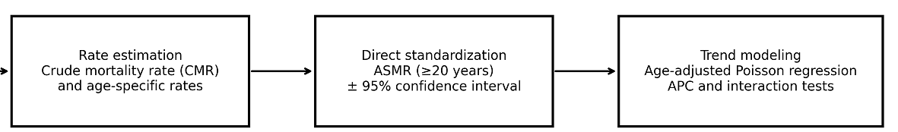
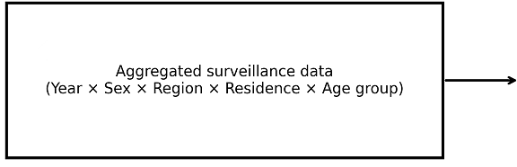
Figure S1. Analytical workflow (schematic).

S1) Overdispersion assessment and alternative count model
We assessed overdispersion in the primary Poisson models using dispersion diagnostics and residual patterns; when present, we refit models using negative binomial regression with the same covariate structure and offset (Table S1).
Table S1. Overdispersion assessment and negative binomial sensitivity model.
Component | Specification | Decision/criterion
Overdispersion diagnostic | Dispersion = Residual deviance / residual df | >1.2 suggests overdispersion
Residual-based check | Pearson residuals vs fitted values | Systematic pattern supports overdispersion
Alternative model | Negative binomial regression | Same covariates and offset as primary model
Robustness criterion | Compare APC and 95% CI (Poisson vs NB) | Consistent direction and similar magnitude

S2) Alternative temporal functional forms
To evaluate departures from a strictly linear year effect, we refit models using year as a categorical variable and restricted cubic splines for year (Table S2; Figure S2). For spline models, we additionally summarized an average annual percent change over 2013–2021 from fitted rates.
Figure S2. Alternative temporal functional forms (schematic).
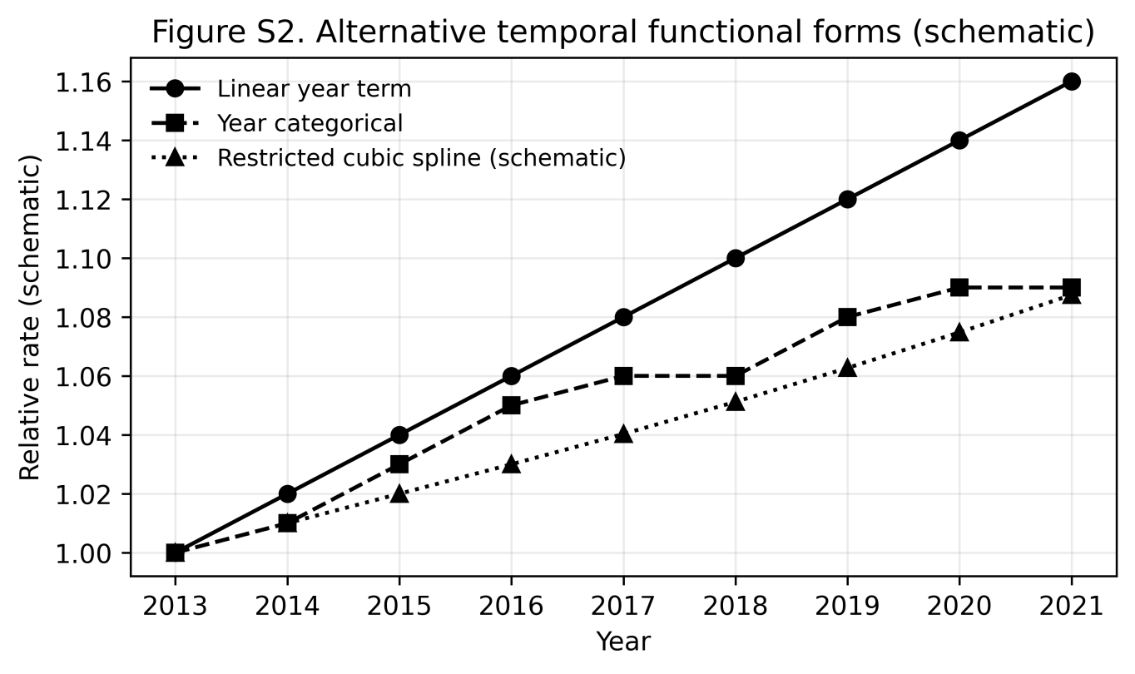
Table S2. Alternative temporal functional forms for year in trend models.
Approach | Implementation | Rationale/output
Year categorical | Indicator for each year (2013–2021) | Does not assume linear trend; enables year-specific effects
Restricted cubic spline | 3–4 knots at prespecified quantiles of study years | Captures nonlinearity while smoothing
Average APC from spline | Computed from fitted rates over 2013–2021 | Reported for comparability with primary APC

S3) ASMR uncertainty specification (Monte Carlo)
We complemented analytic ASMR 95% CIs with a Monte Carlo uncertainty analysis that resampled age-specific deaths under Poisson assumptions and recalculated ASMR across repeated draws (Table S3).
Table S3. Monte Carlo uncertainty analysis for ASMR.
Step | Specification | Notes
Sampling distribution | 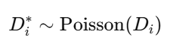(mean = observed D_{i}) | Age-specific deaths resampled
Recalculation per draw |  | Same normalized adult weights
Iterations | ≥5,000 draws per year–subgroup (recommended) | Stable percentile estimates
Uncertainty interval | 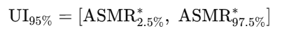2.5th and 97.5th percentiles of ASMR* | Monte Carlo 95% UI

S4) Influence of extreme-age strata
To test whether the oldest age group disproportionately influenced ASMR and trend inferences, we repeated analyses under alternative definitions of extreme-age strata (Table S4).
Table S4. Sensitivity analyses evaluating influence of extreme-age strata.
Sensitivity scenario | Implementation | Interpretation
Oldest-age pooling | Combine 80–84 and ≥85 into 80+ years | Assess influence of sparse/extreme strata
Exclusion analysis | Exclude ≥85 group; recompute ASMR and refit trends | Assess robustness of conclusions
Comparison | Re-evaluate sex/region/residence APC and interaction | Conclusions unchanged = robust

Reporting of sensitivity results
Across sensitivity analyses, we evaluated whether conclusions remained unchanged regarding (i) overall increasing mortality, (ii) faster increases among males than females, (iii) stronger increases in Central/West than East, and (iv) faster increases in rural than urban populations.

