Supplementary information

Do seconds make a difference? Investigating strain-specific behavior of yeast in dynamic glucose environments
Luisa Blöbaum¹, Markus Bünker¹, Julian Schmitz^{1,#}

¹Multiscale Bioengineering, Bielefeld University, Universitätsstr. 25, 33615 Bielefeld, Germany

The supplementary information include:
- Table S1: Reference table for timescales in microbiology and bioprocessing.
- Figure S1: Characterization of the applied microfluidic chip concerning flow profile definition.
- Figure S2: Cellular performance of the three examined yeast strains in different times spent in excess condition.
- Figure S3: Growth, cell size and ATP level of the strain CEN.PK113-7D at 9 s spent in excess conditions over the course of cultivation.
- Figure S4: Growth, cell size and glycolytic flux of the strain CEN.PK113-7D at 9 s spent in excess conditions over the course of cultivation.
- Figure S5: Growth, cell size and glycolytic flux of the strain Ethanol Red at 9 s spent in excess conditions over the course of cultivation.
- Figure S6: Growth, cell size and glycolytic flux of the strain Ethanol Red at 9 s spent in excess conditions over the course of cultivation.
- Figure S7: Growth, cell size and ATP level of the strain PE2 at 9 s spent in excess conditions over the course of cultivation.
- Figure S8: Growth, cell size and glycolytic flux of the strain PE2 at 9 s spent in excess conditions over the course of cultivation.
- Figure S9: Attempted Monod-kinetic fit to illustrate the growth curve behavior for all three yeast strains.

Table S1:
Tab. S1: Reference table for timescales in microbiology and bioprocessing.
Duration / rate |  | Process | Reference
From | To
10 nt/s | 100 nt/s | Transcription | [1]
10 aa/ s (~1 min/protein) |  | Translation | [1]
1 ms | 1 min | Protein folding | [1]
0.7 s (Fumarate in EC) | 3268 s (Ala in SC) | Metabolic turnover time | [2]
1 s | 1 min | Metabolite pool half-life | [1]
10 min | 10 hr | mRNA pool half-life | [1]
1 h | 1 day | Protein pool half-life | [1]
10 min (VN) | Days to years | Doubling time / µ | [3,4]
200 generations (~1.4 days for VN) |  | Mutation accumulation / evolution | [5]
Few min | 2 – 10 h | Fluorophore maturation | [6]
2-7 s | 5 - 15 s | Mixing time lab scale fermenter | [7,8]
0.7 s | 40 s | Min/Max Regime residence time | [9]
3.65 s | 9.37 s | Mean Regime residence time | [9]
2.5* - 20 s | 77 s | Circulation time large scale fermenter (= mixing time / 4) | [9]  *Calculation from [8]
10 s | 175 s | Mixing time 95 % homogeneity large scale | [8]
 | 100 generations | Fermentation time fed batch | [10]
45-60 generations  (VN 7.5 h) |  | seed train to large scale (200 m³) | [10]

Abbreviations: Escherichia coli (EC), Saccharomyces cerevisiae (SC), Vibrio natriegens (VN), nucleotides (nt), amino acids (aa)

References:
1. Shamir M, Bar-On Y, Phillips R, Milo R. SnapShot: Timescales in cell biology. Cell. 2016;164:1302-1302.e1. https://doi.org/10.1016/j.cell.2016.02.058
2. Wang G, Tang W, Xia J, Chu J, Noorman H, van Gulik WM. Integration of microbial kinetics and fluid dynamics toward model-driven scale-up of industrial bioprocesses. Eng Life Sci. 2015;15:20–9. https://doi.org/10.1002/elsc.201400172
3. Hoff J, Daniel B, Stukenberg D, Thuronyi BW, Waldminghaus T, Fritz G. Vibrio natriegens: an ultrafast-growing marine bacterium as emerging synthetic biology chassis. Environ Microbiol. 2020;22:4394–408. https://doi.org/10.1111/1462-2920.15128
4. Weissman JL, Hou S, Fuhrman JA. Estimating maximal microbial growth rates from cultures, metagenomes, and single cells via codon usage patterns. Proc Natl Acad Sci. Proceedings of the National Academy of Sciences; 2021;118:e2016810118. https://doi.org/10.1073/pnas.2016810118
5. Nguyen J, Lara-Gutiérrez J, Stocker R. Environmental fluctuations and their effects on microbial communities, populations and individuals. FEMS Microbiol Rev. 2021;45. https://doi.org/10.1093/femsre/fuaa068
6. Balleza E, Kim JM, Cluzel P. Systematic characterization of maturation time of fluorescent proteins in living cells. Nat Methods. Nature Publishing Group; 2018;15:47–51. https://doi.org/10.1038/nmeth.4509
7. Gaugler L, Hofmann S, Schlüter M, Takors R. Mimicking CHO large-scale effects in the single multicompartment bioreactor: A new approach to access scale-up behavior. Biotechnol Bioeng. 2024;121:1243–55. https://doi.org/10.1002/bit.28647
8. Lara AR, Galindo E, Ramírez OT, Palomares LA. Living with heterogeneities in bioreactors: Understanding the effects of environmental gradients on cells. Mol Biotechnol. 2006;34:355–82. https://doi.org/10.1385/MB:34:3:355
9. Haringa C, Tang W, Deshmukh AT, Xia J, Reuss M, Heijnen JJ, et al. Euler-Lagrange computational fluid dynamics for (bio)reactor scale down: An analysis of organism lifelines. Eng Life Sci. 2016;16:652–63. https://doi.org/10.1002/elsc.201600061
10. Rugbjerg P, Myling-Petersen N, Porse A, Sarup-Lytzen K, Sommer MOA. Diverse genetic error modes constrain large-scale bio-based production. Nat Commun. Nature Publishing Group; 2018;9:787. https://doi.org/10.1038/s41467-018-03232-w

Figure S1

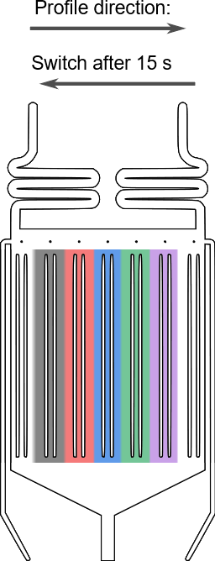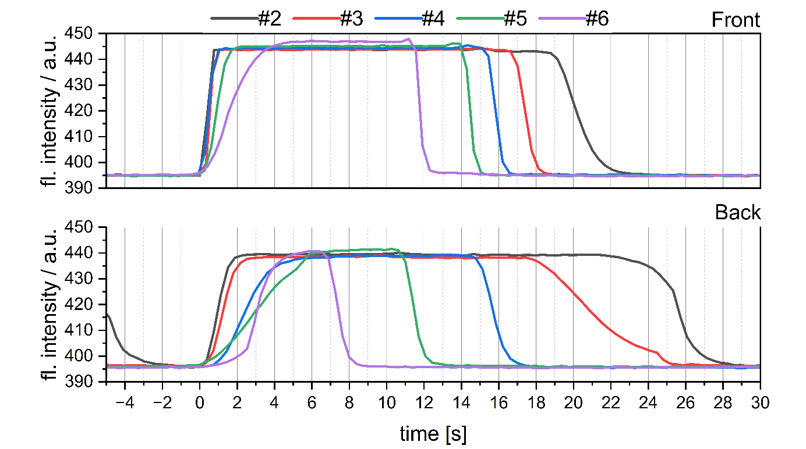
Fig. S1: Characterization of the applied microfluidic chip concerning flow profile definition.
Fluorescent dye exchange in 80 × 90 × 4 µm MGCs was analyzed as a function of chamber position (see Materials and Methods in main paper). For each array pair (#2–#6) within the switching zone, chambers located at both the front and the rear of the array were selected. Pressure conditions were alternated every 15 s, with one representative switching cycle shown. This induced a lateral displacement of the laminar interface from left to right, followed by a return after 15 s. To account for switching-induced delays, time was normalized to the onset of the first detectable signal change within each chamber, thereby excluding the profile switching time from the analysis.
Upon pressure switching, the laminar interface requires 2.7 s to traverse the switching zone, resulting in sequential exposure of array pairs and deviations from the intended 15 s per condition, with only the central array pair #4 experiencing the programmed profile. Exposure times vary substantially across the device, increasing toward the outer arrays and reaching up to 22.5 s deviation in array pair #2. Medium exchange within individual MGCs is diffusion-driven and position-dependent, with slower exchange at the rear of arrays due to gradually developing concentration gradients caused by downstream convection.

Figure S2
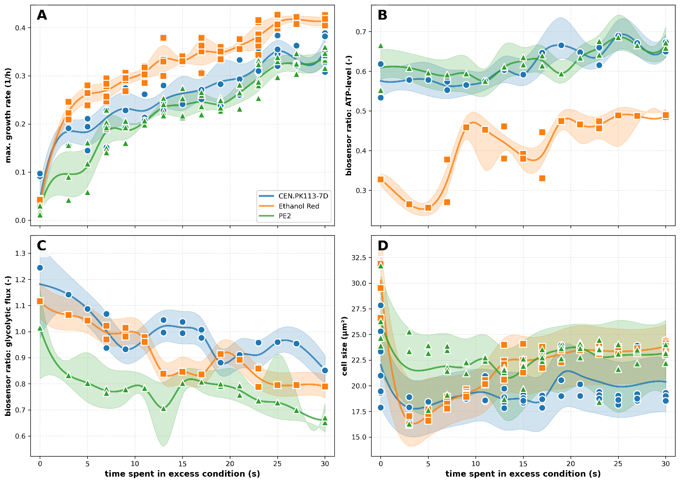
Fig. S2: Cellular performance of the three examined yeast strains for different times spent in excess condition.
The figure shows different key performance indicators (KPIs) of the three yeast strains investigated. The maximum growth rate (µ_{max}) was determined at the population level (A). Cellular ATP levels and glycolytic flux were assessed using the QUEEN-2m sensor (B) and GlyRNA sensor (C), while cell size was monitored in parallel (D). For panels B–D, data are presented as the median of all single-cell measurements ± interquartile range (25–75%) collected over 10–18 hours of cultivation. When multiple experiments were performed under the same dynamic condition, spline curves were generated based on the means of the medians.

Figure S3
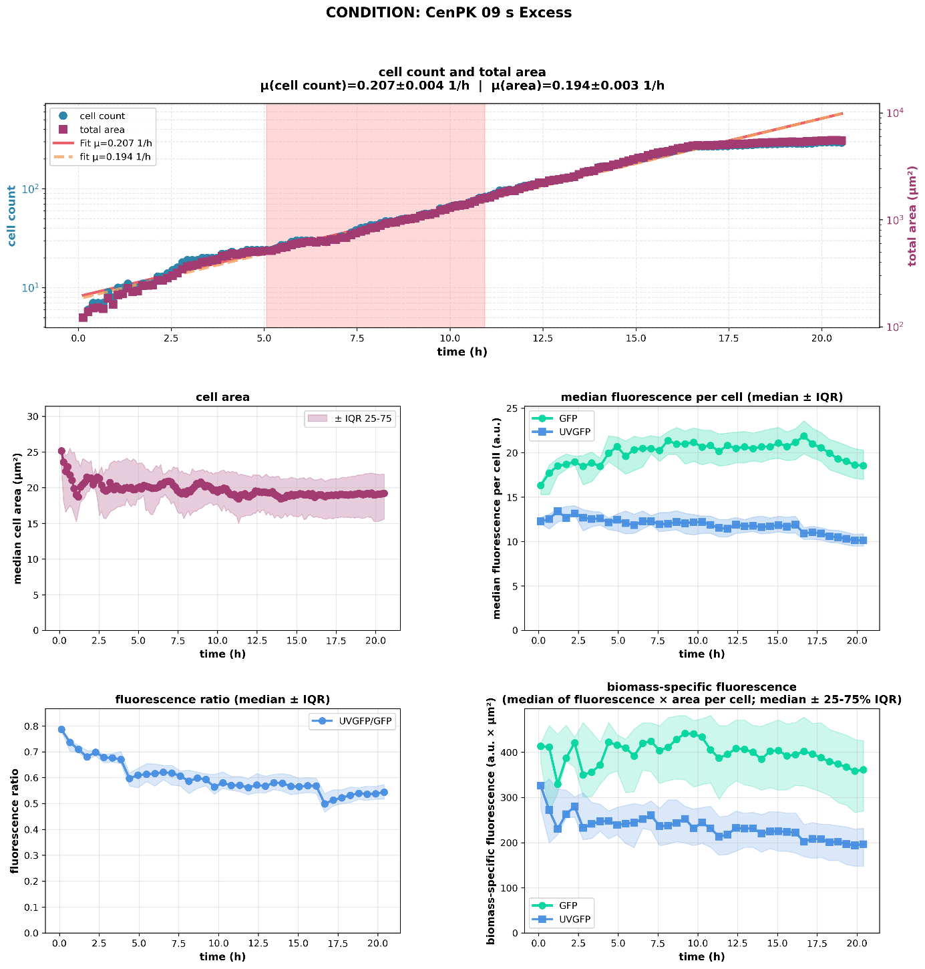
Fig. S3: Growth, cell size and ATP level of the strain CEN.PK113-7D at 9 s spent in excess conditions over the course of cultivation.
The panel illustrates the temporal development of KPIs throughout the cultivation. Cell count and total colony area were used as proxies for cellular growth, with linear fits applied to both parameters to estimate growth rates. Single-cell area served as an indicator of cell size and morphological changes. Biosensor dynamics were assessed based on the fluorescence intensities of two distinct fluorescence channels, representing different conformational states of the QUEEN-2m sensor. The ratio of these fluorescence signals was used to track changes in intracellular ATP levels over the course of cultivation, while biomass-specific fluorescence signals were derived by normalizing fluorescence intensities to the cell area. For all panels excluding the cell count/total area, data are presented as the median of all single-cell measurements ± interquartile range (25–75%) collected over the course of cultivation.

Figure S4
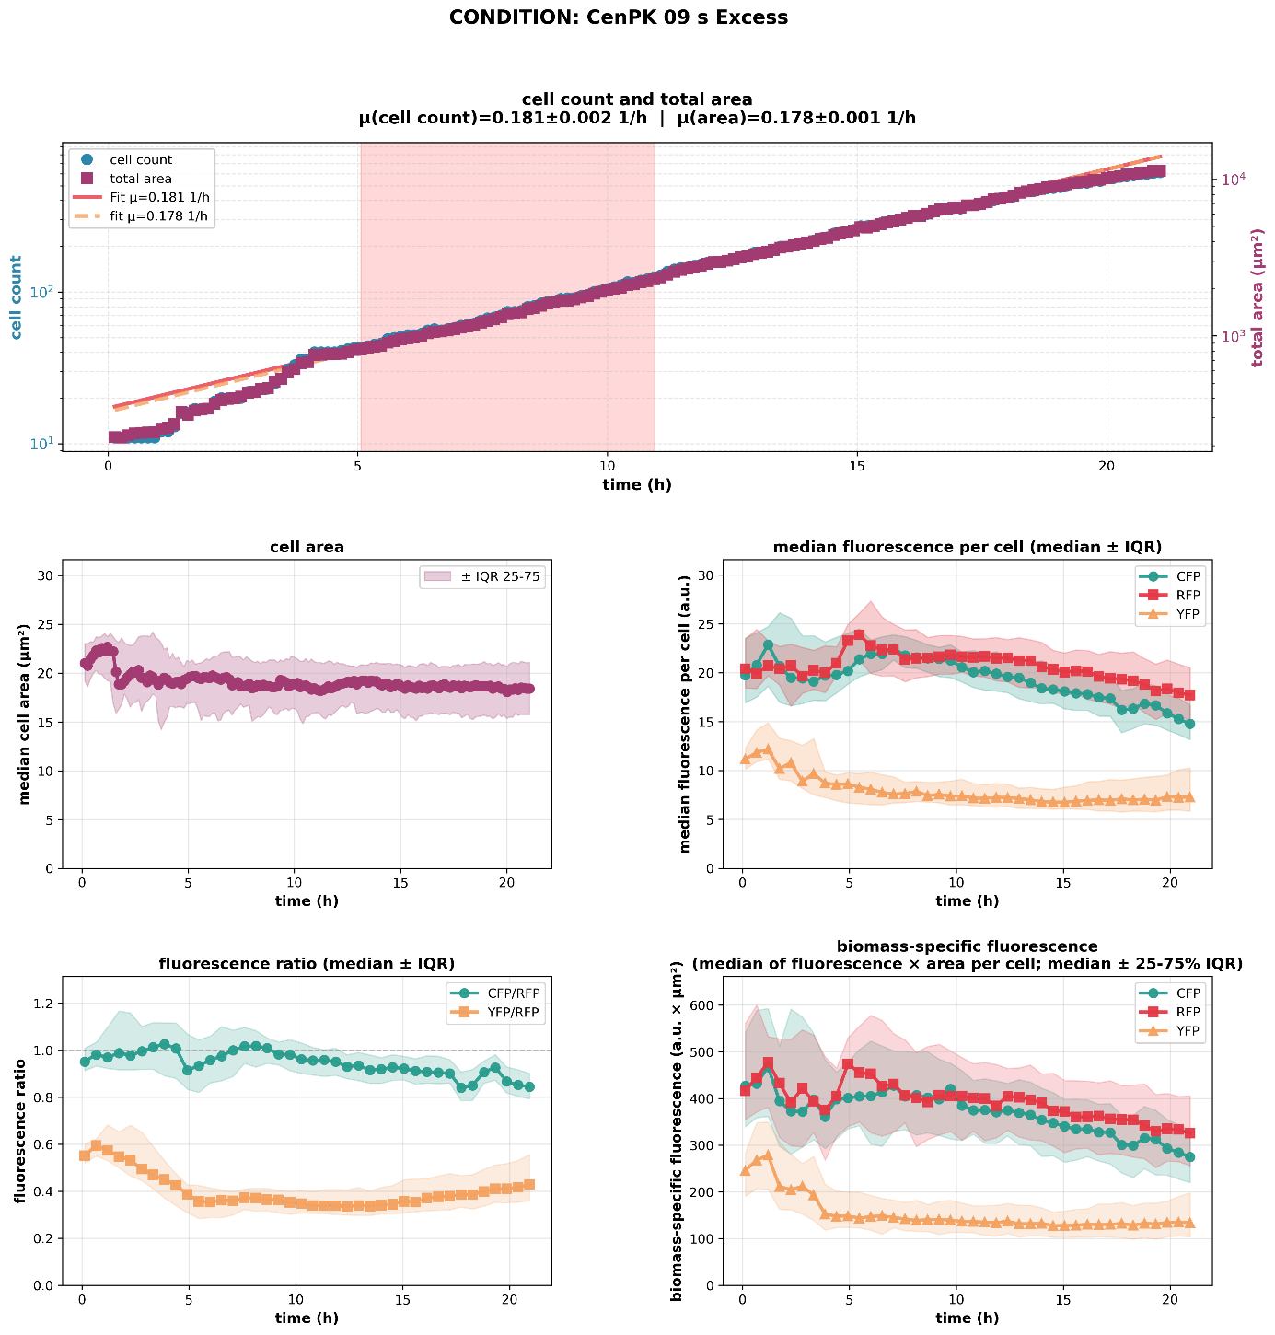
Fig. S4: Growth, cell size and glycolytic flux of the strain CEN.PK113-7D at 9 s spent in excess conditions over the course of cultivation.
The panel illustrates the temporal development of KPIs throughout the cultivation. Cell count and total colony area were used as proxies for cellular growth, with linear fits applied to both parameters to estimate growth rates. Single-cell area served as an indicator of cell size and morphological changes. Biosensor dynamics were assessed based on the ratio the fluorescence intensities of two distinct fluorophores. CFP levels correlate reversely with fructose-1,6-bisphosphate levels and the signal are normalised to constitutively expressed RFP. The ratio of these fluorescence signals was used to track changes in the glycolytic flux over the course of cultivation, while biomass-specific fluorescence signals were derived by normalizing fluorescence intensities to the cell area. The displayed YFP signal and resulting YFP/RFP ratio indicate the level of oxidative stress but was not investigated in the presented study. For all panels excluding the cell count/total area, data are presented as the median of all single-cell measurements ± interquartile range (25–75%) collected over the course of cultivation.

Figure S5
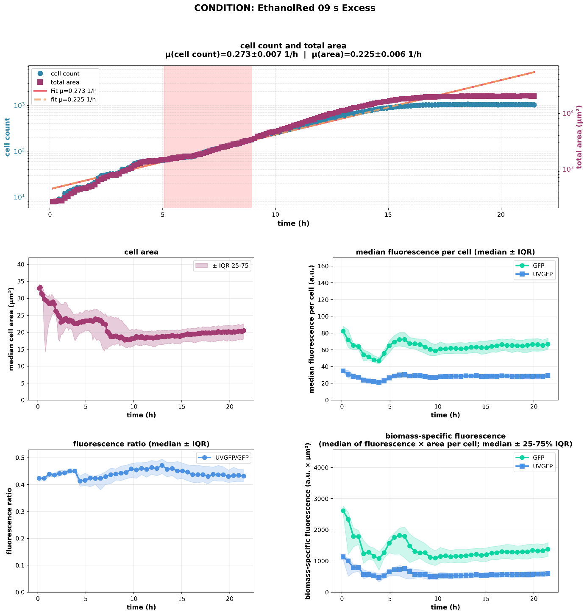
Fig. S5: Growth, cell size and ATP level of the strain Ethanol Red at 9 s spent in excess conditions over the course of cultivation.
The panel illustrates the temporal development of KPIs throughout the cultivation. Cell count and total colony area were used as proxies for cellular growth, with linear fits applied to both parameters to estimate growth rates. Single-cell area served as an indicator of cell size and morphological changes. Biosensor dynamics were assessed based on the fluorescence intensities of two distinct fluorescence channels, representing different conformational states of the QUEEN-2m sensor. The ratio of these fluorescence signals was used to track changes in intracellular ATP levels over the course of cultivation, while biomass-specific fluorescence signals were derived by normalizing fluorescence intensities to the cell area. For all panels excluding the cell count/total area, data are presented as the median of all single-cell measurements ± interquartile range (25–75%) collected over the course of cultivation.

Figure S6
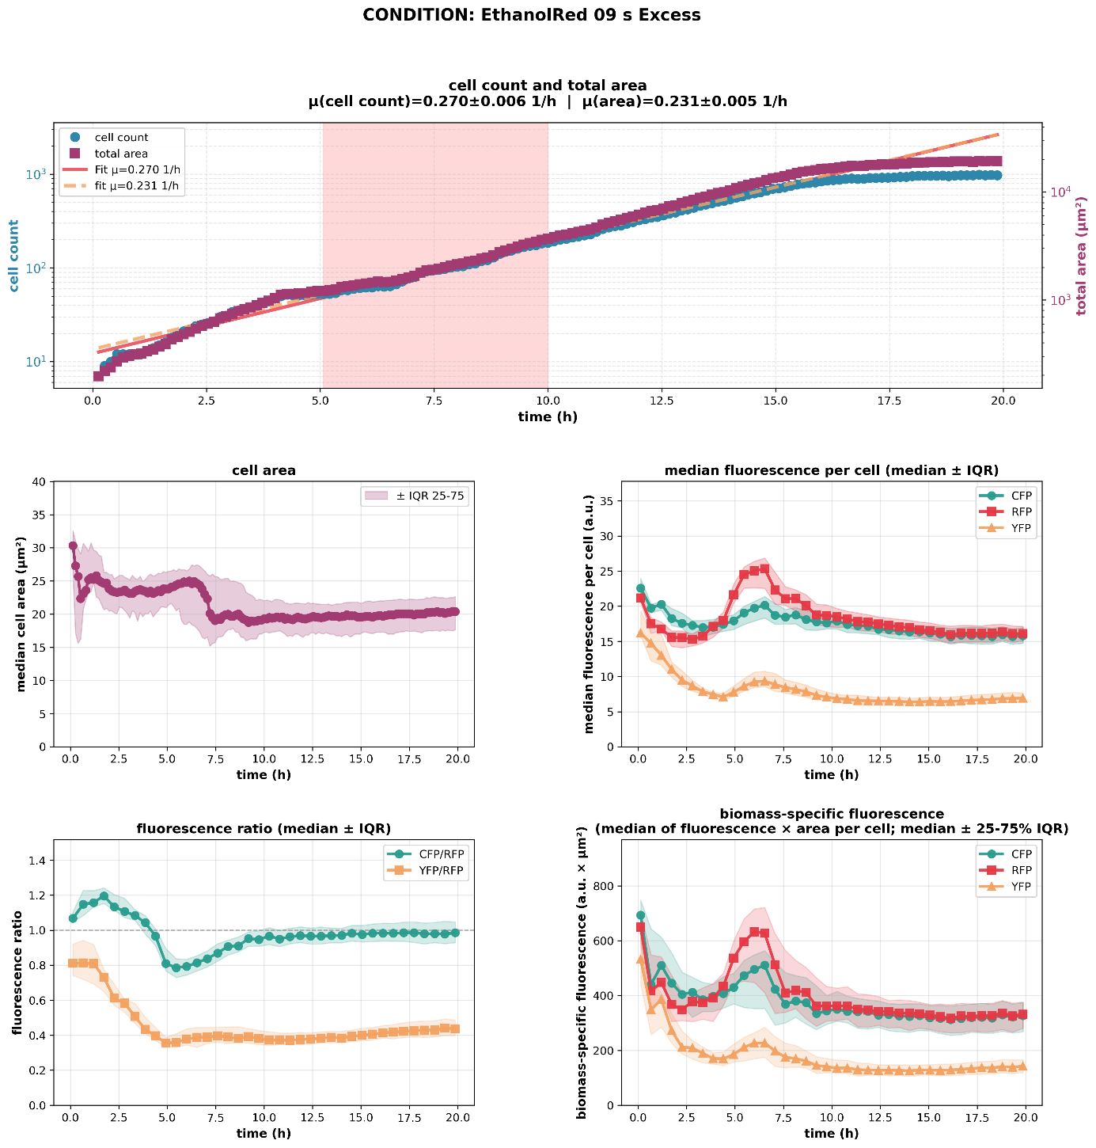
Fig. S6: Growth, cell size and glycolytic flux of the strain Ethanol Red at 9 s spent in excess conditions over the course of cultivation.
The panel illustrates the temporal development of KPIs throughout the cultivation. Cell count and total colony area were used as proxies for cellular growth, with linear fits applied to both parameters to estimate growth rates. Single-cell area served as an indicator of cell size and morphological changes. Biosensor dynamics were assessed based on the ratio the fluorescence intensities of two distinct fluorophores. CFP levels correlate reversely with fructose-1,6-bisphosphate levels and the signal are normalised to constitutively expressed RFP. The ratio of these fluorescence signals was used to track changes in the glycolytic flux over the course of cultivation, while biomass-specific fluorescence signals were derived by normalizing fluorescence intensities to the cell area. The displayed YFP signal and resulting YFP/RFP ratio indicate the level of oxidative stress but was not investigated in the presented study. For all panels excluding the cell count/total area, data are presented as the median of all single-cell measurements ± interquartile range (25–75%) collected over the course of cultivation.

Figure S7
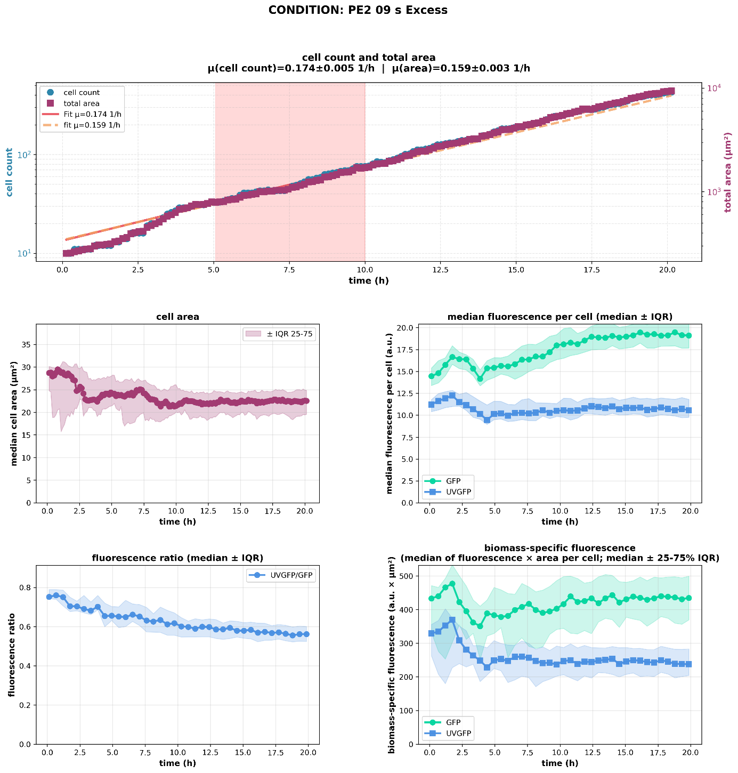
Fig. S7: Growth, cell size and ATP level of the strain PE2 at 9 s spent in excess conditions over the course of cultivation.
The panel illustrates the temporal development of KPIs throughout the cultivation. Cell count and total colony area were used as proxies for cellular growth, with linear fits applied to both parameters to estimate growth rates. Single-cell area served as an indicator of cell size and morphological changes. Biosensor dynamics were assessed based on the fluorescence intensities of two distinct fluorescence channels, representing different conformational states of the QUEEN-2m sensor. The ratio of these fluorescence signals was used to track changes in intracellular ATP levels over the course of cultivation, while biomass-specific fluorescence signals were derived by normalizing fluorescence intensities to the cell area. For all panels excluding the cell count/total area, data are presented as the median of all single-cell measurements ± interquartile range (25–75%) collected over the course of cultivation.

Figure S8
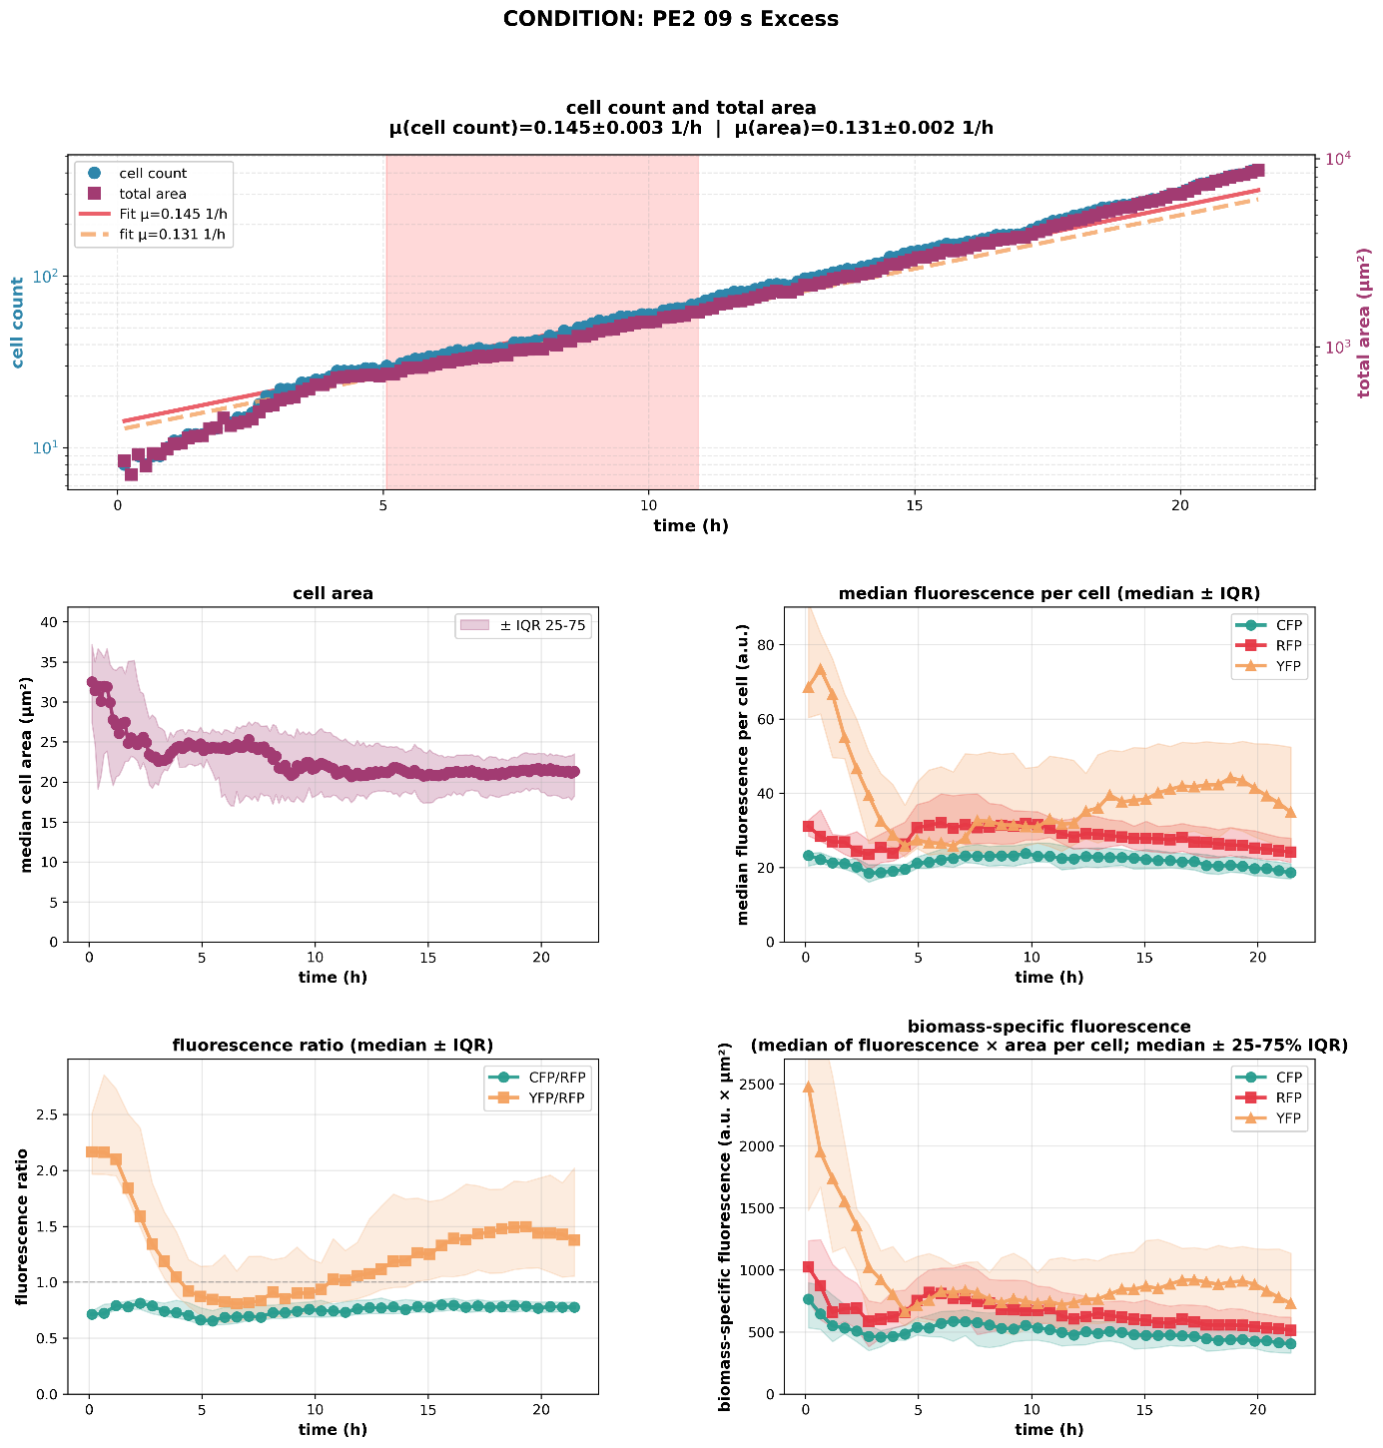
Fig. S8: Growth, cell size and glycolytic flux of the strain PE2 at 9 s spent in excess conditions over the course of cultivation.
The panel illustrates the temporal development of KPIs throughout the cultivation. Cell count and total colony area were used as proxies for cellular growth, with linear fits applied to both parameters to estimate growth rates. Single-cell area served as an indicator of cell size and morphological changes. Biosensor dynamics were assessed based on the ratio the fluorescence intensities of two distinct fluorophores. CFP levels correlate reversely with fructose-1,6-bisphosphate levels and the signal are normalised to constitutively expressed RFP. The ratio of these fluorescence signals was used to track changes in the glycolytic flux over the course of cultivation, while biomass-specific fluorescence signals were derived by normalizing fluorescence intensities to the cell area. The displayed YFP signal and resulting YFP/RFP ratio indicate the level of oxidative stress but was not investigated in the presented study. For all panels excluding the cell count/total area, data are presented as the median of all single-cell measurements ± interquartile range (25–75%) collected over the course of cultivation.

Figure S9
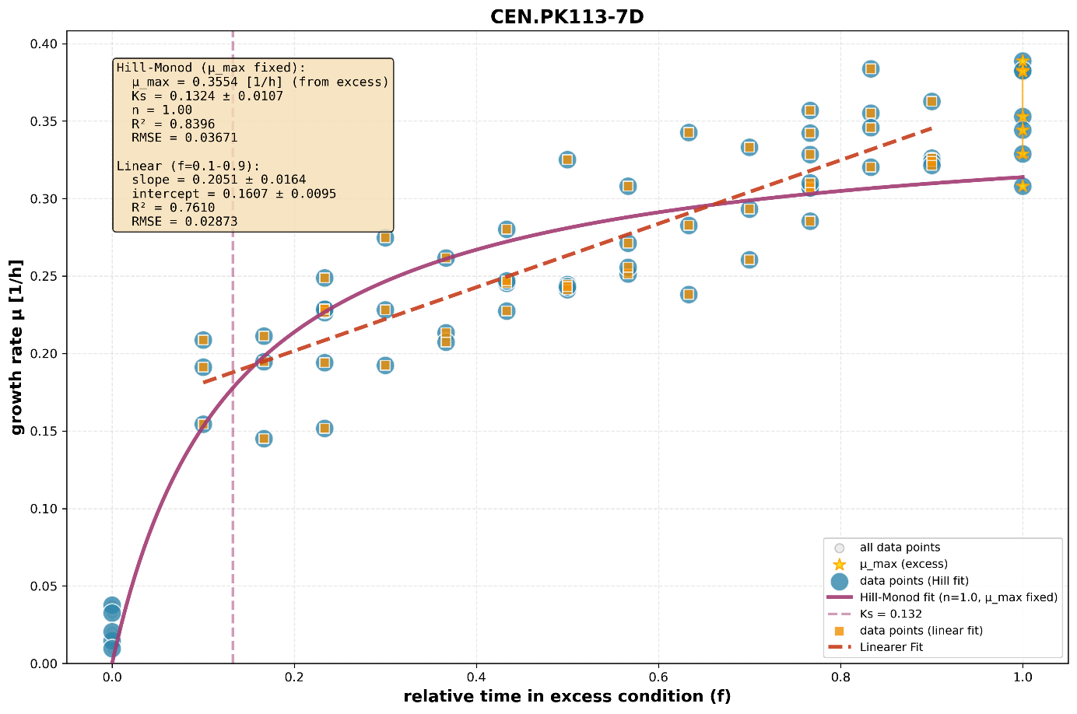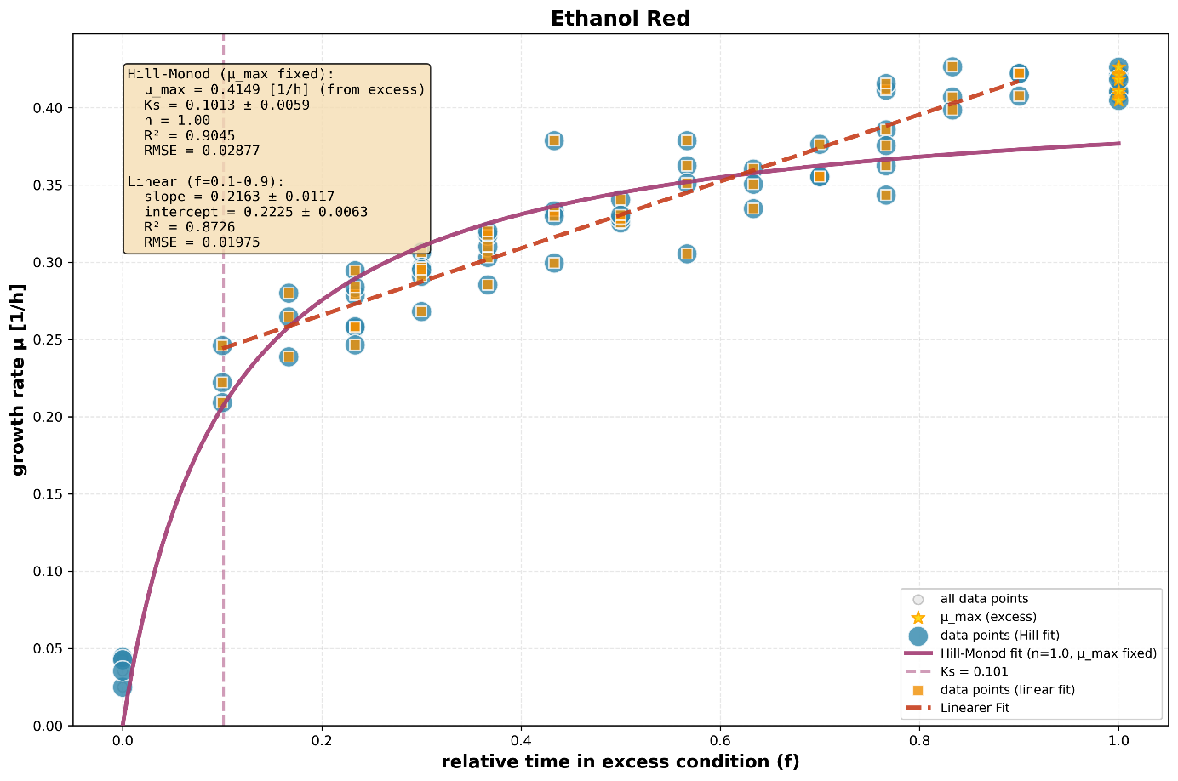
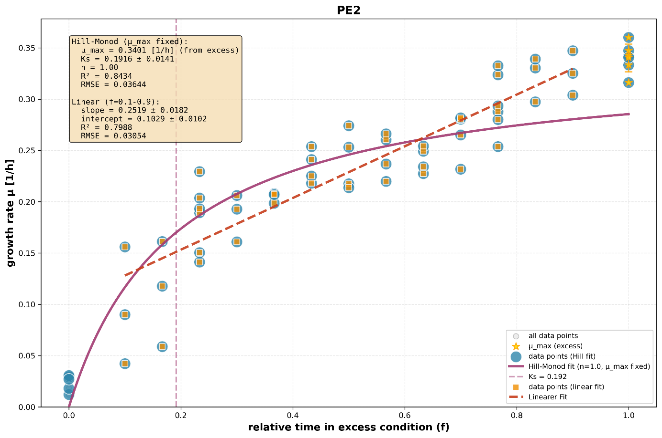
Fig. S9: Attempted Monod-kinetic fit and linear fit to illustrate the growth curve behavior for all three yeast strains.

