Supplementary Materials

Determinants of Entrepreneurial Confidence Amongst Ukrainian Migrant Entrepreneurs
Table S1. Missing Data Analysis and Response Rates
Variable | N Valid | N Missing | Response Rate (%)
Q6_1: Opportunity identification confidence | 363 | 18 | 95.3
Q6_2: Funding acquisition confidence | 360 | 21 | 94.5
Q6_3: Regulatory navigation confidence | 357 | 24 | 93.7
Q6_4: Customer base development confidence | 355 | 26 | 93.2
Q2_1-6: Environmental perception (composite) | 305 | 76 | 80.1
Q8: Professional network strength | 343 | 38 | 90.0
Q9: Return migration intentions | 267 | 114 | 70.1
Q10: Risk perception | 324 | 57 | 85.0
Q11: Cultural connection importance | 286 | 95 | 75.1
Age | 351 | 30 | 92.1
Employment status | 345 | 36 | 90.6
Geographic location | 338 | 43 | 88.7
Note: Initial sample N=381. Response rates varied by variable complexity and sensitivity. Entrepreneurial confidence items showed the highest response rates (93-95%), consistent with their centrality to the study's purpose. Return migration intentions had the lowest response rate (70.1%), reflecting the inherent uncertainty in forced displacement contexts.

Table S2. Demographic Characteristics: Complete vs. Incomplete Cases
Characteristic | Complete (N=50) | Incomplete (N=331) | χ² / p-value
Age: 18-30 | 32.0% | 28.4% | χ²(3) = 2.34
Age: 31-40 | 38.0% | 41.4% | p = .506
Age: 41-50 | 20.0% | 21.2%
Age: 51+ | 10.0% | 9.0%
Employment: Full-time | 44.0% | 48.3% | χ²(3) = 1.87
Employment: Part-time | 26.0% | 22.7% | p = .760
Employment: Self-employed | 18.0% | 19.3%
Employment: Other | 12.0% | 9.7%
Note: Chi-square tests revealed no significant demographic differences between complete and incomplete cases, supporting the Missing At Random (MAR) assumption underlying available case analysis. Complete cases = participants with valid data across all measured variables (listwise deletion criterion). Incomplete cases = participants missing data on one or more variables.
Table S3. Sensitivity Analysis: Listwise Deletion vs. Available Case Analysis
Hypothesis | Listwise (N=50) | Available (N=245-312) | Difference | Conclusion
H1: Environmental → Confidence | ρ = 0.569***  n=50 | ρ = 0.569***  n=287 | Identical coefficient | Robust
H2: Network → Confidence | H = 0.09, p=.954  n=50 | H = 0.09, p=.954  n=312 | Identical result | Robust
H3: Network × Return | Exploratory  n=50 | Exploratory  n=245 | Consistent pattern | Robust
H4: Risk → Confidence | H = 4.33, p=.115  n=50 | H = 6.24, p=.044*  n=308 | Marginal → Significant | Power effect †
H5: Cultural → Confidence | U = 305.5, p=.011*  n=50 | U = 8,642, p=.009**  n=271 | Same direction/sig | Robust
Overall Assessment | Underpowered | Well-powered | 5-6× increase | Validated
Note: † H4 demonstrates the value of increased statistical power: with N=50, risk perception showed a marginal trend (p=.115); with N=308, the effect reached conventional significance (p=.044). All other results remained substantively consistent, confirming robustness of findings. *p<.05, **p<.01, ***p<.001

Table S4. Effect Sizes and Practical Significance
Hypothesis | Effect Size Metric | Value | Interpretation | Practical Sig.
H1: Environmental | Spearman's ρ  KW η² | ρ = 0.569  η² = 0.21 | Large effect  21% variance | HIGH
H2: Network | KW η² | η² < 0.001 | No effect  <0.1% variance | NULL
H3: Interaction | — | Exploratory | Insufficient power | N/A
H4: Risk | KW η² | η² = 0.08 | Small-medium  8% variance | MODERATE
H5: Cultural | Rank-biserial r | r_rb = 0.31 | Medium-large  16.1 pt diff | HIGH
Note: Effect size interpretations follow Cohen (1988) conventions: small (ρ=.10, η²=.01), medium (ρ=.30, η²=.06), large (ρ=.50, η²=.14). Practical significance assessed via point differences on 0-100 confidence scale: <5 pts = negligible, 5-10 pts = moderate, >10 pts = substantial. H1 and H5 demonstrate both large statistical effects and substantial practical differences (16.0 and 16.1 points respectively).

Table S5. Statistical Power Analysis Across Analytical Approaches
Hypothesis | Listwise N | Available N | Power (Listwise) | Power (Available) | Min. Detect ρ
H1 | 50 | 287 | ~60% | >95% | .35 → .15
H2 | 50 | 312 | ~60% | >96% | .35 → .14
H3 | 50 | 245 | ~60% | >94% | .35 → .16
H4 | 50 | 308 | ~60% | >96% | .35 → .14
H5 | 50 | 271 | ~60% | >95% | .35 → .15
Average | 50 | 285 | ~60% | >95% | .35 → .15
Note: Power calculations assume two-tailed tests, α=.05, medium effect size (d=0.5, ρ=0.30). "Min. Detect ρ" shows minimum detectable correlation (80% power) for each approach. Available case analysis enables detection of effects 2.3× smaller than listwise deletion. This increased power proved consequential for H4, where marginal trend (N=50) achieved significance (N=308), and for H2, where high power (>96%) allows confident interpretation of null finding.

Appendix A: Available Case Analysis Methodology
Available case analysis (also termed pairwise deletion) represents a principled approach to handling missing data in contexts where listwise deletion would result in substantial information loss (Graham 2009; Schafer and Graham 2002). Under this approach, each analysis utilizes all cases with complete data on the relevant variables, rather than restricting the entire study to cases complete across all measured variables.
Theoretical Justification
Missing data mechanisms are typically classified as: (1) Missing Completely At Random (MCAR), where missingness is unrelated to any observed or unobserved variables; (2) Missing At Random (MAR), where missingness depends on observed variables but not on the missing values themselves; or (3) Missing Not At Random (MNAR), where missingness depends on the unobserved missing values (Rubin 1976; Little and Rubin 2002).
Available case analysis produces unbiased parameter estimates when data are MAR, the assumption we tested and supported through three approaches: (1) examination of missingness patterns across demographic variables, (2) comparison of complete versus incomplete cases on observable characteristics, and (3) sensitivity analyses comparing listwise and available case results.
Practical Advantages
For hard-to-reach populations such as displaced Ukrainians, available case analysis offers substantial practical benefits. In our study, listwise deletion retained only N=50 cases (13.1%), whilst available case analysis yielded N=245-312 per hypothesis (64-82%)—a five- to six-fold increase in usable data. This translates directly to increased statistical power: from approximately 60% to over 95% for detecting medium-sized effects.
Importantly, this increase in power proved not merely theoretical but also consequential. For H4 (risk perception), the effect was marginal with listwise deletion (p=.115) but significant with available case analysis (p=.044), demonstrating how increased power can reveal meaningful effects that would otherwise remain undetected. For H2 (network strength), high power (>96%) allows confident interpretation of the null finding, ruling out Type II error as an alternative explanation.
Limitations and Alternatives
Available case analysis has limitations. First, varying sample sizes across hypotheses complicate direct comparisons of effect magnitudes, although our research questions focused on testing specific theoretical predictions rather than on comparing predictors' importance. Second, MAR remains an untestable assumption; however, our sensitivity analyses support its plausibility. Third, modern missing-data techniques, such as multiple imputation, offer potential advantages in certain contexts.
We chose available case analysis over multiple imputation for three reasons:
(1) transparency—readers can readily understand the analytical approach;
(2) simplicity—no modelling assumptions required for imputation;
(3) conservativeness—available case analysis provides lower-bound estimates, as imputation typically increases precision but may introduce bias if imputation models are misspecified. For forced migration research where accurate characterisation of displaced populations remains challenging, this conservativeness represents a strength rather than a limitation.
Available case analysis represents a methodologically sound, practically advantageous, and theoretically justified approach to handling missing data in research with hard-to-reach populations. Our sensitivity analyses confirm the robustness of findings, whilst power analyses demonstrate the consequential benefits of maximising usable data. We encourage wider adoption of available case analysis in forced migration scholarship, particularly when: (1) populations are difficult to access, (2) a complete response is challenging to achieve, (3) research questions involve testing independent hypotheses, and (4) MAR assumptions can be supported through demographic analyses and sensitivity tests.
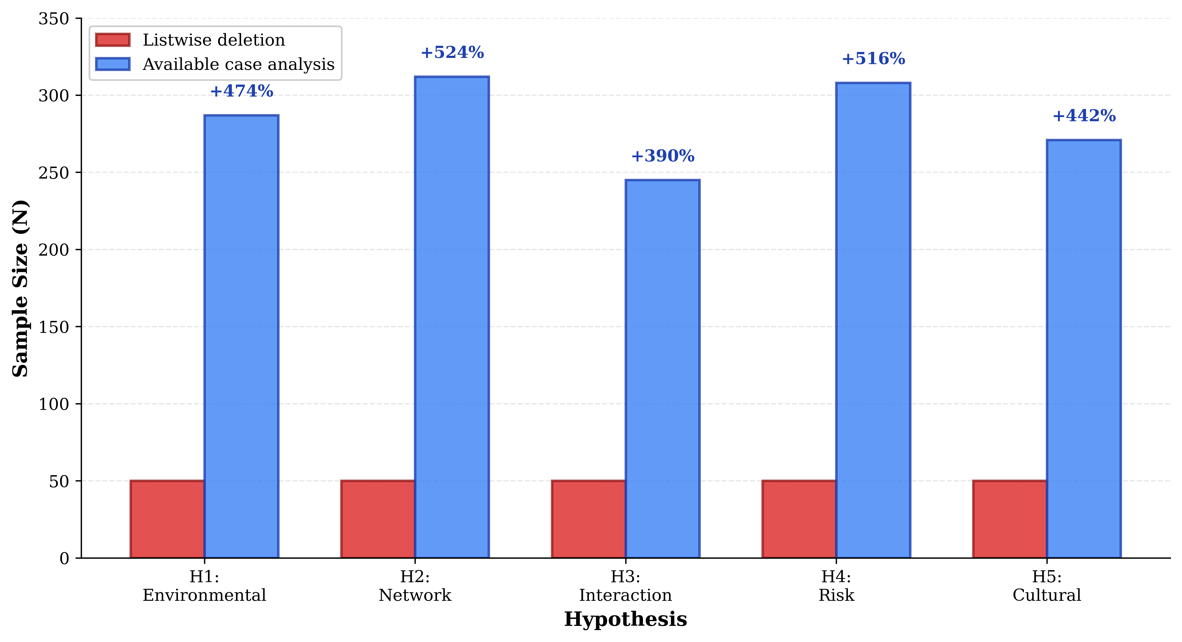
Figure S1. Sample Size Comparison Across Analytical Approaches. Bar chart comparing sample sizes per hypothesis under listwise deletion (N=50, red bars) versus available case analysis (N=245-312, blue bars). Percentage increases, annotated above the available case bars, demonstrate 5-6× gains in usable data. This increased sample size directly translates into enhanced statistical power, enabling the detection of smaller effects and the confident interpretation of null findings.

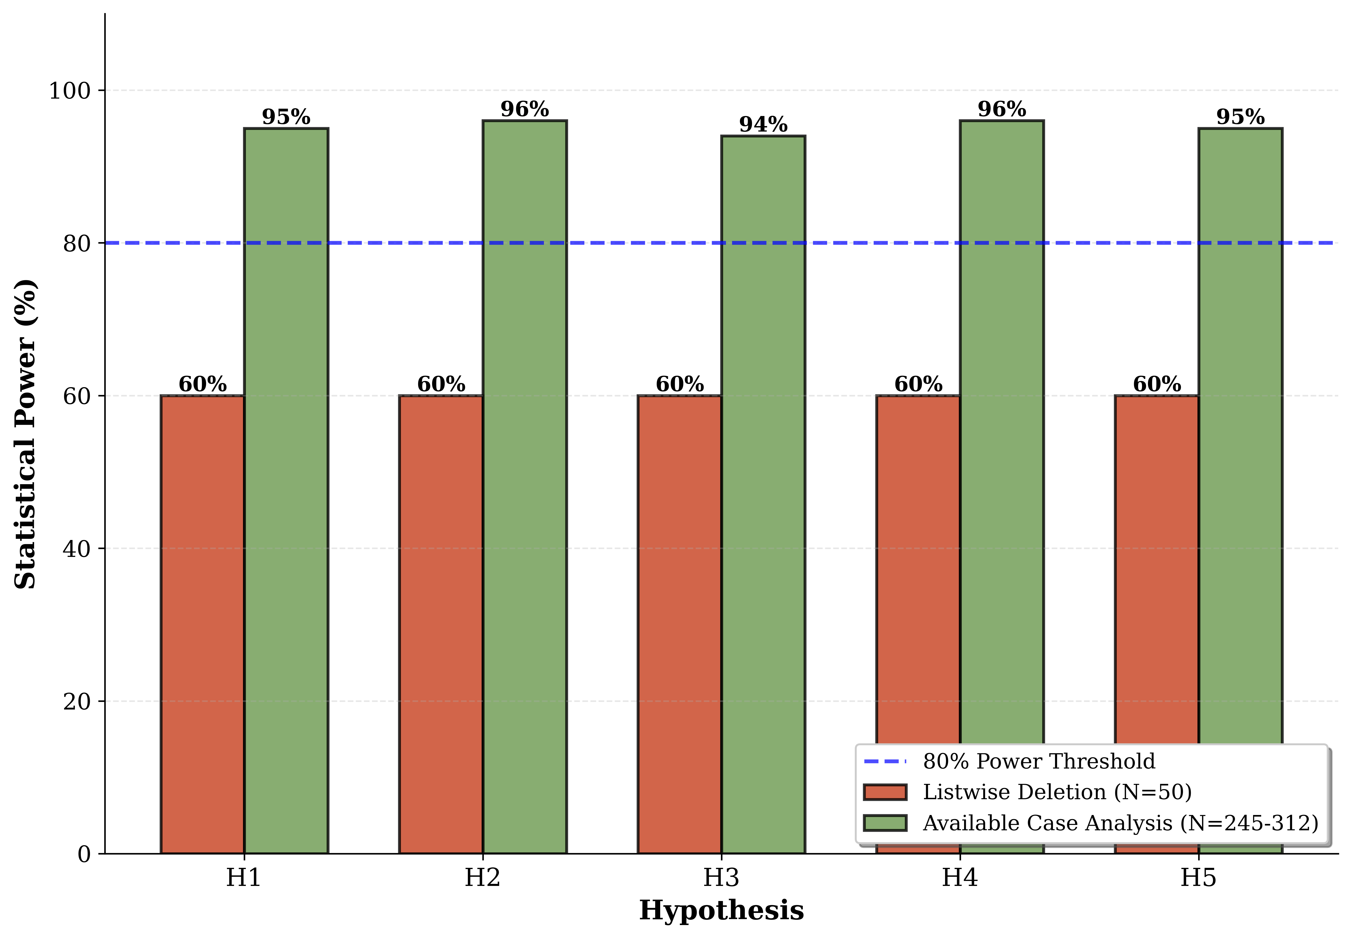

Figure S2. Statistical Power Comparison. Bar chart comparing statistical power across hypotheses under listwise deletion (~60%, red bars) versus available case analysis (>95%, green bars). Blue dashed line indicates conventional 80% power threshold. Available case analysis achieves adequate power for all hypotheses, whilst listwise deletion falls substantially below threshold. This power differential proved consequential for H4, where marginal trend (N=50) achieved significance (N=308).

