Supplementary Information

Intrinsic Neuromorphic Behaviors in PEDOT/PSS Nanoscale Networks and their Enhancement via Ethylene Glycol Doping

Surajit Sarkar¹, Yuta Nishimura¹, Hitomi Hokonohara¹, Masahiro Nakayama¹, Yuma Kondo¹, Tomoki Misaka¹, Hiroshi Ohyama^{1,2}, *Takuya Matsumoto^{1,2}
¹Department of Chemistry, Graduate School of Science, Osaka University
²Forefront Research Center, Graduate School of Science, Osaka University
matsumoto-t@chem.sci.osaka-u.ac.jp

Table of Contents
Supplementary Fig. S1. Schematic and optical picture of electrode structure……3
Supplementary Fig. S2. Periodic signal reconstruction performance of PEDOT/PSS using nano and micro-electrodes………………………………………...………………4
Supplementary Fig. S3. Conductivity of Pristine PEDOT/PSS and EG-doped PEDOT/PSS……………………………………………………………………………...5
Supplementary Fig. S4. AFM topographic images of Pristine PEDOT/PSS……..……6
Supplementary Fig. S5. AFM topographic image of bare SiO₂/Si substrate…………..7
Supplementary Fig. S6. FFT of input signals for EG doped PEDOT/PSS devices………………………………………………………………………………..….8
Supplementary Fig. S7. Lissajous plots and FFT spectra of the output signals for the EG3 device…………………………………………………………………………….…9
Supplementary Fig. S8. Lissajous plots and FFT spectra of the output signals for the EG10 device………………………………………………………………………….…10
Supplementary Fig. S9. Comparison of test accuracy in the waveform generation task for nano-electrode-based EG0, EG3, and EG10 devices. ……………………………...11
Supplementary Fig. S10. Variation of electrical conductivity with temperature for pristine and EG-doped PEDOT/PSS samples………………………………………......12
Supplementary Fig. S11. Dependence of the fitting quality on the ratio ‘$l/a$’………..13
Supplementary Fig. S12. Correlations between $T_{0}$, Scaling factor ($ρ_{0}$), and localization length ($a$) with the increasing EG content…………………….…………….…….……14
Supplementary Table S1. Mixing ratios of ethylene glycol (EG) in PEDOT/PSS at different weight percentages……………..…………..…………………...……….……15
Supplementary Table S2. PSS-to-PEDOT ratio as a function of increasing EG content………………………………………………………………………………….16
Supplementary Note 1. Carrier transport in the nano-electrode devices is influenced by strong electric field…………………………..……………………………………...17
Supplementary References……………………...…………...………………………19

Supplementary Fig. S1. Schematic and optical picture of electrode structure

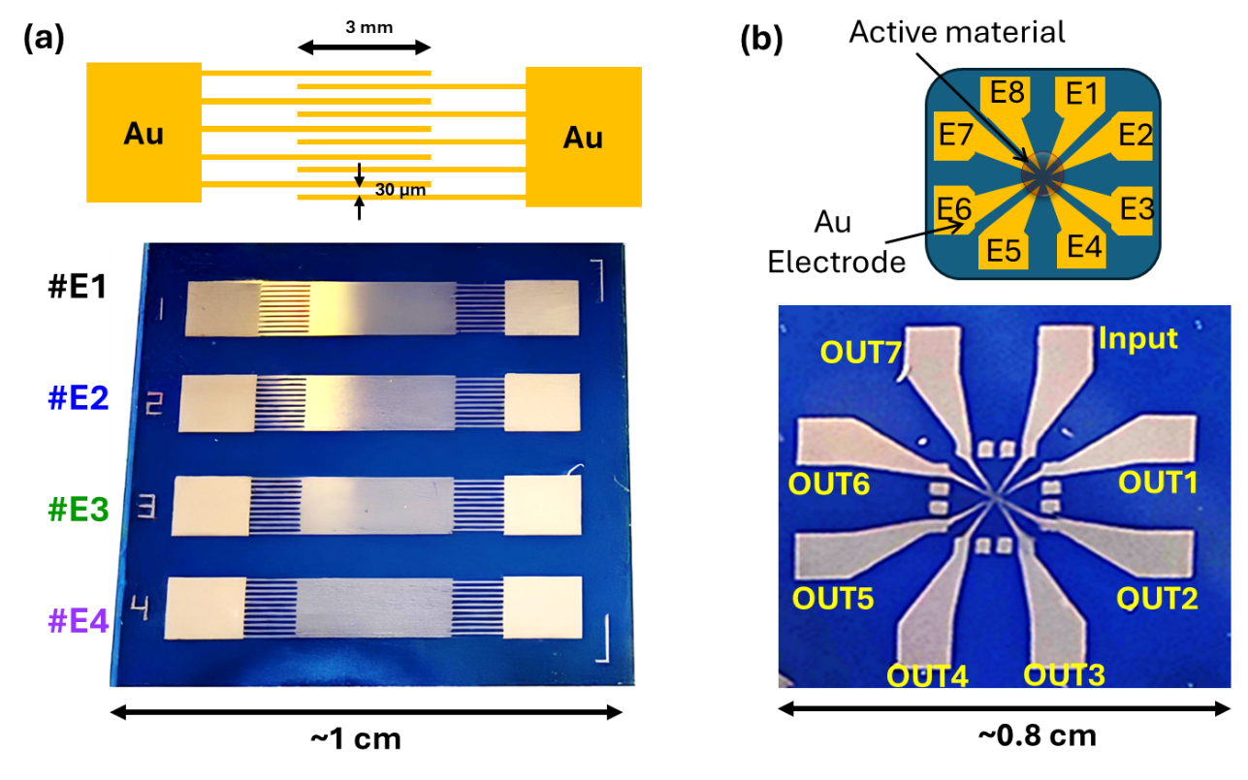

Fig. S1. (a) Schematic elastration and optical image of comb type micro-electrode, where electrode width is 3 mm and spacing between the electrode is 30 μm. (b) Schematic elastration and optical image of hole type nano-electrode, where nearby electrode-electrode (E1-E2) distance is 40 nm and distance between two opposite electrode (E1-E5) is 275 nm.

Supplementary Fig. S2. Periodic signal reconstruction performance of PEDOT/PSS using nano and micro-electrodes.
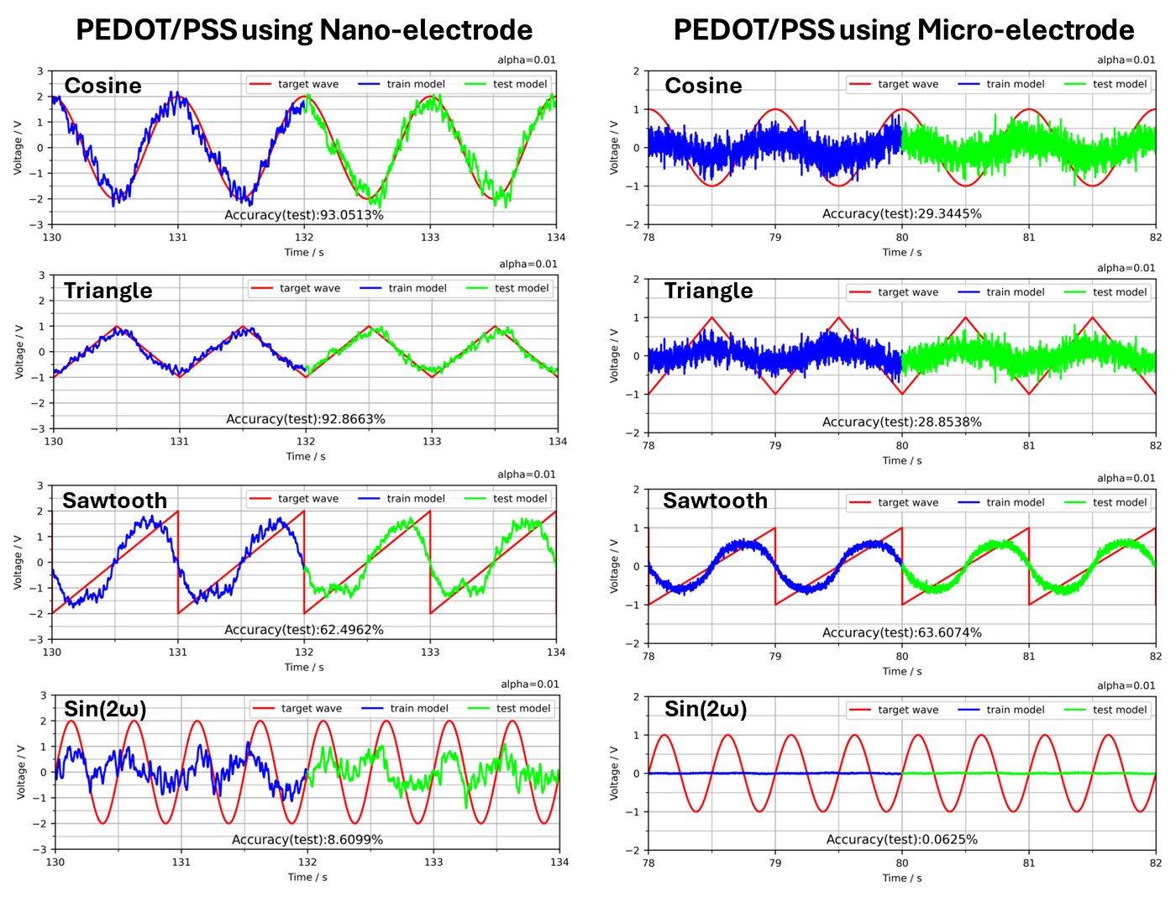
Fig. S2. Periodic signal reconstruction performance of PEDOT/PSS thin films. The dynamic responses of PEDOT/PSS film upon nano-electrode (left) and micro-electrode (right) thin under a sinusoidal input are shown together with their reconstruction of target waveforms, including cosine, triangular, sawtooth, and sin(2ω). The input signal is sin(ω) with a peak-to-peak voltage of 4 V at ω = 1 Hz. The corresponding test accuracies are shown in the center of each plot.

Supplementary Fig. S3. Conductivity of Pristine PEDOT/PSS and EG-doped PEDOT/PSS
To investigate the electrical conductivity of the material, micro-spaced parallel electrodes were used, with an inter-electrode gap of 30 μm, an electrode height of 30 nm, and an electrode length of 600 μm. The material was deposited within the electrode gap, and I–V characteristics were measured by applying a voltage sweep from 0 to 2 V.
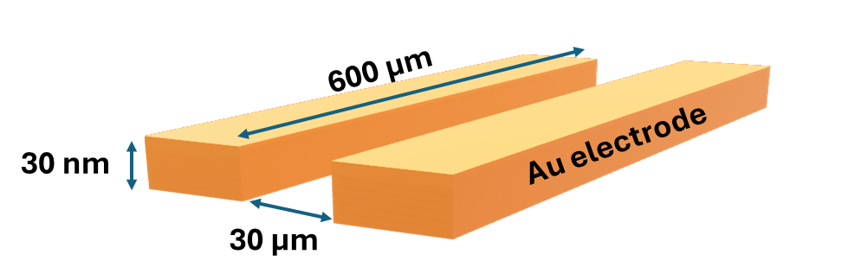
Fig. S3-1. Schematic elastration of parallel electrode to measure conductivity of the materials.
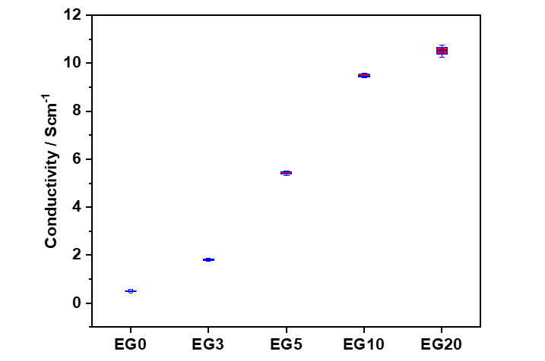
Fig. S3-2. Distribution of electrical conductivity in pristine and EG-doped PEDOT/PSS films. Box plots summarize the conductivity values of PEDOT/PSS films without EG (EG0) and with EG doping (EG3, EG5, EG10 and EG20), where the center line indicates the median, the box denotes the interquartile range, and whiskers represent the full data range.

Supplementary Fig. S4. AFM topographic images of Pristine PEDOT/PSS.
In order to observe AFM topographic image, we have prepared the samples through ink-jet deposition technique, where the material density is highest at the center of the deposited droplet and decreases with increasing radial distance.
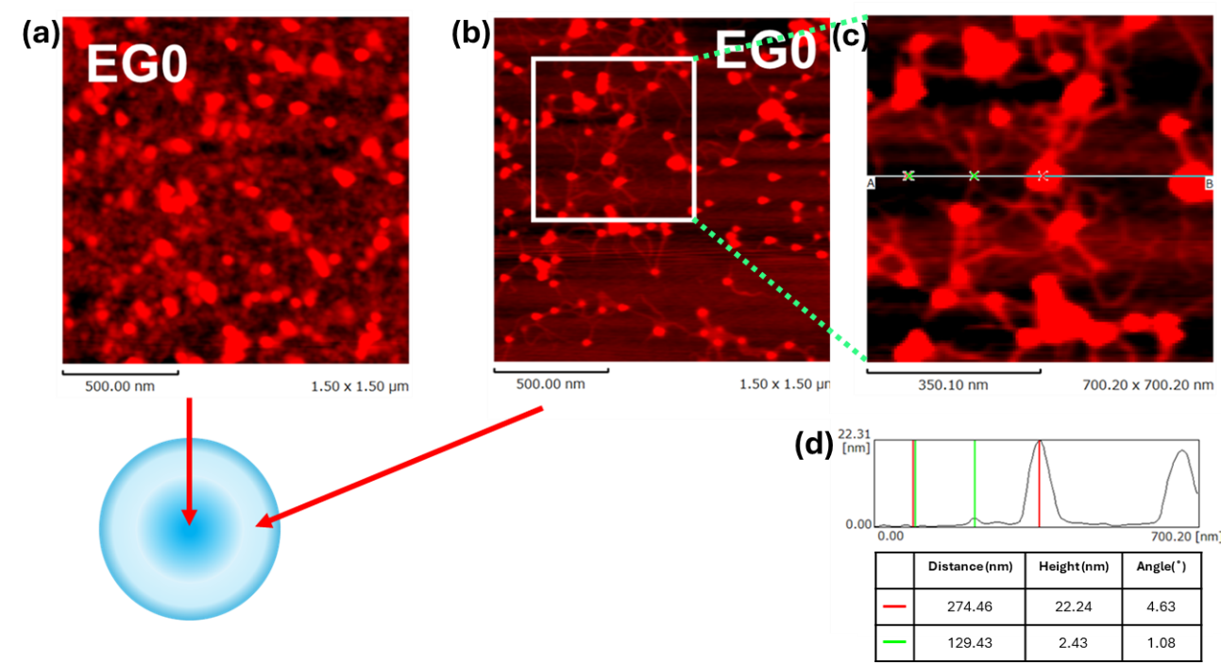

Fig. S4. AFM profile analysis of ink-jet deposited pristine PEDOT/PSS (EG0). a, Topographic image of EG0 taken at the center of the droplet. b, Topographic image of EG0 taken away from the center of the droplet. c, enlarged topographic image of b. d, Height profile extracted from c.

Supplementary Fig. S5. AFM topographic image of bare SiO₂/Si substrate.
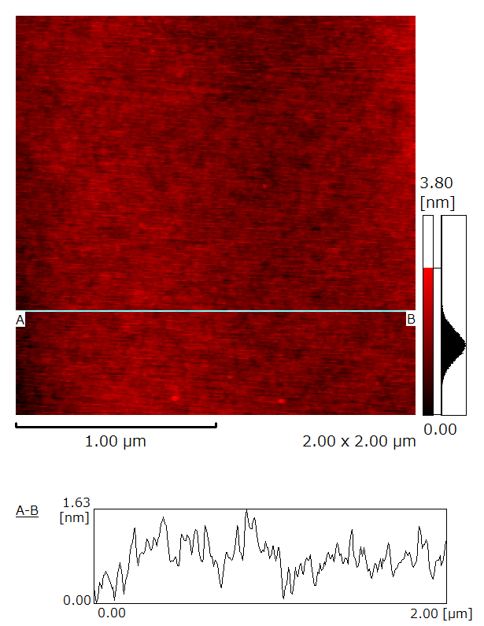

Fig. S5. AFM topographic image of a bare SiO₂/Si substrate, showing a very smooth surface with an average roughness of 1.6 nm.

Supplementary Fig. S6. FFT of input signals for EG doped PEDOT/PSS devices.
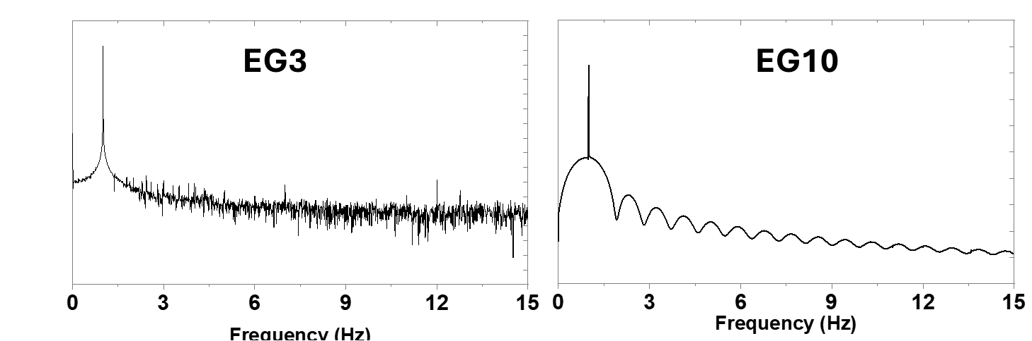

Fig. S6. FFT spectra of the input signals applied to EG3 (left) and EG10 (right), confirming the absence of higher harmonics of input frequency 1 Hz.

Supplementary Fig. S7. Lissajous plots and FFT spectra of the output signals for the EG3 device.
The loops observed in the Lissajous plots indicate the presence of sufficient phase shifts in all EG3 outputs, while the FFT spectra of all outputs reveal higher harmonics, reflecting pronounced nonlinearity and high dimensionality.
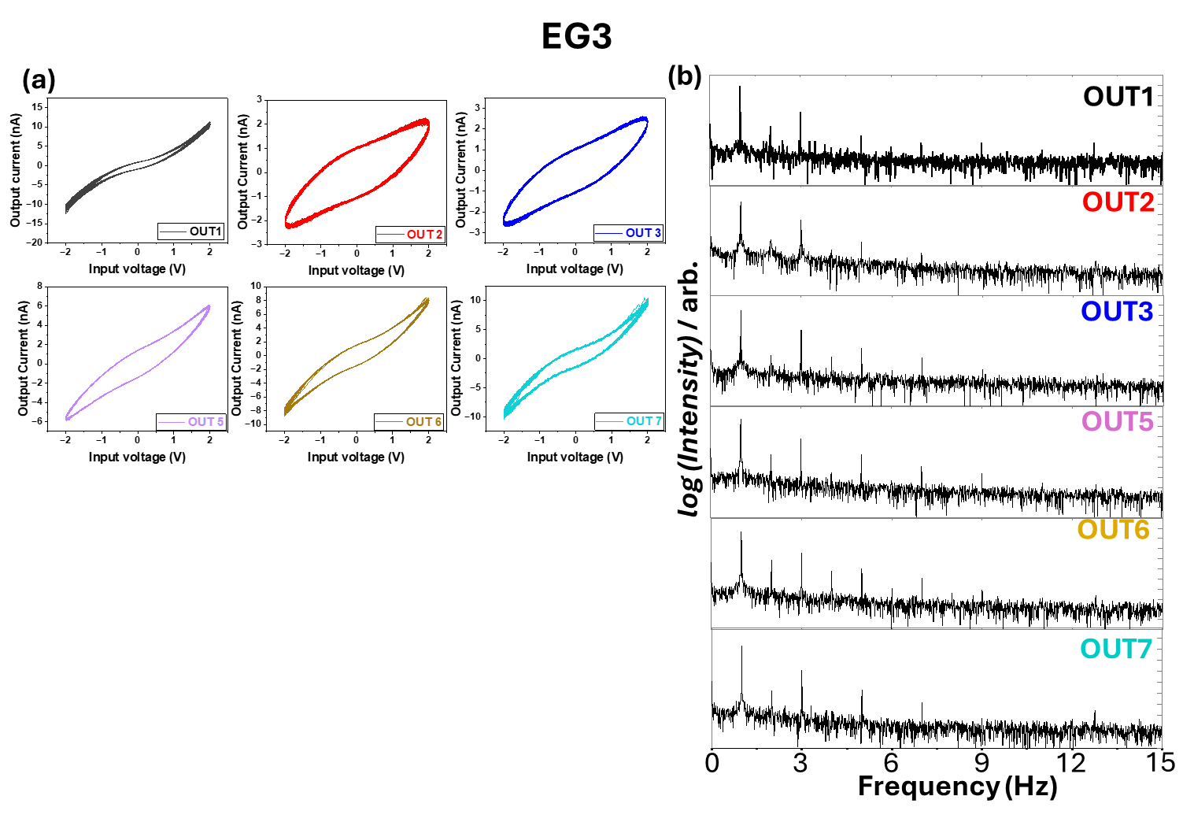
Fig. S7. Lissajous plot and FFT of the output signals from EG3. a, Lissajous plots and b, FFT spectra of EG3 corresponding to output channels 1, 2, 3, 5, 6, and 7.

Supplementary Fig. S8. Lissajous plots and FFT spectra of the output signals for the EG10 device.
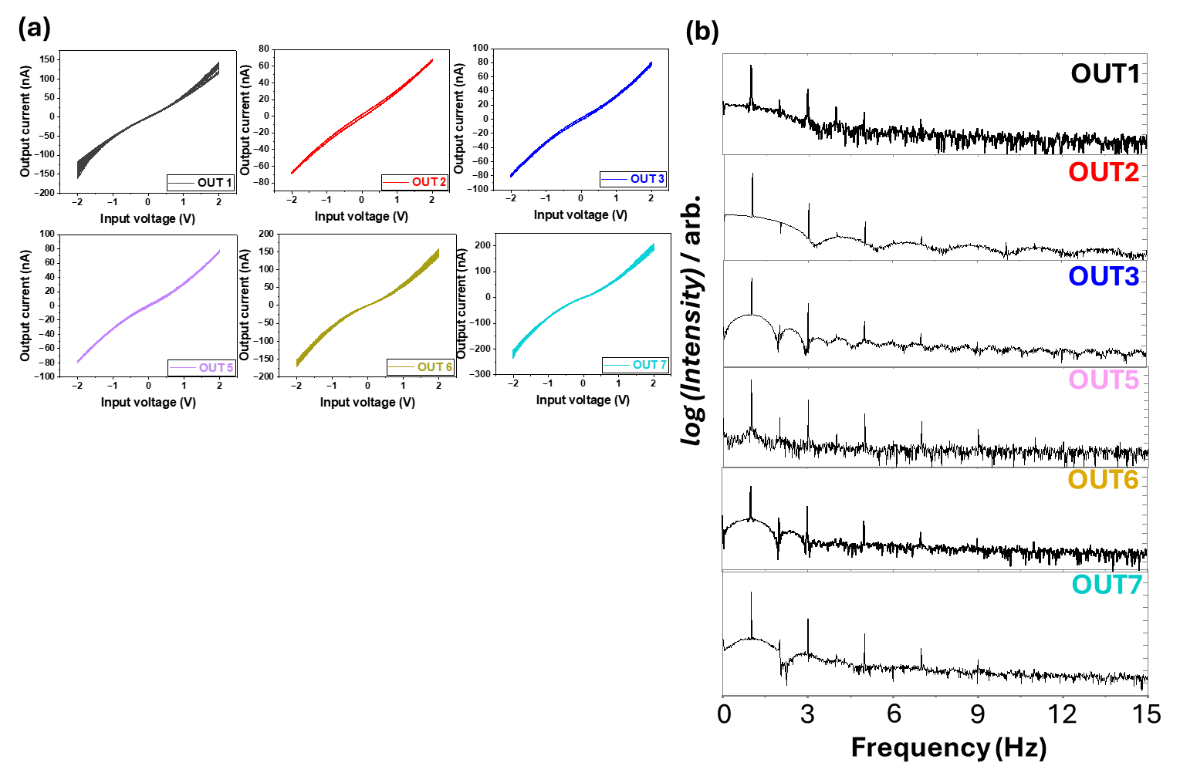
Fig. S8. Lissajous plot and FFT of the output signals from EG10. a, Lissajous plots and b, FFT spectra of EG10 corresponding to output channels 1, 2, 3, 5, 6, and 7.

Supplementary Fig. S9. Comparison of test accuracy in the waveform generation task for nano-electrode-based EG0, EG3, and EG10 devices.

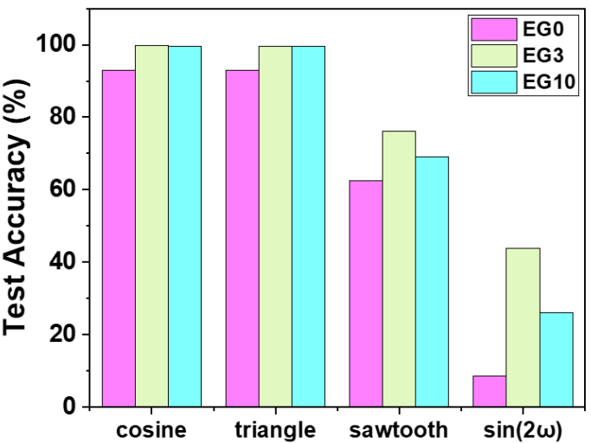

Fig. S9. Comparison of test accuracy in the waveform generation task for nano-electrode-based EG0, EG3, and EG10 devices. For the accuracy test, all seven output channels of each device were trained using ridge regression to generate four waveforms (cosine, triangular, sawtooth, and sin(2ω)), where the peak-to-peak voltage was 4 V and ω was 1 Hz.

Supplementary Fig. S10. Variation of electrical conductivity with temperature for pristine and EG-doped PEDOT/PSS samples.
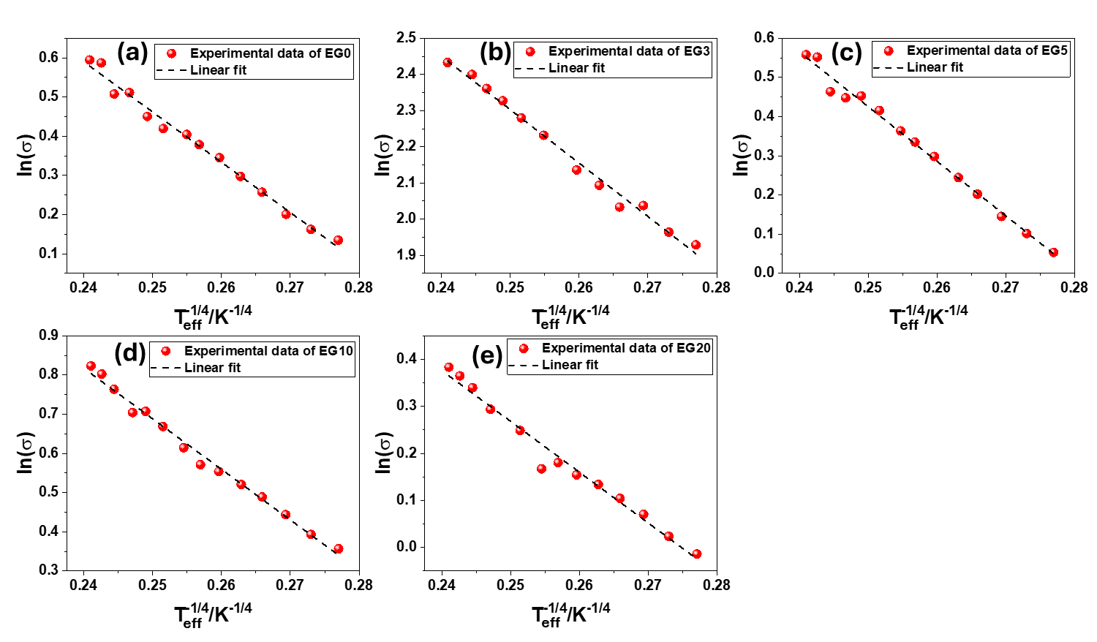

Fig. S10. Temperature dependent conductivity plot ($lnσ$ vs $T_{eff}^{-1/4}$) from 297 K to 170 K indicating three-dimensional variable-range hopping conduction. a, EG0; b, EG3; c, EG5; d, EG10, and e, EG20. Red spheres represent the experimental data, and black dotted lines indicate the linear fits to the data.

Supplementary Fig. S11. Dependence of the fitting quality on the ratio ‘$l/a$’.
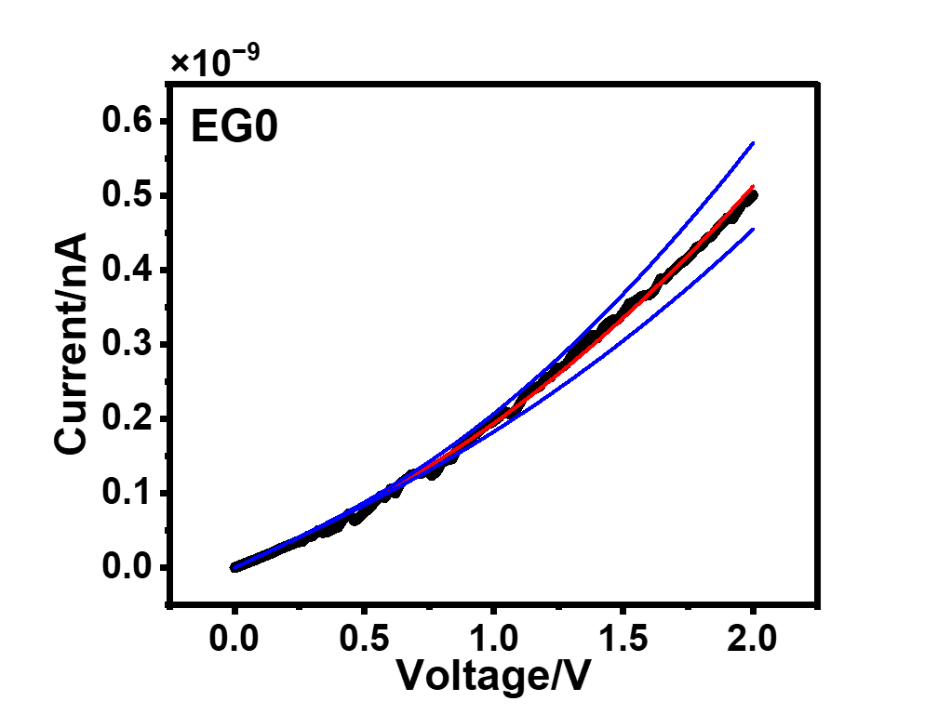
Fig. S11. Effect of the ratio ‘$l/a$’ on the fitting quality of the nonlinear I–V characteristics. The ratio ‘$l/a$’ significantly influences the fitting quality, where ‘$l/a$’ represents the effective number of localized wave functions present between the electrodes. The blue lines indicate the deviated fitted curves, while the red line represents the best fit.

Supplementary Fig. S12. Correlations between $T_{0}$, Scaling factor ($ρ_{0}$), and localization length ($a$) with the increasing EG content.
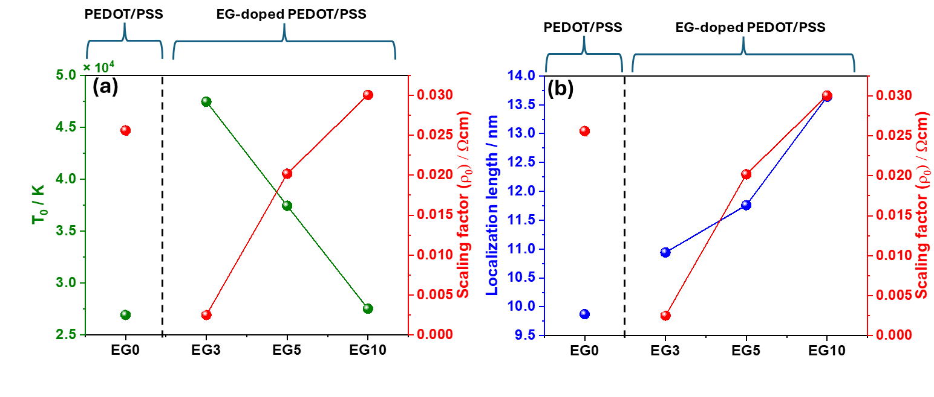
Fig. S12. a, Variation of $T_{0}$ and Scaling factor ($ρ_{0}$); b, Variation of localization length ($a$) and Scaling factor ($ρ_{0}$) with the increasing EG content.

From Fig. S11(a), it is clear that the $T_{0}$ value initially increases upon the addition of EG, and then decreases with further increase in EG concentration. This non-monotonic trend arises from changes in the microstructure of PEDOT/PSS caused by EG doping, specifically a broader grain-size distribution and a more random inter-grain spacing compared to pristine PEDOT/PSS.
According to the relation $k_{B}T_{0}\sim 1/(g\left(E_{F}\right)a^{3})$, the incorporation of EG modifies the density of states at the Fermi level, $g(E_{F})$, as well as the localization length $a$. As a result, $T_{0}$ initially increases, while the VRH scaling factor ($ρ_{0}$) decreases. Our main objective is to realize an EG-controlled device capable of performing waveform generation tasks with high accuracy. The systematic variation of $T_{0}$, $ρ_{0}$, and $a$ observed in the above figure directly supports this objective, as it demonstrates that EG concentration effectively tunes the transport parameters governing nonlinearity and waveform generation performance.

Supplementary Table S1. Mixing ratios of ethylene glycol (EG) in PEDOT/PSS at different weight percentages.

 | PEDOT/PSS  (ml) | Ethylene Glycol  (μl)
EG0 | 3 | 0
EG3 | 3 | 81.8
EG5 | 3 | 136
EG10 | 3 | 273
EG20 | 3 | 545

Table S1. Mixing ratios of ethylene glycol (EG) in PEDOT/PSS at different weight percentages.

Here, EG was mixed with an aqueous dispersion of PEDOT/PSS, in which the concentration of PEDOT/PSS was 4 wt%.

Supplementary Table S2. PSS-to-PEDOT ratio as a function of increasing EG content.
For XPS measurement samples were prepared by inkjet deposition of aqueous dispersions (2 × 10⁻³ wt%) onto SiO₂/Si substrates. PSS:PEDOT ratio decreases along with the increase of EG concentration indicates the depletion of the PSS layer from the film surface¹. EG induce a screening effect between the positively charged PEDOT and negatively charged PSS chains, thus reducing the coulombic interaction between them^{2,3}.

 | PSS : PEDOT
EG0 | 3.96 : 1
EG3 | 3.01 : 1
EG5 | 2.83 : 1
EG10 | 2.73 : 1
EG20 | 2.52 : 1

Table S2. PSS-to-PEDOT ratio as a function of increasing EG content. The data were extracted from the integrated peak areas of the XPS spectra.

Supplementary Note 1. carrier transport in the nano-electrode devices is influenced by strong electric field.

Carrier transport in PEDOT/PSS and EG-doped PEDOT/PSS films occurs through hopping between conductive grains formed within ordered regions of the polymer chains, as illustrated in Fig. 1a of the main text. When a strong electric field ($E$) is applied across nanoscale radial-arrangement electrodes, the hopping process is strongly influenced by the local field enhancement arising from the limited number of conductive pathways^{4,5}. Under such conditions, an electron hopping over a distance $x$ against the electric field gains an additional energy $Δε=eEx$, as schematically shown in Fig. 5(f) of the main text.
At zero temperature ($T=0$), this field-assisted hopping process is analogous to thermally activated transport. The hopping rate ($ν$) can therefore be expressed in terms of the localization length ($a$) as
$ν=ν_{0}exp(-\frac{2x​}{a})=ν_{0}exp(-\frac{2Δε}{eEa}​),$ (S1)
where $ν_{0}$is a prefactor determined by the tunneling mechanism. This expression is formally equivalent to a Boltzmann-type activation process, allowing the definition of an electric-field-induced effective temperature, $T_{field}(E)$, given by

$$T_{field}\left(E\right)=\frac{eEa}{2k_{B}}$$
Accordingly, the hopping rate can be rewritten as
$ν=ν_{0}exp(-\frac{Δε}{{T_{field}(E)k}_{B}}​),$ (S2)

At finite temperatures, both thermal activation and electric-field effects contribute to carrier transport. The resulting effective temperature ($T_{eff}$) is empirically described using a coefficient $γ$as
$T_{eff}^{2}​=T^{2}+{(2γT_{field}​)}^{2}$ (S3)
In the present nanoscale electrode geometry, the effective electric field is highly localized between a small number of conductive grains and can be approximated as $E=Fa$, where $F=V/l$ represents the applied field gradient, distance between the electrode is $l$, and applied potential between the electrode is $V$. Consequently, the effective temperature is expressed as
$T_{eff}=\sqrt{T^{2}+{\left(\frac{γeVa}{k_{B}l}\right)}^{2}}$ (S4)
This enhanced effective temperature reflects the strong electric-field concentration in nano-electrode devices, leading to pronounced nonlinear and asymmetric I–V characteristics compared with micro-electrode configurations, as discussed in the main text.

Supplementary References.
1. Greczynski, G. et al. Photoelectron spectroscopy of thin films of PEDOT–PSS conjugated polymer blend: a mini-review and some new results. J. Electron Spectrosc. Relat. Phenom. 121, 1–17 (2001).
2. Okuzaki, H., Harashina, Y. & Yan, H. Highly conductive PEDOT/PSS microfibers fabricated by wet-spinning and dip-treatment in ethylene glycol. Eur. Polym. J. 45, 256–261 (2009).
3. Kirchmeyer, S. & Reuter, K. Scientific importance, properties and growing applications of poly(3,4-ethylenedioxythiophene). J. Mater. Chem. 15, 2077–2088 (2005).
4. Bao, J., Otsuka, Y., Ohoyama, H. & Matsumoto, T. Shape-Dependent Conduction Regime in Self-Doped Polyaniline. J. Phys. Chem. C 126, 8029–8036 (2022).
5. Usami, Y. et al. In-Materia Neuromorphic Properties Induced by Locally Denatured Regions in Sulfonated Polyaniline Networks Incorporating Au Nanoparticles. Adv. Electron. Mater. 11, 2400699 (2025).

