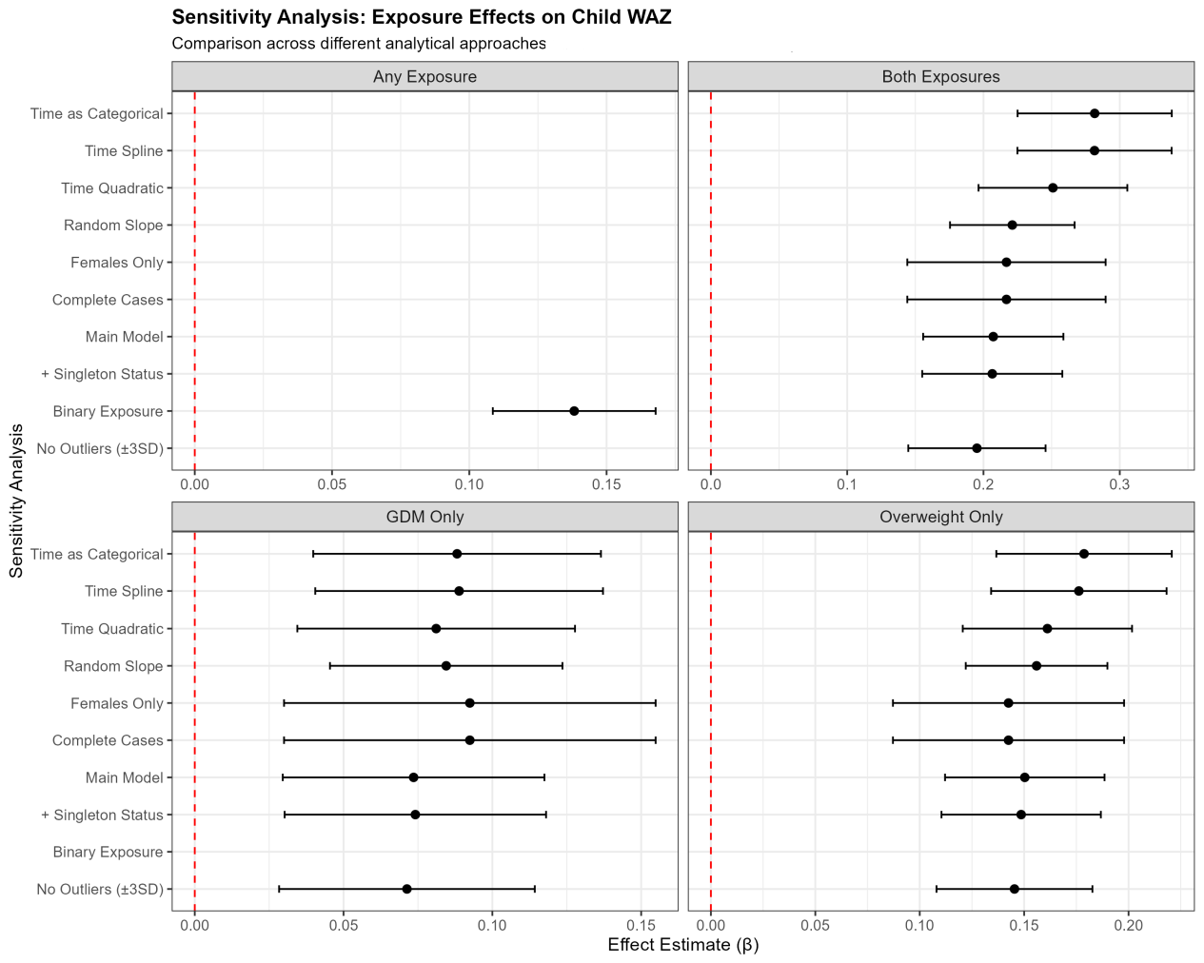
Figure 2 Main effects of exposure groups on child WAZ across different analytical approaches

