Supporting Information

Steering Directional Charge Migration via Ordered Self-Assembled Monolayers for High-Efficiency BiVO₄-Silicon Artificial Leaf
Min Zhao ^{a,b †}, Haoran Wu ^{a,b †}, Xiaodong Sun ^{c}, Wenbo Liu ^{b}, Zongyang Li ^{b}, Bowen Li ^{b}, Zhong-Yong Yuan ^{d}, Jingkun Wang ^{b,} *, Yuying Hao ^{b,} *, Tianyi Ma ^{a,} *
a. Centre for Atomaterials and Nanomanufacturing (CAN), School of Science, RMIT University, Melbourne, VIC 3000, Australia
b. College of Physics and Optoelectronics Engineering, Shanxi Key Lab of Photovoltaic Technology and Application, Taiyuan University of Technology, Taiyuan, 030024, China
c. Institute of Clean Energy Chemistry, Key Laboratory for Green Synthesis and Preparative Chemistry of Adv. Mater., College of Chemistry, Liaoning University, Shenyang 110036, People’s Republic of China
d. Collaborative Innovation Center of Materials Science, Nankai University, Tianjin 300350, China
† These authors contributed equally to this work.
*Correspondence to: Jingkun Wang (wangjingkun0048@link.tyut.edu.cn), Yuying Hao (haoyuying@tyut.edu.cn), Tianyi Ma (tianyi.ma@rmit.edu.au)

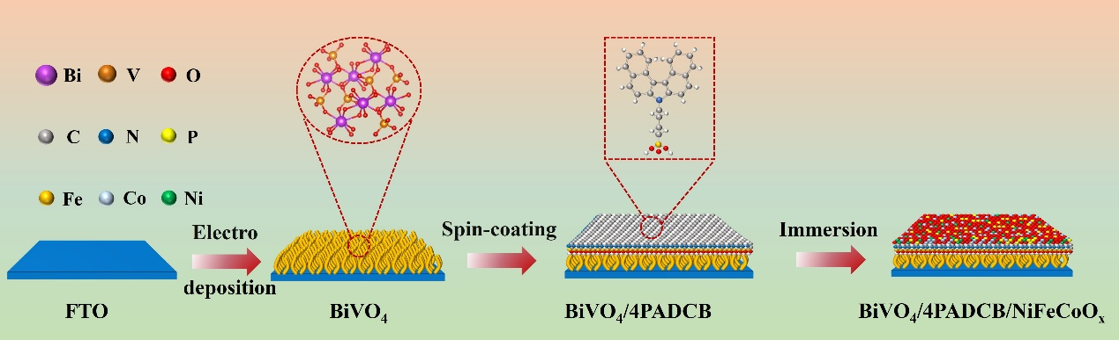
Figure S1. Schematic illustration of the synthesis procedure for the BiVO₄/4PADCB/NiFeCoO_{x} photoanode.
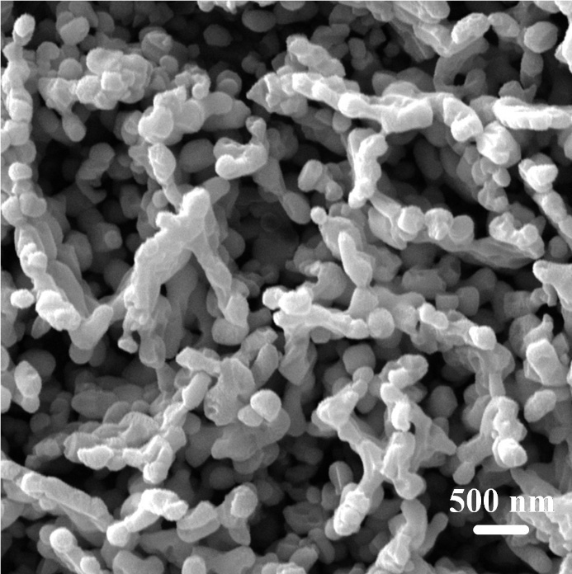
Figure S2. SEM image of BiVO₄.
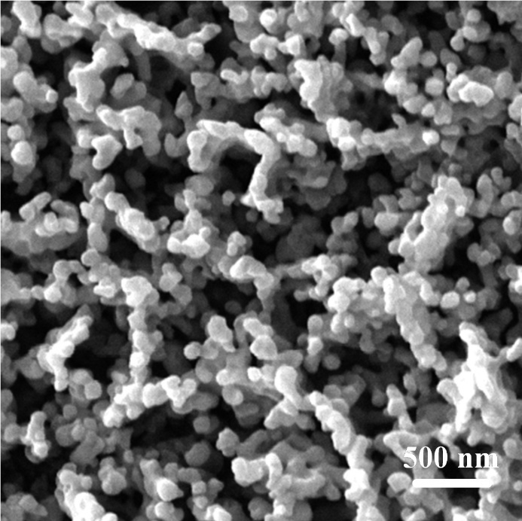
Figure S3. SEM image of BiVO₄/4PADCB.
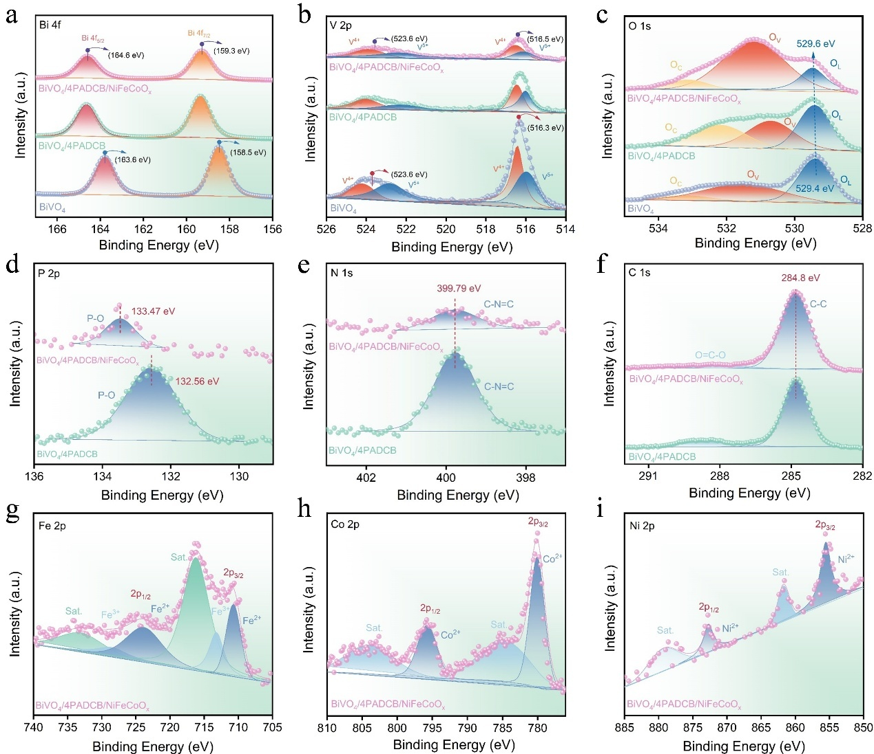
Figure S4. XPS spectra of BiVO₄, BiVO₄/4PADCB, BiVO₄/4PADCB/NiFeCoO_{x}. (a) Bi 4f, (b) V 2p, and (c) O 1s spectra of BiVO₄, BiVO₄/4PADCB, BiVO₄/4PADCB/NiFeCoO_{x}. (d) P 2p, (e) N 1s, and (f) C 1s spectra of BiVO₄/4PADCB, BiVO₄/4PADCB/NiFeCoO_{x}. (g) Fe 2p, (h) Co 2p, and (i) Ni 2p spectra of BiVO₄/4PADCB/NiFeCoO_{x}.
The composition and elemental states of various photoanodes were characterized through X-ray photoelectron spectroscopy (XPS). Compared with pristine BiVO₄, the Bi 4f and V 2p spectra of BiVO₄/4PADCB and BiVO₄/4PADCB/NiFeCoO_{x} photoanodes exhibit slight positive binding energy shifts (Figures S4a, b). On the BiVO₄/4PADCB/NiFeCoO_{x} and BiVO₄/4PADCB photoanodes, there is a noticeable shift in the P 2p orbital originating from 4PADCB, while no significant changes could be observed for the N1s and C1s (Figures S4d-f). These shifts in binding energies indicate strong interactions between 4PADCB and BiVO₄, enabling excellent charge transport behavior at the contact interface. As shown in Figure S4c, the oxygen vacancy (O_{v}) content is significantly enhanced after 4PADCB and NiFeCoO_{x} incorporation, indicating that the introduction of 4PADCB and NiFeCoO_{x} cocatalysts effectively enhanced OER activity. Meanwhile, the constituent elements of the cocatalysts were revealed in the Ni 2p, Fe 2p, and Co 2p spectra, existing in multiple valence states (Figures S4g-i), confirming the presence of the NiFeCoO_{x} cocatalyst. The results of SEM, TEM, XRD, Raman, and XPS demonstrate the successful modification of 4PADCB and NiFeCoO_{x} onto BiVO₄.
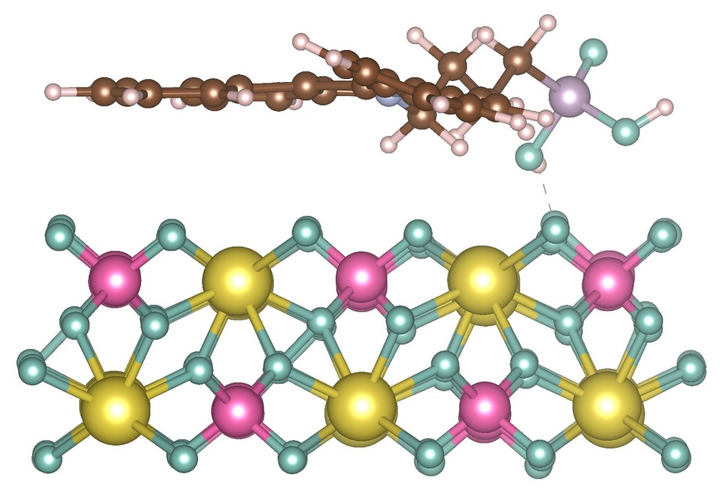
Figure S5. Optimized structure of BiVO₄/4PADCB in side for DFT calculations.
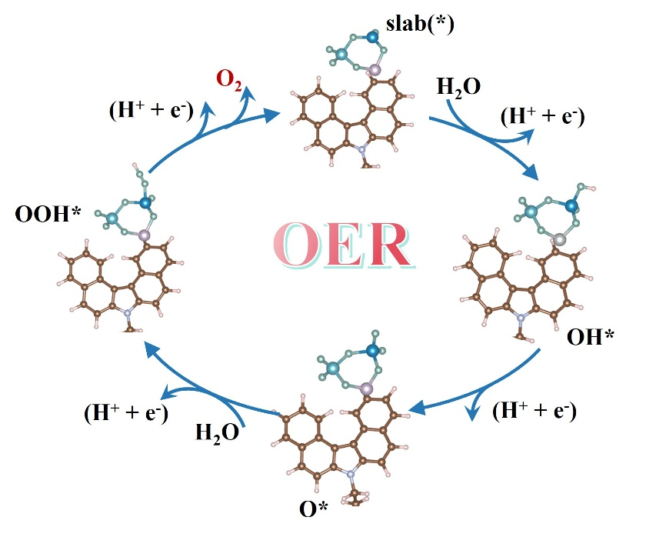
Figure S6. Catalytic OER pathway of 4PADCB/NiFeCoO_{x}.
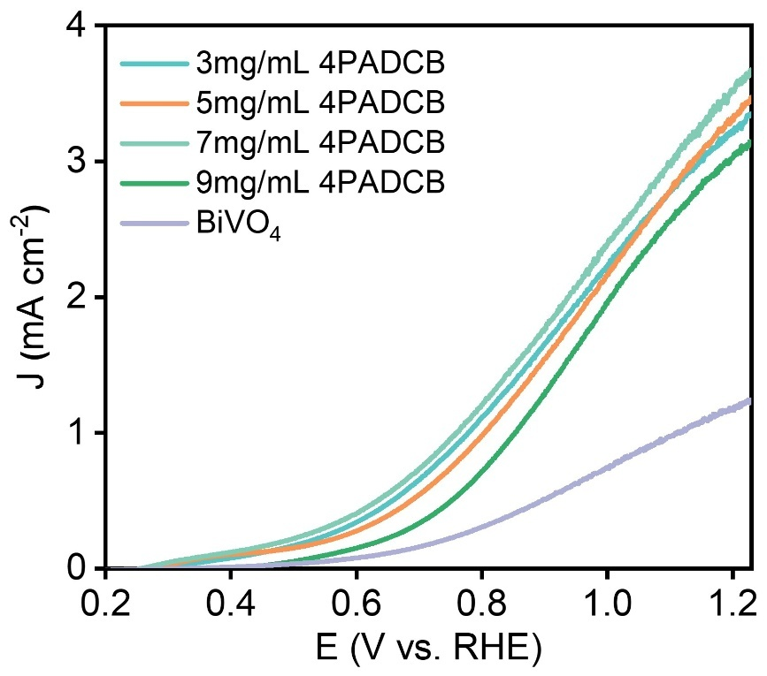
Figure S7. LSV curves of BiVO₄/4PADCB photoanodes with the tunable amount of
4PADCB in 0.5M KBi electrolyte (pH = 9.3) under AM 1.5 G illumination (100 mW
cm⁻²).
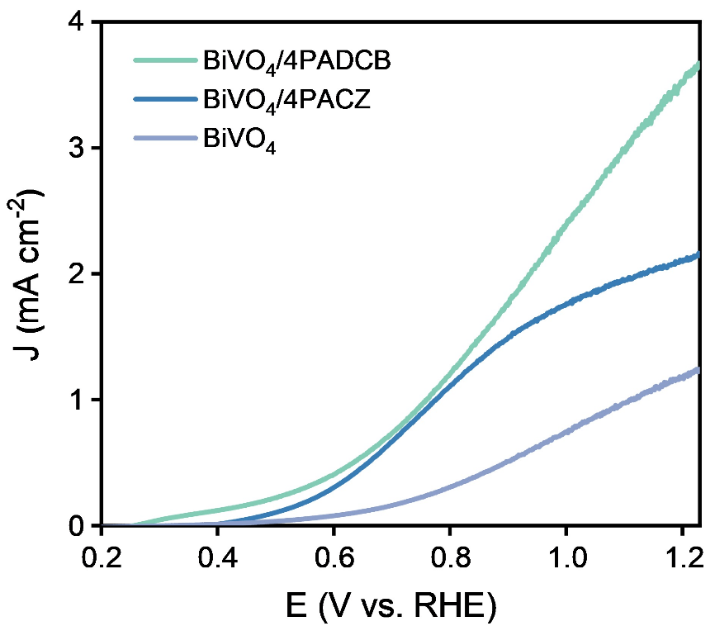
Figure S8. LSV curves of BiVO₄/4PADCB and BiVO₄/4PACZ photoanodes measured in 0.5 M potassium borate electrolyte (pH = 9.3) under AM 1.5G illumination (100 mW cm⁻²).
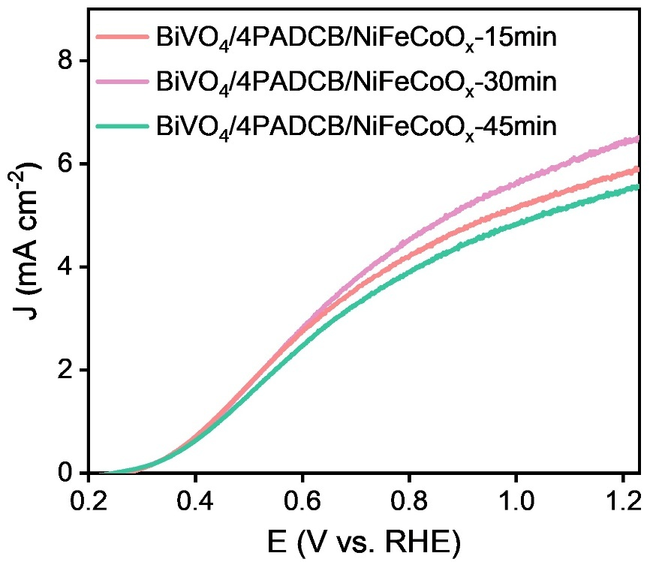
Figure S9. Comparison of NiFeCoO_{x} immersion for different times of LSV measured by 0.5 M KBi under AM 1.5 G simulated solar radiation.
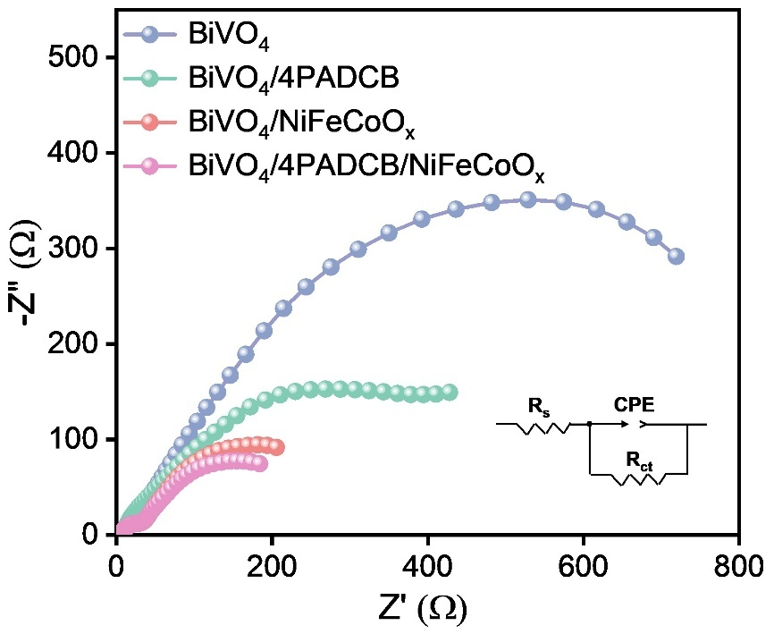
Figure S10. EIS Nyquist plots at 1.23 V_{RHE} and of the BiVO₄, BiVO₄/4PADCB, BiVO₄/NiFeCoO_{x} and BiVO₄/4PADCB/NiFeCoO_{x} photoanode.
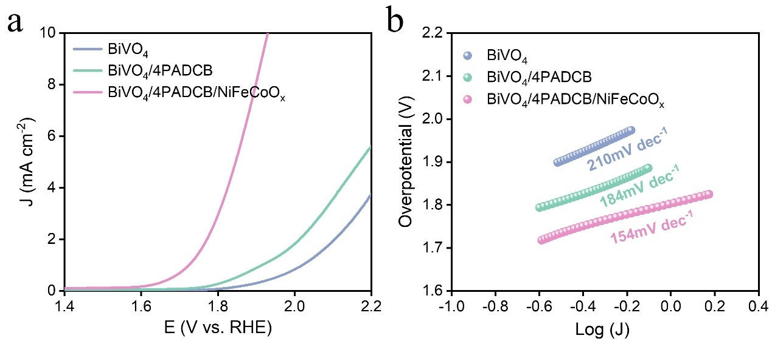
Figure S11. (a) LSV curves of BiVO₄, BiVO₄/4PADCB and BiVO₄/4PADCB/NiFeCoO_{x}. photoanodes in 0.5 M KBi under dark and (b) Tafel slope curves.
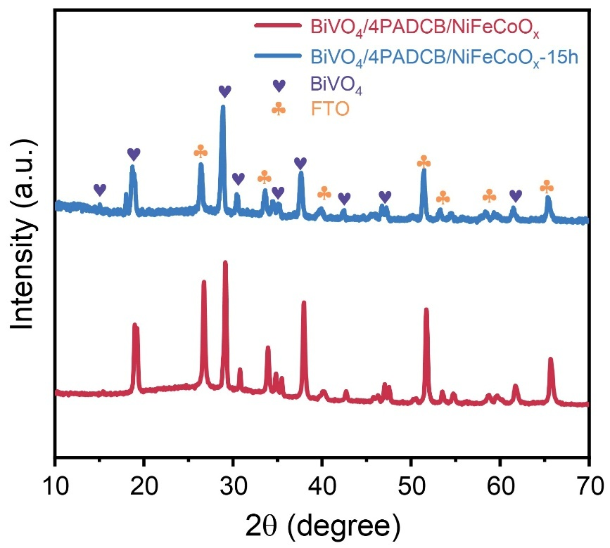
Figure S12. XRD patterns of BiVO₄/4PADCB/NiFeCoO_{x} before and after 15 h of stability test at 1.23 V_{RHE}.
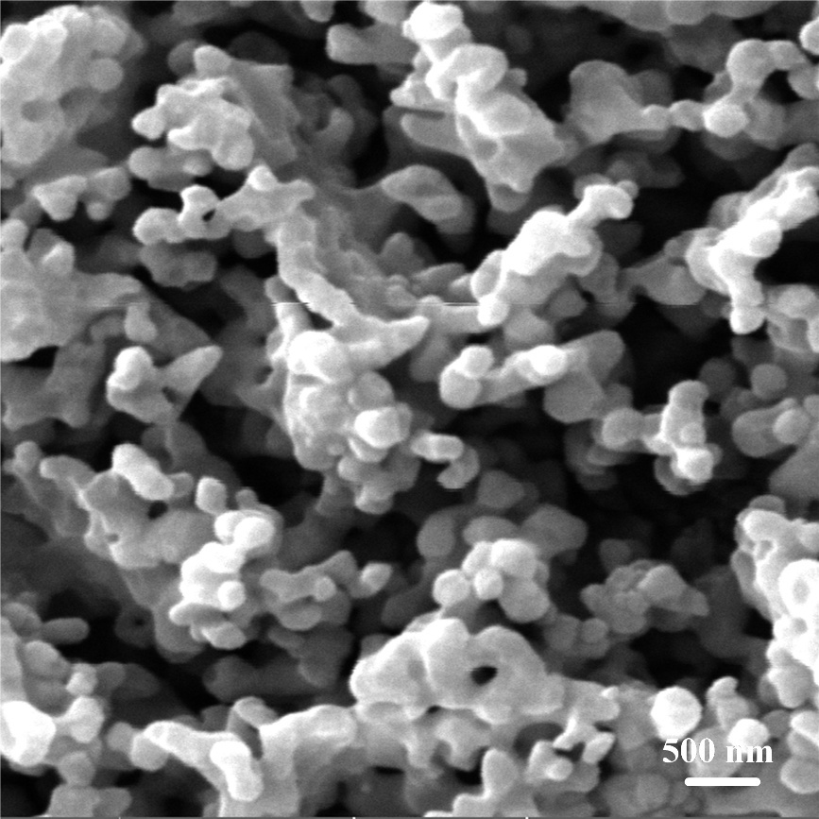
Figure S13. SEM image of BiVO₄/4PADCB/NiFeCoO_{x} after 15 h of stability test at 1.23 V_{RHE}.
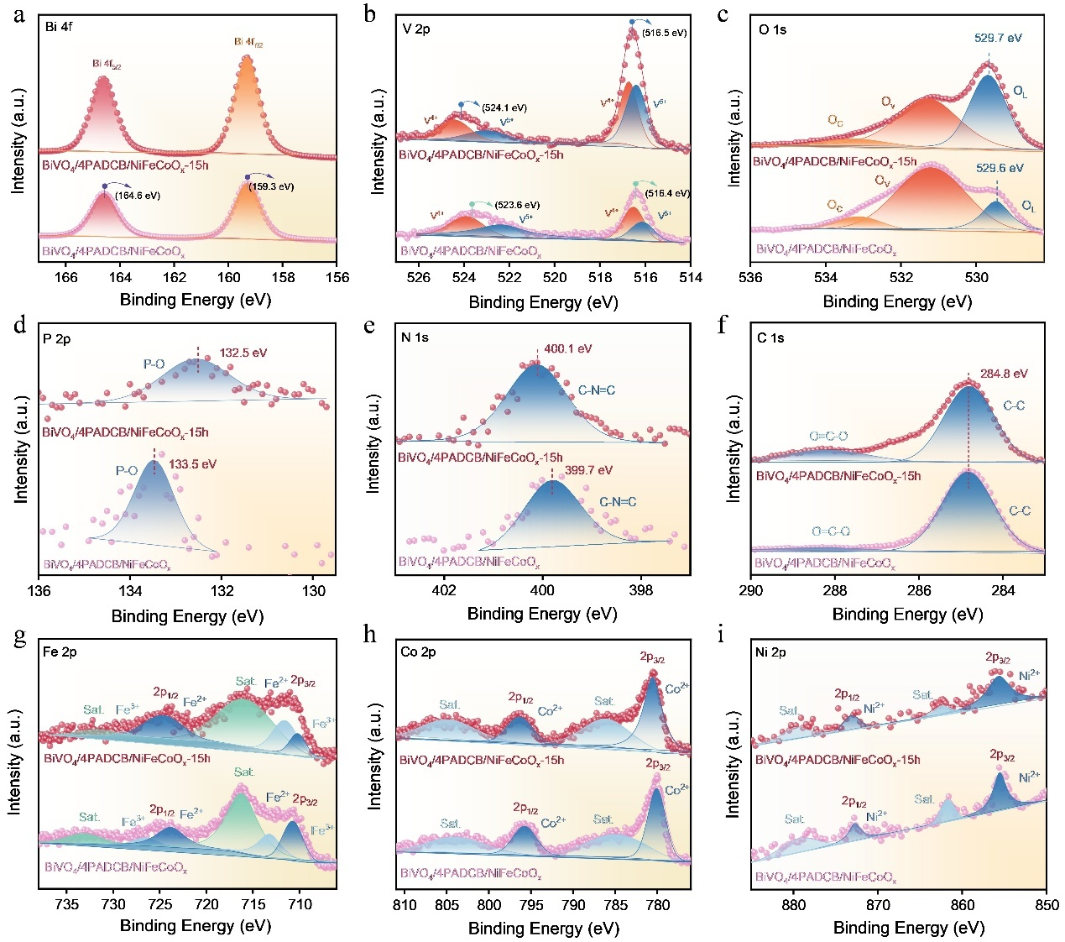
Figure S14. XPS spectra of BiVO₄/4PADCB/NiFeCoO_{x}. and BiVO₄/4PADCB/NiFeCoO_{x}-15h (a) Bi 4f, (b) V 2p, and (c) O1s, (d) P 2p, (e) N 1s, (f) C 1s. (g) Fe 2p, (h) Co 2p, and (i) Ni 2p spectra of BiVO₄/4PADCB/NiFeCoO_{x}. and BiVO₄/4PADCB/NiFeCoO_{x}-15h.
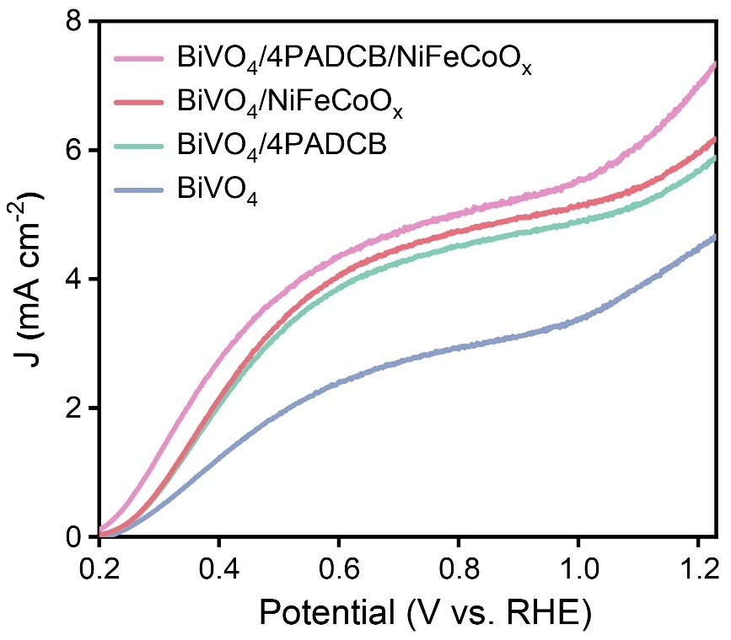
Figure S15. LSV curves of BiVO₄, BiVO₄/4PADCB, BiVO₄/NiFeCoO_{x}, and BiVO₄/4PADCB/NiFeCoO_{x} photoanodes in 0.5 M KBi electrolyte (pH = 9.3) with 0.1 M Na₂SO₃ solution under AM 1.5G simulated sunlight (100 mW cm⁻²)
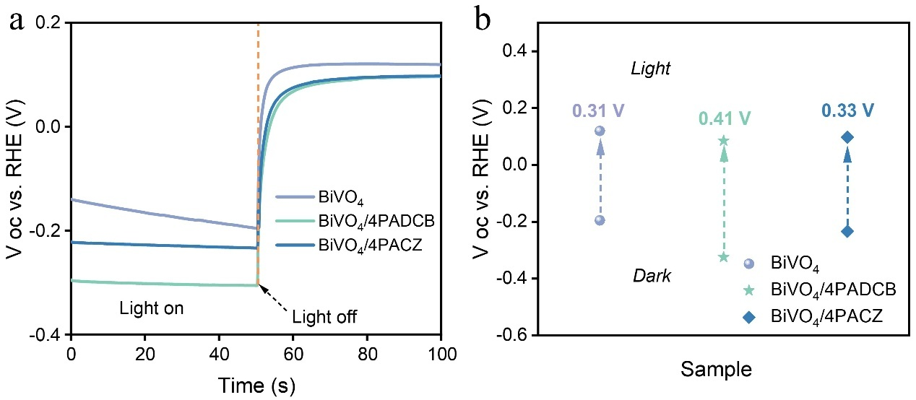
Figure S16. (a) OCP decay profiles and (b) OCP values.
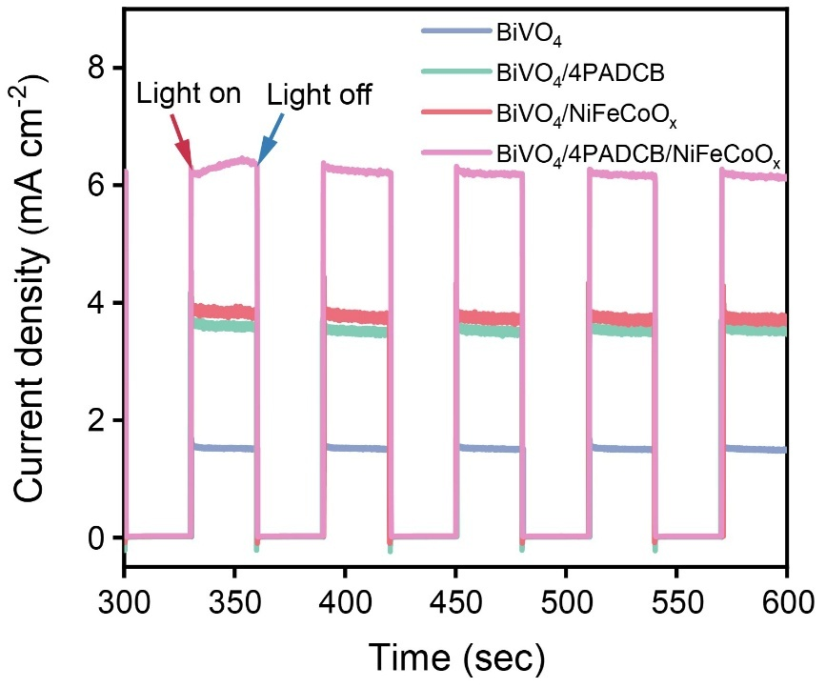
Figure S17. Transient photocurrent density curves of BiVO₄, BiVO₄/4PADCB, BiVO₄/NiFeCoO_{x}, and BiVO₄/4PADCB/NiFeCoO_{x} at 1.23 V vs. RHE in 0.5 M KBi aqueous solution under sequential illumination condition with an interval of 30 s on/off switch.
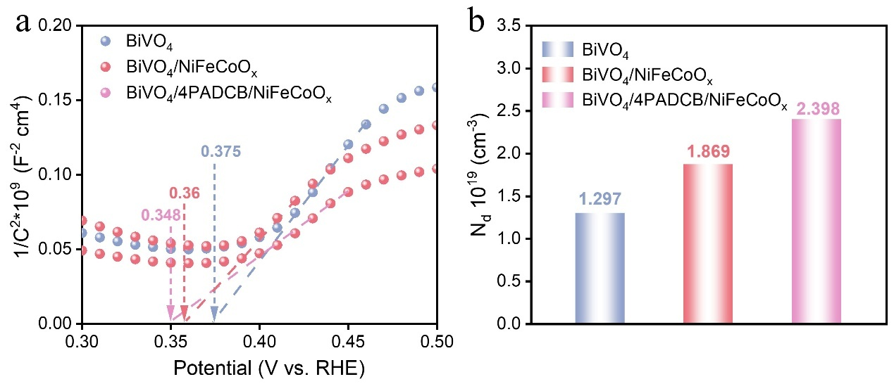
Figure S18. (a) Mott–Schottky plots at a frequency of 1 kHz, b) N_{d} of BiVO₄, BiVO₄/NiFeCoO_{x}, and BiVO₄/4PADCB/NiFeCoO_{x}.
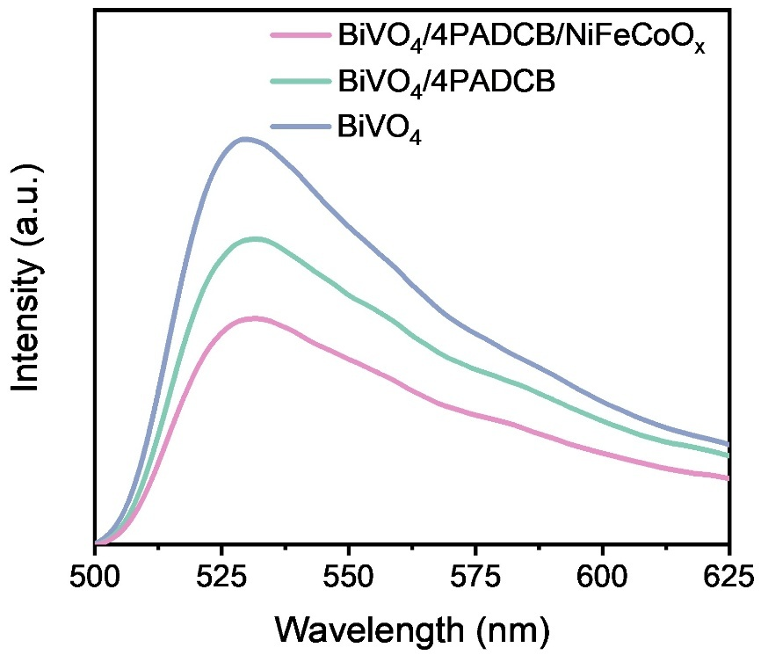
Figure S19. Steady state photoluminescence (PL) spectra of BiVO₄, BiVO₄/4PADCB, and BiVO₄/4PADCB/NiFeCoO_{x} photoanodes.
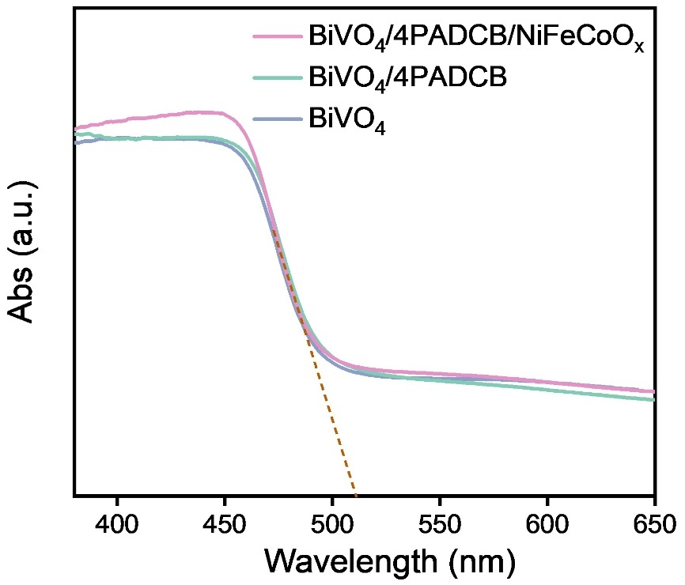
Figure S20. The UV-visible absorption spectra of BiVO₄, BiVO₄/4PADCB, and BiVO₄/4PADCB/NiFeCoO_{x} photoanodes.
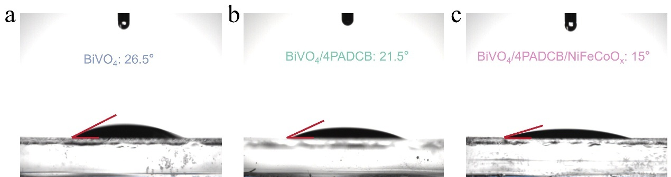
Figure S21. Water contact angle on (a) BiVO₄, (b) BiVO₄/4PADCB, and (c) BiVO₄/4PADCB/NiFeCoO_{x}.

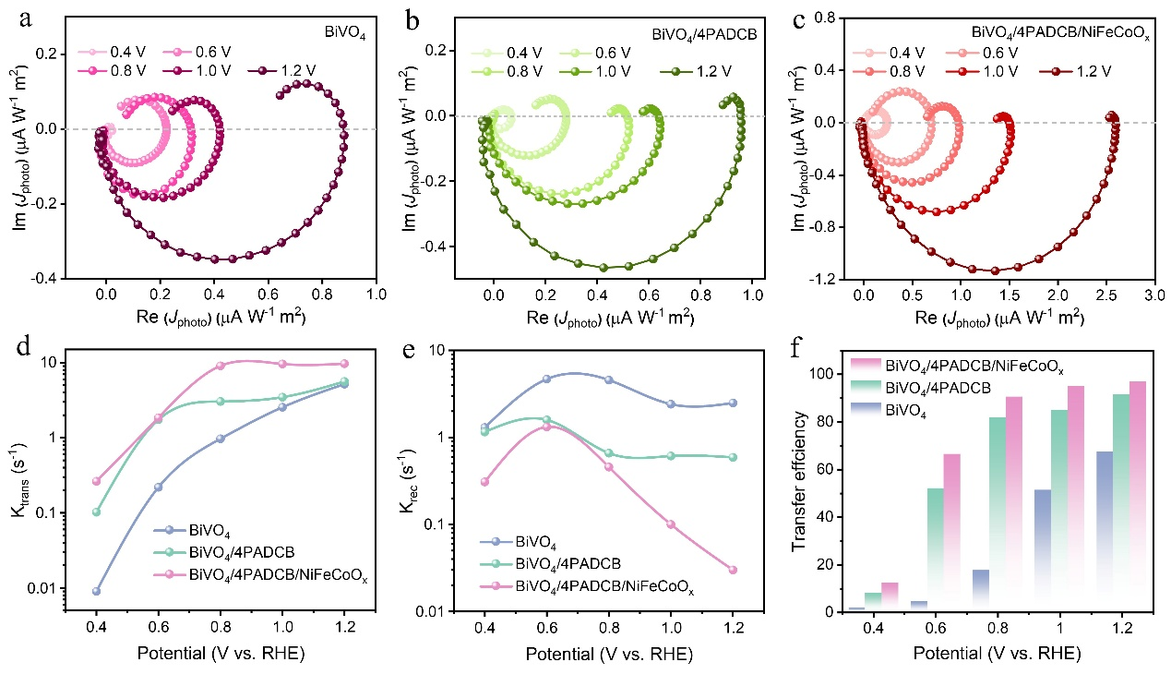
Figure S22. IMPS analysis of BiVO₄, BiVO₄/4PADCB, and BiVO₄/4PADCB/NiFeCoO_{x} under neutral water oxidation. IMPS responses of (a) BiVO₄, (b) BiVO₄/4PADCB, and (c) BiVO₄/4PADCB/NiFeCoO_{x} at various applied potentials. (d) Charge transfer rate constants (K_{trans}), (e) charge recombination rate constants (K_{rec}), (f) charge transfer efficiencies of corresponding photoanodes derived from IMPS data.
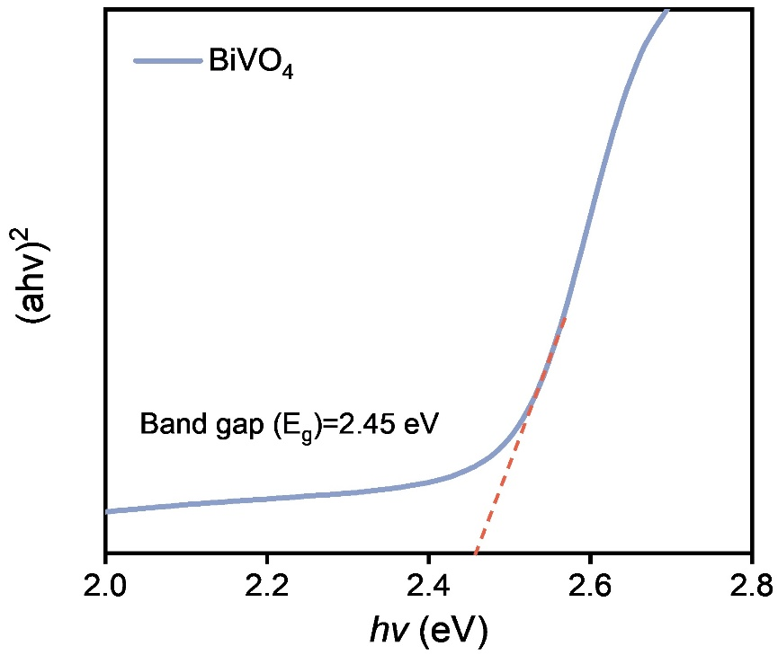
Figure S23. Tauc plot of BiVO₄ photoanode.
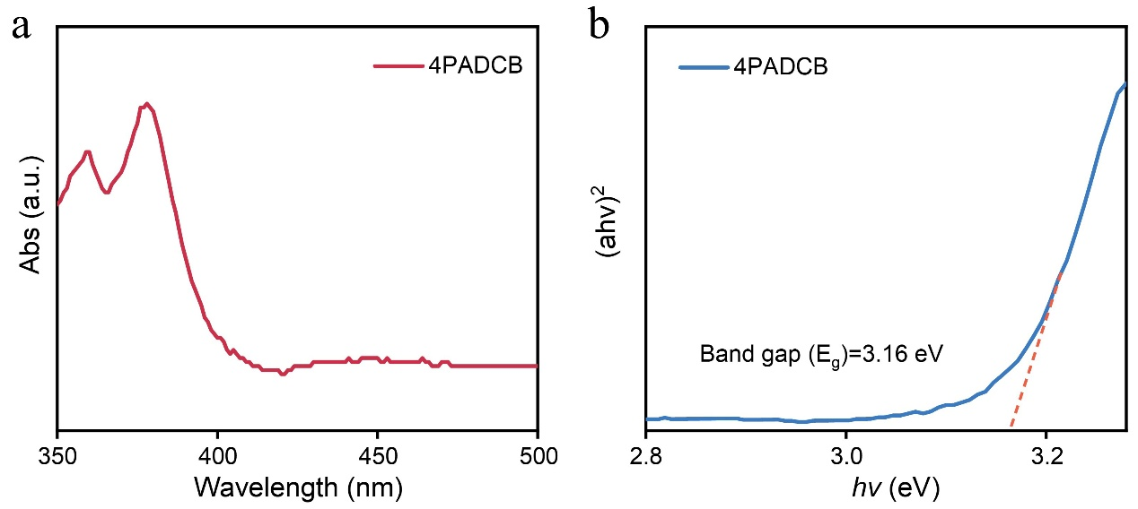
Figure S24. (a) UV-vis spectrum and (b) Tauc plot of 4PADCB.
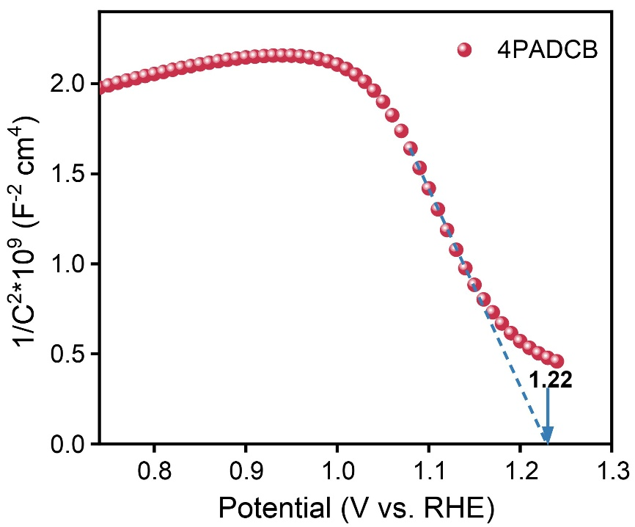
Figure S25. Mott-Schottky plots of 4PADCB.
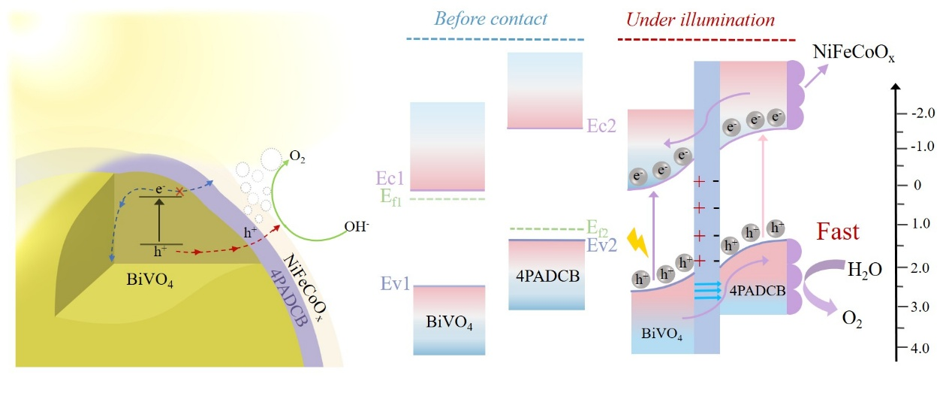
Figure S26. Energy band diagram of BiVO₄/4PADCB.
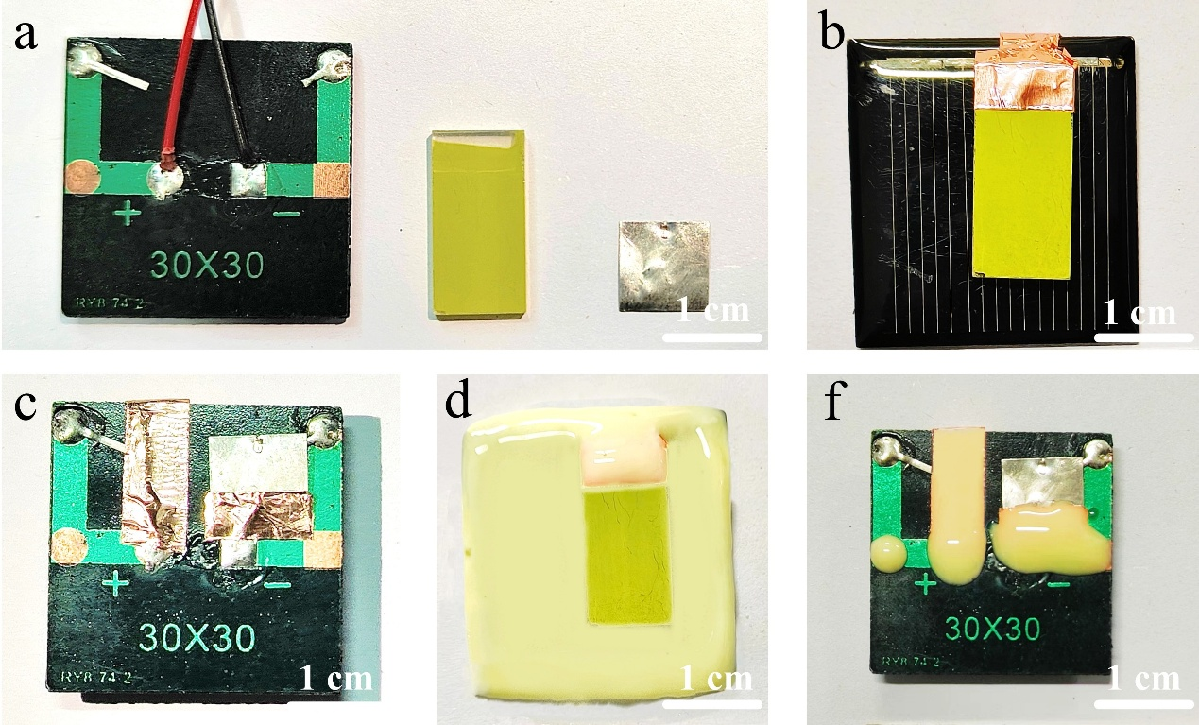
Figure S27. Digital images of a 1.5 cm ×1 cm artificial leaf.
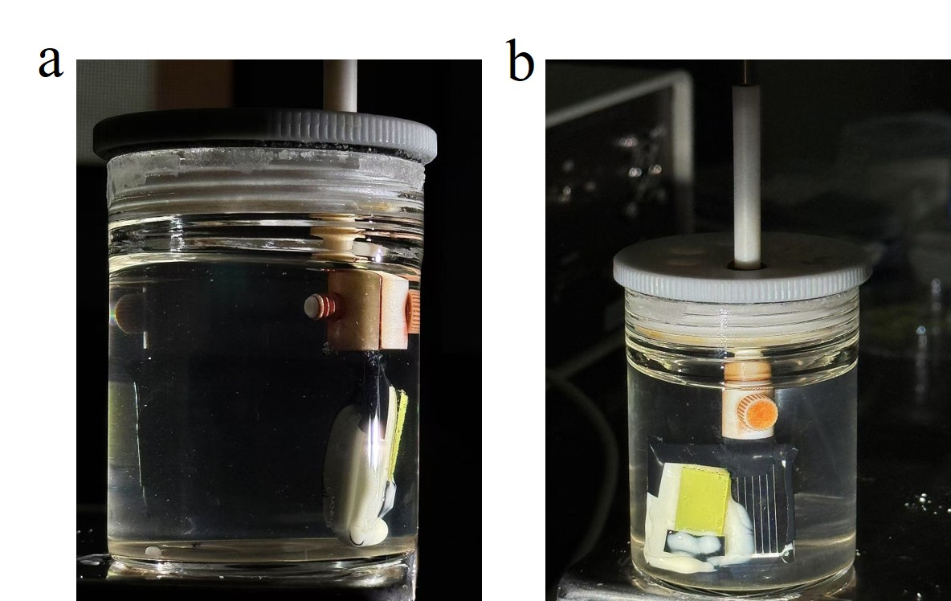
Figure S28. Images of (a) the back and (b) front sides of the operational artificial leaf.

Table S1 Compare the PEC performance of the BiVO₄/4PADCB/NiFeCoO_{x} photoanode developed in this study with other promising organic and inorganic modified BiVO₄ photoanodes.
Photoanodes | J (mA cm⁻² at 1.23 V_{RHE}) | η_{sep} (%) | η_{trans} (%) | Ref.
BiVO₄/4PADCB/NiFeCoO_{x} | 6.34 | 98 | 95.5 | This work
BiVO₄/P3HT-CuPc/LDH | 4.25 | 73.8 | 76.7 | ¹
NiFeCoO_{x}/CPF-TCB/Mo:BiVO₄ | 6.66 | 88 | 85 | ²
R-BV/CoPy/FN-H | 4.75 | 86.6 | 80 | ³
PEG-4000/BiVO₄ | 3.64 | 84.2 | 81 | ⁴
NiFeO_{x}/CTF-BTh/Mo:BiVO₄ | 5.7 | 94 | 61.3 | ⁵
BiVO₄/CTP2/FN | 4.05 | 73.3 | 70 | ⁶
BiVO₄/g-C₃N₄-NS | 3.12 | 53 | 67 | ⁷
NiFeOOH/MoO_{x}/MQD/BiVO₄ | 5.85 |  | 91 | ⁸
FeOOH@1T-MoS₂@BiVO₄ | 4.02 | 84.2 | 81.9 | ⁹
BVO-O_{v}/FeOOH | 7.0 |  | 94.9 | ¹⁰
Ov-BiVO₄@NiFe-MOFs | 5.3 |  |  | ¹¹
BiVO₄/CuSCN/NiFeO_{x} | 5.6 | 96.2 | 79.2 | ¹²
BiVO₄/CuS/NiFeCoO_{x} | 6.56 | 97 | 93.5 | ¹³
CQDs/FeOOH/BiVO₄ | 2.53 |  | 81.1 | ¹⁴
C-BiVO₄/CQDs | 4.83 | 81.2 | 77.9 | ¹⁵
BiVO₄/Co₃O₄/FeOOH/NiOOH | 6.34 |  |  | ¹⁶
N-BiVO₄/NiOOH/FeOOH | 5.0 | 90 |  | ¹⁷
BiVO₄@aNiFe-MOFs | 4.34 | 96 | 82 | ¹⁸

Table S2 Performance comparison state-of-the-art BiVO₄-based photoanode in tandem with the solar cell for zero-bias photoelectrochemical water splitting.
Photoanodes | Solar cell | STH  (%) | Area  (cm²) | Ref.
BiVO₄/4PADCB/NiFeCoO_{x} | Si | 8.75 | 1.5 | This work
BVO-O_{v}/FeOOH | Si | 8.4 | 0.126 | ¹⁰
Co-P_{i}/BiVO₄/WO₃ | GaAs/InGaAsP | 8.1 | 1.0 | ¹⁹
NiOOH/FeOOH/BaSnO_{3-x} | Perovskite | 7.9 | 1.0 | ²⁰
NiOOH/FeOOH/BiVO₄//Ni₂FeO_{x}/Fe₂O₃ | 2jn c-Si | 7.7 | 1.0 | ²¹
BiVO₄/CuS/NiFeCoO_{x} | Si | 7.7 | 1.0 | ¹³
NiOOH/FeOOH/W,Mo:BiVO₄/WO₃ | Dye-sensitized | 7.1 | 1.0 | ²²
BiVO₄/SnO₂ | Perovskite | 7.0 | 3.11 | ²³
NiFeCoO_{x}/CPF-TCB/Mo:BiVO₄/SnO₂ | Perovskite | 6.75 | 1.0 | ²
2 × NiOOH/FeOOH/BiVO₄ (dual PA) | Perovskite | 6.5 | 0.25 | ²⁴
NiOOH/FeOOH/Mo:BiVO₄/SnO₂ | Perovskite | 6.3 | 0.25 | ²⁵
NiFeO_{x}/BiVO₄/In₂O₃ | Perovskite/Si | 6.1 | 1.0 | ²⁶
NiOOH/FeOOH/W,Mo:BiVO₄/WO₃ | Dye-sensitized | 5.7 | 2.25 | ²⁷
Co-P_{i}/W:BiVO₄ | 2jn a-Si | 4.9 | 1.0 | ²⁸
CoO_{x}/BiVO₄/WO₃/SnO₂ | Perovskite | 3.5 | 0.14 | ²⁹
Co-P_{i}/BiVO₄ | Perovskite | 2.5 | 0.54 | ³⁰
NiOOH/FeOOH/BiVO₄ | OPV | 2.2 | 0.036 | ³¹

References
1 Pei, H. et al. A novel BiVO4/P3HT photoanode for highly efficient water oxidation and its hole energy offset effect with CuPc derivative. Appl. Catal. B-Environ. 318, 121865 (2022).
2 Yang, J. W. et al. High-efficiency unbiased water splitting with photoanodes harnessing polycarbazole hole transport layers. Energ. Environ. Sci. 17, 2541-2553 (2024).
3 Ning, X. et al. An efficient strategy for boosting photogenerated charge separation by using porphyrins as interfacial charge mediators. Angew. Chem. Int. Edit. 58, 16800-16805 (2019).
4 Deng, Y., Fu, X., Zhang, Y., Zhu, Y. & Wei, Y. Efficient oxygen evolution reaction on polyethylene glycol‐modified BiVO₄ photoanode by speeding up proton transfer. Small 18, 2201410 (2022).
5 Zhang, Y. et al. Stable Unbiased photo‐electrochemical overall water splitting exceeding 3% efficiency via covalent triazine framework/metal oxide hybrid photoelectrodes. Adv. Mater. 33, 2008264 (2021).
6 Pan, Q. et al. Covalent Triazine-based polymers with controllable band alignment matched with BiVO₄ to boost photogeneration of holes for water splitting. Chem. Mater. 31, 8062-8068 (2019).
7 Feng, C. et al. Ultrathin graphitic C₃N₄ nanosheets as highly efficient metal-free cocatalyst for water oxidation. Appl. Catal. B-Environ. 205, 19-23 (2017).
8 Song, Y. et al. Engineering MoOx/MXene hole transfer layers for unexpected boosting of photoelectrochemical water oxidation. Angew. Chem. Int. Edit. 61, 2200946 (2022).
9 Yu, L. et al. Phase engineering of 1T-MoS₂ on BiVO₄ photoanode with p–n Junctions: establishing high speed charges transport channels for efficient photoelectrochemical water splitting. Chem. Eng. J. 472, 144965 (2023).
10 Liu, B. et al. A standalone bismuth vanadate-silicon artificial leaf achieving 8.4% efficiency for hydrogen production. Nat. Commun. 16, 2792 (2025).
11 Pan, J. B. et al. Activity and stability boosting of an oxygen‐vacancy‐rich BiVO₄ photoanode by NiFe‐MOFs thin layer for water oxidation. Angew. Chem. Int. Edit. 60, 1433-1440 (2020).
12 Wang, J. et al. The CuSCN layer between BiVO₄ and NiFeO_{x} for facilitating photogenerated carrier transfer and water oxidation kinetics. J. Colloid Interf. Sci. 666, 57-65 (2024).
13 Wang, J. et al. Photothermal CuS as a hole transfer layer on BiVO₄ photoanode for efficient solar water oxidation. Angew. Chem. Int. Edit. 64, 2507259 (2025).
14 Zhou, T. et al. Dramatically enhanced solar-driven water splitting of BiVO₄ photoanode via strengthening hole transfer and light harvesting by co-modification of CQDs and ultrathin β-FeOOH layers. Chem. Eng. J. 403, 126350 (2021).
15 Wang, Y. et al. Charge relays via dual carbon‐actions on nanostructured BiVO₄ for high performance photoelectrochemical water splitting. Adv. Funct. Mater. 32, 2112738 (2022).
16 He, B. et al. General and robust photothermal‐heating‐enabled high‐efficiency photoelectrochemical water splitting. Adv. Mater. 33, 2004406 (2021).
17 Kim, T. W., Ping, Y., Galli, G. A. & Choi, K.-S. Simultaneous enhancements in photon absorption and charge transport of bismuth vanadate photoanodes for solar water splitting. Nat. Commun. 6, 9769 (2015).
18 Bai, W. et al. Amorphous metal-organic frameworks loaded on BiVO₄ photoanodes with unique internal metal-like structure for promoting photoelectrochemical water splitting. Appl. Catal. B-Environ. 352, 124023 (2024).
19 Pihosh, Y. et al. Photocatalytic generation of hydrogen by core-shell WO₃/BiVO₄ nanorods with ultimate water splitting efficiency. Sci. Rep. 5, 11141 (2015).
20 Kim, M. et al. Oxygen‐vacancy‐introduced BaSnO_{3−δ} photoanodes with tunable band structures for efficient solar‐driven water splitting. Adv. Mater. 31, 1903316 (2019).
21 Kim, J. H. et al. Hetero-type dual photoanodes for unbiased solar water splitting with extended light harvesting. Nat. Commun. 7, 13380 (2016).
22 Shi, X. et al. Unassisted photoelectrochemical water splitting exceeding 7% solar-to-hydrogen conversion efficiency using photon recycling. Nat. Commun. 7, 11943 (2016).
23 Xu, Z., Chen, L., Brabec, C. J. & Guo, F. All printed photoanode/photovoltaic mini‐module for water splitting. Small Methods 7, 2300619 (2023).
24 Wang, S. et al. New BiVO₄ dual photoanodes with enriched oxygen vacancies for efficient solar‐driven water splitting. Adv. Mater. 30, 1800486 (2018).
25 Xiao, S. et al. Integration of inverse nanocone array based bismuth vanadate photoanodes and bandgap-tunable perovskite solar cells for efficient self-powered solar water splitting. J. Mater. Chem. A 5, 19091-19097 (2017).
26 Lee, M. G. et al. Tailored BiVO₄/In₂O₃ nanostructures with boosted charge separation ability toward unassisted water splitting. Carbon Energy 5, 321 (2023).
27 Shi, X. et al. Unassisted photoelectrochemical water splitting beyond 5.7% solar-to-hydrogen conversion efficiency by a wireless monolithic photoanode/dye-sensitised solar cell tandem device. Nano Energy 13, 182-191 (2015).
28 Abdi, F. F. et al. Efficient solar water splitting by enhanced charge separation in a bismuth vanadate-silicon tandem photoelectrode. Nat. Commun. 4, 3195 (2013).
29 Baek, J. H. et al. BiVO₄/WO₃/SnO₂ double-heterojunction photoanode with enhanced charge separation and visible-transparency for bias-free solar water-splitting with a perovskite solar cell. ACS Appl. Mater. Interfaces 9, 1479-1487 (2017).
30 Chen, Y.-S., Manser, J. S. & Kamat, P. V. All solution-processed lead halide perovskite-BiVO₄ tandem assembly for photolytic solar fuels production. J. Am. Chem. Soc. 137, 974-981 (2015).
31 Peng, Y., Govindaraju, G. V., Lee, D. K., Choi, K.-S. & Andrew, T. L. Integrating a semitransparent, fullerene-free organic solar cell in tandem with a BiVO₄ photoanode for unassisted solar water splitting. ACS Appl. Mate. Interfaces 9, 22449-22455 (2017).

