Supplementary Figures and Figure legends
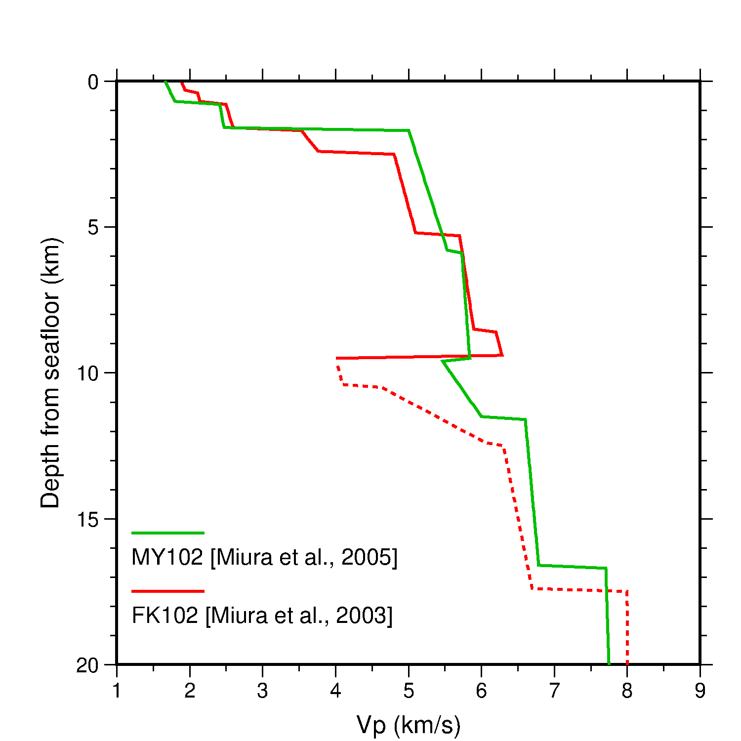
Supplementary Figure 1. Seismic velocity profiles along the Japan Trench. Green and red lines indicate the P-wave velocity (Vp) off Miyagi (MY102 in Miura et al., 2005) and Fukushima (FK102 in Miura et al., 2003) estimated from marine surveys (Miura et al., 2003, 2005). The vertical axis indicates the depth from the seafloor. The lateral axis indicates the Vp. The dashed lines indicate a lower velocity resolution. We can see a low-velocity zone at a depth of 2–5.5 km (upper crust, lower sedimentary layer) and > 10 km depth (channel layer) at the southern segment (green line). On the other hand, the Vp = 6 km/s layer is widely distributed at the ~5.5–10 km depth, where it is directly above the plate interface of the middle and southern segments of the Japan Trench.

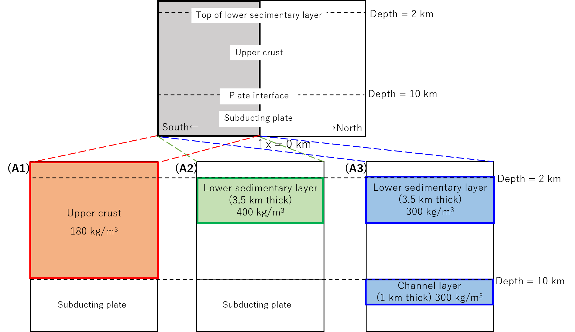
Supplementary Figure 2. Schematic of the density distribution model. Models A1–A3 represent the southern segment of the Japan Trench (gray area in the upper panel).

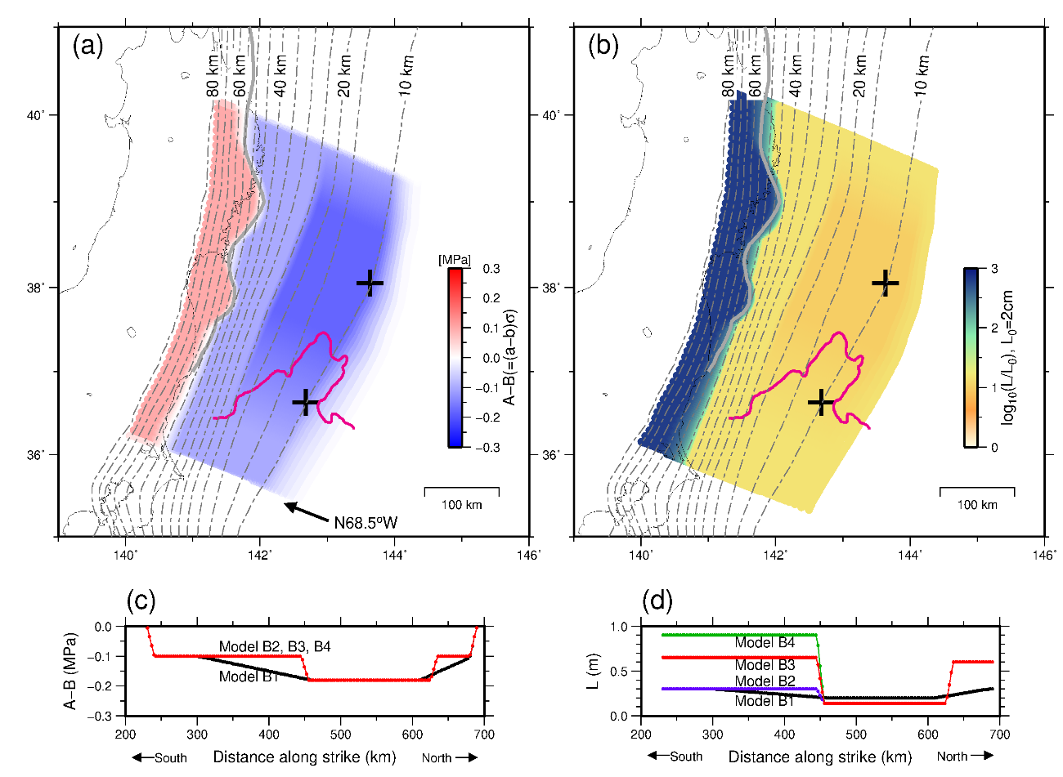
Supplementary Figure 3. Distribution of frictional parameters for Model B1. (a) Spatial distribution on the plate interface of (A–B) (MPa). Magenta lines are the same as that of Supplementary Fig.4. Crosses indicate the points shown in Supplementary Fig. 5. Contours indicate the depth (km) to the upper surface of the descending plate (Baba et al., 2006). The gray solid line indicates the western limit of the inter-plate earthquake distribution (Igarashi et al., 2001). (b) Spatial distribution of the characteristic slip distance (L). (c)–(d) Profiles of A–B and L along the strike at 10.15 km depth. Black, purple, red, and green lines represent the Model B1, B2, B3, and B4, respectively.

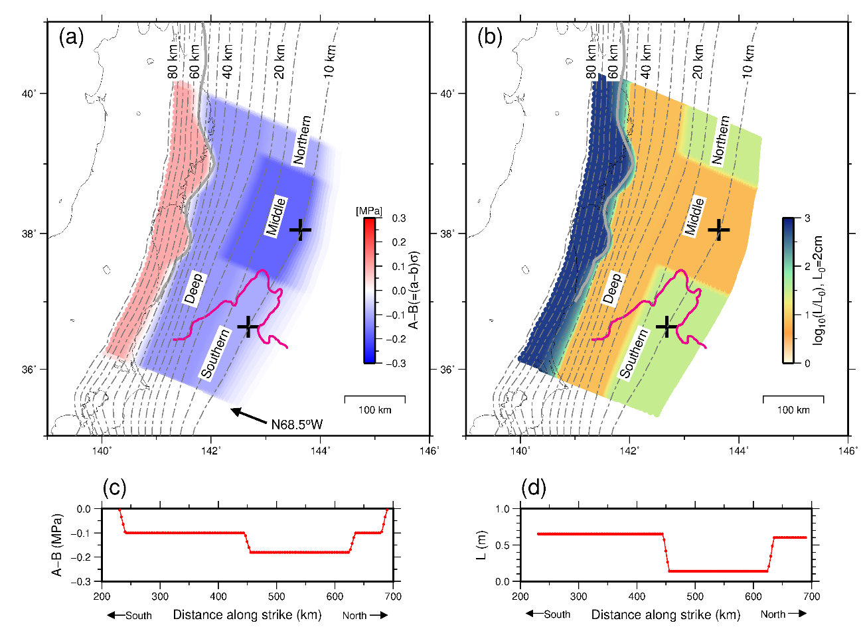
Supplementary Figure 4. Distribution of frictional parameters for Model B3. (a) Spatial distribution on the plate interface of (A–B) (MPa). (b) Spatial distribution of the characteristic slip distance (L). Magenta lines indicate the residual gravity anomaly = 0 (Bassett et al., 2016). Crosses indicate the points shown in Fig. 3. Contours indicate the depth (km) to the upper surface of the descending plate (Baba et al., 2006). The gray solid line indicates the western limit of the inter-plate earthquake distribution (Igarashi et al., 2001). (c)–(d) Profiles of A–B and L along the strike at 10.15 km depth. The descriptions of segments “Northern,” “Middle” “Southern,” and “Deep” are the same as those used in Supplementary Table 3.
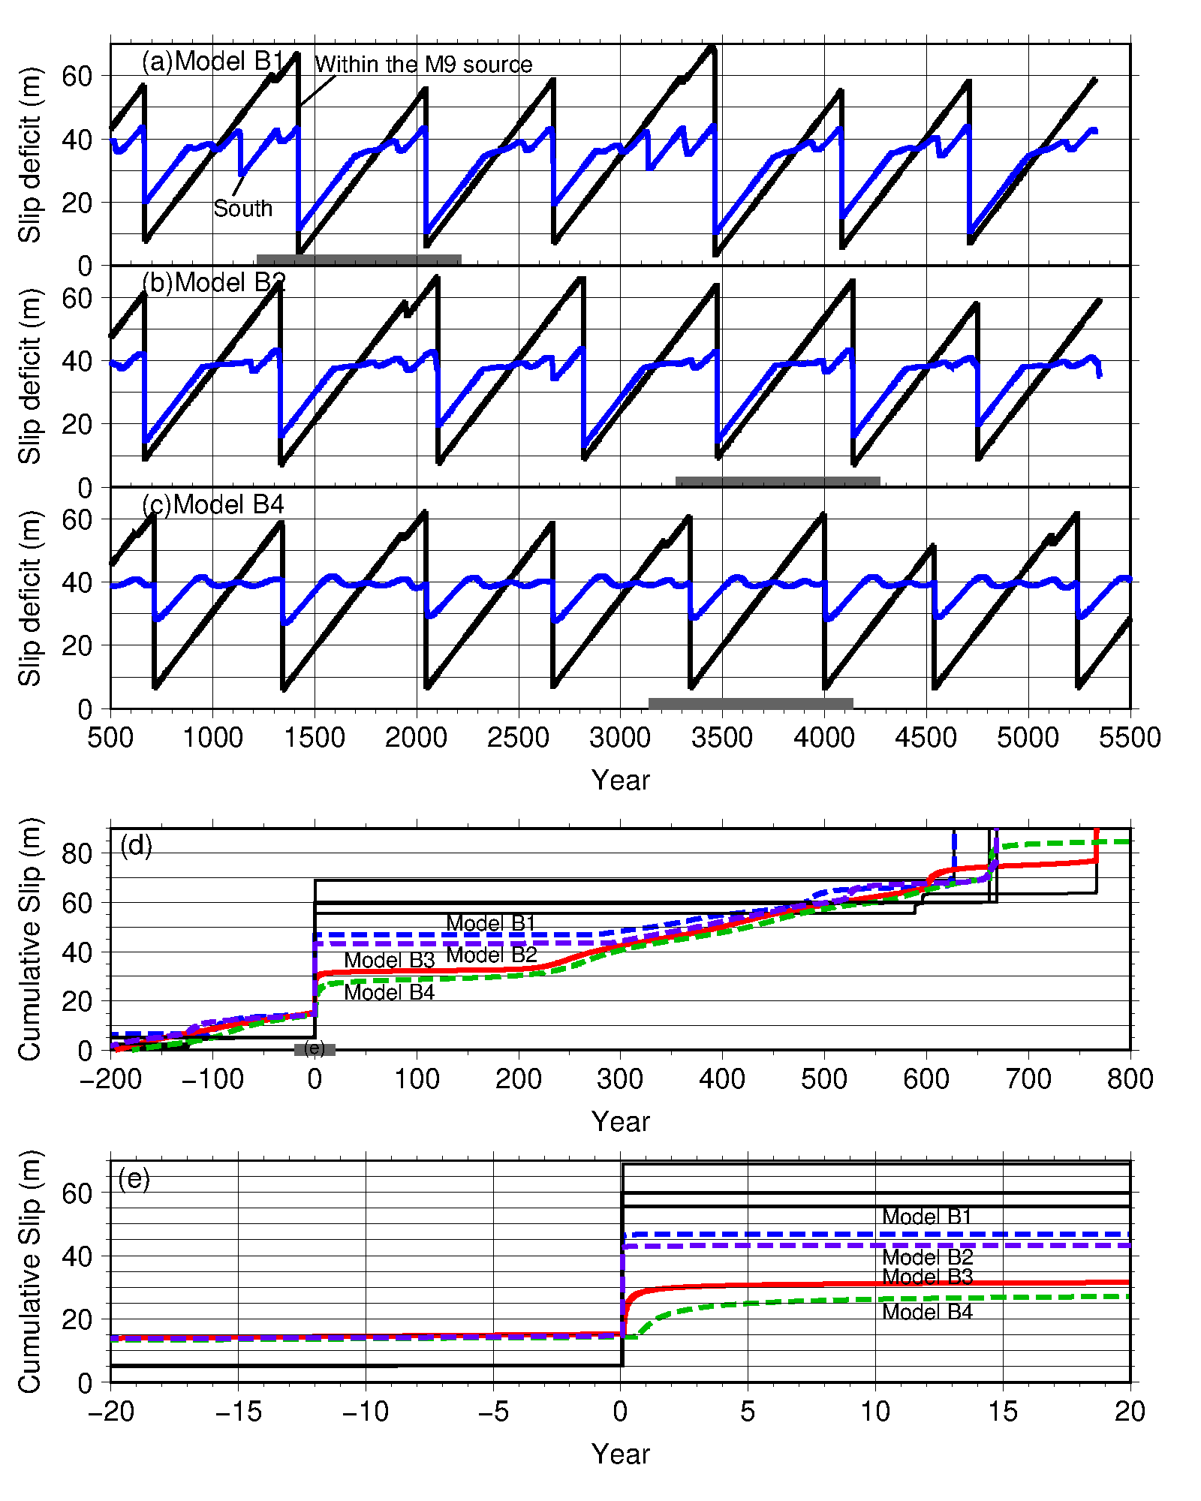
Supplementary Figure 5. (a)–(c) Temporal distribution of slip deficits at the point within the M9 source area (black) and southern segment (blue) over 5000 years for Models B1, B2, and B4, respectively. Thick gray lines indicate the periods shown in (d). (d)–(e) Temporal variation of the cumulative slip at the crosses shown in Fig. 4 and Supplementary Figs. 3, 4, and 6, the point within the M9 source area (black lines) and southern segment (colored lines). For comparison, the cumulative slips for Model B3 are also shown by the red lines, which are the same as the blue lines in Fig. 3b–c. (d) 200 years before and 800 years after the M9 earthquake. (e) 20 years before and after each M9 earthquake obtained for Model B1 (blue), B2 (purple), B3 (red), and B4 (green). These temporal characteristics at the southern segment (recurrence interval of M9 earthquake and perturbation at the later stage of a cycle) were almost the same among four models.

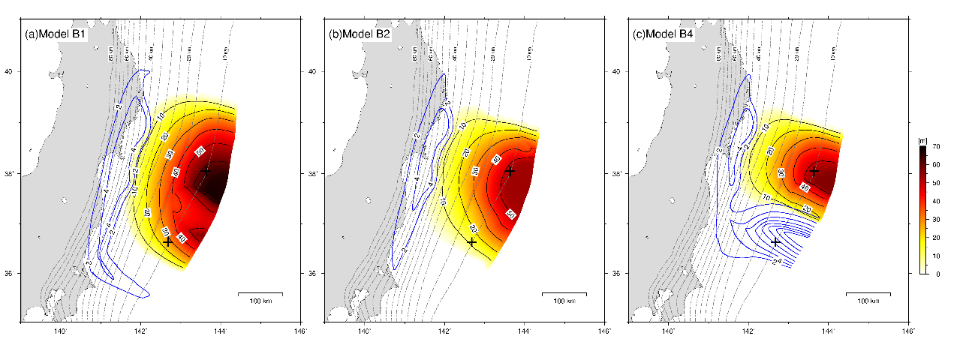
Supplementary Figure 6. Coseismic slip (when V > 1.0 cm/s) distribution (warm colors) and postseismic slip (blue contours) of the simulated M9 earthquake for (a)–(c) Models B1, B2, and B4, respectively. Postseismic slips were calculated for 5 years from 0.1 years after each M9 earthquake when Vpl < V < 1.0 cm/s. Crosses indicate the points shown in Supplementary Fig. 5. The magnitude of each event was 9.13 (T = 1418 yr), 9.03 (T = 3471 yr), and 8.92 (T = 3340 yr) for Models B1, B2, and B4, respectively. There was no postseismic slip at the southern segment in Model B2 because postseismic slip did not occur during the period used for drawing (postseismic slip almost converged within 0.1 years after the M9 earthquake). On the other hand, there was no postseismic slip at the shallow southernmost part of Model B4 because the postseismic slip had not yet propagated to that location.

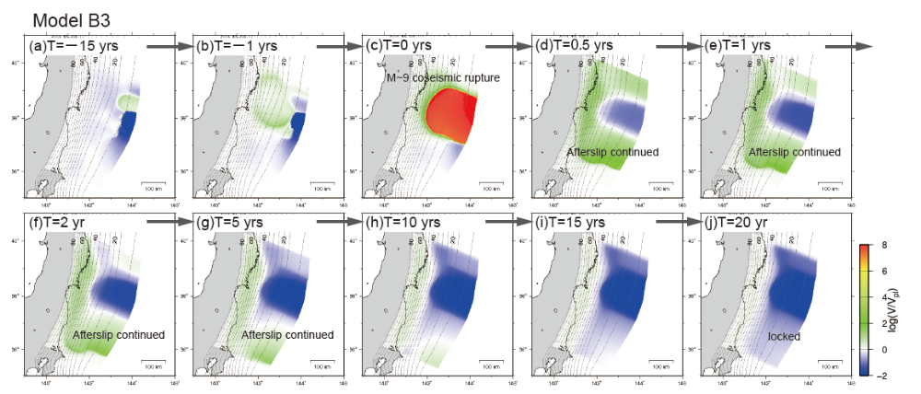
Supplementary Figure 7. Slip velocity distribution prior to, during, and following the M9 earthquake obtained by numerical simulation using Model B3. (a)–(b) 15 years and 1 year prior to the M9 earthquake. (c) Coseismic rupture of the M9 earthquake propagated. (d)–(j) 0.5, 1, 2, 5, 10, 15, and 20 years after the M9 earthquake, respectively. The blue and red areas indicate the locked parts of the fault and unstably slipping parts of the fault, respectively. Yellow/green and white indicate slow slip and plate convergence rates, respectively.

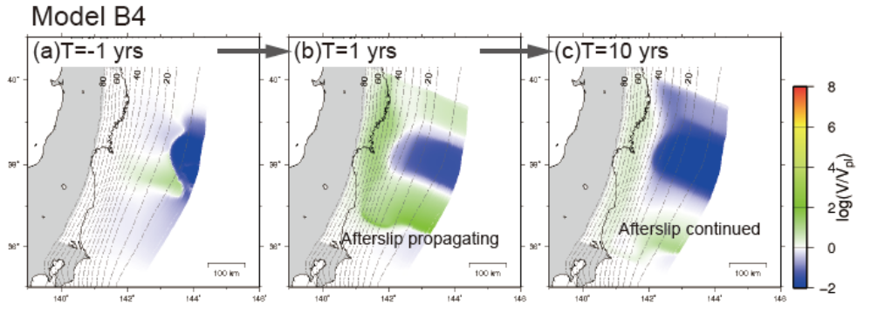
Supplementary Figure 8. Slip velocity distribution prior to and following the M9 earthquake obtained by numerical simulation using Model B4. (a) 1 year prior to the M9 earthquake. (b)–(c) 1 and 10 years after the M9 earthquake.

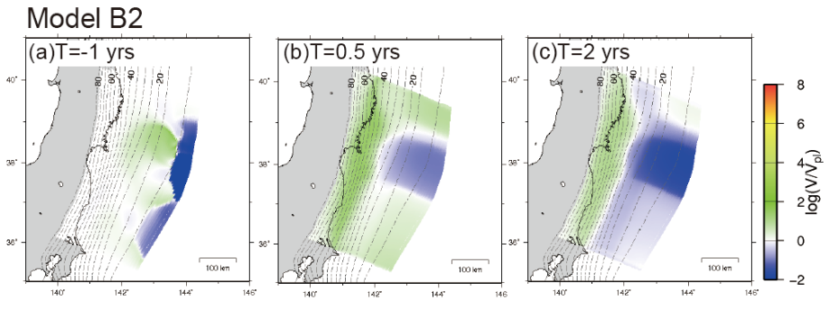
Supplementary Figure 9. Slip velocity distribution prior to and following the M9 earthquake obtained by numerical simulation using Model B2. (a) 1 year prior to the M9 earthquake. (b)–(c) 0.5 and 2 years after the M9 earthquake.

Supplementary Tables
Supplementary Table 1 Parameters at the southern segment for four models.
 | A–B (MPa) | L (m)
Model B1 | −0.10 | 0.30
Model B2 | −0.10 | 0.30
Model B3 | −0.10 | 0.65
Model B4 | −0.10 | 0.90

Supplementary Table 2 Parameters shown in Supplementary Fig. 3 (Model B1).
Area | A–B (MPa) | L (m) | Length (km)
Northern | −0.10 | 0.30 | 15 (*1)
Middle | −0.18 | 0.20 | 150
Southern | −0.10 | 0.30 | 80 (*2)
Deep | −0.10 | 0.30 | 480
*1: Transition between the middle and northern segments is 75 km.
*2: Transition between the middle and southern segments is 160 km.

Supplementary Table 3 Parameters shown in Supplementary Fig. 4 ( Model B3).
Area | A–B (MPa) | L (m) | Length (km)
Northern | −0.10 | 0.60 | 65 (*3)
Middle | −0.18 | 0.14 | 170
Southern | −0.10 | 0.65 | 225 (*3)
Deep | −0.12 | 0.15 | 480
*3: Transition between the middle segment and the northern/southern segment is 10 km.

References
Miura, S., et al. Structural characteristics controlling the seismicity of southern Japan Trench fore-arc region, revealed by ocean bottom seismographic data. Tectonophysics 363, 79–102 (2003).
Miura, S., et al. Structural characteristics off Miyagi forearc region, the Japan Trench seismogenic zone, deduced from a wide-angle reflection and refraction study. Tectonophysics 407, 165–188 (2005).
Bassett, D., Sandwell1, D. T., Fialko Y. & Watts, A. B. Upper-plate controls on co-seismic slip in the 2011 magnitude 9.0 Tohoku-Oki earthquake. Nature 531, 92–96 (2016).
Baba, T., Ito, A., Kaneda, Y., Hayakawa, T. & Furumura, T. 3-D seismic wave velocity structures in the Nankai and Japan Trench subduction zones derived from marine seismic surveys. Japan Geoscience Union Meeting, S111–006 (2006).
Igarashi, T., Matsuzawa, T., Umino, N. & Hasegawa, A. Spatial distribution of focal mechanisms for interplate and intraplate earthquake associated with the subducting Pacific plate beneath the northeastern Japan arc: A triple-planed deep seismic zone. J. Geophys. Res. 106, 2177–2191 (2001).

