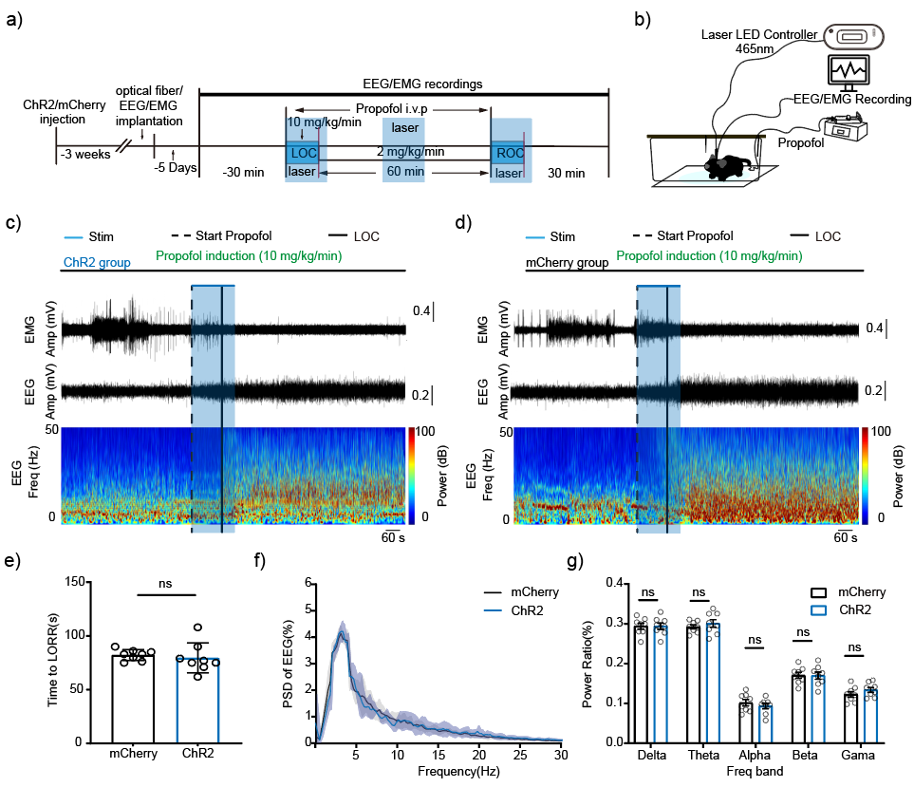
Supplementary figure 2 Optogenetic activation of SNc DA neurons does not accelerate propofol-induced LOC
a) The experimental timeline details the stimulation protocol for the optogenetic activation group and the timing of propofol administration. b) The setup for simultaneous SNc photostimulation and EEG/EMG recording is shown. c) Representative raw traces from a ChR2-expressing mouse during propofol induction are displayed; the black dashed line indicates the start of propofol infusion, and the solid line marks the LOC. The blue shaded area denotes the 3-minute photostimulation period. d) A representative recording from an mCherry control mouse during propofol induction is presented, using the same annotations as in panel c). e) LORR latencies are compared statistically between the ChR2 and mCherry groups. f) The quantified EEG PSD during propofol induction is plotted. g) Relative EEG power across five frequency bands during induction is shown for both groups. Data are mean ± SEM (n=8). *P > 0.05, **P < 0.01, ***P < 0.001.

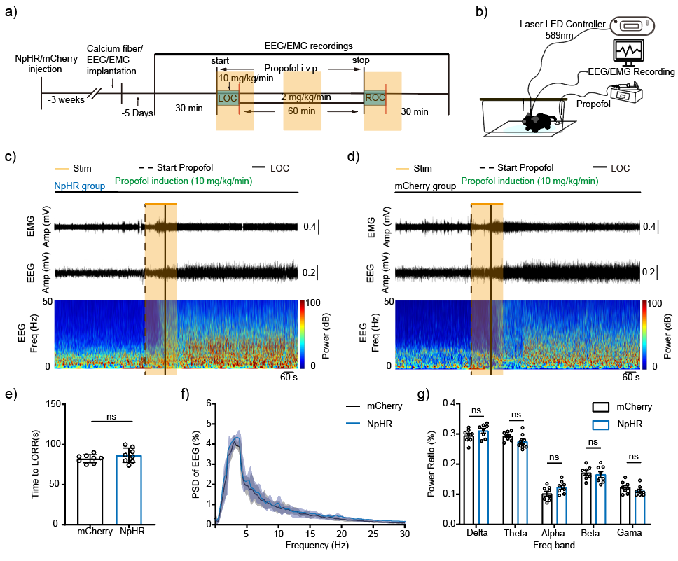
Supplementary figure 3. optogenetic inhibition of SNc^{DA} neurons modulates propofol anesthesia
a) The experimental timeline details the optogenetic inhibition protocol and the timing of propofol administration. b) A schematic illustrates the setup for concurrent SNc photostimulation and EEG/EMG recording in mice. c) Representative raw EEG/EMG traces from an NpHR-expressing mouse show the period of propofol infusion, which began at the black dashed line. The LOC occurred at the solid black line, during the 3-minute photostimulation interval marked by the yellow box. d) A representative recording from a control mouse expressing mCherry is shown under identical conditions and labeling conventions. e) The LOC latencies are compared statistically between the NpHR and mCherry control groups. f) The PSD of the EEG signal was quantified throughout the induction period. g) During induction, the relative EEG power across frequency bands differed between NpHR-expressing mice and mCherry controls. Data represent mean ± SEM (n=8). *P > 0.05, **P < 0.01, ***P < 0.001.
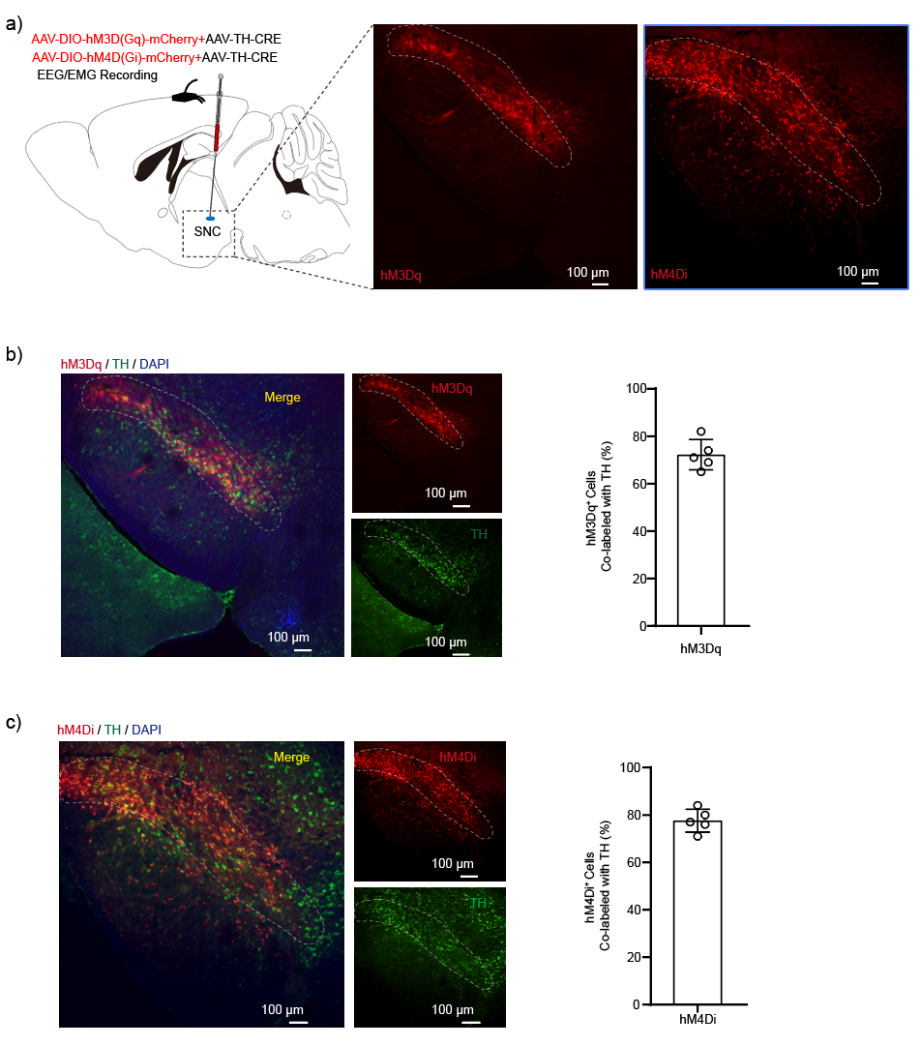
Supplementary figure 4. Optogenetic inhibition of SNc DA neurons modulates propofol anesthesia
a) Schematic of the viral injection and recording strategy for chemogenetic activation or inhibition in the SNc of WT mice. The fluorescence image (right) indicates the viral injection site. b) Viral specificity was validated by immunofluorescence. Representative images (left) show co-localization of the viral construct (hM3Dq, red) with the dopaminergic neuron marker TH (green). The graph (right) quantifies the percentage of hM3Dq expression in TH-positive neurons. c) Specificity for the inhibitory construct was similarly confirmed. Representative images (left) show co-localization of hM4Di (red) with TH (green), with quantification (right) of hM4Di expression in TH-positive neurons.

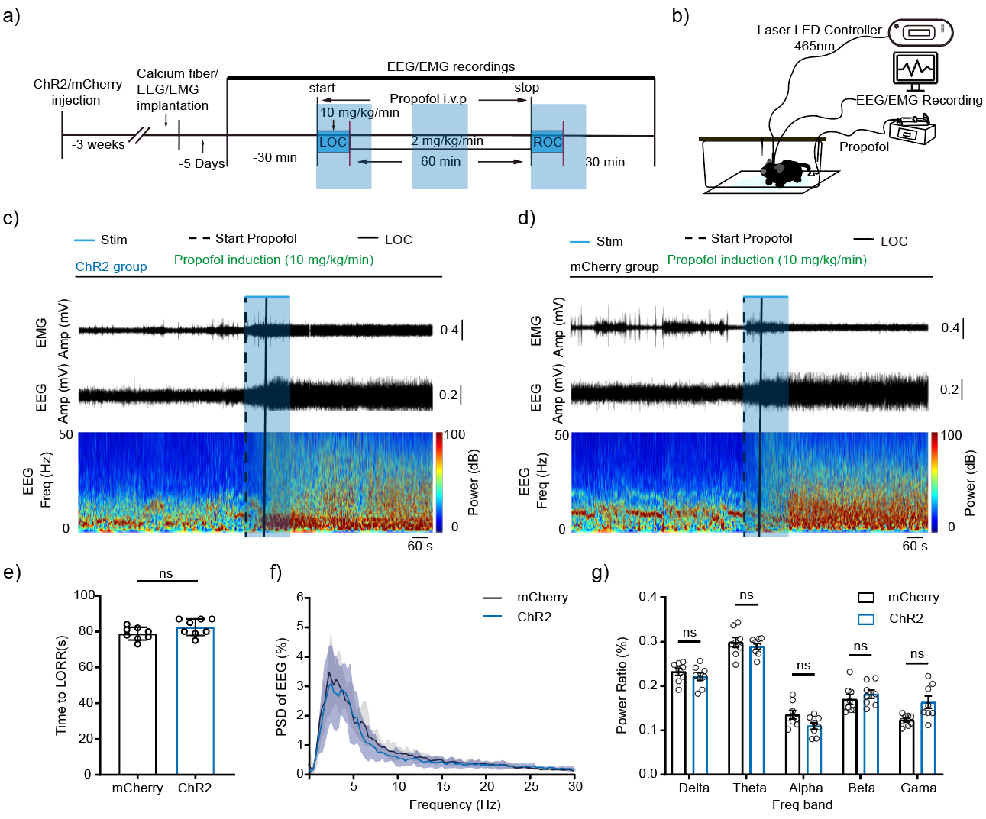
Supplementary Figure 5. Optogenetic activation of SNc^{DA} neuron terminals in the dorsal striatum does not alter anesthetic induction in mice.
a) Schematic timeline of the experimental procedure for optogenetic stimulation of the SNc^{DA}-DS pathway during propofol infusion. b) Schematic of the experimental setup for physiological recording in mice. c) Representative recordings from a ChR2-expressing mouse during propofol induction, showing electromyography (EMG, top), electroencephalography (EEG, middle), and the corresponding EEG spectrogram (bottom). d) Representative recordings from an mCherry control mouse during the same induction phase, presented with the same modalities. e) Quantified time to loss of righting reflex (LORR) for ChR2 and mCherry groups, with statistical comparison. f) PSD plots for both groups during the induction period. G. Statistical comparison of EEG power across frequency bands for the two groups during induction.
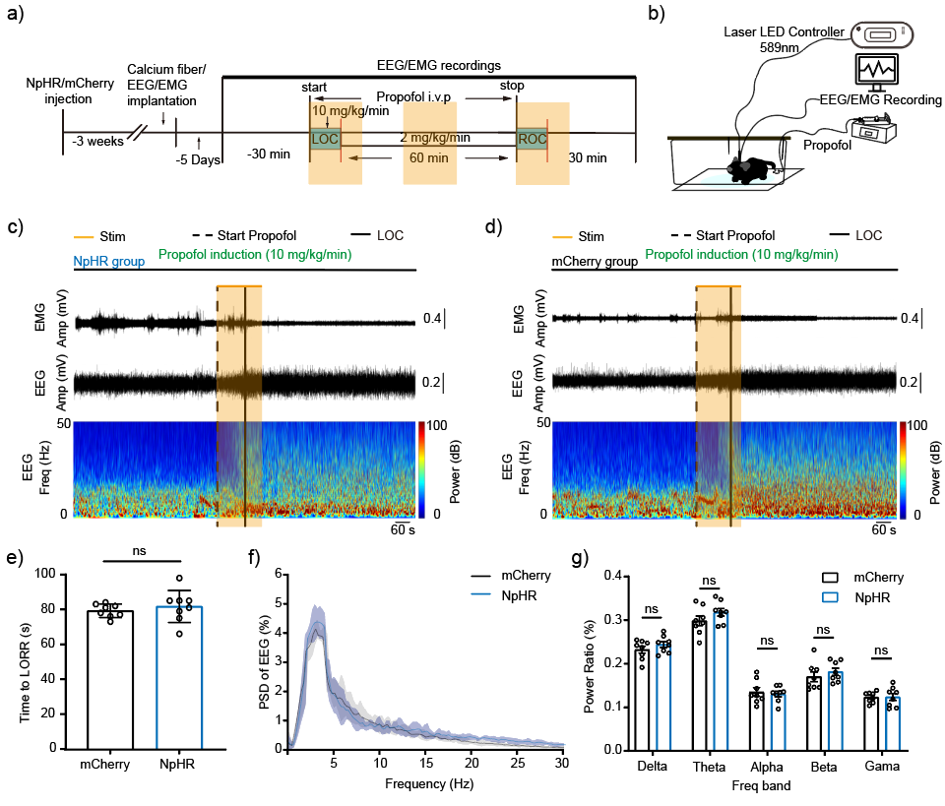
Supplementary Figure 6. Optogenetic inhibition of the SNc^{DA}-DS pathway at its projection terminals in the ds does not affect the anesthesia induction period in mice
a) The experimental timeline for optogenetic inhibition of the SNc^{DA}- DS pathway combined with propofol infusion. b) A diagram of the experimental recording setup in mice. c) Representative recordings from an NpHR-expressing mouse during propofol induction, showing the electromyogram (EMG, top), electroencephalogram (EEG, middle), and EEG spectrogram (bottom). d) Representative recordings from an mCherry control mouse during the same phase. e) A quantified statistical comparison of the LOC times between the NpHR and mCherry groups. f) The PSD during induction compared between groups. g) A statistical comparison of EEG power across frequency bands for the two groups during induction.

