Strain-induced topological transition from planar to filamentous grain boundary oxidation in austenitic stainless steel
Semanti Mukhopadhyay¹, Tingkun Liu¹, Matthew J. Olszta¹, Hyoju Park¹, Ziqing Zhai¹, Mychailo Toloczko¹, Arun Devaraj^{1*}
¹Pacific Northwest National Laboratory, Richland, WA 99352
Supplementary Images
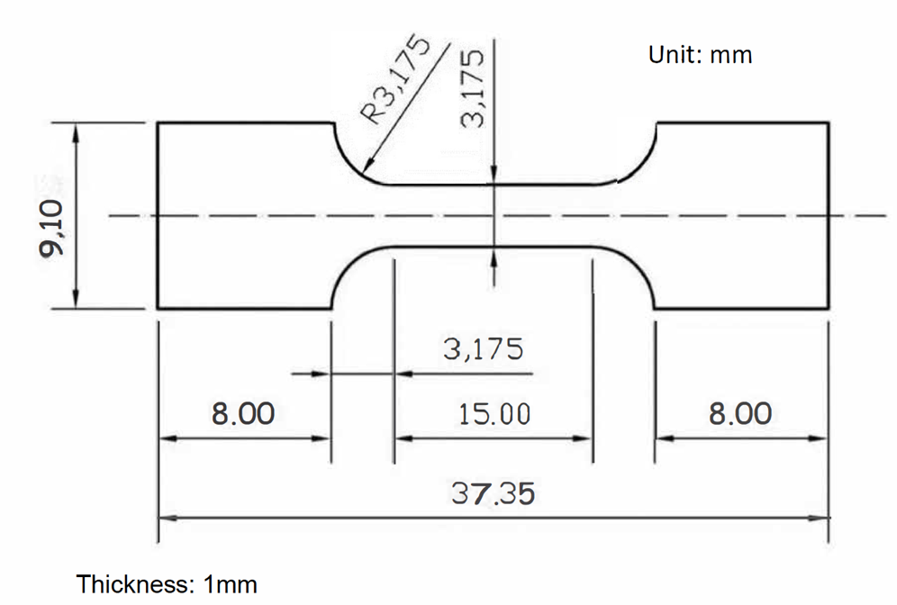
Figure S1: Geometry of the dogbone used for room temperature uniaxial tensile testing. Units in mm.

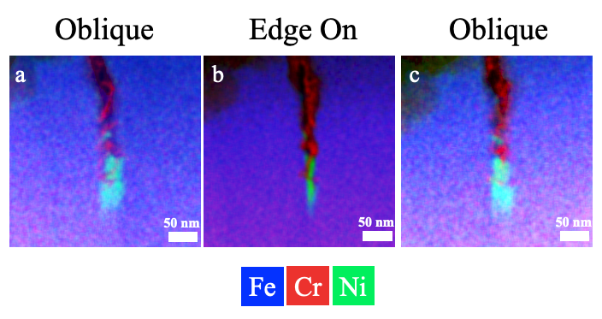
Figure S2: Tilt-series STEM-EDS analysis of a third CTS RHAGB (D-3) showing Cr-enriched filamentary oxide interpenetrating the RHAGB with a Ni-enriched DIGM zone

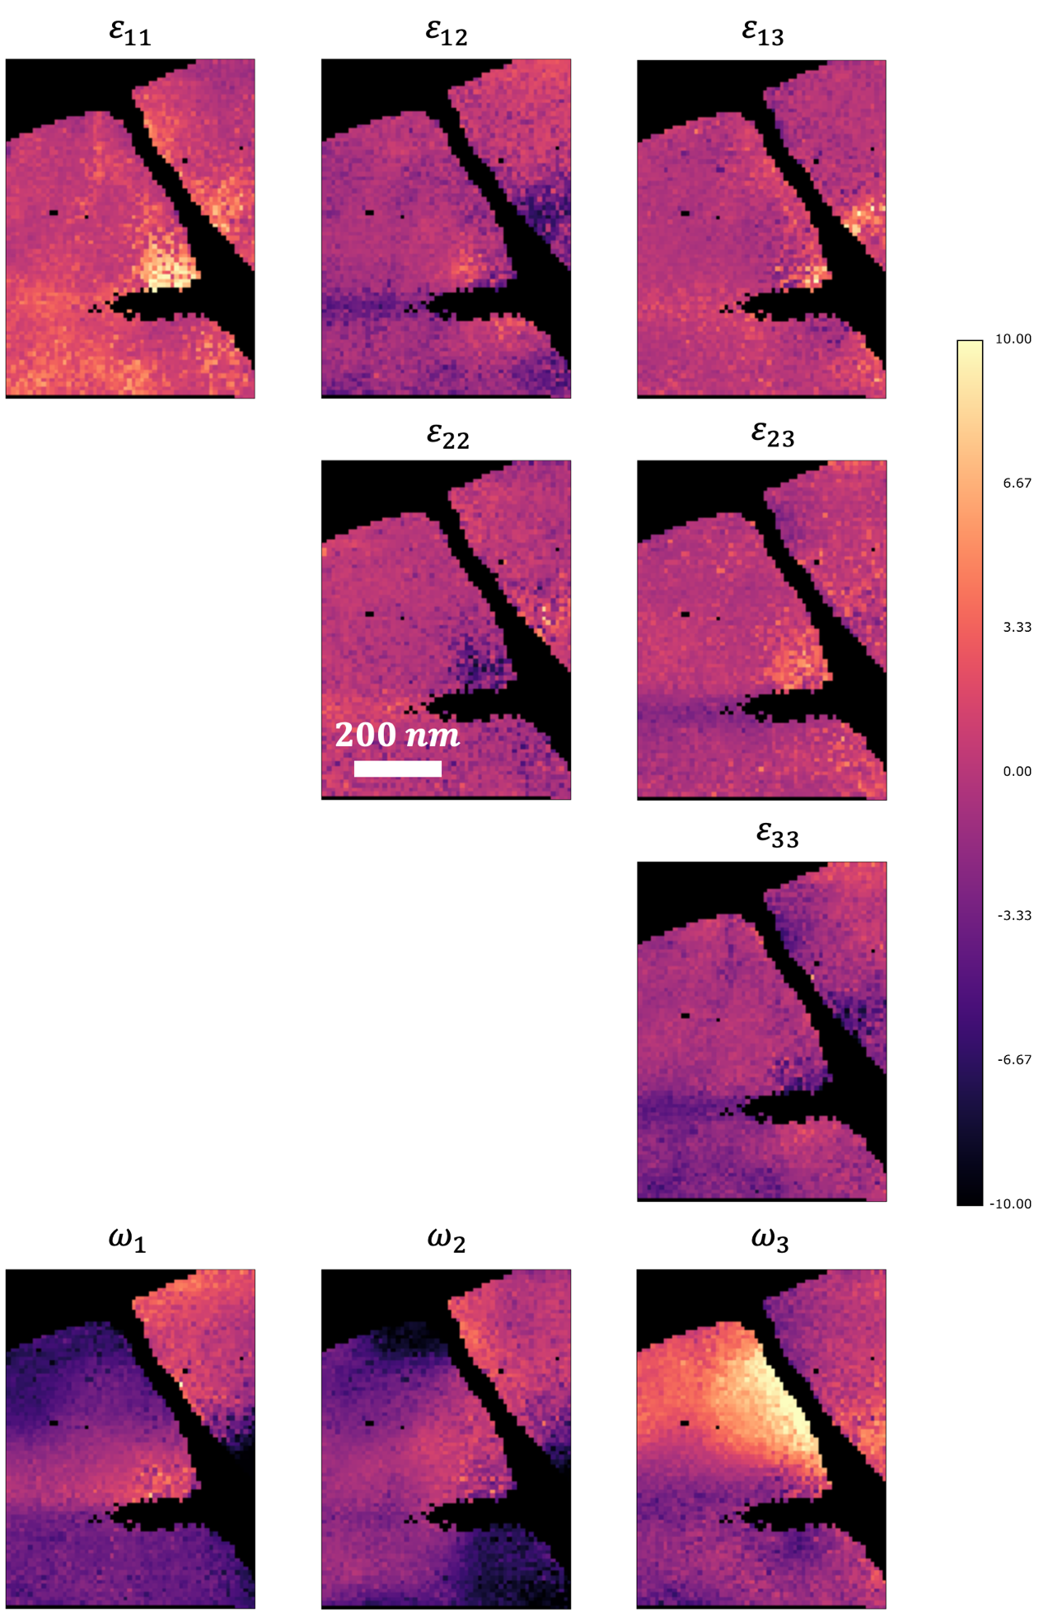
Figure S3: Relative deviatoric strain maps (mm/m) and rotation maps obtained for CTS RHAGB D-1
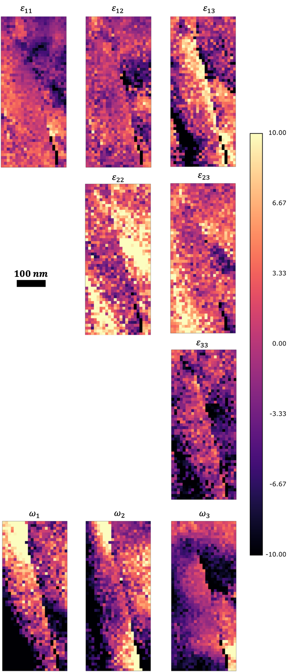
Figure S4: Relative deviatoric strain maps (mm/m) and rotation maps obtained for CTS RHAGB D-2

