Table S1. Anthropometric characteristics of the subjects.
 | All  (n = 176) |  | NW  (n = 88) |  | NWO  (n = 88) |  | P-value
 | median | Q₂₅–Q₇₅ | median | Q₂₅–Q₇₅ | median | Q₂₅–Q₇₅ | P-value
Age [years] | 20 | 19 – 22 | 20 | 19 – 22 | 20 | 19 – 22 | 0.500
Weight [kg] | 60 | 55 – 65 | 58 | 54 – 63 | 62 | 57 – 67 | p < 0.0001
Height [cm] | 168 | 163 – 172 | 169 | 164 – 173 | 167 | 163 – 172 | 0.132
BMI [kg/m²] | 21.4 | 20.2 – 23.1 | 20.4 | 19.5 – 21.7 | 22.7 | 21.3 – 23.7 | p < 0.0001
PBF [%] | 35.2 | 32.1 – 38 | 32.1 | 29.5 – 33.4 | 37.9 | 36.7 – 39.4 | p < 0.0001
WC [cm] | 70 | 67 – 74 | 69 | 66 – 73 | 73 | 69 – 75 | p < 0.0001
HC [cm] | 97 | 91 – 100 | 94 | 90 – 97 | 99 | 96 – 103 | p < 0.0001
WHR | 0.7 | 0.70 – 0.76 | 0.7 | 0.71 – 0.76 | 0.7 | 0.69 – 0.76 | 0.550
WHtR | 42 | 40 – 44 | 41 | 39 – 43 | 43 | 41 – 45 | p < 0.0001
Legend: BMI – body mass index; WC – waist circumference; HC – hip circumference; WHR – waist to hip ratio; WHtR – waist to height ratio

Table S2. Body composition characteristics of the subjects.
 | All  (n = 176) |  | NW  (n = 88) |  | NWO  (n = 88) |  | P-value
 | median | Q₂₅–Q₇₅ | median | Q₂₅–Q₇₅ | median | Q₂₅–Q₇₅ | P-value
FM [kg] | 21.7 | 18.5 – 24.9 | 18.4 | 16.7 – 20.6 | 24.7 | 22.6 – 26.3 | p < 0.0001
FMI [kg/m²] | 7.8 | 6.6 – 8.9 | 6.6 | 6.1 – 7.1 | 8.7 | 8.4 – 9.4 | p < 0.0001
AFM [kg] | 12 | 10.2 – 13.5 | 10.3 | 9.2 – 11.4 | 13.3 | 12.2 – 14.4 | p < 0.0001
AFMI [kg/m²] | 4.3 | 3.7 – 4.8 | 3.7 | 3.3 – 4 | 4.8 | 4.4 – 5.1 | p < 0.0001
TAR | 0.73 | 0.66 – 0.79 | 0.7 | 0.65 – 0.78 | 0.74 | 0.68 – 0.81 | 0.051
FMR | 0.74 | 0.69 – 0.79 | 0.71 | 0.67 – 0.76 | 0.76 | 0.71 – 0.80 | p < 0.0001
APF [%] | 30.8 | 27.5 – 35.6 | 27.6 | 23.8 – 30.1 | 35.6 | 32.7 – 38.1 | p < 0.0001
GPF [%] | 40.6 | 37.8 – 42.9 | 37.7 | 35.1 – 39.3 | 42.9 | 41.6 – 44.5 | p < 0.0001
A/G | 0.77 | 0.71 – 0.83 | 0.73 | 0.67 – 0.79 | 0.82 | 0.76 – 0.88 | p < 0.0001
VFA [cm²] | 45.2 | 36.1 – 56.4 | 39 | 33.7 – 48.5 | 51.8 | 42.3 – 63.2 | p < 0.0001
VFM [g] | 217.9 | 174 – 271.8 | 187.8 | 162.4 – 233.7 | 249.7 | 203.8 – 304.5 | p < 0.0001
VFV [cm³] | 235.6 | 188.1 – 293.8 | 203.1 | 175.5 – 252.7 | 270 | 220.3 – 329.2 | p < 0.0001
FFM [kg] | 37.9 | 35.7 – 41.3 | 38.8 | 36.4 – 41.7 | 37.3 | 35.3 – 40.6 | 0.084
FFMI [kg/m²] | 13.6 | 13 – 14.3 | 13.9 | 12.9 – 14.4 | 13.5 | 13 – 14.2 | 0.374
AFFM [kg] | 16.4 | 14.9 – 17.7 | 16.7 | 15.5 – 18.3 | 16.1 | 14.5 – 17.5 | 0.042
AFFMI [kg/m²] | 5.8 | 5.5 – 6.2 | 5.9 | 5.6 – 6.3 | 5.8 | 5.5 – 6.1 | 0.082
TLM [kg] | 40.3 | 37.7 – 43.5 | 41 | 38.54 – 44.1 | 39.5 | 37.5 – 43.2 | 0.073
TLMI [kg/m²] | 14.4 | 13.8 – 15.1 | 14.6 | 13.8 – 15.2 | 14.3 | 13.8 – 15 | 0.271
ALM [kg] | 17.5 | 15.9 – 18.9 | 17.9 | 16.5 – 19.5 | 17.2 | 15.6 – 18.7 | 0.038
ALMI [kg/m²] | 6.2 | 5.9 – 6.6 | 6.3 | 6 – 6.7 | 6.2 | 5.8 – 6.5 | 0.059
Legend: FM – fat mass; FMI – fat mass index; AFM – appendicular fat mass; AFMI – appendicular fat mass ratio;
TAR - trunk-to-appendicular fat ratio; FMR – fat mass ratio; APF – android percent fat; GPF – gynoid percent fat;
A/G – android percent fat to gynoid percent fat ratio; VFA – visceral fat area; VFM - visceral fat mass; VFV - visceral fat volume; FFM – fat-free mass; FFMI – fat-free mass index; AFFM – appendicular fat-free mass; AFFMI - appendicular fat-free mass index; TLM – total lean mass; TLMI – total lean mass index; ALM – appendicular lean mass; ALMI - appendicular lean mass index

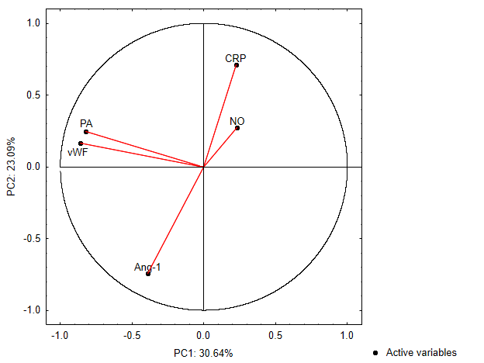
Figure S1. Projection of active variables onto the space of two principal components (PC1 and PC2).

