Supporting Information
Evaluating Cellular Effects of PET Micro- and Nanoplastics in 2D/3D Models: Methodological Considerations of Reagent Interference
Lisa Aichinger^{1,2,3}, Kristina Duswald^{4,5}, Doris Pakusic^{4,6}, Lukas Kogler^{1,3,4,6}, Sarah Stellnberger^{1,3}, Verena Karl⁵, Matea Stojanovic¹, Dominik Wenisch⁷, Michael Jakupec⁷, Cécile Philippe², Lukas Kenner^{4,6,8,9}, Markus Brandstetter^{4,5}, Verena Pichler^{1,4,10*}

¹ Department of Pharmaceutical Science, University of Vienna, 1090 Vienna, Austria
² Department of Biomedical Imaging and Image-guided Therapy, Division of Nuclear Medicine, Medical University of Vienna, 1090 Vienna, Austria
³Vienna Doctoral School of Pharmaceutical, Nutritional and Sport Sciences (VDS PhaNuSpo), 1090 Vienna, Austria
⁴ CBmed GmbH – Centre for Biomarker Research in Medicine, Graz, 8010 Styria, Austria
⁵ RECENDT GmbH – Research Center for Non-Destructive Testing, Linz, Upper Austria, Austria
⁶ Clinical Institute of Pathology, Department for Experimental and Laboratory Animal Pathology, Medical University of Vienna, 1090 Vienna, Austria
⁷ Institute of Inorganic Chemistry, Faculty of Chemistry, University of Vienna, 1090 Vienna, Austria
⁸ University of Veterinary Medicine, Unit of Laboratory Animal Pathology, Vienna 1210, Austria
⁹ Department of Molecular Biology, Umeå University, Umeå 90187, Sweden
¹⁰ Department of Pharmacy, University of Oslo, Sem Sælands vei 3, 0371 Oslo, Norway
Corresponding author: verena.pichler@univie.ac.at

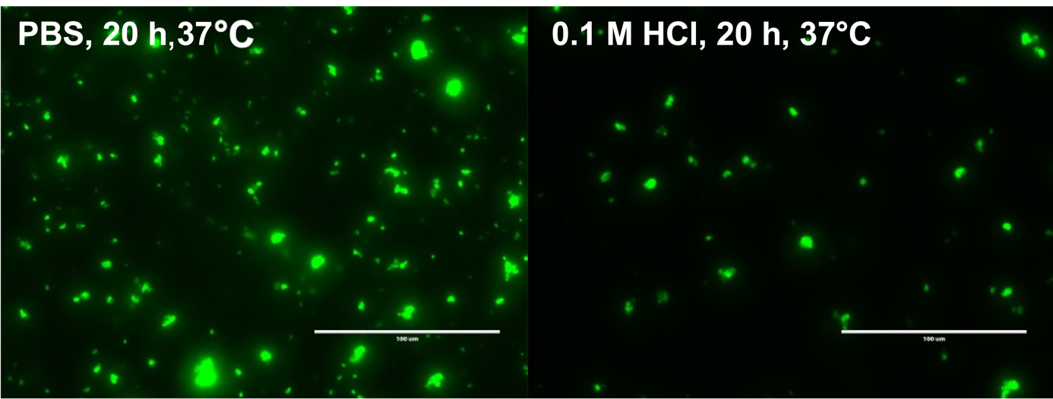
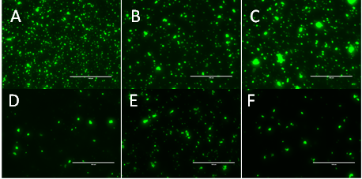
Fig. SI 1. Fluorophore stability and leaching testing for Fluo-PET particles. Stability was assessed qualitatively by fluorescence imaging. A) and D) shows two samples directly after labelling, B) after two DMF washes, C) after incubation at 50°C in 0.12 M HCl for 30 min and F) 37°C, 20 h, 0.1 M HCl, E) 37°C, 20 h PBS buffer. After incubation particles were neutralized if acid treated, centrifuged and resuspended in 0.5 % SDS.
Recent stability testing shows 0.2 % and 1.24 % of free FITC after 20 h incubation at 37°C in phosphate buffer and 0.1 M HCl respectively. Particles were suspended in medium, incubated, and filtered. Supernatants were measured by fluorescence detection and compared to total amount of attached FITC.

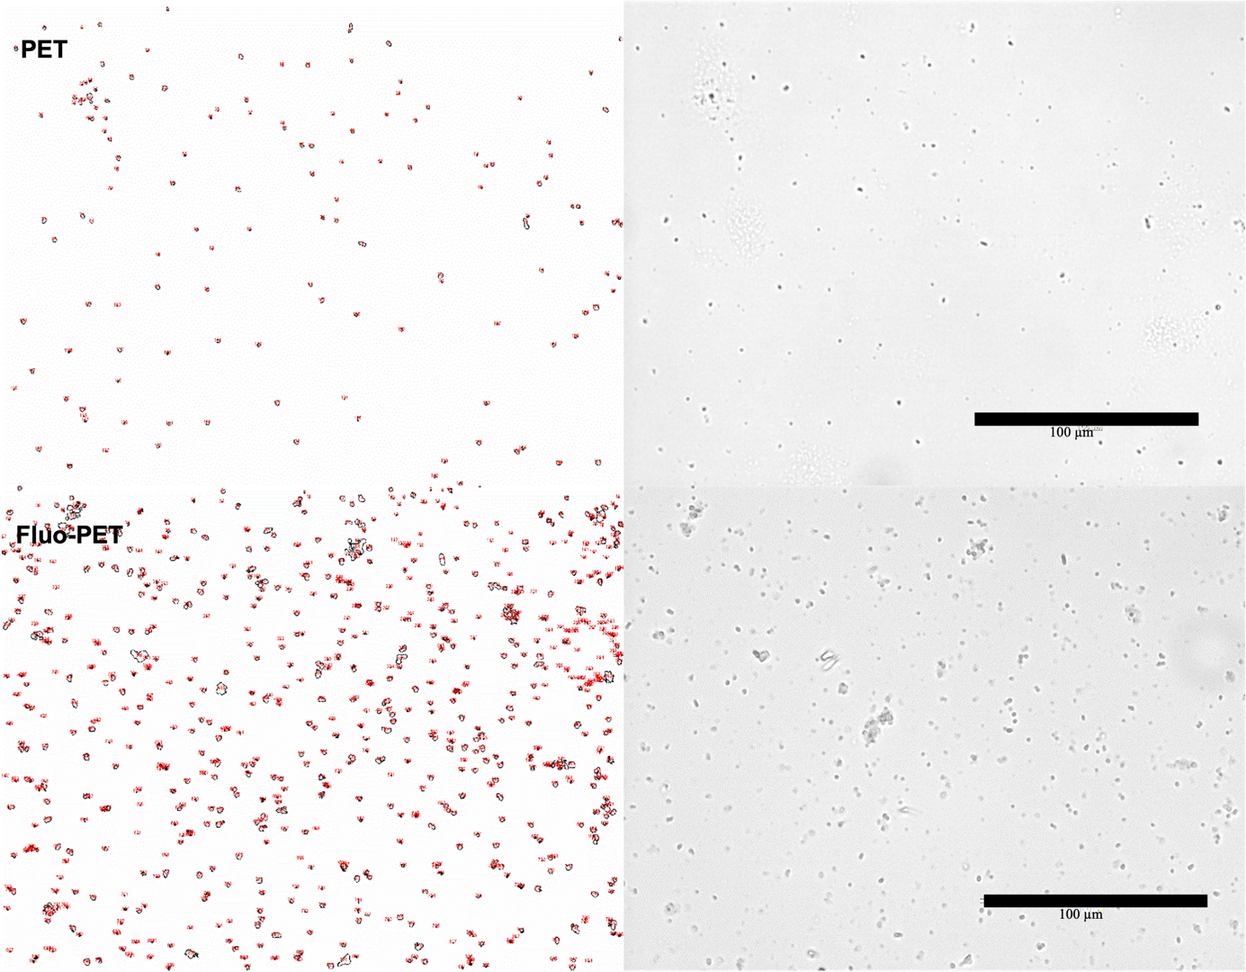
Fig. SI 2. Light microscopy images of PET particle samples (PET and Fluo-PET) and ImageJ masks (red) used for determination of equivalent diameter.

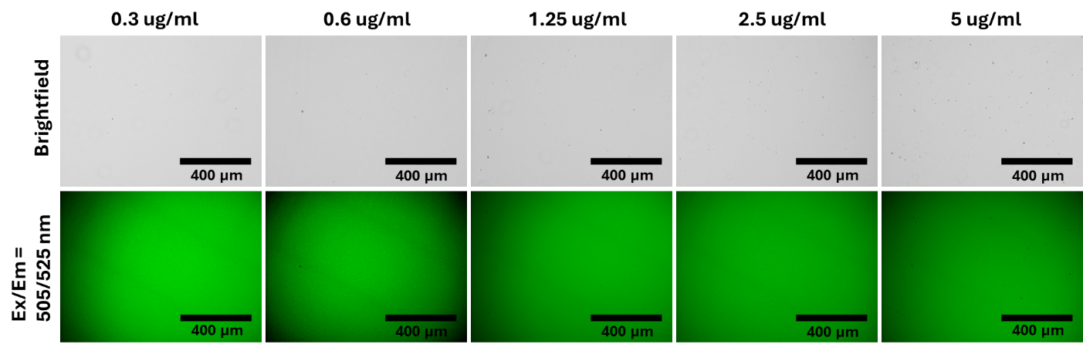
Fig. SI 3. Fluorescence micrographs of PET particles at different concentrations stained with DCFA-DA to assess potential interaction of the dye with the particles. Scale bar: 400 µm.

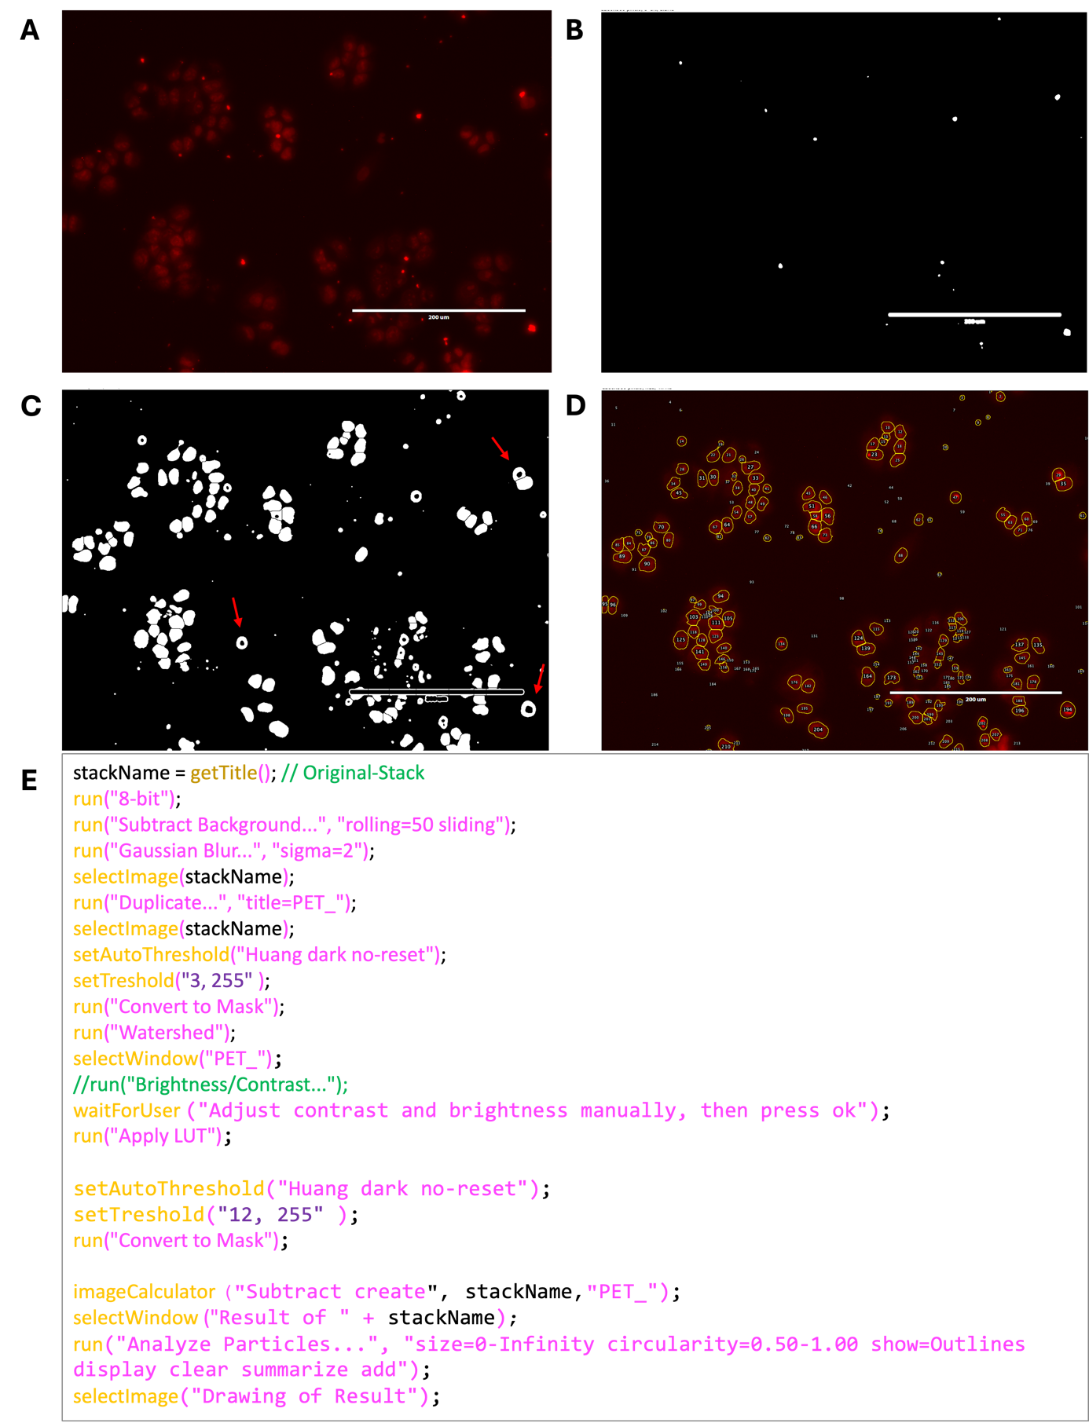
Fig. SI 4. H460 cells treated with PET particles (5 µg/ml). A) Original image; B) Mask showing only the detected PET particles; C) Cell image after subtraction of the PET particles (red arrows mark examples of locations where PET particles were removed from the cell ROIs); D) Analysis image of all cells without PET particles; E) ImageJ/Fiji macro code used (analysis parameters include circularity 0.5–1 to automatically remove scale bars). Scale bar: 200 µm.

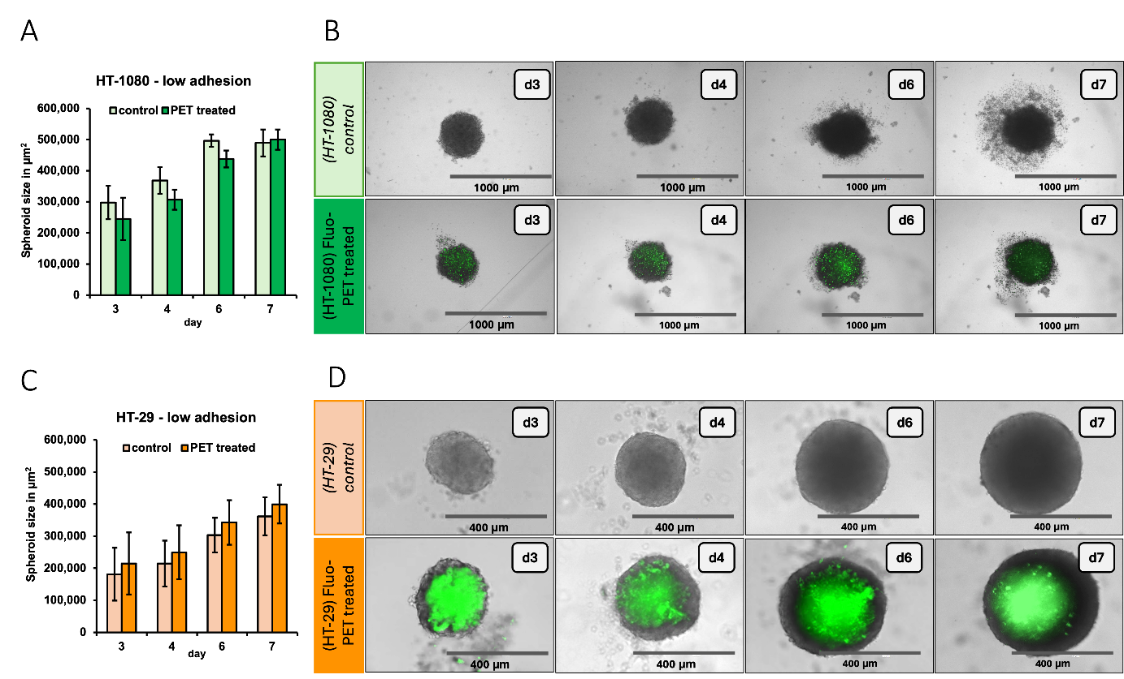Fig. SI 5. Spheroid generation in low-adhesion plates: A) Quantitative measurement of spheroid growth of HT-1080 cells without significant influence of Fluo-PET MPs; B) representative images of particle distribution in HT-1080 spheroids with and without green fluorescent PET particles (conc. 2 µg/ml) at different time points (day 3, 4, 6 and 7); C) Quantitative measurement of spheroid growth of HT-29 cells, without significant influence of Fluo-PET MPs; D) corresponding representative images of particle distribution in HT-29 spheroids at the same time points; n=3; Scale bars: 400 µm to 1000 µm

Fig. SI 6. Control experiments applying 22RV1 cells in the general ROS assay, PET particles and H₂O₂ in different concentrations to access scattering and diffraction effects of the plate reader after A) 10 min and B) 2 h. Increasing PET particle concentrations led to a reduction of the fluorescence signal.
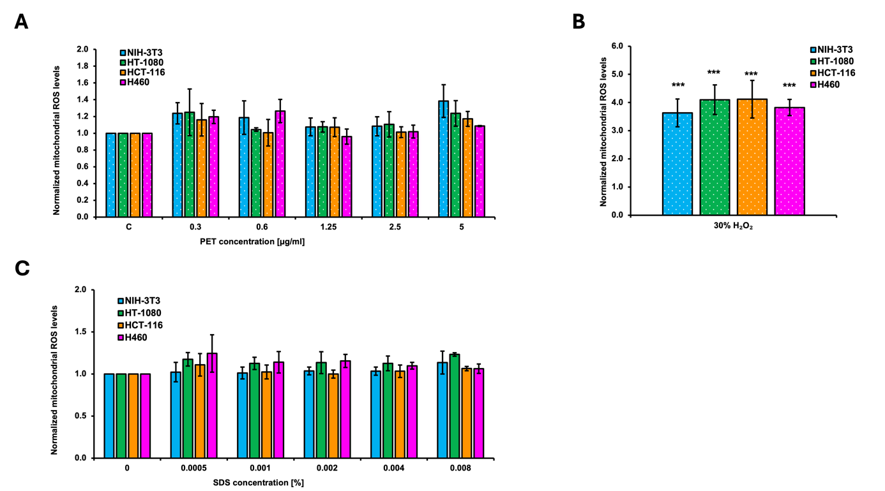
Fig. SI 7. A) Quantification of mitochondrial ROS production with a Tecan Plate Reader in four different cell lines after PET treatment. Data were normalised to the control group (0 µg/ml) and presented as mean ± SD; B) positive control (H₂O₂) showed a significantly increased ROS generation in all cell lines; C) comparison of mitochondrial ROS formation after SDS treatment alone with equivalent amount of SDS as in the PET preparations. Statistically significant differences were labelled with p-values (*p < 0.05, **p < 0.01 and ***p < 0.001), n = 3-4.

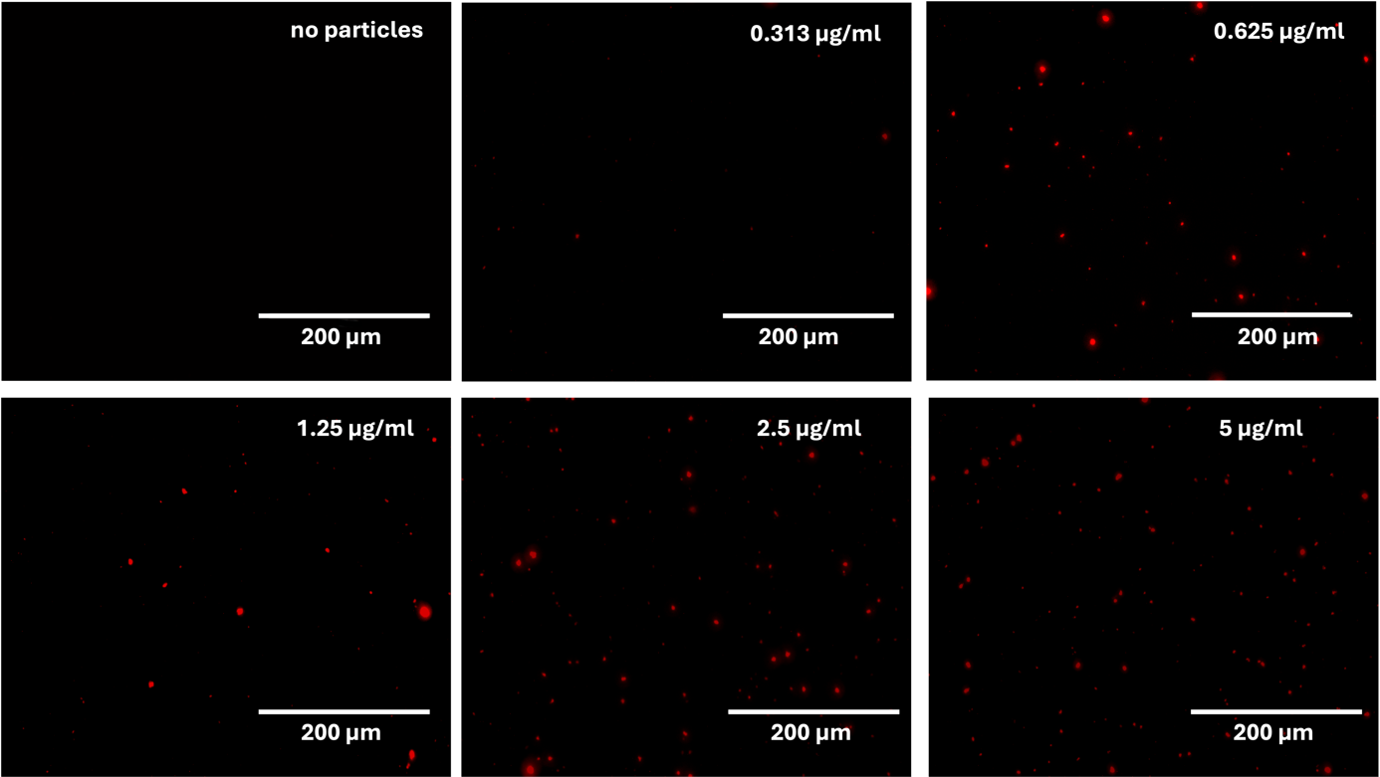
Fig. SI 8. Fluorescence micrographs of PET particles at different concentrations stained with MitoSOX Red® to assess potential interaction of the dye with the particles. Scale bar: 200 µm.

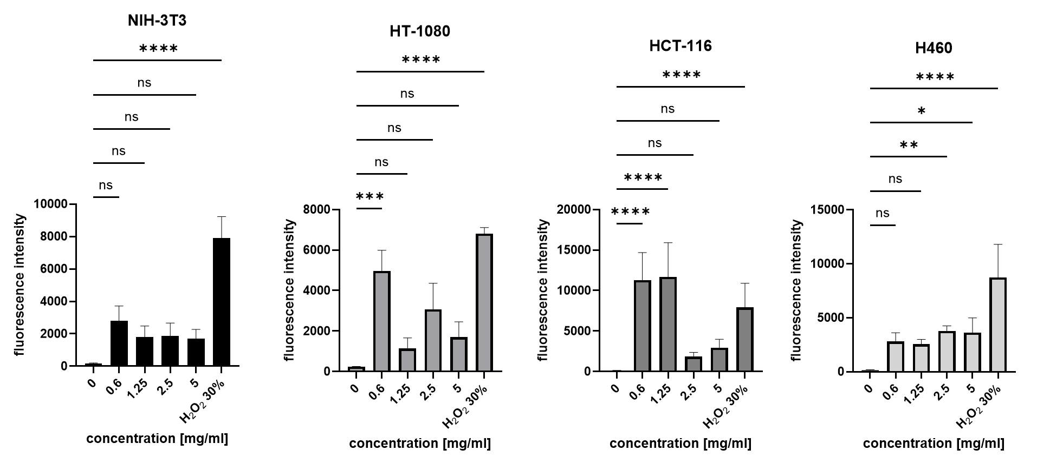
Fig. SI 9. Fluorescence micrographs were analyzed using ImageJ, and results are presented as mean CTCF (see methods for definition). Data are shown as mean ± SD. Statistical significance versus control is indicated as *p < 0.05, **p < 0.01, ***p < 0.001.

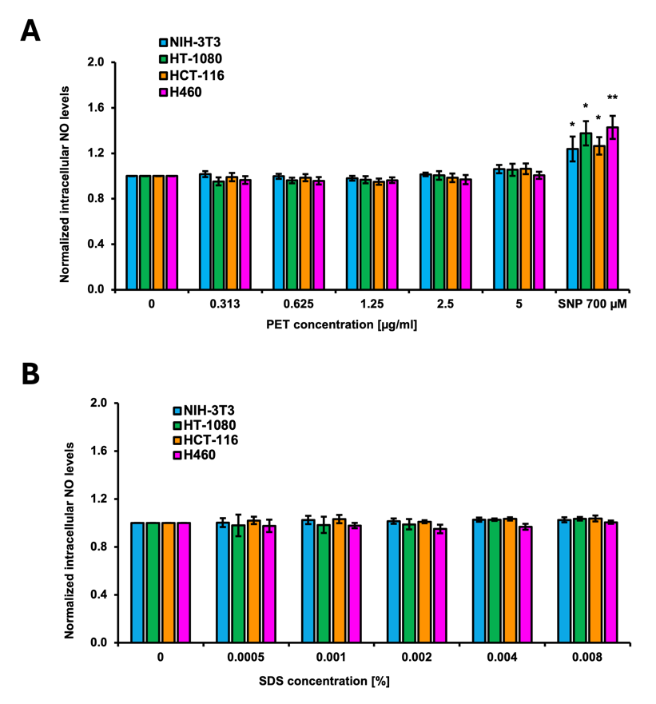
Fig. SI 10. Quantitative measurement of nitric oxide (NO) normalised to the untreated control group and presented as mean ± SD. A) NO-production after different PET concentrations (0-5 µg/ml); positive control (700 µM sodium nitroprusside (SNP)); B) Comparative analysis of NO-generation when treated with equivalent SDS concentrations (% of PET); Statistically significant differences compared to the control group are indicated by p-values (*p < 0.05, **p < 0.01); n = 3.

