Appendix A. Supplementary data
The following is the Supplementary data to this article:
Table s1. EVI-Based Ecological Vulnerability Classification Standards and Ecological Characteristics for Wuwei City.
Vulnerability Level | EVI Range | Level | Feature Description
Potential | EVI≤0. 3766 | 1 | The ecological environment is stable, and the ecosystem structure is intact.
Slightly | 0. 3766<EVI≤ 0. 4198 | 2 | The ecological environment is relatively stable, and the ecosystem structure is relatively intact.
Mild | 0. 4198<EVI≤0. 4566 | 3 | The ecosystem can maintain its basic functions.
Moderate | 0. 4566<EVI≤0. 4832 | 4 | The ecosystem structure is severely damaged but remains within tolerable limits.
Severe | EVI>0. 4832 | 5 | The ecological environment is highly unstable, with an incomplete ecosystem structure that is extremely difficult to restore once damaged.

Table s2. Factor Weighting for Ecological Vulnerability Indicators in Wuwei City, 2014–2023.
Indicator | w_{1j} | 2014 |  | 2015 |  | 2016 |  | 2017 |  | 2018
Indicator | w_{1j} | w_{2j} | w_{j} | w_{2j} | w_{j} | w_{2j} | w_{j} | w_{2j} | w_{j} | w_{2j} | w_{j}
Slope | 0. 0323 | 0. 0815 | 0. 0531 | 0. 0761 | 0. 0509 | 0. 0753 | 0. 0506 | 0. 0755 | 0. 0507 | 0. 0789 | 0. 0521
elevation | 0. 0383 | 0. 0938 | 0. 0620 | 0. 0900 | 0. 0603 | 0. 0885 | 0. 0598 | 0. 0893 | 0. 0600 | 0. 0925 | 0. 0615
Annual precipitation | 0. 0630 | 0. 0923 | 0. 0789 | 0. 0879 | 0. 0764 | 0. 0876 | 0. 0762 | 0. 0864 | 0. 0757 | 0. 0907 | 0. 0781
Annual average temperature | 0. 0519 | 0. 0934 | 0. 0720 | 0. 0914 | 0. 0707 | 0. 0890 | 0. 0698 | 0. 0907 | 0. 0704 | 0. 0929 | 0. 0717
Dryness | 0. 0603 | 0. 0866 | 0. 0748 | 0. 0805 | 0. 0716 | 0. 0824 | 0. 0723 | 0. 0822 | 0. 0723 | 0. 0856 | 0. 0742
Vegetation cover | 0. 1110 | 0. 0883 | 0. 1024 | 0. 0880 | 0. 1015 | 0. 0896 | 0. 1024 | 0. 0871 | 0. 1009 | 0. 0882 | 0. 1022
Soil Erosion Level | 0. 0603 | 0. 0579 | 0. 0611 | 0. 0659 | 0. 0647 | 0. 0738 | 0. 0685 | 0. 0678 | 0. 0656 | 0. 0660 | 0. 0651
Landscape fragmentation | 0. 0903 | 0. 0264 | 0. 0505 | 0. 0433 | 0. 0642 | 0. 0476 | 0. 0673 | 0. 0454 | 0. 0657 | 0. 0295 | 0. 0533
Landscape Diversity | 0. 0838 | 0. 0745 | 0. 0818 | 0. 0704 | 0. 0789 | 0. 0694 | 0. 0783 | 0. 0711 | 0. 0792 | 0. 0696 | 0. 0789
Biological abundance | 0. 1430 | 0. 0872 | 0. 1155 | 0. 0840 | 0. 1126 | 0. 0832 | 0. 1120 | 0. 0845 | 0. 1128 | 0. 0867 | 0. 1150
Net primary productivity of vegetation | 0. 0951 | 0. 0834 | 0. 0922 | 0. 0894 | 0. 0947 | 0. 0875 | 0. 0936 | 0. 0879 | 0. 0938 | 0. 0837 | 0. 0921
Population density | 0. 1127 | 0. 0718 | 0. 0931 | 0. 0705 | 0. 0915 | 0. 0673 | 0. 0894 | 0. 0702 | 0. 0913 | 0. 0720 | 0. 0930
GDP density | 0. 0580 | 0. 0630 | 0. 0625 | 0. 0626 | 0. 0619 | 0. 0588 | 0. 0599 | 0. 0619 | 0. 0615 | 0. 0637 | 0. 0628

Table s2. (Continued) Weighting Factors for Ecological Vulnerability Indicators in Wuwei City, 2014–2023.
Indicator | w_{1j} | 2019 |  | 2020 |  | 2021 |  | 2022 |  | 2023
Indicator | w_{1j} | w_{2j} | w_{j} | w_{2j} | w_{j} | w_{2j} | w_{j} | w_{2j} | w_{j} | w_{2j} | w_{j}
Slope | 0. 0323 | 0. 0765 | 0. 0516 | 0. 0810 | 0. 0529 | 0. 0779 | 0. 0520 | 0. 0796 | 0. 0525 | 0. 0795 | 0. 0524
elevation | 0. 0383 | 0. 0936 | 0. 0622 | 0. 0934 | 0. 0619 | 0. 0939 | 0. 0622 | 0. 0933 | 0. 0619 | 0. 0922 | 0. 0615
Annual precipitation | 0. 0630 | 0. 0913 | 0. 0787 | 0. 0914 | 0. 0785 | 0. 0909 | 0. 0785 | 0. 0911 | 0. 0784 | 0. 0906 | 0. 0782
Annual average temperature | 0. 0519 | 0. 0952 | 0. 0730 | 0. 0931 | 0. 0719 | 0. 0952 | 0. 0729 | 0. 0939 | 0. 0723 | 0. 0940 | 0. 0723
Dryness | 0. 0603 | 0. 0844 | 0. 0741 | 0. 0855 | 0. 0743 | 0. 0843 | 0. 0739 | 0. 0828 | 0. 0732 | 0. 0811 | 0. 0724
Vegetation cover | 0. 1110 | 0. 0900 | 0. 1038 | 0. 0879 | 0. 1022 | 0. 0883 | 0. 1027 | 0. 0883 | 0. 1025 | 0. 0861 | 0. 1012
Soil Erosion Level | 0. 0603 | 0. 0671 | 0. 0660 | 0. 0637 | 0. 0641 | 0. 0628 | 0. 0638 | 0. 0659 | 0. 0653 | 0. 0735 | 0. 0689
Landscape fragmentation | 0. 0903 | 0. 0186 | 0. 0425 | 0. 0259 | 0. 0501 | 0. 0211 | 0. 0453 | 0. 0240 | 0. 0482 | 0. 0261 | 0. 0502
Landscape Diversity | 0. 0838 | 0. 0634 | 0. 0757 | 0. 0677 | 0. 0780 | 0. 0649 | 0. 0765 | 0. 0688 | 0. 0786 | 0. 0706 | 0. 0796
Biological abundance | 0. 1430 | 0. 0875 | 0. 1161 | 0. 0867 | 0. 1153 | 0. 0878 | 0. 1162 | 0. 0876 | 0. 1159 | 0. 0858 | 0. 1146
Net primary productivity of vegetation | 0. 0951 | 0. 0894 | 0. 0957 | 0. 0860 | 0. 0936 | 0. 0887 | 0. 0953 | 0. 0863 | 0. 0938 | 0. 0836 | 0. 0923
Population density | 0. 1127 | 0. 0752 | 0. 0956 | 0. 0716 | 0. 0930 | 0. 0739 | 0. 0946 | 0. 0711 | 0. 0927 | 0. 0698 | 0. 0918
GDP density | 0. 0580 | 0. 0679 | 0. 0651 | 0. 0661 | 0. 0641 | 0. 0700 | 0. 0661 | 0. 0672 | 0. 0646 | 0. 0671 | 0. 0646

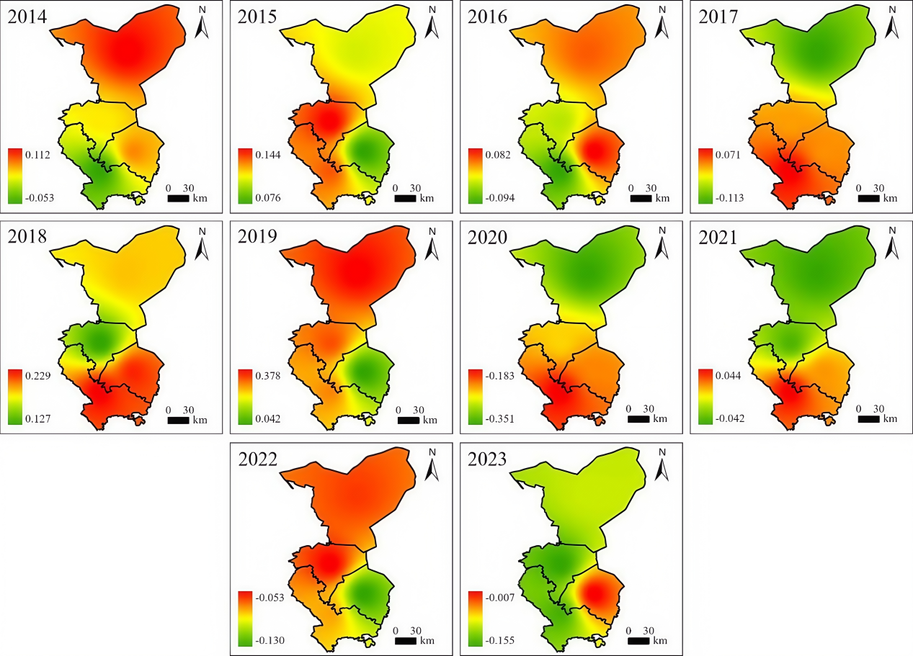
Fig. s1. Spatial Distribution of Annual Average SPI in Wuwei City, 2014–2023 Figure 12: Spatial Distribution of Annual SPI in Wuwei City, 2014-2023.
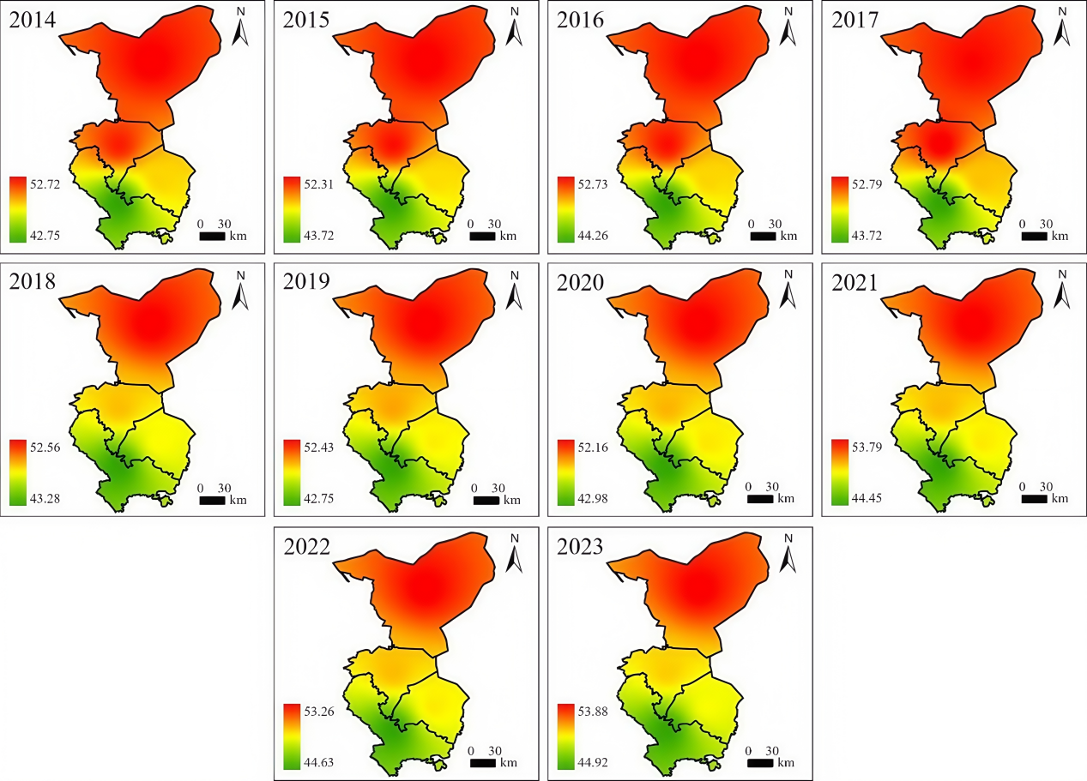
Fig. s2. Spatial Distribution of Annual Mean THI in Wuwei City, 2014-2023.

Fig. s3. Heatmap of Correlation Between Mortality Rates in the Study Population of Wuwei City and Pollutants and Meteorological Factors, 2014–2023 Figure 3 Correlation Heat Map of Mortality Rates in the Study Population of Wuwei City with Pollutants and Meteorological Factors, 2014–2023.
Fig. s4. 3D visualization of SPI impacts on population mortality across high, medium, and low ecological vulnerability levels.
Fig. s5. Cumulative lag effect diagram of SPI on population mortality in high ecological vulnerability levels.
Fig. s6. Cumulative lag effect diagram of SPI on population mortality in medium ecological vulnerability levels.

Fig. s7. Cumulative lag effect diagram of SPI on population mortality in low ecological vulnerability levels.
Fig. s8. 3D visualization of THI effects on mortality across high, medium, and low ecological vulnerability levels.
Fig. s9. Cumulative lag effect diagram of THI on mortality in high ecological vulnerability level.

Fig. s10. Cumulative lag effect diagram of THI on mortality in medium ecological vulnerability level.

Fig. s11. Cumulative lag effect diagram of THI on mortality in low ecological vulnerability level.

