The Biopsychosocial-Economic Impact of Workplace Racism on Black Professionals in the UK: A Mixed Methods Investigation

Quantitative Analysis of Workplace Racism Survey Results

Participants
A total of 53 employees participated in the workplace racism survey. The sample included respondents across a range of age groups and ethnic backgrounds. The age distribution of respondents was broad, with the largest clusters in the middle-age ranges (10 respondents each in their 40s and 50s, comprising about 24% of the sample each) and fewer participants in the youngest (20s: 3 respondents) and oldest (60s: 3 respondents) categories. In total, 41 out of 53 respondents provided their age group (this question was optional). The ethnic composition was predominantly Black – approximately 79.6% of those who reported ethnicity identified as Black (39 out of 49 respondents who answered the question). Smaller proportions of participants identified as Mixed ethnicity (~8%), White (~4%), Asian (~2%), or Other (~4%), and one individual (2%) preferred not to state their ethnicity. Respondents also reported a variety of job roles in the open-ended question on occupation. Many held roles in the education sector (e.g., school teachers, lecturers, professors, and department heads), while others included positions such as a retail customer service assistant. (All 53 participants answered the core survey questions, though response counts for optional demographic questions were slightly lower, as noted above.)

Survey Structure
The survey consisted of 15 questions in total, encompassing multiple question formats. There were four open-ended questions that allowed participants to provide written answers: these included items asking for the respondent’s job role, invitations to describe any racist incidents they had experienced or witnessed, and a question soliciting suggestions for changes to improve workplace inclusiveness. In addition, there were seven closed-ended questions with fixed-choice responses (mostly yes/no type items, with some questions offering a third option like “Not Sure” or “Sometimes”). These categorical questions gathered information on personal experiences of racism, witnessing of racist incidents, comfort in reporting such incidents, the presence of anti-racism policies, participation in anti-racism training, observations of consequences for racist behavior, and perceptions of management’s seriousness about racism. The survey also included two Likert-scale questions that asked respondents to rate aspects of their workplace on a 5-point scale. Specifically, one Likert item asked about the perceived inclusiveness of the workplace culture (with 1 = “Not inclusive” and 5 = “Very inclusive”), and another asked about the perceived effectiveness of the organization’s anti-racism policies (with 1 = “Not effective” and 5 = “Very effective”). Finally, the survey concluded with two demographic questions (both optional) asking respondents to select their age group and ethnicity from given categories. Together, these 15 questions provided a mix of quantitative measures and qualitative insights, suitable for a comprehensive analysis of workplace racism perceptions.

Methods
The survey data were entered into a database and analyzed using IBM SPSS Statistics (version 28) and equivalent statistical tools. Descriptive statistics were utilized to summarize the data. For categorical survey questions (e.g., yes/no questions or multiple-choice items), frequency counts and percentages were calculated to illustrate the proportion of respondents selecting each response option. For the Likert-scale rating questions, the mean (average score) and standard deviation (variability) were computed for each item to summarize the central tendency and spread of the responses. These descriptive analyses provide an overview of the general trends in the data (for example, the average perceived inclusiveness rating and the percentage of respondents who have experienced racism at work).
In addition to descriptive analysis, a one-way Analysis of Variance (ANOVA) was conducted to test for differences in key perception measures across different demographic groups. Specifically, ANOVA tests were used to determine whether respondents’ perceptions of workplace racism and inclusiveness differed significantly by categories such as ethnicity or age group. For example, one ANOVA compared the mean inclusiveness ratings between groups of respondents of different ethnic backgrounds. In this test, the categorical factor (independent variable) was the self-identified ethnicity of respondents, and the dependent variable was the numerical inclusiveness rating (1–5). Similarly, another ANOVA examined differences in inclusiveness ratings across the age-group categories. The ANOVA technique assesses whether observed differences in group means are statistically significant, taking into account within-group variability. For all statistical tests, a significance level of α = 0.05 was used (i.e., differences with p < 0.05 were considered statistically significant). The results of these analyses (F-statistics, degrees of freedom, and p-values) are reported in the Results section below. All analyses were performed in a rigorous, quantitative manner; no qualitative content analysis was conducted on the open-ended responses for the purposes of this report, as the focus is on quantitative results.

Results
Demographics and Sample Characteristics: Of the 53 respondents, a majority provided demographic information. The age and ethnicity distributions of the sample are visualized in Figure 1. As noted, the largest age categories were 40–49 and 50–59 years (each comprising roughly one-quarter of respondents who reported their age). In terms of ethnicity, the survey population was overwhelmingly Black (about four-fifths of respondents), with the remainder of the sample divided among Mixed, White, Asian, and Other ethnicities (each of those smaller groups representing roughly 2–8% of respondents). This context is important to keep in mind when interpreting other results, as the perceptions captured by the survey largely reflect the experiences of Black professionals.
Prevalence of Experienced and Witnessed Racism: A substantial proportion of participants reported encountering racism in their workplace. 73.6% of respondents (39 out of 53) indicated that they have personally experienced racism at work, whereas 26.4% (14 out of 53) answered that they have not experienced such racism. Similarly, 69.8% of respondents (37 out of 53) reported that they have witnessed racist incidents in their workplace (such as seeing a colleague being subjected to racist behavior), while 30.2% (16 respondents) had not witnessed any such incidents. These figures suggest that racist experiences are common among the surveyed employees. In an open-ended follow-up, those who had experienced or witnessed racism were asked to describe the situation, yielding 42 written responses detailing various incidents (qualitative data not quantified here). This indicates that many participants chose to provide additional details about the racist behavior they observed or endured.
Comfort in Reporting Incidents: When asked “Do you feel comfortable reporting racist incidents at your workplace?” responses were mixed and tended toward discomfort. Only 35.8% of participants (19 individuals) answered “Yes”, meaning roughly one-third would feel comfortable reporting a racist incident. In contrast, 43.4% answered “No,” indicating that a larger fraction would not feel comfortable reporting such issues. The remaining 20.8% selected “Not Sure,” reflecting uncertainty about reporting. This distribution is illustrated in the survey results and highlights a potential lack of confidence in reporting mechanisms or fear of repercussions. In summary, fewer than half of respondents are comfortable reporting racism, which may have implications for underreporting of incidents.
Organizational Policies and Training: Respondents were asked about the presence and effectiveness of anti-racism measures in their workplace. First, they answered “Are there clear anti-racism policies at your workplace?” 45.3% of the respondents (24 out of 53) said “Yes,” indicating that less than half could affirm the existence of clear anti-racism policies. 18.9% (10 respondents) answered “No,” and the remaining 35.8% (19 respondents) said “Not Sure.” Thus, a significant number of employees either did not perceive a clear policy or were unaware of one. These results are visualized in Figure 2 (top-left pie chart). Participants who indicated that a policy exists were asked to rate how effective they believe these policies are. On a Likert scale from 1 (Not effective) to 5 (Very effective), the average effectiveness rating was 2.08 (SD = 1.21), which is very low on the 5-point scale. In fact, the most common response for policy effectiveness was 1 (“Not effective”) – chosen by 48% of respondents – suggesting that nearly half of those who answered felt the policies have no real effect. Only a small minority (around 4%) rated the policies as very effective (5 out of 5). This distribution is shown in Figure 2 (bar chart). Finally, the survey asked “Have you attended any anti-racism training at work?” to gauge exposure to organizational training programs. Here, 41.5% of respondents (22 individuals) answered “Yes,” they had attended training, whereas 58.5% (31 individuals) answered “No.” In other words, fewer than half of the surveyed employees had participated in anti-racism training, as reflected in the pie chart of Figure 2 (bottom). This indicates that such training was not universal in their workplaces.
Workplace Culture and Management Responses: The survey also assessed perceptions of the workplace culture’s inclusiveness and management’s handling of racism. In response to “How inclusive do you feel your workplace culture is? (1 = Not inclusive, 5 = Very inclusive)”, answers spanned the full range of the 1–5 scale, but were generally skewed toward the lower end. The mean inclusiveness rating was 2.63 (SD = 1.34) out of 5, suggesting that on average respondents felt their workplace was below moderately inclusive. In fact, the single most common rating was 3 (“moderately” inclusive) – about 30.8% of respondents chose this middle value – and the next most common response was 1 (“Not inclusive”), given by 26.9% of respondents (see Figure 3, top bar chart, for the full distribution of ratings). Very few participants rated their workplace a 5 (only 13.5% gave the highest inclusiveness score). These results indicate that a majority of respondents perceived their workplace culture as only slightly to moderately inclusive at best.
The survey further inquired about accountability and leadership stance by asking two yes/no questions. The first asked “Have you ever seen a colleague face consequences for racist behavior?” – essentially whether racist acts are being disciplined. Here, only 18.9% of respondents (10 individuals) answered “Yes,” meaning they had witnessed a co-worker experience consequences (such as reprimand or disciplinary action) for racist behavior. In contrast, the majority, 64.2% (34 respondents), answered “No,” they had not seen any such consequences occur, and an additional 15.1% (8 respondents) responded “Not Sure.” This breakdown (illustrated in Figure 3, bottom-left pie chart) suggests that formal consequences for racist conduct may be rare or not visible to employees, as over six in ten respondents had never observed any punitive action for racism in their workplace. The second question asked “Do you think management takes racism seriously?” to capture perceptions of leadership commitment. In response, only 21.6% of participants (11 out of 51 who answered) said “Yes,” indicating that roughly one-fifth believe their management truly takes racism seriously. About 49.0% answered “Sometimes,” implying a lukewarm or inconsistent stance by management, and 29.4% (15 respondents) responded “No,” perceiving that their management does not take racism seriously at all. This distribution is shown in Figure 3 (bottom-right pie chart). The fact that half of the respondents selected “Sometimes” suggests that many see management’s commitment to anti-racism as conditional or partial, rather than unequivocal.
ANOVA – Differences Across Groups: One-way ANOVA tests were performed to explore whether these perceptions differed significantly across demographic groups. The analysis revealed a statistically significant difference in perceived inclusiveness ratings by ethnicity. Specifically, the mean inclusiveness score differed among the ethnic groups (F(3, 43) = 15.13, p < 0.001). Black respondents reported the lowest average inclusiveness rating (mean ≈ 2.03 on the 5-point scale, with a standard deviation of 0.87). In comparison, the few White respondents in the sample had a much higher mean inclusiveness rating (mean = 4.00), and those identifying as Mixed or Other ethnicities also reported higher average inclusiveness (mean scores roughly 3.75 and 5.00, respectively, in those small subgroups). Although the non-Black groups were small in number, this result quantitatively indicates that Black employees perceived markedly lower inclusiveness in their workplace culture on average, compared to their colleagues of other ethnic backgrounds. A similar pattern emerged across age groups as well. A one-way ANOVA by age category showed significant differences in inclusiveness ratings (F(5, 35) = 32.95, p < 0.001). Younger respondents tended to give much lower inclusiveness ratings: for instance, respondents in their 20s and 30s reported mean inclusiveness around 1.0 (i.e., “Not inclusive”), whereas those in older groups reported progressively higher averages (participants in the 50–59 group averaged around 2.5, and the oldest category or unclear ages averaged about 3.1). In summary, these statistical tests confirm that perceptions of inclusiveness varied significantly by demographic group in this sample. Ethnic minority status (particularly being Black in this context) and younger age were associated with more negative views of workplace inclusivity, whereas the few respondents who were older or from non-Black ethnic groups reported more positive (or less negative) perceptions on average. No other ANOVA analyses were conducted on the yes/no questions, since those were categorical outcomes; the ANOVA was specifically applied to Likert-scale rating variables. All results reported are based on the quantitative data collected, and no further interpretation is provided beyond these numeric findings.

Figures

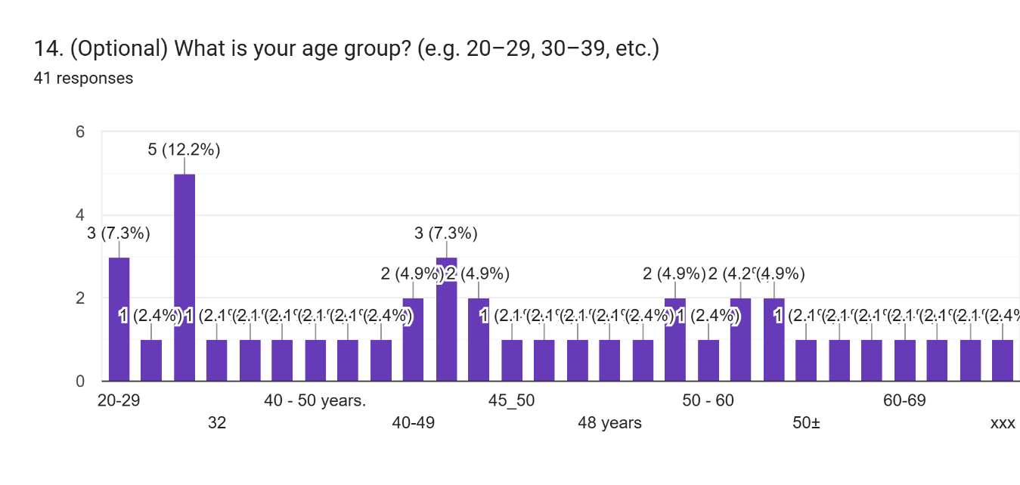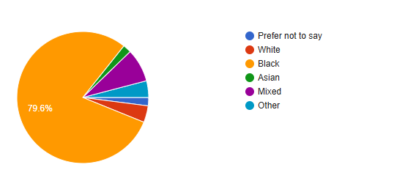
Figure 1. Age and Ethnicity Distribution of Respondents. The bar chart (top) shows the age group breakdown of the 41 respondents who provided their age. The largest groups were ages 40–49 and 50–59 (10 respondents each, ~24% each of those who answered), while the smallest groups were 20–29 and 60–69 (3 respondents each, ~7% each). The pie chart (bottom) shows the ethnic composition of the 49 respondents who reported their ethnicity. The sample was predominantly Black (~79.6% of respondents), with smaller segments identifying as Mixed (8.2%), White (4.1%), Other (4.1%), Asian (2.0%), or preferring not to say (2.0%).
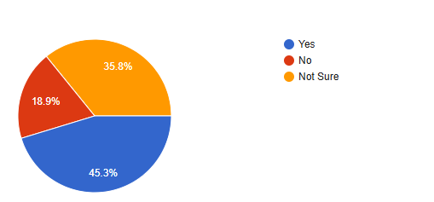
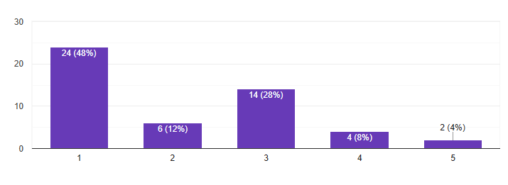

Figure 2. Organizational Anti-Racism Policies and Training Responses. This figure summarizes three survey questions related to workplace policies and training. In the pie chart (top left), 45.3% of respondents answered “Yes” to having clear anti-racism policies at work (blue slice), 18.9% responded “No” (orange slice), and 35.8% were “Not Sure” (gray slice), indicating many employees are unaware of or do not perceive clear policies. The bar chart (top right) displays the effectiveness ratings of those policies on a 1–5 scale: notably, 48% of respondents rated the policies as “1 – Not effective,” and the average rating was low (around 2 out of 5), reflecting a view that current policies are not very effective. The pie chart (bottom) shows that 41.5% of respondents reported having attended an anti-racism training at work (blue), whereas 58.5% had not (red), meaning a majority had no training exposure.

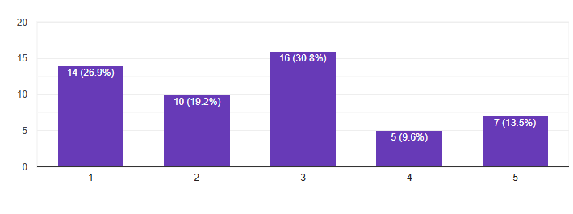

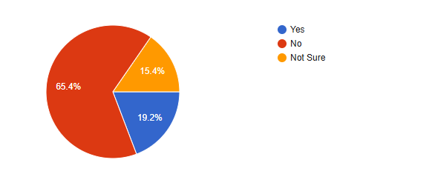
Figure 3. Perceptions of Workplace Inclusiveness and Management Response. The bar chart (top) illustrates responses to the inclusiveness of workplace culture (1 = not inclusive, 5 = very inclusive). The distribution is skewed toward lower ratings: for example, 26.9% of respondents rated inclusiveness as 1 (far left bar) and only 13.5% gave the highest rating of 5, with the mean around 2.6. The pie chart (bottom left) shows that only 19% of employees had seen a colleague face consequences for racist behavior (blue “Yes” slice), versus 65% who had not (red “No” slice) and 15% who were unsure (orange). The pie chart (bottom right) indicates that about 22% of respondents believed management “Yes” takes racism seriously (blue), roughly 49% answered “Sometimes” (orange), and 29% answered “No” (red), suggesting that many view management’s commitment as inconsistent or lacking.

