Pelophylax kurtmuelleri in Croatia: genetic evidence supports a native status in the Konavle Field and Neretva Delta
Matej Vucić1*, Marina Blažević2, Dušan Jelić2, Frederic Grandjean3, Marija Krajnović2, Goran Slivšek4, Karmela Adžić5, Goran Klobučar1

Supplementary material

Table S1. BOLD and GenBank accession numbers of all obtained sequences from this study. (in process, will be added)
Sequence | GenBank accession number | BOLD accession number
SAI-1
PEL1
PEL2
PEL3
PEL4
PEL5
PEL7
PEL8
PEL9
PEL10
PEL11
PEL12
PEL13
PEL14
PEL15
PEL16
PEL17
PEL18
PEL19
PEL20
PEL21
PEL22
PEL23
PEL24
PEL25
PEL26
PEL27
PEL28
PEL29
PEL30
PEL31
PEL32
PEL33
PEL34
PEL35
COI
PEL1
PEL2
PEL3
PEL4
PEL5
PEL7
PEL8
PEL9
PEL10
PEL11
PEL12
PEL13
PEL14
PEL15
PEL16
PEL17
PEL18
PEL19
PEL20
PEL21
PEL22
PEL23
PEL24
PEL25
PEL26
PEL27
PEL28
PEL29
PEL30
PEL31
PEL32
PEL33
PEL34
ND2
PEL1
PEL2
PEL3
PEL4
PEL5
PEL7
PEL8
PEL9
PEL10
PEL11
PEL12
PEL13
PEL15
PEL16
PEL17
PEL18
PEL19
PEL20
PEL21
PEL22
PEL23
PEL24
PEL25
PEL26
PEL28
PEL29
PEL30
PEL31
PEL32
PEL33
PEL34

Table S2. GenBank and BOLD accession numbers of all additional sequences used in this study.
Species | GenBank Accession number | BOLD accession number
SAI-1
Pelophylax kurtmuelleri | MH038019
 | MH038018
 | MH038017
 | MH038016
 | MH038013
 | MH038012
 | MH038011
 | MH038010
 | MW296110
 | MW296109
 | MW296108
 | MW296107
 | MW296106
 | MF667640
 | MF667639
 | MF667638
 | MF667637
 | MF667636
 | MF667635
 | MF667634
 | KY424540
 | MN497957
 | FN432367
 | FN432366
 | MH038019
 | MH038018
 | MH038016
 | MH038013
 | MH038012
 | MW296109
 | MW296108
 | MF667639
 | MF667638
Pelophylax ridibundus | PP210087
 | PP210086
 | PP210088
 | KX503320
 | KX503321
 | KX503322
 | OL702781
 | OL702780
 | MN497958
 | JQ965521
Pelophylax lessonae | MF094367
 | MF094368
Pelophylax shqipericus | MH038015
 | MH038014
 | MW296105
 | MW296102
COI
Pelophylax kurtmuelleri | MT881786 | GBMNF3350-22
 | JN871599.1
Pelophylax ridibundus | MN993187 | BCAHF082
 | HQ954782 | FBHER133-10
 | KP697821 | FBHER216-14
 | KP697877 | FBHER220-14
 | KP697907 | FBHER224-14
 | KP697880 | FBHER228-14
 | MN993187.1
 | HQ954782.1
 | KP697946.1
Pelophylax lessonae | MN993185 | BCAHF016-17
 | MN993184 | BCAHF193-19
 | HM901965 | FBHER061-09
 | KP697908 | FBHER207-14
 | KP697848 | FBHER208-14
 | KP697868 | FBHER209-14
 | KP697934 | FBHER215-14
Pelophylax shqipericus |  | GBMTG4326-16
ND2
Pelophylax kurtmuelleri | OP820697
 | OP820684
 | OP820651
 | OP820692
 | OP820693
 | OP820694
 | OP820691
 | OP820690
 | OP820689
 | OP820686
 | OP820685
 | OP820680
 | OP820670
 | OP820668
 | OP820669
 | OP820656
 | OP820650
 | OP820649
Pelophylax ridibundus | PV177133
 | PV177132
 | PV177130
 | PP335555
 | OP794108
 | OP794100
 | OP794102
Pelophylax lessonae | PV177145
 | PV177144
 | KY129865
 | PV177139
Pelophylax shqipericus | OP794097
 | OP794096
 | OP794095
 | OP794094
 | OP794093

Table S3. Intraspecific uncorrected p-distances of COI sequences of P. kurtmuelleri specimens from this study
Table S4. Intraspecific uncorrected p-distances of COI sequences of P. kurtmuelleri specimens from this study and including publicly available sequences.
*Tables S3 and S4 are provided in separate Excell tables.
Fig S1. Gel electrophoresis of the SAI-1 nuclear marker on all analysed samples.
Fig S2. Detailed view of the gel electrophoresis of the SAI-1 nuclear marker on three samples.
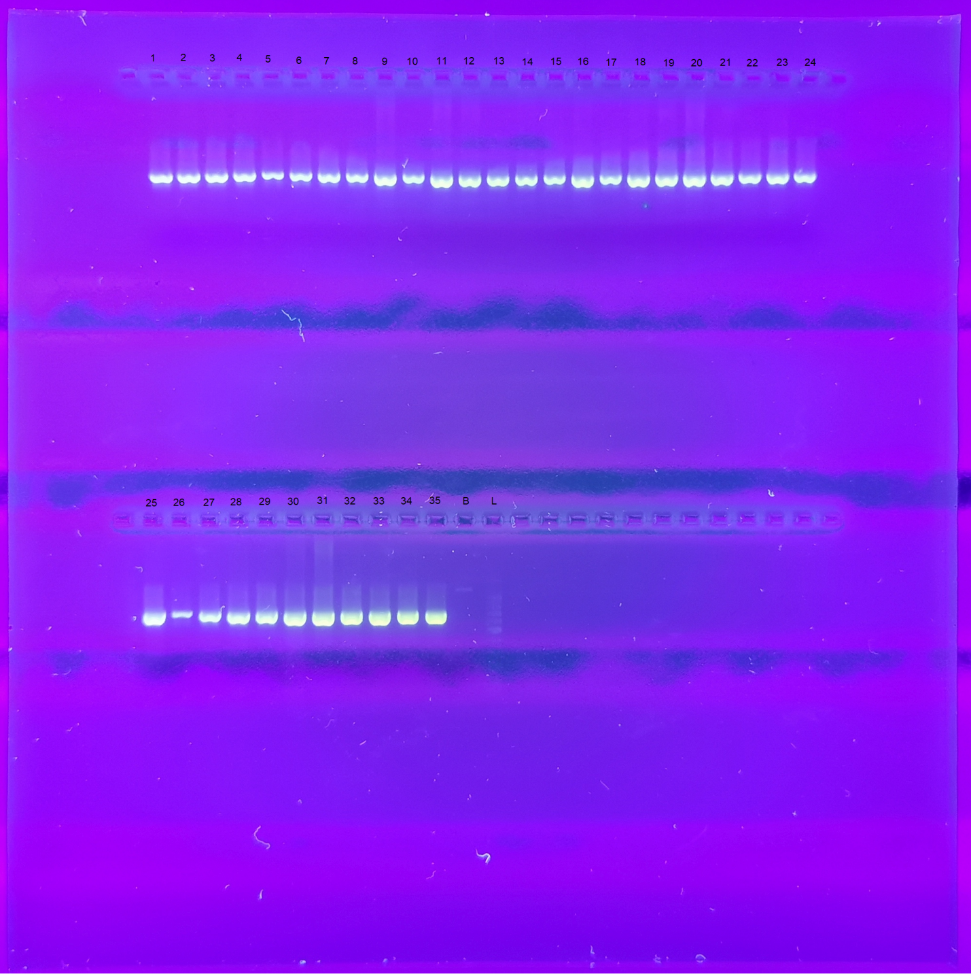
Fig S1. Gel electrophoresis of the SAI-1 nuclear marker on all analysed samples.
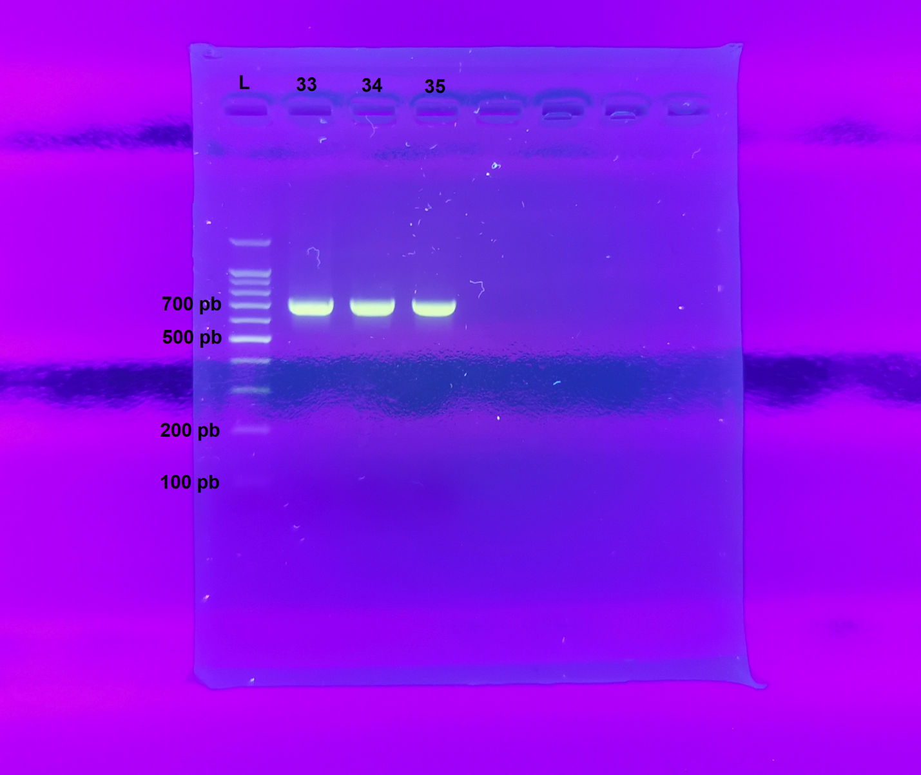
Fig. S2. Detailed view of the gel electrophoresis of the SAI-1 nuclear marker on three samples.

