Spatially Explicit Subpixel-Based Study on the Expansion of Artificial Impervious Surfaces and Its’ Impacts on Soil Organic Carbon
Yan Yan ª, Weige Zhang ^{a*}, Yunfeng Hu ^{b}, Huaipeng Liu ª, Xiaoping Zhang ª and Yongxin Zhang ^{c}
ª School of Land and Tourism, Luoyang Normal University, Luoyang 471934, Henan Province, China
^{b} Institute of Geographic Sciences and Natural Resources Research, Chinese Academy of Sciences, Beijing 100101, China
^{c} School of Information Technology, Luoyang Normal University, Luoyang 471934, Henan Province, China
* Corresponding author. W. Zhang; E-mail address: zhangwg@lynu.edu.cn

Table S1. Soil organic carbon densities (SOCD) under artificial impervious surface (AIS) in different cities
City | Climate | Sample size | Soil depth  (cm) | SOCD±S.E.  （kg C m⁻²） | References
Seoul | Temperate monsoon climate | 29 | 0-100 | 2.7±0.3 | (Bae and Ryu, 2020)
Seoul | Temperate monsoon climate | 29 | 0-500 | 16.9±1.9 | (Bae and Ryu, 2020)
Lahti | Boreal climatic zone | 13 | 0-10 | 0.63 | (Lu et al., 2020)
Lahti | Boreal climatic zone | 13 | 45-55 | 0.37 | (Lu et al., 2020)
Lahti | Boreal climatic zone | 13 | 0-100 | 1.2 | (Lu et al., 2020)
New York | Humid continental to humid subtropical climate | 8 | 0-30 | 2.9±2.6 | (Cambou et al., 2018)
New York | Humid continental to humid subtropical climate | 8 | 30-100 | 6.7±6.1 | (Cambou et al., 2018)
New York | Humid continental to humid subtropical climate | 36 | 0-15 | 2.29±0.82 | (Raciti et al., 2012)
Auburn | Subtropical monsoonal humid climate | 4 | 10-20* | 1.57±0.36-  2.3±0.4 | (Majidzadeh et al., 2018)
Auburn | Subtropical monsoonal humid climate | 4 | 20-30 | 0.93 ± 0.23 | (Majidzadeh et al., 2018)
Paris | Temperate oceanic climate | 7 | 0-30 | 3.4±1.2 | (Cambou et al., 2018)
Leicester | Temperate climate | 12 | 40-100 | 6.7 | (Edmondson et al., 2012)
Leicester | Temperate climate | 5 | 15-100 | 13.5 | (Edmondson et al., 2012)
Shenzhen | Subtropical marine climate | 4 | 0-20 cm | 0.95 | (Dou et al., 2021)
Guangzhou | Subtropical marine climate | 5 | 0-20 cm | 1.92 | (Dou et al., 2021)
Yixing | Northern subtropical monsoon climate | 7 | 0-20 | 2.45±1.13 | (Wei et al., 2014a)
Nanjing | Northern subtropical monsoon climate | 14 | 0-20 | 2.35±0.52 | (Wei et al., 2014b)
Kaifeng | Continent monsoon climate | 3 | 0-100 | 8.88±3.33 | (Sun et al., 2010)
Urumqi | Arid climate | 11 | 0-20 | 1.71±0.20 | (Yan et al., 2015)
Urumqi | Arid climate | 11 | 20-40 | 1.43±1.43 | (Yan et al., 2015)
Urumqi | Arid climate | 11 | 40-60 | 1.30±0.16 | (Yan et al., 2015)
Urumqi | Arid climate | 11 | 60-80 | 0.86±0.16 | (Yan et al., 2015)
Urumqi | Arid climate | 11 | 0-80 | 5.36±0.51 | (Yan et al., 2015)

Table S2. Medium resolution remote sensing data used in this research. The multi-spectral bands of all data with 30-m resolution were used
Year | Sensor type | LANDSAT_SCENE_ID | date acquired | Cloud cover （%）
2000 | ETM+ | LE71230362000089SGS00 | 2000-03-29 | 0.00
2001 | ETM+ | L71124036_03620010510 | 2001-05-10 | 0.00
2002 | ETM+ | LE71240362002245EDC00 | 2002-09-02 | 0.00
2003 | ETM+ | LE71240362003104EDC00 | 2003-04-14 | 0.00
2004 | TM | LT51230362004204BJC02 | 2004-07-22 | 0.00
2005 | TM | LT51230362005174BJC00 | 2005-06-23 | 0.00
2006 | TM | LT51230362006177BJC00 | 2006-06-26 | 0.00
2007 | TM | LT51240362007139IKR00 | 2007-05-19 | 2.00
2008 | TM | LT51230362008135BJC00 | 2008-05-14 | 0.00
2009 | TM | LT51230362009265IKR00 | 2009-09-22 | 1.00
2010 | TM | LT51240362010131BJC02 | 2010-05-11 | 0.00
2011 | TM | LT51240362011134BJC00 | 2011-05-14 | 0.00
2013 | OLI | LC81230362013132LGN03 | 2013-05-12 | 0.00
2014 | OLI | LC81230362014119LGN01 | 2014-04-29 | 0.12
2015 | OLI | LC81230362015250LGN01 | 2015-09-07 | 0.07
2016 | OLI | LC81230362016125LGN01 | 2016-05-04 | 0.02
2017 | OLI | LC81230362017255LGN00 | 2017-09-12 | 0.03
2018 | OLI | LC81230362018162LGN00 | 2018-06-15 | 0.02
2019 | OLI | LC81230362019165LGN00 | 2019-06-20 | 0.06
2020 | OLI | LC81230362020104LGN00 | 2020-04-13 | 0.44

Table S3. Detailed information on soil samples and SOC density of urban soils within 100cm depth in Kaifeng, China. Acquired from Sun et. al., 2010
Site ID | Latitude | Longitude | Land cover | 100cm SOCD (Kg C m⁻²)
Site ID | DD | DD | Land cover | Range | Mean
1 | 34.82 | 114.37 | Urban lawn | 4.38-15.14  (N=17) | 10.24
2 | 34.81 | 114.35 | Urban lawn | 4.38-15.14  (N=17) | 10.24
3 | 34.81 | 114.36 | Urban lawn | 4.38-15.14  (N=17) | 10.24
4 | 34.80 | 114.30 | Urban lawn | 4.38-15.14  (N=17) | 10.24
5 | 34.81 | 114.37 | Urban lawn | 4.38-15.14  (N=17) | 10.24
6 | 34.81 | 114.31 | Urban lawn | 4.38-15.14  (N=17) | 10.24
7 | 34.82 | 114.32 | Urban lawn | 4.38-15.14  (N=17) | 10.24
8 | 34.79 | 114.32 | Urban lawn | 4.38-15.14  (N=17) | 10.24
9 | 34.79 | 114.32 | Urban lawn | 4.38-15.14  (N=17) | 10.24
10 | 34.78 | 114.37 | Shrubs/urban lawn | 4.38-15.14  (N=17) | 10.24
11 | 34.80 | 114.37 | Parterre | 4.38-15.14  (N=17) | 10.24
12 | 34.79 | 114.30 | Urban forest | 4.38-15.14  (N=17) | 10.24
13 | 34.78 | 114.31 | Urban forest | 4.38-15.14  (N=17) | 10.24
14 | 34.79 | 114.40 | Urban forest | 4.38-15.14  (N=17) | 10.24
15 | 34.80 | 114.28 | Urban forest | 4.38-15.14  (N=17) | 10.24
16 | 34.81 | 114.28 | Urban forest | 4.38-15.14  (N=17) | 10.24
17 | 34.80 | 114.33 | Urban forest | 4.38-15.14  (N=17) | 10.24
18 | 34.82 | 114.32 | Bare land | 12.17-15.23  (N=5) | 13.59
19 | 34.77 | 114.32 | Bare land | 12.17-15.23  (N=5) | 13.59
20 | 34.77 | 114.36 | Bare land | 12.17-15.23  (N=5) | 13.59
21 | 34.82 | 114.35 | Bare land | 12.17-15.23  (N=5) | 13.59
22 | 34.80 | 114.35 | Bare land | 12.17-15.23  (N=5) | 13.59
23 | 34.79 | 114.40 | Urban road | 6.88-12.72  (N=3) | 8.88
24 | 34.78 | 114.34 | Building | 6.88-12.72  (N=3) | 8.88
25 | 34.77 | 114.29 | Building | 6.88-12.72  (N=3) | 8.88
26 | 34.82 | 114.27 | Cropland | 5.83-14.07  (N=7) | 8.88
27 | 34.76 | 114.39 | Cropland | 5.83-14.07  (N=7) | 8.88
28 | 34.75 | 114.40 | Cropland | 5.83-14.07  (N=7) | 8.88
29 | 34.74 | 114.27 | Cropland | 5.83-14.07  (N=7) | 8.88
30 | 34.78 | 114.30 | Cropland | 5.83-14.07  (N=7) | 8.88
31 | 34.82 | 114.41 | Cropland | 5.83-14.07  (N=7) | 8.88
32 | 34.81 | 114.39 | Cropland | 5.83-14.07  (N=7) | 8.88

Table S4. SOC density of vegetated soils within 100cm depth in 1994 and 2006 of Kaifeng, China
Site ID | 1994 (kg C m⁻²) | 2006 (kg C m⁻²)
1 | 6.21 | 7.98
2 | 4.05 | 11.24
3 | 5.39 | 11.32
4 | 4.13 | 6.33
5 | 11.40 | 11.79
6 | 2.36 | 9.99
7 | 5.19 | 6.01
8 | 10.61 | 14.98
Mean | 6.17 | 9.96
Annual growth rate | 4.07(%)
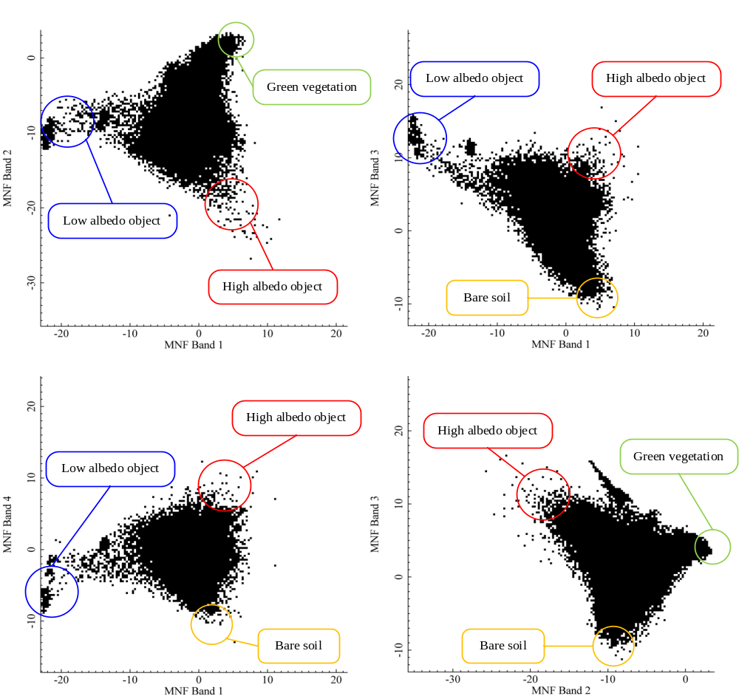
Fig. S1 2D scatter plots generated by first 4 MNF bands. The endmembers can be select from the top of triangle formed by image spaces. Four group of endmembers (i.e., low albedo object, high albedo object, green vegetation and bare land) were selected in this study
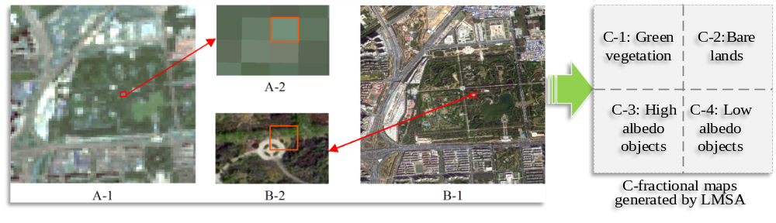
Fig. S2 Diagram introducing concept of Linear Mixture Spectral Analysis model. (A-1: Landsat8 OLI image, acquired on September 18, 2020, with 30m resolution; A-2: A pixel of Landsat 8 image; B-1: Worldview Ⅲ data, acquired on May 26, 2020 with 0.5m resolution; B-2: Worldview Ⅲ image within a rectangular region of 30m×30m area; C: The composition of land covers in a pixel in an ideal state)
Fig. S3 Sampling plots for accuracy assessments in this study. (a) – (e) are the geographical distribution of sampling plots generated by the aggregated artificial impervious surface, which with 120 ×120 m² area; (f) is the local zoomed aggregated artificial impervious surface area from (e), with 120-m resolution, (f-1) and (f-2) is two random sampling plots pick from 2020, the high-resolution image in this map is acquired from Google Earth in 2020
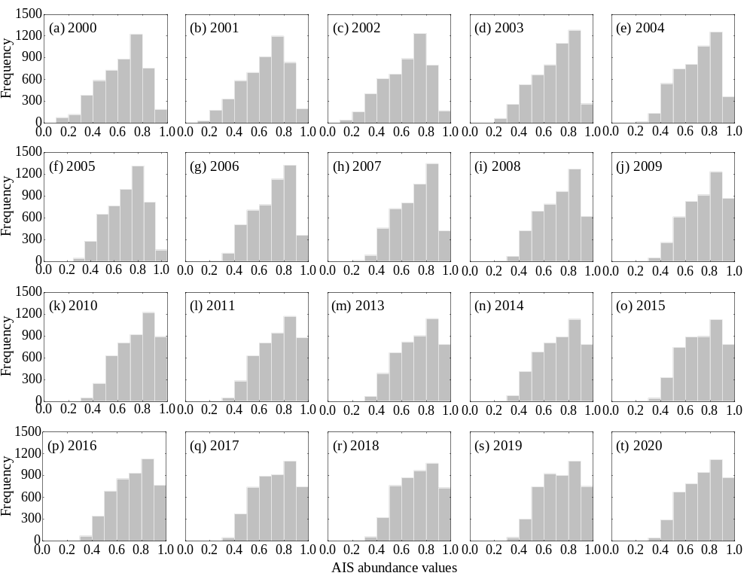
Fig. S4 Histograms of fractional AIS value in Kaifeng from 2000-2020. Histogram statistics for abundance values can draw the changes in inner structure of AIS. From 2000 to 2020, the frequency of lower AIS abundance values gradually decreases, while the higher values gradually increase. Specifically, in 2000, the mode (peak value) of the AIS component was 0.7-0.8 and shifted to the right in 2003, which was 0.8-0.9 and kept this distribution until 2020. Meanwhile, AIS component values lower than 0.3 completely disappeared after 2006, and values higher than 0.9 continued to grow after 2015. However, the highest component values (0.9-1.0) decreased slightly from 2013 to 2015 rather than increasing.
Fig. S5 Comparison on the area of a pixel between our study and GAIA data

References:
Bae, J., Ryu, Y., 2020, High soil organic carbon stocks under impervious surfaces contributed by urban deep cultural layers, Landscape and Urban Planning 204:103953.
Cambou, A., Shaw, R. K., Huot, H., Vidal-Beaudet, L., Hunault, G., Cannavo, P., Nold, F., Schwartz, C., 2018, Estimation of soil organic carbon stocks of two cities, New York City and Paris, Science of The Total Environment 644:452-464.
Dou, X., Lu, M., Chen, L., 2021, Comparison on soil organic carbon and nitrogen dynamics between urban impervious surfaces and vegetation, Authorea.
Edmondson, J. L., Davies, Z. G., McHugh, N., Gaston, K. J., Leake, J. R., 2012, Organic carbon hidden in urban ecosystems, Scientific Reports 2.
Lu, C., Johan, K. D., M., S. H., 2020, Soil sealing causes substantial losses in C and N storage in urban soils under cool climate, Science of The Total Environment 725:138369.
Majidzadeh, H., Lockaby, B. G., Price, R., Governo, R., 2018, Soil carbon and nitrogen dynamics beneath impervious Surfaces, Soil Science Society of America Journal 82(3):663-670.
Raciti, S. M., Hutyra, L. R., Finzi, A. C., 2012, Depleted soil carbon and nitrogen pools beneath impervious surfaces, Environmental Pollution 164:248-251.
Sun, Y., Zhou, Q., Xie, X., Liu, R., 2010, Spatial, sources and risk assessment of heavy metal contamination of urban soils in typical regions of Shenyang, China, Journal of Hazardous Materials 174(1):455-462.
Wei, Z., Wu, S., Yan, X., Zhou, S., 2014a, Density and stability of soil organic carbon beneath impervious surfaces in urban areas, in: PloS one, pp. e109380.
Wei, Z. Q., Wu, S. H., Zhou, S. L., Li, J. T., Zhao, Q. G., 2014b, Soil Organic Carbon Transformation and Related Properties in Urban Soil Under Impervious Surfaces, Pedosphere 24(1):56-64.
Yan, Y., Kuang, W., Zhang, C., Chen, C., 2015, Impacts of impervious surface expansion on soil organic carbon – a spatially explicit study, Scientific Reports 5.

