Supplementary Materials

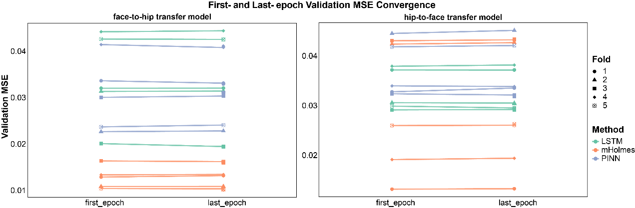
Supplementary Figure 1. Comparison of validation mean squared error (MSE) at the first epoch and the last epoch across five-fold cross-validation for LSTM, mHolmes, and PINN. The left panel shows the evolution of validation loss for the face-to-hip transfer model during training; the right panel shows the corresponding evolution for the hip-to-face transfer model. Results demonstrate that all models achieve stable convergence throughout training, with mHolmes exhibiting the lowest final validation MSE, indicating its superior and highly stable training convergence performance.

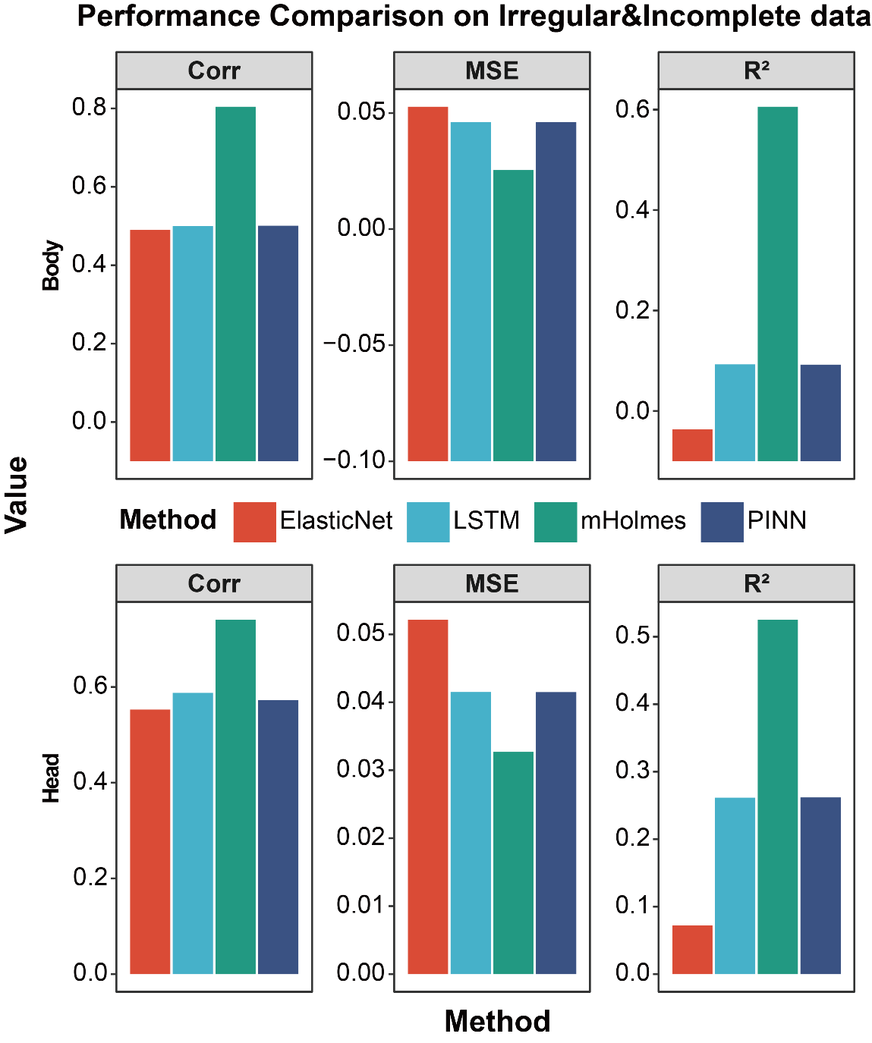
Supplementary Figure 2. External validation performance on irregular and incomplete data. The bar charts illustrate the generalization capability of four transfer learning models (ElasticNet, LSTM, mHolmes, and PINN) applied to independent Body (top row) and Head (bottom row) datasets. Performance is evaluated using Pearson correlation (Corr), MSE, and Coefficient of Determination (R²). Across both anatomical regions, mHolmes consistently outperforms baseline methods, exhibiting higher accuracy (Corr, R²) and lower error (MSE), thereby demonstrating superior robustness in handling irregular and sparse time-series data.

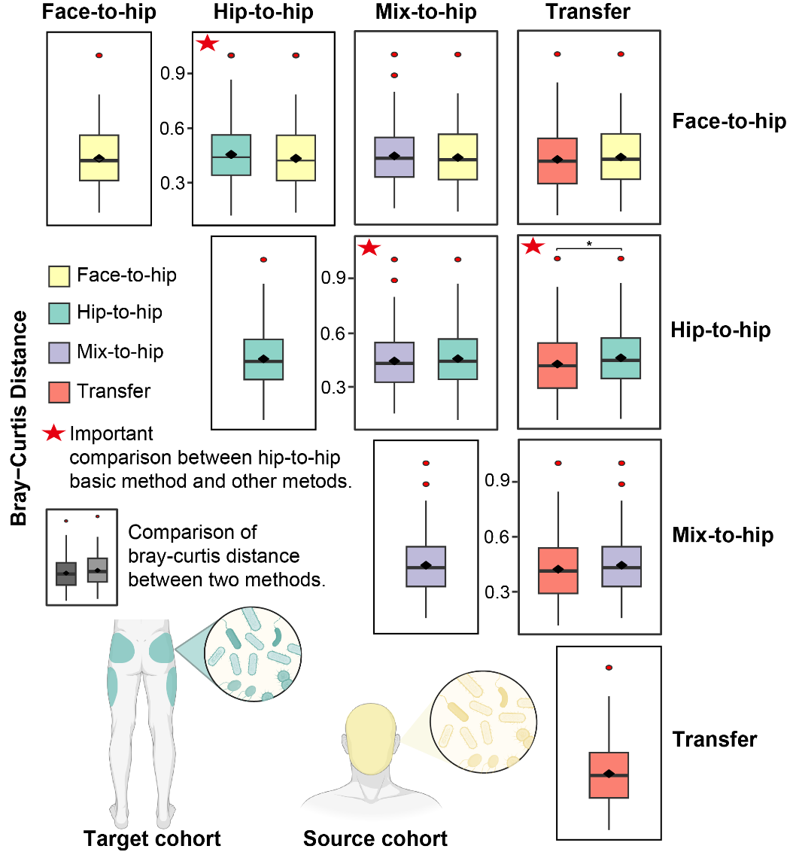
Supplementary Figure 3. Bray-Curtis (BC) dissimilarity was calculated between predicted and observed microbial community compositions within the hip validation cohort. Performance was assessed across four training strategies: Face-to-hip (trained on face data); Hip-to-hip (trained on hip data; baseline); Transfer (pre-trained on face data with subsequent fine-tuning on a hip subset); and Mix-to-Face (trained on a pooled dataset of face and hip fine-tuning cohorts). Lower BC values indicate higher similarity to the ground truth (greater ecological fidelity). Red stars denote important comparison with Hip-to-hip baseline (Wilcoxon rank-sum test; *P < 0.05, **P < 0.01, ***P < 0.001). Source and target cohort assignments are schematically illustrated in the adjacent panel.

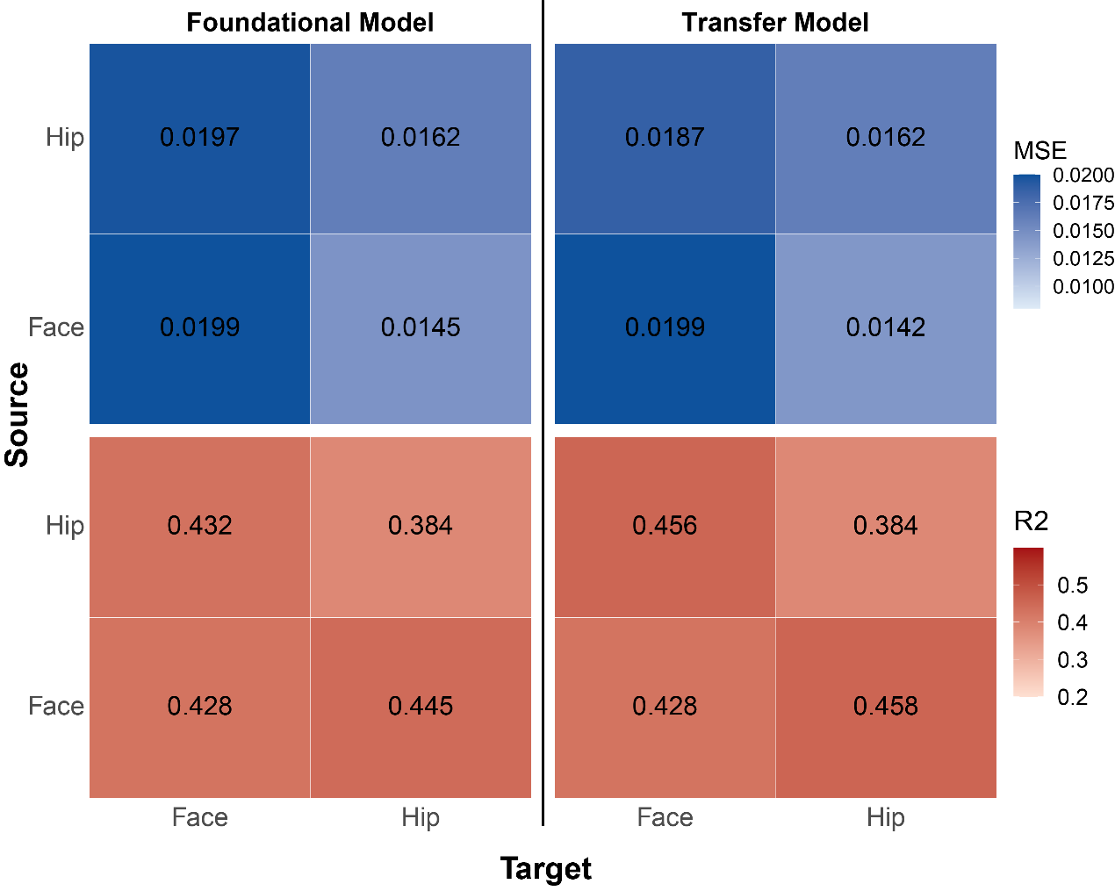
Supplementary Figure 4. Heatmap showing predictive performance of the foundational and transfer models across source-to-target body site combinations (mean values from five-fold cross-validation). Upper panel: validation MSE (lighter: lower error); lower panel: R² (darker: higher explanatory power). Rows indicate the source site (discovery cohort used for pre-training); columns indicate the target site (validation cohort). When source and target sites match (face-to-face, hip-to-hip), the foundational model is applied directly without transfer learning. The transfer model, when applied to cross-site tasks (face-to-hip and hip-to-face), achieves slightly lower MSE and higher R² than the corresponding foundational models trained from scratch on the target site, confirming effective knowledge transfer. Overall, both models perform better when the hip is the target site than when the face is the target site.

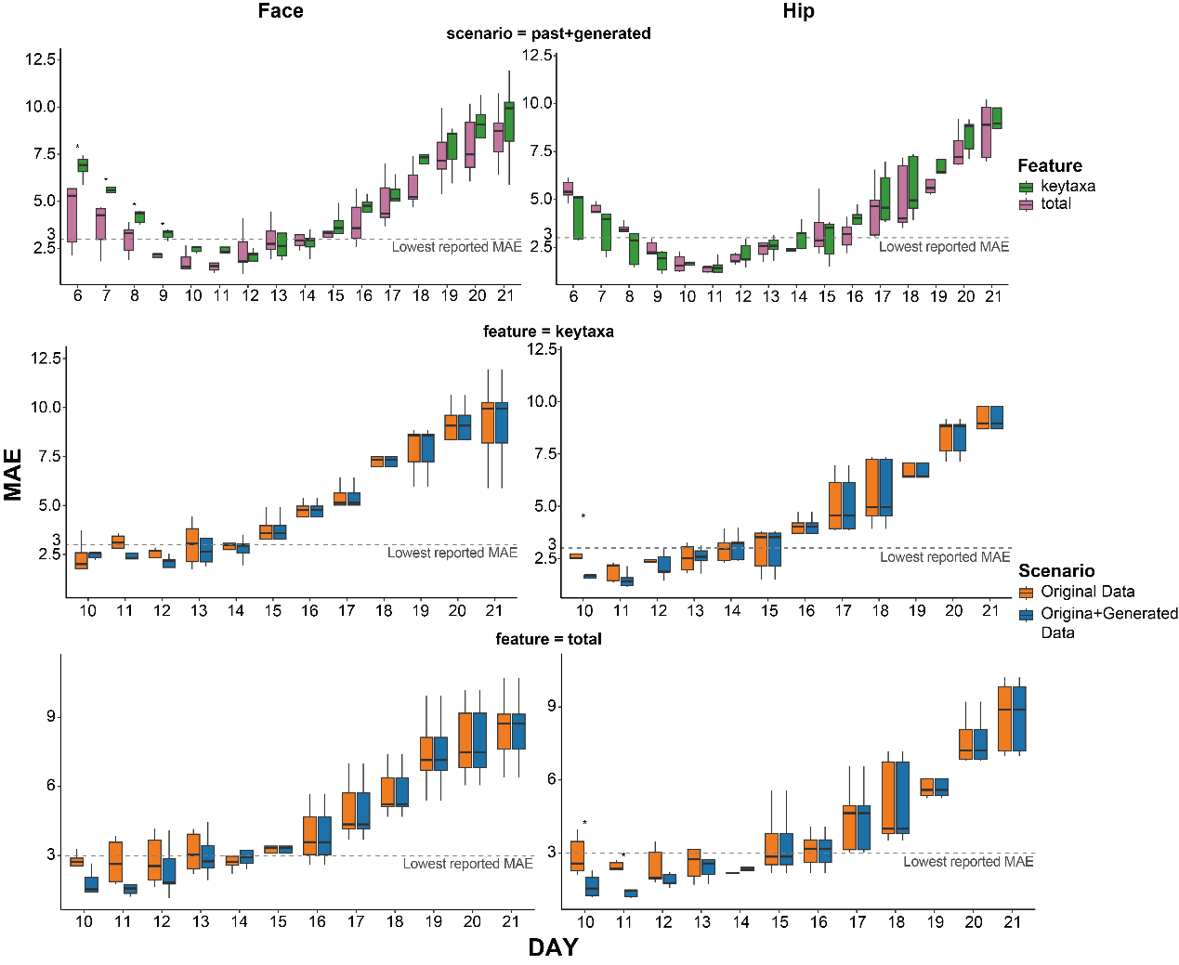
Supplementary Figure 5. Prediction performance of mHolmes forPMI on face and hip datasets, where bodies were discovered after 10 days postmortem (MAE in days, five-fold cross-validation). Top panel: comparison between using the total feature set and using only keytaxa when microbial successions for the first four days of the 11-day PMI are generated by mHolmes from real sampling data of the last seven days. Middle and bottom panels: comparison between using only real sampled data (Past-Only, orange) and supplementing early-day real data with mHolmes-generated profiles for prior days (Past+Generated, blue), using keytaxa alone (middle) or the total feature set (bottom). The gray dashed line indicates the lowest MAE previously reported in the literature. Across both body sites, the Past+Generated scenario achieves MAE comparable to or lower than Past-Only, demonstrating that mHolmes-generated successional sequences are highly biologically plausible and can effectively substitute for missing real sequencing data in accurate PMI estimation. The highest accuracy is obtained when the total feature set is used. Boxes represent the interquartile range, horizontal lines indicate medians, whiskers extend to 1.5 × IQR, and outliers are plotted individually. The dashed gray line indicates the lowest previously reported MAE for reference. Significance (Wilcoxon rank-sum test): *p < 0.05.

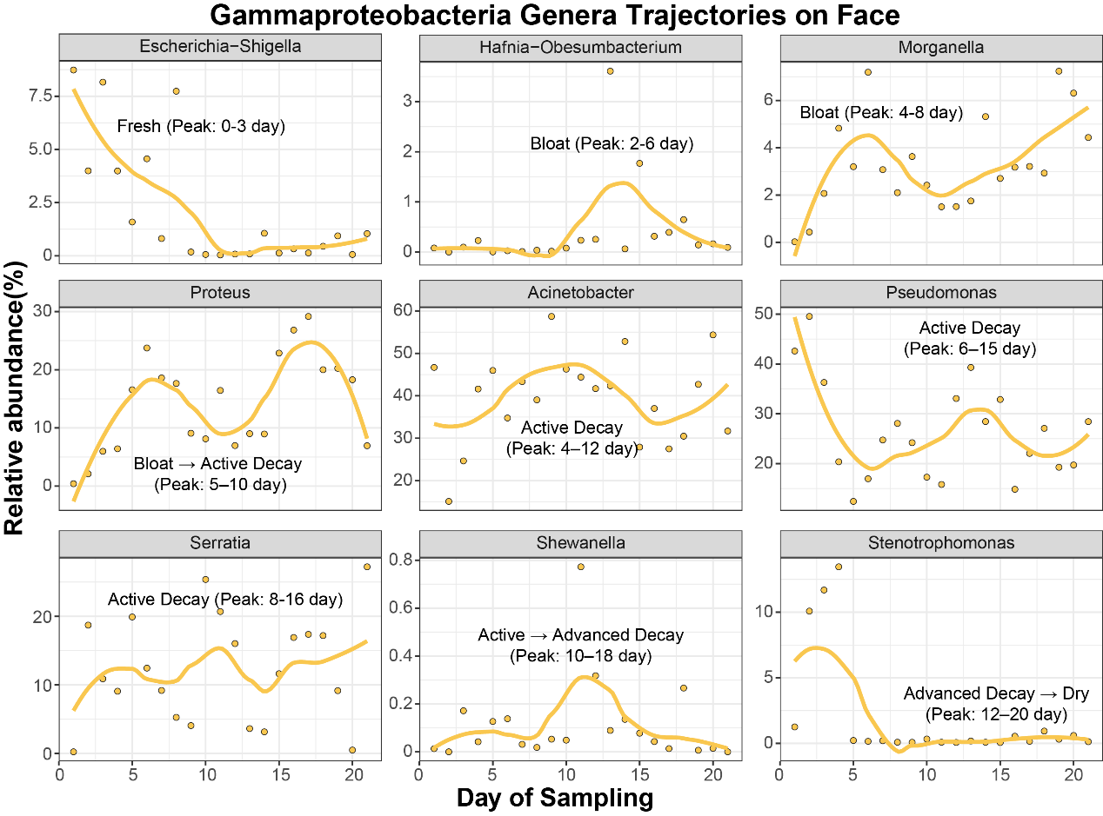
Supplementary Figure 6. Dynamic trajectories of relative abundance for nine representative Gammaproteobacteria genera in the face microbiome during cadaver decomposition (days 1–21 sampling; n = 34 cadavers). Yellow curves show LOESS-smoothed trends; pale yellow dots represent individual sample observations. Decomposition stages (annotated in each panel) are defined as follows: Fresh (no visible bloating), Bloat (marked abdominal distension), Active Decay (liquefaction and major soft-tissue loss), Advanced Decay (largely skeletonised with residual desiccated tissue), and Dry (near-complete skeletonisation). Peak abundance windows for each genus are derived from a comprehensive literature synthesis. Escherichia-Shigella declines sharply in the Fresh stage; Hafnia-Obesumbacterium and Morganella peak during Bloat; Proteus dominates the Bloat-to-Active Decay transition (days 5–10); Acinetobacter, Pseudomonas, and Serratia predominate throughout Active Decay (days 4–16); Shewanella shows a transient rise during the Active-to-Advanced Decay transition. These successional patterns are consistent with the established ecological roles of Gammaproteobacteria in cadaver decomposition and provide a robust genus-level reference for forensic microbiome-based estimation of PMI. (Notably, Stenotrophomonas did not show the pronounced late-stage enrichment commonly reported in the literature, possibly due to dry, cold, or low-humidity environmental conditions that suppressed its growth, or because freeze–thaw cycles prior to placement resulted in substantial early loss of this genus.)

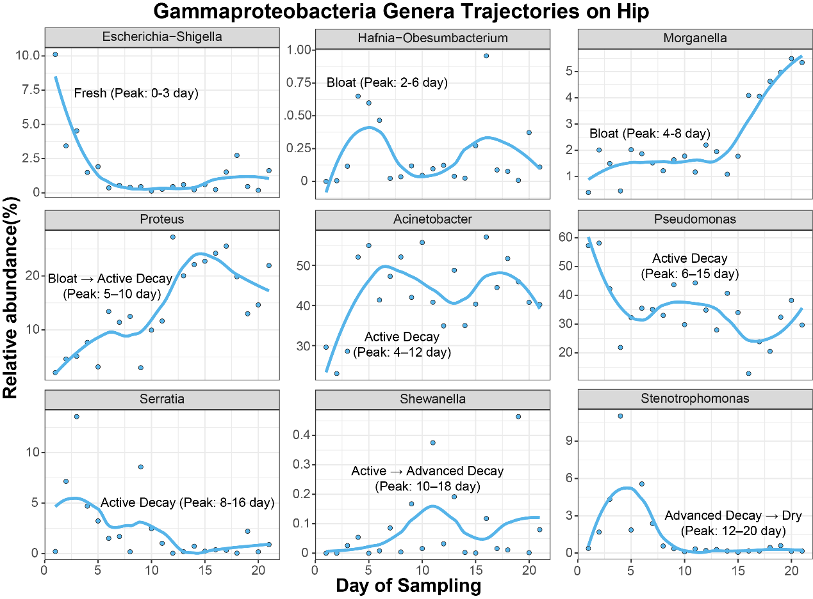
Supplementary Figure 7. Dynamic trajectories of relative abundance for nine representative Gammaproteobacteria genera in the hip microbiome during cadaver decomposition (days 1–21 sampling; n = 34 cadavers). Blue curves show LOESS-smoothed trends; pale blue dots represent individual sample observations. Decomposition stages (annotated in each panel) are defined as follows: Fresh (no visible bloating), Bloat (marked abdominal distension), Active Decay (liquefaction and major soft-tissue loss), Advanced Decay (largely skeletonised with residual desiccated tissue), and Dry (near-complete skeletonisation). Peak abundance windows for each genus are derived from a comprehensive literature synthesis. Escherichia-Shigella declines sharply in the Fresh stage; Hafnia-Obesumbacterium and Morganella peak during Bloat; Proteus dominates the Bloat-to-Active Decay transition (days 5–10); Acinetobacter, Pseudomonas, and Serratia predominate throughout Active Decay (days 4–16); Shewanella shows a transient rise during the Active-to-Advanced Decay transition. These successional patterns are consistent with the established ecological roles of Gammaproteobacteria in cadaver decomposition and provide a robust genus-level reference for forensic microbiome-based estimation of PMI. (Notably, Stenotrophomonas did not show the pronounced late-stage enrichment commonly reported in the literature, possibly due to dry, cold, or low-humidity environmental conditions that suppressed its growth, or because freeze–thaw cycles prior to placement resulted in substantial early loss of this genus.)

