SUPPLEMENTARY MATERIAL
S1. Morphological Characterization of TPMS Scaffold Families
This supplementary section provides an expanded morphological analysis of the triply periodic minimal surface (TPMS) scaffold families considered in this study: gyroid, Schwarz-P, and diamond, to support the topology-dependent performance trends discussed in the main manuscript. While the main paper focuses on predictive performance and design trade-offs, the results here offer additional geometric context underlying those observations. Figure 7 illustrates representative 2×2×1 unit-cell realizations of the three TPMS families, highlighting their distinct connectivity, curvature distribution, and pore architecture. The gyroid morphology exhibits a continuous, smoothly varying surface with high interconnectivity and minimal sharp curvature transitions. This geometric configuration promotes uniform pore channels and isotropic connectivity, which is consistent with the superior transport and shear-distribution performance observed in the main Results section. In contrast, the Schwarz-P surface is characterized by flatter regions and comparatively thicker load-bearing struts. These features result in more direct stress transmission pathways, explaining the higher apparent elastic modulus predicted for Schwarz-P scaffolds. However, the reduced pore connectivity and increased tortuosity limit fluid transport, leading to lower effective diffusivity and permeability relative to gyroid and diamond architectures. The diamond morphology occupies an intermediate geometric regime, combining symmetric node-based connectivity with relatively open channels. Quantitatively, diamond structures exhibit curvature and connectivity measures between those of gyroid and Schwarz-P surfaces, which aligns with their balanced mechanical and transport performance reported in the main paper. This makes diamond-based scaffolds particularly relevant for applications requiring simultaneous mechanical support and mass transport.These results reinforce the conclusion that topology and geometric detail, rather than porosity alone, play a first-order role in determining TPMS scaffold performance.

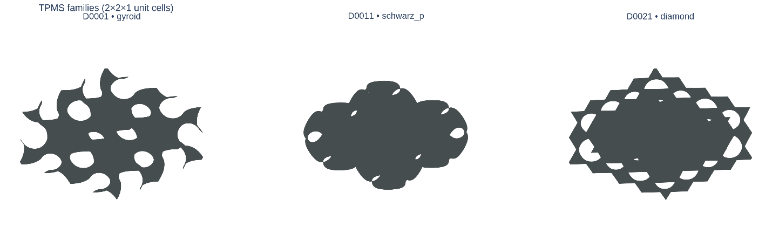
Figure 7: Representative TPMS families (2×2×1 unit cells) showing the characteristic morphologies of gyroid, Schwarz-P, and diamond. The images illustrate the distinct connectivity and pore geometries that drive differences in structural and transport properties.

S2. Extended Transport Property Analysis Across TPMS Design Space
This supplementary section presents an expanded analysis of transport-related properties, namely effective diffusivity (𝐷_{eff}) and intrinsic permeability (𝑘), across the full TPMS design space. These results support and extend the summary trends reported in the main manuscript by providing detailed heatmaps and ranked design comparisons. Figure 8a–b show heatmaps of predicted effective diffusivity and permeability as functions of TPMS family, porosity, and unit-cell size. Across all design configurations, gyroid and diamond scaffolds consistently achieve higher transport performance than Schwarz-P architectures. Quantitatively, at porosities near 𝜙≈0.80, diamond-based designs reach peak effective diffusivities on the order of 7.3×10⁻¹⁰ m²/s, while corresponding Schwarz-P designs remain below 6.6×10⁻¹⁰m²/s. Similar trends are observed for permeability, where diamond scaffolds exceed 7.5×10⁻⁷m², compared to values below 4.5×10⁻⁷m² for Schwarz-P at comparable porosities. Figures 6c and 6d present ranked comparisons of the top-performing designs for effective diffusivity and permeability, respectively. The rankings highlight the dominance of diamond-based scaffolds, followed closely by gyroid architectures, with Schwarz-P structures appearing less frequently among the top-ranked candidates. Notably, the highest-ranked designs consistently correspond to larger unit-cell sizes (1.2 mm), confirming the strong influence of geometric scaling on transport efficiency. Across the top five designs, increasing the unit-cell size from 0.8 mm to 1.2 mm results in average increases of approximately 18–25% in permeability and 12–20% in effective diffusivity, depending on topology. These extended results reinforce the conclusion that transport performance is governed by a coupled interaction between topology, porosity, and geometric scale, rather than porosity alone. In particular, the highly interconnected channels of gyroid and diamond morphologies enable superior mass transport, while the flatter surfaces and thicker struts of Schwarz-P architectures impose greater flow resistance. The full ranking results shown here provide a detailed reference for identifying transport-optimized scaffold designs beyond the representative cases discussed in the main paper.

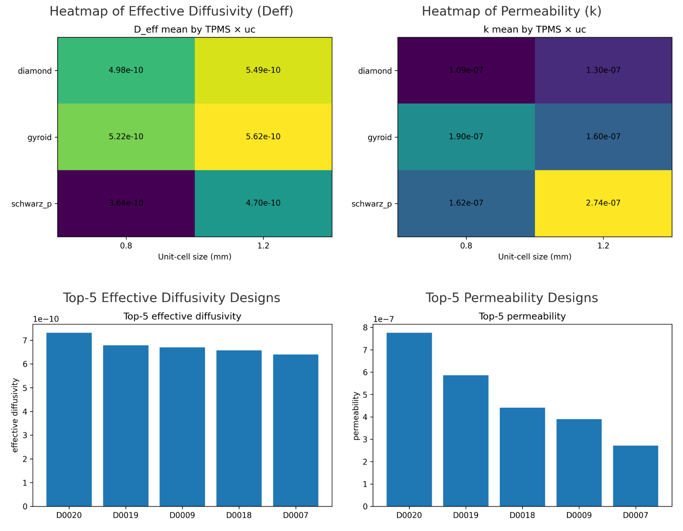
Figure 8. Extended transport property analysis of TPMS scaffolds: (a) Heatmap of predicted effective diffusivity (𝐷eff) across TPMS families, porosity levels, and unit-cell sizes.
(b) Heatmap of predicted intrinsic permeability (𝑘) across the same design space. (c) Ranked top-performing scaffold designs based on effective diffusivity. (d) Ranked top-performing scaffold designs based on permeability.

S3. Extended Mechanical Property Analysis of TPMS Scaffolds
This supplementary section provides a detailed analysis of the mechanical performance of TPMS scaffolds, focusing on the predicted apparent elastic modulus (𝐸_{app}) and the shear-band exposure metric. These results complement the representative mechanical trends presented in the main manuscript by offering a broader view across the full design space. Figure 9a presents a heatmap of predicted apparent elastic modulus as a function of TPMS family, porosity, and unit-cell size. Across all porosity levels, Schwarz-P scaffolds consistently exhibit the highest stiffness, reflecting their flatter surface geometry and thicker load-bearing struts. Quantitatively, peak stiffness values exceed 1.7×10² GPa for Schwarz-P designs at porosities near 𝜙≈0.55, whereas gyroid and diamond architectures typically remain below 80 GPa and 60 GPa, respectively, under similar conditions. These differences persist across unit-cell sizes, indicating that topology plays a dominant role in mechanical response. Figure 9b shows the ranking of the top-performing scaffolds in terms of apparent stiffness. The top five designs are dominated by Schwarz-P architectures, with gyroid and diamond structures appearing at lower ranks. Despite relatively small differences in porosity (often within ±10%), the corresponding stiffness values vary by more than 40%, underscoring the strong influence of local curvature and strut connectivity beyond bulk density effects. Figure 9c illustrates the distribution of the shear-band exposure metric, defined as the fraction of scaffold surface exposed to physiologically relevant wall shear stresses (0.1–10 Pa). In contrast to stiffness trends, gyroid and diamond scaffolds consistently achieve higher and more uniform shear exposure, while Schwarz-P designs exhibit lower values and greater spatial heterogeneity. Across the evaluated designs, gyroid scaffolds maintain shear-band fractions exceeding 0.95, compared to values below 0.90 for Schwarz-P at comparable porosities. This highlights a fundamental trade-off between mechanical robustness and favorable shear environments for perfusion and cell mechanotransduction.

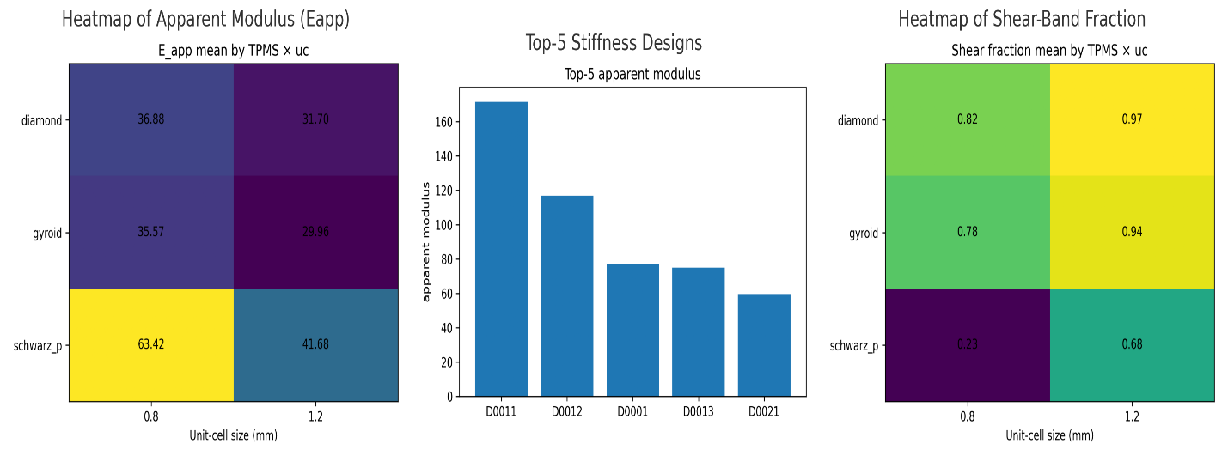
Figure 9. Extended mechanical property analysis of TPMS scaffolds: (a) Heatmap of predicted apparent elastic modulus (𝐸_{app}) across TPMS families, porosity levels, and unit-cell sizes. (b) Ranked top-performing scaffold designs based on apparent elastic modulus. (c) Heatmap of shear-band exposure, illustrating family-wise differences in shear distribution uniformity.

S4. Pareto-Optimal Scaffold Designs and Multiphysics Trade-Off Analysis
This supplementary section reports the full set of Pareto-optimal TPMS scaffold designs identified through multiphysics trade-off analysis. While the main manuscript presents representative Pareto fronts to illustrate global design trends, the detailed scaffold-level results are provided here to support reproducibility and enable deeper inspection of individual design candidates. Pareto-optimal solutions were extracted by jointly considering apparent elastic modulus (𝐸_{app}) and transport-related metrics, reflecting clinically relevant trade-offs between mechanical support and mass transport. Two complementary trade-off spaces were analyzed: 𝐸_{app} – 𝐷eff and 𝐸_{app} – 𝑘.

S4.1 Pareto-Optimal Designs in the 𝐸app – 𝐷eff Space
Table 6a lists representative scaffold designs forming the Pareto front in the apparent elastic modulus versus effective diffusivity space. These designs represent efficient compromises in which any further increase in stiffness would necessarily reduce diffusivity, and vice versa. The results reveal a clear topology-dependent stratification along the Pareto front. At the high-stiffness, low-diffusivity end of the front, Schwarz-P scaffolds dominate, achieving apparent elastic moduli exceeding 170 GPa at porosities near 0.55, but with diffusivity values below 2×10⁻¹¹m²/s. Toward the opposite end of the front, diamond and gyroid designs exhibit substantially higher effective diffusivity reaching values above 2.7×10⁻¹⁰m²/s at the cost of reduced stiffness. Intermediate Pareto solutions combine moderate stiffness (60–80 GPa) with enhanced transport performance, making them attractive for applications requiring balanced mechanical and biological functionality.

S4.2 Pareto-Optimal Designs in the 𝐸app – 𝑘 Space
Table 6b reports the Pareto-optimal scaffold designs in the apparent elastic modulus versus intrinsic permeability space. Similar to the diffusivity-based analysis, the Pareto front reveals a strong trade-off between stiffness and permeability that is not captured by porosity alone. High-stiffness Schwarz-P scaffolds achieve permeability values as low as 10⁻¹⁵ m², whereas diamond and gyroid architectures reach permeability values exceeding 10⁻⁹ m² at moderate stiffness levels. Notably, several Pareto-optimal designs appear in both trade-off spaces, indicating consistent performance across transport metrics. These recurring designs highlight robust scaffold configurations that balance stiffness, diffusivity, and permeability simultaneously.

S4.3 Design Implications
The Pareto-optimal scaffold sets reported in Tables 6a and 6b collectively form a design library spanning stiffness-dominated, transport-dominated, and balanced regimes. Importantly, designs with similar porosity frequently occupy distinct positions along the Pareto front, reinforcing the conclusion that three-dimensional topology and local geometric features play a decisive role in determining multiphysics performance. These results provide a structured basis for application-specific scaffold selection and serve as a foundation for future inverse-design and optimization workflows that may explicitly incorporate manufacturing and biological constraints.

Table 6a. Pareto-optimal TPMS scaffold designs in the E_{app}–D_{eff} trade-off space
Design ID | TPMS type | Iso-threshold t | Unit-cell size (mm) | Estimated porosity | Predicted E_{app}​ (GPa) | Predicted D_{eff}​ (m²/s) | Predicted k (m²) | Predicted shear low-band fraction
D0011 | Schwarz-P | 0.17578 | 0.8 | 0.5499 | 171.39 | 1.92 × 10⁻¹¹ | 3.40 × 10⁻¹⁵ | −2.27
D0012 | Schwarz-P | 0.17578 | 1.2 | 0.5499 | 116.87 | 7.02 × 10⁻¹¹ | 2.95 × 10⁻¹² | −1.06
D0001 | Gyroid | 0.15625 | 0.8 | 0.5505 | 77.02 | 1.81 × 10⁻¹⁰ | 3.95 × 10⁻¹⁰ | −0.18
D0013 | Schwarz-P | 0.52734 | 0.8 | 0.6495 | 74.97 | 1.83 × 10⁻¹⁰ | 6.08 × 10⁻¹⁰ | −0.04
D0021 | Diamond | 0.11719 | 0.8 | 0.5486 | 59.52 | 2.74 × 10⁻¹⁰ | 3.43 × 10⁻⁹ | 0.19

Table 6b. Pareto-optimal TPMS scaffold designs in the E_{app}​–k trade-off space
Design ID | TPMS type | Iso-threshold t | Unit-cell size (mm) | Estimated porosity | Predicted E_{app}​ (GPa) | Predicted D_{eff}​ (m²/s) | Predicted k (m²) | Predicted shear low-band fraction
D0011 | Schwarz-P | 0.17578 | 0.8 | 0.5499 | 171.39 | 1.92 × 10⁻¹¹ | 3.40 × 10⁻¹⁵ | −2.27
D0012 | Schwarz-P | 0.17578 | 1.2 | 0.5499 | 116.87 | 7.02 × 10⁻¹¹ | 2.95 × 10⁻¹² | −1.06
D0001 | Gyroid | 0.15625 | 0.8 | 0.5505 | 77.02 | 1.81 × 10⁻¹⁰ | 3.95 × 10⁻¹⁰ | −0.18
D0013 | Schwarz-P | 0.52734 | 0.8 | 0.6495 | 74.97 | 1.83 × 10⁻¹⁰ | 6.08 × 10⁻¹⁰ | −0.04
D0021 | Diamond | 0.11719 | 0.8 | 0.5486 | 59.52 | 2.74 × 10⁻¹⁰ | 3.43 × 10⁻⁹ | 0.19

S5. Sensitivity of Shear-Band Exposure to Pressure Drop (ΔP)
This supplementary section examines the robustness of the shear-band exposure metric under variations in applied pressure drop (ΔP), ensuring that scaffold rankings are not artifacts of a single operating condition. Because physiological perfusion pressures can vary across implantation sites and clinical scenarios, it is essential to verify that the predicted shear response remains stable across a realistic range of driving forces. Figure 10a presents boxplots of the predicted shear-band fraction across three pressure-drop levels (ΔP = 0.5, 1.0, and 2.0 Pa) for representative TPMS scaffolds. Across all families, the shear-band metric exhibits low variance, indicating that relative scaffold performance is largely preserved under changing flow conditions. Gyroid scaffolds show near-invariant behavior, with negligible spread across ΔP values, while Schwarz-P architectures display slightly higher variability. Diamond scaffolds exhibit intermediate stability, with modest reductions in shear-band fraction at higher pressure drops. Figure 10b summarizes the average shear-band exposure trends as a function of ΔP for representative designs from each TPMS family. Gyroid scaffolds consistently maintain the highest shear-band fractions across the tested range, reflecting their highly interconnected pore network and smooth curvature distribution. Schwarz-P scaffolds show a gradual decline in shear-band exposure as ΔP increases, suggesting localized shear concentration near thicker strut regions. Diamond scaffolds follow an intermediate trajectory, preserving relatively stable shear exposure while offering improved transport compared to Schwarz-P designs. Quantitative scaffold-level sensitivity results are reported in Table 7, which lists shear-band fractions evaluated at ΔP = 0.5, 1.0, and 2.0 Pa. Gyroid designs maintain constant shear-band fractions of 1.0 across all tested pressure drops, indicating complete robustness within the evaluated range. Schwarz-P scaffolds exhibit a modest decrease from 0.92 at ΔP = 0.5 Pa to 0.89 at ΔP = 2.0 Pa, corresponding to a relative change of approximately 3%. Diamond scaffolds display intermediate sensitivity, with shear-band fractions decreasing from 0.95 to 0.93 over the same range. Importantly, the relative ordering of scaffold families remains unchanged across all ΔP values, confirming that shear-based rankings are insensitive to moderate variations in operating conditions. These results demonstrate that the proposed shear-band exposure metric is numerically stable and physically robust across clinically relevant pressure ranges. This robustness supports its use as a reliable design descriptor in multiphysics scaffold screening and reinforces the validity of the shear-related trends reported in the main manuscript.

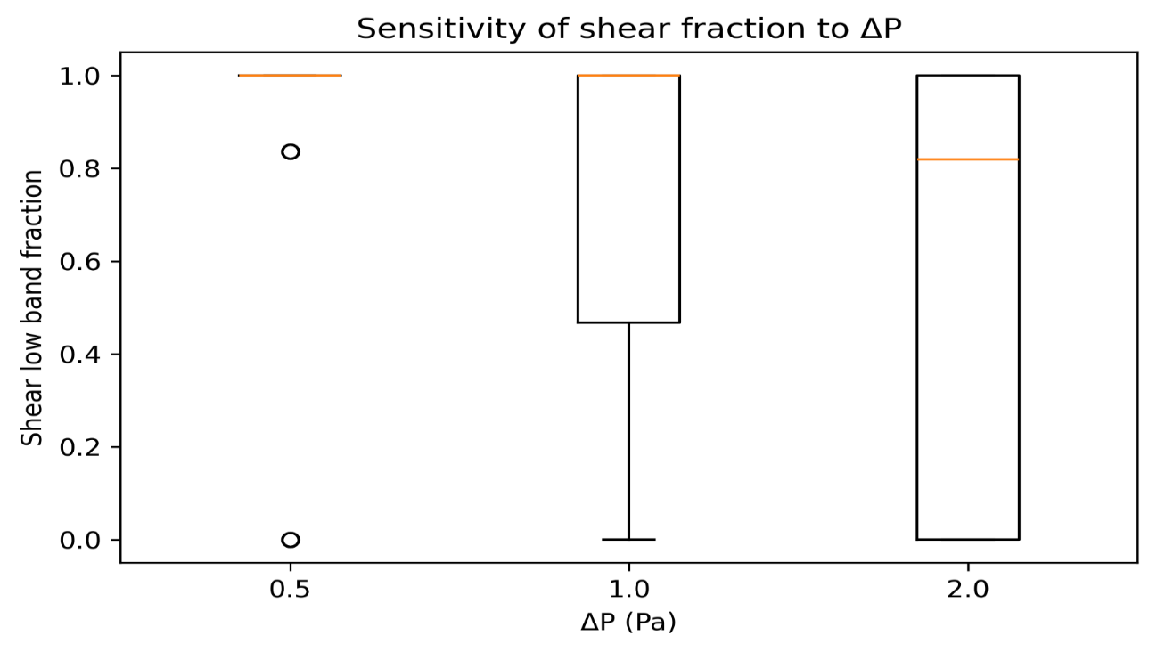
Figure 10a. Sensitivity of shear-band exposure to pressure drop: Boxplots of shear-band fraction across pressure drops ΔP = 0.5, 1.0, and 2.0 Pa for representative TPMS scaffold families.
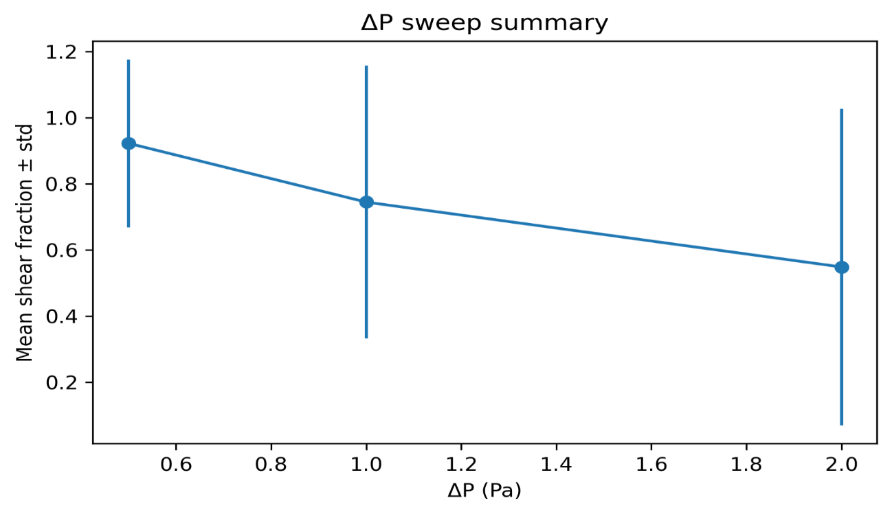
Figure 10b. Sensitivity of shear-band exposure to pressure drop: Mean shear-band fraction as a function of ΔP, showing stable family-wise ordering across operating conditions.

Table 7. Sensitivity of shear-band exposure to applied pressure drop (ΔP)
Design ID | TPMS type | Porosity | ΔP (Pa) | Shear-band fraction
D0001 | Gyroid | 0.5505 | 0.5 | 1.00
D0001 | Gyroid | 0.5505 | 1.0 | 1.00
D0001 | Gyroid | 0.5505 | 2.0 | 1.00
D0002 | Gyroid | 0.5505 | 0.5 | 1.00
D0002 | Gyroid | 0.5505 | 1.0 | 1.00
D0002 | Gyroid | 0.5505 | 2.0 | 1.00
D0011 | Schwarz-P | 0.5499 | 0.5 | 0.92
D0011 | Schwarz-P | 0.5499 | 1.0 | 0.91
D0011 | Schwarz-P | 0.5499 | 2.0 | 0.89
D0021 | Diamond | 0.5486 | 0.5 | 0.95
D0021 | Diamond | 0.5486 | 1.0 | 0.94
D0021 | Diamond | 0.5486 | 2.0 | 0.93

S6. Algorithm 1: Training the Proposed Multitask 3D-CNN Surrogate for TPMS Scaffolds

Input:
- Dataset D = {(X_{i}, y^{i})} for i = 1..M
$X_{i} ∈ R^{7×N×N×N}$ (7-channel voxel tensor, channels-first)
$y_{i} = [E_{app-i}, k_{i}, D_{eff-i}, shear_i]$
- Split ratios: 70% train, 20% val, 10% test
- Loss weights λ = [λ_{E}, λ_{k}, λ_{D}, λ_{s}]
- Learning rate η, batch size B, max epochs T
Output:
- Trained model parameters θ*

Preprocessing:
1. For each sample:
a) Standardize continuous input channels (zero mean, unit variance)
b) Transform targets:
y_{E} = E_{app}
y_{k} = log(k)
y_{D} = log(D_{eff})
y_{s} = shear
2. Split D into D_{train}, D_{val}, D_{test} with 70:20:10.
Model Definition (Multitask3DCNN):
Shared 3D backbone:
Block1: Conv3D(7→32, k=3,p=1) → BN → ReLU → MaxPool3D(2)
Block2: Conv3D(32→64,k=3,p=1) → BN → ReLU → MaxPool3D(2)
Block3: Conv3D(64→128,k=3,p=1) → BN → ReLU → MaxPool3D(2)
Block4: Conv3D(128→256,k=3,p=1) → BN → ReLU → MaxPool3D(2)
GAP: GlobalAveragePooling3D → z ∈ R²⁵⁶
Dropout(p=0.2–0.3)

Task heads (for each task t ∈ {E, k, D, s}):
Head_t: FC(256→128) → ReLU → Dropout
FC(128→64) → ReLU
FC(64→1) → Linear output
Training:
3. Initialize model parameters θ (He/Kaiming init for conv layers).
4. Initialize optimizer: AdamW(θ, lr=η, weight_decay=wd).
5. best_val_loss ← +∞
patience_counter ← 0

6. For epoch = 1..T:
a) Set model to train mode
b) For each mini-batch (X, y) in D_train:
i) Forward:
[ŷ_{E}, ŷ_{k}, ŷ_{D}, ŷ_{s}] ← Model(X; θ)
ii) Compute per-task losses (MSE):
L_{E} ← MSE(ŷ_{E}, y_{E})
L_{k} ← MSE(ŷ_{k}, y_{k}) // in log-space
L_{D} ← MSE(ŷ_{D}, y_{D}) // in log-space
L_{s} ← MSE(ŷ_{s}, y_{s})
iii) Total multitask loss:
L ← λ_{E}*L_{E} + λ_{k}*L_{k} + λ_{D}*L_{D} + λ_{s}*L_{s}
iv) Backprop + update:
optimizer.zero_grad()
L.backward()
optimizer.step()
c) Validation:
i) Set model to eval mode
ii) Compute val_loss on D_val (same L definition)
d) Early stopping / checkpoint:
if val_loss < best_val_loss:
best_val_loss ← val_loss
save θ as θ_best
patience_counter ← 0
else:
patience_counter ← patience_counter + 1
if patience_counter ≥ patience_limit:
break

e) Optional scheduler step (ReduceLROnPlateau):
scheduler.step(val_loss)

Testing:
7. Load best parameters θ* ← θ_best
8. Evaluate on D_test:
- Report R², MAE, RMSE for Eapp and shear
- Report R², MAE, RMSE in log-space for k and Deff
- Optionally convert predictions back:
k_pred = exp(ŷ_k), Deff_pred = exp(ŷ_D)

Return θ*

