Table 1. Participants’ Demographic Information
 | n | Child age (years) | Child gender | Parental education | Family adversity index
 | n | M (SD) | % girls | Parental education | M (SD)
England | 420 | 5.39 (0.42) | 54.7% | 14.6% Secondary school or below  46.9% University undergraduate degree  29.0% University Master’s degree  9.5% PhD | 1.82 (1.85)
Hong Kong | 369 | 5.03 (0.42) | 47.2% | 46.4% Secondary school or below  36.9% University undergraduate degree  15.3% University Master’s degree  1.4% PhD | 2.12 (1.94)
Mainland China | 392 | 5.30 (0.65) | 46.9% | 19.6% Secondary school  54.6% University undergraduate degree  22.9% University Master’s degree  2.8% PhD | 2.02 (1.89)

Table 2. Descriptive Statistics and Model Fit Coefficients for Child- and Parent-Rated School Wellbeing per Geographic Context and Item
 | School wellbeing scored on a binary scale |  |  |  |  |  | Standardised parameter estimates for CFA
 | Child-rated  (1 = happy, 0 = otherwise) |  |  | Parent-rated  (1 = very happy, 0 = otherwise) |  |  | Child-rated |  |  | Parent-rated
 | ENG | HK | MC | ENG | HK | MC | ENG | HK | MC | ENG | HK | MC
Item | M ± SD | M ± SD | M ± SD | M ± SD | M ± SD | M ± SD
1. On my way to school I feel… | 0.74 ± 0.44 | 0.81 ± 0.39 | 0.74 ± 0.44 | 0.32 ± 0.47 | 0.33 ± 0.47 | 0.26 ± 0.44 | 0.716 | 0.727 | 0.692 | 0.756 | 0.817 | 0.748
2. When I am in the classroom I feel… | 0.62 ± 0.49 | 0.73 ± 0.44 | 0.73 ± 0.45 | 0.31 ± 0.46 | 0.30 ± 0.46 | 0.31 ± 0.46 | 0.622 | 0.716 | 0.548 | 0.844 | 0.887 | 0.901
3. When I am doing my work I feel… | 0.56 ± 0.50 | 0.54 ± 0.50 | 0.54 ± 0.50 | 0.39 ± 0.49 | 0.20 ± 0.40 | 0.20 ± 0.40 | 0.612 | 0.461 | 0.523 | 0.702 | 0.861 | 0.707
4. When I am in the playground I feel… | 0.89 ± 0.31 | 0.92 ± 0.27 | 0.92 ± 0.28 | 0.49 ± 0.50 | 0.52 ± 0.50 | 0.69 ± 0.46 | 0.491 | 0.564 | 0.540 | 0.503 | 0.705 | 0.641
5. When I think about the other children I feel… | 0.61 ± 0.49 | 0.78 ± 0.41 | 0.72 ± 0.45 | 0.23 ± 0.42 | 0.28 ± 0.45 | 0.36 ± 0.48 | 0.731 | 0.776 | 0.746 | 0.678 | 0.863 | 0.704
6. When I think about my teacher I feel… | 0.65 ± 0.48 | 0.63 ± 0.48 | 0.68 ± 0.47 | 0.26 ± 0.44 | 0.29 ± 0.45 | 0.30 ± 0.46 | 0.648 | 0.684 | 0.611 | 0.942 | 0.880 | 0.826
7. When I think about school I feel… | 0.68 ± 0.47 | 0.74 ± 0.44 | 0.69 ± 0.46 | 0.50 ± 0.50 | 0.29 ± 0.46 | 0.32 ± 0.47 | 0.765 | 0.865 | 0.830 | 0.729 | 0.825 | 0.744
Total possible score (7) | 4.75 ± 1.94 | 5.16 ± 1.85 | 5.02 ± 1.83 | 2.49 ± 2.19 | 2.21 ± 2.36 | 2.44 ± 2.14
Note. ENG = England; HK = Hong Kong; MC = mainland China.

Table 3. Tests of Measurement Invariance for Child- and Parent-Rated School Wellbeing Across Sites
 | χ² | df | RMSEA [90% CI] | CFI | TLI | Comparison | Δχ²
Child-rated school wellbeing
Measurement CFA
M1. Whole sample (n = 1,175) | 49.532 (p < .001) | 13 | 0.049 [0.035, 0.064] | 0.981 | 0.970
M2. England (n = 415) | 24.162 (p = .030) | 13 | 0.045 [0.014, 0.073] | 0.983 | 0.973
M3. Hong Kong (n = 368) | 20.511 (p = .083) | 13 | 0.040 [0.000, 0.071] | 0.990 | 0.984
M4. Mainland China (n = 392) | 22.761 (p = .045) | 13 | 0.044 [0.007, 0.073] | 0.982 | 0.971
Multiple-groups CFA
M5: Equal form | 64.706 (p = .014) | 42 | 0.037 [0.017, 0.054] | 0.988 | 0.983
M6: Equal form, loadings, and thresholds | 89.251 (p = .013) | 62 | 0.033 [0.016, 0.048] | 0.986 | 0.986 | M6 – M5 | 25.954 (p = .167)
M7: Partial scalar invariance, equal factor variance and mean | 93.428 (p = .010) | 64 | 0.034 [0.017, 0.049] | 0.985 | 0.985 | M7 – M6 | 3.878 (p = .144)
Parent-rated school wellbeing
Measurement CFA
M8. Whole sample (n = 1,124) | 47.203 (p < .001) | 10 | 0.058 [0.042, 0.075] | 0.992 | 0.983
M9. England (n = 377) | 29.212 (p = .001) | 10 | 0.071 [0.042, 0.102] | 0.986 | 0.970
M10. Hong Kong (n = 360) | 23.940 (p = .008) | 10 | 0.062 [0.030, 0.095] | 0.995 | 0.990
M11. Mainland China (n = 387) | 8.067 (p = .622) | 10 | 0.000 [0.000, 0.047] | 1.000 | 1.000
Multiple-groups CFA
M12: Equal form | 68.692 (p < .001) | 33 | 0.054 [0.036, 0.072] | 0.994 | 0.988
M13: Equal form, loadings, and thresholds | 79.838 (p = .004) | 49 | 0.041 [0.024, 0.057] | 0.995 | 0.993 | M13 – M12 | 17.467 (p = .356)
M14: Partial scalar invariance, equal factor variance and mean | 77.932 (p = .009) | 51 | 0.038 [0.019, 0.054] | 0.995 | 0.994 | M14 – M13 | 1.921 (p = .383)
Note. RMSEA, Root Mean Square Error of Approximation; 90% CI, 90% confidence interval for RMSEA; CFI, Comparative Fit Index; TLI, Tucker–Lewis Index. The WLSMV χ² difference tests were used to compare models.
Table 4. Heatmap Correlations Between Key Study Variables
4a. England | 4b. Hong Kong | 4c. Mainland China
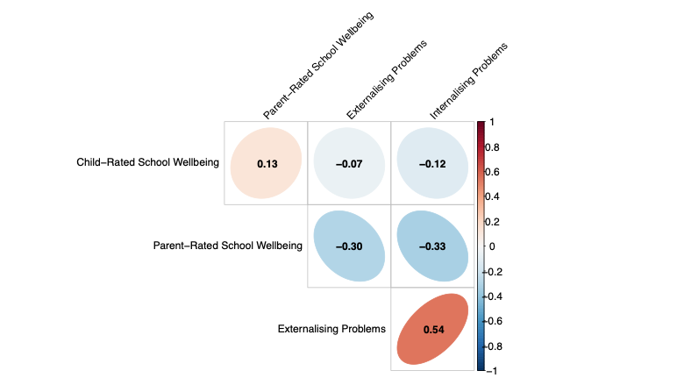 | 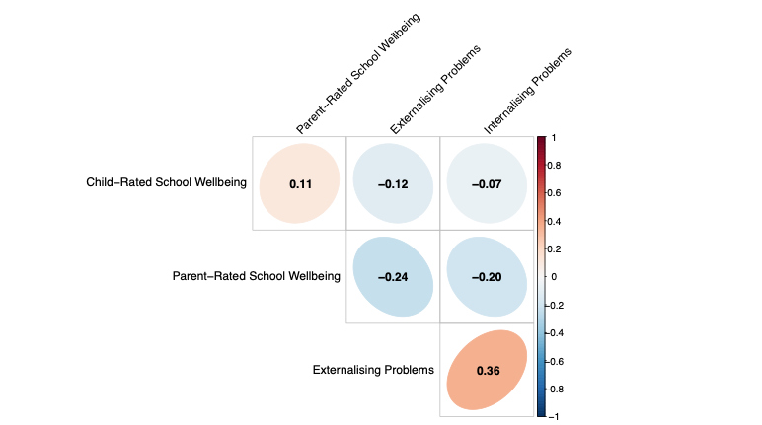 | 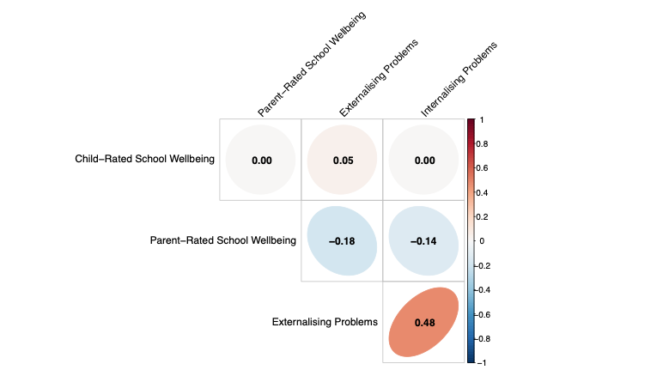
Note. The colour gradient legend on the right represents the strength and direction of correlation coefficients. Blue shades represent positive correlations; red shades represent negative correlations. Deeper colours reflect stronger correlations, while lighter shades reflect weak or no correlation. Ellipses oriented toward the right indicate positive correlations; those oriented toward the left indicate negative correlations. From left to right the heatmap correlations correspond to the England, Hong Kong, and mainland China sites respectively.

