Supplementary Material

The social restrictions imposed during the COVID-19 pandemic required the adoption of remote (online) methods across much of developmental psychology (Sheskin et al., 2020; Su & Ceci, 2021). In the current supplementary study, rather than the traditional in-person interview formats adopted in previous studies using the HIFAMS as a measure of school wellbeing (e.g., Allen et al., 2018) we examined the utility of online data collection for this contextual measure of wellbeing in comparison to an in-person approach in classrooms.
Early findings from studies of children’s cognitive skills indicate remarkably similar results for in-person vs online testing (Kominsky et al., 2021). Indeed, some have suggested that a shift to remote testing represents a long-overdue adaptation of developmental research to an increasingly digitised environment (Sheskin et al., 2020; Su & Ceci, 2021), and one that increases sample diversity and facilitates multi-time-point follow ups (Bambha & Casasola, 2021; Segal & Moulson, 2021). Kominsky et al. (2021) argue that data collected remotely should be as informative as traditional face-to-face data collection. Nonetheless, formal examination of the measurement properties of scales administered online but originally developed for face-to-face testing is advisable (Cieciuch & Davidov, 2015).
In this supplementary study we aimed to examine the measurement invariance of child-reported school wellbeing using the HIFAMS measure across assessment modalities (i.e., in-person vs. online). To this end, we drew on data from Hong Kong, where a separate sample of children were assessed in-person at their school, in addition to the main cohort of children tested via online assessments.
Methods
Participants
Participants comprised 550 children (48.9% girls) across 5 schools in Hong Kong, interviewed between November and December of 2022. Of these, 259 (47.5%) were in Kindergarten 2 (equivalent to 4 - 5 years of age) and 286 (52.5%) children were in Kindergarten 3 (equivalent to 5 - 6 years of age). Information on year group was missing for 5 children. Given the opt-out nature of consent, we were only permitted to collect information on child sex and year group, alongside child-reported school wellbeing. Participants who completed the study measures online comprised the Hong Kong sample from the main study presented in this paper.
Procedure
Ethical approval was granted by [masked]. Two trained researchers conducted individual interviews with each child in a quiet area within their school. Prior to participation, parents were provided with an information sheet and given three weeks to return an opt-out form if they did not want their child to participate. Researchers sought assent from each child before completing the questionnaire. The school wellbeing measure administered was identical to that presented in the main study. For each item, children were shown the three alternative response options and asked to point to their chosen response.
Statistical analysis
To assess the comparability of using the child-reported school wellbeing across different modalities the factor structure of the HIFAMS across online and in-person administration was examined. Measurement invariance of online and in-person administration was conducted using the same steps as outlined in the main study.
Results
Measurement invariance across assessment modalities
Item-level response profiles for online and in-person administration of the HIFAMS are visualised in Figure A.
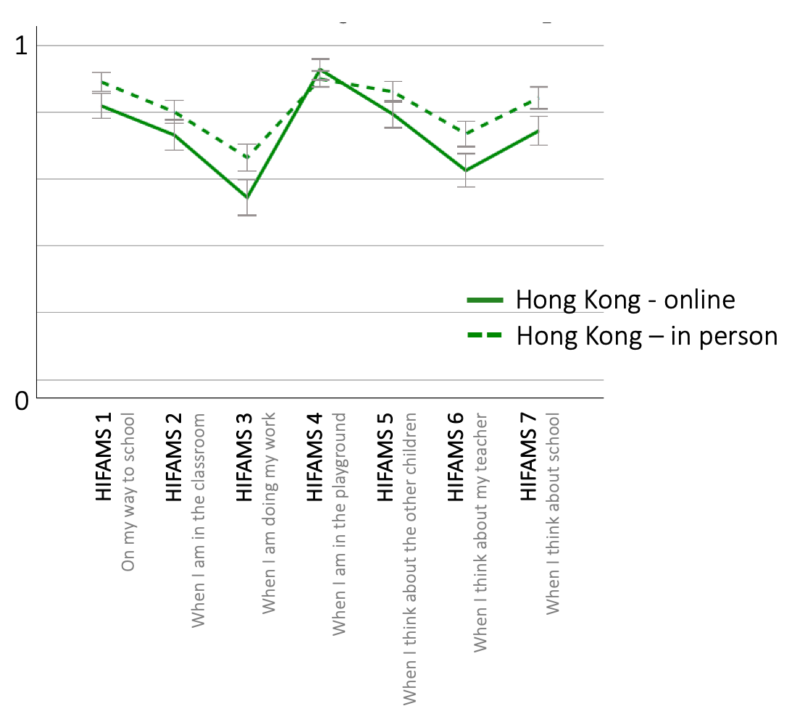
Figure A. Item-level response profiles across HIFAMS for Hong Kong online and in-person cohorts.
Individual CFAs showed a good model fit for a one-factor model for both in-person (χ² = 16.499, df = 14, RMSEA = 0.018 [95% CI = 0.000-0.047], CFI = 0.994, TLI = 0.967) and online assessment modalities (χ² = 29.197, df = 14, RMSEA = 0.058 [95% CI = 0.028-0.088], CFI = 0.967, TLI = 0.950). Measurement invariance across modalities showed good model fit for the configural (χ² = 45.673, df = 28, RMSEA = 0.038 [95% CI = 0.016-0.058], CFI = 0.980, TLI = 0.970), metric ( χ² = 52.464, df = 34, RMSEA = 0.035 [95% CI = 0.014-0.053], CFI = 0.979, TLI = 0.975, ΔRMSEA = 0.003, ΔCFI = 0.001, ΔTLI = 0.005) and scalar model (χ² = 80.658, df = 47, RMSEA = 0.041 [95% CI = 0.025-0.055], CFI = 0.962, TLI = 0.966, ΔRMSEA = 0.006 , ΔCFI = 0.017, ΔTLI = 0.009). In sum, these results indicate that conditions for measurement invariance of the child-reported school wellbeing across assessment modality were met, underscoring that an online administration of school wellbeing is comparable to traditional in-person administration. Standardised coefficients per item across assessment modality are presented in Table A.
Table A. Standardised coefficients derived from multi-group confirmatory factor analysis for child-rated school wellbeing across assessment modality
Item | Online | In-person
- On my way to school I feel… | 0.503 | 0.454
- When I am in the classroom… | 0.548 | 0.456
- When I am doing my work… | 0.440 | 0.479
- When I am in the playground… | 0.353 | 0.263
- When I think about the other children… | 0.558 | 0.469
- When I think about my teacher… | 0.658 | 0.703
- When I think about school… | 0.634 | 0.542

Since invariance was established across the two assessment modalities, we proceeded to compare mean school wellbeing scores for the online and in-person administration. We found significantly higher mean school wellbeing scores for the in-person (M = 5.69, SD = 1.57) compared to the online assessment modality (M = 5.19, SD = 1.83), t(870) = 4.339, p < 0.001.

