SUPPORTING INFORMATION FOR:

Otterbach, N. & Fröhling, M. Assessing Raw Material Criticality from a Corporate Perspective - Method and Application to European Electrolyser Production. Journal of Industrial Ecology.
This supporting information provides further information about the integration into corporate processes, including the set-up of the data base and the visualisation.

Corporate data base requirements and structure
A business intelligence platform that enables companies to collect, analyse and visualise information from various sources is chosen to assess risks efficiently. The platform must be able to connect to exogenous and endogenous data sources, including multiple data formats (e.g., csv, xlsx, spold). Automated checks for missing, outdated, or inconsistent data, and the traceability of data sources and transformation processes, contribute to assure high data quality.

The calculation logic is based on a material and a country index. These are necessary to join the various data sources correctly. The material index is an alphanumeric index consisting of a number representing the respective raw material, followed by E, P or S as assignment of the type, i.e. extraction, (initial) processing or secondary material. The types E, P and S allow risks to be differentiated and recorded more granularly. In addition, the index table ensures complete mapping by listing alternative names, e.g. spelling variants such as aluminium (BE) and aluminum (AE), as well as the element symbols. The country index can be based on the ISO country codes. It includes variations in spelling and names of the countries of origin. The two indices uniquely assign each data point, enabling calculations for different materials with different indicators and levels.

Data sources are connected and transformed in data flows. The titles of the data flows contain all relevant information in a uniform format. It should be clear whether a data source is being connected and adapted or whether an indicator calculation is being performed. For data flows in the first category, it is advisable to specify the core information and the type of connection, e.g.:
Source_KeyInformation_API/Import/Manual
e.g., USGS_GlobalProductionShares_Import
For data flows which calculate indicators, these should be named and correctly classified, e.g.:
Calc_Dimension_Indicator_Material/Product/Company-level_DataReadinessLevel
e.g., CALC_ SUPPLY-RISKS_STATIC-REACH-RESERVES_M_L1
Automated updating of data sources requires the structure of the data source (especially the columns) to remain the same or to be aligned before uploading. Within each source, it is advisable to add columns with the evaluated period, publication date, the validity period (if applicable) and a unique source designation. This allows the various sources to be correctly linked and traced, while at the same time enabling risk developments to be recorded.

Visualisation
A clear presentation of the results is key for a successful analysis by the internal experts and convincing communication of findings to relevant stakeholders, such as the management. A classic tabular presentation can provide a good foundation for expert analysis. Conditional formatting with a colour scale facilitates the identification of relevant values and patterns (e.g., Table 5 of main study). To visualise the key findings, such as focus products and materials, a sunburst chart is considered beneficial (Kolotzek, 2018). The multi-level structure enables an aggregation of risks without information loss (Otterbach & Fröhling, 2025). In this way, even non-specialists can easily be given an overview and at the same time, the sources of risk can be presented by means of the indicators. Figure 3 depicts exemplary the raw material risks for platinum.

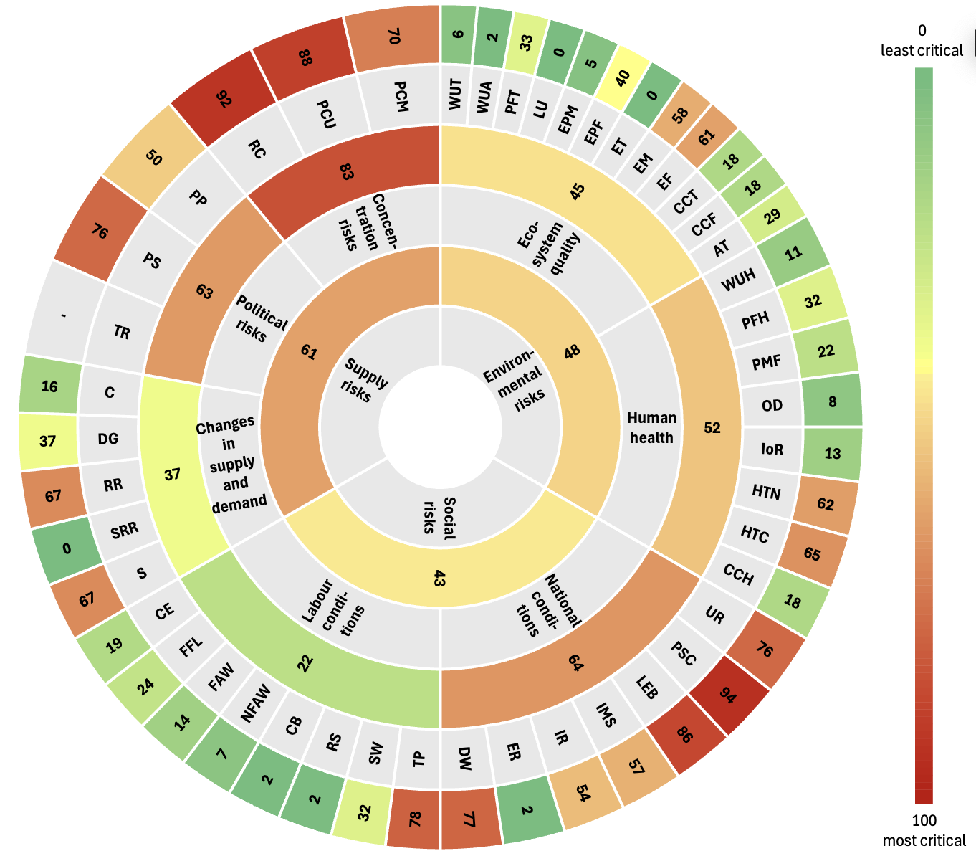
Figure 3 Visualisation of raw material risks at material level, readiness level 1, exemplary for platinum, following Kolotzek et al. (2018). It depicts the higher risk stage, i.e. for supply and social risks at extraction stage and for environmental risks at processing stage.

Integration into corporate processes
An effective integration into corporate operations requires relevance and timeliness of the risk assessment. As long as most sources are updated annually (e.g., USGS, 2025), an annual cycle is also advisable for the assessment. In addition, rapidly changing risks, such as acute mine impairments or trade restrictions, should be monitored continuously wherever possible. The big data early warning system currently being set up by the German Mineral Resources Agency might be beneficial (Buchholz et al., 2022; DERA, 2026).

Within the company, risk results should be discussed regularly in a decision-making committee, while interfaces with core departments enable the effective implementation of derived risk mitigation measures (e.g., VW, 2024). The core departments depend on the company structure, but usually encompass:
- Procurement (e.g., supplier selection and diversification)
- Research and development (e.g., material selection, circular design)
- Logistics (e.g., transportation routes, stockpiling, reverse logistics)
- Strategy and sustainability (e.g., risk management, CE strategy)
- Finance and accounting (e.g., price risk hedging)
Clear responsibilities and collaboration across the departments, as well as across company borders can unlock the long-term potential of the CRMCA. At the Volkswagen Group, for example, there is a working group per focus material. These groups analyse the criticality and take care of derived measures (VW, 2024, 2025). Various subsidiaries and departments work together on one focus material. In bi-weekly meetings, there is an exchange between the different focus material groups. Representatives of the senior management meet quarterly to make decisions on proposals and to track measures already initiated (VW, 2024, 2025). Thorough integration of the risk assessment results into business processes is crucial in order to leverage the added value.

References

Buchholz, P., Schumacher, A., & Al Barazi, S. (2022). Big data analyses for real-time tracking of risks in the mineral raw material markets: implications for improved supply chain risk management. Mineral Economics, 35(3-4), 701–744. https://doi.org/10.1007/s13563-022-00337-z
DERA. (2026). Echtzeitmonitoring. https://www.deutsche-rohstoffagentur.de/DERA/DE/Themen/Rohstoffmarktrisiken/Echtzeitmonitoring/echtzeitmonitoring_node.html
Kolotzek, C. (2018). Entwicklung einer nachhaltigkeitsorientierten Rohstoffbewertung zur Unterstützung von Entscheidungsprozessen in Unternehmen. Springer Fachmedien Wiesbaden. https://doi.org/10.1007/978-3-658-22392-2
Kolotzek, C., Helbig, C., Thorenz, A., Reller, A., & Tuma, A. (2018). A company-oriented model for the assessment of raw material supply risks, environmental impact and social implications. Journal of Cleaner Production, 176, 566–580. https://doi.org/10.1016/j.jclepro.2017.12.162
Otterbach, N., & Fröhling, M. (2025). Raw material criticality assessments as decision-making support for corporate circular economy strategies – A systematic review. Resources, Conservation and Recycling, 219, 108299. https://doi.org/10.1016/j.resconrec.2025.108299
USGS. (2025). Mineral commodity summaries 2025. https://www.usgs.gov/centers/national-minerals-information-center/mineral-commodity-summaries
VW. (2024). Responsible raw materials report 2023.
VW. (2025). Responsible raw materials report 2024.

