Supplementary Information (SI)

Imperceptible Energy Harvesting Device and Biomedical Sensor based on Ultraflexible Ferroelectric Transducers and Organic Diodes

Andreas Petritz^{1,2}, Esther Karner-Petritz^{1,2}, Takafumi Uemura^{1,3}, Philipp Schäffner², Teppei Araki^{1,3}, Barbara Stadlober^{2,}*, Tsuyoshi Sekitani^{1,3,}*

1. Electrical poling and hysteresis measurements of ferroelectric P(VDF:TrFE) layers
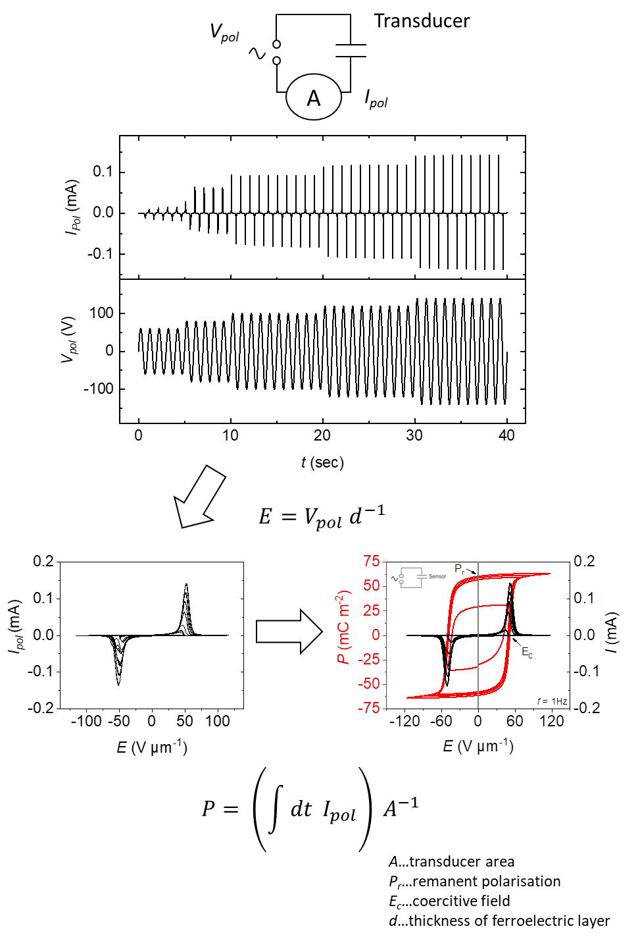
Supplementary Figure S1 | Schematic procedure for ‘poling’ of a ferroelectric transducer.

2. Ferroelectric-to-paraelectric phase transition
As expected, we observe a clear ferroelectric-to-paraelectric phase transition in our ultraflexible ferroelectric polymer transducer, which appears in Fig. S2a as a peak in the temperature behaviour of the relative permittivity ε_{r} (T)^{S1}. At a temperature of 105 °C, the permittivity exhibits a maximum (ε_{r} ~ 40) that corresponds to the complete loss of remnant polarization (see P_{r}(T) in Fig. S2a). In this figure, a dramatic step between 100 °C ≤ T ≤ 105 °C is observed, which serves as direct evidence for the transition from the ferroelectric to the paraelectric phase. The temperature at which this phase transition occurs is referred to as the Curie temperature T_{C}. A T_{C} of about 105 °C—as derived for our ultraflexible ferroelectric transducer—is in good agreement with previously reported values for P(VDF:TrFE) layers with 70:30 mol%^{S2}. Noticeably, the Curie temperature for a non-poled layer is also located at 105 °C, as shown in Fig. S2a; this implies that the intrinsic property of ferroelectricity, the existence of polar molecular crystallites with non-centric symmetry (as is the case in the all-trans conformation of PVDF), is not influenced by poling in our experiment. This result is in contrast to those in previous reports^{S3}. At temperatures below T_{C}, the permittivity of the poled layer ε_{r,poled} is lower than that of the unpoled layer ε_{r,unpoled} and, as shown in Fig. S2b, it is nearly flat over a wide temperature range (i.e., from −100 to 90 °C). This phenomenon, i.e., the temperature insensitivity of ε_{r,poled}, is attributed to electrical poling that generally reduces disorder in the all-trans conformation of the ferroelectric phase, thereby resulting in a decrease in thermal fluctuations, and in turn, a decrease in permittivity^{S3}.
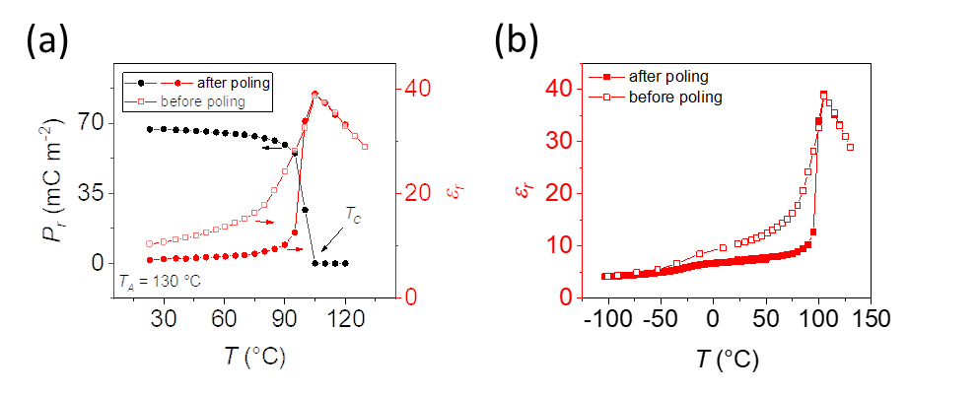
Supplementary Figure S2 | Ferroelectric-to-paraelectric phase transition. (a) Temperature dependence of P_{r} and the relative permittivity ε_{r} associated with the ferroelectric-paraelectric phase transition in a 1.5-µm thin P(VDF:TrFE)_{70:30} copolymer layer that was annealed at 130 °C. The Curie temperature (T_{C}) is about 105 °C. At T_{C}, the ferroelectric-to-paraelectric phase transition is observed. The relative permittivity was measured before and after electrical poling of the layer. (b) Temperature dependence of the relative permittivity ε_{r} of a 1.5-µm thin P(VDF:TrFE)_{70:30} copolymer annealed at 130 °C measured in the range −100 °C to 125 °C. The relative permittivity was measured before and after electrical poling of the ferroelectric layer.

3. AFM-images of P(VDF:TrFE) films for different annealing temperatures
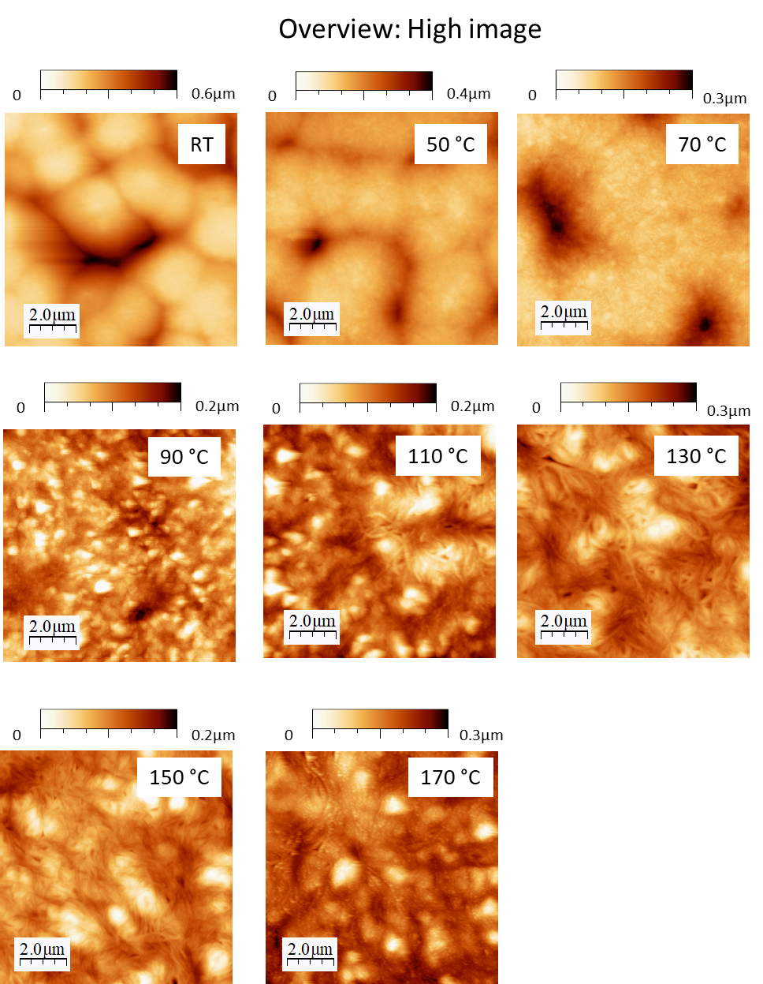

Supplementary Figure S3a | AFM-images of P(VDF:TrFE) films for different annealing temperatures. AFM topography images (tapping mode, 10 µm × 10 µm scan size) of ~ 1.4 µm thin P(VDF:TrFE)_{70:30} layers annealed between RT and 170 °C.

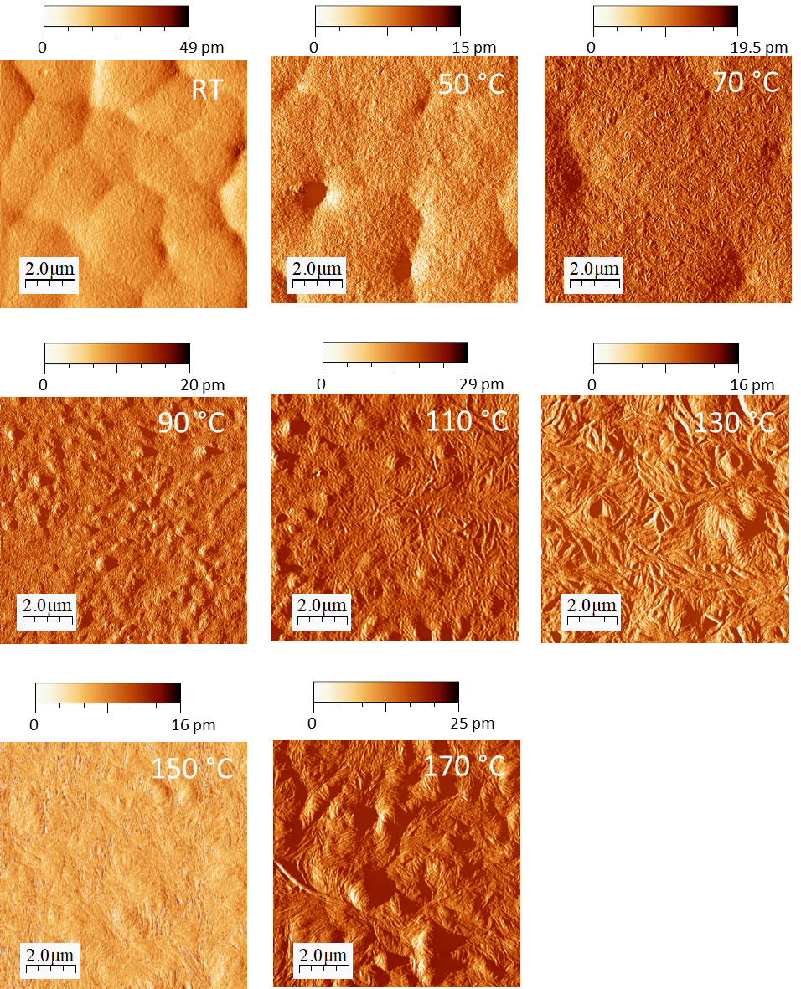

Supplementary Figure S3b | AFM-images of P(VDF:TrFE) films for different annealing temperatures. Characteristic non-contact (NC) atomic force microscopy images for different annealing temperatures T_{A} of spin-coated P(VDF:TrFE)_{70:30} thin films (thickness ≈ 1.4 µm).

4. XRD-pattern of P(VDF:TrFE) films for different annealing temperatures
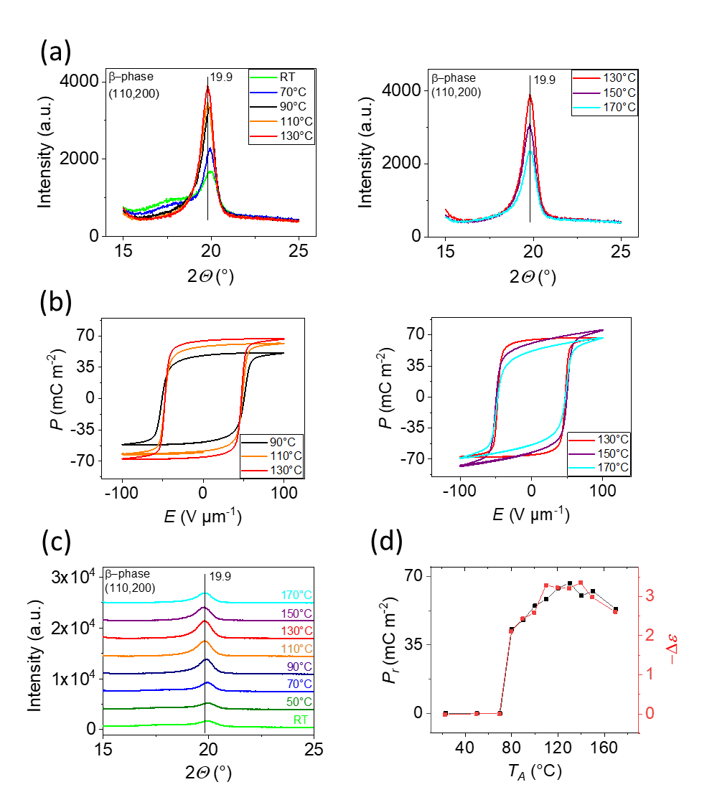

Supplementary Figure S4 | XRD-pattern of P(VDF:TrFE) films for different annealing temperatures. (a,c) XRD-measurements of the P(VDF:TrFE)_{70:30} layer for different annealing temperatures T_{A}. (b) Poling curves for different T_{A} after spin coating of the ferroelectric polymer. (d) Change in the relative permittivity ε_{r} after the electrical poling as a function of various annealing temperatures T_{A}.

5. Determination of crystallinity X_{c}
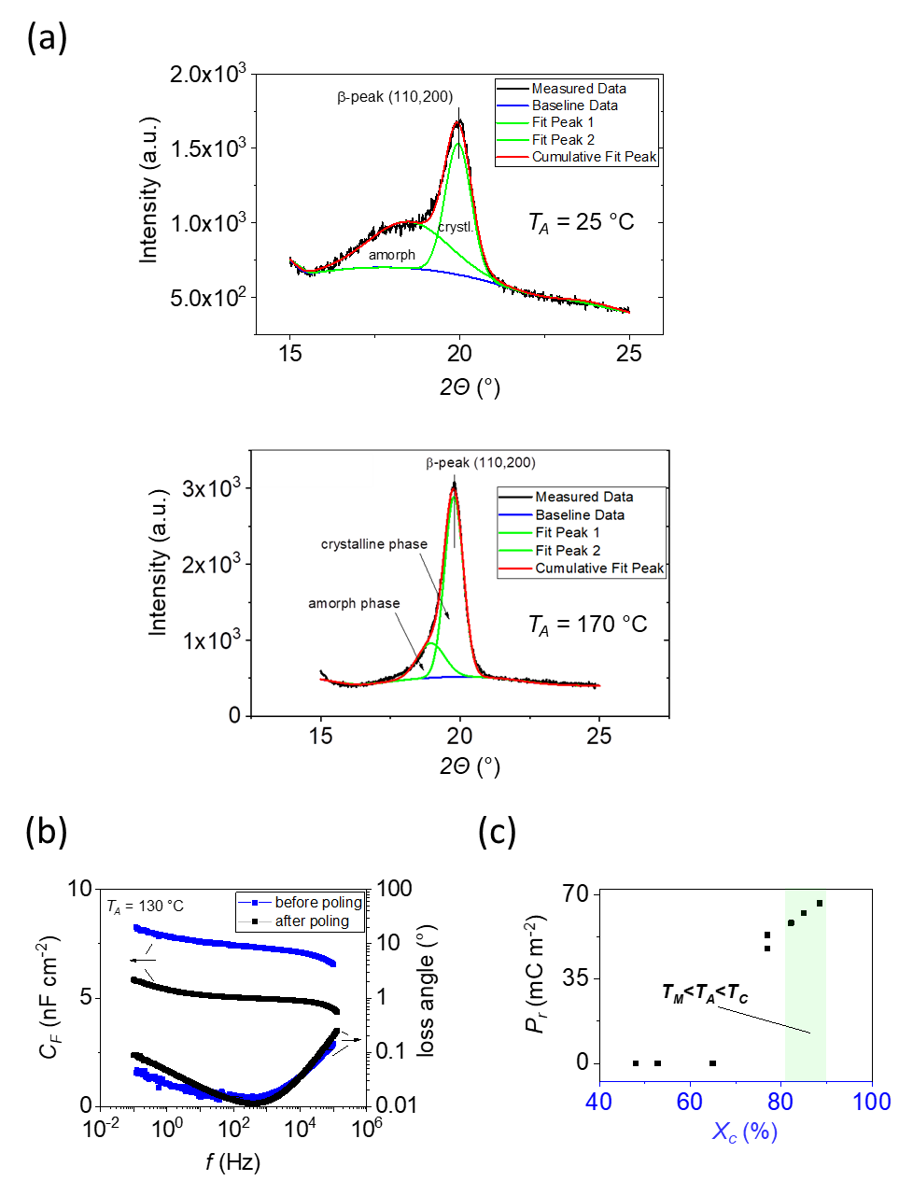
Supplementary Figure S5 | Determination of crystallinity X_{c}. (a) Diffraction pattern and fitting plots to determine the degree of crystallinity X_{c} for a 1.4-µm thick P(VDF:TrFE) layer annealed at RT and 170 °C. The XRD-signal around 2Θ: ~ 20° can be fitted by the superposition of two Gaussian functions: one attributed to the (110) and the (200) reflection of the copolymer’s β-phase at 2Θ = ~ 19.9°, and the other to the amorphous phase. The fit yields the integrated peak areas and a refinement of the peak positions from which X_{c} can be determined. (b) Impedance measurements of a ferroelectric copolymer transducer (≈ 1 cm² area), annealed at 130 °C, show the frequency dependence of the capacitance C_{F} and the loss angle before and after electrical poling. (c) Remnant polarization P_{r} as a function of the crystallinity X_{c} of the ferroelectric co-polymer layer. The highest polarization values were observed for crystallinity levels between 80 and 90% achieved for annealing temperatures T_{A} between the melting temperature T_{M} and the Curie temperature Tc.
Supplementary Table S1 | Transducer charge response under transversal load for the three excitation scenarios.
Carrier^{a)} | Number of transducer layers | Transversal load
Carrier^{a)} | Number of transducer layers | S_{F}  (nC N⁻¹) ^{b)} | ∆F  (N)^{c)} | S_{p}  (pC kPa⁻¹)^{b)} | ∆p  (kPa) ^{c)}
Glass  (D = 6 mm, Y ~ 70 GPa) | 1 | 0.054 (0.008) | 0.2-10 | 11 (1.6) | 1–50
Silicone rubber (D = 6 mm, Y = 1.45 MPa) | 1 | ≈ 1.3 | 0.1–1 | ≈ 260 | 0.5–5
Silicone rubber (D = 6 mm, Y = 1.45 MPa) | 2 | ≈ 2.5 | 0.1–1 | ≈ 520 | 0.5–5
Pre-bent silicone rubber (D = 6 mm, r = 1.5 cm) | 1  2  3 | ≈ 4.8  ≈ 9.7  ≈ 14.8 | 2.5 | n/a | n/a
^{a)} Y: Young modulus; D: thickness; and r: bend radius. ^{b)} Sensitivity S_{F} = ∆Q/∆F [nC N⁻¹], and S_{p} = ∆Q/∆p [pC kPa⁻¹]. ^{c)} Applied force ∆F and pressure ∆p change range during transversal load tests. The sensitivity values on glass are mean values (calculated for six transducers), and standard derivations are indicated in brackets.

6. Transversal load tests on various substrates
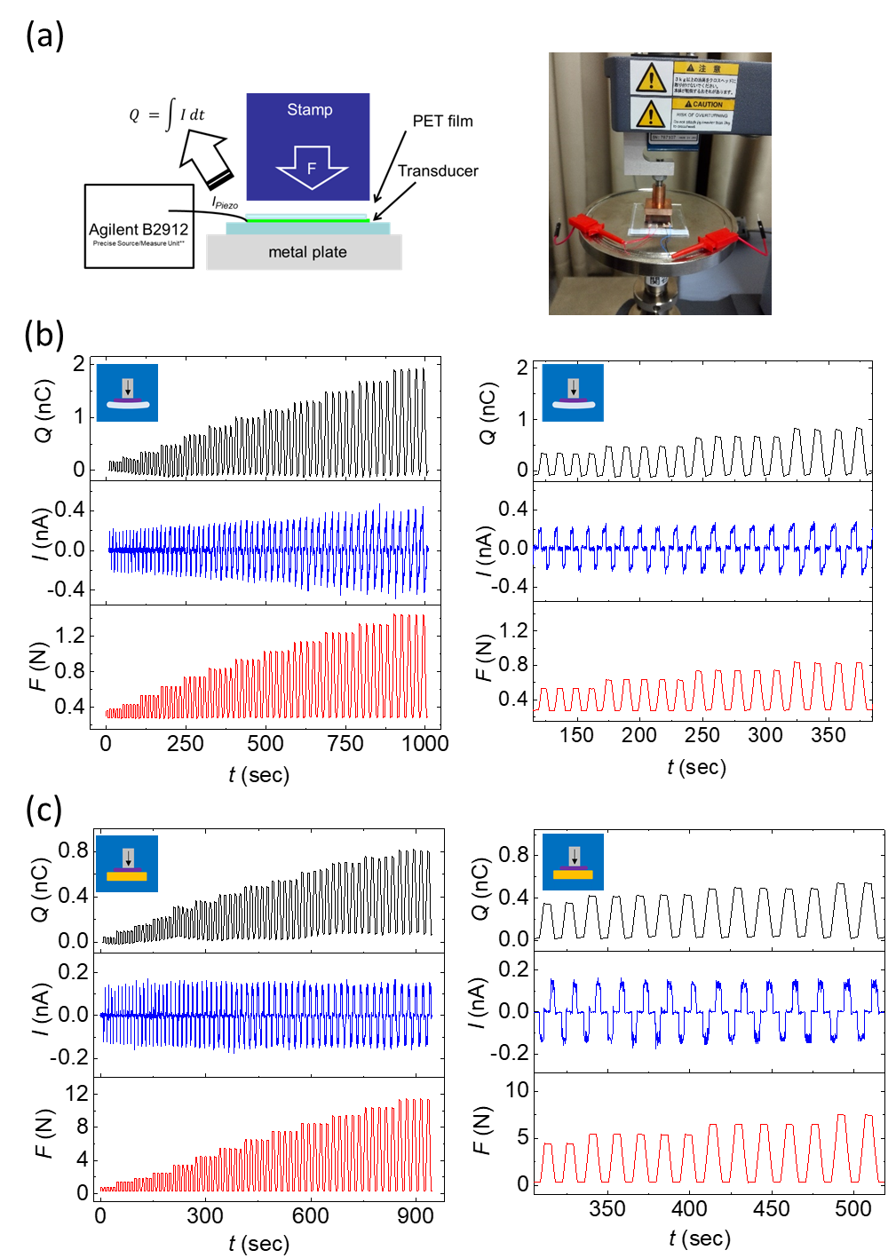
Supplementary Figure S6 | Transversal load tests on various substrates. (a) Schematic image and photograph of the transversal load test setup (contact area: 2 cm², transducer area 2.25 cm²). (b-c) Current response I and calculated charge response Q of one transducer layer attached (b) on silicone rubber for loads between 0.25 and 1.25 N and (c) on the glass for loads between 0.25 N and 10.25 N.

7. FEM simulation of the transversal load test on elastic rubber:

Supplementary Table S2. Geometry and material parameters used for FEM analysis
Component | Part | Description | Symbol | Value
UFPT | Piezoelectric layer | Side length | L_{t} | 15 mm
UFPT | Piezoelectric layer | Thickness | D_{t} | 1.5 µm
UFPT | Piezoelectric layer | Young modulus | E_{t} | 2.2 GPa
UFPT | Piezoelectric layer | Poisson ratio | ν_{t} | 0.28
UFPT | Piezoelectric layer | Remnant polarization | P_{r} | 65 mC m⁻²
UFPT | Parylene substrate | Side length | L_{sub} | 15 mm
UFPT | Parylene substrate | Thickness | D_{sub} | {1, 2, 5} µm
UFPT | Parylene substrate | Young modulus | E_{sub} | 2.8 GPa
UFPT | Parylene substrate | Poisson ratio | ν_{sub} | 0.40
UFPT | Parylene substrate | Side length | L_{t} | 15 mm
Stamp |  | Side length | L_{sp} | 10 mm
Stamp |  | Thickness | D_{sp} | 0.4 mm
Stamp |  | Edge curvature | r_{sp} | 0.2 mm
Stamp |  | Young modulus | E_{sp} | 200 GPa
Stamp |  | Poisson ratio | ν_{sp} | 0.27
Rubber substrate |  | Side length | L_{sp} | 20 mm
Rubber substrate |  | Thickness | D_{sp} | 6 mm
Rubber substrate |  | Young modulus | E_{sp} | 1.45 MPa
Rubber substrate |  | Poisson ratio | ν_{sp} | 0.49

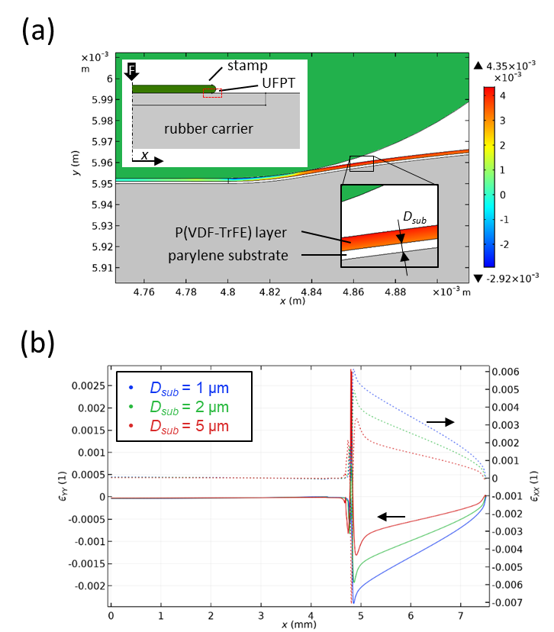
Supplementary Figure S7 | FEM simulation of the transversal load test on elastic rubber carrier. (a) Calculated volumetric strain in the piezoelectric layer of the UFPT near the stamp edge at F = 4 N (ε > 0: tensile strain, ε < 0: compressive strain). The inset shows the 2D model with a symmetry plane at x = 0 m. The elastic rubber carrier has a thickness of 6 mm and the parylene substrate thickness is 1 µm, in accordance with the experiment depicted in Fig. 3c (Table S2). (b) Local transversal and longitudinal strain components ϵ_{YY} (solid lines) and ϵ_{XX} (dotted lines), respectively, in the piezoelectric layer for three different thickness values D_{sub} of the UFPT substrate (here parylene). Strong deformation occurs near the edge of the stamp (x ~ 5 mm) because of the elastic underground, with pronounced longitudinal tensile strain and transversal compressive strain outside the stamp area. The locally induced piezoelectric polarization P_{piezo} is directly related to the transversal strain via the remnant polarization, $P_{piezo}=-e_{YY}⋅P_{r}$. Obviously, the thinner the substrate layer of the UFPT is, the more the deformation of the rubber transfers into the ferroelectric layer causing a stronger piezoelectric response.

8. Transversal load tests: Multiple layers

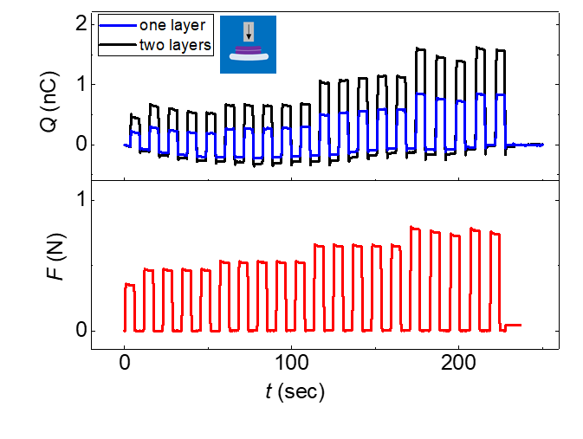
Supplementary Figure S8 | Transversal load tests: Multiple layers. Charge response upon transversal load of one and two transducer layers attached on a 6-mm-thick silicone rubber carrier.

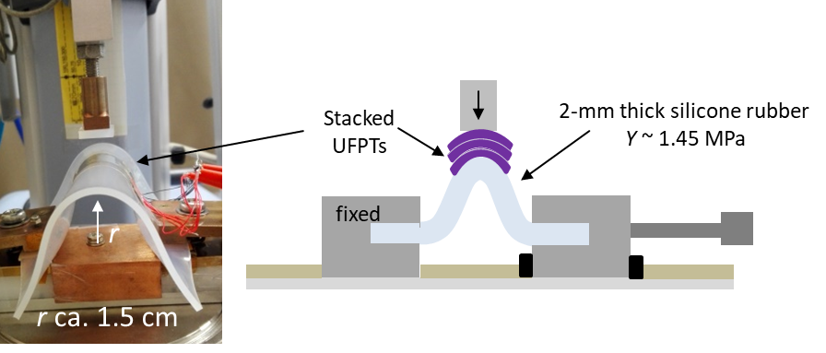

Supplementary Figure S9 | Transversal load tests: Multiple layers. Photograph and schematics of the transversal load setup for UFPTs films attached on a pre-bent silicone rubber carrier.

9. Strain tests

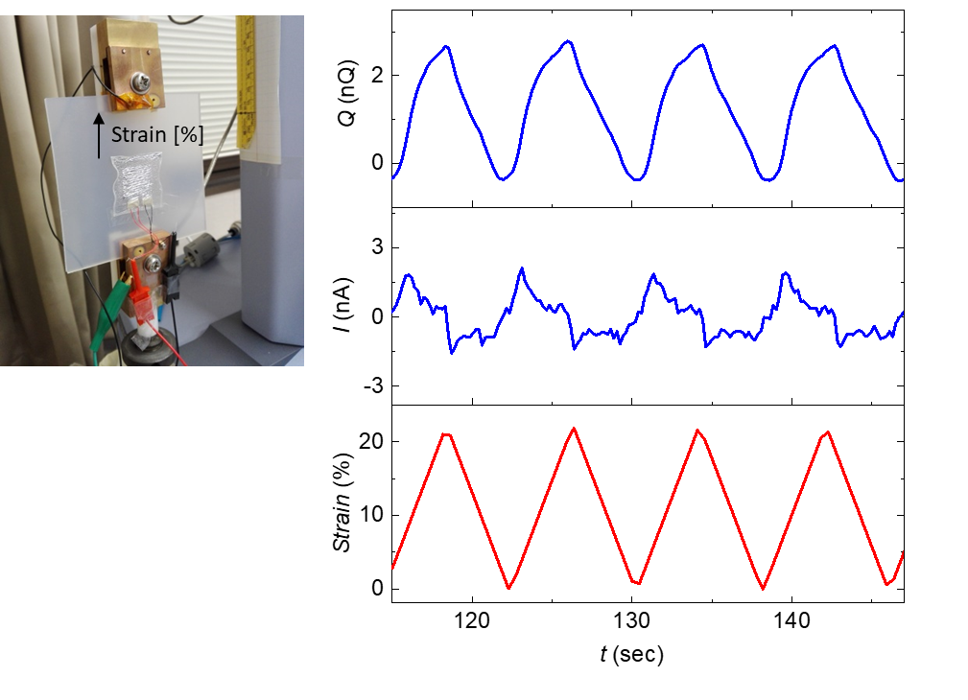

Supplementary Figure S10 | Strain tests. Photo of the strain measurement setup showing an ultraflexible transducer attached to a pre-stretched 2-mm thin silicone rubber carrier. Current and charge response are plotted for strains up to 20 %.

10. Organic diode: Vertical Schottky setup

The structure of the vertical Schottky diode is displayed in Fig. S11. A 50-nm Au electrode was thermally evaporated through a metal mask on the parylene substrate followed by PFBT-SAM (2,3,4,5,6-Pentafluorobenzenethiol, TCI chemicals) treatment. Prior to the SAM treatment, the samples were cleaned by oxygen plasma treatment at 100 W for 3 min. For the SAM treatment, the sample was immersed in a 10-mMol 2-propanol solution of PFBT for 3 h. After this immersion step, the samples were carefully rinsed with pure solvent and blown dry by nitrogen. Then, a 100-nm thick layer of DNTT was thermal evaporated at a rate of 0.3 Å s⁻¹ and a pressure of 10⁻⁴ Pa. Finally, a top electrode was formed on the DNTT surface by thermally evaporating a 100-nm thick aluminium layer through a shadow mask.
The different injection barriers between the two different metals and the organic semiconductor are used for rectification. Because of their work functions, the Al electrode blocks the injection of holes and the Au electrode permits the injection of holes. Typical current/voltage characteristics of a vertical diode are plotted in Fig. S11b, revealing a rectification ratio over 10² (between −5 V and +5 V) and a current density of about 0.3 A cm⁻² at a forward voltage of +5 V. The overall diode performance could be strongly improved by introducing a PFBT-SAM between the Au and DNTT interface. The SAM treatment results in a decrease of the injection barrier (Fig. S11a) and, as is often shown in literature^{S4–S7}, in an enhanced crystallinity and molecular packing of the organic semiconductor. The SAM-modified diodes feature a more than 30 times higher current density of 10 A cm⁻² at +5 V, and four orders of magnitude higher rectifying ratio of > 10⁶, high reverse breakdown voltages over −15 V and measured operation frequencies of a few megahertz (Fig. S11c).
However, the SAM modification layer leads to an increase in the transition voltage from V_{T} < 0.1 V to V_{T} >> 0.3 V. This built-in voltage drop across the diode is a result of the relative difference between the Au and Al work function. The PFBT-SAM modification layer further enlarges this voltage gap by elevating the work function of the Au-electrode (Fig. S11a)^{S4}. This effect deteriorates the rectifying performance of the diodes and makes it ineffective for energy harvesting applications because a part of the generated voltage is lost because of the large built-in voltage drop across the diodes. Another considerable disadvantage of the vertical diodes is that the overall device-to-device reproducibility and electrical stability are rather poor for both, SAM- and non-SAM-modified diodes, most probably caused by the oxidation processes near the aluminium/semiconductor interface.
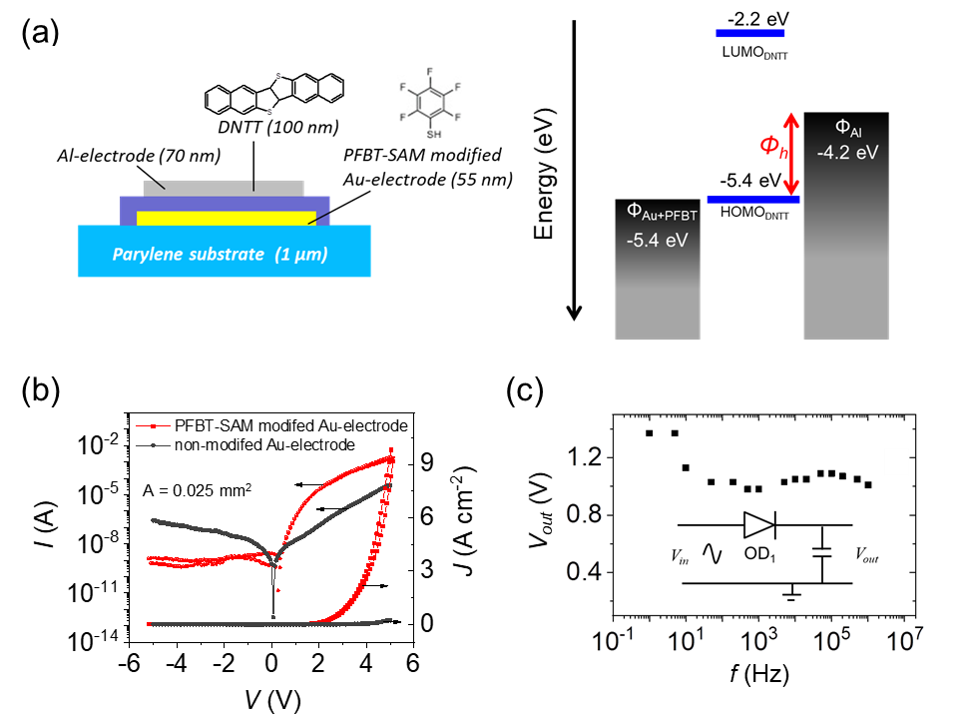
Supplementary Figure S11 | Organic diode: Vertical Schottky setup. (a) Image of a vertical organic diode stack, and schematic of approximate energy levels for the different materials in the device stack; the HOMO/LUMO levels for DNTT are from the work of Yamamoto et al.^{[S8]}. The work functions of the modified and non-modified Au and Al electrodes are from Kuzumoto et al.^{[S4]} and Kumar et al.^{[S9]}, respectively. (b) I/V and J/V curve of a vertical Schottky diode with and without PFBT SAM-modified electrodes. (c) DC-output voltage vs. frequency of an organic diode in a half-wave rectifier configuration (C = 100 nF).

Supplementary Table S3 | Comparison of the performance parameter of vertical diodes and OTFT-based diodes, both with DNTT as the active semiconducting layer.
 | Gate dielectric | OSC | J ^{a)}  (mA cm⁻²) | V_{T} ^{b)}  (V) | Rectifying ratio^{c)} | V_{break} ^{d)}  (V)
Vertical diode with PFBT | - | DNTT | 10⁴ @ 5V | 0.3–1.0 | >10⁶ | >−15
OTFT-based diode (W=27mm) | AlO_{x}+ SAM | DNTT | 105 @ 2V | <0.1 | >10⁷ | >−5
OTFT-based diode (W=7mm) | AlO_{x}+ SAM | DNTT | 75 @ 2V | <0.1 | >10⁶ | >−5
OTFT-based diode (W=0.5mm) | AlO_{x}+ SAM | DNTT | 65 @ 2V | <0.1 | >10⁵ | >−5
^{a)} Current density range of vertical Schottky and OTFT-based diodes at forward voltages of 5 V and 2 V, respectively. The channel length of the OTFTs is 12 µm, and the channel width varies between 0.5 mm and 27 mm; the area of the vertical diodes is 0.025 mm² and for the OTFT-based diodes, it is between 0.018 and 0.65 mm². ^{b)} V_{T} is the transition voltage; ^{c)} Rectifying ratio is defined as a ratio of the current in the ‘on’ (V = 5 V) and ‘off’ states (V = −5 V) for the vertical and ± 2 V for the OTFT-based diode; and ^{d)} V_{break} is the reverse breakdown voltage.

As is obvious from Table S3 the OTFT-based diodes with shorted drain-gates outperform the vertical diodes in terms of their low transition voltage, their better device-to-device reproducibility and their high electrical stability. These features are caused by the dielectric and interface properties of organic diodes in a shorted OTFT setup, where the charge carrier transport takes place at the smooth dielectric/semiconductor interface. This transport can be more easily controlled and optimised in shorted OTFT diodes than in lateral diodes, where the charge transport occurs vertically through the semiconducting layer and is prone to trapping.

11. OTFT-based organic diodes
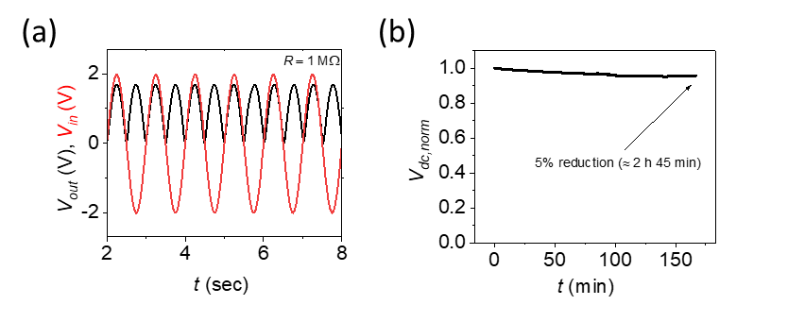
Supplementary Figure S12 | OTFT-based organic diodes. (a) AC input voltage V_{in} (red) and DC output voltage V_{out} (black) after rectification with an OTFT-based FWR circuit (OFWR) and connection to a 1 MΩ resistor. The OTFTs in the OFWR circuit have an AlO_{x} + SAM gate dielectric, a DNTT semiconductor and a W/L = 7 mm/ 12 µm. (b) Time dependence of the normalized output voltage V_{dc,norm} of OFWR for V_{in} = 3 V sin(ω∙t), f = 0.1 Hz, and C = 10 µF. After 2 h and 45 min continuous operation, V_{dc,norm} was reduced by not more than 5 %.

12. Ultraflexible energy harvesting device (UEHD)

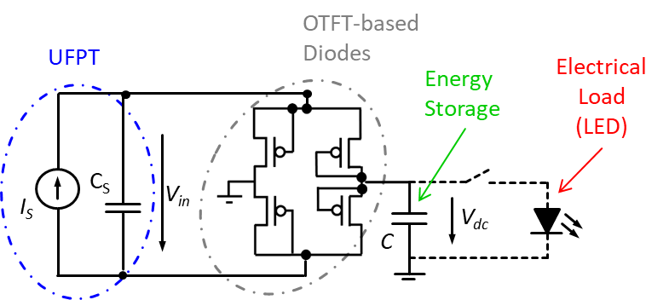

Supplementary Figure S13 | Ultraflexible energy harvesting device (UEHD). Equivalent circuit diagram of the ultraflexible energy harvesting device comprising UFPT, full wave diode-based rectifier circuit, thin film capacitor (C) and an LED as the electrical load.

13. Energy harvesting: Energy output by periodic manual bending of one UFPT (mode A)

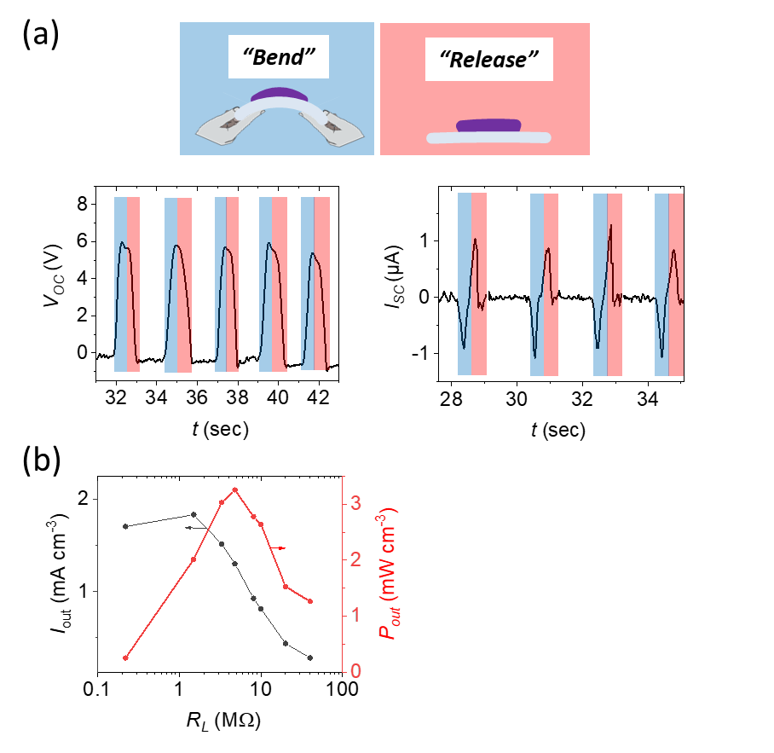
Supplementary Figure S14 | Energy harvesting: Energy output by periodic manual bending of one UFPT (mode A). (a) Time evolution of the electrical energy output of an UFPT (open circuit voltage V_{oc} and short-circuit current I_{sc}) for manual periodic bending at ~ 2 Hz, blue phase is for bending and red phase is for releasing. (b) The current density I_{out} as well as the corresponding output power density P_{out} are plotted as a function of load resistance R_{L} for such an excitation scheme.

14. Energy harvesting: UFPT bending tests on rail (mode B)
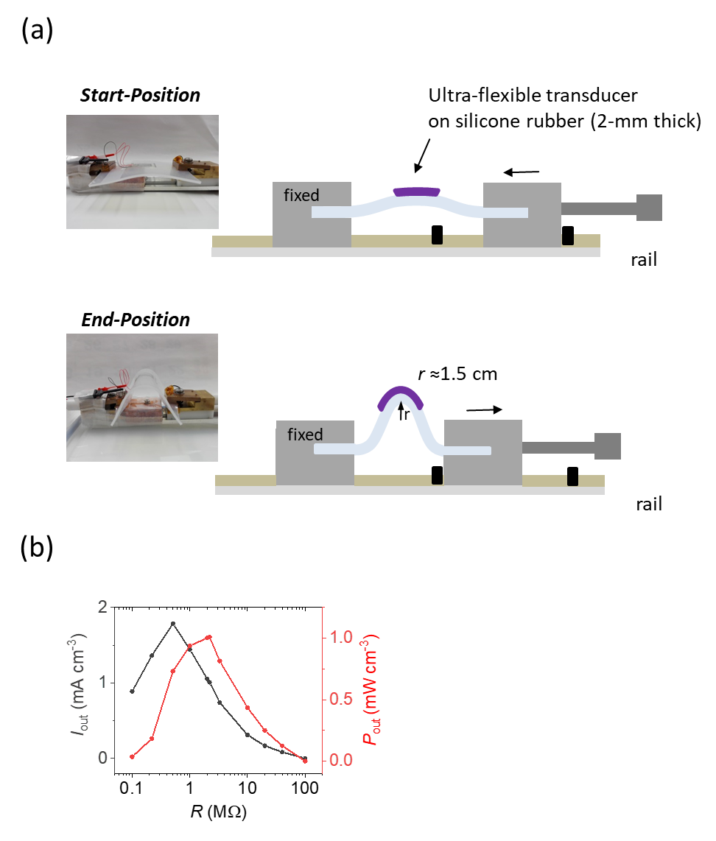

Supplementary Figure S15 | Energy harvesting: UFPT bending tests on rail (mode B). (a) Schematic image and photographs of the bending test setup on a rail. The transducer is attached on the 2-mm thick silicone rubber film fixed between two clamps on a rail, whereby one side can be moved (typically by hand) between two pre-defined positions (mode B). (b) The current density I_{out} as well as the corresponding output power density P_{out} are plotted as a function of load resistance R_{L} for such an excitation scheme.

15. Energy harvesting: Continuous pressing with fingertip on a bent transducer (mode C)

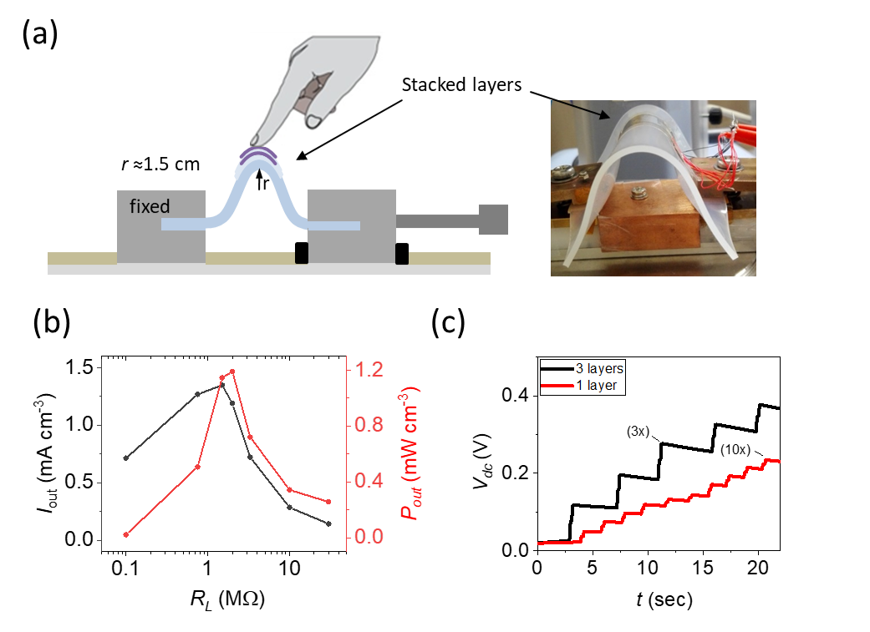
Supplementary Figure S16 | Energy harvesting: Continuous pressing with a fingertip on the bent transducer (mode C). (a) Schematic image and photograph of the energy harvesting test setup showing multiple layers of transducers stacked on a curved silicone rubber carrier. Energy is generated by continuous touching on the PENGs (stacked PENGs are connected in parallel) (mode C). (b) The current density I_{out} as well as the corresponding output power density P_{out} are plotted as a function of load resistance R_{L} for continuous pressing with a fingertip on one bent transducer. (c) Loading voltages of a 1 µF capacitor corresponding to the energy generated with either a one- or three--stacked transducers during touching. For the triple-stack PENG three times (3x) slow touching delivers the same voltage on the capacitor as 10 times (10x) fast touching of a single layer PENG.

16. Thin-film capacitor

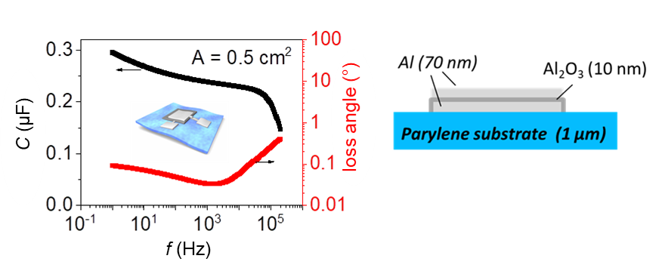

Supplementary Figure S17 | Thin-film capacitor. Schematic image and LCR measurements of an Al (60–80 nm)/Alumina (10 nm, anodized)/Al (60–80 nm) thin-film capacitor.

References
S1. Stadlober, B., Zirkl, M. & Irimia-Vladu, M. Route towards sustainable smart sensors: ferroelectric polyvinylidene fluoride-based materials and their integration in flexible electronics. Chem. Soc. Rev. 48, 1787–1825 (2019).
S2. Neumann, N., Köhler, R. & Hofmann, G. Infrared sensor based on the monolithic structure Si-P(VDF/TrFE). Ferroelectrics 171, 225–238 (1995).
S3. Furukawa, T. Ferroelectric properties of vinylidene fluoride copolymers. Phase Transitions 18, 143–211 (1989).
S4. Kuzumoto, Y. & Kitamura, M. Work function of gold surfaces modified using substituted benzenethiols: Reaction time dependence and thermal stability. Appl. Phys. Express 7, 035701 (2014).
S5. Liu, C., Xu, Y. & Noh, Y. Contact engineering in organic field-effect transistors. Mater. Today 18, 79–96 (2015).
S6. Kang, C. et al. 1 GHz Pentacene diode rectifiers enabled by controlled film deposition on SAM-Treated Au anodes. Adv. Electron. Mater. 2, 1500282 (2016).
S7. Kang, C., Shin, H. & Lee, C. High-frequency organic rectifiers through interface engineering. MRS Commun. 7, 755–769 (2017).
S8. Yamamoto, T. & Takimiya, K. Facile synthesis of highly pi-extended heteroarenes, dinaphtho 2,3-b : 2 ’,3 ’-f chalcogenopheno 3,2-b chalcogenophenes, and their application to field-effect transistors. J. Am. Chem. Soc. 129, 2224 (2007).
S9. Kumar, B., Kaushik, B. K. & Negi, Y. S. Perspectives and challenges for organic thin film transistors: materials, devices, processes and applications. J. Mater. Sci. Mater. Electron. 25, 1–30 (2014).

