Supplementary material
Table S1. Complete list of fungal infections and adverse events codes considered
Descriptive text | ICD9-CM
Dermatophytosis (other and unspecified) | 111.8, 111.9
Aspergillosis | 117.3
Other Systemic Mycoses | 117.7-118
Candida Infections  Candidiasis (all forms)  Neonatal candidiasis  Other forms of candidiasis | 112.0 – 112.9  771.7  112.81 – 112.89
Diaper dermatitis | 691.0
Otomycosis | 380.15
Itch | 698.2, 698.8, 698.9
Erythema/Skin rash | 695.1, 782.1
Dermatitis/Eczema | 698.4, 692.3, 692.9, 782.8
Edema | 782.3, 782.2
Urticaria/ Skin vescicular | 708.0, 708.3, 708.9
Pain at the application site | 682.0, 780.99
Generic allergic reaction | 995.3
Hypertrichosis | 704.1, 704.2
Hypopigmentation | 709.0
Skin atrophy | 701.8

Table S2. Complete findings regarding the treatment prescription and the treatment outcome.

A – Onychomycosis

Onychomycosis
N = 298*
More than one prescription at the first consultation | 21 (7.0)
Treatment prolongation (same ATC prescribed later) | 72 (24.2)
Antifungal switch (different ATC code during the episode) | 3 (1.0)
Tioconazole → Ketoconazole (350 days) | 1 (33.3)
Fluconazole → Terbinafine (416 days) | 1 (33.3)
Itraconazole → Terbinafine (3 days) | 1 (33.3)
ATC: Anatomical Therapeutic Code. *1 episode with ATC missing excluded

B – Skin and mucocutaneous mycoses

Skin and mucocutaneous mycoses
N = 11,622
More than one prescription at the first consultation, n (%) | 1,086 (9.3)
Treatment prolongation (same ATC prescribed later) n (%) | 724 (6.2)
Antifungal switch (different antifungal ATC code during the episode) n (%) | 91 (0.7)
Switch time (in days), mean (sd) – median (Q1-Q3) | 22 (15) - 19 (11-32)
ATC: Anatomical Therapeutic Code. *48 Patients with ATC missing excluded

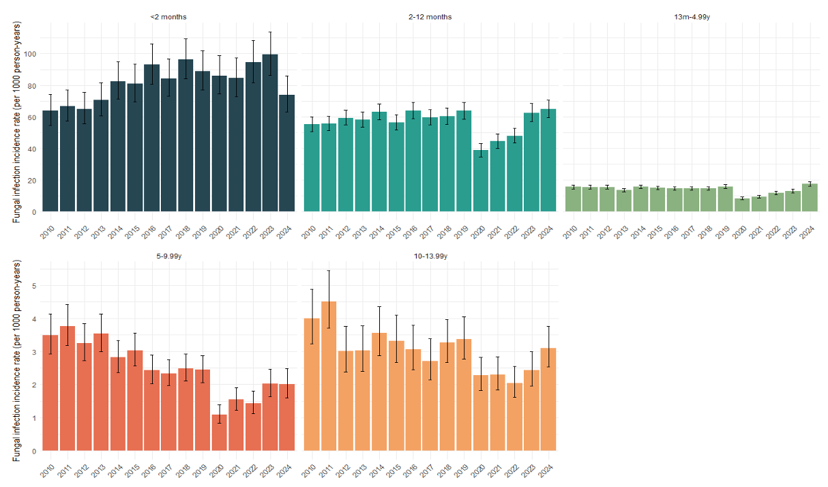
Figure S3. Annual incidence rate with 95% confidence intervals of fungal infection episodes stratified by age class.

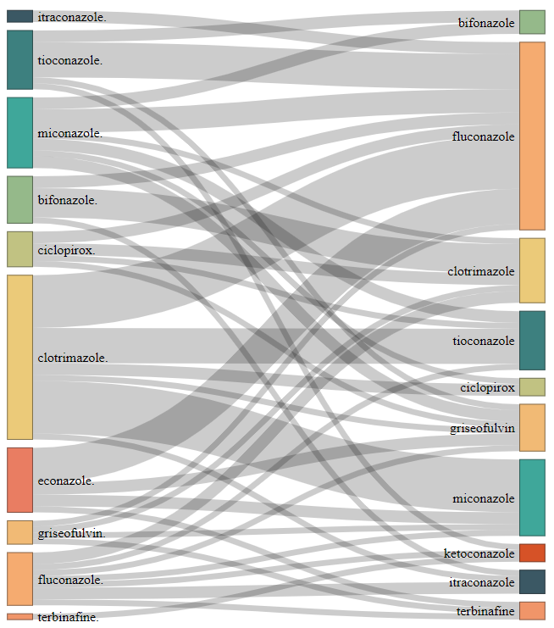
Figure S4. The Sankey diagram presents the antifungal treatment switching during the skin and mucocutaneous episodes (N = 91).

