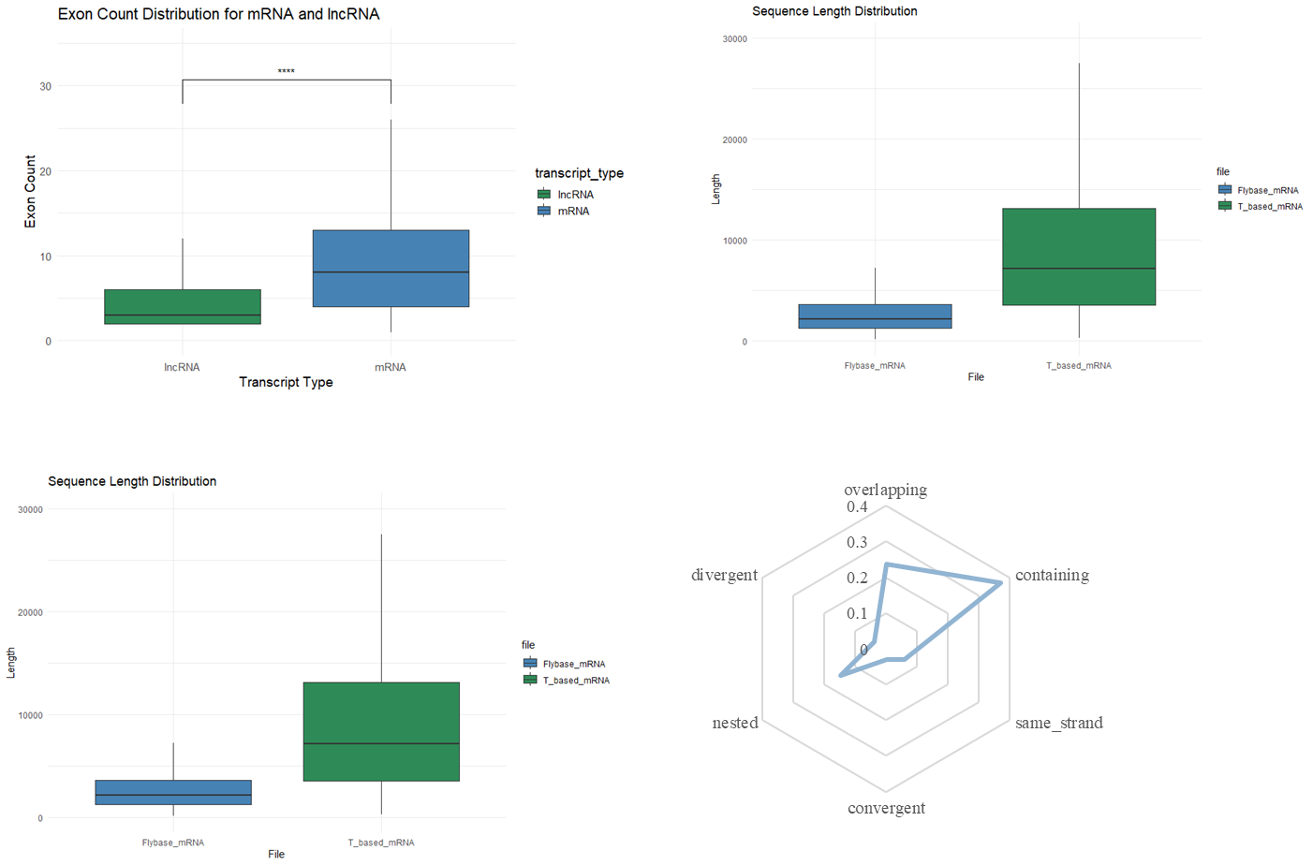
Figure S1. Comparative analysis of transcriptomic features between mRNA and lncRNA. (A) Boxplot showing the exon count distribution of mRNA and lncRNA transcripts. mRNAs exhibit significantly higher exon numbers than lncRNAs (****p < 0.0001), reflecting greater splicing complexity in protein-coding genes. (B–C) Sequence length distributions of FlyBase-annotated mRNAs (Flybase_mRNA) and de novo-assembled T-based mRNAs (T_based_mRNA). The T-based mRNAs show a broader and longer length distribution compared to reference annotations, indicating improved capture of full-length transcripts, including alternatively spliced isoforms and long non-coding variants. (D) Hexagonal plot depicting the genomic overlap patterns between T-based lncRNAs. Most overlapping regions are classified as “containing” or “same_strand”, with minimal divergent or convergent transcription.
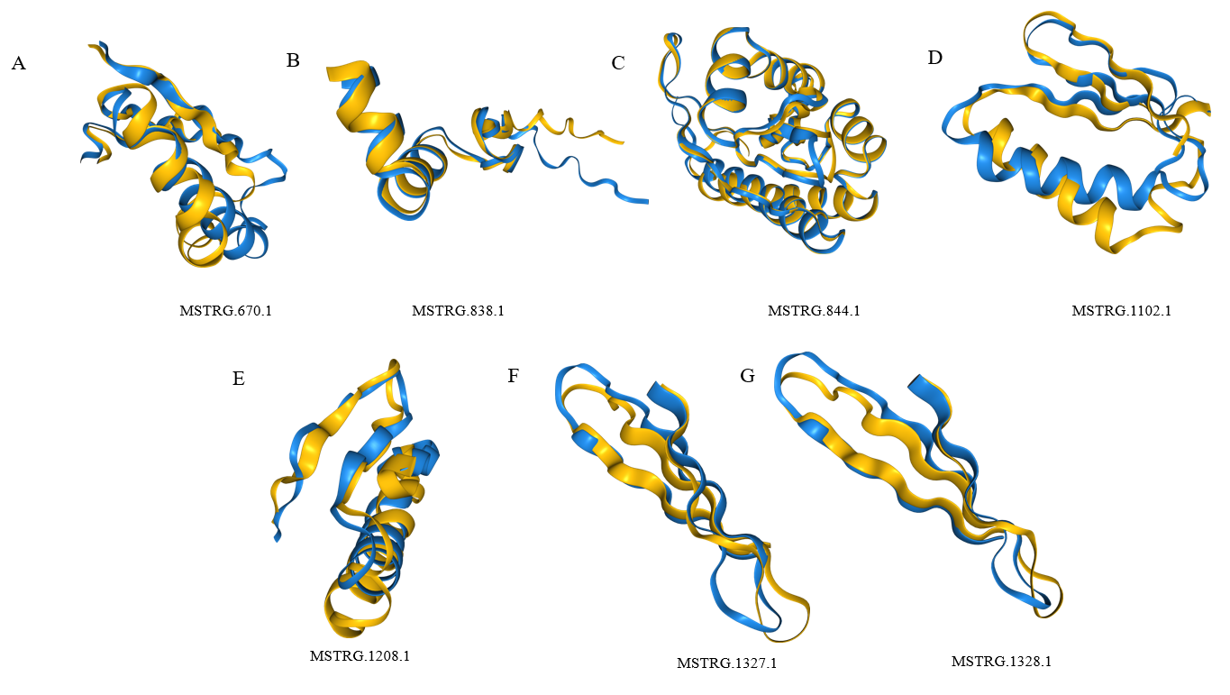
Figure S2. Structural similarity analysis of uncharacterized super-housekeeping transcripts reveals functional homologs. From left to right, top to bottom: MSTRG.670.1, MSTRG.838.1, MSTRG.844.1 (Retroviral Pol), MSTRG.1102.1, MSTRG.1208.1, MSTRG.1327.1 & MSTRG.1328.1. Structural models of six previously unannotated super-housekeeping transcripts were predicted using AlphaFold3 and compared to afdb-swissprot database via structure-based alignment. Each panel displays a ribbon diagram showing the predicted structure of an uncharacterized transcript (blue) superimposed with its top structural homolog (yellow). The high degree of structural conservation across diverse functional classes—including DNA replication, retrotransposition, signal regulation, and nucleic acid processing—suggests conserved molecular functions despite low sequence identity. These results highlight the power of deep learning-based structure prediction in uncovering hidden functional annotations for poorly characterized genes.
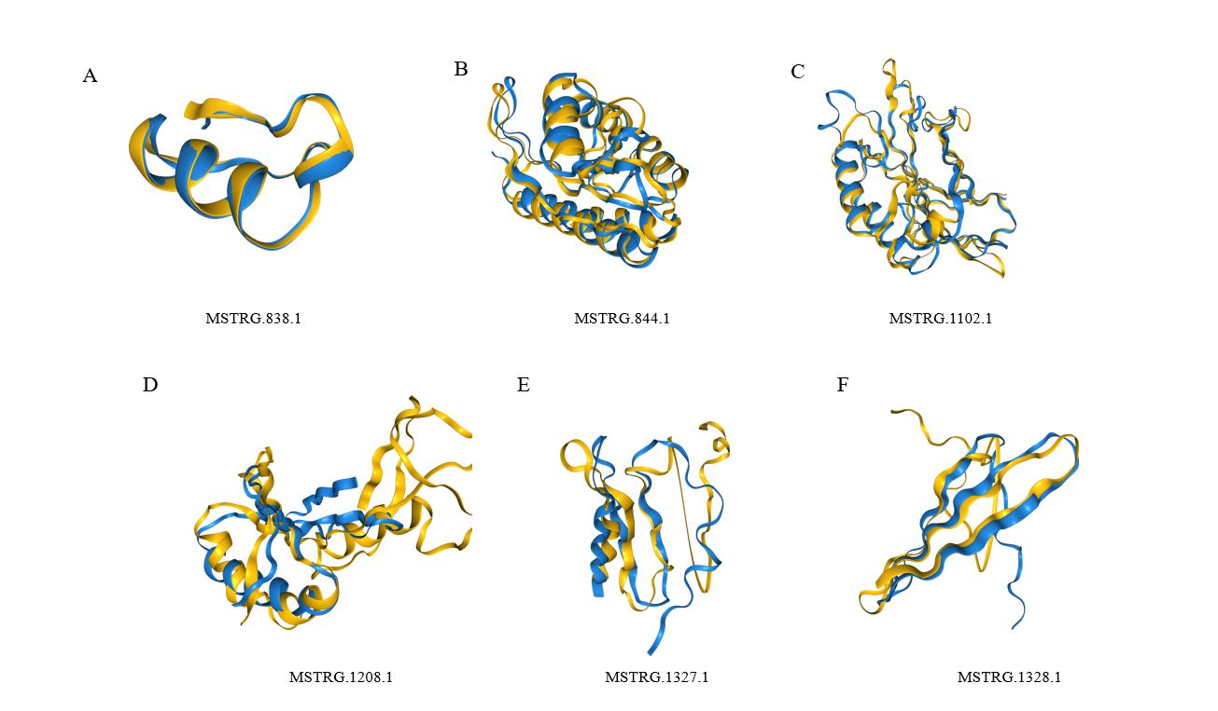
Figure S3. Structural homology of uncharacterized super-housekeeping transcripts reveals functional insights through PDB100 alignment. Structural models of six previously unannotated super-housekeeping transcripts were predicted using AlphaFold3 and structurally aligned against the PDB100 database. Each panel shows a ribbon representation of the predicted structure (blue) superimposed with its best-matching known protein structure (yellow), based on structural similarity. The high-confidence matches include: (1) a zinc finger domain (MSTRG.838.1), (2) retrotransposon endonuclease domains from Bombyx mori R2 elements (MSTRG.844.1, MSTRG.1102.1), (3) a ribosomal protein (MSTRG.1208.1), and (4) the AMPK β-subunit complexed with AMP (MSTRG.1327.1, MSTRG.1328.1). These results demonstrate that even in the absence of sequence conservation, structural similarity can reveal functional annotations for orphan genes involved in key cellular processes such as gene regulation, genome defense, translation, and energy sensing.
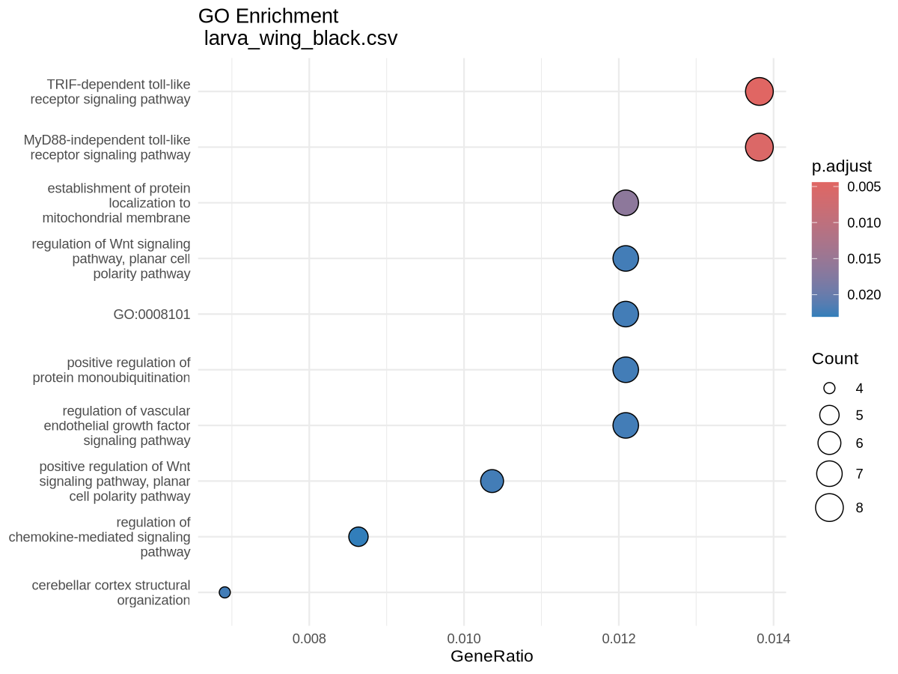
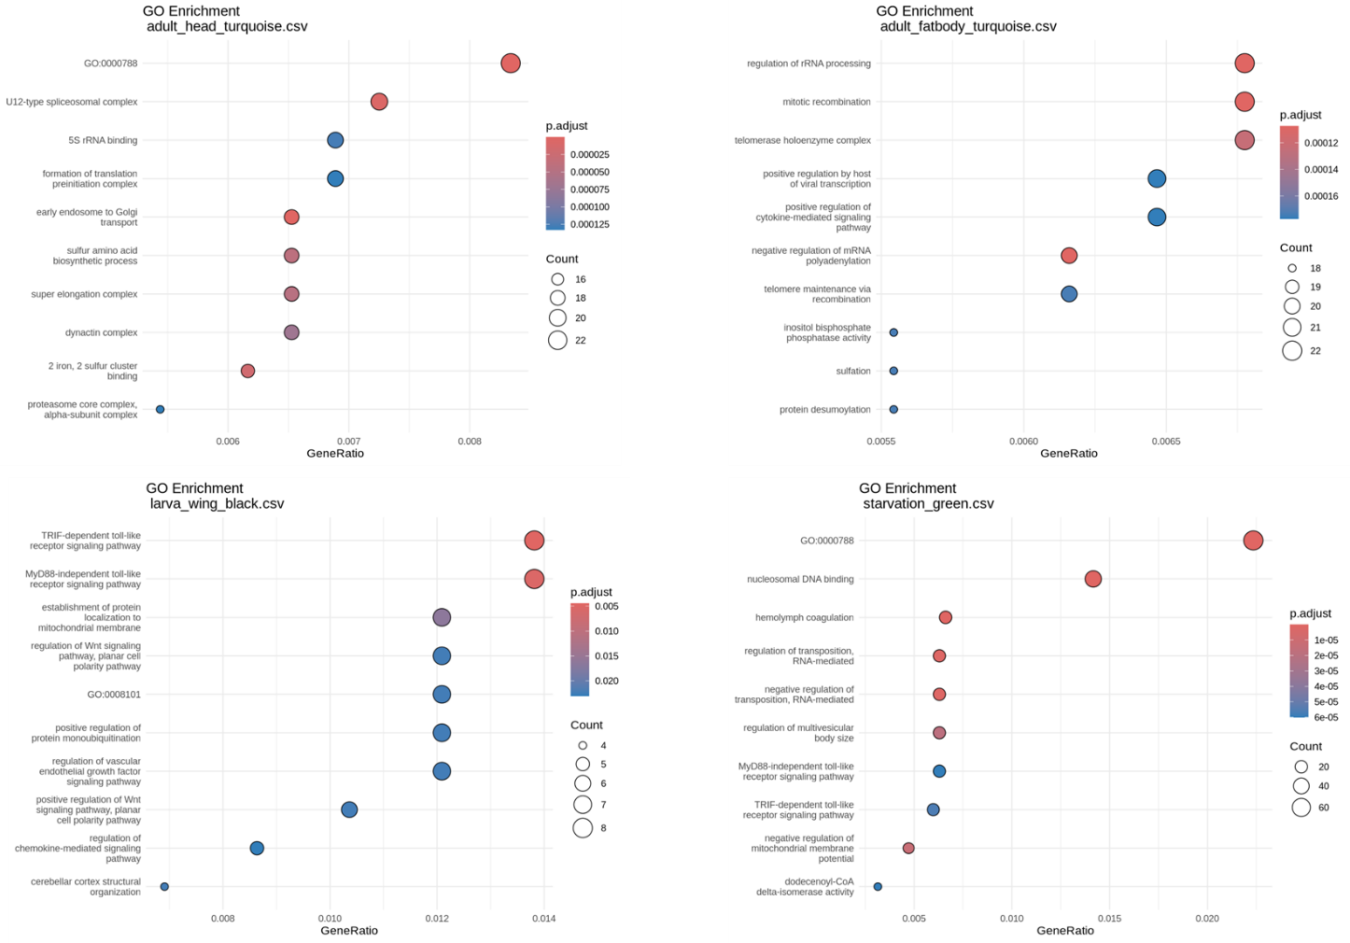
Figure S4. Functional enrichment of tissue- and stage-specific co-expression modules reveals distinct biological programs. Each panel corresponds to a WGCNA module significantly enriched in a specific tissue or developmental context (e.g., adult head, adult fat body, larval wing). Dot plots show top Gene Ontology (GO) terms significantly enriched (FDR-adjusted p < 0.05) within each module. Dot size represents the number of genes assigned to the term, and color intensity indicates statistical significance (–log₁₀(p.adjust)). The adult head “turquoise” module is enriched for translation initiation and proteasome-mediated protein catabolism; the adult fat body “turquoise” module highlights rRNA processing, cytokine signaling, and telomere maintenance; and the larval wing “black” module is associated with Toll-like receptor signaling, Wnt pathway regulation, and mitochondrial protein targeting.

