Supplementary material
Title: External validation of population pharmacokinetic models of adalimumab in adult patients with inflammatory bowel disease: Towards model-informed precision dosing
Authors: Irene Aguilo-Lafarga¹⁻³, Tonet Serés-Noriega⁴, Vicente Gimeno Ballester¹, Pilar Antonia Corsino Roche⁵, Raquel Vicente Lidon⁵, Eva Maria Sierra Moros⁵, Sonia Gallego⁵, Santiago Garcia Lopez⁵, Maria Reyes Abad Sazatornil¹.
¹ Hospital Pharmacy Service, Hospital Universitario Miguel Servet, Zaragoza, Spain.
² Hospital Pharmacy Service, Hospital Universitario San Jorge, Huesca, Spain.
³ Facultad de Medicina, Universidad de Zaragoza, Zaragoza, Spain.
⁴ Endocrinology and Nutrition, Centro Médico Milenium, Zaragoza, Spain.
⁵ Inflammatory Bowel Disease Unit, Gastroenterology and Digestive System Department, Hospital Universitario Miguel Servet, Zaragoza, Spain.
ORCID:
Irene Aguilo-Lafarga, 0000-0002-9431-6967
Tonet Serés-Noriega, 0000-0003-4974-0969
Corresponding author:
Irene Aguilo-Lafarga, Hospital Pharmacy Service, Hospital Universitario Miguel Servet, P.º de Isabel la Católica, 1-3, 50009 Zaragoza, Spain Tel: +34 976 76 55 00. E-mail: ireneaguilolafarga@gmail.com

Supplementary Table 1. Patient characteristics and adalimumab population models from literature.
 |  | Berends | FDA | Marquez | Sanchez | Ternant | Vande
Patient characteristics
Disease |  | CD | CD | CD/UC | CD/UC | CD | CD
Study design |  | Retrospective | Prospective | Retrospective | Prospective | Prospective | Prospective
Number of patients |  | 96 | 299 | 54 | 104 | 65 | 28
Sex (feminine) |  | 61 (64.0) | NA | 24 (44.4) | 46 (44.2) | 49 (75.4) | 15 (53.6)
Age (years) |  | 38 (32-44) | - | 43.5 (11–89) | 43 (32-56) | 37 (17-61) | 37 (30-49)
Weight (kg) |  | 65 (58-76) | - | 67 (35–94) | 68 (56-80) | 68 (43-109) | 66 (55-73)
Positive AAA |  | 17 (18.0) | - | 9 (16.7) | 0 | 9 (13.8) | 5 (17.9)
AAA analysis |  | Antigen-binding test | ELISA | Double-antigen ELISA | ELISA | Double-antigen ELISA | In-house developed drug-resistant AAA assay
Dosing regimen | EW | 24 (25.0) | - | 0 (0) | - | 30 (46.2) | 0 (0)
Dosing regimen | EOW | 72 (75.0) | - | 65 (100) | - | 35 (53.8) | 28 (100)
BMI (kg/m²) |  | - | - | 22.8 (14.1–32.0) | 23.7 (21.1-27.1) | - | 22.6 (19.1-24.3)
UDASC |  | - | - | - | 9 (8.7) | - | -
LBW (kg) |  | - | - | - | 60.0 (51.2-67.3) | - | 47.8 (43.6-54.7)
ALB (g/dL) |  | 4.3 (4.0-4.5) | - | 3.86 (1.97–4.96) | 4.5 (4.3-4.7) | - | 3.99 (3.64-4.37)
FCP (mg/kg) |  | - | - | 513 (25–3600) | 74 (17-282) | - | -
Pen | 40mg | - | - | - | 275 (90.8) ∫ | 65 (100.0) | -
Pen | 80mg | - | - | - | 28 (9.2) ∫ | 0 (0) | -
Estimates (%RSE)
Proportional error |  | 0.30 (9) | 0.32 (NA) | 0.547 (8.4) | 0.22 (13) | 0.15 (16) | -16.6 (0.07)
Additive error (mg/L) |  | 1.02 (23) | - | - | - | 1.8 (8) | -
CL/F (L/d) |  | 0.32 (8) | 0.30 (4.24) | 0.75 (10.9) | 0.38 (3) | 0.42 (9) | 0.33 (0.02)
V_{d}/F (L) |  | 4.07 (27) | 9.39 (3.25) | 7.76 (24.1) | 11.2 (9) | 13.5 (10) | 7.8 (0.07)
Ka (d⁻¹) |  | 0.2 (fix) | 0.648 (fix) | 0.15 (fix) | 0.15 (fix) | 0.15 (fix) | 0.34 (0.1)
AAA-CL/F |  | 3.14 (24) | - | 4.5 (fix) | - | 4.5 (NA) | 1.59 (18.1)
Dosing-CL/F |  | 0.40 (23) | - | - | - | - | -
BMI-CL/F |  | - | - | - | 1.11 (16) | - | -
LBW-CL/F |  | - | - | - | - | - | 1.97 (0.5)
ALB-CL/F |  | - | - | 0.667 (15.5) | - | -
UDASC-CL/F |  | - | - | - | 1.20 (28) | - | -
FCP-CL/F |  | - | - | - | 0.06 (24) | - | -
Pen-CL/F |  | - | - | - | 0.24 (35) | - | -
IIV-CL/F |  | 49.1 (12) | 0.227 (18.4) | 0.667 (15.5) | 23.2 (9) | 65 (10) | 0.326 (0.2)
IIV-V_{d}/F |  | - | 0.123 (19.8) | 0.477 (33.9) | - | 48 (19) | 0.356 (0.04)
IIV-Ka |  | - | - | - | - | - | 1.039 (1.1)
Data are shown as n (percentage within each column), mean (SD) or median (Q1-Q3).
∫Data calculated on the total number of samples analyzed.
AAA: anti-adalimumab antibodies; ALB: serum albumin; BMI: Body mass index; CD: Crohn’s disease; CL/F: apparent clearance; EW: every week; EOW: every other week; FCP: faecal calprotectin; IIV-CL/F: interindividual variability on clearance; IIV-V_{d}/F: interindividual variability on volume of distribution; fix: fixed parameter; Ka: first-order absorption constant rate; LBW: lean body weight; NA: not available; Pen: adalimumab pen device; RSE: residual standard error; UC: ulcerative colitis; UDASC: unexplained decline in adalimumab serum concentrations; V_{d}/F: apparent volume of distribution.

Supplementary Table 2. Mathematical equations describing the six population pharmacokinetic models of adalimumab in patients with inflammatory bowel disease evaluated.
Population pharmacokinetic models (popPK)
Berends | $$\frac{CL}{F} \left(\frac{L}{h}\right)=0,324x\left(1+3,14 x AAA\right)x\left(1+0,40 x DOSING\right)$$
FDA | $$\frac{V_{d}}{F}(L)=9,39+0,126 (WT -72)) \frac{CL}{F}\left(\frac{L}{h}\right)=0,0127$$
Marquez | $$\frac{CL}{F}\left(\frac{L}{h}\right)=CLpop x\left(1+ AAA x {Cov}_{AAA -\frac{CL}{F}} \right)x{\left(\frac{ALB}{mALB}\right)}^{{Cov}_{AAA -\frac{CL}{F}}}$$
Sanchez | $$\frac{CL}{F}\left(\frac{L}{h}\right)=0,0157x {\left(\frac{IMC}{23,7}\right)}^{1,11}x \left(1+1,20 x UDASC\right) x \left(1+0,24xPEN\right)x{\left(\frac{FCP}{74}\right)}^{0,064}$$
Ternant | $$\frac{CL}{F}\left(\frac{L}{h}\right)=0,42 x (1+4,5 x AAA )$$
Vande | $$\frac{CL}{F}\left(\frac{L}{h}\right)=0,01375 x \left(1+1,59 x AAA\right) x{\left(\frac{LBW}{47,81}\right)}^{1,97}$$
AAA: anti-adalimumab antibodies; ALB: serum albumin; BMI: Body mass index; CL/F: apparent clearance; DOSING: (0: Every other week, 1: Every week); FCP: faecal calprotectin; LBW: lean body weight; PEN: adalimumab pen device (0: 40mg; 1: 80 mg); UDASC: unexplained decline in adalimumab serum concentrations (0: No, 1: Yes); V_{d}/F: apparent volume of distribution.

Supplementary Table 3. Montreal classification of inflammatory bowel disease among participants.
Montreal classification
(n=201)
Ulcerative colitis (n=24) | Extension | Proctitis | 4 (16.7)
Ulcerative colitis (n=24) | Extension | Left-side colitis | 11 (45.8)
Ulcerative colitis (n=24) | Extension | Pancolitis | 9 (37.5)
Crohn’s disease  (n=177) | Age at diagnosis | ≤ 16 years | 15 (8.5)
Crohn’s disease  (n=177) | Age at diagnosis | 16-40 years | 83 (46.9)
Crohn’s disease  (n=177) | Age at diagnosis | >40 years | 79 (44.6)
Crohn’s disease  (n=177) | Location | Ileal | 93 (52.5)
Crohn’s disease  (n=177) | Location | Colonic | 21 (11.9)
Crohn’s disease  (n=177) | Location | Colonic, upper gastrointestinal disease | 1 (0.6)
Crohn’s disease  (n=177) | Location | Ileocolonic | 62 (35.0)
Crohn’s disease  (n=177) | Behavior | Nonstricturing, nonpenetrating | 94 (54.1)
Crohn’s disease  (n=177) | Behavior | Stricturing | 53 (29.9)
Crohn’s disease  (n=177) | Behavior | Penetrating | 30 (17.0)
Crohn’s disease  (n=177) | Perianal disease |  | 27 (15.3)
Data are shown as n (percentage within each IBD group).

Supplementary Figure 1. Distribution of the mean predicted error (MPE) simulated by bootstrap across the different models.
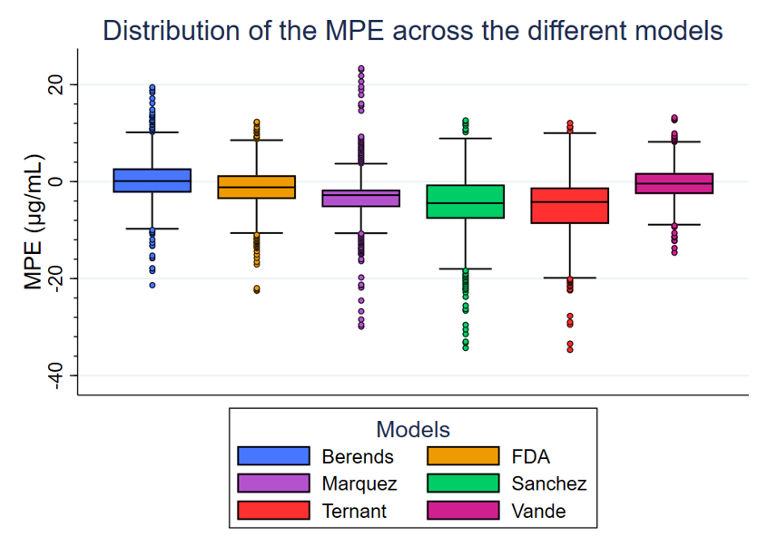

Supplementary Figure 2. Distribution of the mean absolute predicted error (MAPE) simulated by bootstrap across the different models.
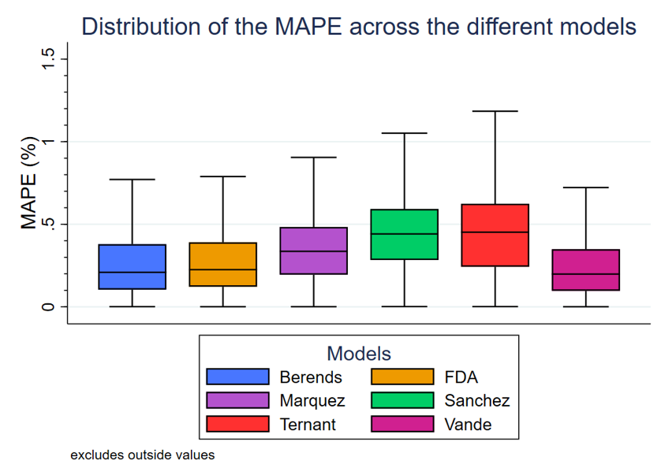

Supplementary Figure 3. Distribution of the root mean squared error (RMSE) simulated by bootstrap across the different models.
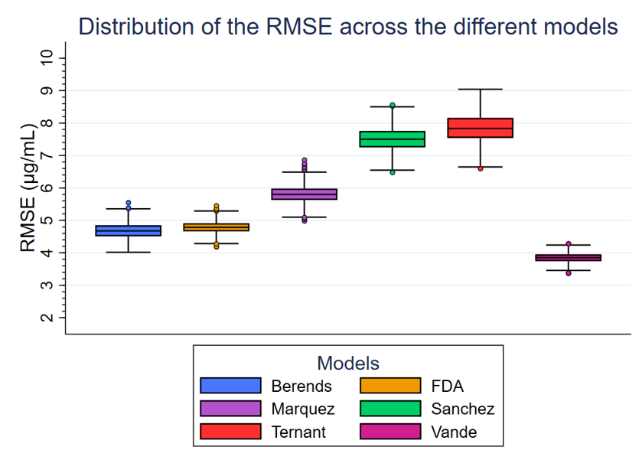

Supplementary Figure 4. Analysis of the residuals among models.
From left to right: distribution of the residuals, scatter plot of the residuals vs. individual prediction and vs. time.

