TableS1
name | Average Shortest Path Length | Betweenness Centrality | Closeness Centrality | Clustering Coefficient | Degree
SACM1L | 1.0926 | 0.1221 | 0.9153 | 0.5782 | 49
PI4K2B | 1.1111 | 0.0697 | 0.9000 | 0.6082 | 48
GNPAT | 1.1296 | 0.0407 | 0.8852 | 0.6318 | 47
CEPT1 | 1.1296 | 0.0326 | 0.8852 | 0.6346 | 47
DDHD1 | 1.1481 | 0.0211 | 0.8710 | 0.6609 | 46
ABHD3 | 1.1667 | 0.0511 | 0.8571 | 0.6727 | 45
PIK3CB | 1.1667 | 0.0172 | 0.8571 | 0.6838 | 45
MTMR6 | 1.1667 | 0.0172 | 0.8571 | 0.6838 | 45
PLD1 | 1.1852 | 0.0141 | 0.8438 | 0.7040 | 44
ETNK1 | 1.1852 | 0.0141 | 0.8438 | 0.7040 | 44
LYPLA1 | 1.2037 | 0.0106 | 0.8308 | 0.7298 | 43
MTM1 | 1.2037 | 0.0252 | 0.8308 | 0.7165 | 43
PIK3CA | 1.2037 | 0.0106 | 0.8308 | 0.7298 | 43
RAB5A | 1.2037 | 0.0130 | 0.8308 | 0.7165 | 43
PLEKHA3 | 1.2222 | 0.0092 | 0.8182 | 0.7503 | 42
OSBPL8 | 1.2593 | 0.0068 | 0.7941 | 0.7897 | 40
PIKFYVE | 1.2593 | 0.0068 | 0.7941 | 0.7897 | 40
CPNE3 | 1.3148 | 0.0045 | 0.7606 | 0.8393 | 37
RAB14 | 1.3333 | 0.0036 | 0.7500 | 0.8603 | 36
SYNJ1 | 1.3333 | 0.0037 | 0.7500 | 0.8603 | 36
SLC44A1 | 1.3889 | 0.0015 | 0.7200 | 0.9261 | 33
INPP5F | 1.3889 | 0.0014 | 0.7200 | 0.9280 | 33
PIK3C2A | 1.3889 | 0.0014 | 0.7200 | 0.9261 | 33
MTMR9 | 1.4074 | 0.0010 | 0.7105 | 0.9476 | 32
PIK3CG | 1.4074 | 0.0009 | 0.7105 | 0.9496 | 32
GPCPD1 | 1.4444 | 0.0012 | 0.6923 | 0.9355 | 31
CPNE6 | 1.4259 | 0.0450 | 0.7013 | 0.8129 | 31
LPGAT1 | 1.5000 | 0.0002 | 0.6667 | 0.9841 | 28
HADHB | 1.5185 | 0.0002 | 0.6585 | 0.9801 | 27
PTEN | 1.5185 | 0.0000 | 0.6585 | 1.0000 | 27
PLEKHA2 | 1.5185 | 0.0000 | 0.6585 | 1.0000 | 26
PITPNB | 1.5370 | 0.0000 | 0.6506 | 1.0000 | 26
MTMR12 | 1.5556 | 0.0007 | 0.6429 | 0.9529 | 24
PIK3R1 | 1.6111 | 0.0000 | 0.6207 | 1.0000 | 22
PLA2G4A | 1.6296 | 0.0000 | 0.6136 | 1.0000 | 21
LPCAT2 | 1.6481 | 0.0000 | 0.6067 | 1.0000 | 20
FIG4 | 1.6481 | 0.0000 | 0.6067 | 1.0000 | 20
DGKQ | 1.6667 | 0.0000 | 0.6000 | 1.0000 | 19
PIP5K1A | 1.6667 | 0.0000 | 0.6000 | 1.0000 | 19
CHKB | 1.6852 | 0.0000 | 0.5934 | 1.0000 | 18
AGPAT1 | 1.7037 | 0.0000 | 0.5870 | 1.0000 | 16
AGPAT3 | 1.7037 | 0.0000 | 0.5870 | 1.0000 | 16
PNPLA8 | 1.7407 | 0.0000 | 0.5745 | 1.0000 | 15
AGK | 1.7778 | 0.0000 | 0.5625 | 1.0000 | 14
SLC44A2 | 1.7778 | 0.0000 | 0.5625 | 1.0000 | 13
PCTP | 1.9259 | 0.0000 | 0.5192 | 1.0000 | 8
STARD7 | 1.9259 | 0.0000 | 0.5192 | 1.0000 | 6
MFSD2A | 1.9815 | 0.0000 | 0.5047 | 1.0000 | 3
PIP4K2B | 2.0370 | 0.0000 | 0.4909 | 1.0000 | 3
PIK3R4 | 2.0556 | 0.0000 | 0.4865 | 1.0000 | 2
GPD2 | 2.1481 | 0.0000 | 0.4655 | 0.0000 | 1
PIP5K1C | 2.4074 | 0.0000 | 0.4154 | 0.0000 | 1
PLEKHA8 | 2.0926 | 0.0000 | 0.4779 | 0.0000 | 1
PIK3C2B | 2.0741 | 0.0000 | 0.4821 | 0.0000 | 1
MBOAT7 | 1.0000 | 0.0000 | 1.0000 | 0.0000 | 1
DGAT2 | 1.0000 | 0.0000 | 1.0000 | 0.0000 | 1
PIK3R3 | 2.0741 | 0.0000 | 0.4821 | 0.0000 | 1

Table S2
Gene | Fold change | Average (Asthma) | P value | Average (Healthy)
ABHD3 | 0.2369 | 1.9699 | 1.009E-10 | 8.3154
AGPAT1 | 2.3232 | 0.3042 | 1.009E-10 | 0.1309
AGPAT3 | 1.7596 | 2.3519 | 2.243E-12 | 1.3367
CEPT1 | 0.4993 | 1.1847 | 4.410E-08 | 2.3730
CHKB | 0.4023 | 1.4815 | 4.261E-11 | 3.6828
CPNE6 | 1.4995 | 1.8587 | 4.512E-09 | 1.2395
DDHD1 | 0.3607 | 3.2550 | 3.481E-09 | 9.0250
ETNK1 | 0.3134 | 1.2774 | 6.577E-08 | 4.0763
FIG4 | 0.5472 | 19.4502 | 4.242E-06 | 35.5476
GNPAT | 0.4519 | 0.7919 | 2.660E-09 | 1.7522
GPCPD1 | 0.3988 | 9.7526 | 9.664E-08 | 24.4527
HADHB | 0.5649 | 1.9833 | 4.512E-09 | 3.5111
INPP5F | 0.6131 | 0.7397 | 1.383E-06 | 1.2065
LPCAT2 | 0.5081 | 1.9126 | 2.121E-05 | 3.7640
LPGAT1 | 0.5812 | 1.2461 | 2.121E-05 | 2.1442
LYPLA1 | 0.2839 | 0.6637 | 1.009E-10 | 2.3376
MFSD2A | 1.3864 | 1.7886 | 4.242E-06 | 1.2901
MTM1 | 0.4750 | 2.2493 | 3.239E-06 | 4.7350
MTMR6 | 0.3691 | 2.4971 | 8.804E-07 | 6.7659
MTMR9 | 0.6115 | 1.2005 | 6.446E-07 | 1.9631
OSBPL8 | 0.4877 | 2.0670 | 5.139E-05 | 4.2384
PCTP | 0.7557 | 1.7428 | 1.680E-05 | 2.3060
PI4K2B | 0.3979 | 0.9457 | 6.446E-07 | 2.3767
PIK3CA | 0.3726 | 0.7433 | 2.348E-08 | 1.9951
PIK3CB | 0.5015 | 2.0458 | 1.039E-05 | 4.0795
PIK3CG | 0.6019 | 2.8116 | 6.343E-05 | 4.6712
PIK3R1 | 0.5882 | 1.9150 | 7.797E-05 | 3.2556
PIKFYVE | 0.5096 | 1.0876 | 5.497E-07 | 2.1344
PIP4K2B | 2.9560 | 1.5865 | 2.981E-05 | 0.5367
PITPNB | 0.6629 | 0.9332 | 2.005E-07 | 1.4079
PLA2G4A | 0.5816 | 0.7375 | 2.823E-06 | 1.2681
PLD1 | 0.3983 | 1.5705 | 1.518E-09 | 3.9426
PLEKHA2 | 0.5130 | 1.7048 | 7.542E-07 | 3.3231
PLEKHA3 | 0.4485 | 1.6927 | 1.601E-06 | 3.7737
PNPLA8 | 0.6940 | 2.4566 | 4.676E-07 | 3.5400
PTEN | 0.5645 | 0.9694 | 4.843E-06 | 1.7174
RAB14 | 0.4046 | 2.0925 | 1.507E-08 | 5.1721
RAB5A | 0.4096 | 0.7247 | 5.817E-09 | 1.7691
SACM1L | 0.4034 | 1.8296 | 2.823E-06 | 4.5354
SLC44A1 | 0.4916 | 1.1907 | 6.446E-07 | 2.4221
SLC44A2 | 2.5343 | 3.3265 | 2.836E-07 | 1.3126
SYNJ1 | 0.5287 | 2.7153 | 9.547E-05 | 5.1362

Full uncropped Gels and Blots image
FIG4
MFSD2A
HADHB
PCTP
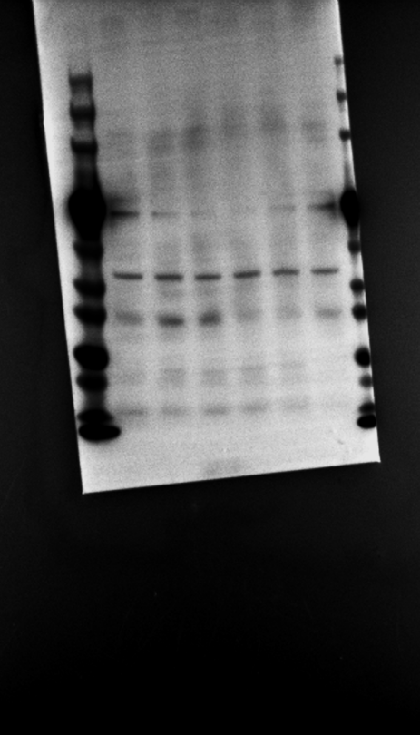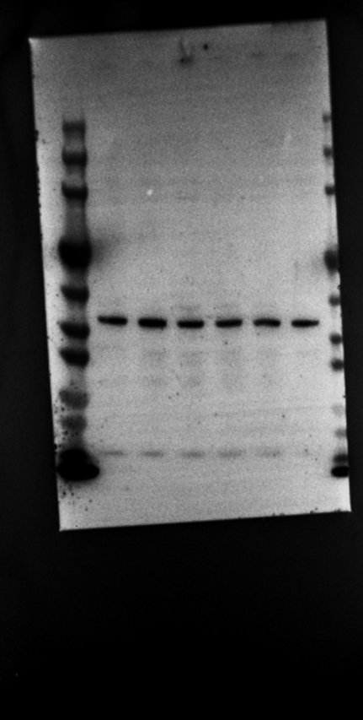

Target protein bands are shown in the left panel, and β-actin (loading control) bands are shown in the right panel. In each panel, the three left lanes represent the control group, and the three right lanes represent the experimental group.

