Supplementary Material
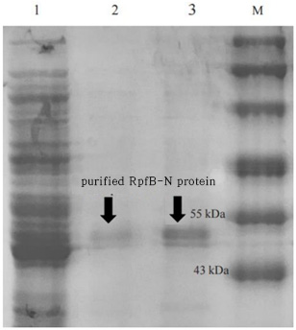
Figure S1. RpfB Purified Protein
M: Protein Marker, 1: RpfB crude protein, 2 : RpfB protein eluted with 10 mM imidazole buffer, 3: Purified RpfB protein eluted with 50 mM imidazole buffer
Table S1. Protein and polysaccharide contents of N. antarcticus
Classification | culture supernatant | High-molecular solution | Low-molecular solution
protein concentration (mg/mL) | 0.798 | 4.480 | 0.315
polysaccharide concentration (mg/mL) | 2.51 | 11.09 | 0.22

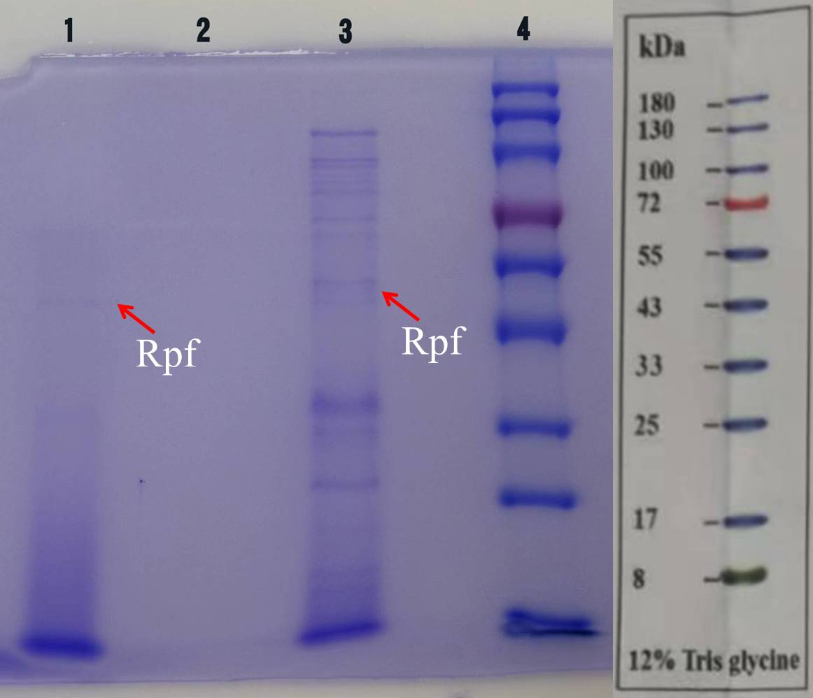.
Figure S2 : SDS-PAGE protein electrophoresis of culture supernatant of N. antarcticus
1: culture supernatant, 2: low-molecular solution, 3: high-molecular solution, 4: Protein Marker
Table S2. Absorbance (OD₆₀₀) of dilution series of soil samples.
Dilution series  Absorbance |  | 10⁻⁵ | 10⁻⁶ | 10⁻⁷ | 10⁻⁸ | 10⁻⁹ | 10⁻¹⁰ | 10⁻¹¹ | 10⁻¹²
OD₆₀₀ | 1 | 0.594 | 0.610 | 0.621 | 0.584 | 0.045 | 0.046 | 0.045 | 0.045
OD₆₀₀ | 2 | 0.508 | 0.532 | 0.543 | 0.647 | 0.045 | 0.045 | 0.046 | 0.045
OD₆₀₀ | 3 | 0.553 | 0.526 | 0.527 | 0.564 | 0.594 | 0.045 | 0.045 | 0.045
control |  | 0.046 | 0.045 | 0.045 | 0.046 | 0.047 | 0.045 | 0.046 | 0.045
R2A liquit medium, 20℃, 7d thermostatic shaking culture
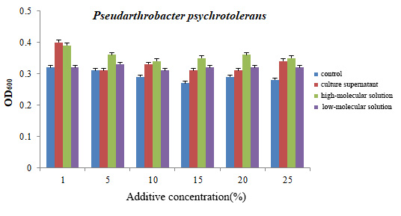
Figure S3. Effect of N. antarcticus culture supernatant on the growth of P. psychrotolerans
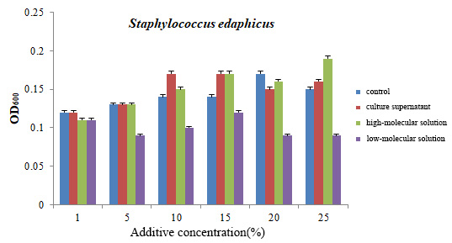
Figure S4. Effect of N. antarcticus culture supernatant on the growth of S. edaphicus
Table S3. Bacterial diversity index of soil samples treated with N. antarcticus culture supernatant
Classification | OUT  (number) | Shannon | Simpson | Sobs | Coverage
control | 5078 | 6.2145 | 0.0072 | 4128.3478 | 0.9824
culture supernatant | 6656 | 6.4734 | 0.0058 | 4924.2865 | 0.9831
high-molecular solution | 7098 | 6.7648 | 0.0041 | 5186.3642 | 0.9835
low-molecular solution | 4863 | 6.1456 | 0.0076 | 4036.6824 | 0.9823

