Supplementary Information

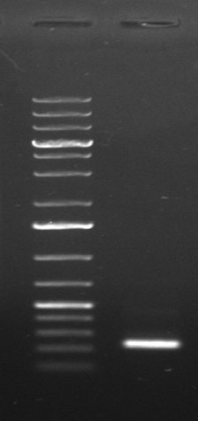

Figure S1. Full uncropped gel image corresponding to Figure 3A, showing amplification of the 238 bp 3′UTR fragment. The image is presented as obtained directly from the gel documentation system.

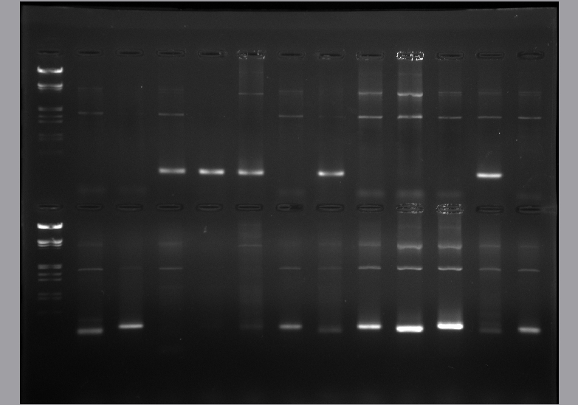

Figure S2. Full uncropped gel image corresponding to Figure 3B, confirming amplification of the 238 bp 3′UTR fragment in all samples. The image is shown in its original, unmodified form.

