Supplementary information
Supplementary Materials and Methods
DNA extraction and amplicon sequencing.
Fungal community profiling.
Determination of the abundance of Fusarium pseudograminearum by real-time quantitative PCR .
Growth of Fusarium pseudograminearum in response to nitrogen supply forms and iron supply.
Identification of nitrogen-responsive ASVs in wheat rhizosphere.
Co-occurrence network analysis and the identification of keystone taxa in wheat rhizosphere.
Soil physicochemical characteristics.
Statistical pipeline for model selection, validation and attribution.
Visualization of iron uptake in response to nitrogen supply forms and Fusarium pseudograminearum inoculation.
Bacterial isolation and identification.
Determination of siderophore production of bacterial isolates.
Phylogenetic tree of cultivable bacteria isolates.
Antagonistic assay of siderophore-producing bacteria against Fusarium pseudograminearum.
Counting siderophore-producing bacteria in pot Experiment 2.
Transcriptional analysis of Fusarium pseudograminearum when co‑cultured with isolated siderophore-producing bacteria.
Field harvest and persistence distribution analysis of root endosphere ASVs.
Supplementary Figures (Figure 1 to Figure 28)
Supplementary Tables (Table 1 to Table 13)
Supplementary references

Supplementary Materials and Methods

DNA extraction and amplicon sequencing
In pot Experiment 1, soil DNA was extracted using the MP FastDNA™ SPIN Kit for Soil (MP Biomedicals, Santa Ana, CA, United States) following the manufacturer’s protocol. Briefly, 0.5 g soil sample was added to a Lysing Matrix E tube, followed by the addition of Sodium Phosphate Buffer and MT Buffer. Samples were homogenized in a FastPrep® instrument at 6.0 m s⁻¹ for 40 s to disrupt cell walls and release nucleic acids. The homogenized samples were centrifuged at 14,000 × g for 10 min to precipitate debris, and the supernatant was transferred to a clean tube. DNA was then purified using the Binding Matrix and eluted in DES (DNase / Pyrogen-Free Water).
The V4-V5 region of the 16S rRNA gene for bacteria was amplified using universal primers 515F (5’-GTGCCAGCMGCCGCGGTAA-3’) and 907R (5’-CCGTCAATTCMTTTRAGTTT-3’). The ITS2 region for fungi was amplified using primers ITS9F (5’-GAACGCAGCRAANNGYGA-3’) and ITS4R (5’-TCCTCCGCTTATTGATATGC-3’)^{1,2}. The PCR reaction mixture included 4 μl 5 × Fast Pfu buffer, 2 μl 2.5 mM dNTPs, 0.8 μl of each primer (5 μM), 0.4 μl Fast Pfu polymerase, 10 ng of template DNA, and double-distilled H₂O to a final volume of 20 μl. The thermal cycling conditions for bacterial PCR were as follows: initial denaturation at 95 °C for 3 min, followed by 40 cycles of denaturation at 95 °C for 30 s, annealing at 55 °C for 30 s, and extension at 72 °C for 45 s, with a final extension at 72 °C for 10 min. Fungal PCR was performed for 35 cycles. PCR products were purified and quantified prior to subjecting to high throughput sequencing using Illumina MiSeq PE300 platform (Illumina, San Diego, USA) at Shanghai Majorbio Bio-Pharm Technology Co., Ltd., Shanghai, China, generating paired-end reads (2 × 300 bp)³.

Fungal community profiling
To identify the dominant fungal taxa associated with Fusarium crown rot (FCR) in wheat roots, we performed differential abundance analysis using STAMP v2.1.3, comparing rhizosphere samples between diseased and healthy wheat roots in the field trials. Amplicon sequence variant (ASV) counts were normalized by the total sum scaling; taxa presented in ≥20% of samples and comprising ≥0.01% of reads were tested using two‑sided White’s nonparametric t‑tests with Benjamini–Hochberg FDR correction (q < 0.05) to compare fungal communities in wheat roots between healthy and diseased treatments. Only fungal species with FDR-corrected q < 0.05 were displayed in Supplementary Figure 2, highlighting the key fungal taxa associated with FCR in the field trial.

Determination of the abundance of Fusarium pseudograminearum by real-time quantitative PCR
The gene copy number of Fusarium pseudograminearum (Fpg) was quantified by fluorescence quantitative PCR (qPCR) from soil samples in both field collected and pot Experiment 1. The following primer pairs were used: RPB2F, 5′-TTGCTATCGACAAAGAGATCC-3′, and RPB2R, 5′-ATATAAGACGCGAACCCTTTT-3′⁴. The reaction contained 3.3 μl of double-distilled H₂O, 5 μl of 2× SYBR® Green master-mix (Bio-Rad Laboratory, Hercules, CA, USA), 0.2 μl ROX Reference Dye II, 0.25 μl of each primer (10 μM), and 1 μl of template DNA. The PCR procedure was as follows: 95 °C for 2 min; and 40 cycles of 95 °C for 15 s, 60 °C for 30 s, and 72 °C for 60 s. Each sample was measured with three replicates. A standard curve was constructed based on the results of the concentration gradient of the standard plasmid. The gene copy number of Fpg was calculated as per gram of soil sample, and then log₁₀-transformed for subsequent analysis⁵.

Fpg growth in response to nitrogen form and iron supply
In vitro cultures were used to investigate the effects of nitrogen (N) supply form, and available iron (Fe) supply on the growth of Fpg. Fpg was inoculated onto potato dextrose agar (PDA) with a natural pH of approximately 6.5, and incubated at 26 °C in the dark for 5 d for subsequent tests. Iron availability was modulated by adding the Fe chelator of 2,2’-bipyridine to PDA at pH 6.5. Iron concentrations were set at 0, 50, 100, and 200 μM respectively. Additionally, 50 μM FeCl₃ was added to PDA as the control of the high-Fe supply. Each treatment had 10 replicates.
The effect of N supply form on Fpg growth was examined in a modified 1/2 MS media containing 5 mM of either ammonium sulfate or calcium nitrate as the sole N source, with the media pH adjusted to 8.00 to simulate soil pH in the field. A 5 mm Fpg plug was collected using the hole puncher, inoculated at the center of petri dish and maintained at 26 °C in the dark for 4 d. The colony diameter was used to measure Fpg growth, with plugs grown in natural PDA Petri dishes as control. Each N supply form treatment comprised of 40 technical replicates.

Identification of nitrogen- responsive ASVs in wheat rhizosphere
In pot Experiment 1, we performed indicator species analysis to identify ASVs potentially associated with FCR occurrence under different N supply form. First, differential abundance analysis was performed using the edgeR package to identify ASVs which were significantly enriched in ammonium or nitrate diseased treatment⁶. We then utilized the indicspecies package to perform indicator species analysis on these enriched ASVs⁷. The multipatt function was applied to calculate the connection strength of each ASV in relation to the respective N supply form treatments⁷. This was evaluated by the computing indicator values (IndVal), which combined the specificity and sensitivity of each ASV to a given treatment. The statistical significance of the indicator values was determined using a permutation test with 10⁴ permutations, and ASVs with P < 0.05 were considered significant. Additionally, we used the likelihood ratio test (LRT) function to screen differential ASV abundance between diseased and healthy soils in the ammonium diseased or nitrate diseased treatment⁶. ASVs showing significant differences in the abundance between ammonium diseased and nitrate diseased treatments, with a false discovery rate (FDR) corrected P < 0.05, were responsive to N supply form. ASVs screening through both indicator species analysis and LRT were defined as N- responsive ASVs (nrASVs).

Co-occurrence network analysis and the identification of keystone taxa in wheat rhizosphere
To explore how soil microbial community response to N supply form and identify keystone ASVs linked to Fpg occurrence, we constructed bacterial-fungal meta co-occurrence networks using samples from the disease treatments in pot Experiment 1 (Supplementary Table 1). The Spearman’s rank correlation analysis was performed on trimmed mean of M-values (TMM)-normalized counts per million (CPM), and significant positive correlations (Spearman’s r > 0.7, P < 0.001) were visualized using a Fruchterman-Reingold layout and 10⁴ permutations in the R package igraph⁸. To further evaluate the interplay between bacterial and fungal communities under disease conditions, Spearman’s rank correlations were computed for all bacterial and fungal ASVs. Descriptive and topological network properties, including the total number of nodes (ASVs), total number of edges (significant positive correlations between ASVs), and node degree (number of direct connections for a given node), were calculated in igraph. Meta co-occurrence networks were constructed by combining TMM-normalized CPM values of bacteria and fungi into a single ASV tables for diseased communities. Spearman’s rank correlations were then computed for all pairs of bacterial ASVs and fungal ASVs and network properties were calculated as above. To explore community structure within the disease associated meta-networks, network modules were identified using the greedy optimization of modularity algorithm in igraph⁹. Keystone ASVs were identified as microbial taxa with high co-occurrence intensity in the microbial co-occurrence network, defined as nodes within the top 1% of degree values in each network¹⁰.

Soil physicochemical characteristics
Soil physicochemical properties were determined following the standard procedures¹¹. Soil pH was measured using a glass electrode in a soil-to-water ratio of 1:2.5 (w/v). NH₄⁺-N and NO₃⁻-N were extracted from 6.00 g soil with 50 ml 1 M potassium chloride and quantified using an Automated Wet Chemistry Platform (AMS Alliance SmartChem® 450 Discrete Analyzer, Roma, Italy). Soil water content was determined by gravimetric analysis after 12 h drying at 105 °C. Samples were then centrifuged at 450 × g for 20 min at 4 °C, and the supernatant was filtered through a 0.45-μm cellulose nitrate membrane before quantifying dissolved organic carbon (DOC) using a Total Organic Carbon (TOC) analyzer (Multi N / C 3100, Jena, Germany). Soil organic carbon (SOC) was determined by digesting soil samples with 0.8 M K₂Cr₂O₇ and concentrated H₂SO₄ (v/v, 1:1) at 150 °C for 30 min, followed by oxidation with potassium dichromate and titration with 0.5 M FeSO₄ solution¹². Total N (TN) concentration was determined using the Kjeldahl digestion method. Plant-available soil phosphorus (AP, Olsen P) was extracted with (0.5 M NaHCO₃) and determined using the molybdenum blue method¹³. Available potassium (AK) concentrations were determined by flame emission spectrometry after extracting with 1 M CH₃COONH₄¹¹. Trace elements such as Fe, Mn, Cu, and Zn were determined in 5 mM DTPA extract and inductively coupled plasma atomic emission spectroscopy (ICP-AES)^{14,15}.

Statistical pipeline for model selection and validation
Eleven soils parameters, including soil water content, TC, TN, C:N, pH, Olsen P, available K, available Fe, available Zn, and inorganic N (NH₄⁺ and NO₃⁻) were employed to predict Fpg abundance. We performed an exhaustive best-subset search with regsubsets¹⁶ to obtain the optimal combination of predictors for each subset size (Supplementary Fig. 27). For each candidate subset, we refitted linear models and computed adjusted R², Mallows’ C_{p}, and BIC (Supplementary Table 2) using outputs from summary.regsubsets and base R statistics. Afterwards, we validated the model size by leave-one-out cross-validation with cv.glm¹⁷ and by small-sample AICc with MuMIn::AICc¹⁸ (Supplementary Table 2). The final model (Fpg abundance ~ available Fe + available Zn) was refitted for reporting coefficients, standard errors, t-values and P-values (Supplementary Table 3); standardized betas were obtained by z-scoring variables before refitting, and the multicollinearity (Supplementary Table 4) was checked with variance inflation factor (VIF) ¹⁹. Diagnostic plots (residuals versus fitted, normal Q–Q, and residuals versus leverage/Cook’s distance) suggested approximate linearity and homoscedasticity, approximately normal residuals, and no unduly influential observations (Supplementary Fig. 28). To quantify the relative contributions, we used the relaimpo²⁰ lmg metric with rela = TRUE, and derived 95% percentile bootstrap confidence intervals (CIs) from boot.relimp followed by booteval.relimp (2000 resamples, Supplementary Table 3).

Visualization of iron uptake in response to nitrogen supply form and Fpg inoculation
X-ray fluorescence (XRF) scanning and the Perls staining method were used to visualize iron (Fe) uptake by wheat roots in response to N supply form challenged with Fpg (Supplementary Fig. 11). Wheat roots from pot Experiment 2 were washed with deionized water, gently blotted dry, and stored at -20 °C for subsequent XRF analysis²¹. Briefly, samples were cut and placed in an ice box for 1 h, covered with polypropylene film, and transferred to the film in an orderly manner. Another layer of polypropylene film was used to fix the samples in the box to prevent water evaporation. XRF scanning was performed using an M4 Tornado Plus spectrometer (Bruker) equipped with a 30 W rhodium target X-ray tube, two 60 mm² silicon drift detectors, and a working distance of 9 mm. The pixel integration time was 2 ms, and the scan step size was 50 μm²².
The Perls staining method was used to further visualize root Fe uptake. The medium was modified half-strength MS with N supplied as either 5 mM (NH₄)₂SO₄ or 5 mM Ca(NO₃)₂, adjusted to pH 6.5. Sterilized wheat seeds (Triticum aestivum L. cv. Longtang 1) were transferred to water-agar medium and germinated in the dark at 28 °C and 60% humidity for 5 d. Uniform seedlings were transferred to the modified half-strength MS medium. On 3rd day after transfering, 10 ml Fpg spore suspension (10⁴ spores ml⁻¹) was added next to wheat roots. Roots were collected for Perls staining at both 2 h prior to, and 24 h after Fpg inoculation. Roots were vacuum-infiltrated in Perls staining solution containing 4% (w/v) K₄[Fe(CN)₆] and 4% (v/v) HCl for 15 min, washed three times with deionized water. Roots were observed under an Olympus optical microscope at 10× magnification^{23,24}.
The XRF and Perls staining images were quantitatively analyzed using ImageJ (Fiji v.1.54f). Because ImageJ intensity thresholds are expressed as unitless gray values depending on image bit depth (0–255 for 8 - bit images), all images were converted to 8-bit prior to threshold-based quantification. In terms of XRF maps, the red channel was quantified without segmenting by intensity (display range 0–255), and the mean gray value of red pixels was calculated (18 root replicates per N treatment). For Perls staining, a fixed threshold (gray value 15–110, 8-bit) was applied to segment the stained signal, and the integrated density of red pixels was calculated (12 root replicates per treatment). Integrated density corresponds to the sum of pixel intensities within the selected area (equivalent to mean gray value × area).

Bacterial isolation and identification
Bacteria were isolated from rhizosphere samples in pot Experiment 1. Rhizosphere samples were suspended in the phosphate-buffered saline (PBS) buffer (0.1 M phosphate buffer, pH 7.0), and the solution was then diluted to concentration gradients of 10⁻¹−10⁻⁷ and plated on the Lysogeny Broth (LB) medium. After culturing at 28°C in the dark for 48 h, single colony in the culture medium was selected, purified and identified. DNA from each isolate was extracted using lysis buffer (0.25% SDS, 0.05 N NaOH) and incubated at 95 °C for 10 min²⁵. The identification of bacterial taxa was performed using PCR to amplify the V1-V9 region of 16S rRNA with primers 27F (5'-AGAGTTTGATCCTGGCTCAG-3') and 1492R (5'-ACGGTTACCTTGTTACGACTT-3')²⁶. The PCR reaction included 19.0 μl of double-distilled H₂O, 25.0 μl of 2 × Rapid Taq Master Mix (Vazyme, Nanjing, China), 2.0 μl of each primer (10 μM), and 2.0 μl of template DNA. The PCR procedure was denaturation at 95 °C for 3 min, followed by 35 cycles of 95 °C for 15 s, 60 °C for 15 s, and 72 °C for 15 s, with a final extension at 72 °C for 5 min. To evaluate the coverage of isolates in wheat rhizobacteria, cultural strains were compared with bacterial ASVs with a relatively high abundance (relative abundance >0.1%). Ultimately, 115 bacterial strains were obtained through purification, and the purified strains were stored in 60% glycerol solutions at -80 °C.

Determination of siderophore production of bacterial isolates
To determine the siderophore production of the purified 115 isolates (Supplementary Table 5), we measured the bacterial supernatant using the chrome azurol S (CAS) assay²⁷. Isolates were resuscitated by transferring 5 μl freezer stocks into a 96-well plate containing 195 μl TSB per well, followed by overnight incubation at 30 °C with shaking (180 rpm). The OD₆₀₀ of the overnight culture was adjusted to 0.2, and 10 μl of the culture was transferred to new 96-well plates containing 190 μl of MKB medium (2.5 g l⁻¹ K₂HPO₄, 2.5 g l⁻¹ MgSO₄·7H₂O, 15 ml l⁻¹ glycerol, and 5.0 g l⁻¹ casamino acids, pH 7.2)²⁸. MKB medium was supplemented with 200 μM 2,2’-bipyridine as the Fe-limited control and 50 μM FeCl₃ as the Fe-rich treatment. After 48 h incubation at 30 °C with shaking (180 rpm), bacterial growth was measured using a microplate reader (OD₆₀₀; SpectraMax M5). The cell-free supernatant was harvested by centrifugation (10,000 rpm, 5 min at 4 °C) and filtrated (0.22 μm filter).
Siderophore production was measured using the liquid CAS assay, where 125 μl of cell-free supernatant or deionized water (control) was added to 125 μl of CAS assay solution in a 96-well plate. After 2 h static incubation at room temperature, OD₆₃₀ was measured using a microplate reader. The CAS assay solution was prepared by dissolving 21.9 mg hexadecyltrimethylammonium bromide (HDTMA) in 25 ml water, mixing 1.5 ml of 1 mM FeCl₃·6H₂O (in 10 mM HCl) with 7.5 ml of 2 mM CAS, and slowly adding this to the HDTMA solution and filled it to 100 ml by adding deionized water. Siderophore production was quantified using the formula: (Ar – A) ÷ Ar, where Ar is the OD₆₃₀ of the control and A is the OD₆₃₀ of the cell-free supernatants^{29,30}.

Phylogenetic tree of cultivable bacteria isolates
The 16S rRNA gene sequences of cultivable bacterial isolates were BLASTN (megablast) against the NCBI 16S rRNA reference database. Taxonomic assignments were made to the lowest rank supported by sequence identity and query coverage, applying conventional 16S rRNA similarity thresholds (≥99% at species level, ≥95% at genus level) and requiring high query coverage (≥90%) to reduce spurious matches. Because the known variations in 16S rRNA similarity thresholds across taxa, assignments below the species threshold were conservatively reported at the genus level. After dereplication, isolates recovered from both ammonium- and nitrate-treated soils were excluded to focus on strains uniquely associated with each N form. Representative 16S sequences of keystone ASVs identified in pot Experiment 1 were included as reference anchors. A maximum likelihood (ML) tree was constructed using MEGAX software with the Kimura 2-parameter (K2) best-fit model based on 1000 bootstrap replications. The resulting tree was visualized and annotated in EvolView, and outer-ring annotations were used to display isolate, N-supply form and siderophore production phenotypes.

Antagonistic assay of siderophore-producing bacteria against Fpg
To investigate the antagonistic effect of siderophore-producing bacteria (SPB) on Fpg, we selected 61 bacterial isolates in pot Experiment 1 based on their relatively higher siderophore production. These isolates were co-cultured with Fpg mycelial homogenate (Supplementary Table 6). Fpg growth was quantified by pathogen spore counts. Bacterial cultures were initiated by transferring 5 μl frozen stocks to 195 μl TSB medium and incubated overnight at 28 °C. Cultures were adjusted to an OD₆₀₀ of 0.2 with sterile deionized water. Subsequently, 10 μl of each culture was transferred to 190 μl of Fe-limited MKB medium and incubated in the dark at 28 °C for 48 h²⁸. Sterile supernatants were obtained from these cultures. Fpg mycelial homogenate was prepared by transferring mycelia grown on PDA to sterile deionized water in an Erlenmeyer flask with 5 mm sterile silica beads, followed by homogenization at 180 rpm for 20 min. For the co-culture, 20 μl of bacterial supernatant and 180 μl of mycelial homogenate were added to 1800 μl of carboxymethyl cellulose medium containing 200 μM 2,2’-bipyridine. The mix was incubated at 26 °C in the dark for 4 d. Two controls of 20 μl of sterile deionized water and 180 μl of mycelial homogenate³¹ were included. Spore counts were determined using a hemocytometer under a microscope. The siderophore-mediated spore production effect (SSPE) was calculated as (control spore count (CSC) - treatment spore count) / CSC × 100%)²⁹. A linear correlation between SSPE and the observed spore counts was established to determine the relationship between siderophore production and Fpg growth.

Counting SPB in pot Experiment 2
A 10⁻¹ soil suspension was prepared by mixing 10 g fresh rhizosphere soil with 90 ml of sterile deionized water in 250 ml Erlenmeyer flasks. Soils was taken from pot Experiment 2 from the following four treatments: (NH₄)₂SO₄ + Fpg, (NH₄)₂SO₄ + Bacteria + Fpg, Ca(NO₃)₂ + Fpg, Ca(NO₃)₂ + Bacteria + Fpg treatments. The suspension was serially diluted to 10⁻² in 10 ml centrifuge tubes and vortexed for 30 s. 100 μl aliquots were spread on CAS and LB agar Petri dishes, and incubated at 28 °C in the dark for 2 d. Colony-forming units (CFUs) of SPB were counted based on the presence of colonies with diameters greater than 1 mm or orange halos on CAS agar³². The correlation between SPB counts and the absolute abundance of Fpg in the rhizosphere was assessed by partial correlation analysis.

Transcriptional analysis of Fpg when co‑cultured with SynCom1 or asb mutant strains
To characterize the transcriptional response of Fpg to specific microbial interactions, we performed in vitro co‑culture assays under Fe‑limited conditions. Fpg was co‑cultured with either SynCom1 (with or without FeCl₃ supplementation), or with two mutant derivatives (ΔrirA, in which deletion of the Fe-responsive repressor RirA leads to depression of petrobactin biosynthesis and transport module; ΔrirA/ΔasbA double mutant defective in petrobactin synthesis) of the plant associated Rhizobiales Ensifer fredii CCBAU45436³³, which harbors the asb siderophore biosynthetic gene cluster. Briefly, after co-incubation for 72 h, mycelial mats (≈100 mg wet weight) were gently harvested, snap‑frozen in liquid nitrogen and stored at −80 °C. Each treatment had three replicates.
Total RNA was extracted using the RNeasy Plant Mini Kit (Qiagen) with on‑column DNase I digestion to remove genomic DNA. The integrity of RNA was assessed on an Agilent 2100 Bioanalyzer (RIN > 8.0), and the concentration was quantified by Qubit RNA HS assay (Invitrogen). Ribosomal RNA was depleted using the Ribo-Zero™ Gold kit (Illumina), and strand‑specific libraries were prepared with the NEBNext® Ultra™ II Directional RNA Library Prep Kit (New England Biolabs). Libraries were indexed, pooled equimolarly, and sequenced on an Illumina NovaSeq 6000 platform (2 × 150 bp), yielding an average of 40 million paired‑end reads per sample.
For pathway and functional enrichment analysis, significantly regulated genes were annotated via InterProScan v5.56‑89.0 and mapped to KEGG pathways using KAAS. The enrichment was then tested using the hypergeometric tests (FDR < 0.05). Expression changes in key signaling components (PKA, PRKAR), toxin‑biosynthesis genes (TRI5), as well as siderophore‑biosynthesis/transport related genes (NPS6, SIDA, SIT1), was visualized by plotting mean ± s.e.m. across biological replicates. RNA-seq data was deposited in GEO with the accession number GSE308676 (samples GSM9251146–GSM9251157; platform GPL36271).

Field harvest and grain yield
At physiological maturity (mid‑June 2024), wheat plants were harvested from all plots (each 2 m × 2 m). The treatment comprised of three treatments of uninoculated control, Fpg-only, and Fpg + SynCom1 in a randomized complete‑block design. Each was replicated with four blocks. Inoculation procedures and application times were described in the Materials and Methods (Field experiment: SynCom1 enhances wheat yield and suppresses FCR incidence). Wheat aboveground was cut at the soil surface with sterilized shears and placed in paper bags. Samples were transported to the laboratory within 2 h to minimize moisture loss. Wheat grains were mechanically threshed, and 2 mm sieved to remove chaff or broken grains, and then weighed immediately to record yield.

Supplementary Figures
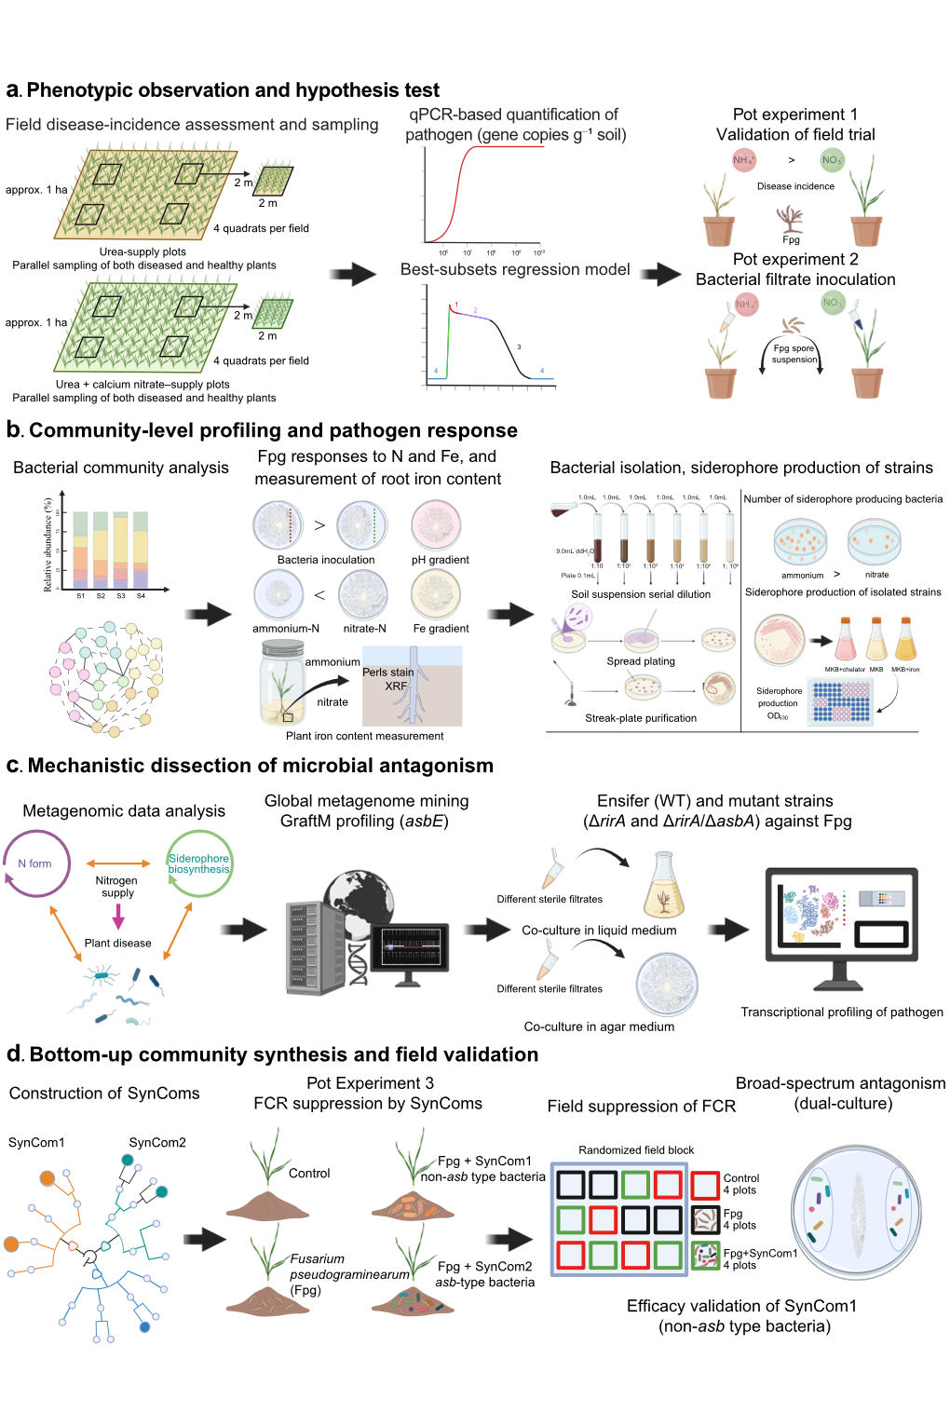

Supplementary Fig. 1: Deciphering nitrogen-form modulated rhizosphere microbial siderophores to suppress wheat Fusarium crown rot
The study employes a multi-scale experimental strategy (Fig. 1) to systematically investigate how nitrogen supply form modulates the protective role of rhizosphere siderophore-producing bacteria (SPB) in wheat (Triticum aestivum L.) against Fusarium pseudograminearum (Fpg). The workflow progresses from field surveys to mechanistic dissection and concludes with functional validation.
a, Phenotypic observation and hypothesis test
Field surveys across different nitrogen fertilizer forms showed that the incidence of Fusarium crown rot (FCR) was reduced in the nitrate dominant treatment, whereas it was enhanced in the ammonium dominant treatment. These observations were further validated under controlled conditions in two independent greenhouse pot Experiments. In Experiment 1, field soil was used as the inoculum, and in Experiment 2, bacterial filtrates were applied. In both experiments, wheat plants were subjected to either ammonium or nitrate, and challenged with Fpg.
b, Community-level profiling and pathogen response
The rhizosphere microbiome (pot Experiment 1) was analyzed using 16S rRNA gene amplicon sequencing to resolve nitrogen-form effects on bacterial community composition and structure. The effects of ammonium- or nitrate-conditioned communities on Fpg growth, and the responses of Fpg to N form and iron availability were assessed. The siderophore-producing bacteria (SPB) were isolated from the wheat rhizosphere with their abundance and siderophore production quantified in vitro.
c, Mechanistic dissection of microbial antagonism
Shotgun metagenomics was used to determine how nitrogen form reshapes rhizosphere functional potential, with emphasis on siderophore-related genes in pot Experiment 1. To further verify the metagenomics results, we first did meta-analysis on public global soil metagenomes to confirm the enrichment of asb-type siderophore biosynthesis in Fusarium disease–associated soils. Second, using a targeted mutant approach, we tested the specific role of siderophore types by comparing the biocontrol efficacy of wild type strain against its isogenic ΔrirA/ΔasbA mutant, deficient in siderophore biosynthesis. Finally, transcriptional profiling of Fpg in response to the filtrates of the wild type, ΔrirA or the ΔrirA/ΔasbA mutant strain was conducted.
d, Bottom-up community synthesis and field validation
Based on genomic and culturing antagonism data, synthetic microbial communities (SynComs) were constructed to test the efficacy of defined SPB consortia in conferring disease resistance. The efficacy of disease suppression was evaluated in pot Experiment 3 and field trials. Finally, the antagonism of SynCom against other pathogenic fungi was tested in vivo.
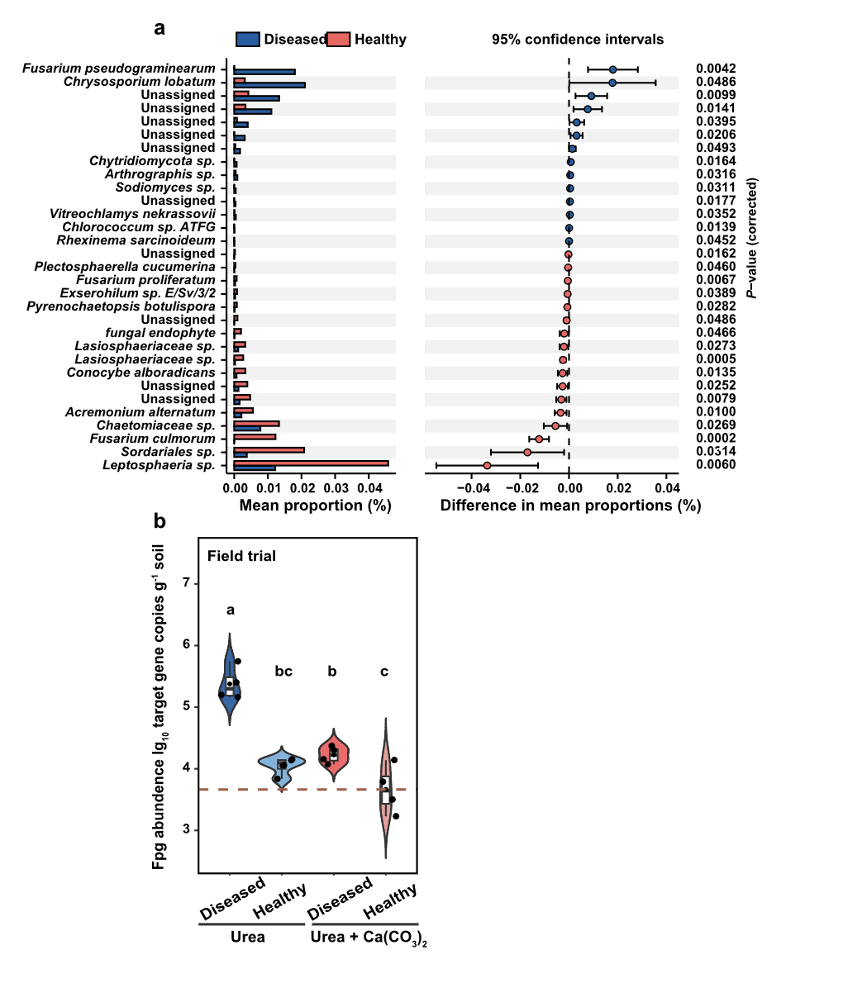Supplementary Fig. 2 Identification of putative fungal pathogens causing Fusarium crown rot in the field and quantification of Fusarium pseudograminearum (Fpg) abundance.
a, Putative fungal pathogens (left) infecting wheat roots in field plots, identified by ITS amplicon sequencing. Only taxa with FDR-adjusted P values (q values) < 0.05 (right) are shown. Significant differences in the relative abundance at the species level between healthy and diseased wheat roots are detected using STAMP (two-sided White’s non-parametric t-test with Benjamini–Hochberg false discovery rate correction (FDR); b, Abundance of Fusarium pseudograminearum (ITS gene copies per gram of rhizosphere soil) in field soils amended with urea or urea +Ca(NO₃)₂. n = 4; two-way ANOVA followed by Tukey’s HSD post hoc test. Violin plots show the data distribution; the center line (or dot) indicates the median; box edges indicate the 25th and 75th percentiles, and whiskers extend to 1.5 × the interquartile range (IQR). Bars with different lowercase letters differ significantly at P < 0.05 (Tukey’s HSD).

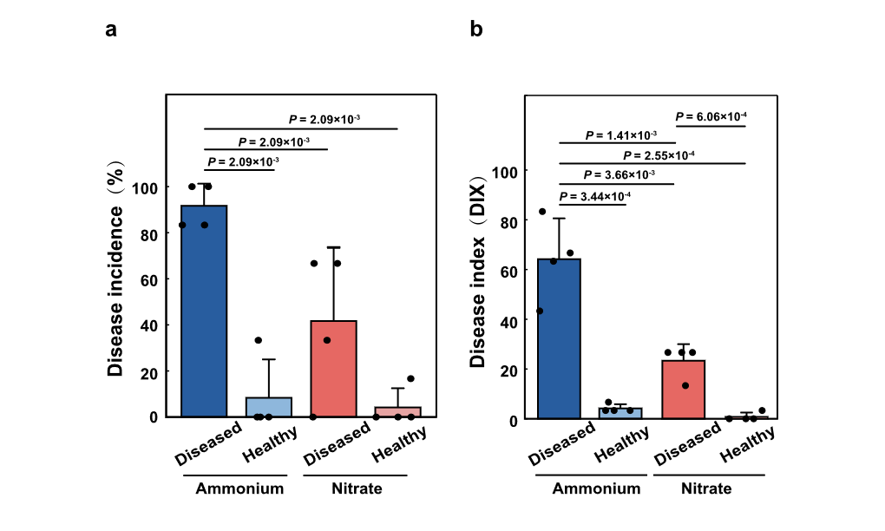
Supplementary Fig. 3 Disease incidence (a) and disease index (b) in response to ammonium versus nitrate supply in diseased versus healthy soils in pot Experiment 1.
Bar charts are mean ± s. d., n = 4. Pairwise comparisons are indicated by horizontal brackets with exact two-sided P values shown above. Significant differences are assessed using Kruskal–Wallis tests, followed by Mann–Whitney U tests for multiple comparisons.

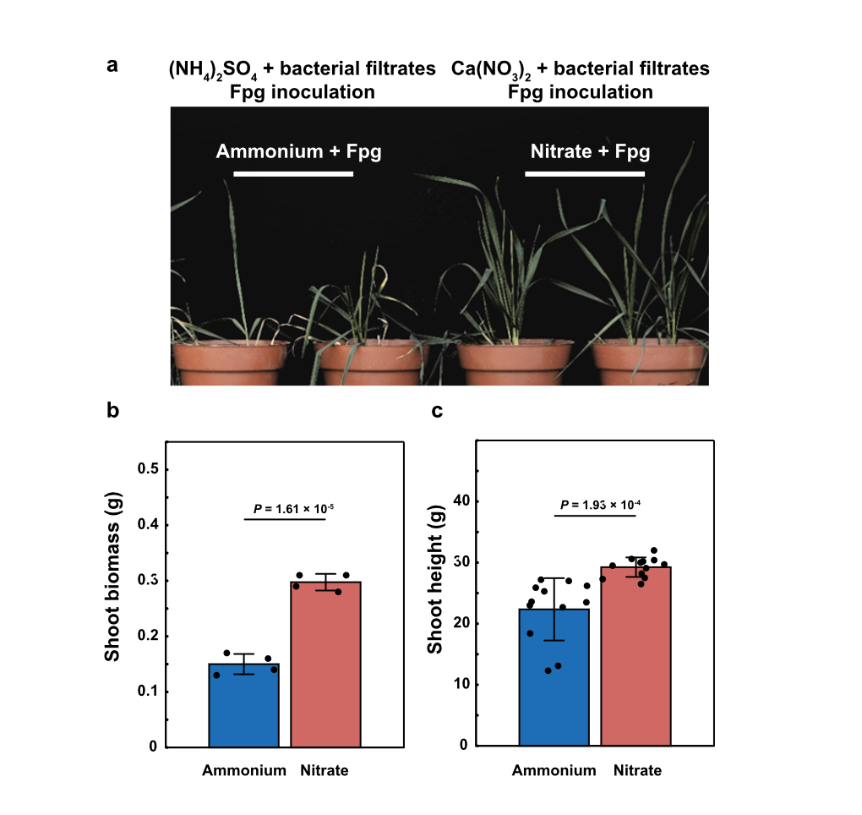
Supplementary Fig. 4 Effects of bacterial filtrates derived under ammonium or nitrate supply on wheat growth in pot Experiment 2.
a, Wheat growth in response to bacterial filtrates derived from the ammonium or nitrate treatment in pot Experiment 1 and challenged with Fusarium pseudograminearum (Fpg). b, shoot biomass, and c, height of wheat grown in soil inoculated with Fpg in the presence of bacterial filtrates derived from the ammonium or nitrate treatment in pot Experiment 1. Bar charts are mean± s.e.m., n = 4; P values are calculated using a two-tailed unpaired Student’s t-test.
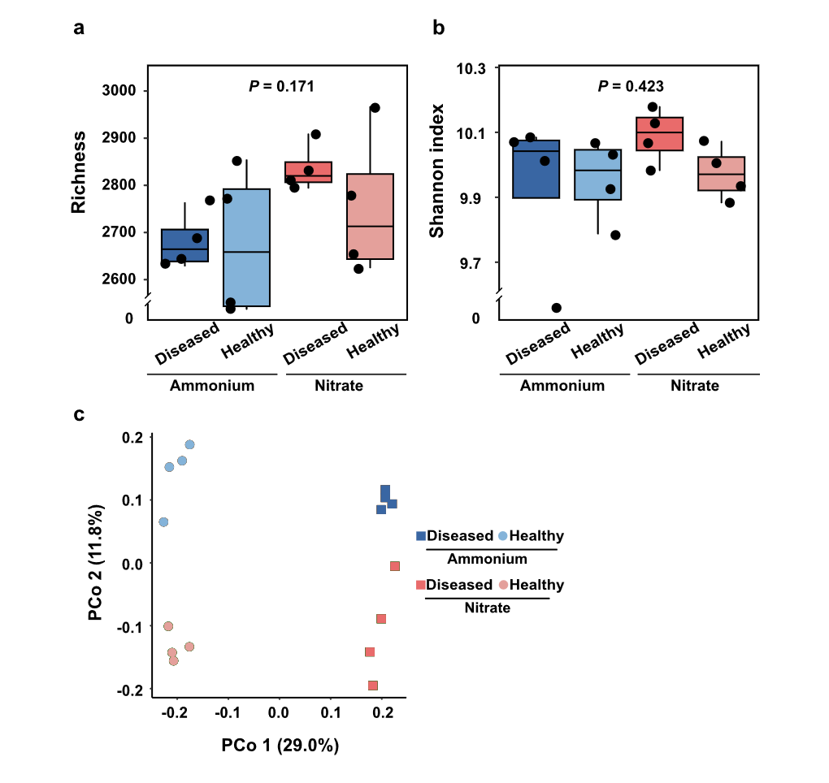Supplementary Fig. 5 Alpha diversity and PCoA analysis of bacterial communities in pot Experiment 1.
a, Richness estimated by Chao1, and b, Shannon diversity index in different treatments. For box plots, center lines indicate medians; boxes indicate the IQR; whiskers extend to 1.5 × IQR. Outliers are shown as individual points. n = 4; One-way analysis of variance. c, Principal coordinates analysis (PCoA) of bacterial community composition, showing clear separation by health status along PC1 and by nitrogen form along PC2. Significance was tested by PERMANOVA (adonis) (P < 0.001).
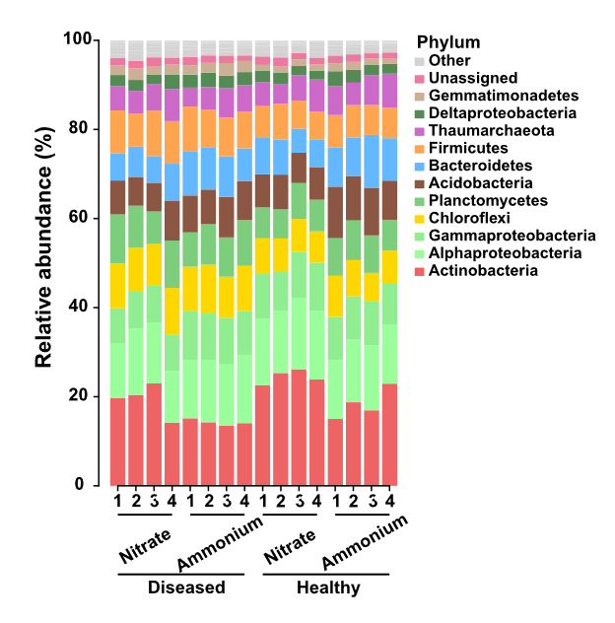
Supplementary Fig. 6 Relative abundance of bacterial communities at the phylum level (Experiment 1) in pot Experiment 1.
1–4 represent the four biological replicates.

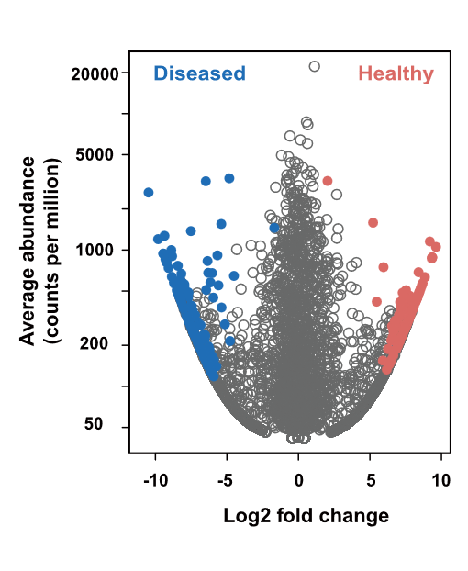
Supplementary Fig. 7 Abundant bacterial ASVs identified in healthy and diseased soils under ammonium or nitrate supply (pot Experiment 1).
The x- axis is the log₂ fold change in ASV abundance in healthy relative to diseased soils, and the y-axis shows the mean ASV abundance (counts per million). ASVs enriched in healthy and diseased soils are shown in red and blue, respectively. ASVs that are not significantly different are in grey (likelihood ratio test, P < 0.05, FDR-corrected).

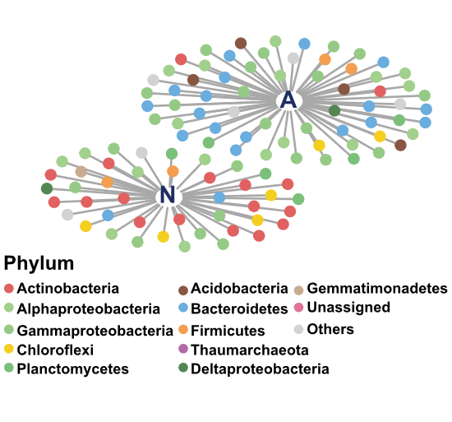
Supplementary Fig. 8 Bipartite networks linking bacterial amplicon sequence variants (ASVs) to diseased soils under ammonium or nitrate supply treatment (pot Experiment 1).
ASVs shown are those identified by indicator species analysis as significantly associated with the ammonium (A) or nitrate (N) treatment within diseased soils (Permutation test, P < 0.05). Circles represent individual ASVs, and grey edges linking each ASV to the nitrogen-form group with which it is significantly associated (indicator ASV).

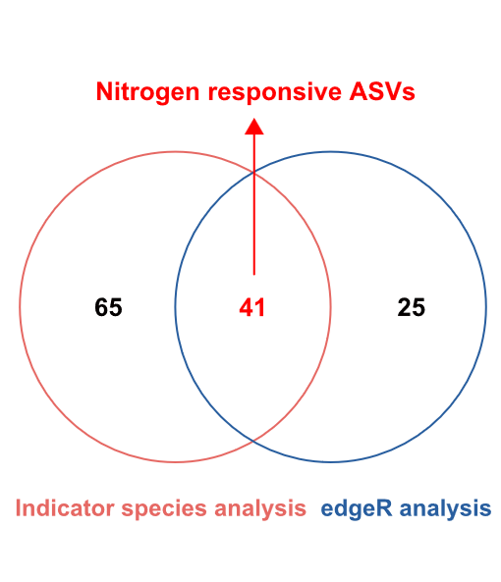
Supplementary Fig. 9 Defining nitrogen responsive bacterial ASVs (ns ASVs) in diseased soils under ammonium or nitrate supply conditions in pot Experiment 1.
Venn diagrams (diseased soils only) show the number of ASVs responding to nitrogen form identified by indicator species analysis (red) and by edgeR (blue).

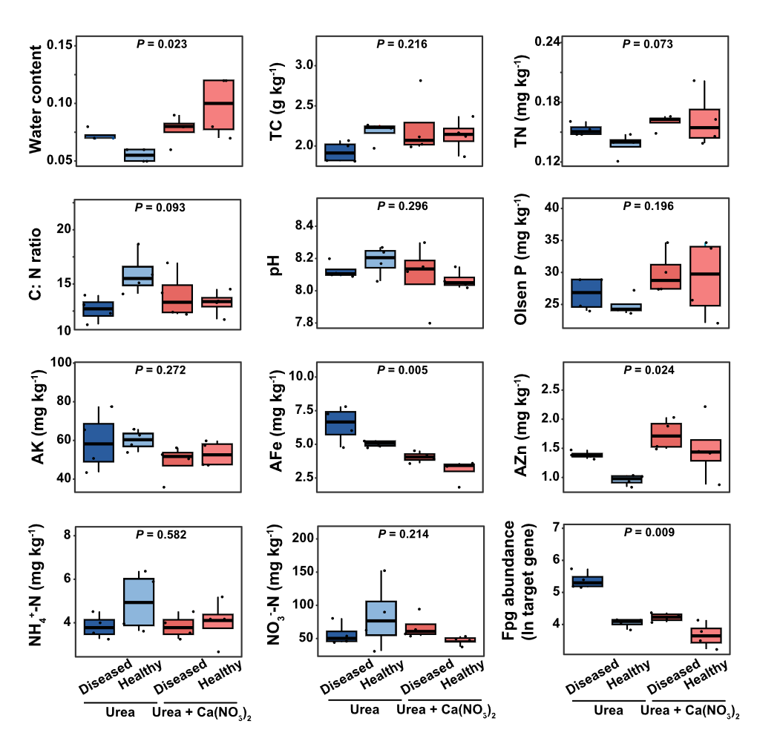
Supplementary Fig. 10 Soil physicochemical properties and Fpg abundance in field soils amended with urea or a combination of urea + Ca(NO₃)₂.
Soil water content, total carbon (TC), total nitrogen (TN), Olsen P, available K (AK), available Fe (AFe), available Zn (AZn), ammonium (NH₄⁺-N), nitrate (NO₃⁻-N), and Fusarium pseudograminearum (Fpg) abundance are shown for healthy and diseased soils following urea or urea + Ca(NO₃)₂ application (n = 4). Box plots are the median (center line) and interquartile range (25th–75th percentiles; box); whiskers extend to 1.5 × the IQR, with individual data points overlaid. For each variable, effects of nitrogen fertilizer form and disease status were tested using two-way ANOVA, followed by Post hoc multiple-comparison testing (see Methods for details). Fpg abundance is quantified as ITS gene copy number per gram soil.
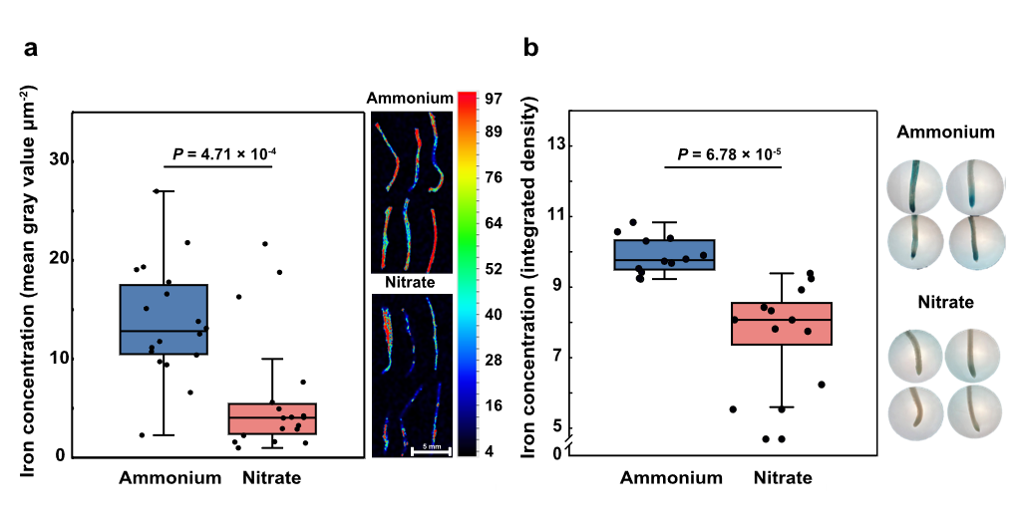
Supplementary Fig. 11 Root iron concentration under ammonium or nitrate supply measured by X-ray fluorescence and Perls staining.
a, X-ray fluorescence (XRF) maps showing iron (Fe) distribution in 30-day-old wheat roots from pot Experiment 2 after inoculating with Fusarium pseudograminearum, under ammonium or nitrate supply. b, Quantification of Fe signal intensity by Perls staining 24 h after inoculating with Fusarium pseudograminearum in an independent in vitro assay. For each nitrogen treatment, maturation zones from 12 biologically independent roots were analyzed. Box plots show the median (center line), the 25th–75th percentiles (box), and whiskers extending to 1.5 × the IQR. Two-sided P values are calculated using a Wilcoxon rank-sum test.
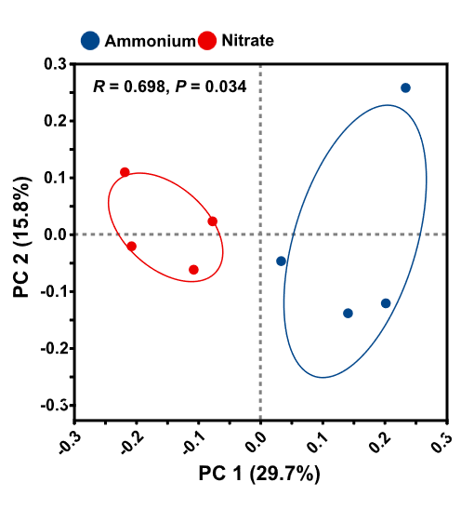
Supplementary Fig. 12 Principal coordinate analysis (PCoA) of bacterial communities based on non-redundant (nr) annotation of KEGG ko01053.
PCoA ordinations are shown for ammonium- and nitrate-diseased treatments in pot Experiment 1, using species profiles annotated to the non-redundant protein database for KEGG pathway ko01053 of “Biosynthesis of siderophore group non-ribosomal peptides.” Group differences are tested by PERMANOVA.

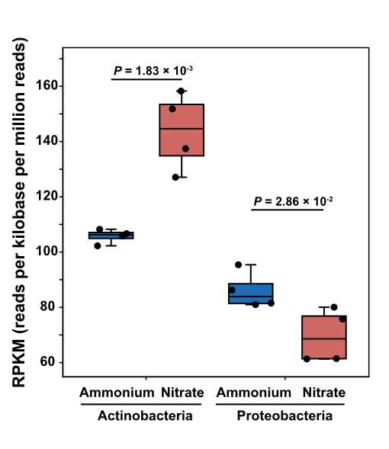
Supplementary Fig. 13 Differences in the relative abundance (RPKM) of Actinobacteria and Proteobacteria between ammonium and nitrate supply treatments in pot Experiment 1.
Box plots show the median (centre line) and the 25th–75th percentiles (box); whiskers extend to 1.5× the IQR. n = 4; two-sided unpaired t-tests.

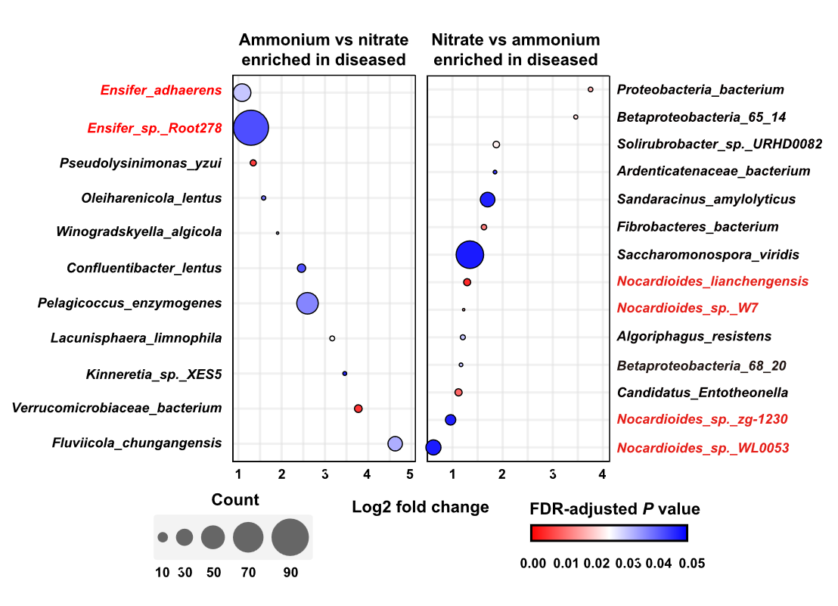
Supplementary Fig. 14 Species enriched in the rhizosphere under ammonium (left) versus nitrate (right) diseased treatments based on NR-annotated KEGG ko01053 features in pot Experiment 1.
Species labels in red indicate taxa overlapping with keystone amplicon sequence variants (ASVs). Bubble area is proportional to the number of ko01053-annotated genes (NR hits) assigned to each species, and bubble colour represents the Benjamini–Hochberg false discovery rate (FDR)–adjusted P value (q).

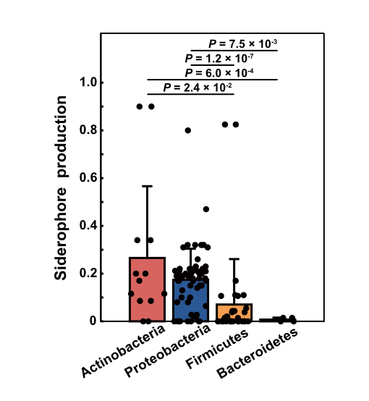
Supplementary Fig. 15 Siderophore production by isolated bacteria from rhizosphere belonging to four phyla of Actinobacteria, Proteobacteria, Firmicutes, Bacteroidetes in pot Experiment 1. Bar charts are mean ± s.e.m.; n denotes the number of isolates in each phylum (total n = 115);Two-sided Mann–Whitney U tests.

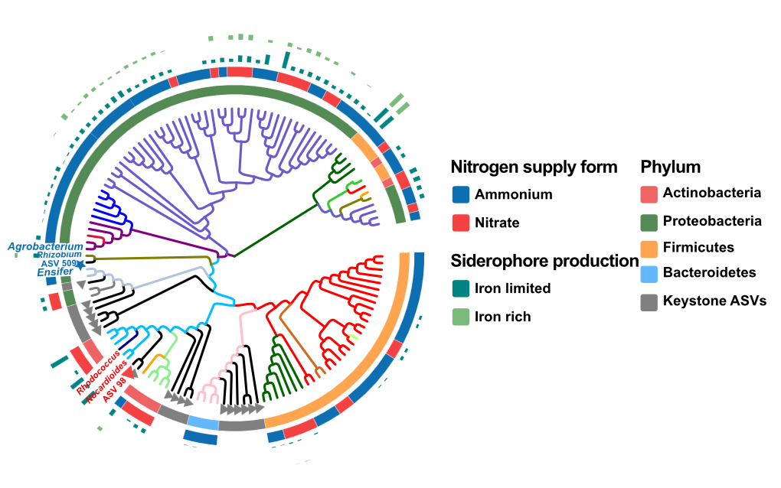
Supplementary Fig. 16 Phylogenetic tree constructed based on the 16S rDNA sequences of bacteria isolated from rhizosphere soil in pot Experiment 1. The innermost phylogenetic tree branches represent genus-level annotations for each strain. The pentagon and triangle symbols at the tips of the branches denote the annotations for keystone ASVs, with blue pentagons and red triangles representing keystone ASVs enriched under the ammonium diseased and nitrate diseased treatment respectively. The second ring indicates the phylum-level annotations corresponding to the isolated strains and keystone ASVs. The outermost ring indicates nitrogen supply form. The outer ring bar plot shows normalized siderophore production of the isolates under Fe-limited (light green) and Fe-rich (dark green) conditions (see Methods for normalization).

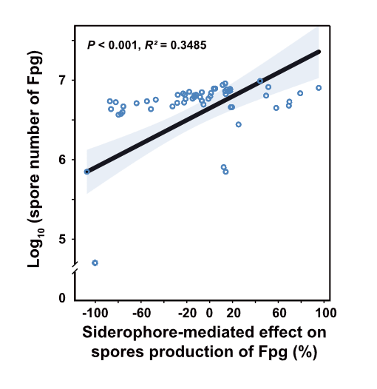
Supplementary Fig. 17 Siderophore mediated effect on the suppression of Fpg sporulation. Sporulation suppression is calculated relative to the corresponding control as (S_{control} - S_{treatment}) / S_{control} (×100% where shown). The black line and blue shaded area represent the best fit line from linear regression and the 95% confidence interval, respectively (n = 61; two-tailed test of the regression slope, P < 0.001 Student's t-test).

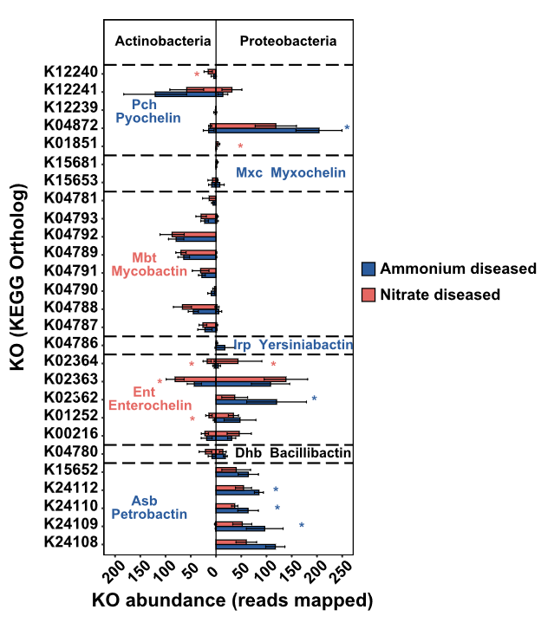
Supplementary Fig. 18 Differential analysis of KEGG pathway ko01053 in Actinobacteria and Proteobacteria between ammonium diseased and nitrate diseased treatments.
Ammonium disease
Nitrate disease
Ammonium disease
Nitrate disease
The KO abundance of genes for KEGG pathway ko01053 from Actinobacteria and Proteobacteria are detected by metagenomics in pot Experiment 1.

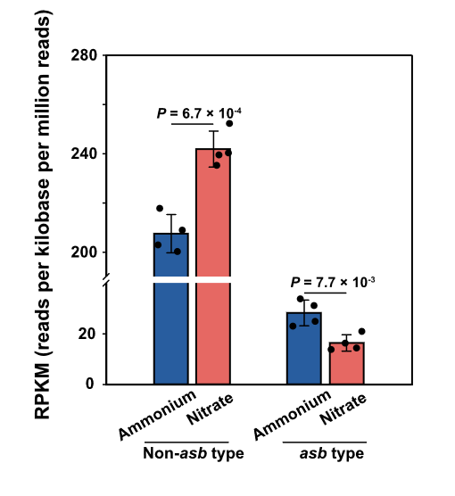
Supplementary Fig. 19 Relative abundance of non-asb type and asb type siderophore-producing bacterial genera under ammonium-diseased and nitrate-diseased treatments (pot Experiment 1).
Bar charts show the mean ± s.e.m. of the summed genus-level RPKM (reads per kilobase per million mapped reads) of siderophore-producing bacteria lacking (non-asb type) or carrying the asb gene cluster (asb type). n = 4; Kruskal–Wallis test followed by two-sided Mann–Whitney U tests (P < 0.05).
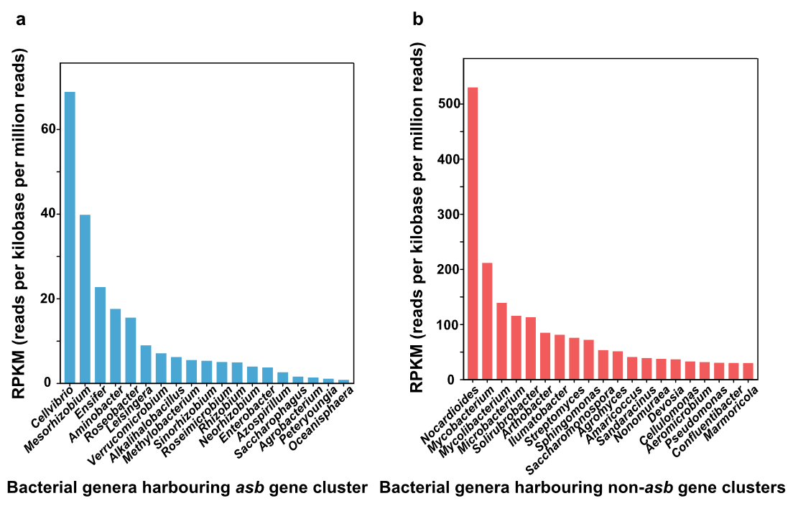
Supplementary Fig. 20 Relative abundance (RPKM) of bacterial genera from KEGG pathway ko01053 harbouring asb-type (a) or non-asb (b) siderophore gene clusters (pot Experiment 1).

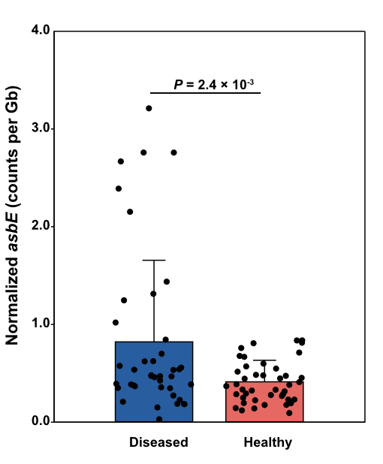
Supplementary Fig. 21 Global distribution of asbE across diseased and non-diseased soils. Normalized asbE counts per metagenome (dots) are shown for globally distributed soils with disease status labels (collected n = 226 SRA runs, asbE detected in 84 runs by a GraftM package targeting asbE). Bars show mean ± s.d. and dots represent individual metagenomes. Normalized counts were computed as the ratio of reads placed in tree to the total number of bases sequenced (paired-end libraries were divided by 2; that is, reads placed in tree/read (Gbp)/2) to account for depth. Group differences were assessed using two-sided unpaired t-tests; exact P values are shown on the plot. Methods for phylogeny-informed placement and normalization follow a gene-centric workflow based on GraftM (HMMER + pplacer; see Methods).

Supplementary Fig. 22 Effects of cell-free bacterial filtrates on Fpg under iron- limited conditions.
a, Cell-free filtrates from seven non-asb strains comprising SynCom1, together with a medium-only control; (b) six asb-type strains from SynCom2. For each strain–treatment (and the control) combination, three replicate wells are shown (n = 3 wells), representing three independent Fpg–bacterial filtrate interactions. Dual-culture filtrate assays were performed on Fe-limited medium; each well showed the confrontation between Fpg mycelia and the respective bacterial filtrates. The growth inhibition denotes the antagonistic activity under Fe limited conditions.

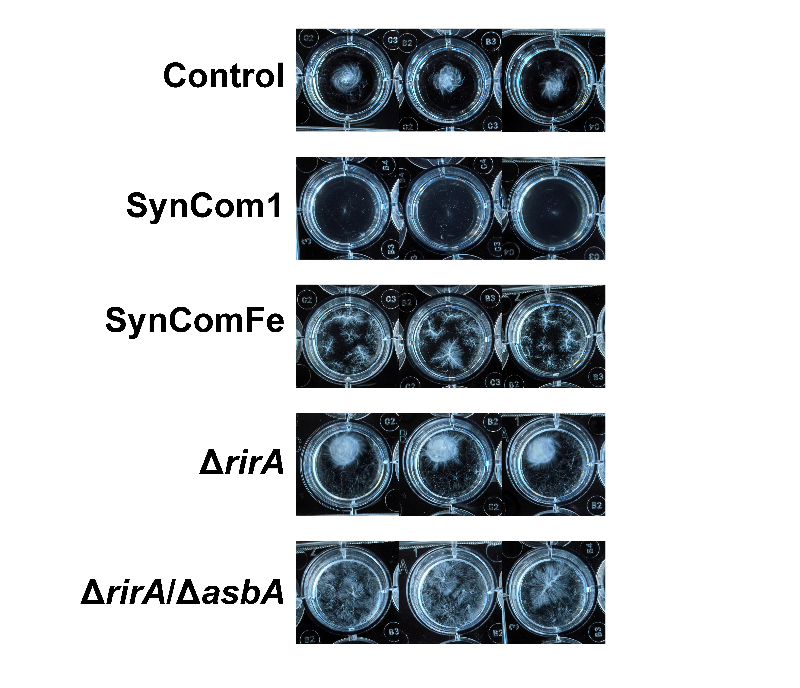
Supplementary Fig. 23 Iron-dependent inhibition of Fpg by cell-free filtrates from SynCom1 and Ensifer mutants. Treatments included sterile filtrates from SynCom1, SynCom1 + 50 μM FeCl₃ (SynComFe), ΔrirA mutant, and ΔrirA/ΔasbA mutant. They were co-incubated with Fpg under Fe-limited conditions. The growth of mycelium reflects the promotion or inhibition of Fpg.

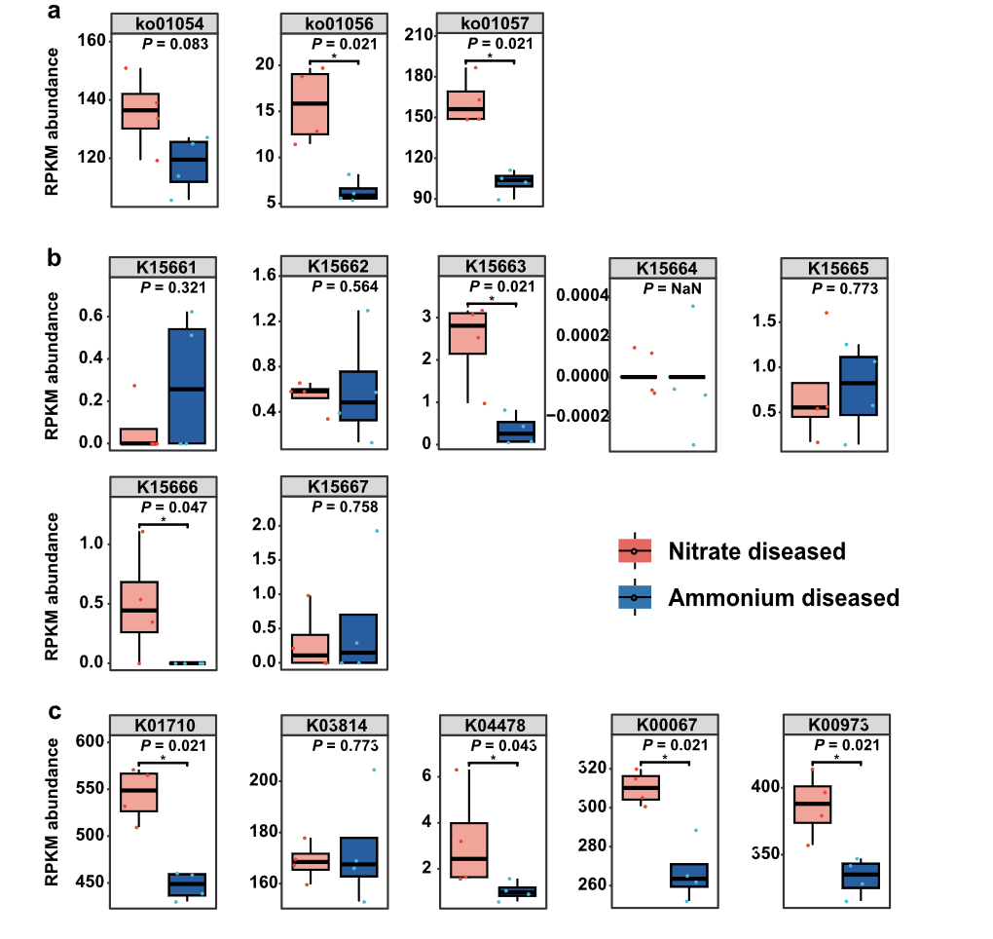Supplementary Fig. 24 Nitrogen supply form affects antifungal secondary metabolism and associated functional potential in the wheat rhizosphere microbiome.
a, Target-specific antifungal lipopeptide modules. Boxplots of RPKM abundances for the iturin synthetase module (K15661–K15663) and the fengycin/plipastatin synthetase module (K15664–K15667) under ammonium and nitrate treatments. b, Core scaffold biosynthetic potential. Boxplots of pathway-level RPKM abundances for nonribosomal peptide structures (ko01054) and type II polyketide biosynthesis pathways (ko01056, ko01057), representing core NRPS/PKS scaffold production capacity. c, Deoxysugar-associated glycosylation capacity. Boxplots of RPKM abundances for dTDP-L-rhamnose pathway genes (K00973, K01710, K00067) together with glycosyltransferase-associated genes (K03814, K04478), summarized as a glycosylation-related functional capacity metric. Box plots show the median (center line) and interquartile range (box); whiskers extend to 1.5 × IQR. n = 4 biologically independent metagenomes per treatment. KEGG Orthology and pathway mappings follow KEGG annotations.

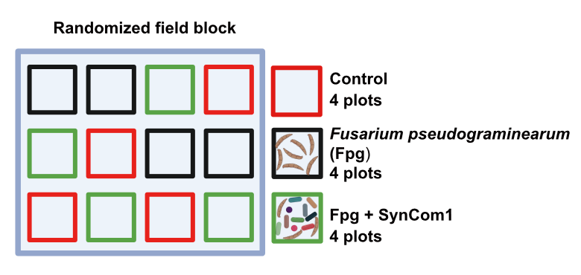
Supplementary Fig. 25 Field trial in a randomized block design (n = 4 plots per treatment).

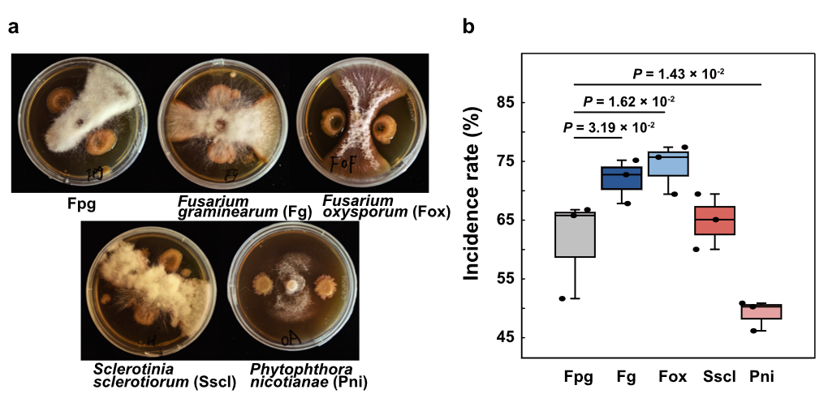
Supplementary Fig. 26 Antagonism against fungal pathogens. Antagonistic activity (a) and mycelial growth inhibition rate (b) of SynCom1 against pathogens. The five pathogenic fungi included: Fusarium pseudograminearum (Fpg), Fusarium graminearum (Fg), Fusarium oxysporum (Fox), Sclerotinia sclerotiorum (Sscl) and Phytophthora nicotianae (Pni). Box plots show the median (center line) and the 25th–75th percentiles (box limits); whiskers extend to 1.5 × the interquartile range. n = 3; one-way ANOVA followed by Tukey’s HSD post hoc test (two-sided).

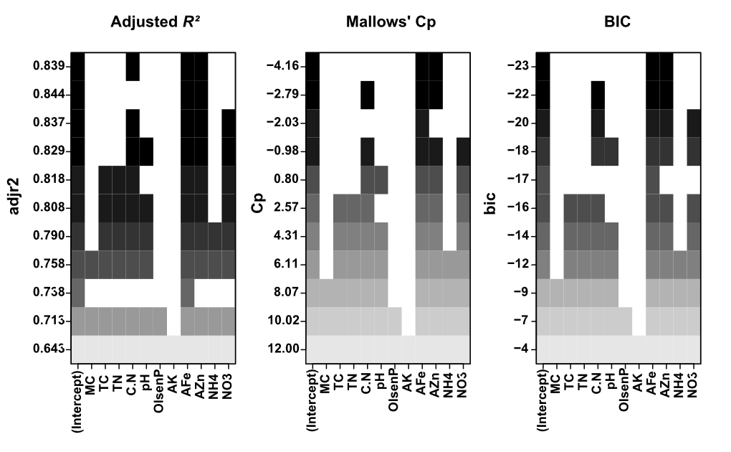
Supplementary Fig. 27 Best-subset selection paths and criteria.
Three panels depict the selection criteria across subset sizes using plot.regsubsets: (left) Adjusted R², (middle) Mallows’ Cp, and (right) BIC. Points highlight the best size under each criterion; here Cp and BIC select two predictors (AFe + AZn), while Adjusted R² peaks at three. These plots are generated from leaps::regsubsets outputs.

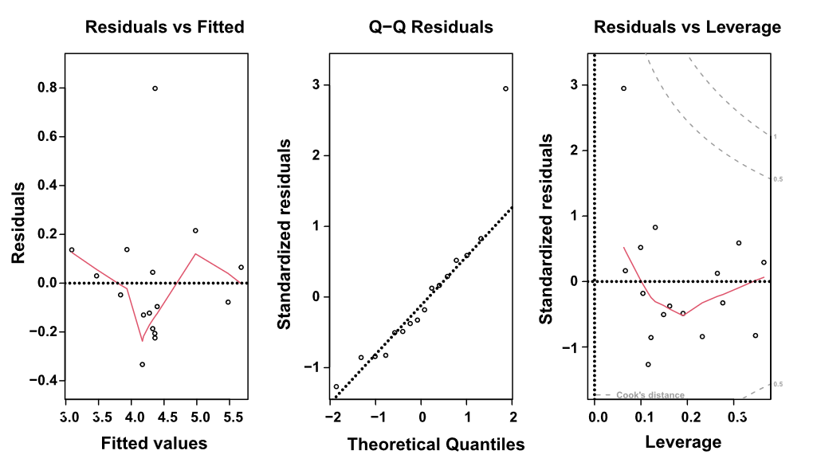
Supplementary Fig. 28 Final-model diagnostics.
Diagnostic plots for the refit two-predictor model (Fpg abundance ~ AFe + AZn, Fpg: Fusarium pseudograminearum abundance): residuals vs fitted (left, trend/heteroscedasticity), Normal Q–Q (middle, normality of residuals), and residuals vs leverage with Cook’s distance contours (right, influence). No systematic deviations or undue influence were detected.

Supplementary Tables
Supplementary Tables are provided in a separate Excel file
Supplementary Table 1. Keystone bacterial ASVs identified through microbial co-occurrence network analysis, comparing rhizosphere communities between healthy and diseased soils (pot Experiment 1).
Supplementary Table 2. Best-subsets regression model of 11 soil physicochemical variables in healthy versus diseased field soils.
Supplementary Table 3. Key predictors in the minimal-subset models distinguishing healthy versus diseased field soils.
Supplementary Table 4. Selected best-subsets model predicting Fusarium pseudograminearum abundance in the field trial based on soil physicochemical properties.
Supplementary Table 5. Siderophore production of 115 bacterial isolates derived from rhizosphere soil of wheat grown under contrasting nitrogen (ammonium versus nitrate) and iron (iron rich versus limited) conditions.
Supplementary Table 6. Effects of different bacterial strains on spore growth of Fusarium pseudograminearum (Fpg), and the quantification of the inhibition rate and siderophore production of different strains in co-culture assays.
Supplementary Table 7. KEGG orthologues (KOs) assigned to pathway ko01053 (biosynthesis of siderophore group non-ribosomal peptides) grouped by nitrogen supply form and disease-status.
Supplementary Table 8. Taxonomic annotations of KOs in pathway ko01053 (biosynthesis of siderophore group non-ribosomal peptides) across nitrogen supply form and disease status.
Supplementary Table 9. Metadata for 226 soil metagenomes from globally distributed Fusarium-infected and healthy soils used in the GraftM analyses.
Supplementary Table 10. Summary statistics of metagenome-assembled genomes (MAGs) across nitrogen supply form and disease-status.
Supplementary Table 11. Analysis of MAG-level relative abundances using GTDB taxonomy across nitrogen supply form and disease-status.
Supplementary Table 12. Composition and siderophore production of SynCom1 and SynCom2, and their antagonism against Fusarium pseudograminearum.
Supplementary Table 13. Metagenome assembly statistics across nitrogen supply form and disease status.

Supplementary references
1. Yuan, J. et al. Predicting disease occurrence with high accuracy based on soil macroecological patterns of Fusarium wilt. ISME J. 14, 2936-2950 (2020).
2. Ware, I. M. et al. Climate-driven divergence in plant-microbiome interactions generates range-wide variation in bud break phenology. Commun. Biol. 4, 748 (2021).
3. Derakhshani, H., Tun, H. M. & Khafipour, E. An extended single-index multiplexed 16S rRNA sequencing for microbial community analysis on MiSeq illumina platforms. J. Basic Microbiol. 56, 321-326 (2016).
4. He, Y. et al. Rapid and specific identification of Fusarium pseudograminearum by qPCR based on RPB sequence. Acta Phytopathol. Sin. 54, 995-1007 (2024).
5. Liu, H. et al. Evidence for the plant recruitment of beneficial microbes to suppress soil-borne pathogens. New Phytol. 229, 2873-2885 (2021).
6. Robinson, M. D., McCarthy, D. J. & Smyth, G. K. edgeR: a Bioconductor package for differential expression analysis of digital gene expression data. Bioinformatics 26, 139-140 (2010).
7. De Cáceres, M., Legendre, P. & Moretti, M. Improving indicator species analysis by combining groups of sites. Oikos 119, 1674-1684 (2010).
8. Csárdi, G. & Nepusz, T. The igraph software package for complex network research. InterJournal Complex Syst. 1695, 1-9 (2006).
9. Clauset, A., Newman, M. E. & Moore, C. Finding community structure in very large networks. Phys. Rev. E 70, 066111 (2004).
10. van der Heijden, M. G. & Hartmann, M. Networking in the Plant Microbiome. PLoS Biol. 14, e1002378 (2016).
11. Pansu, M. & Gautheyrou, J. Handbook of Soil Analysis: Mineralogical, Organic and Inorganic Methods. (Springer, 2006).
12. Meersmans, J., Van Wesemael, B., & Van Molle, M. Determining soil organic carbon for agricultural soils: a comparison between the Walkley & Black and the dry combustion methods (north Belgium). Soil Use Manag. 25, 346-353 (2009).
13. Olsen, S. R. Estimation of Available Phosphorus in Soils by Extraction with Sodium Bicarbonate. (US Department of Agriculture, 1954).
14. Le Riche, H. H., & Weir, A. H. A method of studying trace elements in soil fractions. J. Soil Sci. 14, 225-235 (1963).
15. Soltanpour, P. N. Determination of nutrient availability and elemental toxicity by AB-DTPA soil test and ICPS. Adv. Soil Sci. 16, 165-190 (1991).
16. Lumley, T., & Lumley, M. T. Package ‘leaps’: Regression Subset Selection. (2013).
17. Shao, J. Linear model selection by cross-validation. J. Am. Stat. Assoc. 88, 486-494 (1993).
18. Cavanaugh, J. E., & Neath, A. A. The Akaike information criterion: Background, derivation, properties, application, interpretation, and refinements. Wiley Interdiscip. Rev. Comput. Stat. 11, e1460 (2019).
19. O’brien, R. M. A caution regarding rules of thumb for variance inflation factors. Qual. Quant. 41, 673-690 (2007).
20. Grömping, U. Relative importance for linear regression in R: the package relaimpo. J. Stat. Softw. 17, 1-27 (2007).
21. Ren, Z. W. et al. Fast X-ray fluorescence microscopy provides high-throughput phenotyping of element distribution in seeds. Plant Physiol. 191, 1520-1534 (2023).
22. Sun, S. K. et al. A molecular switch in sulfur metabolism to reduce arsenic and enrich selenium in rice grain. Nat. Commun. 12, 1392 (2021).
23. Hsiao, P. Y., Cheng, C. P., Koh, K. W. & Chan, M. T. The Arabidopsis defensin gene, AtPDF1.1, mediates defence against Pectobacterium carotovorum subsp. carotovorum via an iron-withholding defence system. Sci. Rep. 7, 9175 (2017).
24. Lei, G. J. et al. Abscisic acid alleviates iron deficiency by promoting root iron reutilization and transport from root to shoot in Arabidopsis. Plant Cell Environ. 37, 852-863 (2014).
25. Zhang, J. et al. High-throughput cultivation and identification of bacteria from the plant root microbiota. Nat. Protoc. 16, 988-1012 (2021).
26. Heuer, H., Krsek, M., Baker, P., Smalla, K. & Wellington, E. Analysis of actinomycete communities by specific amplification of genes encoding 16S rRNA and gel-electrophoretic separation in denaturing gradients. Appl. Environ. Microbiol. 63, 3233-3241 (1997).
27. Schwyn, B. & Neilands, J. B. Universal chemical assay for the detection and determination of siderophores. Anal. Biochem. 160, 47-56 (1987).
28. Höfte, M., Buysens, S., Koedam, N. & Cornelis, P. Zinc affects siderophore-mediated high affinity iron uptake systems in the rhizosphere Pseudomonas aeruginosa 7NSK2. Biometals 6, 85-91 (1993).
29. Gu, S. et al. Competition for iron drives phytopathogen control by natural rhizosphere microbiomes. Nat. Microbiol. 5, 1002-1010 (2020).
30. Sathe, S., Mathew, A., Agnoli, K., Eberl, L. & Kummerli, R. Genetic architecture constrains exploitation of siderophore cooperation in the bacterium Burkholderia cenocepacia. Evol. Lett. 3, 610-622 (2019).
31. Venkatesh, N. et al. Bacterial hitchhikers derive benefits from fungal housing. Curr. Biol. 32, 1523-1533 (2022).
32. Sun, X. et al. High bacterial diversity and siderophore-producing bacteria collectively suppress Fusarium oxysporum in maize/faba bean intercropping. Front. Microbiol. 13, 972587 (2022).
33. Liu, K. H. et al. Rhizobiales-specific RirA represses a naturally “synthetic” foreign siderophore gene cluster to maintain Sinorhizobium–legume mutualism. Mbio 13, e02900-02921 (2022).

