Supporting Information
for
Controllable removal/release of phosphate by light-responsive layered double hydroxide composite electrode

Figure S 1. Linear sweep voltammograms of a single metal salt of 0.1 M Mg(NO₃)₂ or Mn(NO₃)₂ at a scan rate of 25 mV/s.

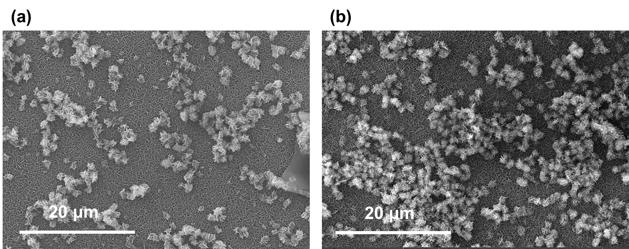
Figure S 2. The electrochemical in situ growth of MgMn-LDH using (a) constant voltammetry method and (b) pulse voltammetry method.

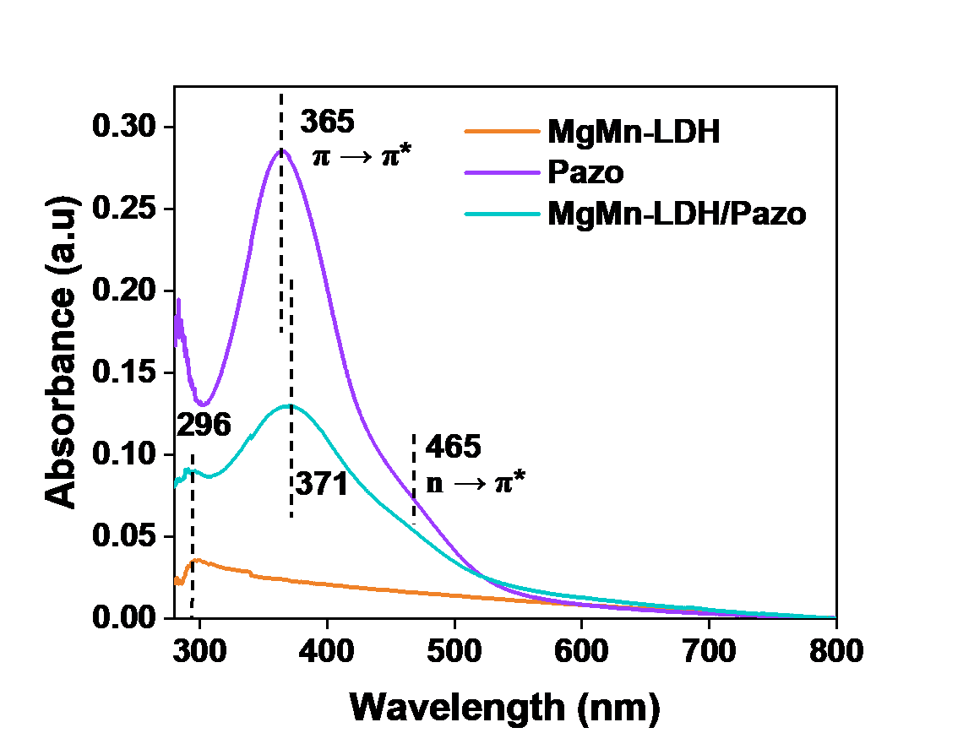
Figure S 3. UV-Vis absorption spectra of MgMn-LDH, Pazo, and MgMn-LDH/Pazo films.
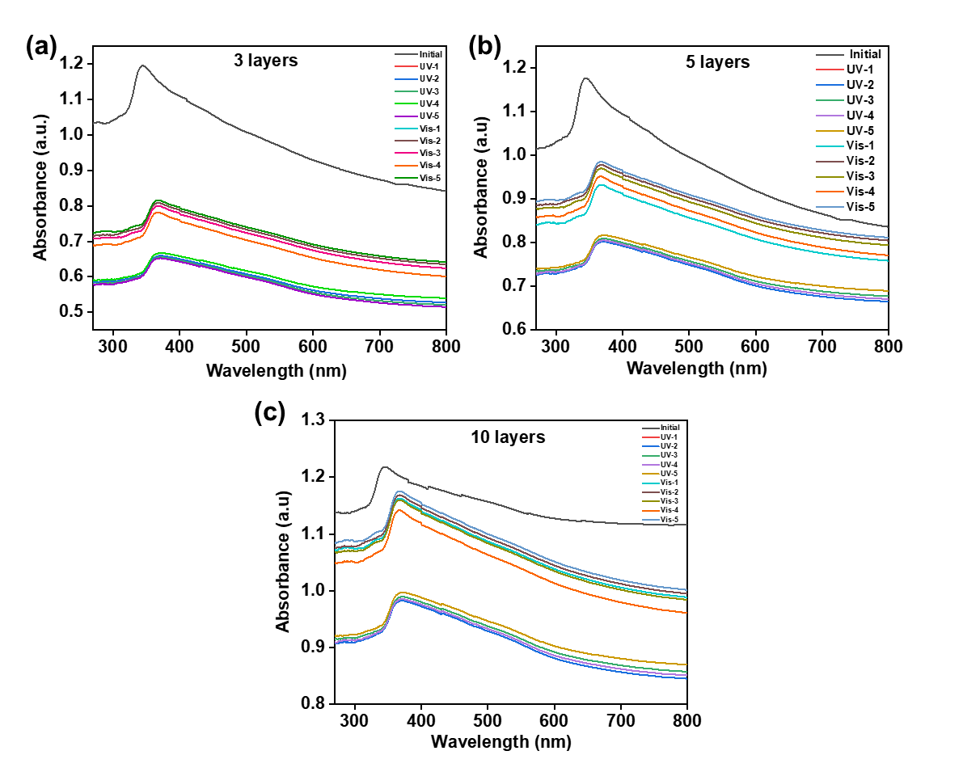
Figure S 4. UV-visible absorption spectra of multilayer films of MgMn-LDH/Pazo under alternating UV (365 nm) and visible light exposure: (a) 3 layers, (b) 5 layers, and (c) 10 layers.
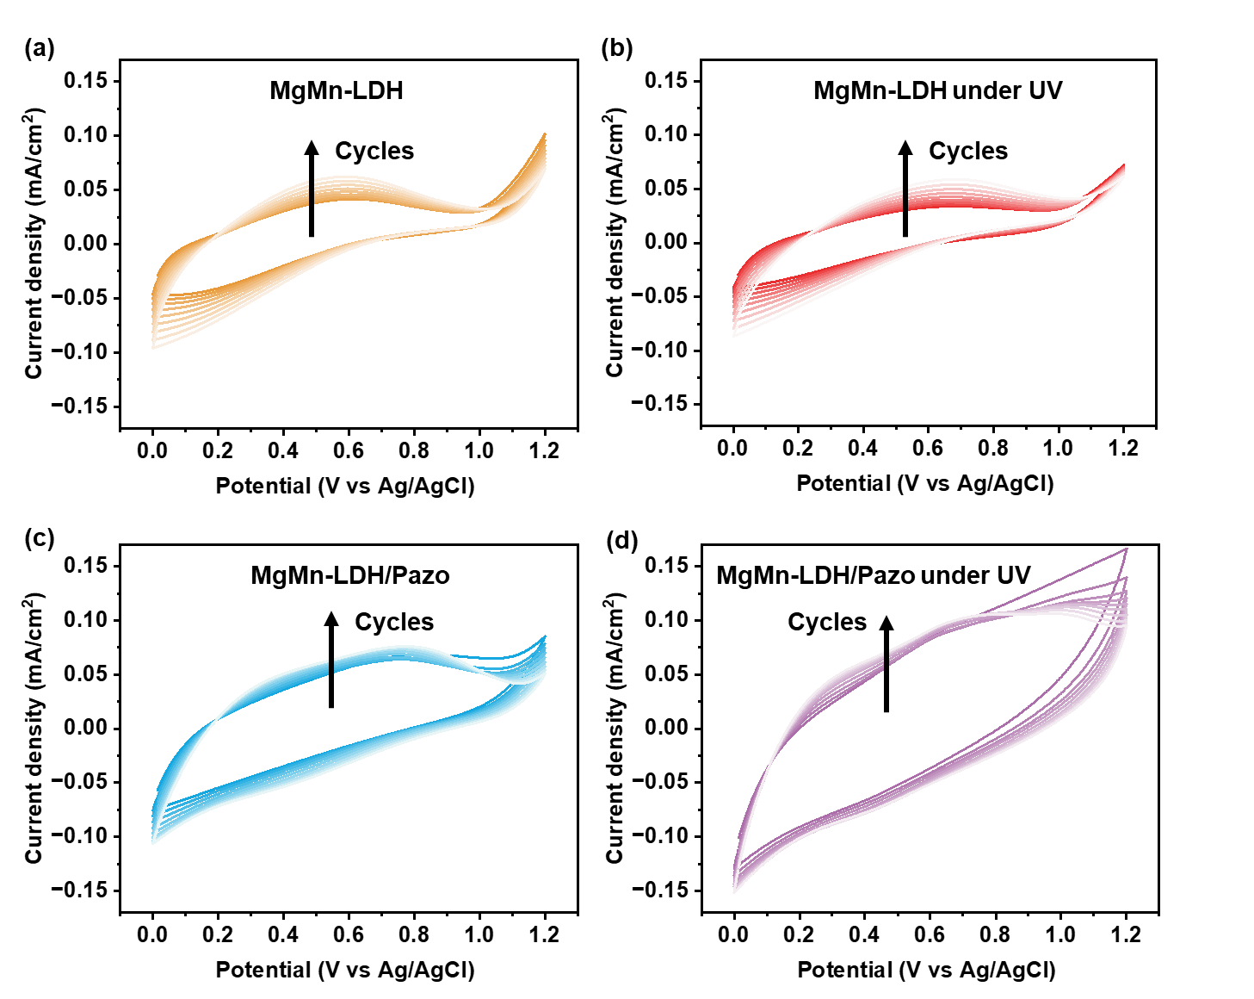
Figure S 5. The CV cycles of electrodeposited films with/without UV irradiation: (a) MgMn-LDH, (b) MgMn-LDH under UV irradiation, (c) MgMn-LDH/Pazo, and (d) MgMn-LDH/Pazo under UV irradiation.

