Supporting Information
for
Controllable removal/release of phosphate by light-responsive layered double hydroxide composite electrode
Da-Wei Huang^{a†}, Kiruthikha Duraisathiamoorthy^{a,b†}, Dhanaprabhu Pattappanª, Chen-Jie Liaoª, Yu-Jr Changª, Yi-Ting Lai^{a,c,d*}
ªDepartment of Materials Engineering, Ming Chi University of Technology, New Taipei City, 24301, Taiwan, ROC.
^{b}Materials Science and Engineering, National Taiwan University of Science and Technology, Taipei City, 106335, Taiwan, ROC.
^{c}Biochemical Technology R&D Center, Ming Chi University of Technology, New Taipei City, 24301, Taiwan, ROC.
^{d}Center for Plasma and Thin Film Technologies, Ming Chi University of Technology, New Taipei City, 24301, Taiwan, ROC.

† These authors contributed equally to this work.
*Corresponding author: Yi-Ting Lai (laieating@mail.mcut.edu.tw)

Fig S 1: Linear sweep voltammograms of a single metal salt of 0.1 M Mg(NO₃)₂ or Mn(NO₃)₂ at a scan rate of 25 mV/s.

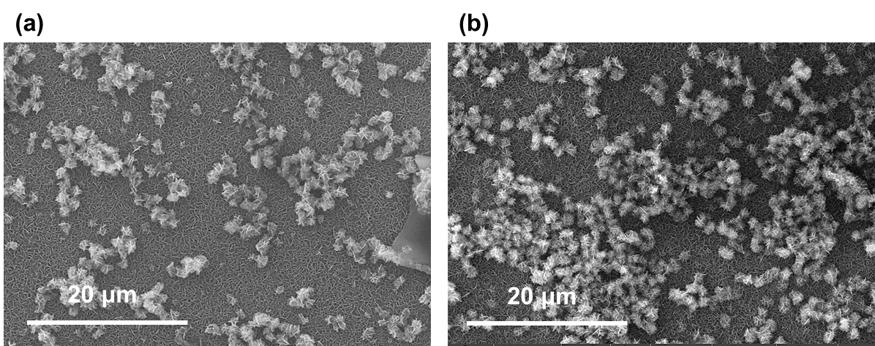
Fig S 2: The electrochemical in situ growth of MgMn-LDH using (a) constant voltammetry method and (b) pulse voltammetry method.

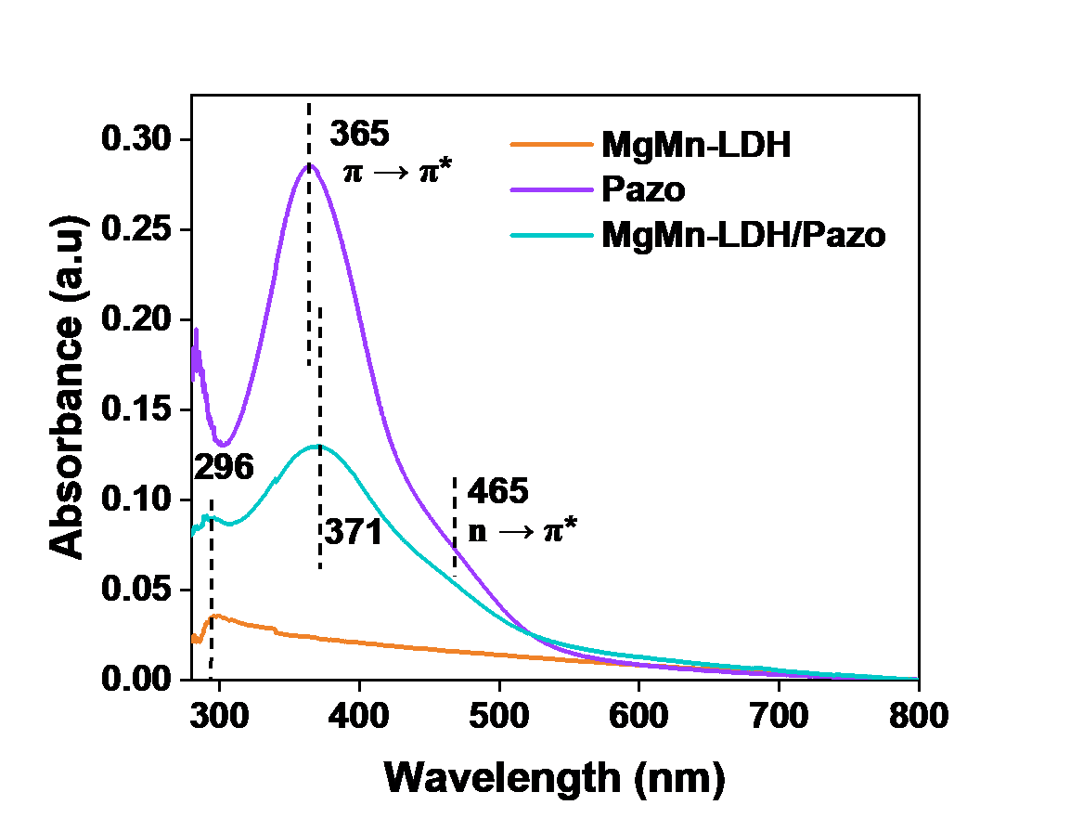
Fig S 3: UV-Vis absorption spectra of MgMn-LDH, Pazo, and MgMn-LDH/Pazo films.
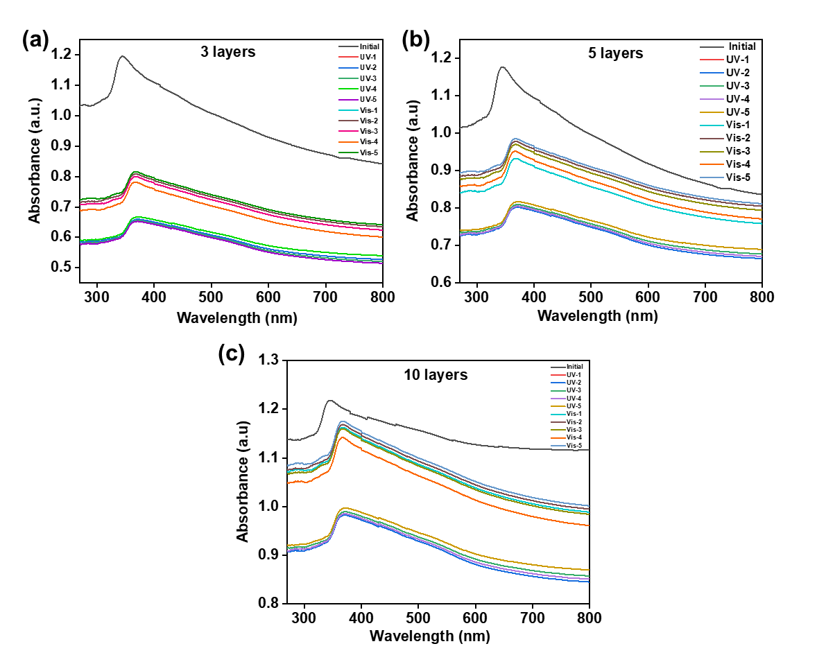
Fig S 4: UV-visible absorption spectra of multilayer films of MgMn-LDH/Pazo under alternating UV (365 nm) and visible light exposure: (a) 3 layers, (b) 5 layers, and (c) 10 layers.
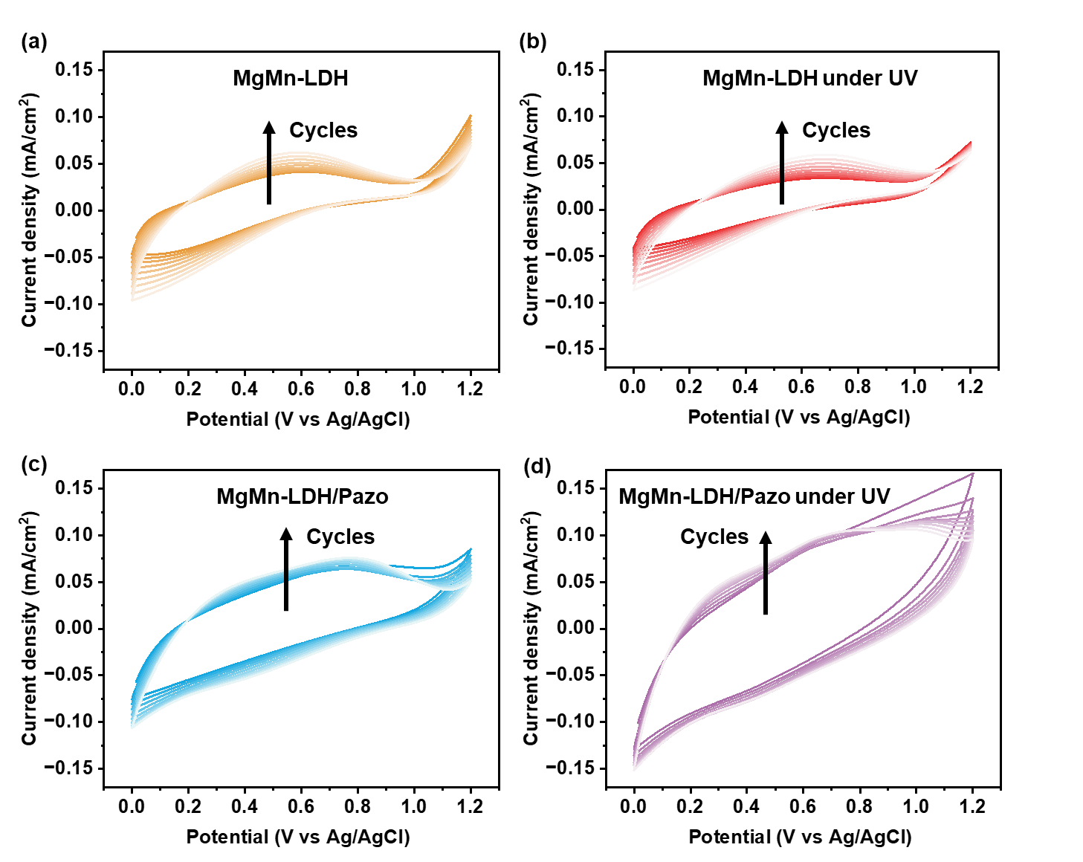
Fig S 5: The CV cycles of electrodeposited films with/without UV irradiation: (a) MgMn-LDH, (b) MgMn-LDH under UV irradiation, (c) MgMn-LDH/Pazo, and (d) MgMn-LDH/Pazo under UV irradiation.

