Table 1 Comparison of academic performance between the two groups(scores, x±s)
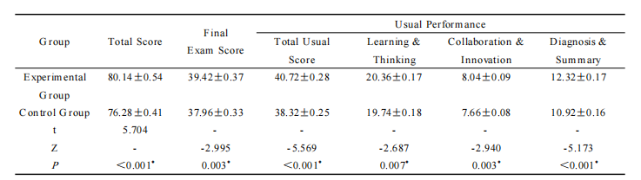
*The P-value for the comparison of experimental group and control group

Table 2 Comparison of self-directed learning ability and learning engagement level between the two groups (scores, x±s)
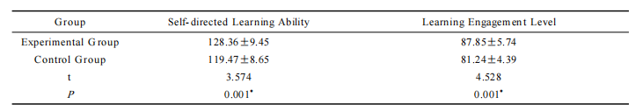 *The P-value for the comparison of experimental group and control group

Table 3 Satisfaction survey of the "AI+Knowledge Graph" teaching model based on the ARCS motivation model (n, %)
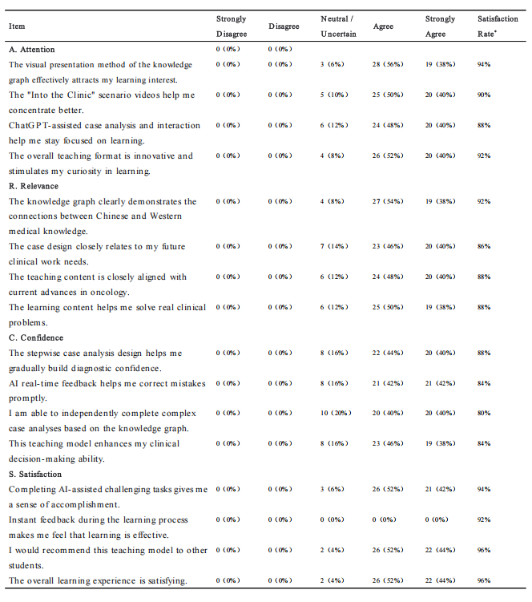*Satisfaction Rate = Percentage of respondents who selected "Agree" or "Strongly Agree".

Table 4 Self-assessment of the "AI+Knowledge Graph" Teaching Model Based on the ARCS Motivation Model(n, %)
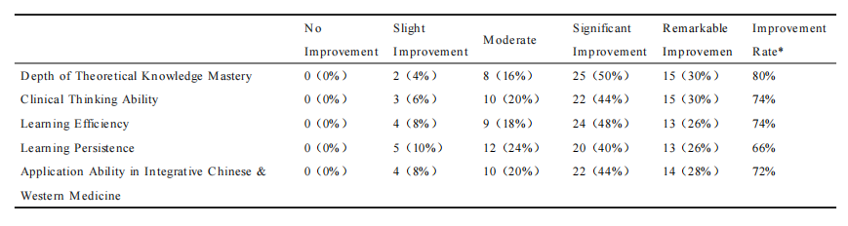*Improvement Rate = Percentage of respondents reporting "Significant improvement" or "Remarkable improvement".

