Supporting Information

High-Precision Sign Language Recognition Enabled by Self-Recoverable Near-Infrared Mechanoluminescent Materials
Xue Meng, Panlai Li*, Mingxin Zhou, Jinlong Wang, Guodong Zhang*, Hao Suo, Zhijun Wang*
Hebei Key Laboratory of Optic-electronic Information and Materials, College of Physics Science & Technology, Hebei University, Baoding 071002, China

1. Experimental section
1.1 Synthesis of ML phosphors
ZnGaInO₄: xCr³⁺ (x = 0, 0.01, 0.02, 0.03, 0.04, and 0.05) and ZnGa_{1-m}Al_{m}InO₄: 0.04Cr³⁺ (m = 0, 0.01, 0.02, 0.03, 0.04, 0.06, 0.08, 0.10, 0.20, 0.40, 0.60, 0.80, and 1.00) phosphors were synthesized via a high-temperature solid-state reaction method. High-purity raw materials, including ZnO (99.99%, Aladdin), Ga₂O₃ (99.99%, Aladdin), In₂O₃ (99.99%, Aladdin), Al₂O₃ (99.99%, Aladdin), and Cr₂O₃ (99.99%, Aladdin), were used as starting reagents. The raw materials were precisely weighed according to the stoichiometric ratios, thoroughly mixed, and ground in an agate mortar to ensure homogeneity. The homogeneous mixtures were then transferred to alumina crucibles and sintered in a muffle furnace at 1450 ℃ for 10 hours under an air atmosphere. After sintering, the samples were allowed to cool naturally to room temperature, reground in an agate mortar to achieve fine powders, and subsequently subjected to further characterization and testing.
1.2 Fabrication of ML film
Fabrication of powders in PET film
The powders were mixed with ethanol into a paste, which was then homogeneously coated onto the lower PET film (approximately 40 × 40 mm square). After ethanol volatilization, the powders were enclosed in an upper PET film and thermally over-molded into a hard film using a laminator for subsequent characterization.
Fabrication of powders in PDMS film
Flexible membranes were fabricated by dispersing ZnGaInO₄: 0.04Cr³⁺ and ZnAlInO₄: 0.04Cr³⁺ ML phosphors in Polydimethylsiloxane (PDMS, Sylgard 184, Dow Corning). The ML phosphor was mixed well with the PDMS (1:5) and then uniformly placed on a square mold. The square mold with the composite was then placed in oven and heated at 70 ℃ for 2 h. Then a flexible ML film was fabricated for the measurement.
Fabrication of powders in PU film
The powders, PU-A and PU-B (with a ratio of 1:1:1), were stirred in a beaker until well-mixed and then transferred to a quadrate Teflon mold with a side length of 40 mm. After drying at 70 ℃ for 5 h, the powder@PU was obtained.
1.3 Characterization method
Morphological structure characterization
The structural properties of the samples were characterized using X-ray diffraction (XRD) patterns, which were recorded on a Bruker D8 Advanced X-ray diffractometer operating at 40 kV and 40 mA with Cu-Kα radiation (λ = 1.5406 Å). The obtained XRD data were refined using the Rietveld method, implemented in the General Structure Analysis System (GSAS) refinement program, to determine the crystal structure and phase purity. Morphological analysis was conducted using a field-emission scanning electron microscope (FE-SEM, Nova Nano SEM 450), which provided high-resolution images of the sample surfaces. Elemental composition and distribution were analyzed using energy-dispersive X-ray spectroscopy (EDS) coupled with the FE-SEM. Chemical states and surface composition were further investigated using X-ray photoelectron spectroscopy (XPS) on a ThermoFisher ESCALAB 250Xi system, with monochromatic Al-Kα radiation (1486.6 eV) as the excitation source.
Optical performance characterization
The optical properties of the samples were systematically evaluated. Photoluminescence (PL) and photoluminescence excitation (PLE) spectra were measured using a Horiba FL3 fluorescence spectrometer equipped with a 450 W xenon lamp as the excitation source. Lifetime measurements were also performed using the same spectrometer. Diffuse reflectance (DR) spectra were acquired using a Hitachi 4100 UV-vis-NIR spectrophotometer, with BaSO₄ as a reference. Thermoluminescence (TL) spectra were recorded on an FJ-427A1 TL dosimeter at a heating rate of 1 K·s⁻¹ Prior to TL measurements, all samples were pre-irradiated with 254 nm UV light for 10 minutes to populate the traps. Persistent luminescence (PersL) spectra were monitored at room temperature using the Horiba FL3 fluorescence spectrometer, following pre-irradiation with 254 nm light for 10 minutes. Raman spectra were collected using a HORIBA LabRAM HR Evolution Raman spectrometer equipped with a 532 nm Nd-YAG laser as the excitation source.
ML performance characterization
Mechanoluminescence (ML) properties were investigated using a custom-built ML measurement system. The setup consisted of a digital push-pull force gauge for applying controlled mechanical stress, a photon counting system (Maya2000 Pro, Ocean Optics) for detecting emitted light, and a computer for data acquisition and analysis. The ML spectra were recorded under consistent experimental conditions to ensure reproducibility.
1.4 Assembly of ML-Driven Interactive Tactile Sensing System
An ML-driven interactive tactile sensing system prototype was constructed by integrating ML films, photoelectric sensors (PES) and electronic control modules into portable sign language recognition gloves. The electronic control module is mainly composed of a transimpedance amplifier (TIA) module, a multiplexer (MUX), an analog-to-digital conversion (ADC) module, a microcontroller unit (MCU) module (STM32), a Wi-Fi module and a DC power supply module.
1.5 Data Acquisition and Dataset Configuration
As a self-powered sensing unit without any energy supply, the ML films were integrated at the finger joint positions of the wearable glove carrier. When the user performs hand gestures and applies pressure, the ML films emit near-infrared (NIR) light instantaneously. The variations in ML signals are captured by PES in real time and converted into current signals, which are then transformed into amplified analog voltage signals by the TIA module. Subsequently, the ADC module converts these multi-channel sensing data into digital voltage with a sampling rate of 50 samples per second (sps) (response time per data point: 20 ms), featuring low acquisition threshold and high precision. Afterwards, the digital voltage data are collected and preprocessed by the MCU chip. The built-in gesture recognition algorithm completes feature extraction and classification, and then the results are transmitted to external devices (computers) via the serial-port-connected Wi-Fi module for result visualization and interactive control (corresponding to Figure 5A). The stability of the system was tested under three conditions: no interference, ambient light interference (indoor LED lights) and hand sweat/environmental humidity interference (corresponding to Figure S21). Sensing signals generated by different gestures were collected separately, including data signals output by five finger-joint sensors. Each gesture was repeated 200 groups, with 3 repeated gestures per group, resulting in a total of 2000 samples for 10 gestures. To balance the distribution range of sensor signals in the samples, the min-max normalization technique was adopted. This method aims to reduce the negative impact of signal amplitude differences on training effectiveness. Subsequently, the normalized samples were randomized to construct the dataset, where 70% of the samples were allocated to the training set, 15% to the test set, and the remaining 15% to the validation set.
1.6 CNN Training
The neural network was implemented in TensorFlow 2.10, developed and debugged based on the Python 3.10 environment via PyCharm Community Edition, and trained on an ASUS TUF Gaming A15 (2022) laptop in CPU training mode. The network architecture was tailored to the characteristics of tactile sensing data for sign language recognition, consisting of an input layer (matching the 165-dimensional feature vector of 33 sampling points × 5 channels of finger-joint tactile signals), three fully connected hidden layers with ReLU activation function, and a Softmax output layer with 10 neurons (corresponding to the 10-class sign language gesture classification task).
The training process adopted categorical cross-entropy loss function and Adam optimizer (learning rate = 0.001, β₁ = 0.9, β₂ = 0.999), with a maximum of 50 training epochs. To suppress overfitting, Dropout regularization was applied sequentially after each hidden layer (dropout rates: 0.3, 0.3, 0.2 respectively), combined with Batch Normalization to accelerate convergence. Meanwhile, an early stopping strategy was enabled, which terminates training if the validation set accuracy shows no improvement for 5 consecutive epochs. The generalization ability of the model was verified using an independent test set (accounting for 15% of the total dataset). The test set included tactile data collected under no-interference, ambient light interference and humidity interference scenarios, ensuring that the model exhibits stable recognition performance in practical sign language interaction scenarios when running on the ASUS TUF Gaming A15 (2022) laptop.

2. Supplementary Figures
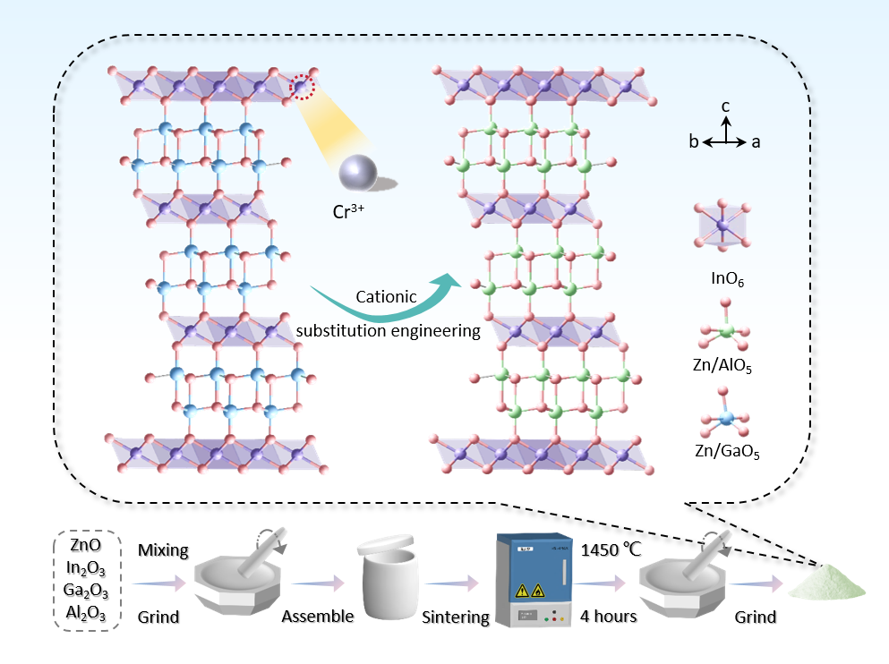
Figure S1. Crystal structures of ZnGaInO₄ and ZnAlInO₄.

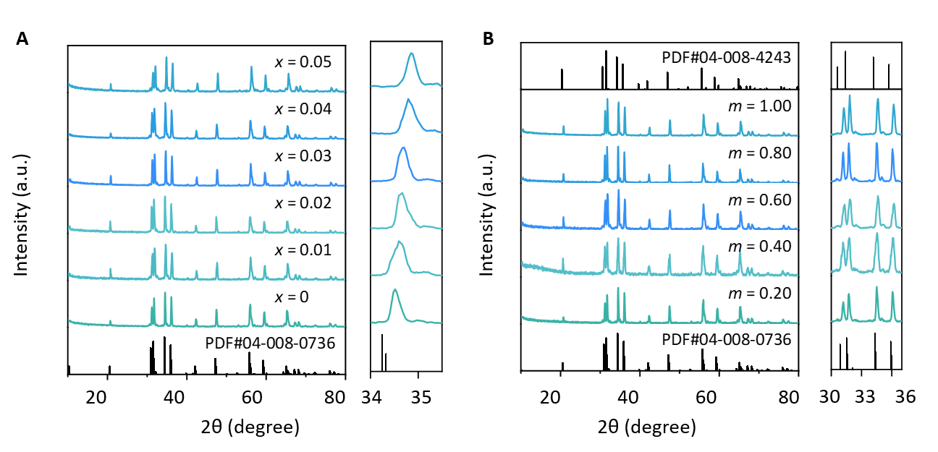
Figure S2. X-ray diffraction patterns of ZGIO:xCr³⁺ and ZnGa_{1-m}Al_{m}InO₄:0.04Cr³⁺.

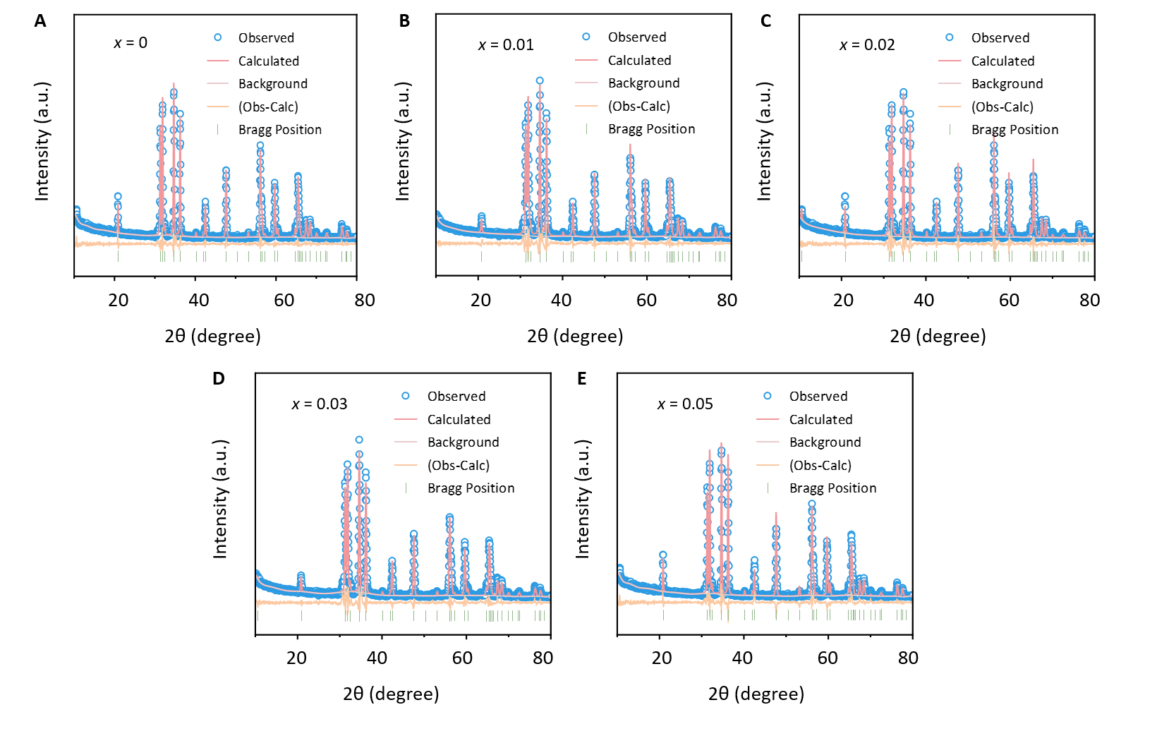
Figure S3. Rietveld refinement of XRD patterns for ZGIO:xCr³⁺ crystals.

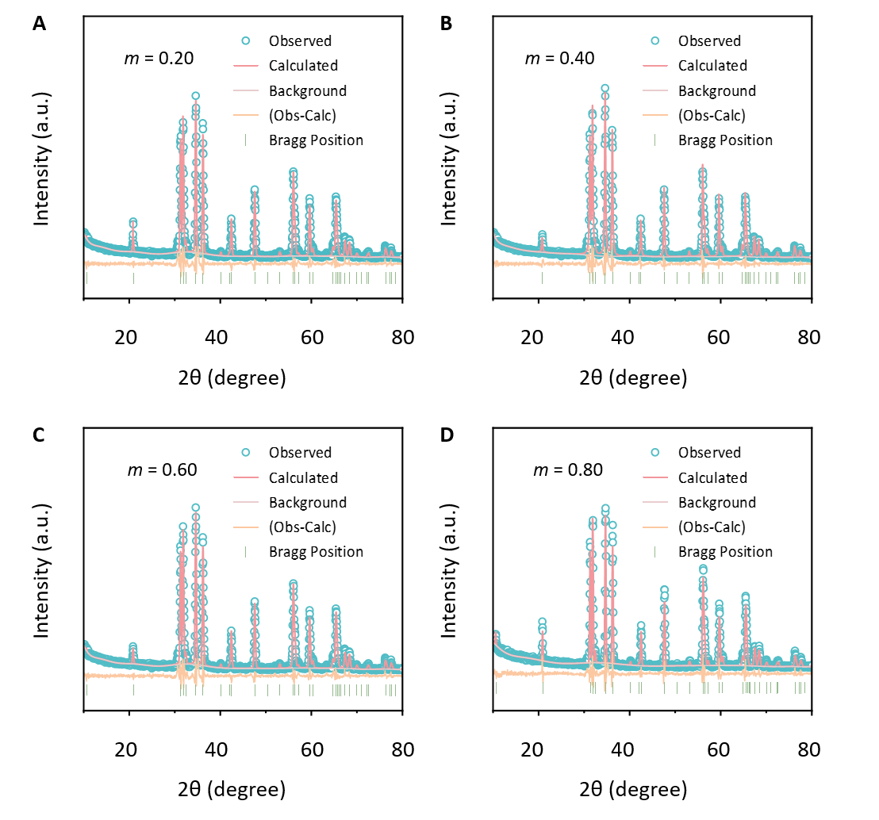
Figure S4. Rietveld refinement of XRD patterns for ZnGa_{1-m}Al_{m}InO₄:0.04Cr³⁺ crystals.

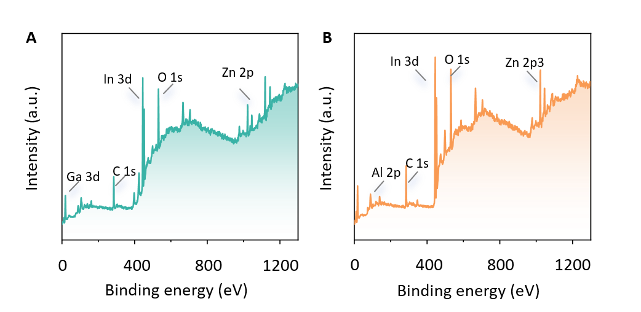
Figure S5. XPS analysis of ZGIO:0.04Cr³⁺ and ZAIO:0.04Cr³⁺.

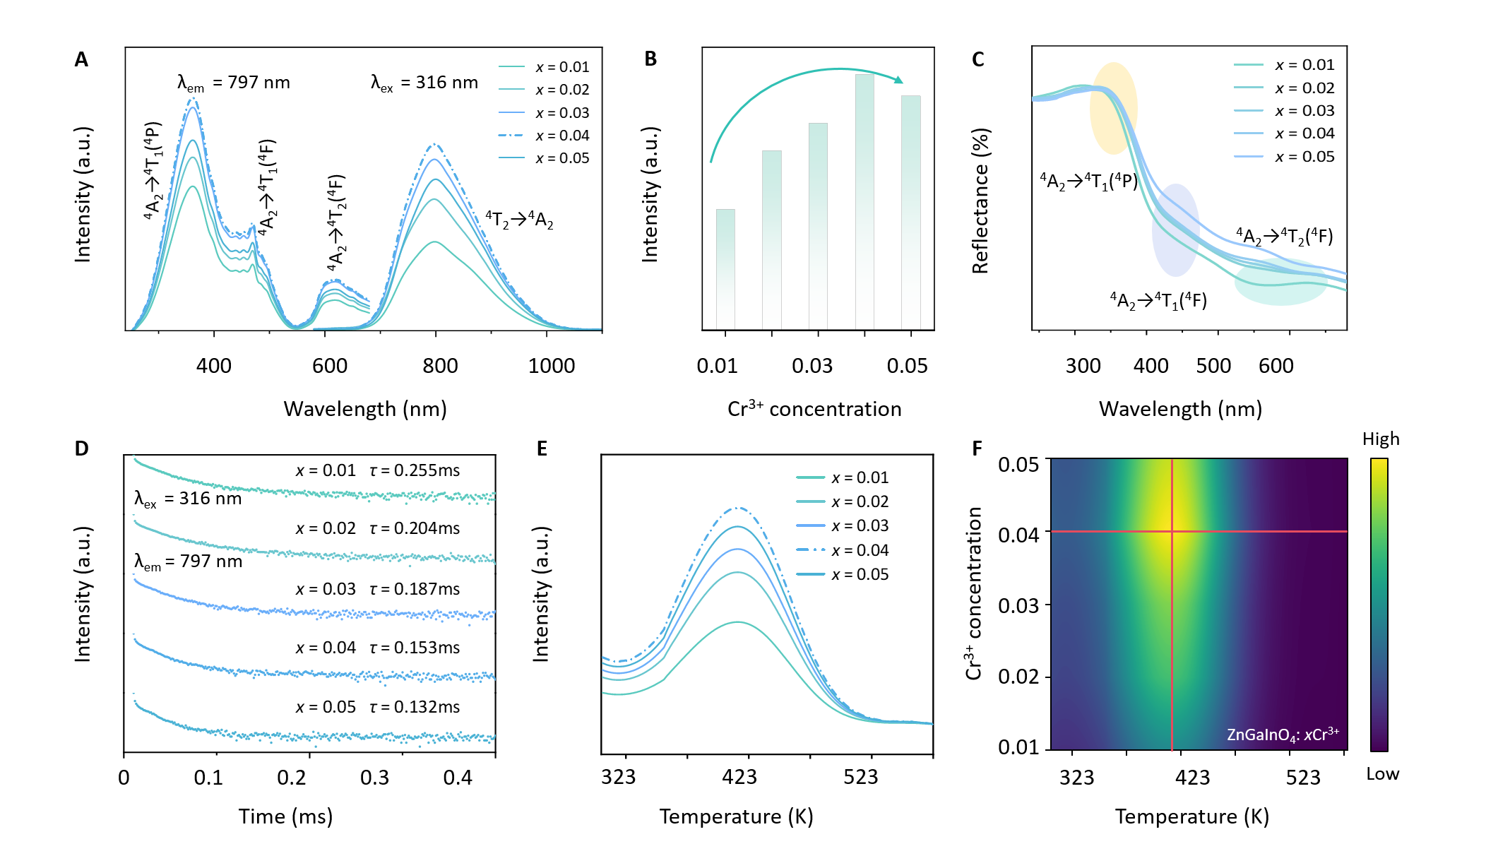
Figure S6. (A) PLE and PL spectra of ZGIO:xCr³⁺. (B) Relationship between Cr³⁺ ion concentration and PL intensity. (C) Diffuse reflectance spectra of ZGIO:xCr³⁺ (with the vertical axis inverted). (D) Decay curves of the ⁴T₂/⁴A₂ transition of ZGIO:xCr³⁺. (E) Thermoluminescence spectra and (F) Contour plots of the TL intensity as a function of the doping concentration x and temperature T of (A) ZGIO:xCr³⁺.

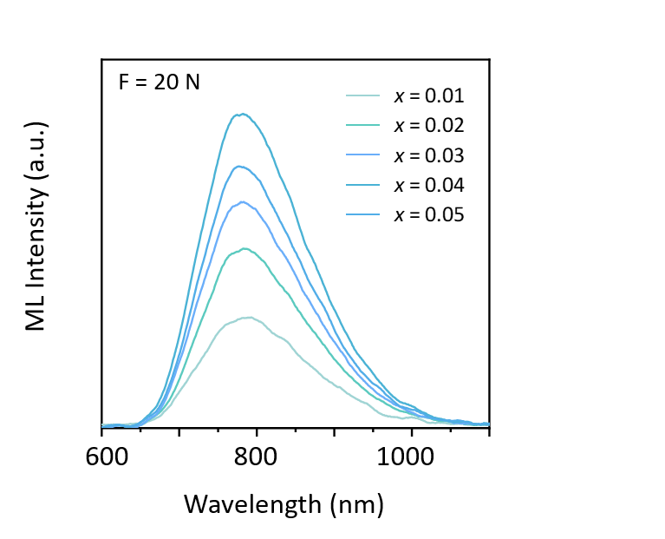
Figure S7. ML spectra of ZGIO:xCr³⁺.

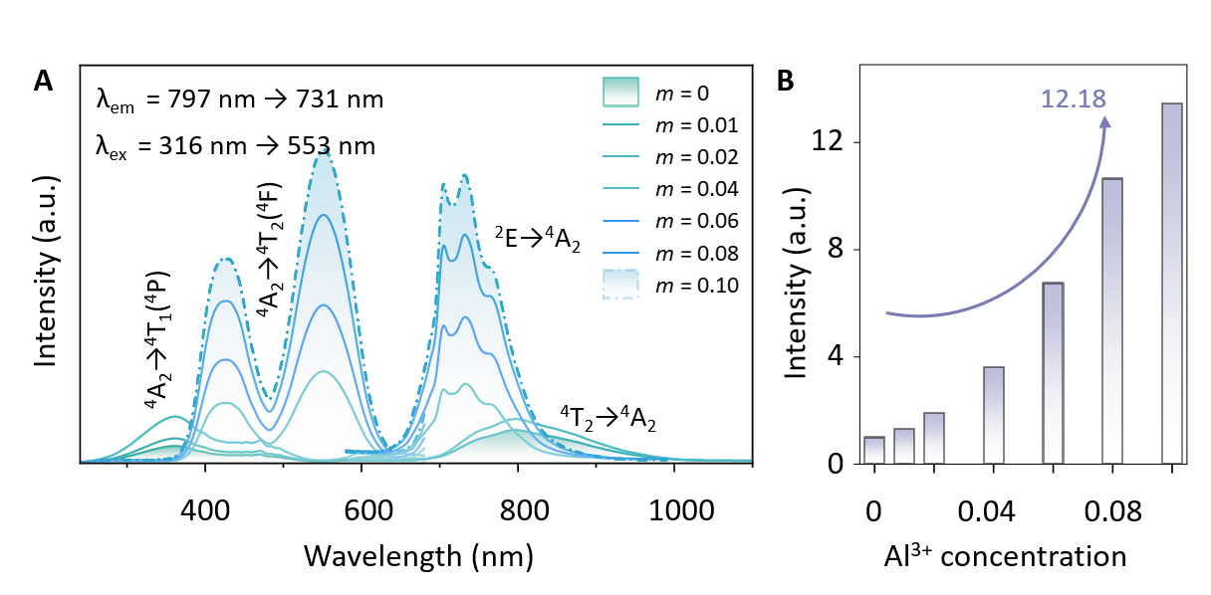
Figure S8. (A) PLE and PL spectra of ZnGa_{1-m}Al_{m}InO₄:0.04Cr³⁺ (m = 0 - 0.10). (B) Relationship between Al³⁺ ion concentration and PL spectrum intensity (m = 0 - 0.10).

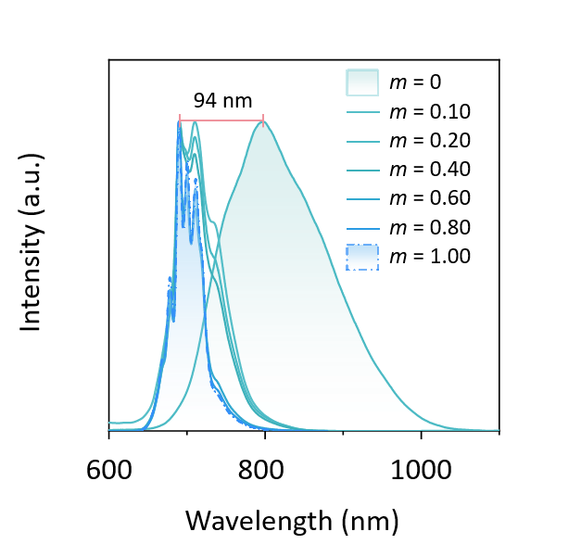
Figure S9. The normalized emission spectrum of ZnGa_{1-m}Al_{m}InO₄:0.04Cr³⁺.

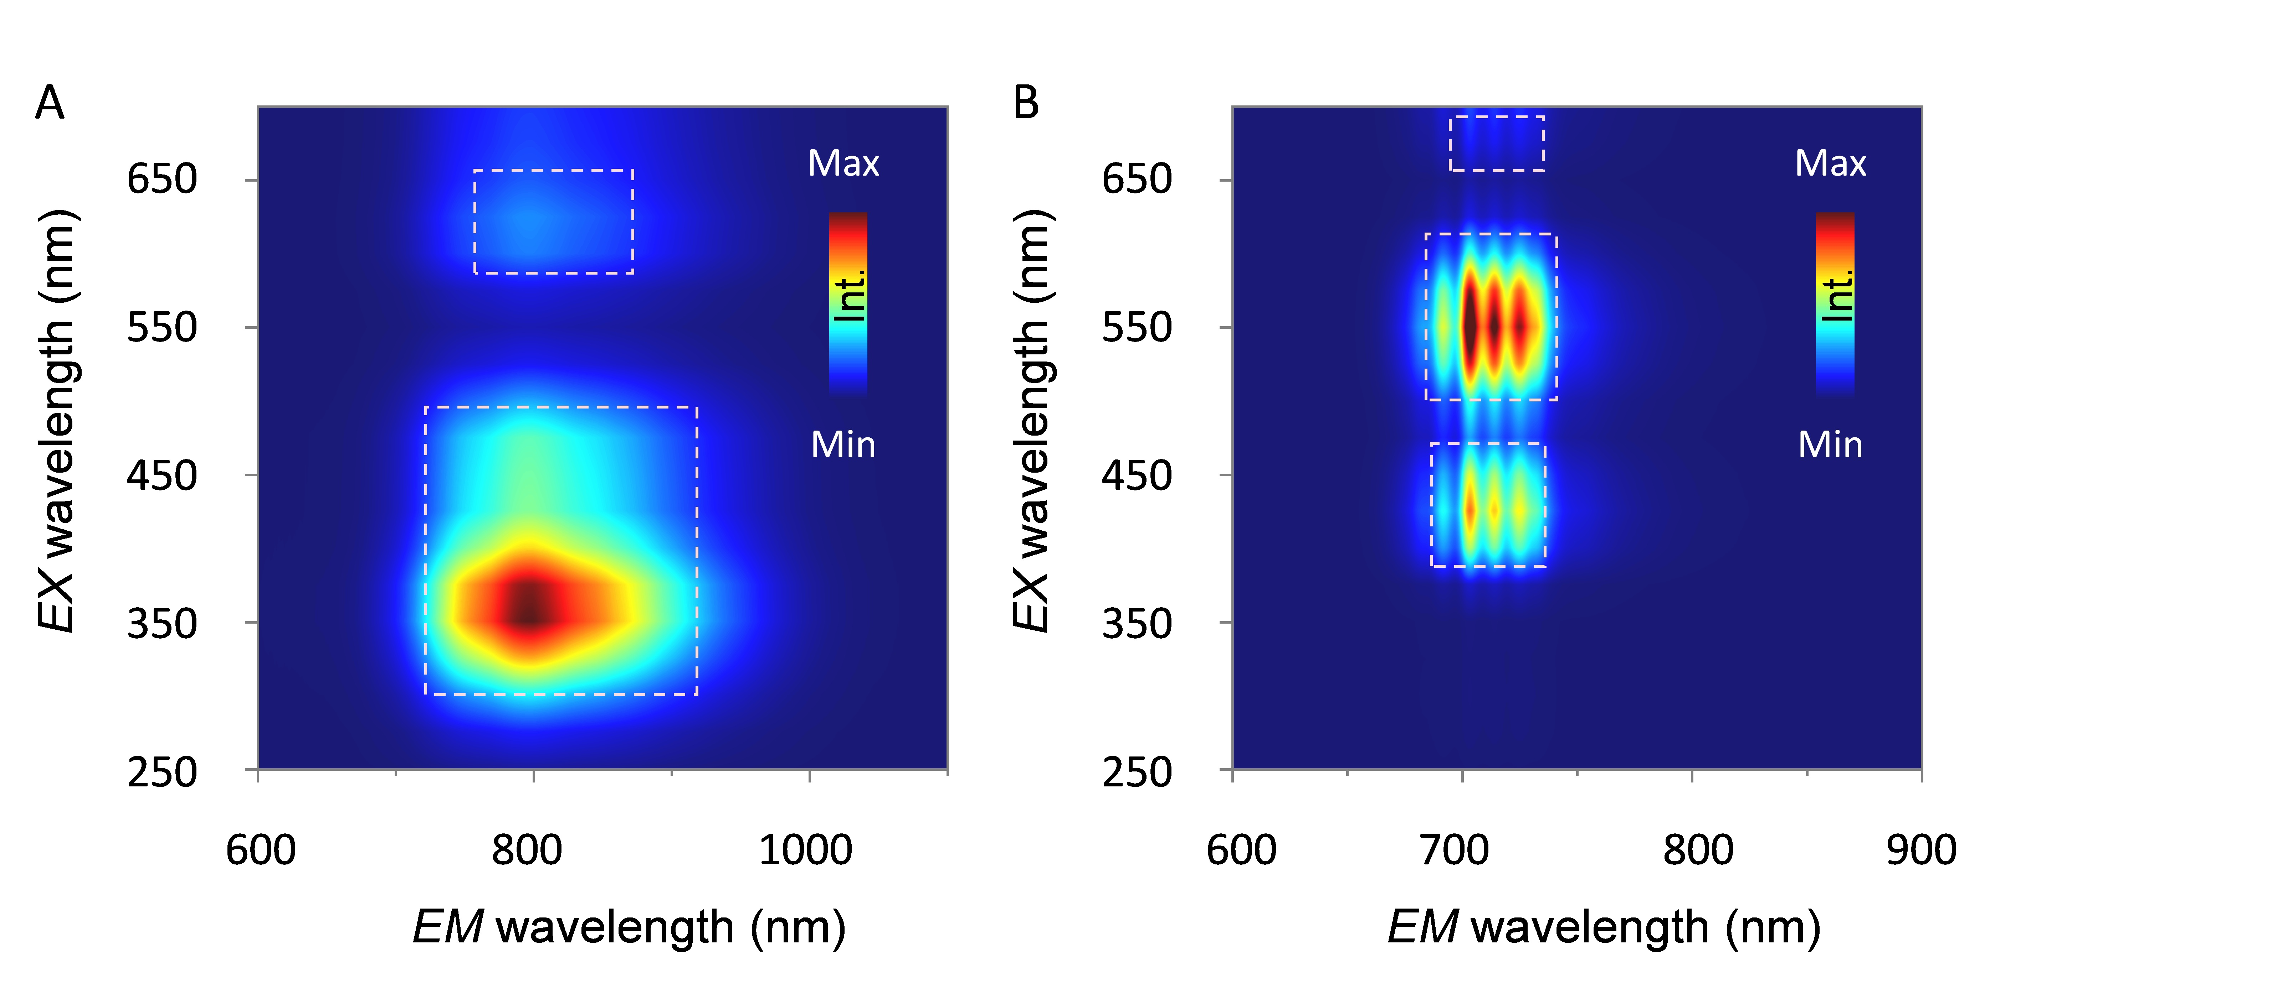
Figure S10. Isochronal plots of excited wavelength resolved photoluminescence (PL) spectra of ZGIO:Cr³⁺ and ZAIO:Cr³⁺ at room temperature.

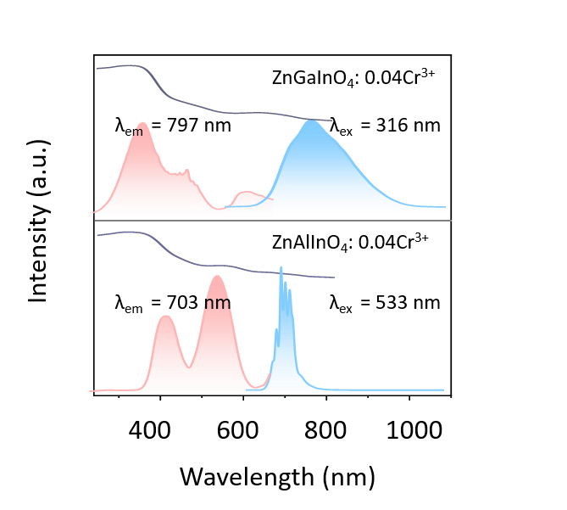
Figure S11. The combination of excitation light, emission spectrum and diffuse reflection spectrum.

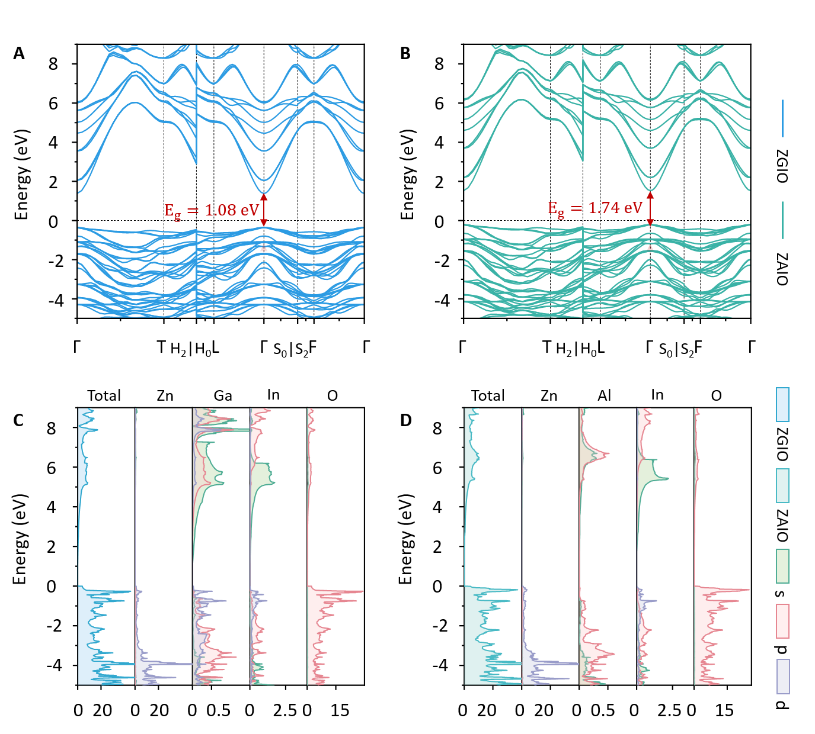
Figure S12. Band structure and electron densities of state of ZnGaInO₄ and ZnAlInO₄.

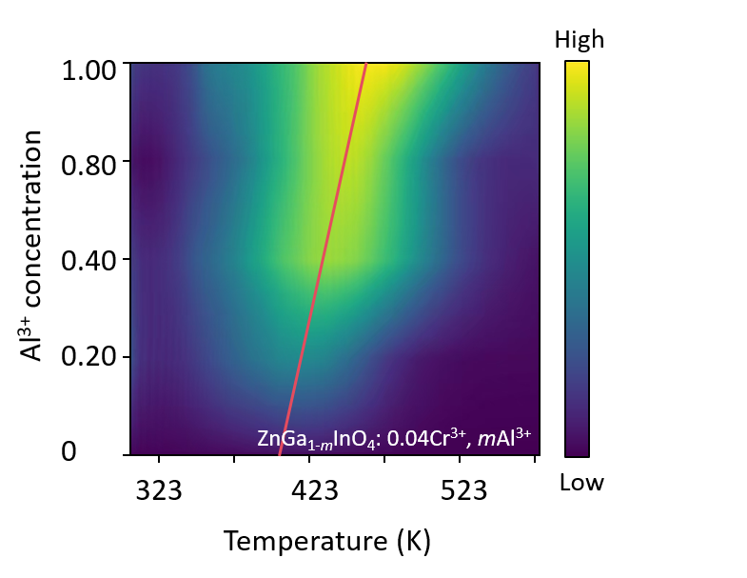
Figure S13. Contour plots of the TL intensity as a function of the doping concentration x and temperature T of ZnGa_{1-m}Al_{m}InO₄:0.04Cr³⁺.

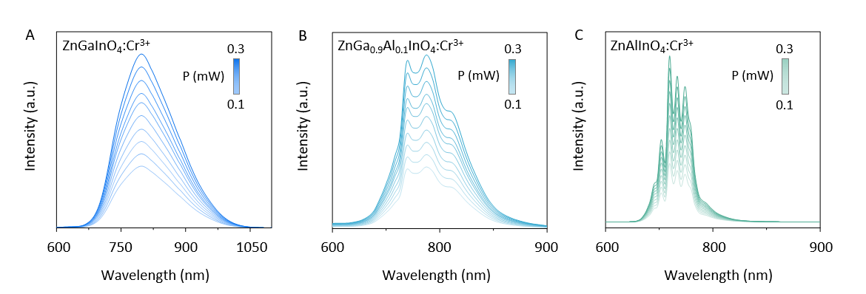
Figure S14. The variation patterns of the near-infrared emission spectra of Cr³⁺ doped oxides with different components (ZnGaInO₄:Cr³⁺, ZnGa_{0.9}A_{0.1}InO₄:Cr³⁺, ZnAlInO₄:Cr³⁺) with respect to the excitation power (P, mW).

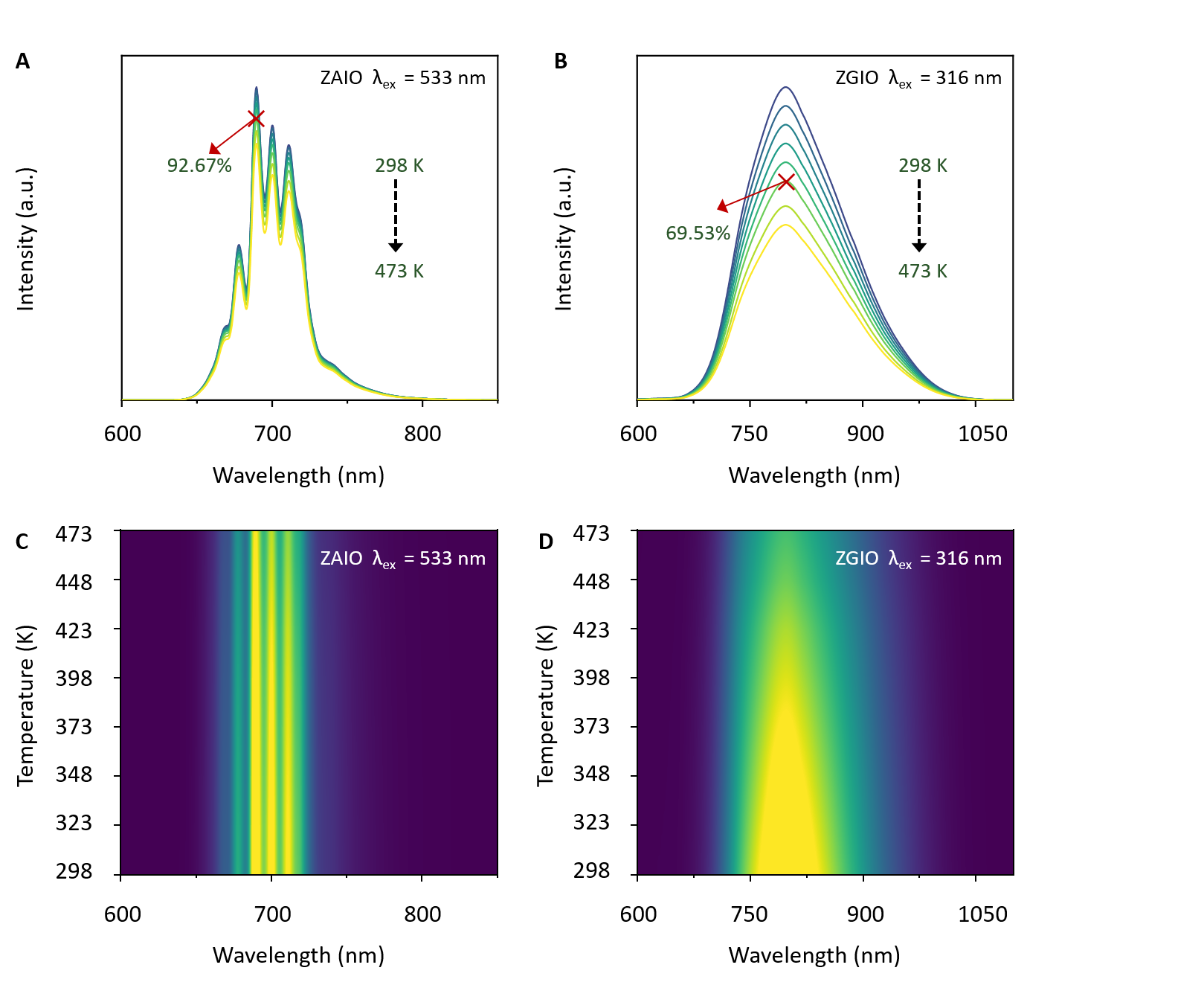
Figure S15. Thermal stability spectra of ZnGaInO₄:Cr³⁺, ZnAlInO₄:Cr³⁺.

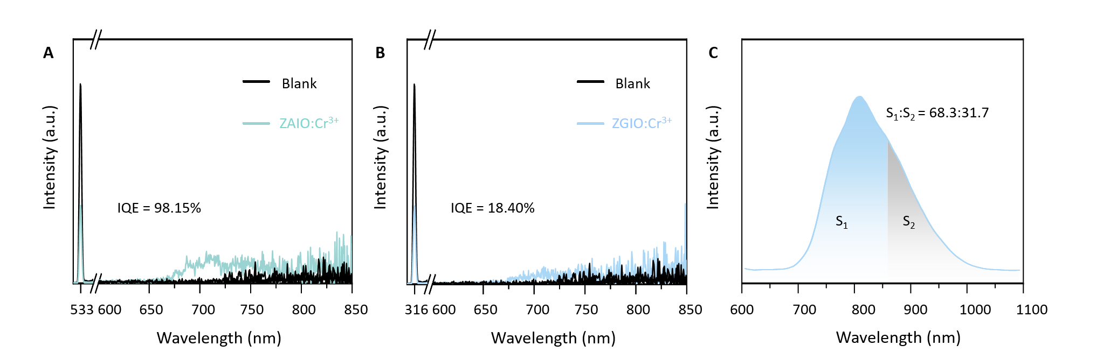
Figure S16. (A-B) The QY measurement results of ZAIO:Cr³⁺ and ZGIO:Cr³⁺. (C) The emission spectrum of ZGIO:Cr³⁺ in the 600 to 1100 nm range.

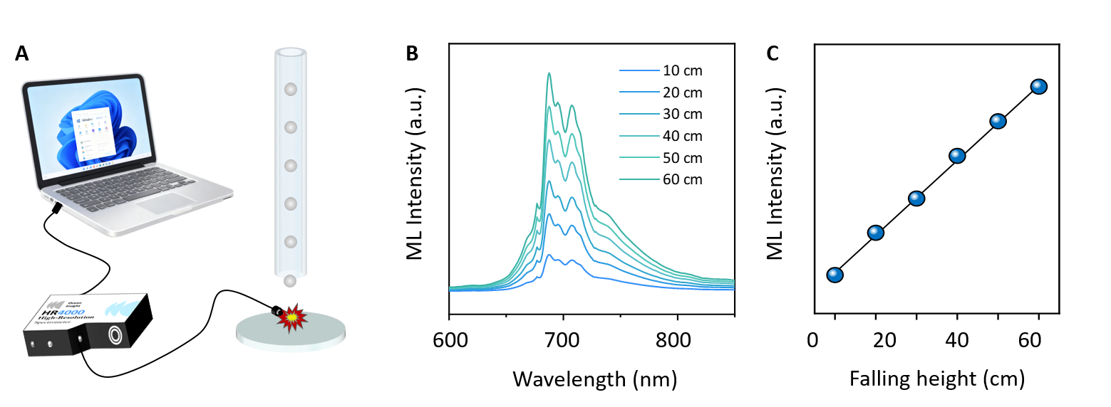
Figure S17. (A) Experimental schematic diagram. (B) Impact-magnetic resonance (ML) spectra generated by the collision of ZAIO: Cr³⁺ with steel balls freely falling from different heights (10 to 60 centimeters). (C) Linear relationship between ML intensity and falling height.
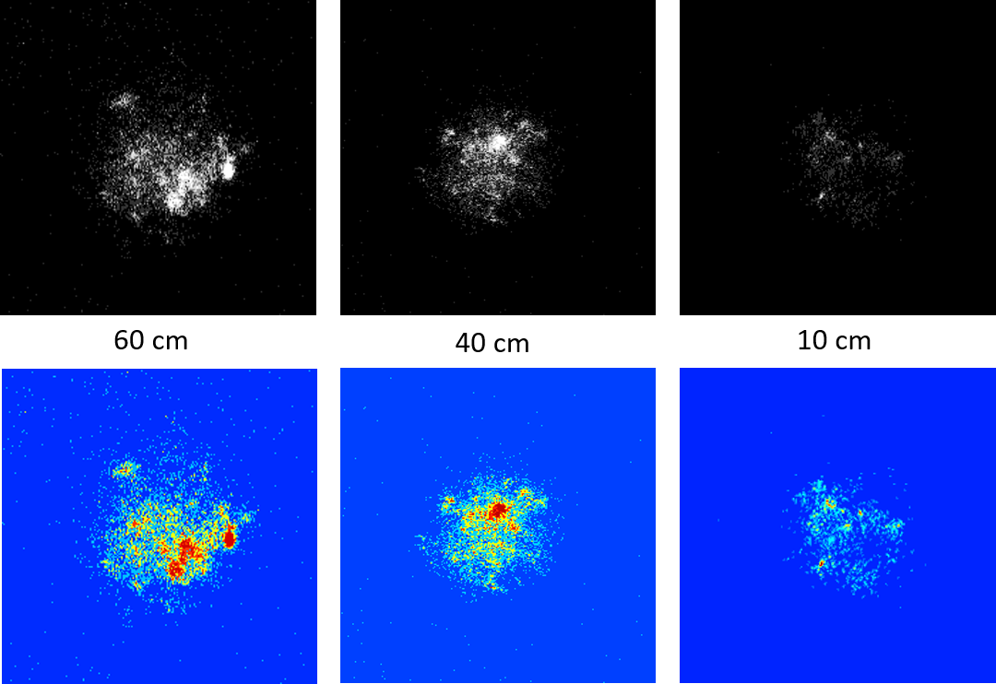
Figure S18. Photos of powder particles illuminated by the NIR camera when small steel balls fall from different heights.

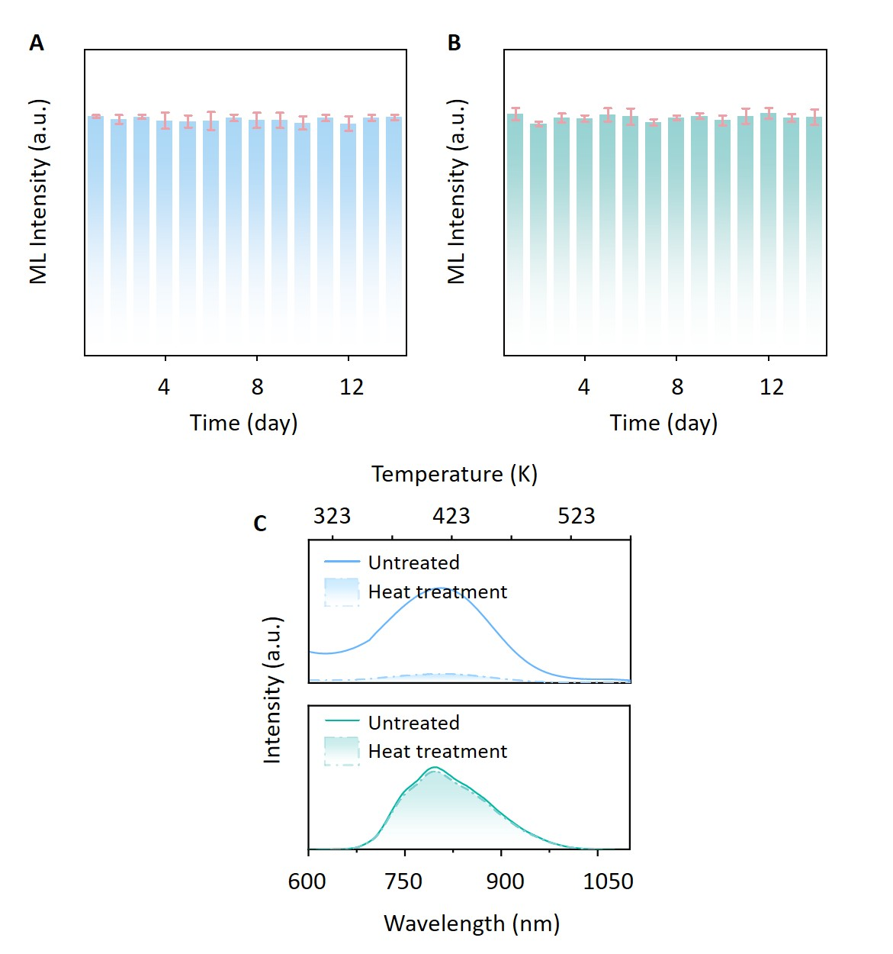
Figure S19. (A-B) The ML intensities of ZGIO:Cr³⁺ and ZAIO:Cr³⁺ measured in two weeks.

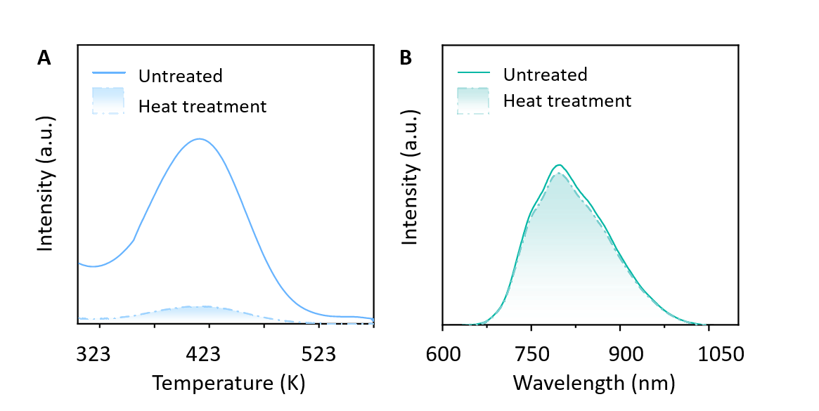
Figure S20. TL and ML spectra of ZGIO:Cr³⁺ before and after heating at 573 K for 20 min.

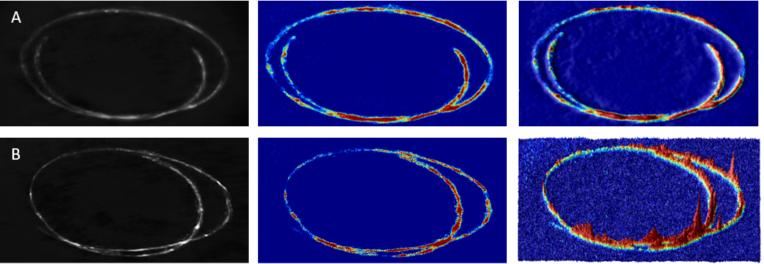
Figure S21. Using ZGIO:Cr³⁺ (A) and ZAIO:Cr³⁺ (B) for stress visualization diagrams, as well as ML images recorded in darkness using a NIR camera. The spatial distribution of relative ML intensity can be extracted from the NIR-ML images based on the gray value.

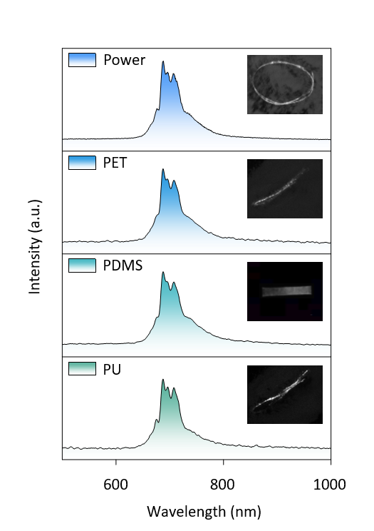
Figure S22. ML spectra of ZAIO:Cr³⁺ encapsulated in different flexible polymers under friction load. The inset shows corresponding ML images captured in dark conditions.
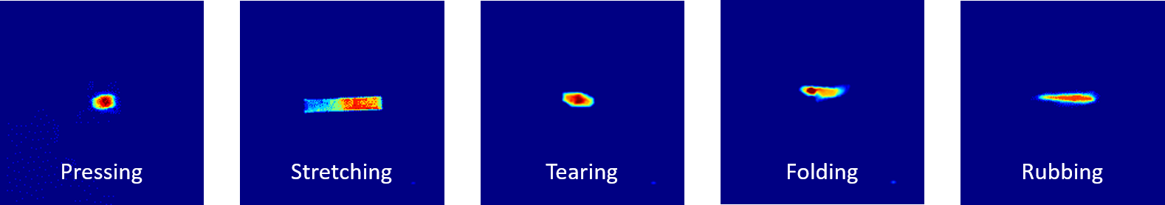
Figure S23. The luminescence images captured during different operations on PDMS were processed with pseudocolor.

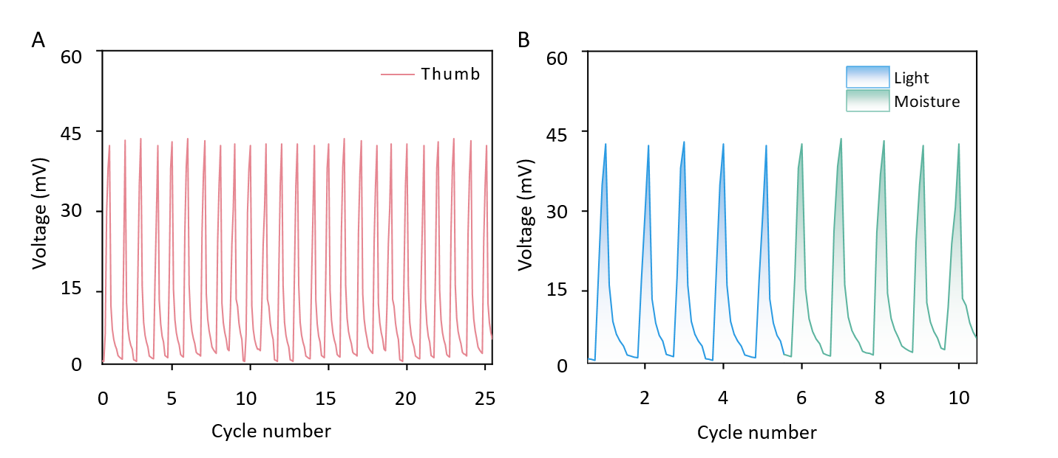
Figure S24. Cyclic testing was conducted while accounting for the effects of ambient light and humidity.
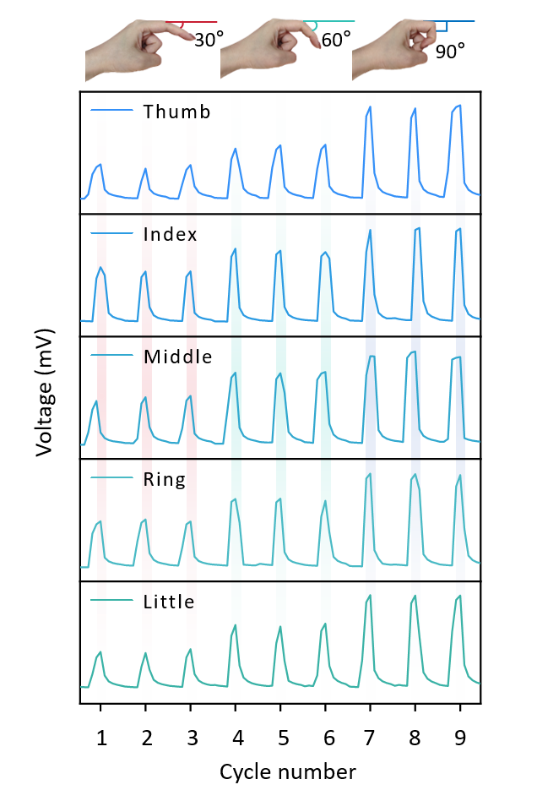
Figure S25. Voltage signals for each finger at different bending angles.

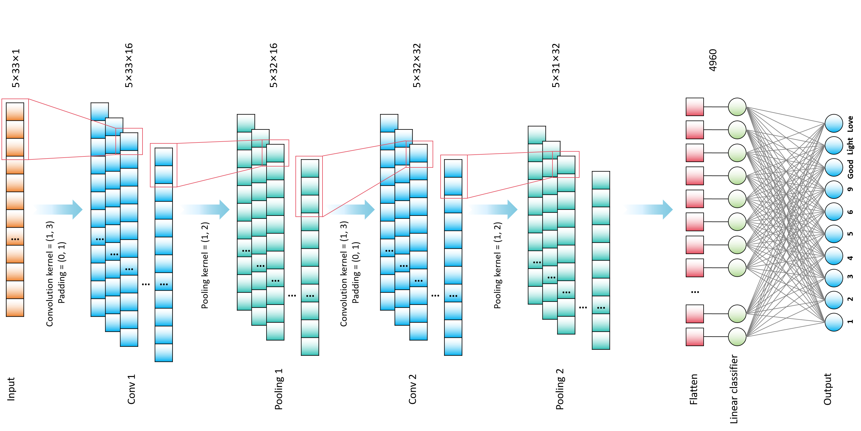
Figure S26. Schematic diagram of the overall structure of CNN.

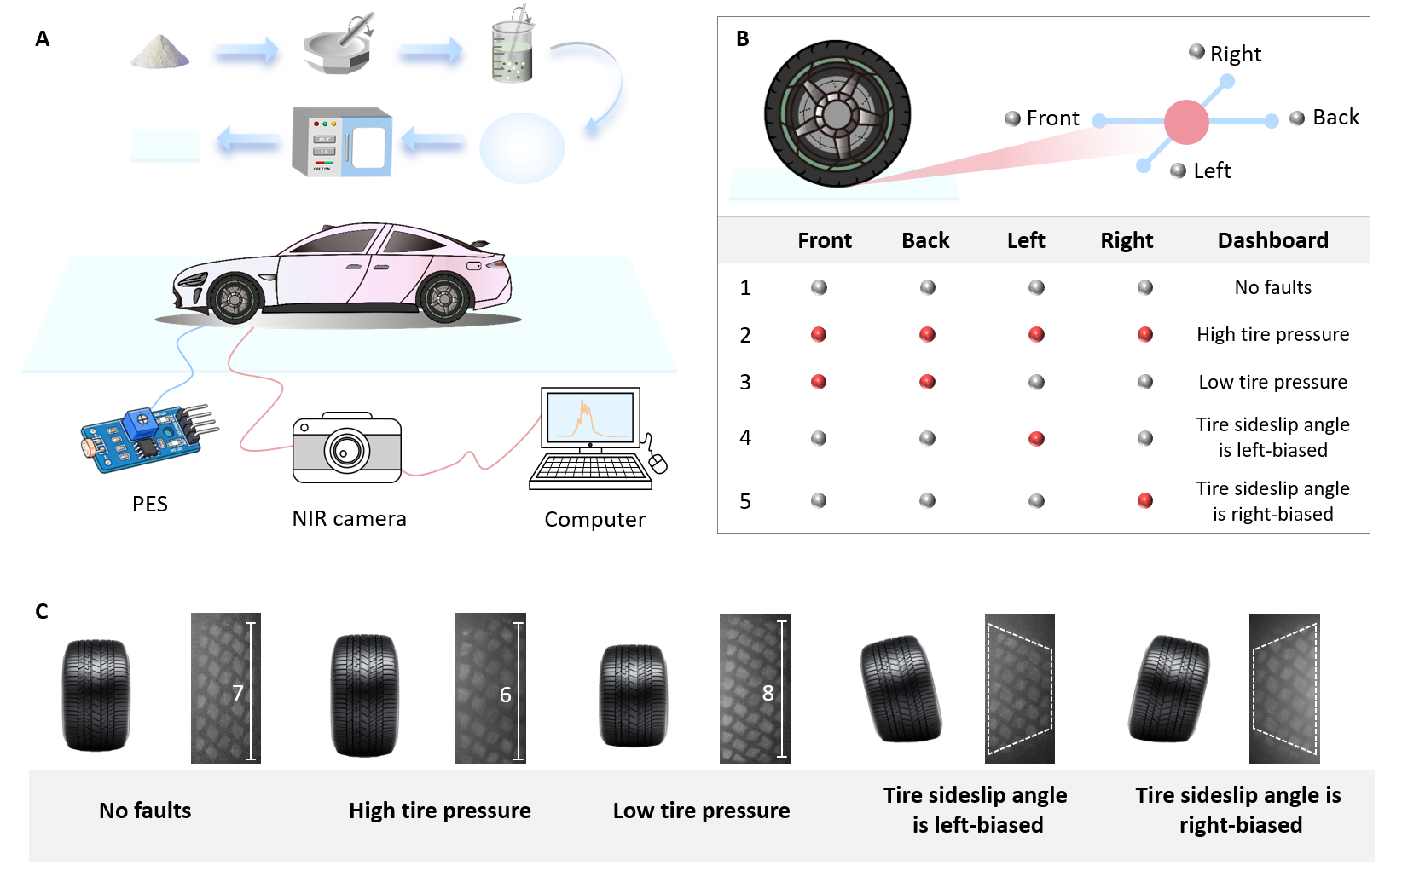
Figure S27. (A) Intelligent road surface composite image and workflow diagram. (B) Four-point monitoring method for intelligent road surface. (C) Diagram illustrating the luminous tire marks caused by road surface stress.

3. Supplementary Tables
Table S1. The comparison of the radii of Zn²⁺, Ga³⁺, In³⁺, Al³⁺ and Cr³⁺.
All ions | Coordination number (CN) | Ionic radii (Å)
Zn²⁺ | 5 | 0.68
Ga³⁺ | 5 | 0.55
In³⁺ | 6 | 0.80
Al³⁺ | 5 | 0.48
Cr³⁺ | 6 | 0.615
Table S2. Lattice parameters and agreement factors for ZnGaInO₄:xCr³⁺ refined by Rietveld method.
x | 0 | 0.01 | 0.02 | 0.03 | 0.04 | 0.05
Crystal system | Rhombohedral
Space group | R-3m
a (Å) | 3.2897 | 3.2829 | 3.2713 | 3.2466 | 3.2377 | 3.2356
b (Å) | 3.2897 | 3.2829 | 3.2713 | 3.2466 | 3.2377 | 3.2356
c (Å) | 25.9544 | 25.8892 | 25.2496 | 24.6416 | 24.5604 | 24.4618
Volume (Å³) | 243.25 | 241.10 | 240.23 | 239.92 | 239.71 | 236.85
Z | 3.00
R_{p} (%) | 5.14 | 4.70 | 5.33 | 4.88 | 5.20 | 4.57
R_{wp} (%) | 8.87 | 8.20 | 8.58 | 7.09 | 7.21 | 7.83
χ² | 2.27 | 2.43 | 1.97 | 2.62 | 2.45 | 2.36

Table S3. Lattice parameters and agreement factors for ZnGa_{1-m}InO₄:0.04Cr³⁺, mAl³⁺ refined by Rietveld method.
m |  | 0.20 | 0.40 | 0.60 | 0.80 | 1.00
Crystal system |  | Rhombohedral
Space group |  | R-3m
a (Å) |  | 3.3112 | 3.2923 | 3.2707 | 3.2527 | 3.2481
b (Å) |  | 3.3112 | 3.2923 | 3.2707 | 3.2527 | 3.2481
c (Å) |  | 26.3309 | 25.9020 | 25.7181 | 25.5079 | 24.8742
Volume (Å³) |  | 249.68 | 246.65 | 244.65 | 242.95 | 241.51
Z | 3.00
R_{p} (%) |  | 5.02 | 5.48 | 5.33 | 4.76 | 5.69
R_{wp} (%) |  | 8.61 | 9.07 | 8.89 | 8.54 | 9.04
χ² |  | 2.03 | 1.64 | 2.23 | 1.48 | 1.79

Table S4. PL peak wavelengths, IQE/EQE and FWHM values of several Cr³⁺-doped NIR phosphors with peak positions ranging from 800 to 850 nm
Phosphors | λ_{em} (nm) | IQE (%) | FWHM (nm) | Ref
Mg_{13.7}Ga_{4.6}Ge_{1.7}O₂₄:Cr³⁺ | 820 | 80.74 | 240 | ¹
ScBO₃:Cr³⁺ | 800 | 65 | 120 | ²
KGaP₂O₇:Cr³⁺ | 815 | 55.8 | 125 | ³
La₃Sc₂Ga₃O₁₂:Cr³⁺ | 818 | 35 | 145 | ⁴
InBO₃:Cr³⁺ | 820 | 46.3 | 138 | ⁵
Ca₃ZnZrGe₃O₁₂:Cr³⁺ | 795 | 96% | 140 | ⁶
LiInSi₂O₆:Cr³⁺ | 840 | 75 | 143 | ⁷
GaTaO₄:Cr³⁺ | 840 | 91.2 | 140 | ⁸
LiGaP₂O₇:Cr³⁺ | 846 | 47.8 | 168 | ⁹
ZnGaInO₄:Cr³⁺ | 797 | 26.94 | 159.2 | This work
ZnAlInO₄:Cr³⁺ | 703 | 98.15 | 64 | This work

Table S5 ML properties of Cr³⁺ doped materials.
Composition | EX wavelength (nm) | EM wavelength (nm) | FWHM (nm) | Ref
ZnGa₂O₄:Cr³⁺ | 408 | 700 | ~ 35 | ¹⁰
Zn₃Ga₂GeO₈:Cr³⁺ | 408 | 700 | ~ 35 | ¹⁰
Ga₂O₃:Cr³⁺ | 442 | 715 | ～110 | ¹¹
LaAlO₃:Cr³⁺ | 260 | 734 | <50 | ¹²
Lu₃Ga₅O₁₂:Cr³⁺ | 270 | 716 | 120 | ¹³
Mg_{13.7}Ga_{4.6}Ge_{1.7}O₂₄:Cr³⁺ | 450 | 840 | 208 | ¹
Y₃Al₄GaO₁₂:Cr³⁺ | 489 | 689 | ~ 20 | ¹⁴
Lu₃Al₂Ga₃O₁₂:Cr³⁺ | 270 | 816 | ~ 55 | ¹⁵
MgGa₂O₄:Cr³⁺ | 420 | 709 | ~ 50 | ¹⁶
Gd₃Ga₅O₁₂:Cr³⁺ | 456 | 725 | 100 | ¹⁷
SrGa₁₂O₁₉:Cr³⁺ | 448 | 750 | 100 | ¹⁸
Mg₃GaInGeO₈:Cr³⁺ | 266 | 803.5 | 179.4 | ¹⁹
Ca₂YGa₃Ge₂O₁₂:Cr³⁺ | 266 | 760 | 155.5 | ²⁰
BaGa₁₂O₁₉:Cr³⁺ | 434 | 708 | 179.4 | ²¹
Sr₂GaSbO₆:Cr³⁺ | 520 | ～830 | 134 | ²²
Sr₂ScSbO₆:Cr³⁺ | 550 | ～890 | 116 | ²²
Ba₂ScSbO₆:Cr³⁺ | 630 | ～1010 | 163 | ²²
ZnGaInO₄:Cr³⁺ | 316 | 797 | 159.2 | This work
ZnAlInO₄:Cr³⁺ | 533 | 703 | 64 | This work

4. Supplementary Reference
1 F. Zhao, Y. Shao, H. Liu, Q. Mao, H. Yang, M. Liu, Q. Liu, J. Zhong, Self-recoverable and tunable ultra-broadband NIR mechanoluminescence in Cr³⁺-doped gallogermanate material, Chemical Engineering Journal, 2025, 512, 162575.
2 M.-H. Fang, P.-Y. Huang, Z. Bao, N. Majewska, T. Leśniewski, S. Mahlik, M. Grinberg, G. Leniec, S.M. Kaczmarek, C.-W. Yang, K.-M. Lu, H.-S. Sheu, R.-S. Liu, Penetrating Biological Tissue Using Light-Emitting Diodes with a Highly Efficient Near-Infrared ScBO₃:Cr³⁺ Phosphor, Chemistry of Materials, 2020, 32(5), 2166-2171.
3 F.Y. Zhao, H. Cai, S.Y. Zhang, Z. Song, Q.L. Liu, Octahedron-dependent near-infrared luminescence in Cr³⁺-activated phosphors, Materials Today Chemistry, 2022, 23, 100704.
4 X. Xie, W. Ge, Y. Tian, Q. Zhang, M. Yang, C. Wu, P. He, H. Yin, La₃Sc₂Ga₃O₁₂:Cr³⁺, Nd³⁺ near-infrared phosphor for nondestructive detection and luminescence thermometry, Ceramics International, 2024, 50(22), 46098-46106.
5 Z. Sun, Q. Ning, W. Zhou, J. Luo, P. Chen, L. Zhou, Q. Pang, X. Zhang, Structural and spectroscopic investigation of an efficient and broadband NIR phosphor InBO₃: Cr³⁺ and its application in NIR pc-LEDs, Ceramics International, 2021, 47(10), 13598-13603.
6 D. Liu, G. Li, P. Dang, Q. Zhang, Y. Wei, L. Qiu, H. Lian, M. Shang, J. Lin, Valence conversion and site reconstruction in near-infrared-emitting chromium-activated garnet for simultaneous enhancement of quantum efficiency and thermal stability, Light: Science & Applications, 2023, 12(1), 248.
7 X. Xu, Q. Shao, L. Yao, Y. Dong, J. Jiang, Highly efficient and thermally stable Cr³⁺-activated silicate phosphors for broadband near-infrared LED applications, Chemical Engineering Journal, 2020, 383, 123108.
8 J. Zhong, Y. Zhuo, F. Du, H. Zhang, W. Zhao, S. You, J. Brgoch, Efficient Broadband Near‐Infrared Emission in the GaTaO₄:Cr³⁺ Phosphor, Advanced Optical Materials, 2021, 10(2), 2101800.
9 C. Yuan, R. Li, Y. Liu, L. Zhang, J. Zhang, G. Leniec, P. Sun, Z. Liu, Z. Luo, R. Dong, J. Jiang, Efficient and Broadband LiGaP₂O₇:Cr³⁺ Phosphors for Smart Near‐Infrared Light‐Emitting Diodes, Laser & Photonics Reviews, 2021, 15(11), 2100227.
10 P. Xiong, B. Huang, D. Peng, B. Viana, M. Peng, Z. Ma, Self‐Recoverable Mechanically Induced Instant Luminescence from Cr³⁺‐Doped LiGa₅O₈, Advanced Functional Materials, 2021, 31(19), 2010685.
11 H. Suo, Y. Wang, X. Zhang, W. Zheng, Y. Guo, L. Li, P. Li, Y. Yang, Z. Wang, F. Wang, A broadband near-infrared nanoemitter powered by mechanical action, Matter, 2023, 6(9), 2935-2949.
12 P. Shao, P. Xiong, Y. Xiao, Z. Chen, D. Chen, Z. Yang, Self-recoverable NIR mechanoluminescence from Cr3+ doped perovskite type aluminate, Advanced Powder Materials, 2024, 3(2), 100165.
13 S. Wu, B. Xiao, D. Jiang, Y. Xiao, P. Shao, Z. Zhou, Y. Wang, P. Xiong, Realizing Near Infrared Mechanoluminescence Switch in LAGO:Cr Based on Oxygen Vacancy, Small, 2024, 20(31), 2309034.
14 Z. Liu, X. Yu, Q. Peng, X. Zhu, J. Xiao, J. Xu, S. Jiang, J. Qiu, X. Xu, NIR Mechanoluminescence from Cr³⁺ Activated Y₃Al₅O₁₂ with Intense Zero Phonon line, Advanced Functional Materials, 2023, 33(27), 2214497.
15 S. Wu, B. Xiao, Y. Xiao, P. Shao, Y. Wang, P. Xiong, Cr³⁺-activated broadband near-infrared mechanoluminescence in garnet compound, Nano Energy, 2023, 116, 108811.
16 X. Yu, X.-X. Yang, J. Huan, J. Tong, Y. Qiao, J.-J. Xing, Z.-J. Zhang, J.-T. Zhao, Intense NIR mechanoluminescence from Al³⁺-regulated MgGa₂O₄: Cr³⁺, Chemical Engineering Journal, 2024, 491, 152155.
17 W. Bu, T. Wang, Y. Wang, W. Huang, L. Guo, Y. Yue, X. Zhu, J. Xiao, X. Yu, Near‐Infrared Mechanoluminescence of Gd₃Ga₅O₁₂: Cr³⁺, La³⁺ for Biological Stress Imaging, Laser & Photonics Reviews, 2024, 19(1), 2400893.
18 S. Yu, S. Fang, L. Zhao, Y. Bai, R. Wang, Z. Wang, Self-recoverable and cyclically stable near-infrared mechanoluminescence for dual-mode mechanics visualization and biomechanics detection, Chemical Engineering Journal, 2023, 474, 145542.
19 B. Xiao, S. Wu, P. Xiong, Y. Xiao, P. Shao, Z. Zhou, Y. Wang, F. Wang, Broadband near-infrared mechanoluminescence in Cr³⁺ doped Mg₃Ga₂GeO₈, Chemical Engineering Journal, 2024, 498, 155040.
20 S. Wu, S. Wang, B. Xiao, Z. Zhou, H. Yu, Z. Shao, Y. Wang, P. Xiong, Regulating Broadband Near‐Infrared Mechanoluminescence via Energy‐Level Engineering for Potential Biomechanical Imaging, Laser & Photonics Reviews, 2024, 19(4), 2401441.
21 X. Wang, Y. Xiao, P. Xiong, P. Zheng, S. Wu, Z. Zhou, B. Xiao, P. Shao, M. Zhang, J. Liu, J. Gan, Y. Wang, Q. Qian, Self-recoverable broadband near infrared mechanoluminescence from BaGa₁₂O₁₉:Cr³⁺ using a multi-site occupation strategy, Materials Horizons, 2025, 12(11), 3815-3826.
22 C. Dou, T. Liang, M. Zhao, Z. Song, L. Ning, D. Peng, Q. Liu, Self‐Recoverable and NIR‐I to NIR‐II Tunable Broadband Mechanoluminescence of Cr³⁺‐Doped Antimonate Double Perovskites, Advanced Functional Materials, 2024, 35(14), 2419716.

