Supporting Information
Freeze-structuring unlocks minimal-processing strategies for legume texturization
Andrea Bach*, Elin Perler*, Lenja S. Lemcke, and Patrick A. Rühs
Institute of Food, Nutrition, and Health, Department of Health Sciences and Technology, ETH Zürich
*co-first authors

Iodine staining
Heat-induced molecular changes of chickpea (CP) suspensions were examined with light microscopy. Starch was stained with Lugol’s solution prepared following the protocol using elemental iodine (I2, resublimed, VWR chemicals, Japan) and potassium iodide (KI, >99.5%, Honeywell Fluka, Germany), dissolved in deionized water at a mass ratio of 1:2 (I2:KI)¹. Changes of CP starch upon heat treatment were evaluated using 10 g of heat-treated (30 minutes at 90 °C) and non-heat-treated CP suspensions (1.0 wt%), which were stained with one drop (0.03 - 0.05 g) of Lugol’s solution. The stained solutions were immediately examined under a Leica light microscope (DM6 B, Leica Microsystems GmbH, Wetzlar, Germany) (Figure S1).
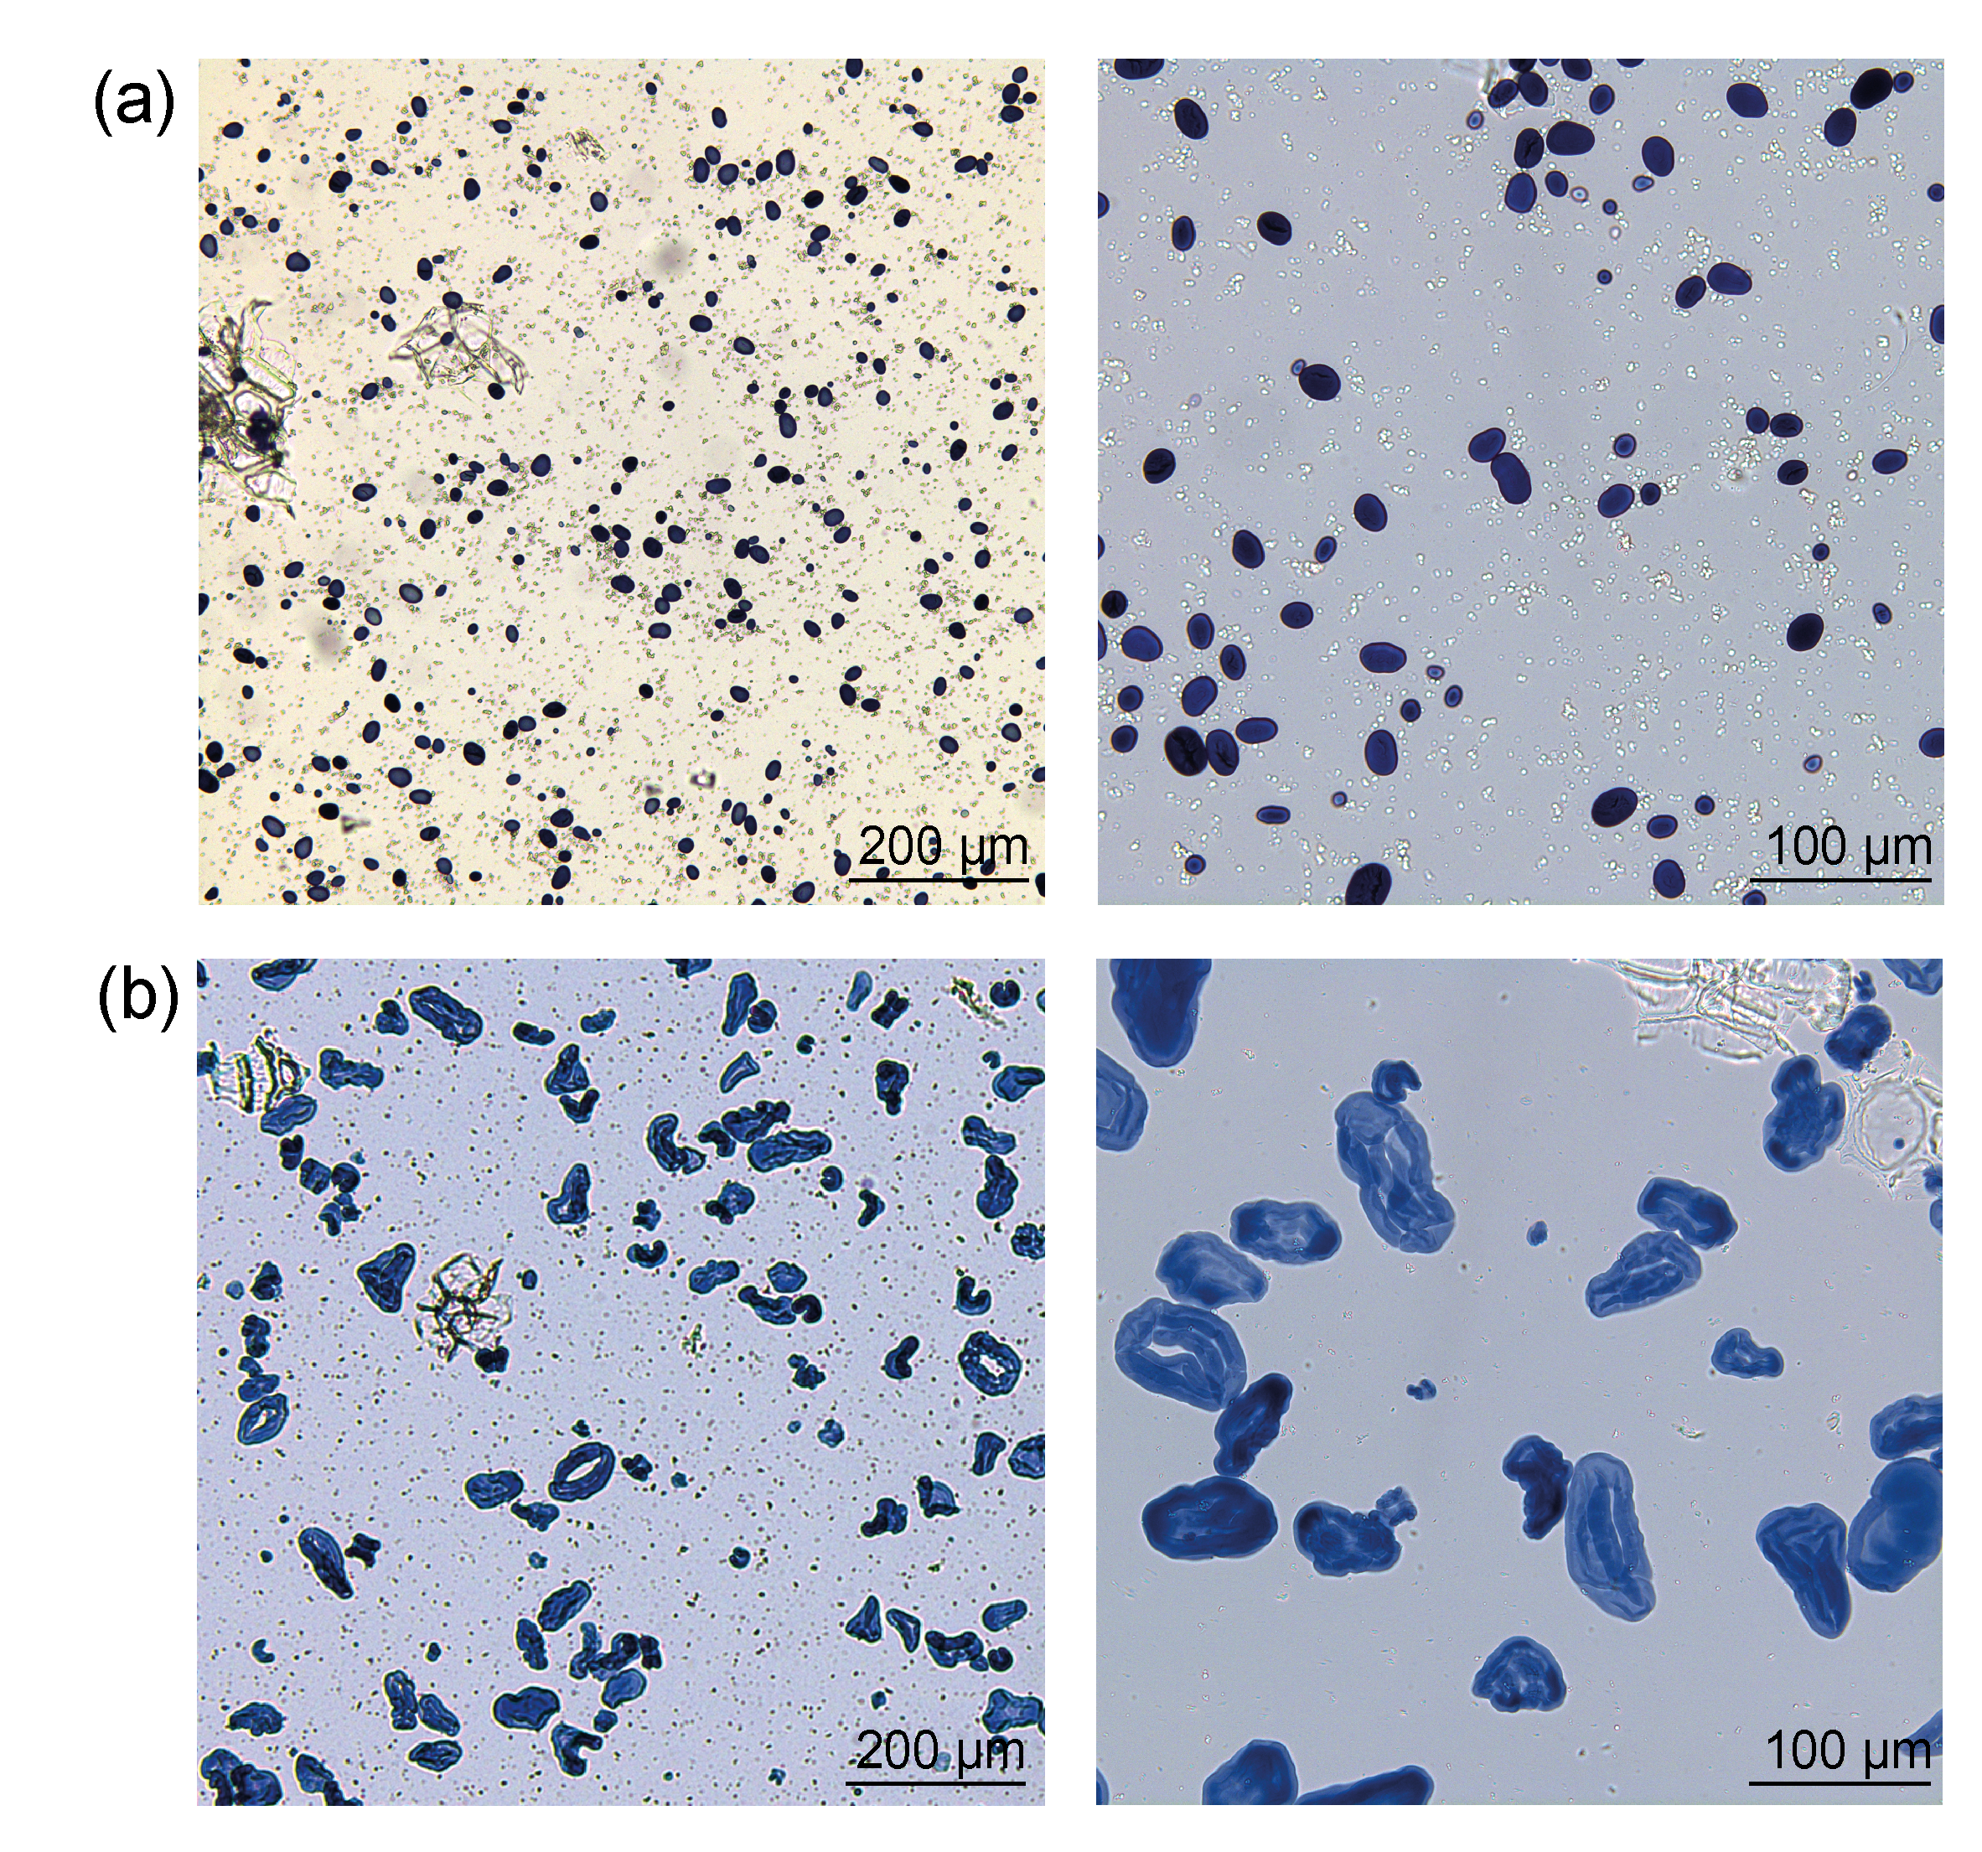

Figure S1. Comparison of chickpea suspensions before and after thermal treatment. (a) 1.0 wt% chickpea suspension stained with iodine solution (pre-heating). (b) 1.0 wt% chickpea suspension after heating at 90 °C for 30 min, stained with iodine solution (post-heating).

Freezing process
Directional freezing can be implemented using different setups by establishing a controlled temperature gradient that drives solidification from one side to the other. Silicone moulds (56 mm height; outer diameter 74 mm; inner diameter 28 mm) were employed for controlled laboratory experiments (Figure S2). On the bottom of each mould, an aluminium foil was added to prevent low-viscosity samples from running out. Then, the mould was placed on a 10 mm-thick aluminium plate to create a bottom-up temperature gradient and covered with a 21 mm-thick silicone lid after filling (Figure 2a). This configuration ensures directional solidification from the aluminium interface upward, resulting in anisotropic structuring (Figure 2b). For simplified, household-scale experiments, a plastic beaker or container, either cylindrical or cuboid, can be inserted snugly into an expanded polystyrene (EPS) foam container (e.g., Styrofoam) to provide insulation and minimize lateral heat transfer (Figure 2c). Beakers with diameters of 3-10 cm and heights of 10-25 cm were successfully used in this setup, which enables anisotropic structuring without specialized equipment (Figure 2d).
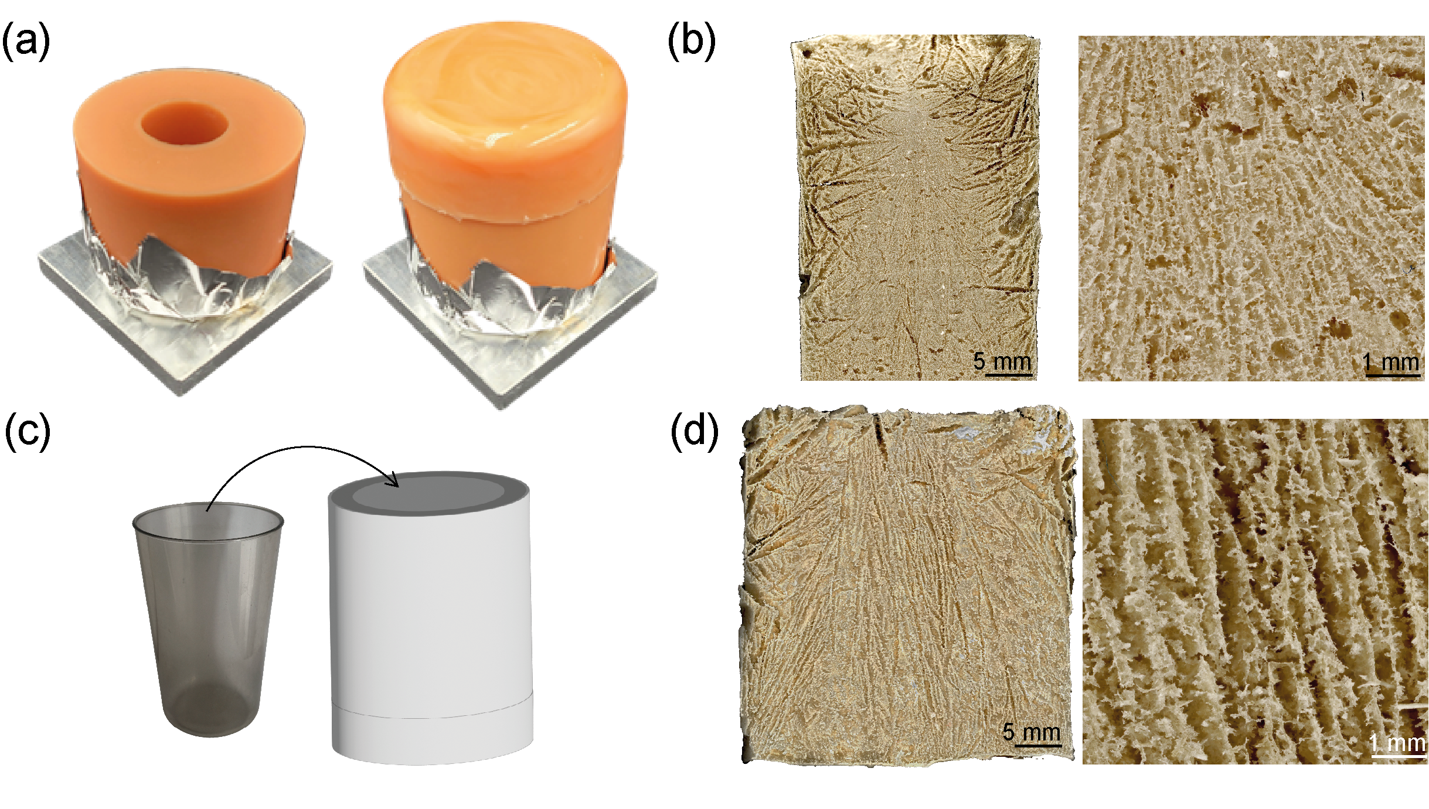
Figure S2. Freezing setups for directional freezing. (a) Silicone mould configuration: mould placed on an aluminium plate to create a bottom-up temperature gradient, without lid (before filling), then with lid in place. (b) Freeze-dried structure of a 12.5 wt% chickpea gel, frozen in the silicone mould setup. (c) Insulated beaker or container setup: plastic beaker (cylindrical or rectangular) inserted snugly into an insulating EPS foam container. (d) Freeze-dried structure of a 12.5 wt% chickpea gel prepared using the insulated beaker or container setup.

Practical guide for directional freezing at home
Method to replicate directional freezing using household equipment:
- Soak legumes: Soak whole legumes for at least 8 h in water.
- Prepare suspension: Blend the hydrated legumes with various amounts of water to achieve the desired solids concentration (e.g., 12.5-20.0 wt%). Salt and other spices can be added freely.
- Thermal treatment: Cook the homogenized legumes until the mixture thickens and the starch is gelatinized. This can be done:
  - On a stovetop in a pan or pot while stirring.
  - Using a microwave, heating in short intervals and stirring until the suspension thickens.
- Moulding: Quickly pour the hot suspension into a plastic beaker or food-grade container.
- Insulation setup: Place the container inside an EPS foam mould (negative) with at least 2-3 cm wall thickness. This insulation minimizes heat transfer from all sides except the top, promoting unidirectional freezing from the exposed surface downward. Do not cover the container.
- Freezing: Put the insulated setup in a household freezer (-25 °C to -10 °C) and allow complete freezing for 12-24 hours depending on the container size.

Supplementary rheological analysis
Further analyses of oscillatory shear experiments (Figure 3a) highlight differences in viscoelastic behaviour and yielding characteristics among F, DF, and R gels. Variations in G′ and G″ are most likely linked to microstructural changes induced during freezing. The loss tangent (tan δ = G″/G′) of the LVER remained relatively stable across samples (F = 0.122, DF = 0.126, R = 0.096), indicating that the elastic-viscous balance was largely unaffected. In contrast, the dynamic yield stress, derived from amplitude sweep curves, revealed marked differences: DF exhibited the highest yield stress (τ* = 4.1 kPa at 136% strain), compared to F (1.9 kPa at 130%) and R (1.6 kPa at 119%). This suggests that DF gels can withstand greater stress and deformation before yielding, consistent with their aligned lamellar structure. F formed an isotropic network with intermediate strength, whereas R showed the lowest resistance to yielding.

Regression statistics for rheological analysis
Linear regression was applied to the LVER G′ (kPa) data obtained from amplitude sweep tests for F, DF, and R gels (Figure 3b). All statistical analyses were performed with Origin Pro 2025 (v10.2.0.196).

Table S1. Regression statistics for rheological analysis. Summary of linear regression parameters for LVER G′ (Pa) obtained from amplitude sweep tests. Degrees of freedom (DOF) of model and error, intercept and standard error (SE), slope and SE, Pearson correlation coefficient (Pearson R), R², adjusted R², F-value, and model significance (p-value) for chickpea gels F, DF, and R.
Sample | n | DOF | Interc. | SE | Slope | SE | Pear. R | R² | Adj. R² | F | p
F | 7 | 1, 5 | -14'504 | 4’075 | 3'895 | 303 | 0.99 | 0.97 | 0.96 | 165.63 | <0.0001
DF | 7 | 1, 5 | -25’350 | 13’329 | 6’111 | 990 | 0.94 | 0.88 | 0.86 | 38.09 | 0.00163
R | 7 | 1, 5 | -21'685 | 5’084 | 3'123 | 377 | 0.97 | 0.93 | 0.92 | 68.40 | 4.22×10⁻⁴

Sample syneresis and corrected rheological analysis
Syneresis was determined on thawed gels by placing each sample on a 0.5 mm² mesh sieve for 3 minutes to allow liquid drainage. The drained liquid was weighed, and syneresis was calculated according to equation (S1):
$$\begin{aligned}\text{Syneresis (\%)}=\frac{\text{Mass of drained liquid (g}\text{)}}{\text{Initial sample mass (g)}}×100 \#\left(S1\right)\end{aligned}$$
After syneresis, the actual solids concentration of the gel was recalculated to account for water loss according to equation (S2):
$$\begin{aligned}\text{Corrected concentration (wt\%)}=\frac{\text{Initial concentration (wt\%)}}{100-\text{Syneresis (\%)}}×100 \#\left(S2\right)\end{aligned}$$
For the 5.0 wt% R sample, syneresis reached 100%, as the sample was liquid and passed through the sieve (Figure S3a). In the rheological analysis, the entire liquid phase was measured, therefore, no syneresis correction was applied. For all other concentrations and cooling conditions, the solids were retained after syneresis and subsequently measured, therefore, concentration adjustments were applied to account for water loss (Figure S3b).
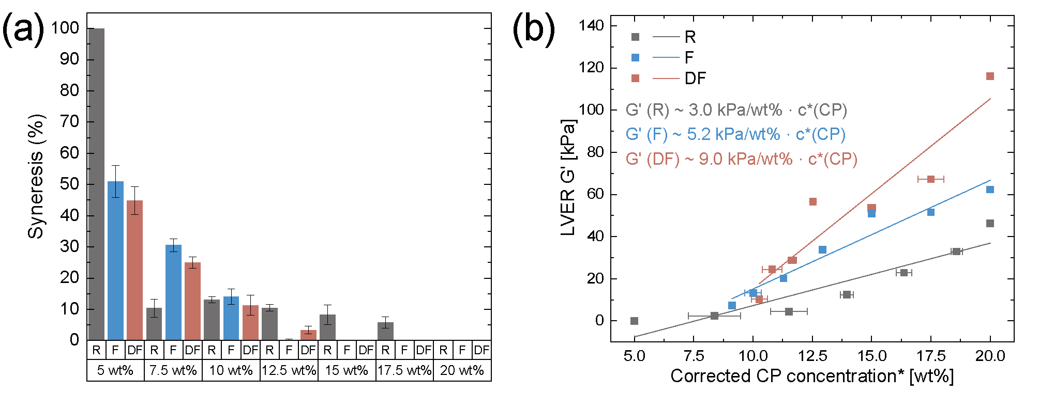

Figure S3. Syneresis and corrected rheological analysis. (a) Syneresis data for R, F, and DF chickpea gels measured at initial concentrations of 5.0 to 20 wt%. (b) Corrected rheological analysis corresponding to Figure 3b, recalculated based on actual concentrations after syneresis adjustment. G′ in the linear viscoelastic region (LVER) of amplitude sweeps of R, F, and DF gels from corrected chickpea concentrations, with corresponding regression lines.

Linear regression was applied to the LVER G′ (kPa) data obtained from amplitude sweep tests for F, DF, and R gels after correcting for actual concentrations.

Table S2. Regression statistics for rheological analysis with corrected concentrations. Summary of linear regression parameters for LVER G′ (Pa) obtained from amplitude sweep tests after correcting for actual concentrations following syneresis. Degrees of freedom (DOF) of model and error, intercept and standard error (SE), slope and SE, Pearson correlation coefficient (Pearson R), R², adjusted R², F-value, and model significance (p-value) for chickpea gels F, DF, and R.
Sample | n | DOF | Interc. | SE | Slope | SE | Pear. R | R² | Adj. R² | F | p
F | 7 | 1, 5 | -22'425 | 7’640 | 2'969 | 535 | 0.93 | 0.86 | 0.83 | 30.97 | 0.00258
DF | 7 | 1, 5 | -36'490 | 7’972 | 5'162 | 562 | 0.97 | 0.94 | 0.93 | 84.40 | 2.56×10⁻⁴
R | 7 | 1, 5 | -74'822 | 20’288 | 9'013 | 1’411 | 0.94 | 0.89 | 0.87 | 40.77 | 0.00140

Statistics for hardness

Hardness regression analysis
Regression analysis of hardness measurements of 12.5-20.0 wt% chickpea gels was performed using a weighting factor of 1/e² to account for measurement uncertainty.

Figure S4. Hardness regression analysis for chickpea gels of 12.5 to 20.0 wt%. Hardness in N for R, F, DF parallel, and DF perpendicular chickpea samples of 12.5-20.0 wt% with corresponding regression lines.

Table S3. Regression statistics for hardness. Summary of linear regression parameters for hardness in N using a weighting of 1/e² obtained from single compression tests corresponding to Figure 3d. Degrees of freedom (DOF) of model and error, intercept and standard error (SE), slope and SE, Pearson correlation coefficient (Pearson R), R², adjusted R², F-value, and model significance (p-value) for chickpea gels F, DF, and R, with DF measured in parallel (par) and perpendicular (perp) direction to the temperature gradient.
Sample | n | DOF | Interc. | SE | Slope | SE | Pear. R | R² | Adj. R² | F | p
DF par | 4 | 1, 2 | -0.90 | 0.77 | 3.70 | 0.51 | 0.98 | 0.96 | 0.95 | 53.54 | 0.02
DF perp | 4 | 1, 2 | -0.81 | 0.54 | 3.64 | 0.39 | 0.99 | 0.98 | 0.97 | 87.91 | 0.01
F | 4 | 1, 2 | 1.26 | 0.32 | 0.89 | 0.17 | 0.96 | 0.93 | 0.89 | 25.75 | 0.04
R | 4 | 1, 2 | 0.46 | 1.00 | 1.37 | 0.35 | 0.94 | 0.88 | 0.83 | 15.29 | 0.06

Hardness ANOVA
Comparisons were made across cooling conditions (R, F, and DF) and concentrations (12.5-20.0 wt%), and for DF samples, direction of compression (parallel vs. perpendicular). Two-way ANOVA was applied to assess the effects of cooling condition and concentration and for DF compression direction and concentration, followed by groupwise comparisons (Tukey’s HSD) to identify significant differences.

Table S4. Two-Way ANOVA for hardness of chickpea gels. Summary of analysis of variance (ANOVA) results for hardness in N of R, F, and DF chickpea gels at concentrations 12.5-20.0 wt%, including their interaction. Reported values include degrees of freedom (DOF), sum of squares, mean squares, F-statistic, and model significance (p-value).
Source | DOF | Sum of squares | Mean squares | F | p
Condition | 2 | 304.25 | 152.13 | 192.87 | <0.0001
Concentration | 3 | 314.34 | 104.78 | 132.84 | <0.0001
Interaction | 6 | 167.38 | 27.9 | 35.37 | <0.0001
Model | 11 | 957.47 | 87.04 | 110.35 | <0.0001
Error | 37 | 29.18 | 0.79
Corrected Total | 48 | 986.65

Table S5. Groupwise comparisons for cooling conditions. Summary of mean hardness in N for chickpea gels under different conditions. Letters indicate statistically significant groupings based on Tukey’s HSD post-hoc test.
Condition | Mean hardness (N) | Group
DF | 8.57 | A
F | 3.9 | B
R | 3.45 | B

Table S6. Groupwise comparisons for concentrations. Summary of mean hardness in N for chickpea gels at concentrations 12.5-20.0 wt%. Letters indicate statistically significant groupings based on Tukey’s HSD post-hoc test.
Concentration | Mean hardness (N) | Group
20.0 | 10.59 | A
17.5 | 6.53 | B
15.0 | 4.64 | C
12.5 | 2.18 | D

Table S7. Interaction for cooling condition and concentration. Summary of mean hardness in N for chickpea gels across conditions and concentrations (12.5-20.0 wt%). Letters indicate statistically significant groupings based on Tukey’s HSD post-hoc test.
Condition | Concentration | Mean hardness (N) | Group
DF | 20.0 | 16.36 | A
DF | 17.5 | 9.03 | B
F | 20.0 | 6.19 | C
DF | 15.0 | 6.06 | C
R | 20.0 | 4.9 | C D
R | 17.5 | 4.63 | C D E
F | 17.5 | 3.45 | D E
R | 15.0 | 3.35 | D E F
F | 15.0 | 3.09 | D E F
DF | 12.5 | 2.84 | D E F
F | 12.5 | 2.11 | E F
R | 12.5 | 0.91 | F

Table S8. Two-Way ANOVA for compression direction. Summary of analysis of variance (ANOVA) results for hardness in N of chickpea gels tested in parallel and perpendicular directions at concentrations 12.5-20.0 wt%. Reported values include degrees of freedom (DOF), sum of squares, mean squares, F-statistic, and model significance (p-value).
Source | DOF | Sum of squares | Mean squares | F | p
Concentration | 3 | 600.28 | 200.09 | 466.88 | <0.0001
Direction | 1 | 9.94 | 9.94 | 23.19 | 0.00019
Interaction | 3 | 7.96 | 2.65 | 6.19 | 0.00539
Model | 7 | 618.18 | 88.31 | 206.06 | <0.0001
Error | 16 | 6.86 | 0.43
Corrected Total | 23 | 625.04

Table S9. Groupwise comparison for compression direction. Summary of mean hardness in N for chickpea gels tested in parallel and perpendicular directions. Letters indicate statistically significant groupings based on Tukey’s HSD post-hoc test.
Direction | Mean hardness (N) | Group
par | 9.22 | A
perp | 7.93 | B

Table S10. Interaction for concentration and compression direction. Summary of mean hardness in N for chickpea gels tested in parallel and perpendicular directions across concentrations (12.5-20.0 wt%). Letters indicate statistically significant groupings based on Tukey’s HSD post-hoc test.
Concentration | Direction | Mean hardness (N) | Group
20.0 | par | 17.93 | A
20.0 | perp | 14.8 | B
17.5 | par | 9.5 | C
17.5 | perp | 8.56 | C
15.0 | par | 6.62 | D
15.0 | perp | 5.5 | D
12.5 | perp | 2.86 | E
12.5 | par | 2.83 | E

Syneresis-corrected hardness

Figure S5. Hardness of chickpea gels with syneresis adjusted concentrations. Hardness of R, F, DF parallel, and DF perpendicular chickpea gels of 12.5-20.0 wt% with concentrations adjusted for syneresis.

Statistics for cohesiveness

Table S11. Two-Way ANOVA for cohesiveness of chickpea gels. Summary of analysis of variance (ANOVA) results for cohesiveness (%) of R, F, and DF chickpea gels at concentrations 12.5-20.0 wt%, including their interaction. Reported values include degrees of freedom (DOF), sum of squares, mean squares, F-statistic, and model significance (p-value).
Source | DOF | Sum of squares | Mean squares | F | p
Condition | 2 | 5714.71 | 2857.35 | 152.7 | <0.0001
Concentration | 3 | 369.02 | 123.01 | 6.57 | 0.00113
Interaction | 6 | 726.05 | 121.01 | 6.47 | <0.0001
Model | 11 | 7091.54 | 644.69 | 34.45 | <0.0001
Error | 37 | 692.35 | 18.71
Corrected Total | 48 | 7783.89

Table S12. Groupwise comparisons for cooling conditions. Summary of mean cohesiveness (%) for chickpea gels under different cooling conditions. Letters indicate statistically significant groupings based on Tukey’s HSD post-hoc test.
Condition | Mean cohesiveness (%) | Group
DF | 56.55 | A
F | 37.53 | B
R | 32.96 | C

Table S13. Groupwise comparison for concentrations. Summary of mean cohesiveness (%) for chickpea gels at concentrations 12.5-20.0 wt%. Letters indicate statistically significant groupings based on Tukey’s HSD post-hoc test.
Concentration | Mean cohesiveness (%) | Group
17.5 | 48.26 | A
15.0 | 47.74 | A
20.0 | 47.59 | A
12.5 | 39.17 | B

Table S14. Interaction for cooling condition and concentration. Summary of mean cohesiveness (%) for chickpea gels across conditions and concentrations (12.5-20.0 wt%). Letters indicate statistically significant groupings based on Tukey’s HSD post-hoc test.
Condition | Concentration | Mean cohesiveness (%) | Group
DF | 17.5 | 63.35 | A
DF | 15.0 | 59.6 | A
DF | 20.0 | 58.39 | A
DF | 12.5 | 44.86 | B
F | 20.0 | 42.3 | B C
F | 15.0 | 38.99 | B C D
F | 17.5 | 36.12 | B C D
R | 12.5 | 35.84 | B C D
R | 20.0 | 33.04 | C D
R | 15.0 | 32.78 | C D
F | 12.5 | 31.1 | C D
R | 17.5 | 30.19 | D

Table S15. Two-Way ANOVA for compression direction. Summary of analysis of variance (ANOVA) results for cohesiveness (%) of chickpea gels tested in parallel and perpendicular directions at concentrations 12.5-20.0 wt%. Reported values include degrees of freedom (DOF), sum of squares, mean squares, F-statistic, and model significance (p-value).
Source | DOF | Sum of squares | Mean squares | F | p
Concentration | 3 | 1173.28 | 391.09 | 14.05 | <0.0001
Direction | 1 | 14.06 | 14.06 | 0.51 | 0.4874
Interaction | 3 | 78.56 | 26.19 | 0.94 | 0.444
Model | 7 | 1265.9 | 180.84 | 6.5 | 0.00097
Error | 16 | 445.25 | 27.83
Corrected Total | 23 | 1711.16

Table S16. Groupwise comparison for compression direction. Summary of mean cohesiveness (%) for chickpea gels tested in parallel and perpendicular directions. Letters indicate statistically significant groupings based on Tukey’s HSD post-hoc test.
Direction | Mean cohesiveness (%) | Group
par | 57.32 | A
perp | 55.79 | A

Table S17. Interaction for concentration and compression direction. Summary of mean cohesiveness (%) for chickpea gels tested in parallel and perpendicular directions across concentrations (12.5-20.0 wt%). Letters indicate statistically significant groupings based on Tukey’s HSD post-hoc test.
Concentration | Direction | Mean cohesiveness (%) | Group
17.5 | par | 63.61 | A
17.5 | perp | 63.1 | A
20.0 | par | 61.94 | A
15.0 | par | 60.36 | A B
15.0 | perp | 58.84 | A B
20.0 | perp | 54.85 | A B C
12.5 | perp | 46.36 | B C
12.5 | par | 43.37 | C

Chewiness and springiness
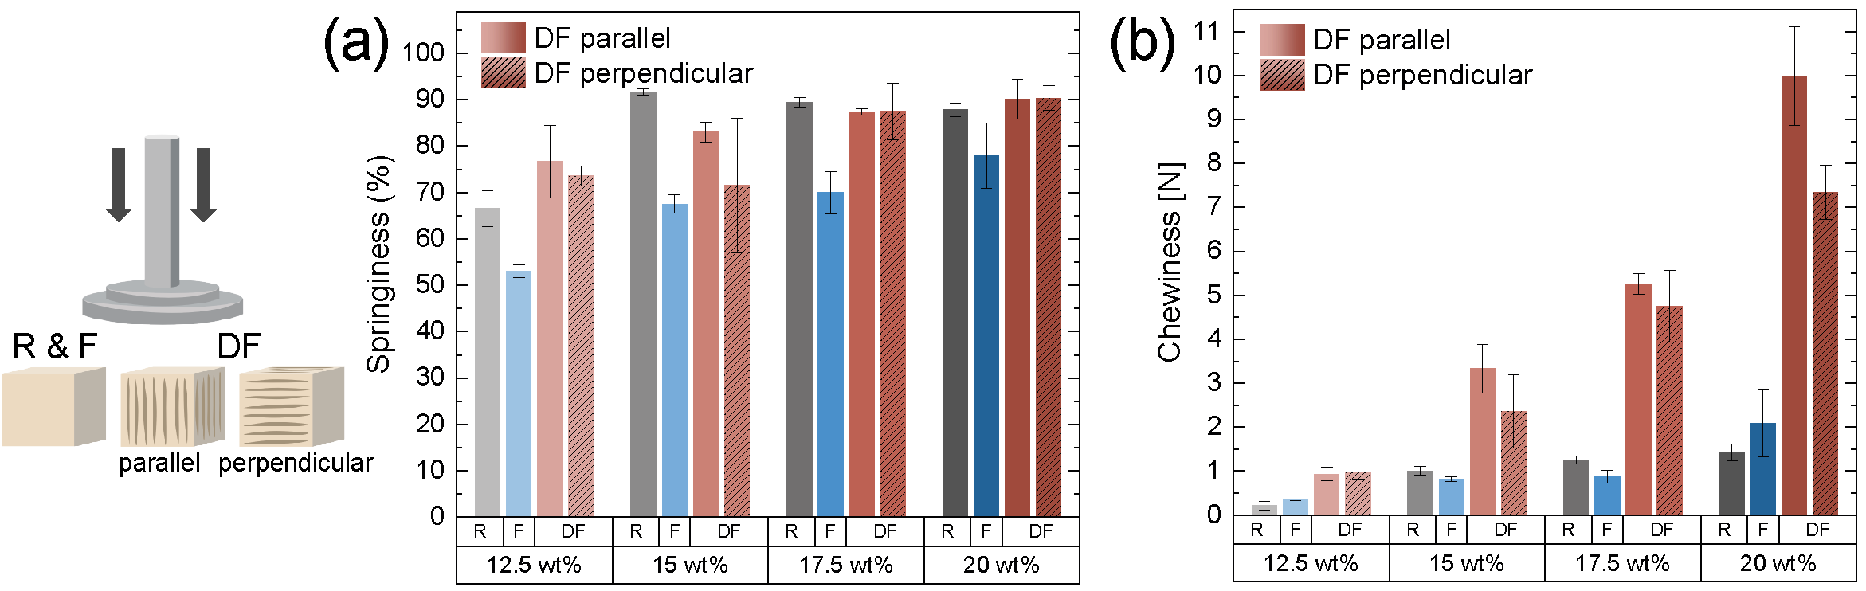Figure S6. Springiness and chewiness of chickpea gels. Double compression of chickpea gels at concentrations 12.5-20.0 wt%, with DF measured parallel and perpendicular to the temperature gradient. (a) Springiness (%) and (b) Chewiness in N of R, F, and DF samples.

Statistics for springiness

Table S18. Two-Way ANOVA for springiness (%) of chickpea gels. Summary of analysis of variance (ANOVA) results for springiness (%) of R, F, and DF chickpea gels at concentrations 12.5-20.0 wt%, including their interaction. Reported values include degrees of freedom (DOF), sum of squares, mean squares, F-statistic, and model significance (p-value).
Source | DOF | Sum of squares | Mean square | F | p
Condition | 2 | 2377.95 | 1188.97 | 38.64 | <0.0001
Concentration | 3 | 2706.12 | 902.04 | 29.31 | <0.0001
Interaction | 6 | 660.21 | 110.03 | 3.58 | 0.0068
Model | 11 | 5458.29 | 496.21 | 16.13 | <0.0001
Error | 37 | 1138.53 | 30.77
Total | 48 | 6596.82

Table S19. Groupwise comparisons for cooling conditions. Summary of mean springiness (%) for chickpea gels under different conditions. Letters indicate statistically significant groupings based on Tukey’s HSD post-hoc test.
Condition | Mean springiness (%) | Group
R | 83.87 | A
DF | 82.52 | A
F | 67.98 | B

Table S20. Groupwise comparisons for concentrations. Summary of mean springiness (%) for chickpea gels at concentrations 12.5-20.0 wt%. Letters indicate statistically significant groupings based on Tukey’s HSD post-hoc test.
Concentration | Mean springiness (%) | Group
20.0 | 85.91 | A
17.5 | 83.57 | A B
15.0 | 78.45 | B
12.5 | 67.46 | C

Table S21. Interaction for cooling condition and concentration. Summary of mean springiness (%) for chickpea gels across conditions and concentrations (12.5-20.0 wt%). Letters indicate statistically significant groupings based on Tukey’s HSD post-hoc test.
Condition | Concentration | Mean springiness (%) | Group
R | 15.0 | 91.67 | A
DF | 20.0 | 90.22 | A
R | 17.5 | 89.42 | A B
R | 20.0 | 87.84 | A B C
DF | 17.5 | 87.44 | A B
F | 20.0 | 78.00 | A B C D
DF | 15.0 | 77.29 | B C D
DF | 12.5 | 75.13 | C D
F | 17.5 | 69.99 | D
F | 15.0 | 67.56 | D E
R | 12.5 | 66.54 | D E
F | 12.5 | 53.05 | E

Table S22. Two-Way ANOVA for compression direction. Summary of analysis of variance (ANOVA) results for springiness (%) of chickpea gels tested in parallel and perpendicular directions at concentrations 12.5-20.0 wt%. Reported values include degrees of freedom (DOF), sum of squares, mean squares, F-statistic, and model significance (p-value).
Source | DOF | Sum of squares | Mean square | F | p
Concentration | 3 | 992.34 | 330.78 | 7.70 | 0.0021
Direction | 1 | 76.70 | 76.70 | 1.78 | 0.2003
Interaction | 3 | 135.93 | 45.31 | 1.05 | 0.3960
Model | 7 | 1204.96 | 172.14 | 4.00 | 0.0102
Error | 16 | 687.77 | 42.99
Total | 23 | 1892.74

Table S23. Groupwise comparison for compression direction. Summary of mean springiness (%) for chickpea gels tested in parallel and perpendicular directions. Letters indicate statistically significant groupings based on Tukey’s HSD post-hoc test.
Concentration | Mean springiness (%) | Group
20.0 | 90.22 | A
17.5 | 87.44 | A B
15.0 | 77.29 | B C
12.5 | 75.13 | C

Table S24. Interaction for concentration and compression direction. Mean springiness (%) for chickpea gels tested in parallel and perpendicular directions across concentrations (12.5-20.0 wt%). Letters indicate statistically significant groupings based on Tukey’s HSD post-hoc test.
Direction | Mean springiness (%) | Group
par | 84.31 | A
perp | 80.73 | A

Statistics for chewiness

Table S25. Two-Way ANOVA for chewiness of chickpea gels. Summary of analysis of variance (ANOVA) results for chewiness of R, F, and DF chickpea gels at concentrations 12.5-20.0 wt%, including their interaction. Reported values include degrees of freedom (DOF), sum of squares, mean squares, F-statistic, and model significance (p-value).
Source | DOF | Sum of squares | Mean square | F | p
Condition | 2 | 138.04 | 69.02 | 121.31 | <0.0001
Concentration | 3 | 77.15 | 25.72 | 45.20 | <0.0001
Interaction | 6 | 69.27 | 11.55 | 20.29 | <0.0001
Model | 11 | 340.51 | 30.96 | 54.41 | <0.0001
Error | 37 | 21.05 | 0.57
Total | 48 | 361.56

Table S26. Groupwise comparisons for cooling conditions. Summary of mean chewiness in N for chickpea gels under different conditions. Letters indicate statistically significant groupings based on Tukey’s HSD post-hoc test.
Condition | Mean chewiness (N) | Group
DF | 4.37 | A
F | 1.11 | B
R | 0.98 | B

Table S27. Groupwise comparisons for concentrations. Summary of mean chewiness in N for chickpea gels at concentrations 12.5-20.0 wt%. Letters indicate statistically significant groupings based on Tukey’s HSD post-hoc test.
Concentration | Mean chewiness (N) | Group
20.0 | 4.97 | A
17.5 | 3.03 | B
15.0 | 1.88 | C
12.5 | 0.62 | D

Table S28. Interaction for cooling condition and concentration. Mean chewiness in N for chickpea gels across conditions and concentrations (12.5-20.0 wt%). Letters indicate statistically significant groupings based on Tukey’s HSD post-hoc test.
Condition | Concentration | Mean chewiness (N) | Group
DF | 20.0 | 8.66 | A
DF | 17.5 | 5.00 | B
DF | 15.0 | 2.85 | C
RF | 20.0 | 2.09 | C D
FC | 20.0 | 1.42 | C D
FC | 17.5 | 1.25 | C D
FC | 15.0 | 1.01 | C D
DF | 12.5 | 0.96 | D
RF | 17.5 | 0.88 | D
RF | 15.0 | 0.81 | D
RF | 12.5 | 0.35 | D
FC | 12.5 | 0.22 | D

Table S29. Two-Way ANOVA for compression direction. Summary of analysis of variance (ANOVA) results for chewiness in N of chickpea gels tested in parallel and perpendicular directions at concentrations 12.5-20.0 wt%. Reported values include degrees of freedom (DOF), sum of squares, mean squares, F-statistic, and model significance (p-value).
Source | DOF | Sum of squares | Mean square | F | p
Concentration | 3 | 196.74 | 65.58 | 154.06 | <0.0001
Direction | 1 | 6.29 | 6.29 | 14.78 | 0.0014
Interaction | 3 | 6.05 | 2.02 | 4.74 | 0.0150
Model | 7 | 209.08 | 29.87 | 70.17 | <0.0001
Error | 16 | 6.81 | 0.43
Total | 23 | 215.89

Table S30. Groupwise comparison for compression direction. Summary of mean chewiness in N for chickpea gels tested in parallel and perpendicular directions. Letters indicate statistically significant groupings based on Tukey’s HSD post-hoc test.
Direction | Mean chewiness (N) | Group
par | 4.88 | A
perp | 3.86 | B

Table S31. Interaction for concentration and compression direction. Summary of mean chewiness in N for chickpea gels tested in parallel and perpendicular directions across concentrations (12.5-20.0 wt%). Letters indicate statistically significant groupings based on Tukey’s HSD post-hoc test.
Direction | Concentration | Mean chewiness (N) | Group
par | 20.0 | 9.99 | A
perp | 20.0 | 7.34 | B
par | 17.5 | 5.27 | C
perp | 17.5 | 4.74 | C D
par | 15.0 | 3.33 | D E
perp | 15.0 | 2.36 | E F
par | 20.0 | 1.80 | F G
par | 17.5 | 1.06 | G H
perp | 12.5 | 0.98 | F G H
par | 12.5 | 0.94 | F G H
par | 15.0 | 0.91 | G H
perp | 12.5 | 0.28 | H

References for texture analysis
For texture comparison, commercially available mozzarella, brie, silken, and firm tofu were analysed. Double compression tests were performed to determine hardness, springiness, cohesiveness, and chewiness using the same experimental setup and data processing workflow as for chickpea gels (Table S32).

Table S32. Texture properties of food reference samples. Summary of texture analysis results for commercial reference samples (mozzarella, brie, silken tofu, and firm tofu) obtained using the same double compression method as for chickpea gels. Reported parameters include hardness (N), cohesiveness (%), springiness (%), and chewiness (N), with mean, standard deviation (SD), minimum, median, and maximum values (n = 3).
Property | Sample | N | Mean | SD | Minimum | Median | Maximum
Hardness (N) | Mozzarella | 3 | 13.86 | 2.85 | 10.89 | 14.12 | 16.58
 | Brie | 3 | 11.81 | 0.64 | 11.13 | 11.88 | 12.42
 | Silken Tofu | 3 | 2.72 | 0.40 | 2.30 | 2.76 | 3.11
 | Firm Tofu | 3 | 31.29 | 0.26 | 31.02 | 31.31 | 31.54
Cohesiveness | Mozzarella | 3 | 82.00 | 1.60 | 80.19 | 82.62 | 83.20
 | Brie | 3 | 65.78 | 4.23 | 61.27 | 66.43 | 69.64
 | Silken Tofu | 3 | 37.38 | 5.51 | 32.19 | 36.78 | 43.17
 | Firm Tofu | 3 | 70.83 | 1.85 | 69.04 | 70.71 | 72.74
Springiness (%) | Mozzarella | 3 | 85.58 | 4.49 | 81.71 | 84.52 | 90.50
 | Brie | 3 | 73.21 | 8.06 | 66.41 | 71.11 | 82.11
 | Silken Tofu | 3 | 82.69 | 3.83 | 78.30 | 84.47 | 85.30
 | Firm Tofu | 3 | 91.22 | 4.91 | 87.12 | 89.88 | 96.66
Chewiness (N) | Mozzarella | 3 | 9.74 | 2.06 | 7.38 | 10.64 | 10.64
 | Brie | 3 | 5.70 | 0.95 | 5.05 | 5.26 | 5.26
 | Silken Tofu | 3 | 0.85 | 0.26 | 0.66 | 0.75 | 0.75
 | Firm Tofu | 3 | 20.24 | 1.69 | 19.11 | 19.43 | 19.43

Worldwide legume production
Global production volumes of major legume crops in 2023 were compiled from FAOSTAT². The share of selected legumes (*) was calculated as a percentage of total legume production, representing 96% of global output (Table S33).

Table S33. Global production of major legume crops in 2023. Global production volumes of major legume crops in 2023, sorted by crop type. Data from FAOSTAT (Food and Agriculture Organization of the United Nations)².
Item |  | Value | Unit | Item Code (CPC)
Beans, dry* |  | 28’505’529.5 | t | 01701
Broad beans and horse beans, dry |  | 6’073’526.2 | t | 01702
Chickpeas, dry* |  | 16’517’592.3 | t | 01703
Black-eyed peas, dry* |  | 9’784’129.4 | t | 01706
Lentils, dry* |  | 7’068’620.6 | t | 01704
Lupins* |  | 1’918’642.2 | t | 01709.02
Other pulses n.e.c. |  | 5’183’944.4 | t | 01709.90
Peas, dry* |  | 13’763’334.1 | t | 01705
Pigeon peas, dry |  | 4’585’466.3 | t | 01707
Soya beans* |  | 371’173’609.3 | t | 0141
Vetches |  | 671’463.3 | t | 01709.01
Selected (*) |  | 448'731’457.5 | t
Total |  | 465’245’857.6 | t
Percentage selected (*) of total |  | 96.450 %

Additional legumes structured by directional freezing
Directional freezing was applied to a broader range of legumes to demonstrate further versatility. The following species were structured into anisotropic gels: Black lentils (BL) (Lens culinaris), yellow lentils (YL) (Lens culinaris), kidney beans (KB) (Phaseolus vulgaris), navy beans (NB) (Phaseolus vulgaris), and lupins (LU) (Lupinus albus).
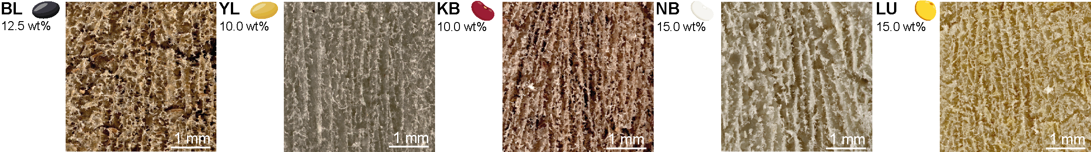
Figure S7. Additional freeze-structured legumes. Digital micrographs of freeze-dried legume gels structured under DF, including black lentil (BL, 12.5 wt%), yellow lentil (YL, 10.0 wt%), kidney bean (KB, 10.0 wt%), navy bean (NB, 15.0 wt%), and lupin (LU, 15.0 wt%).

Legume composition table
Protein-to-starch ratio was calculated by dividing the protein content (in weight percent) by the starch content (in weight percent) and expressed as grams of protein per gram of starch (Table S34).

Table S34. Macronutrient composition of selected legumes. Protein, starch, fibre, and fat contents (% dry matter) and calculated protein-to-starch ratio for chickpea, red lentil, green peas, black bean, mung bean, black-eyed pea, and soybean. Data from FAO (2023)² and soybean values from Stevenson et al.³.
Legume | Protein (% dry) | Starch (% dry) | Fibre (% dry) | Fat (% dry) | Protein/starch ratio
Chickpea | 22.4 | 23.2 | 22.8 | 4.39 | 0.97
Red lentil | 27.1 | 34.6 | 17.1 | 0.95 | 0.78
Green peas | 26.1 | 20.5 | 24 | 1.91 | 1.27
Black bean | 25.1 | 21 | 23.8 | 1.55 | 1.20
Mung bean | 23.2 | 37.9 | 17 | 1.16 | 0.61
Black-eyed pea | 25.2 | 36.1 | 16.3 | 1.67 | 0.70
Soybean | 40.1 | 11.3 | 20 | 20 | 3.55

Okara and soy

Table S35. Macronutrient composition and partitioning during tofu production from whole soybeans. Average macronutrient composition (% dry basis) of whole soybeans, tofu, and okara, and reported average distribution of protein, lipids, and dietary fibre between tofu, okara, and whey, expressed as percentages of the total nutrient content in whole soybeans. Data adapted from van der Riet et al.⁴.
 | Soybeans (%) | Tofu (%) | Okara (%) | % of total in Tofu | % of total in Okara | % of total in Whey
Protein | 39.8 | 53.15 | 26.9 | 72% | 23% | 8%
Lipids | 19.6 | 32.6 | 10.1 | 82% | 16% | <1%
Fibres | 22.15 | 6.55 | 55.45 | 15% | 85% | 0

References
1. Zhao, S., Ren, Y. & Wei, C. Staining starch with iodine solution. Methods Mol Biol 2566, 281–290 (2023).
2. FAO. FAOSTAT: Crops and livestock products. https://www.fao.org/faostat/en/#data/QCL. Licence: CC-BY-4.0 (2023).
3. Stevenson, D. G., Doorenbos, R. K., Jane, J. L. & Inglett, G. E. Structures and functional properties of starch from seeds of three soybean (Glycine max (L.) Merr.) varieties. Starch/Staerke 58, 509–519 (2006).
4. van der Riet, W. B., Wight, A. W., Cilliers, J. J. L. & Datel, J. M. Food chemical investigation of tofu and its byproduct okara. Food Chem 34, 193–202 (1989).

