Upward and downward colonization of vegetation following the retreat of the Aneto glacier, since the Little Ice Age
Alpine Botany
Pablo Tejero Ibarra^{1-2*}, César Deschamps-Berger, Nahia Carretero-Roque, Juan Ignacio Lopez-Moreno, Jesús Revuelto, Francisco Rojas-Heredia, Ixeia Vidaller, Pierre René, Sébastien Lavergne, Aina Alvarez, Alba López-Varela, Olatz Fernández, Sara Palacio
¹ JACA Herbarium, Instituto Pirenaico de Ecología (CSIC), Av. Nuestra Señora de la Victoria 16, 22700, Jaca, Spain.
² Botanika Saila, Sociedad de Ciencias Aranzadi, Zorroagagaina 11, 20014 Donostia-San Sebastián, Gipuzkoa, Spain
*ptibarra@ipe.csic.es
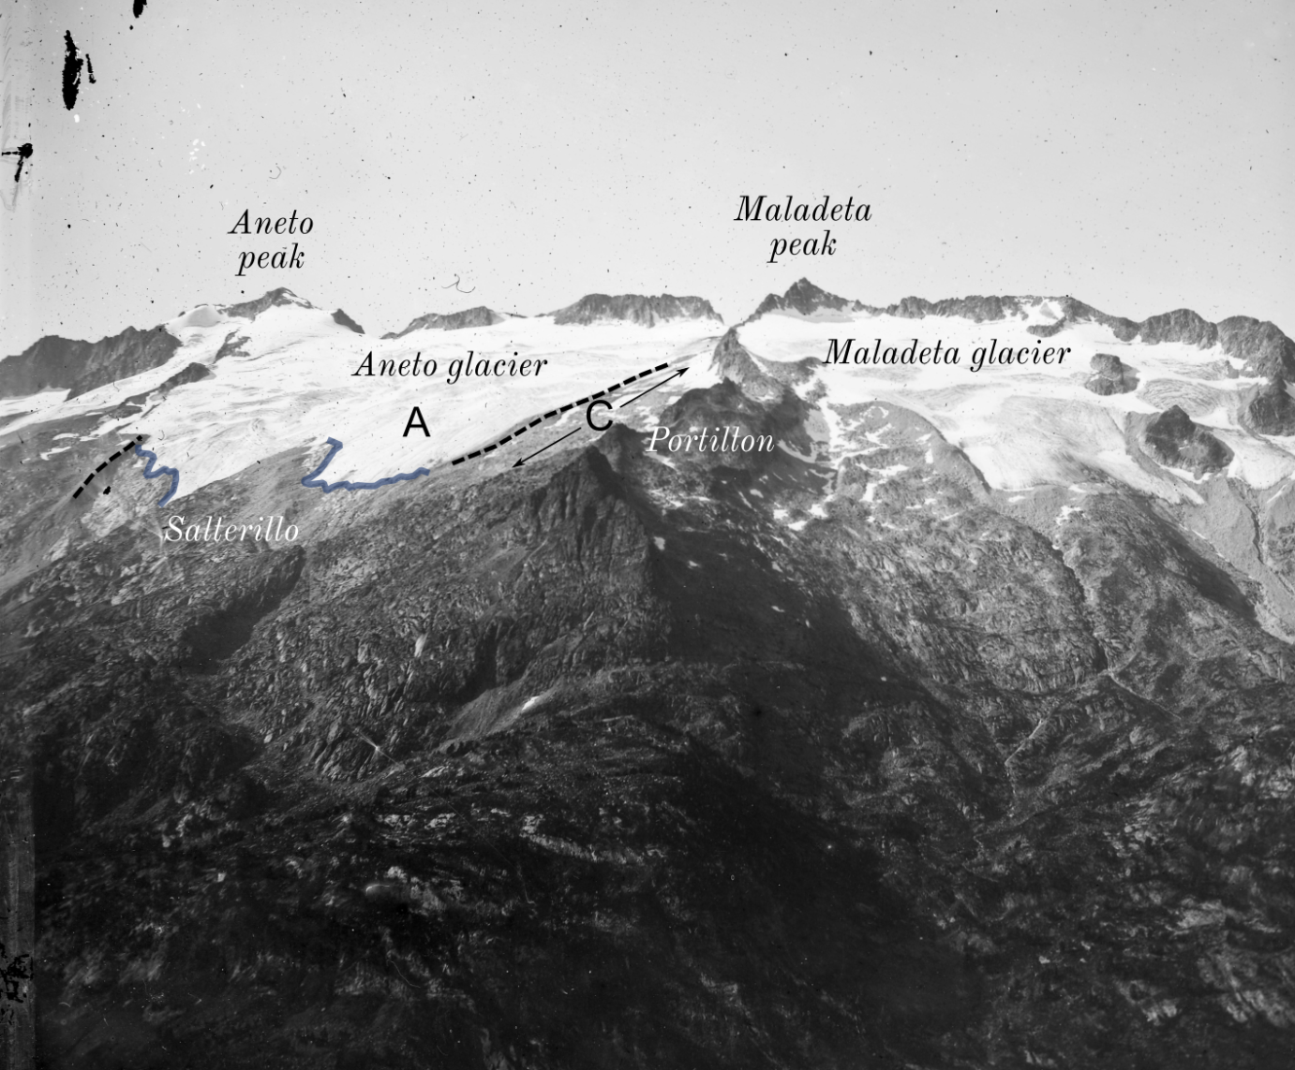
Fig. S1 Photography attributed to Eugène Trutat on 1 September 1875 (© Fonds Eugène Trutat, Muséum de Toulouse). The photograph was taken close to the Port de Benasque, roughly looking southward (Copyright Museum d’Histoire Naturelle de Toulouse, Fonds Eugène Trutat). The front of the glacier was digitalized (blue line) and projected in geographical coordinates after identification of ground control points with the MonoPlotting tool (Wiesmann et al. 2012). Lateral moraines are shown in dashed lines.
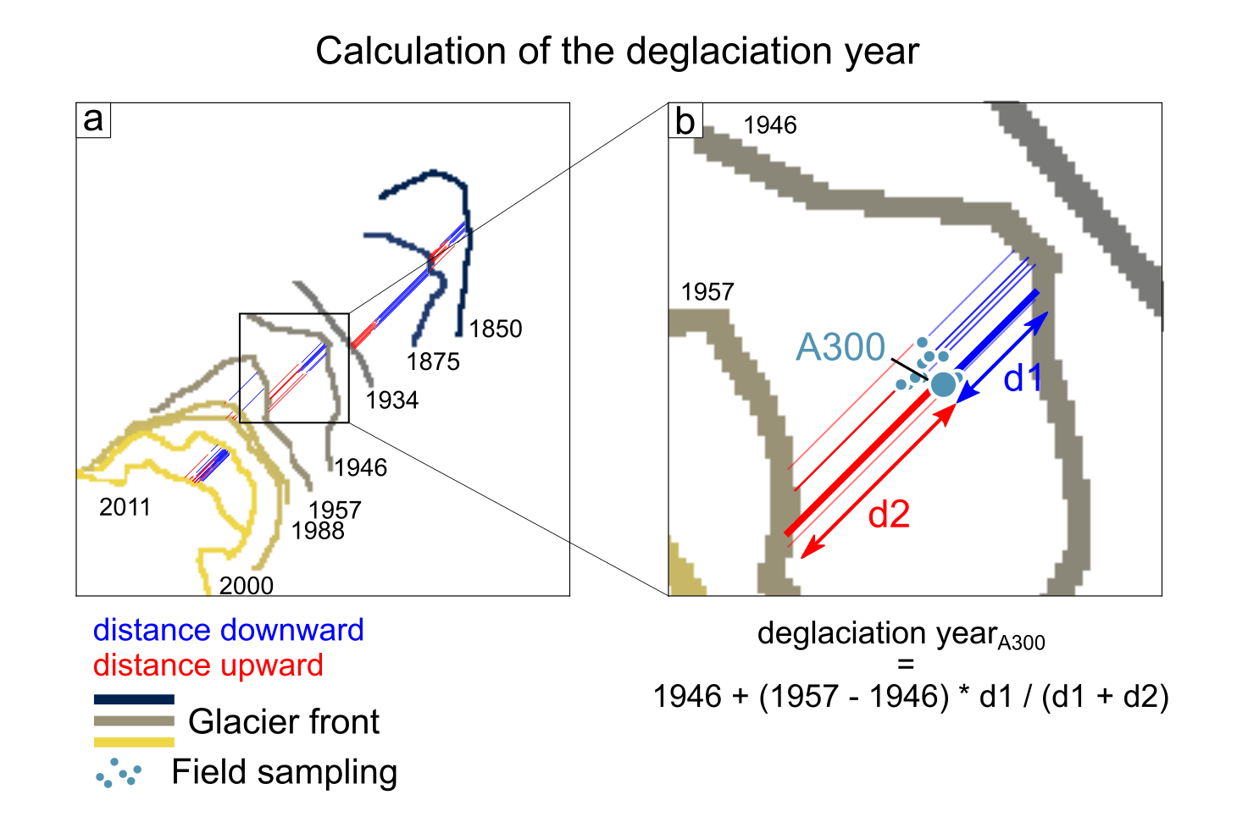
Fig. S2 Method to calculate the deglaciation year of each plot exemplified for A3_00 plot. The distance between the plot and the two closest glacier front positions is calculated and used to interpolate the deglaciation year at the plot position. The distances are calculated along the main slope of a smoothed DEM.
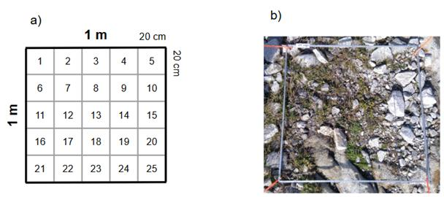
Fig. S3 Example of a plot (1 m x 1 m) and subplots (20 cm x 20 cm) used in the study. a) Schematic representation. b)Image of a sampling plot (area A5_08). Photo: Pablo Tejero.
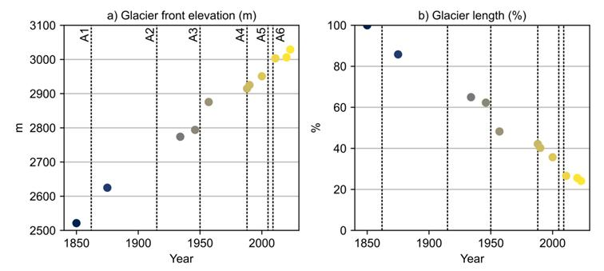
Fig. S4 Dynamics of ice retreat in Aneto glacier. a) Elevation of the ice front (lowest point) of the Aneto glacier and b) percentage of the glacier length relative to its 1850 value. The vertical dotted lines show the median deglaciation year of the different sampling sites.
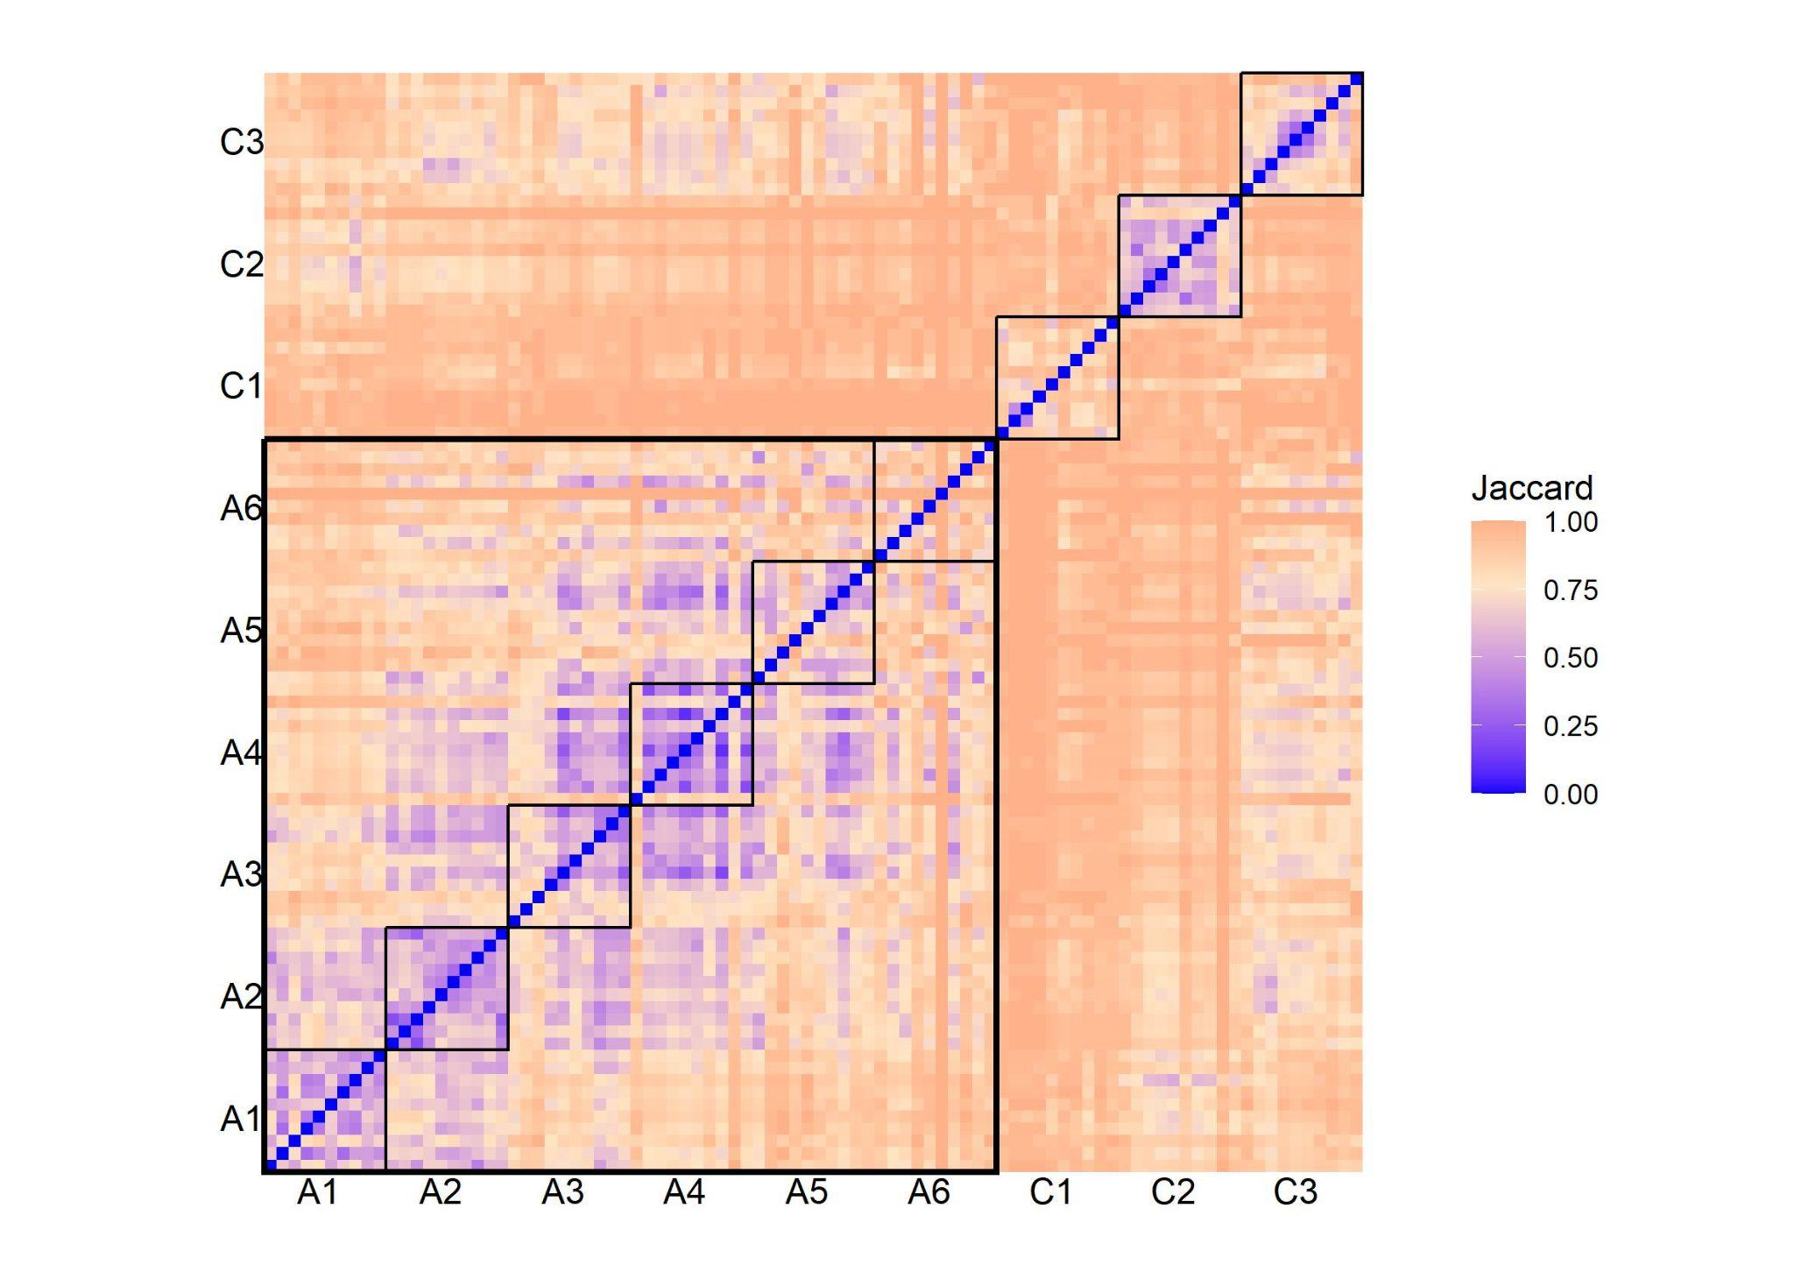
Fig. S5 Jaccard distance matrix between vegetation plots reflecting differences in species composition.
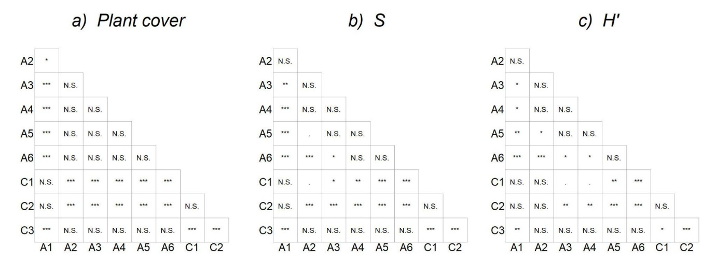
Fig. S6 Post hoc significance for pair wise comparisons of species richness (S), Shannon Index (H’), and vegetation cover.p < 0.01; * p < 0.05; ** p < 0.01; *** p < 0.001; NS = not significant.

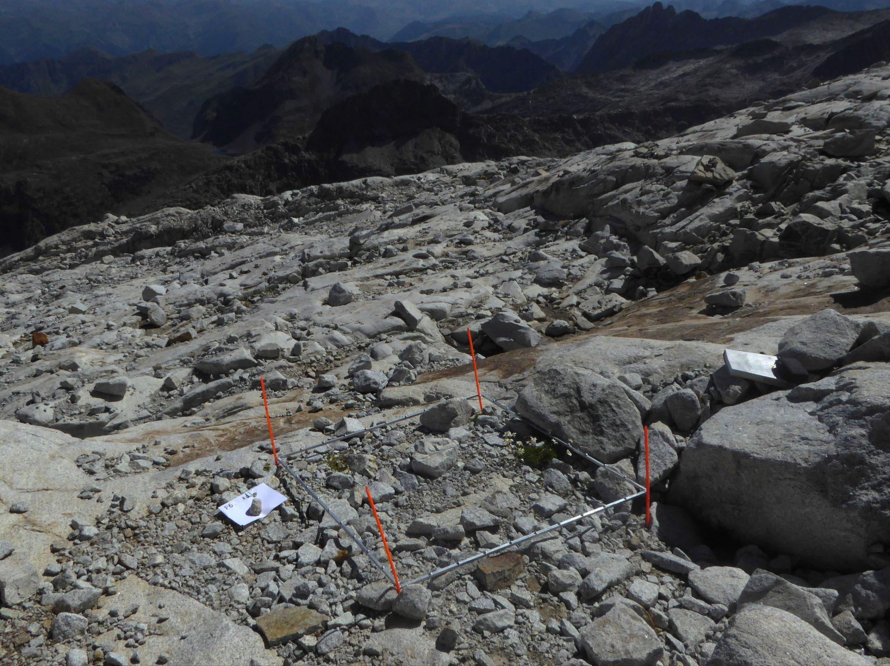
Fig. S7 Extensive granite surface left as a result of Aneto glacier retreat shown from A5 area (plot 03). Photo: Pablo Tejero.

Table S1 Inventories used to evaluate the source of colonization (Fernández and Herreros 2014, 2019, 2022).
Locality: Aneto Years: 2014; 2019; 2022 Autor: Olatz Fernandez, Mª Jesús Herreros
GPS (data) Altitude: 3.404m
Androsace ciliata  Armeria alpina  Cerastium alpinum  Draba fladnizensis  Erigeron uniflorus  Linaria alpina  Minuartia sedoides  Poa alpina | Poa laxa  Potentilla frigida  Pritzelago alpina alpina  Ranunculus glacialis  Saxifraga bryoides  Saxifraga oppositifolia  Saxifraga pubescens
Locality: Col de Portillón Year: 2014 Autor: Olatz Fernandez, Mª Jesús Herreros
GPS (data) Altitude: 2.800m
Agrostis rupestris  Alchemilla alpina  Armeria alpina  Cardamine bellidifolia alpina  Cardamine wettesteiniana  Cerastium alpinum  Cystopteris fragilis  Epilobium anagallidifolium  Erigeron uniflorus  Euphrasia minima  Festuca glacialis  Galium pyrenaicum  Gentiana alpina  Leontodon pyrenaicus  Leucanthemopsis alpina  Linari alpina  Luzula spicata | Murbeckiella pinnatifida  Phyteuma hemisphaericum  Poa alpina  Poa laxa  Potentilla nivalis  Saxifraga bryoides  Saxigraga moschata  Sedum alpestre  Sedum rosea  Sempervivum montanum  Senecio pyrenaicus  Silene acaulis  Silene rupestris  Thymus praecox  Trifolium alpinum  Vaccinium uliginosum  Veronica alpina
Locality: Salterillo Year: 2024 Autor: Olatz Fernandez, Pablo Tejero, Nahia Carretero
GPS (data) Altitude: 2.500m
Alchemilla alpina  Alchemilla fissa  Allium ericetorum  Armeria alpina  Calluna vulgaris  Campanula rotundifolia  Cardamine resedifoia  Carex echinata  Carex parviflora  Carex pyreniaca  Carex sempervirens  Cerastium cerastoides  Dianthus hyssopifolius  Euphrasia minima  Festuca borderei  Festuca eskia  Festuca glacialis  Festuca nigrescens  Gentiana alpina  Geum pyrenaicum  Homogyne alpina  Jasione montana | Leontodon dubosii  Leontodon hispidus  Leucanthemopsis alpina  Lotus alpinus  Luzula alpinopilosa  Nardus stricta  Phyteuma hemisphaericum  Poa alpina  Poa cenisia  Polygonum viviparum  Potentilla erecta  Rhododendron ferrugineum  Saxifraga moschata  Sempervivum montanum  Senecio pyrenaicus  Silene acaulis  Thymus praecox  Trifolium alpinum  Trifolium pratense  Vaccinium myrtillus  Vaccinium uliginosum

Table S2 List of the most abundant species in the study. Scientific names after Gómez et al. 2020.
 | Deglaciated (A) |  |  | Control (C) |  |  | Total
Species | N_{site} | N_{plot} | N_{cell} | N_{site} | N_{plot} | N_{cell} | N_{site} | N_{plot} | N_{cell}
Poa alpina | 6 | 49 | 515 | 2 | 9 | 59 | 8 | 58 | 574
Leucanthemopsis alpina | 6 | 41 | 363 | 2 | 10 | 48 | 8 | 51 | 411
Veronica alpina | 6 | 42 | 336 | 2 | 11 | 56 | 8 | 53 | 392
Sedum alpestre | 5 | 43 | 287 | 1 | 13 | 61 | 6 | 56 | 348
Armeria alpina | 4 | 23 | 249 | 1 | 3 | 5 | 5 | 26 | 254
Cerastium cerastoides | 5 | 25 | 224 | 1 | 4 | 13 | 6 | 29 | 237
Sagina saginoides | 5 | 30 | 189 | 1 | 8 | 61 | 6 | 38 | 250
Festuca glacialis | 2 | 11 | 196 | 2 | 5 | 35 | 4 | 16 | 231
Euphrasia minima | 2 | 14 | 194 | 2 | 10 | 49 | 4 | 24 | 243
Gnaphalium supinum | 6 | 29 | 175 | 2 | 5 | 13 | 8 | 34 | 188
Oxyria dygina | 6 | 34 | 149 | 1 | 7 | 49 | 7 | 41 | 198
Saxifraga moschata | 6 | 18 | 109 | 1 | 6 | 44 | 7 | 24 | 153
Pritzelago alpina | 4 | 17 | 107 | 0 | 0 | 0 | 4 | 17 | 107
Agrostis rupestris | 3 | 11 | 88 | 3 | 17 | 95 | 6 | 28 | 183
Sibbaldia procumbens | 2 | 7 | 71 | 3 | 7 | 26 | 5 | 14 | 97
Linaria alpina | 6 | 13 | 42 | 0 | 0 | 0 | 6 | 13 | 42
Androsace ciliata | 3 | 8 | 15 | 0 | 0 | 0 | 3 | 8 | 15
Alchemilla fissa | 1 | 1 | 8 | 3 | 6 | 43 | 4 | 7 | 51
Scorzoneroides duboisii | 2 | 2 | 6 | 2 | 13 | 82 | 4 | 15 | 88
Vaccinium uliginosum | 1 | 2 | 4 | 2 | 9 | 119 | 3 | 11 | 123
Festuca eskia | 1 | 1 | 1 | 2 | 7 | 112 | 3 | 8 | 113
Trifolium alpinum | 0 | 0 | 0 | 2 | 9 | 107 | 2 | 9 | 107
Thymux praecox | 0 | 0 | 0 | 2 | 8 | 102 | 2 | 8 | 102
Carex curvula | 0 | 0 | 0 | 1 | 9 | 92 | 1 | 9 | 92
Rhododendron ferrugineum | 0 | 0 | 0 | 2 | 4 | 22 | 2 | 4 | 22

Appendix 1. Species list of scientific names used in the study after Gómez et al., (2020).
Agrostis rupestris All., Alchemilla alpina L., Alchemilla fissa Hoern., Alchemilla saxatilis Buser., Allium schoenoprasum L., Androsace ciliata DC., Antennaria dioica (L.) Gaertn., Arabis alpina L., Armeria alpine Willd., Athyrium distentifolium Tausch ex Opiz., Bartsia alpina L., Bupleurum angulosum L., Calluna vulgaris (L.) Hull., Campanula rotundifolia L., Campanula scheuchzeri Vill., Cardamine bellidifolia L. Cardamine resedifolia L. Carex curvula All. Carex parviflora Host. Carex pyrenaica Wahlenb., Carex sempervirens Will., Cerastium alpinum L., Cerastium cerastoides (L.) Britton., Cryptogramma crispa (L.) R. BR. Ex Hook., Cystopteris fragilis (L.) Bernh., Dryopteris oreades Fomin., Epilobium anagallidifolium Lam., Erigeron uniflorus L.,Euphrasia alpina Lam., Euphrasia minima Jack ex DC., Festuca borderei (Hack.) K.Richt., Festuca eskia Ramond ex DC., Festuca glacialis (Miégev. ex Hack.) K.Richt., Festuca nigrescens Lam., Festuca rubra L., Festuca yvesii Sennen & Pau., Galium marchandii Roem. & Schult., Gentiana acaulis L., Gentiana alpina Vill., Gentianella campestris (L.) Borner., Geum montanum L., Gnaphalium norvergicum Gunnerus., Gnaphalium supinum L., Hieracium ramondii Griseb., Juncus trifidus L., Juncus triglumis L., Juniperus communis L., Leontodon hispidus L., Leontodon pyrenaicus Gouan., Leucanthemopsis alpina (L.) Heywood., Linaria alpina (L.) Mill., Lotus alpinus (DC.) Ramond., Luzula alpinopilosa (Chaix) Breistr., Luzula spicata (L.) DC., Luzula sudetica (Willd). Schult., Meum athamanticum Jacq., Minuartia sedoides (L.) Hiern., Minuartia verna (L.) Hiern., Murbeckiella pinnatífida (Lam.) Rothm., Nardus stricta L. Oreochloa disticha(Wulfen) Link., Oxyria digyna (L. ) Hill., Parnassia palustris L., Pedicularis pyrenaica J. Guy., Peucedanum ostruthium (L.) W.D.J.Koch., Phyteuma hemisphaericum L., Pilosella breviscapa (DC.) Soják., Pilosella lactucella (Wallr.) P.D.Sell & C.West., Pinguicula vulgaris L., Plantago alpina L., Poa alpina L., Poa cenisia All., Poa glauca Vahl., Poa laxa Haenke., Potentilla nivalis Lapeyr., Potentilla pyrenaica Ramond., Primula integrifolia L., Pritzelago alpina (L.) O. Kuntze., Pulsatilla vernalis (L.) Mill., Ranunculus glacialis L., Rhododendron ferrugineum L., Sagina saginoides (L.) Karsten., Salix herbacea L., Saxifraga bryoides L., Saxifraga moschata Wulfen., Saxifraga oppositifolia L., Saxifraga pubescens ssp iratiana (F.W. Schultz)., Saxifraga stellaris L., Scorzoneroides duboisii (Sennen) Greuter., Sedum alpestre Vill., Sedum atratum L., Sedum rosea (L.) Scop., Selaginella selaginoides (L.) P.Beauv., Selinum pyrenaeum (L.) Gouan., Sempervivum montanum L., Senecio pyrenaicus L., Seseli montanum L., Sibbaldia procumbens L., Silene acaulis (L.) Jacq., Silene rupestris L., Soldanella alpina L., Succisa pratensis Moench., Taraxacum pyrenaicum Reut., Thesium pyrenaicum L., Thymus praecox Opiz., Trichophorum cespitosum (L.) Hartm., Trifolium alpinum L., Trifolium pratense L., Vaccinium myrtillus L., Vaccinium uliginosum L., Veronica alpina L., Veronica nummularia Gouan., Veronica ponae Gouan., Viola biflora L., Viola palustris L.

