Supplementary information.

Supplementary Method

In silico simulation of a test dataset

Microbiome composition and abundances
Sequence abundances were calculated with Kraken2 [11] (v2.1.2) and adjusted with Bracken [12] (v2.6) using a facial skin dataset [26]. To perform an in silico model of the microbiome for the experiment, we selected the 150 most abundant species and normalised their abundances. It contained 147 bacteria and 3 fungi. All abundances are given in the Supplementary File 1, and constitute the basis for our replication number 1. Other replicates were derived from number 1. A vector of 150 values was generated following a normal distribution of parameters mean = 1, standard deviation = 0.05. The abundances were multiplied by this vector to generate noise. The parameters ensure that the most extreme values in the vector will be around 1.2, which is the minimum value we tested as a fold change. Thus, it was sure that the signal was stronger than the noise. The method was applied 4 times to obtain 5 replicates.

Setting the simulation parameters
The two main parameters chosen for the simulation were the signal strength and sequencing depth. Signal is here defined as a stronger-than-noise change of abundances for the chosen species. Three signal strengths were determined for the experiment: 1.5, 2 and 3. Each of these values were tested at different sequencing depths; 10 million, 20 million, and 40 million reads. Additional values of 1.2, 1.3 and 1.4 were tested at 40M reads only. The lists of abundances without added signal were used as controls for their respective signal versions.

Functional enrichment
To obtain a functional enrichment, three operons were chosen. They had to be bacterial to avoid bias of k-mer uniqueness, contain several genes to obtain a finer resolution of metrics, and be absent of all genomes. To verify their absence, the sequences were blasted against the genomes of the 150 species. The final choice was the bacilysin excretion system (7 genes) for C. acnes, the operon of ptxB pertussis toxin binding subunits (5 genes) for S. epidermidis, and the operon of nodulation proteins (5 genes) for S. pyogenes.

Sequencing simulation
CAMISIM [27] (v1.3) was the tool used to simulate the sequencing step. The genomes used to simulate sequencing were references downloaded from the NCBI. 10 samples were produced for each experiment, using the default error profile for Illumina with paired-end reads of length 150bp.

Skin and colorectal cancer datasets
A real dataset was used to obtain the reference for the simulation, and a second real dataset was chosen to test our pipeline. The first dataset is from Barnard et al [26] and is a WGS of healthy and acneic skin metagenomes. It is composed of 82 samples, 40 controls and 42 cases. It has a sequencing depth averaging around 7M reads per sample, with a high variance. It is a mixture of different technologies, both singleend and paired-end. Our second dataset comes from a Japanese cohort of colorectal cancer, from Yachida et al. [7]. The groups chosen within the colorectal cancer dataset are categorized as Healthy (n=251), Stage I and II (n=111), Stage III and IV (n=74).

Machine learning methodology
We configured and optimized several machine learning models for our metagenomic analysis, including Random Forest (RFR), Support Vector Machine (SVR), Linear Discriminant Analysis (LDA), K-Nearest Neighbors (KNN), and XGBoost. Each model had specific hyper-parameters to tune, with XGBoost being particularly suited for handling complex, high-dimensional data like ours.
We optimized three hyper-parameters across all models: n aug, p, and g. The n aug parameter sets the number of augmentations; a setting of 0 means only the original dataset is used, while 1 includes both the original and an augmented version. Each additional augmentation effectively replicates the entire dataset with added noise or dropout. The p hyper-parameter controls the level of Gaussian noise added, from 0 (no noise) to 1 (full Gaussian noise). The g parameter sets the dropout level, which refers to the proportion of input values that are randomly removed. Together, p and g manage the amount of noise and sparsity introduced, helping the model become more robust to real-world data issues.
To build models that generalize well to new data, we optimize hyper-parameters using a validation set to guide the search, then retain the best configuration and report its performance on a separate test set to ensure generalizability. Fine-tuning these settings helps the model learn patterns that aren’t tied too closely to the training data, so it can make accurate predictions on unseen data. By adjusting things like regularization strength or learning rate, we strike a balance that keeps the model from overfitting while still capturing the essential patterns. This optimization makes our models more adaptable and reliable when applied to new datasets.
We used scikit-optimize with Bayesian optimization to tune hyper-parameters efficiently. The initial iterations are exploratory, while subsequent ones use information from earlier trials to focus the search on more promising regions of the parameter space, helping us quickly find the best settings for the regularization parameters and learning rate without excessive computation. Bayesian optimization is particularly useful because it can efficiently explore complex search spaces where traditional grid or random search would be computationally prohibitive. It uses a surrogate model, specifically a Gaussian Process, to approximate model performance across the hyperparameter space, and selects new configurations to evaluate by maximizing an acquisition function that balances exploration and exploitation. This approach allowed us to streamline the tuning process and improve model performance with minimal overhead. We ran 20 optimization iterations per model.
For all models, we fit a scaler to handle feature scaling, treating the choice of scaling method (binary, minmax, standard, or robust) as a hyperparameter. Additionally, zeros cutoff, used to filter features based on zero-value prevalence, was also treated as a hyperparameter.
RandomForest (RF): the hyper-parameters included max depth (10–100) for tree complexity, max samples (0.1–1) to control the sample proportion drawn per tree, and parameters like min samples split (2–10), min samples leaf (1–10), and n estimators (1–100) to refine how trees are grown. Support Vector Machine (SVM): the hyper-parameters included tol (1e-4 to 1) for stopping criteria, kernel type (linear, rbf, or poly), and regularisation C (0.001–100). These options help balance noise addition and dropout to make the model more robust while giving flexibility in data mapping and generalisation. Linear Discriminant Analysis (LDA): LDA has no additional hyper-parameters than those shared by all models. XGBoost: we optimised the hyper-parameters max depth for tree complexity, eta for learning rate, min child weight for minimum sum of instance weights, gamma to control tree split regularisation, and subsample to prevent over-fitting. K-Nearest Neighbors: we optimised the hyper-parameter n neighbors, which controls the number of neighbours considered in the algorithm. Higher values lead to a smoother decision boundary, reducing the risk of over-fitting.
Data augmentation was applied to the abundance matrices. Data augmentation helps the model generalise better by expanding the dataset to simulate noise and missing values, which are common in real data. We used two main strategies. The first is to drop out a fraction of the inputs by replacing their values with 0. The purpose of dropping out some inputs is to prevent the model from over-relying on specific features, encouraging it to learn more generalised patterns. The second method was to add random Gaussian noise to each feature.
In order to retrieve the features with highest importance in the decision-making of the models, we calculated Shapley values (a contribution of the features to the model) with the shap package. We scaled the absolute values returned so that all contributions, including the base values, sum to 1.
We used Neptune to store our results and code, ensuring reproducibility and making them easy to share. Python packaged used were scikit-learn (v1.30.0) [50], scikit-optimize (v0.10.1) , ipython (v8.12.2) [51], ipykernel (v6.25.0), shap (v0.44.1) [52], xgboost (v2.1.0) [53], torch (v2.2.2+cu121), seaborn (v0.12.2) [54], matplotlib (v3.7.2) [55], tabulate (v0.8.10), umap-learn (v0.5.6) [56], neptune (v1.10.4) [57].

Comparison of META-DIFF against differential analysis methods
To demonstrate the value of our pipeline, we benchmarked it against five alternative methods: DESeq2 (v1.46) [34], limma (v3.62.1) [33], ALDEx2 (v1.38.0) [32], the Wilcoxon test, and ANCOMBC2 (version 2.8.0) [31]. The methods were applied to matrices of abundances of the samples obtained using Kraken2 (v2.1.12) [11], with count adjustment using Bracken (v2.6) [12]. For the Wilcoxon test, a centered-log ratio (CLR) normalisation was applied with mixOmics (v6.30) [58], edgeR (v4.4.2) [59] effect size calculation was used for limma, and internal normalisation was used for other methods. Other packages used were optparse (v1.7.5), tidyverse (v2.0.0), and phyloseq (v1.50.0) [60]. R was v4.4.2.
Most of the default parameters were kept. For DESeq2, the local fit was chosen, with a prevalence cut-off of 0.9 . For ALDEx2, the default parameters were used, the number of MCC was set to 128, gamma was set to 1 (higher values up to 2 were tested but did not impact the results) and the test chosen was Kruskal-Wallace. For limma, the normalisation factors were calculated using edgeR and the method ”quantile”, and the p-value adjustment method was set to Benjamini-Hochberg. For ANCOMBC2, the default parameters were chosen, with the sensibility analysis enabled, a prevalence cut-off of 0.6, and a p-value adjustment method set to Holm. For the Wilcoxon’s test, a prevalence cut-off of 0.9 was applied.

Supplementary results

Overview of the results
Simulated data allow one to estimate the accuracy of the methodology and the impact of the different parameters on the results. An in-depth analysis was conducted about the origin of these k-mers, their nature (unique to a genome or not), and how their compaction into unitigs could lead a user to a biological result and its potential interpretation. For real-case datasets, the pipeline described in the method was applied.

Benchmark results: influence of the parameters

Benchmark: k-mers
As enrichment was carried out only in cases, it was expected to see enriched k-mers in cases, and not in controls. There was a clear difference between the number of k-mers detected in cases (up to > 13M) and controls (< 1000) (4), which demonstrated Kmdiff [15] can detect a one-sided enrichment. It also emphasised that only an important number of k-mers detected as enriched in the controls (compared to the number of k-mers enriched in cases) should be considered as a signal: otherwise, it was only the consequence of a change in relative abundance of the k-mers (more of one means less of the others, mechanically). It was verified that Kmdiff [15] could also detect a signal in controls only by swapping cases and controls for all replicates at FC3 and 40M reads (see Supp. Fig. 9). Furthermore, the possibility that there could be an enrichment in both cases and controls was considered. C. acnes was enriched 3fold in the cases, and M. restricta 3-fold in the controls (see Supp. Fig. 10). The number of k-mers was influenced by both the FC and the sequencing depth, but the FC had a greater impact. At the same sequencing depth (10M), a fold change increase from 1.5 to 2 raised the number of enriched k-mers in the cases by 100-fold, and the same effect was observed from a FC of 2 to 3. In contrast, for the same value of FC, doubling the sequencing depth multiplies the number of enriched k-mers by approximately 10. It must be noted though that this difference tended to narrow at the highest FC. In
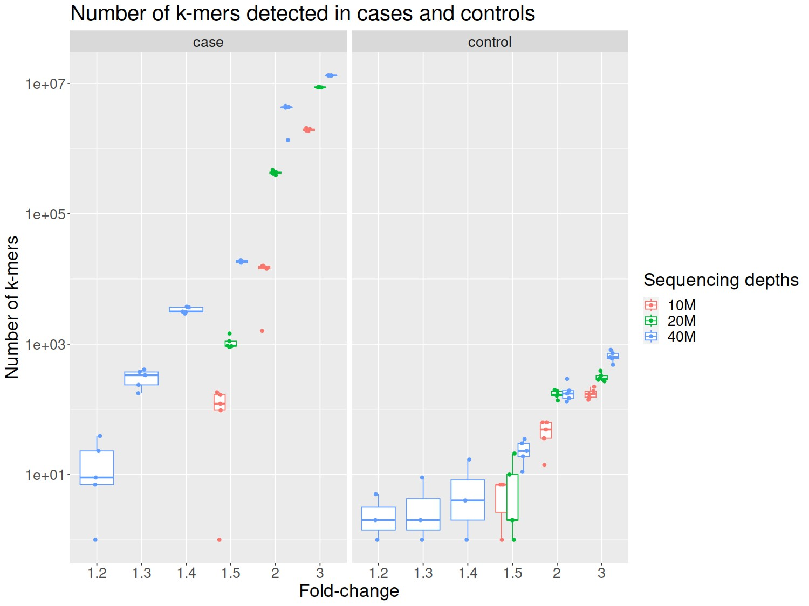
Supp. Fig. 4 Distribution of k-mer counts in cases and controls for 12 combinations of fold-change and sequencing depths.
the cases, even at the lowest FC, 4 out of 5 replicates yielded results. In the controls, only 2 out of 5 replicates yielded results at FC inferior to 1.5 . The k-mers enriched in the controls were k-mers shared by several species. At low FC and sequencing depth, they were shared by diverse small sets of species, and as the values of the parameters increased, the k-mers were shared by more species. The fact that common k-mers were detected only at high values of the parameters can be explained by the distribution of abundances. Most species had a low abundance, which meant that their coverage was low as well. This resulted in a few reads per genome randomly distributed and thus a high variation of k-mer counts, making a change of abundance difficult to detect. Thus, only a strong signal (resulting in a more noticeable change of counts) and sufficient sequencing depth allowed to detect this differential abundance of most common kmers. Under this ”threshold” values, k-mers detected as enriched in the controls were randomly selected and not consistent across replicates.
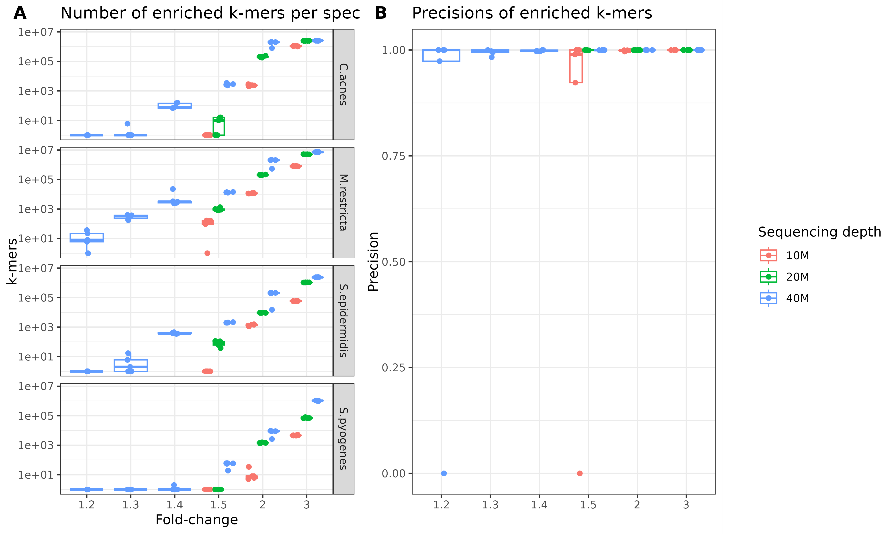
Supp. Fig. 5 Global vue of the k-mers enriched. A Number of k-mers enriched per species and B precision of k-mers per species.

Impact of the parameters summarised
All the figures together present a comprehensive view of the number of k-mers detected and their nature across different parameters. Supp. Fig. 6 simplifies the visualization by fixing two out of the three parameters to better understand how each of them influences the number of k-mers detected as enriched. Supp. Fig. 6A shows the effect of doubling the sequencing depth: increasing from 20M reads to 40M had a much greater impact than going from 10M to 20M reads. Supp. Fig. 6B shows the impact of the fold-change: the change from FC2 to FC3 had the greatest impact, by several orders of magnitude. Finally, the number of unique k-mers in a genome and relative abundance influenced the number of k-mers (Supp. Fig. 6C). C. acnes and M. restricta have the same order of magnitude of k-mers detected as enriched, even if C. acnes has a higher relative abundance, because M. restricta had more unique k-mers. C. acnes and S. epidermidis had a similar magnitude of unique k-mers (1.6M and 1.5M respectively), but C. acnes had more k-mers detected as enriched due to its much higher relative abundance.
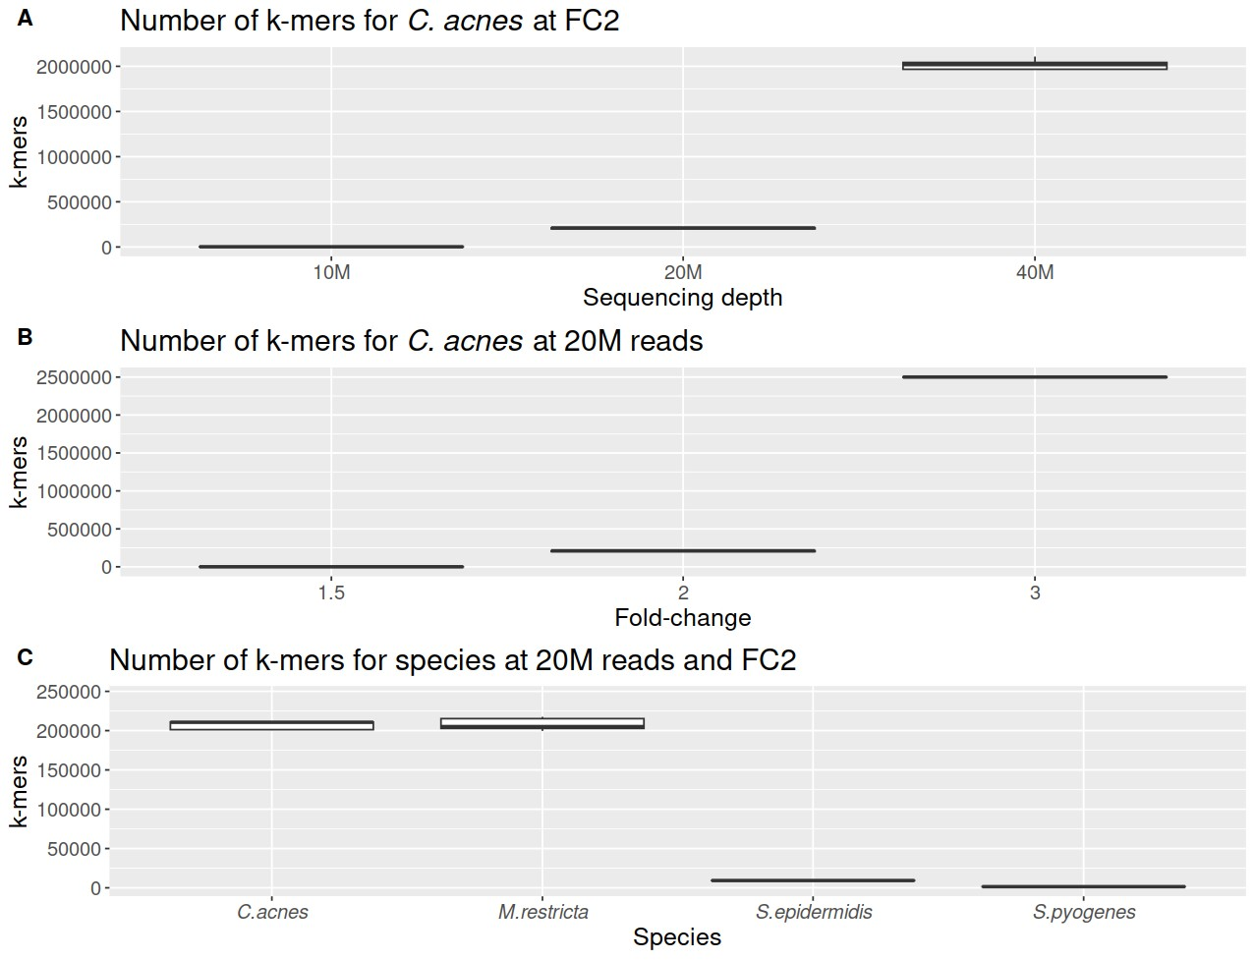
Supp. Fig. 6 Overview of the impact of different parameters of the number of k-mers detected as enriched. Panel A: Impact of the sequencing depth on the number of k-mers for C. acnes at FC2. Panel B: impact of the fold-change on the number of k-mers for C. acnes at FC2. Panel C: impact of abundance and genome characteristics on the number of k-mers at 20M reads and FC2.
It was anticipated that a higher sequencing depth would be beneficial, but the simulation underscored an impact greater than expected. The fold-change also had a pronounced effect as predicted. Both a higher relative abundance and a greater number of k-mers unique to the genome contributed to an increased number of kmers detected as enriched. Overall, a sequencing depth of 40M is can be recommended for microbiomes of similar diversity. This may not be sufficient for more complex microbiomes, and the rule of thumb is higher is better. At moderate FC and sequencing depth, species with low abundance might not be detected.

The colorectal cancer cohort: stage I/II versus stage III/IV
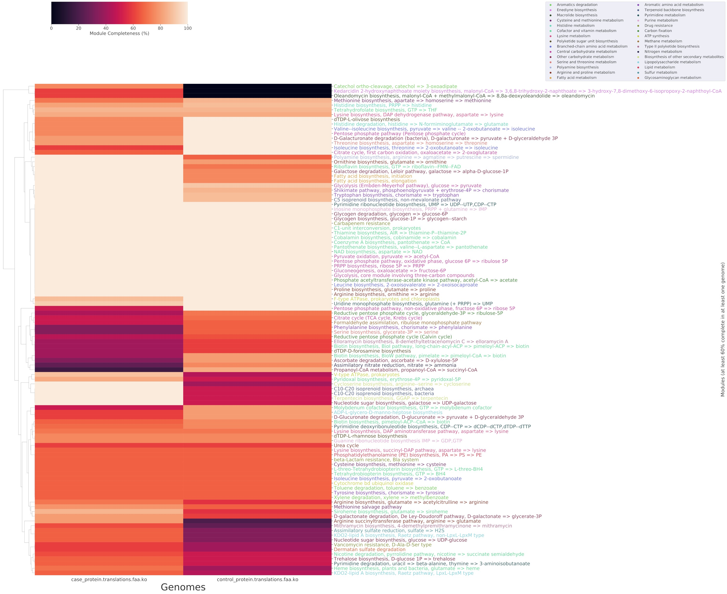
Supp. Fig. 7 Metabolic summary of differential pathways in CRC, stages 1/2 versus healthy.

The colorectal cancer cohort: stage III/IV versus stage I/II

P. copri and F. prausnitzii still dominant in the taxonomic results
There are 417M k-mers detected as differentially abundant in the stages III/IV, and 361M in the stages I/II for this comparison. The respective number of unitigs are 12.9M and 11.3M .
Supp. Table 4 shows an overview of the taxonomic assignments of the unitigs in the comparison of the most advanced cases (stages III/IV) of colorectal cancer with milder ones (stages I/II). In the stages III/IV, the taxa with the most length assigned is P. copri, followed by A. muciniphila, Klebsiella aerogenes and F. prausnitzii. Then come higher taxonomic groups and another Prevotella as well as a Bifidobacterium. In stages I/II, P. copri is also the most enriched species, followed by P. plebeius, P.

Stage III/IV (number of genes) | Stage I/II (number of genes)
Prevotella copri (1512) | Prevotella copri (1088)
Akkermansia muciniphila (399) | Phocaeicola plebeius (401)
Klebsiella aerogenes (424) | Phocaeicola coprocola (113)
Faecalibacterium prausnitzii (162) | Faecalibacterium prausnitzii (40)
Ruminococcus (664) | Raoultella (628)
Lachonospiraceae (126) | Bacteroides stercoris (247)
Alistipes (470) | Roseburia inulonivorans
Prevotella intermedia (343) | Prevotellamassilia timoensis (0)
Unclassified clostridium (113) | Lachnospira eligens (15)
Bifidobacterium adolescentis (303) | Megamonas (240)
Supp. Table 4 Curated top 10 results of the unitig assignment in acneic and healthy skin, based on accumulated length of the unitigs assigned to the taxa. The curation was done by removing uninformative taxa (e.g., ’Bacteria’) or a level of taxonomy that was represented by a member (e.g., ’Bacteroides’ would be removed).
coprocola, F. prausnitzii. Then comes a Bacteroides and various Lachnospiraceae. Of all the gene sequences detected, 7 were detected twice, with only one being detected in both conditions but detected in different unitig sequences, assigned to the genus Prevotella. The others were detected twice in the stages III/IV.
As in the previous comparison, P. copri and F. prausnitzii are top results in both conditions. Other taxa are quantified again as well, like Alistipes.

Top biomarkers are mostly functionally unknown and from cases
The model performing best for colorectal cancer stages III/IV versus I/II was a SVM. Confusion matrices and histogram of Shap values are shown in Supp. Fig. 12, and the characteristics of the top 10 features are shown in Supp. Table 5. 7444 features were selected by the model.

TCA cycle and isoprenoids enriched in stages III/IV compared to stages I/II
There were 19.5K and 17K unitigs with lengths equal to or greater than 1000 nucleotides in the stages III/IV and stages I/II, respectively. The differences were more pronounced than in the previous comparison, with more modules with 80% completeness or more. Pathways with significant enrichment in stages III/IV compared to stages I/II included methylbenzoate and benzoate catabolism; catabolism of molecules related to the cysteine biosynthesis (cysteine catabolism, sulfate reduction), and citric acid cycle (2-oxoglutarate, methylaspartate cycle). The isoprenoid biosynthesis pathways were stronger in the stages III/IV and have been suggested as a target to reduce chemoresistance of CRC [61], as they promote lipid production, which are then available in the environment of cancerous cells and aids their proliferation. The presence of these pathways in both comparisons, with a gradation from Healthy to stage III/IV, might indicate that isoprenoid production increases as the condition worsens. Shiga

Relative  Shapley value | Unitig length (bp) | Taxonomic assignment | Number gene  of | Functional annotation | Condition
2.1% | 3727 | Bacteroides  cellulocysticus | 3 | No (3) | case
0.76% | 2994 | Desulfosporosinus orientis | 1 | No (1) | case
0.70% | 3852 | Phocaeicola vulgatus | 3 | Yes (1) | case
0.54% | 4391 | Bacteria | 5 | No (4), Yes (1) | case
0.51% | 2591 | Unclassified | 1 | Yes (1) | case
0.41% | 2351 | Prevotella copri | 3 | No (2), Yes (1) | case
0.36% | 3039 | Acidaminococcus fermentans | 2 | Yes (2) | case
0.35% | 2861 | Unclassified | 2 | Yes (2) | case
0.31% | 2967 | Bacteroidetes | 3 | No (2), Yes (1) | case
0.30% | 3190 | Dialister hominis | 6 | No (6) | case
Supp. Table 5 Table of the top 10 features of the best model and their characteristics: Shapley value, length, taxonomic assignment, number of genes detected in the sequence, function annotation and condition in which the unitig is found to be enriched. In the column ”Functional annotation”, the number between parenthesis indicates the number of genes with unknown functions (No) and known or putative function (Yes).
toxin catabolism is enriched in stages I/II compared to stages III/IV. The heatmap of pathway completions is shown in Supp. Fig. 8.
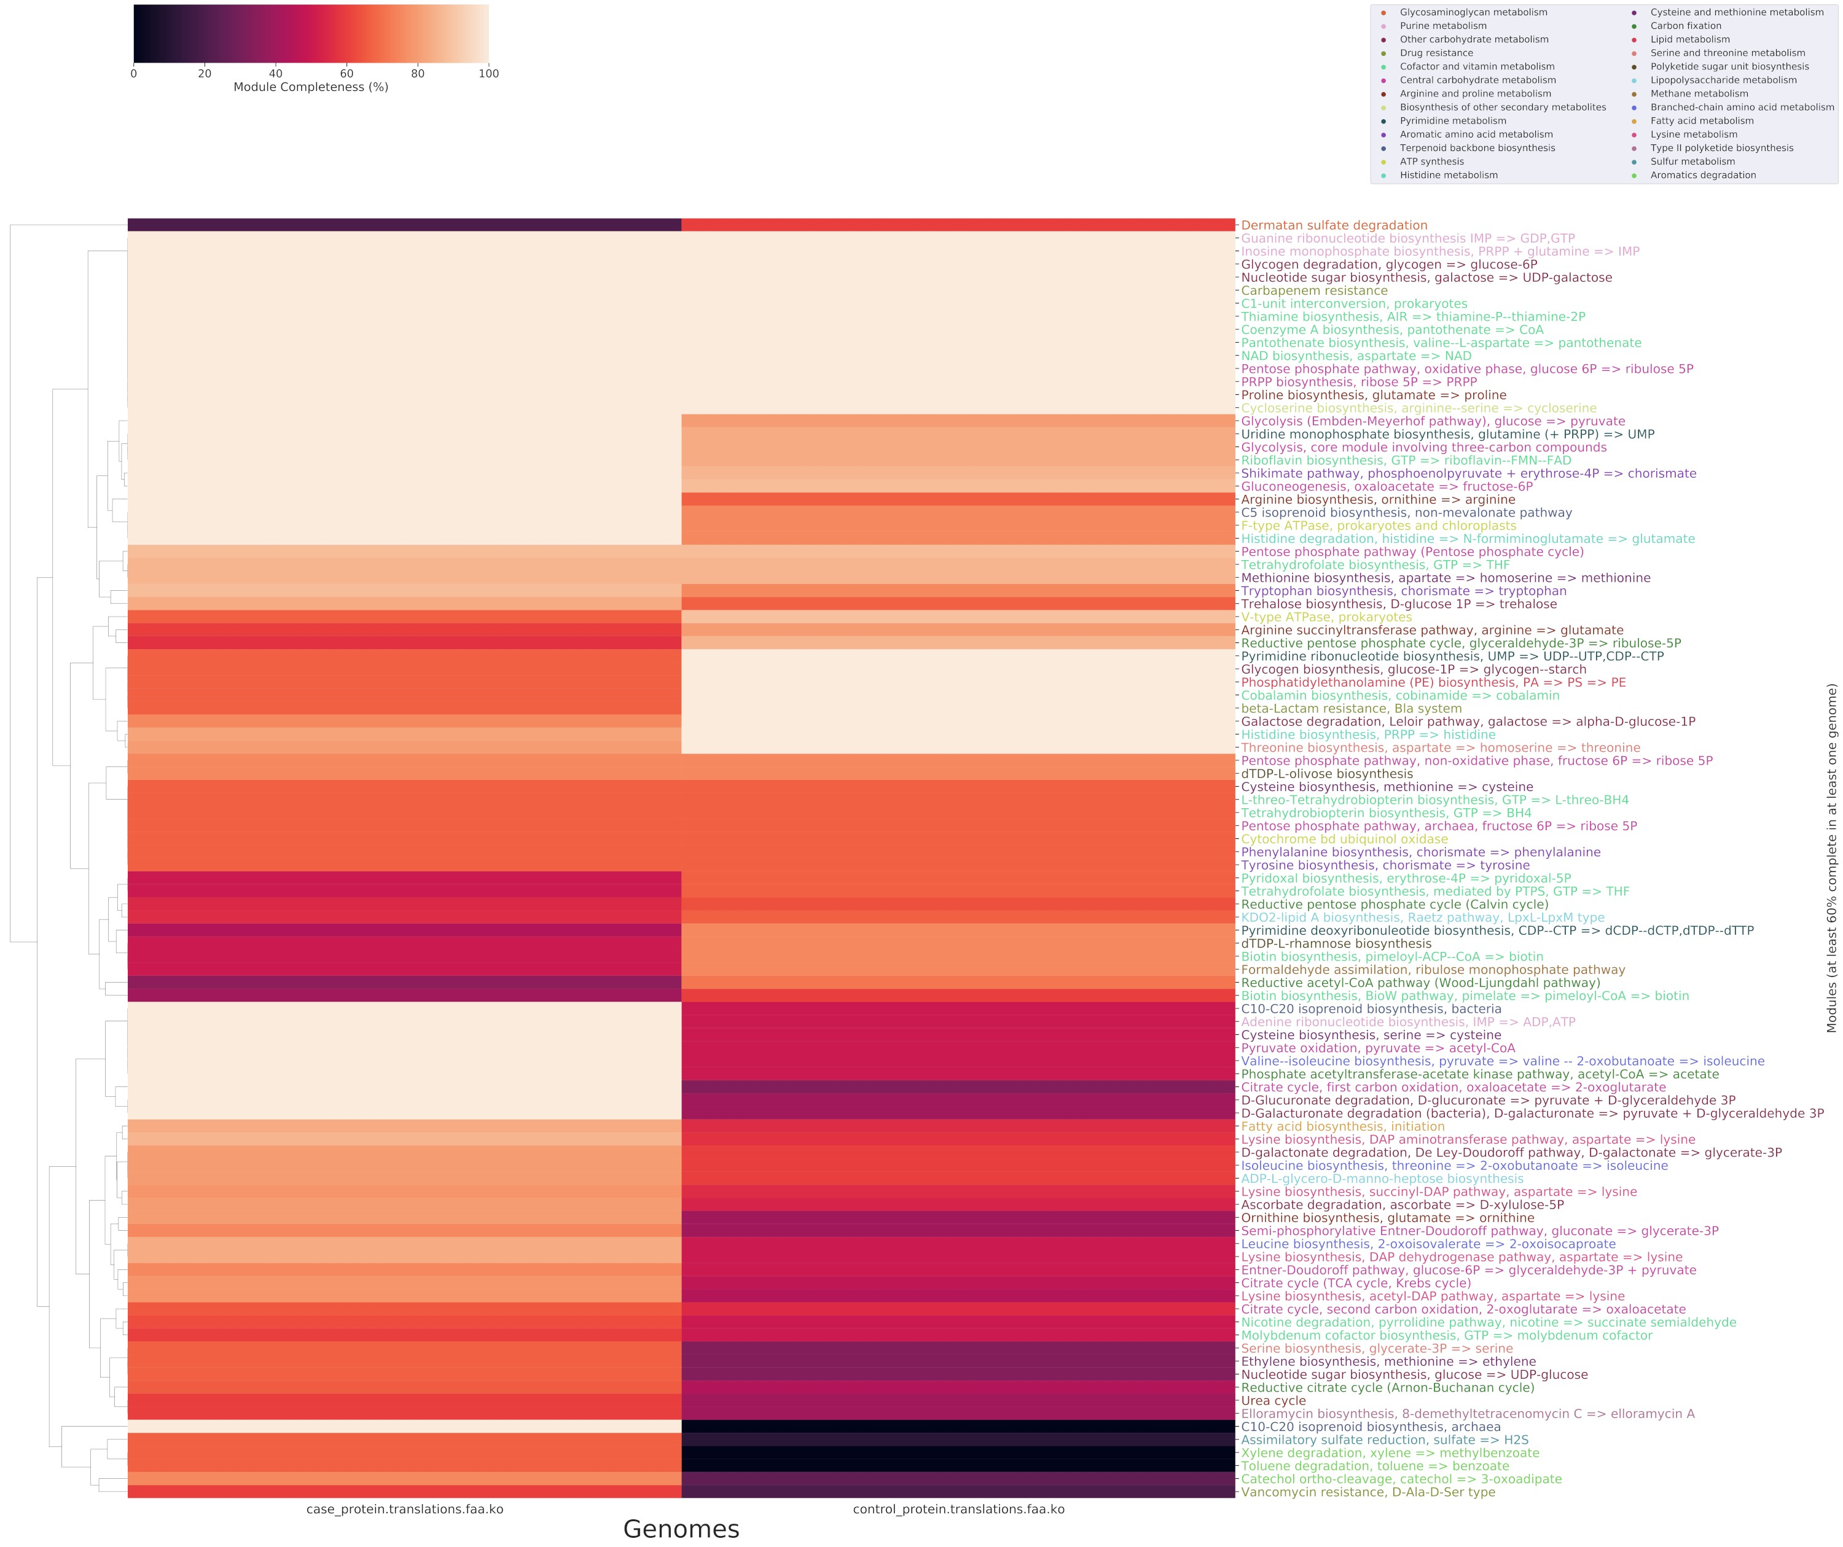
Supp. Fig. 8 Metabolic summary of differential pathways in CRC, stages 3/4 versus stages 1/2.

Supplementary discussion
In CRC comparisons, the differences between stages I/II and healthy were lesser than those than between stages III/IV and stages I/II. This might reflect a functional shift that occurs when the condition worsens and the regulation of cells (both human and microbial) is disrupted. Several results echo Yachida et al. [7]: the potential role of benzoate, and catabolism of cysteine. Other pathways were interesting, as they are mentioned in the literature, but did not show much contrast between conditions: catabolism of aromatic amino acids [62] and lipid biosynthesis of KDO2 [63]. Finally, basic functions appear in most comparisons (carbohydrates metabolism, carbon fixation), which might simply be because these functions are ubiquitous to the differentially abundant organisms. A comparison of the results from Yachida et al [7] is given in Table 3. Overall, each functional annotation still brought new relevant elements.

Supplementary tables and figures
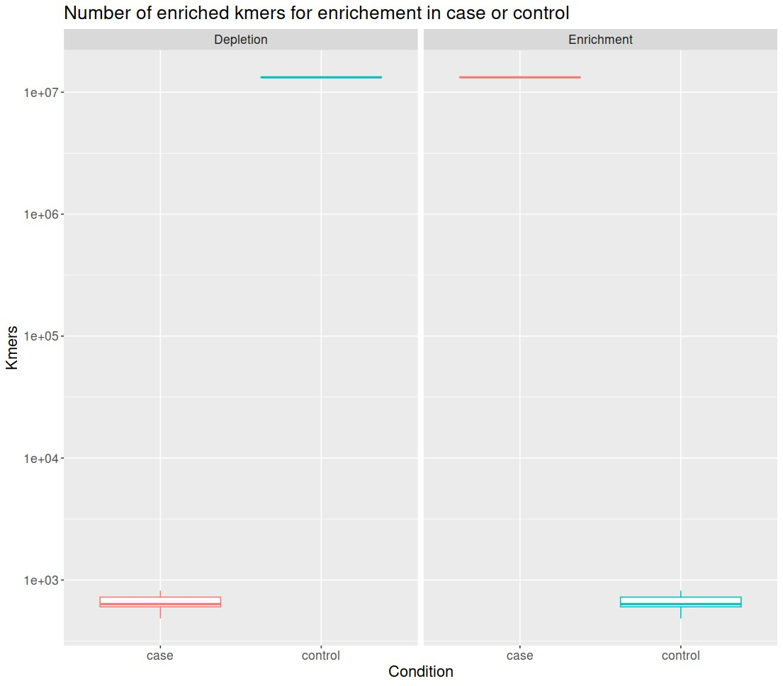
Supp. Fig. 9 Enriched k-mer counts at FC3 40M reads, with signal in cases (enrichment) and controls
(depletion).
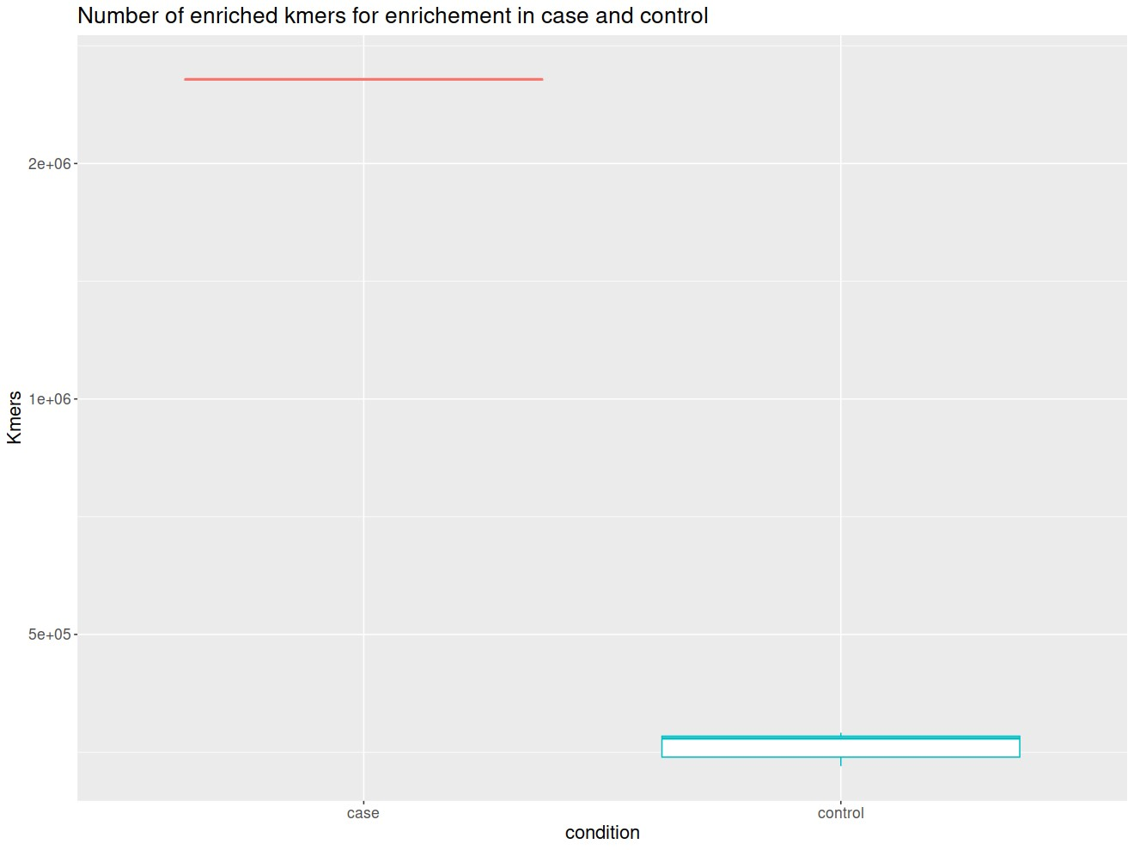
Supp. Fig. 10 Enriched k-mers at FC3 (C. acnes) and FC0.33 (M. restricta) at 20M in cases and controls
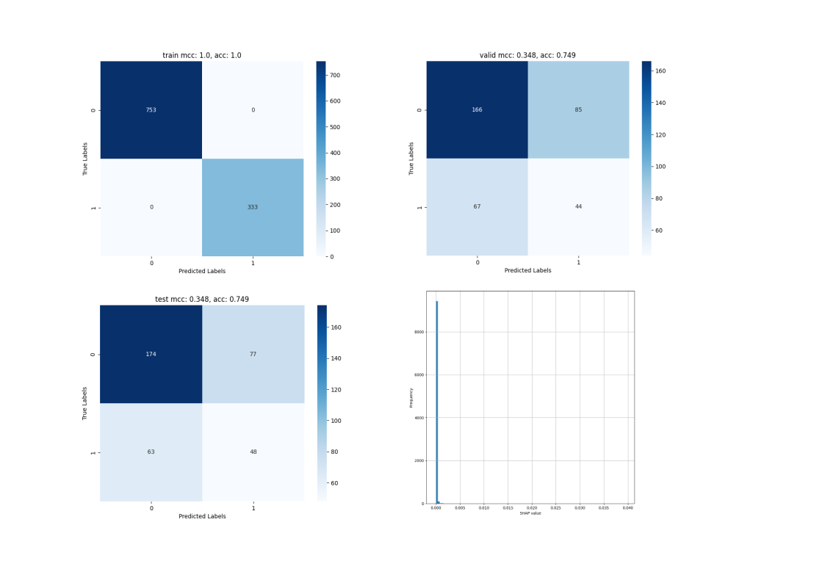
Supp. Fig. 11 Confusion matrices and Shapley values for the training, validation and test set for colorectal cancer, stages I/II versus Healthy. MCC and accuracy are given for each. 7444 features were selected by the model.

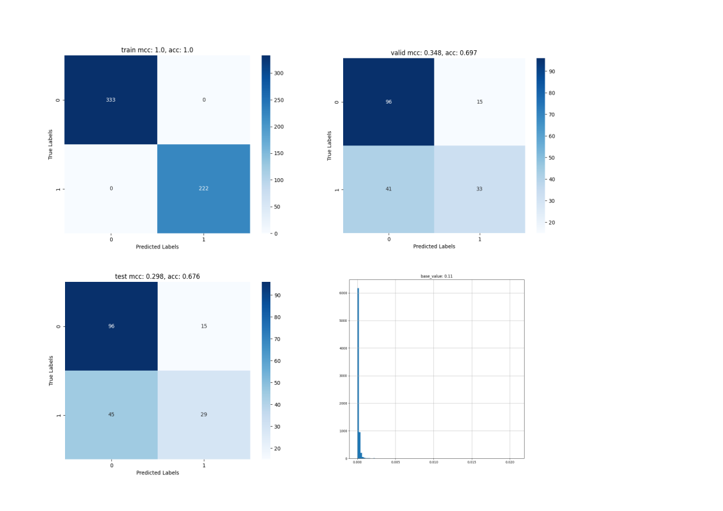
Supp. Fig. 12 Confusion matrices and histogram of Shapley values for the comparison of colorectal cancers stages III/IV and I/II. MCC and accuracy are given for each set. The histogram shows the number of features for each Shapley values.

Supplementary references

- Pedregosa, F., Varoquaux, G., Gramfort, A., Michel, V., Thirion, B., Grisel, O., Blondel, M., Prettenhofer, P., Weiss, R., Dubourg, V., Vanderplas, J., Passos, A., Cournapeau, D., Brucher, M., Perrot, M., Duchesnay, E.: Scikit-learn: Machine learning in Python. Journal of Machine Learning Research 12, 2825–2830 (2011)
- Pérez, F., Granger, B.E.: IPython: a system for interactive scientific computing. Computing in Science and Engineering 9(3), 21–29 (2007) https://doi.org/10. 1109/MCSE.2007.53
- Lundberg, S., Lee, S.-I.: A Unified Approach to Interpreting Model Predictions (2017). https://arxiv.org/abs/1705.07874
- Chen, T., Guestrin, C.: Xgboost: A scalable tree boosting system. In: Proceedings of the 22nd ACM SIGKDD International Conference on Knowledge Discovery and Data Mining. KDD ’16, pp. 785–794. Association for Computing Machinery, New York, NY, USA (2016). https://doi.org/10.1145/2939672.2939785 . https: //doi.org/10.1145/2939672.2939785
- Waskom, M.L.: seaborn: statistical data visualization. Journal of Open Source Software 6(60), 3021 (2021) https://doi.org/10.21105/joss.03021
- Hunter, J.D.: Matplotlib: A 2d graphics environment. Computing in Science & Engineering 9(3), 90–95 (2007) https://doi.org/10.1109/MCSE.2007.55
- McInnes, L., Healy, J., Saul, N., Großberger, L.: Umap: Uniform manifold approximation and projection. Journal of Open Source Software 3(29), 861 (2018) https://doi.org/10.21105/joss.00861
- neptune.ai: Neptune.ai: Experiment Tracker. https://neptune.ai
- Rohart, F., Gautier, B., Singh, A., Lê Cao, K.-A.: mixomics: An r package for ‘omics feature selection and multiple data integration. PLoS computational biology 13(11), 1005752 (2017)
- Chen, Y., Chen, L., Lun, A.T., Baldoni, P.L., Smyth, G.K.: edger v4: powerful differential analysis of sequencing data with expanded functionality and improved support for small counts and larger datasets. Nucleic Acids Research 53(2), 018 (2025)
- McMurdie, P.J., Holmes, S.: phyloseq: an r package for reproducible interactive analysis and graphics of microbiome census data. PloS one 8(4), 61217 (2013)
- Vasseur, S., Guillaumond, F.: Lipids in cancer: A global view of the contribution of lipid pathways to metastatic formation and treatment resistance. Oncogenesis 11(1), 46 (2022)
- Chen, J., Cui, L., Lu, S., Xu, S.: Amino acid metabolism in tumor biology and therapy. Cell Death & Disease 15(1), 42 (2024)
- Wang, X., Quinn, P.J., Yan, A.: Kdo2-lipid a: structural diversity and impact on immunopharmacology. Biological Reviews 90(2), 408–427 (2015)

