Uncropped blots
Dotted blue box indicates the cropped regions of blots used in original manuscript
Figure 1
Pane C
GFP Ponceau Stain
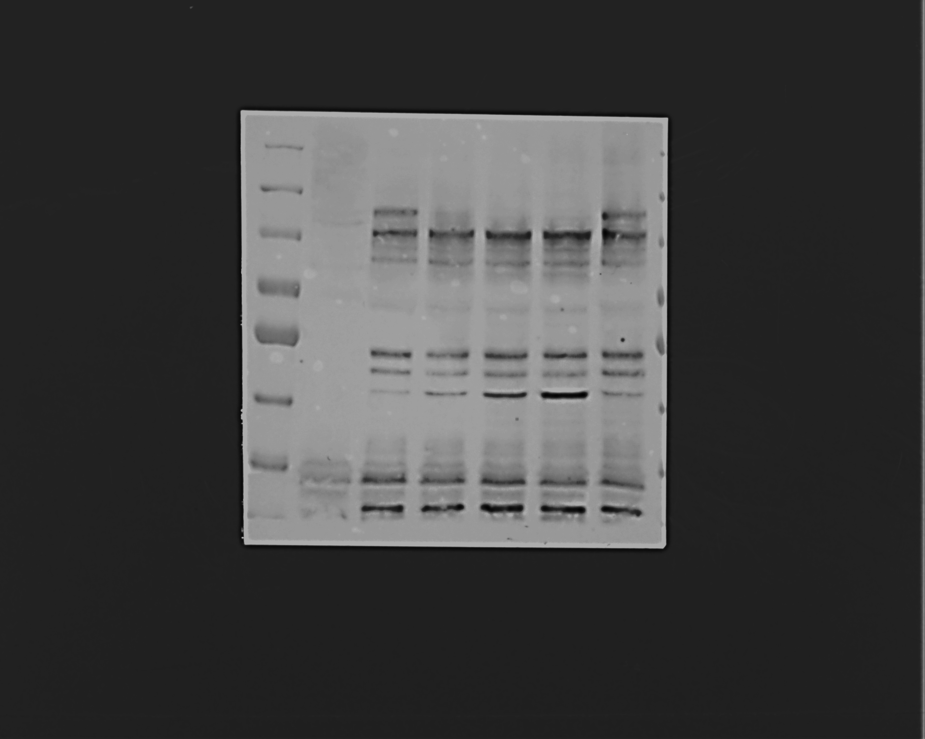

Panel D
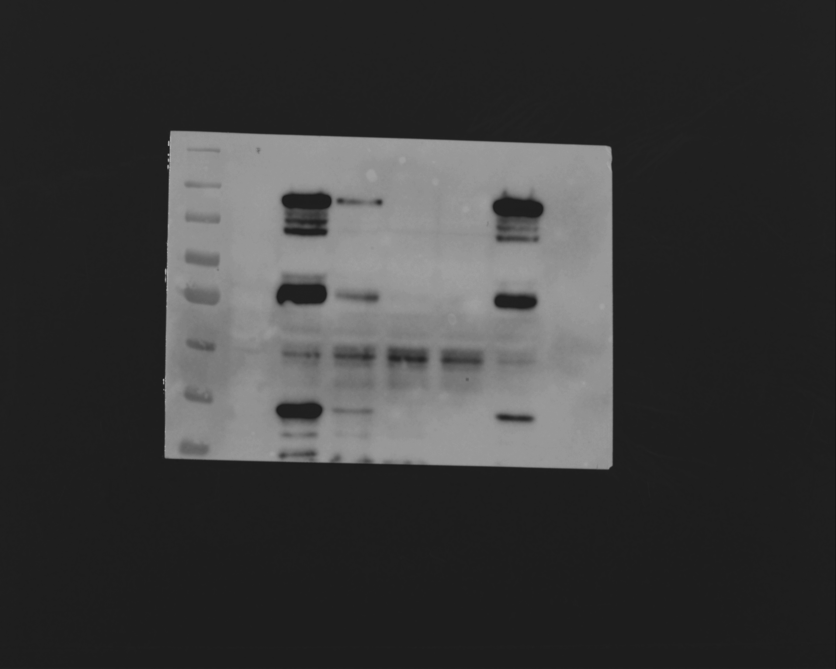
FLAG Ponceau Stain

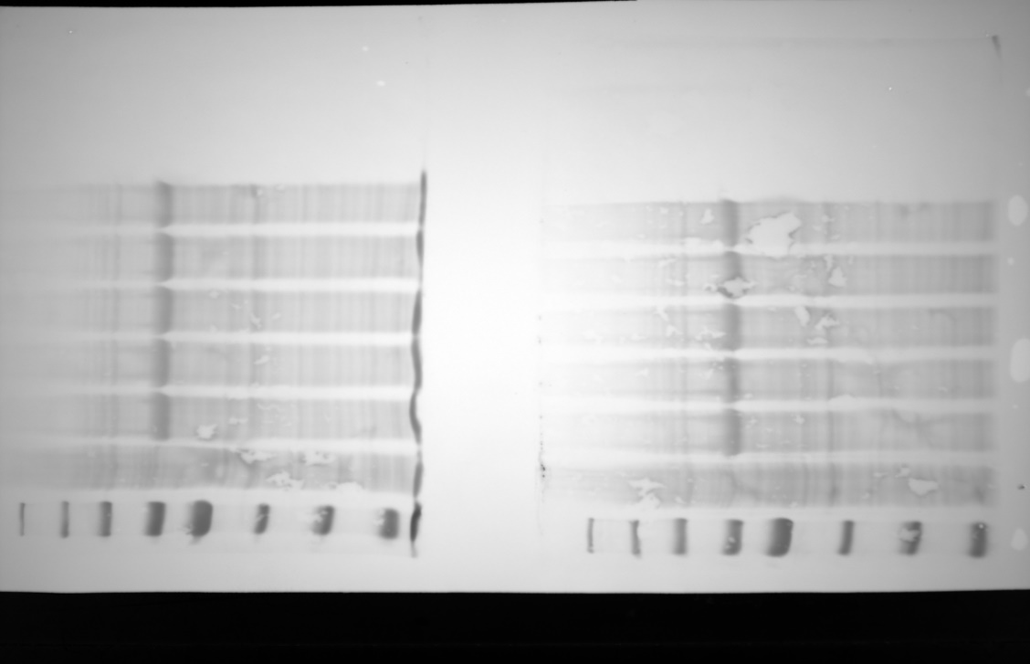

Figure 3

Panel D

JPh1

Ponceau stain

Figure 5
Panel D

JPh1
Ponceau stain

Panel F

JPh1

Tubulin

Histone

Ponceau stain

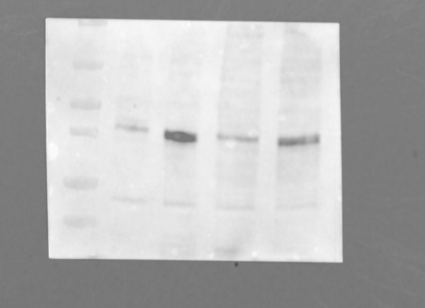
Panel K

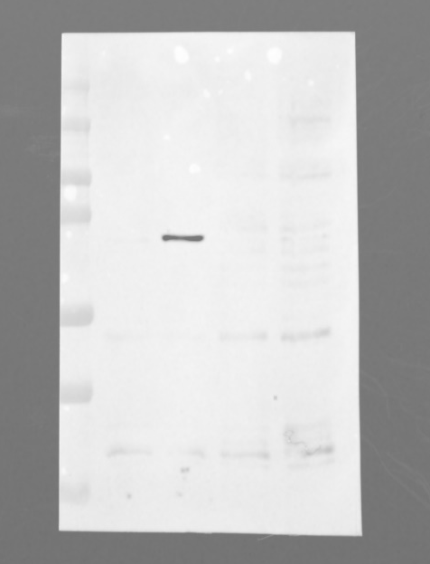
JP
JPh1

HSP70

Histone

Ponceau stain

Figure 6
Panel A

JPh1

Ponceau stain

Figure 7
Panel G
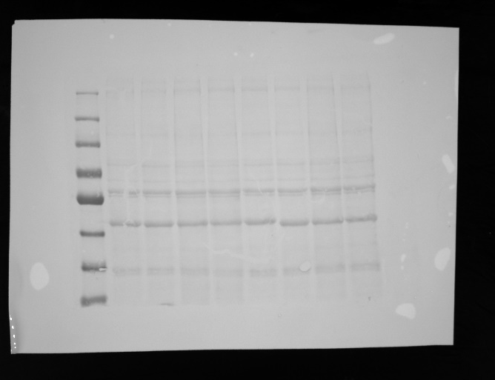
Soluble Protein fractions
JPh1 Ponceau stain

Insoluble Protein fractions
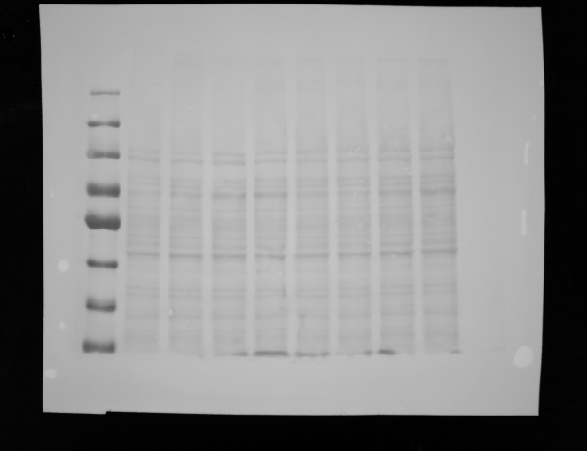
JPh1 Ponceau stain

Supplemental Figure S1

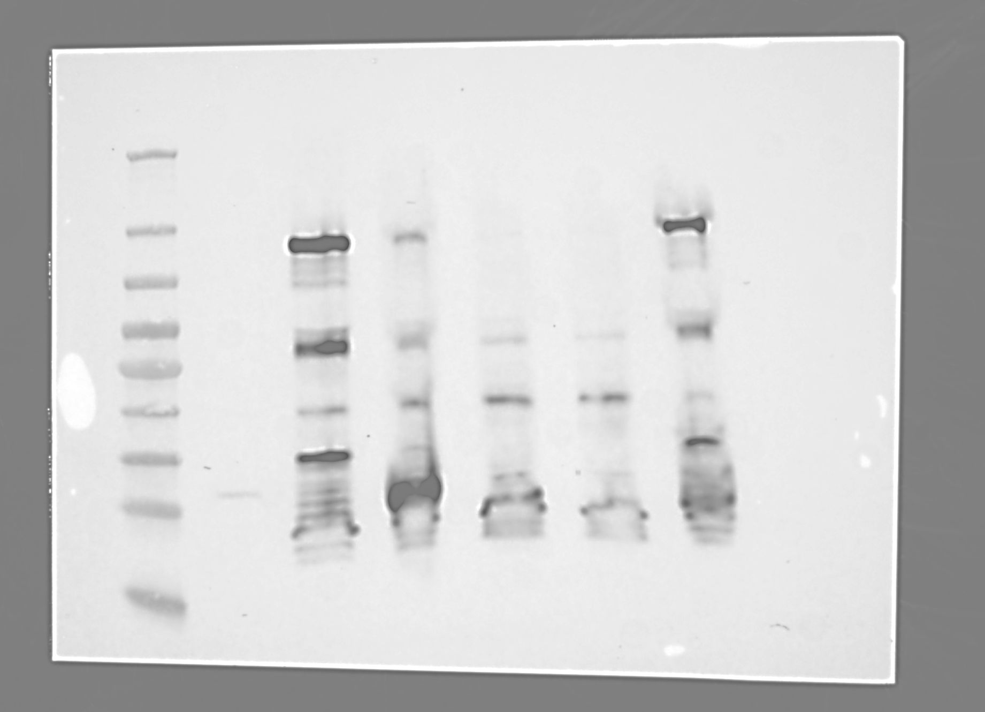
FLAG

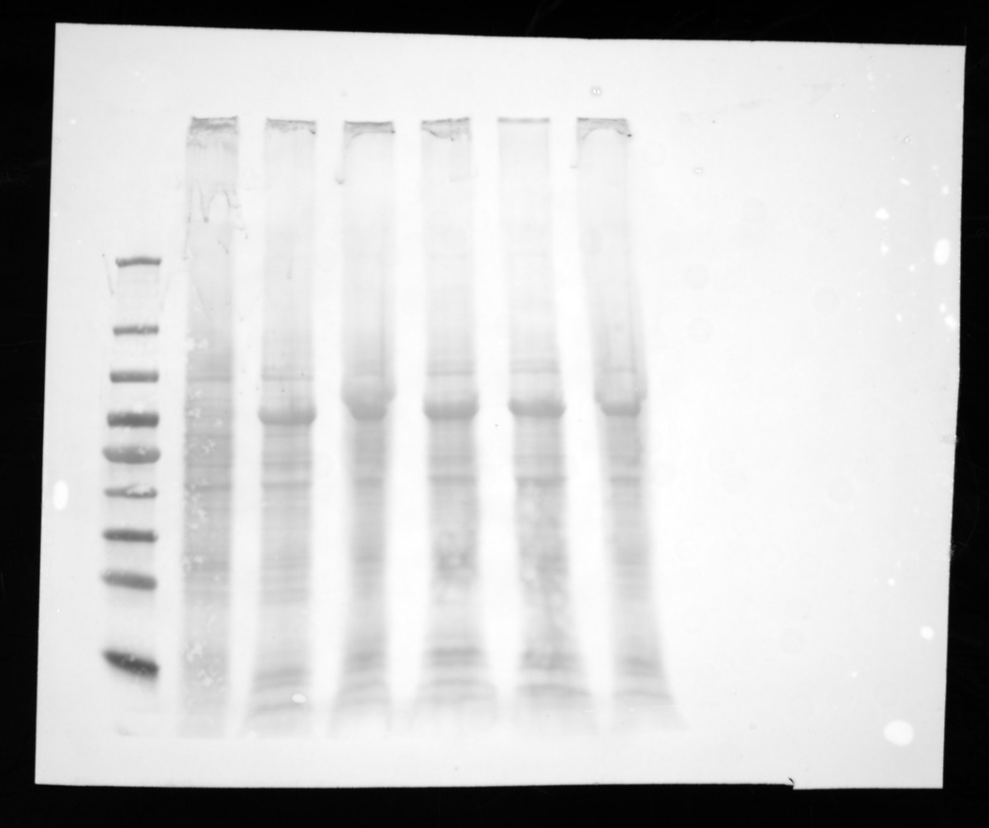
Ponceau stain

