Supplementary Materials for

Reconciling tradeoffs among hydropower, decarbonization, and freshwater biodiversity through carbon offsets

Sebastian A. Heilpern^{1,2*}, Felipe S. Pacheco³, Marc Grimson⁴, Suresh A. Sethi⁵, Zhongdi Qu⁴, Rafael M. Almeida⁶, Yue Mao⁴, Imanol Miqueleiz⁷, Andrew C. Wilcox⁸, Rebecca Mast⁹, Maria Camila Mejia Garcia¹⁰, Guido A. Herrera-R³, Hector Angarita¹¹, A.F.M. Kamal Chowdhury¹², Bridget R. Deemer¹³, Peter B. McIntyre⁷, Marcela Miranda³, Hansapani Rodrigo¹⁰, Rafael J.P. Schmitt¹⁴, Steven Thomas¹⁵, Thomas B. Wild¹², Christiane Zarfl⁹, Carla Gomes^{4*}, Alexander S. Flecker^{3*}

*Corresponding author. Email: heilpern@stanford.edu, gomes@cs.cornell.edu, asf3@cornell.edu

This PDF file includes:

Figs. S1 to S12
Table S1 to S2

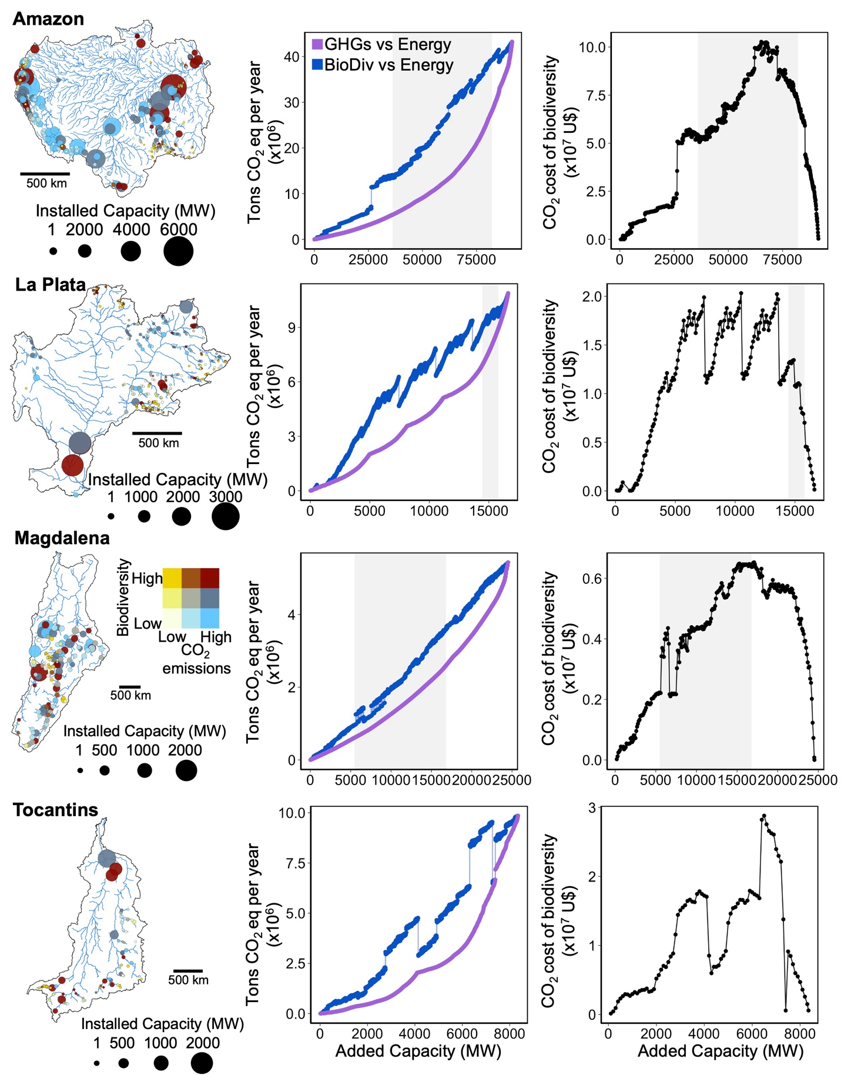

Fig. S1. Biodiversity-centered hydropower planning can result in higher carbon emissions than low-carbon planning in South American basins. First column: dams vary in their biodiversity impacts, carbon emissions and energy capacity. Second column: Thus, basin-wide Pareto optimal solutions for low-carbon hydropower planning (purple) emit less carbon than Pareto optimal solutions for biodiversity-centered planning (blue). Third column: Offsetting carbon emissions from biodiversity-centered planning to levels equivalent to those associated with lowest-carbon dam portfolios depends on the additional capacity installed, and varies across basins. The grey shaded area represents the potential range of future hydropower expansion for each basin from ref. (10).

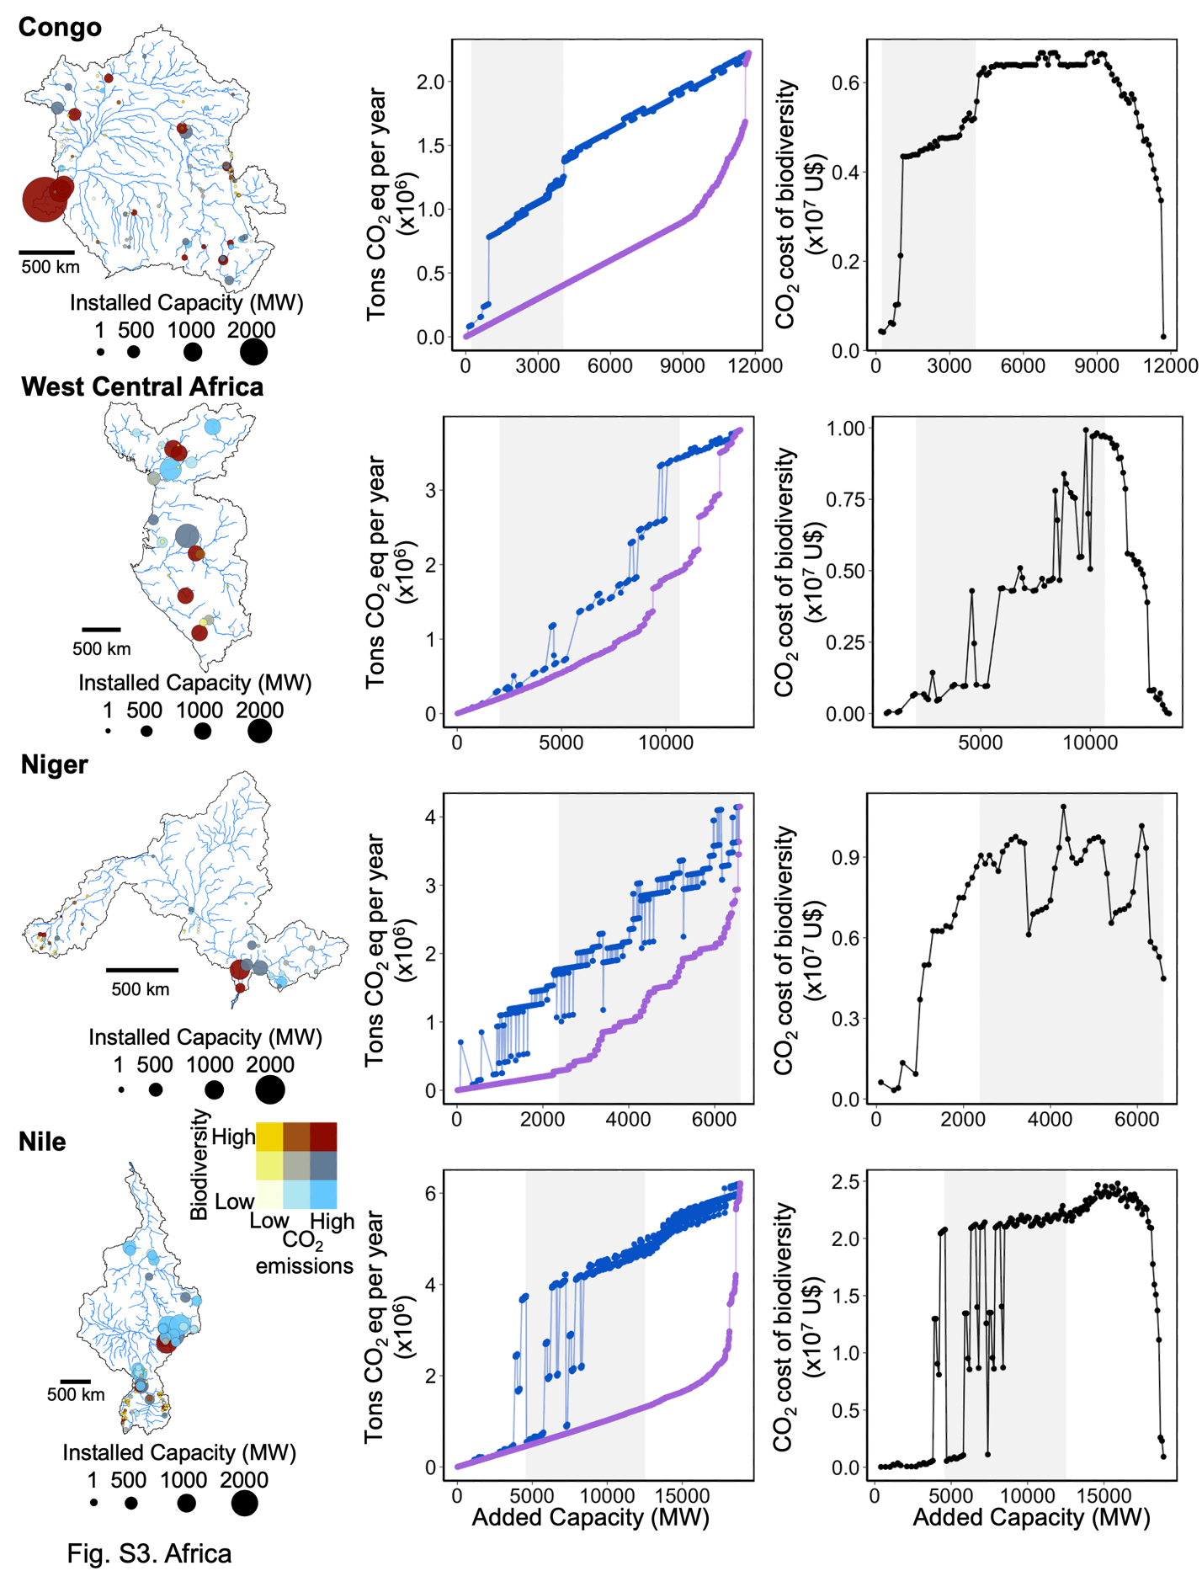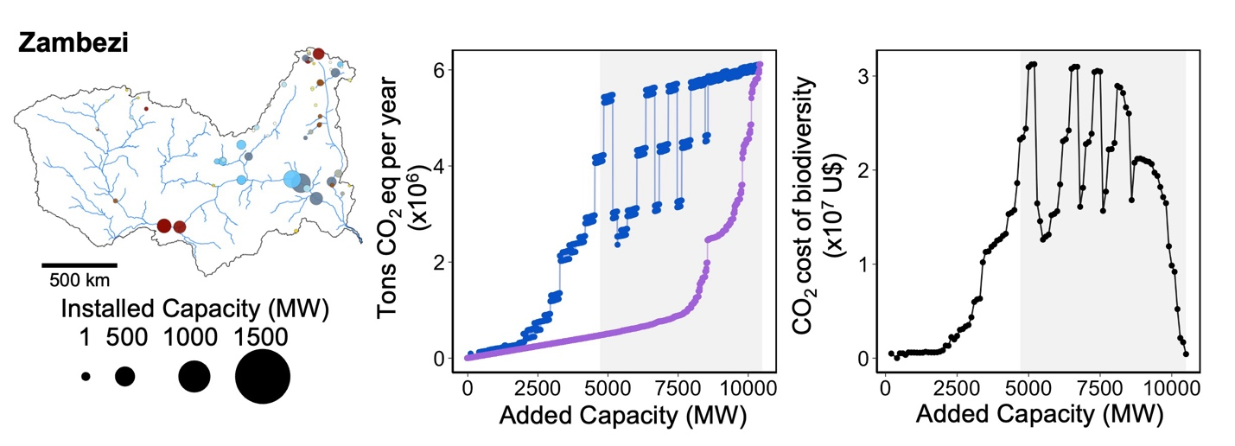

Fig. S2. Biodiversity-centered hydropower planning can result in higher carbon emissions than low-carbon planning in African basins. First column: dams vary in their biodiversity impacts, carbon emissions and energy capacity. Second column: Thus, basin-wide Pareto optimal solutions for low-carbon hydropower planning (purple) emit less carbon than Pareto optimal solutions for biodiversity-centered planning (blue). Third column: Offsetting carbon emissions from biodiversity-centered planning to levels equivalent to those associated with lowest-carbon dam portfolios depends on the additional capacity installed, and varies across basins. The grey shaded area represents the potential range of future hydropower expansion for each basin from ref. (10).

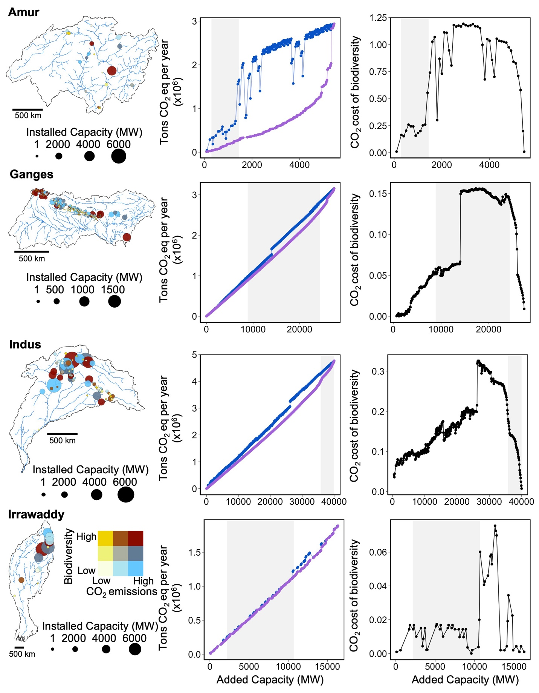

Fig. S3. Biodiversity-centered hydropower planning can result in higher carbon emissions than low-carbon planning in a subset of Asian basins. First column: dams vary in their biodiversity impacts, carbon emissions and energy capacity. Second column: Thus, basin-wide Pareto optimal solutions for low-carbon hydropower planning (purple) emit less carbon than Pareto optimal solutions for biodiversity-centered planning (blue). Third column: Offsetting carbon emissions from biodiversity-centered planning to levels equivalent to those associated with lowest-carbon dam portfolios depends on the additional capacity installed, and varies across basins. The grey shaded area represents the potential range of future hydropower expansion for each basin from ref. (10).

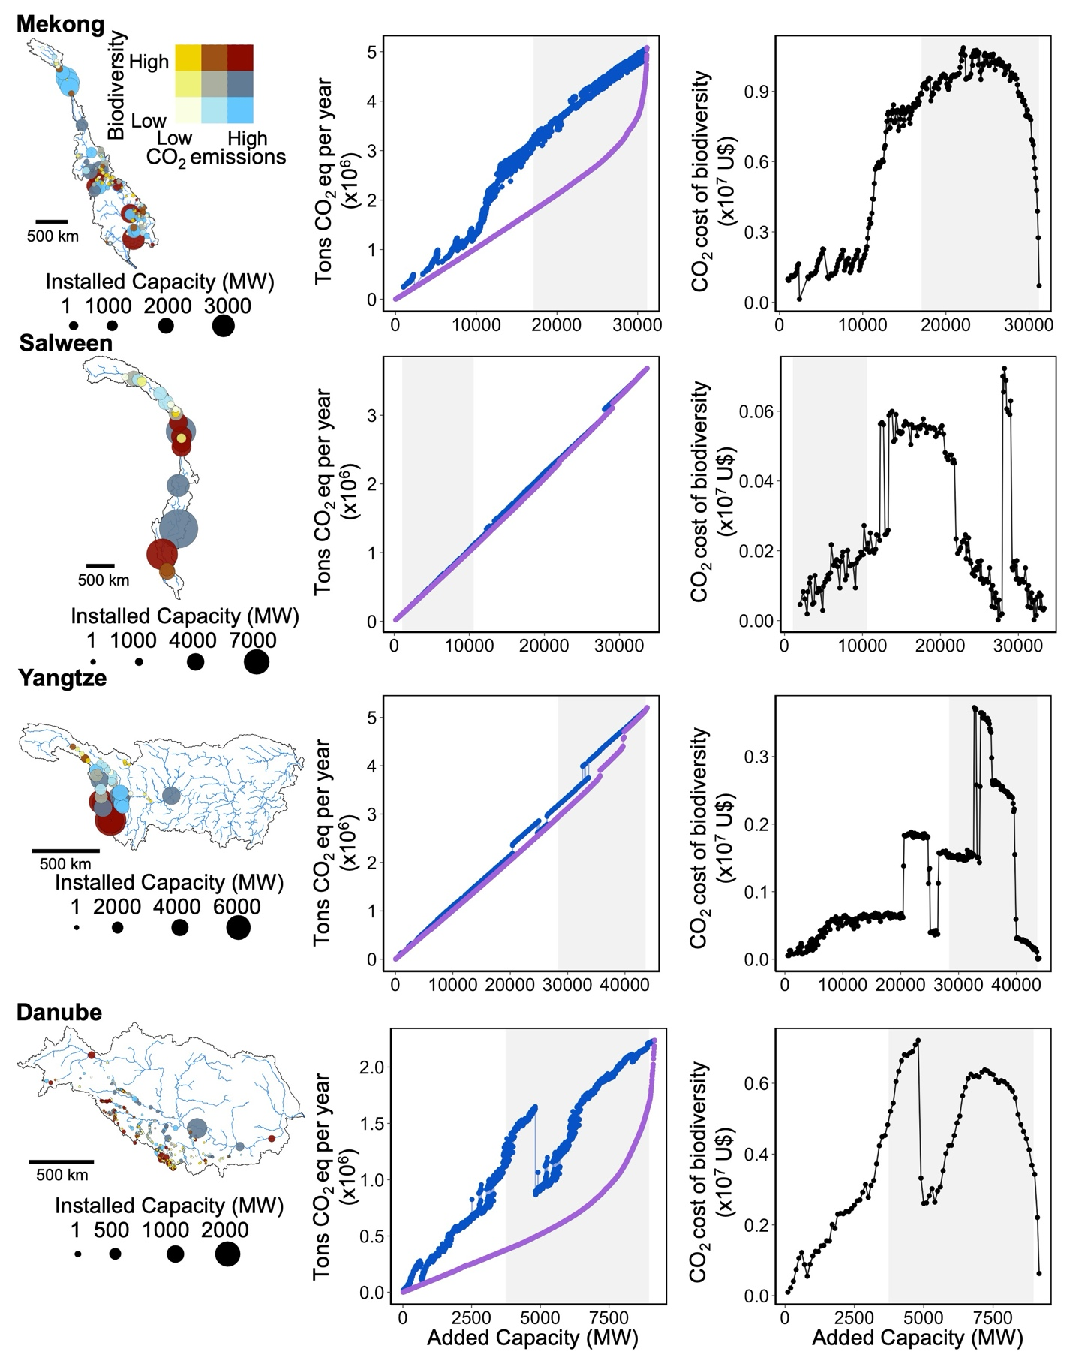
Fig. S4. Biodiversity-centered hydropower planning can result in higher carbon emissions than low-carbon planning in the second subset of Asian basins. First column: dams vary in their biodiversity impacts, carbon emissions and energy capacity. Second column: Thus, basin-wide Pareto optimal solutions for low-carbon hydropower planning (purple) emit less carbon than Pareto optimal solutions for biodiversity-centered planning (blue). Third column: Offsetting carbon emissions from biodiversity-centered planning to levels equivalent to those associated with lowest-carbon dam portfolios depends on the additional capacity installed, and varies across basins. The grey shaded area represents the potential range of future hydropower expansion for each basin from ref. (10).

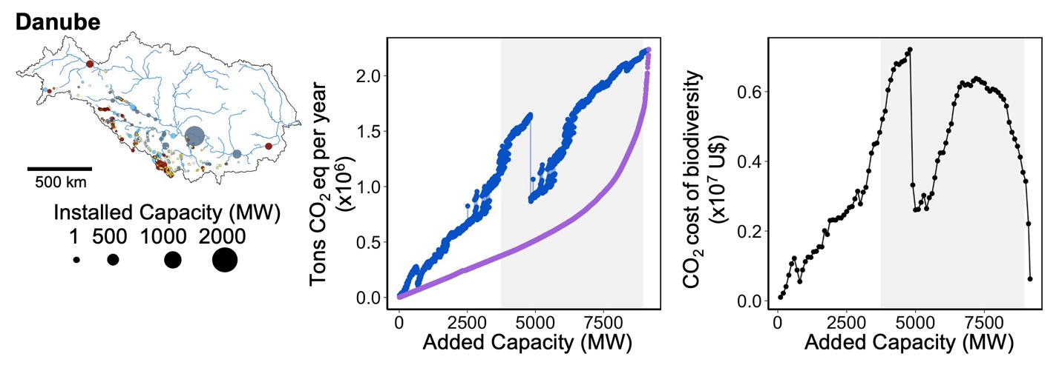Fig. S5. Biodiversity-centered hydropower planning can result in higher carbon emissions than low-carbon planning in the Danube. First column: dams vary in their biodiversity impacts, carbon emissions and energy capacity. Second column: Thus, basin-wide Pareto optimal solutions for low-carbon hydropower planning (purple) emit less carbon than Pareto optimal solutions for biodiversity-centered planning (blue). Third column: Offsetting carbon emissions from biodiversity-centered planning to levels equivalent to those associated with lowest-carbon dam portfolios depends on the additional capacity installed, and varies across basins. The grey shaded area represents the potential range of future hydropower expansion for each basin from ref. (10).

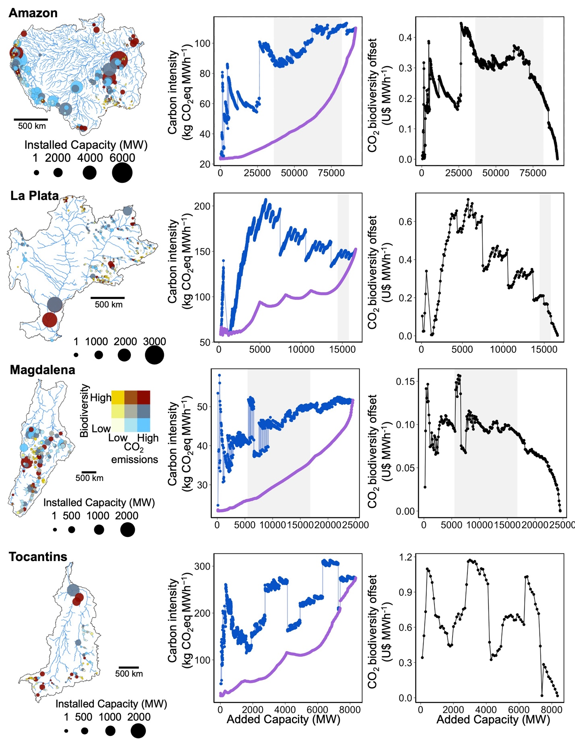

Fig. S6. Biodiversity-centered hydropower planning can more than triple carbon intensities in comparison to low-carbon planning in South American basins. First column: Dams vary in their biodiversity impacts, carbon emissions and energy capacity. Second column: Thus, basin-wide Pareto optimal solutions for low-carbon hydropower planning (purple) have lower carbon intensities than Pareto optimal solutions for biodiversity-centered planning (blue). Third column: Offsetting carbon emissions from biodiversity-centered planning to levels equivalent to those associated with lowest-carbon dam portfolios depends on the additional capacity installed, and varies across basins. The grey shaded area represents the potential range of future hydropower expansion for each basin from ref. (10).

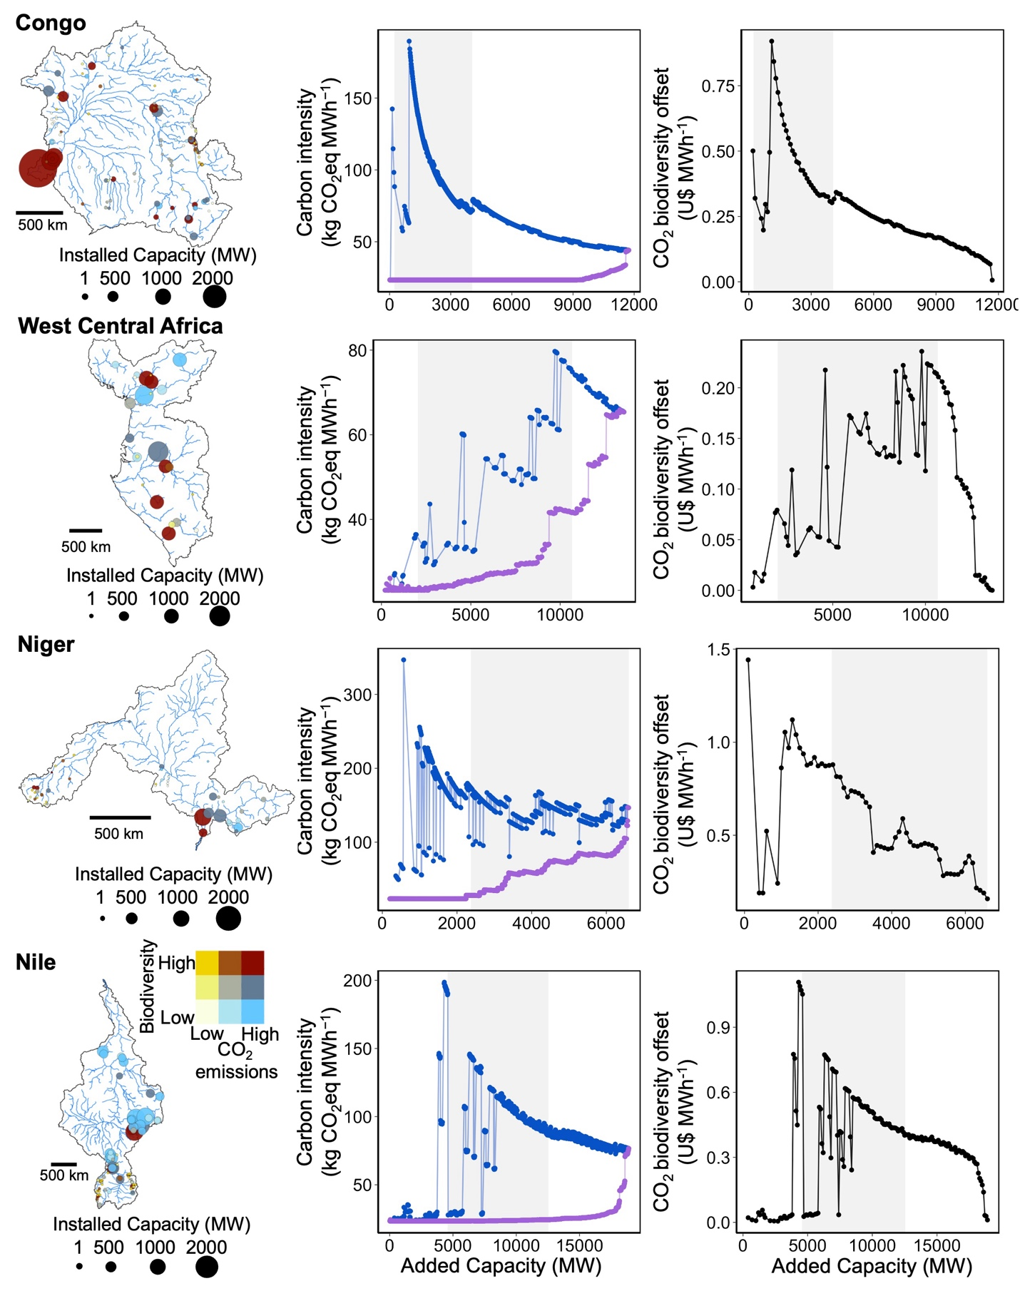

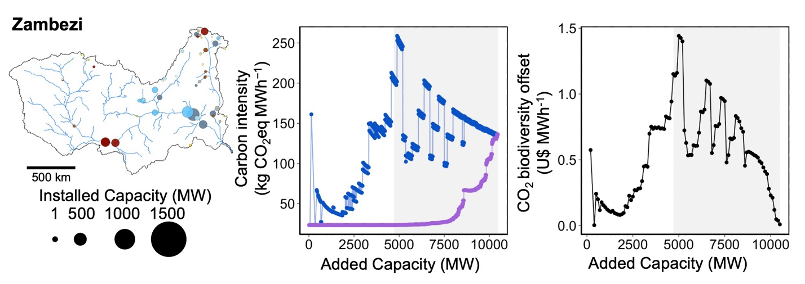Fig. S7. Biodiversity-centered hydropower planning can more than triple carbon intensities in comparison to low-carbon planning in African basins. First column: Dams vary in their biodiversity impacts, carbon emissions and energy capacity. Second column: Thus, basin-wide Pareto optimal solutions for low-carbon hydropower planning (purple) have lower carbon intensities than Pareto optimal solutions for biodiversity-centered planning (blue). Third column: Offsetting carbon emissions from biodiversity-centered planning to levels equivalent to those associated with lowest-carbon dam portfolios depends on the additional capacity installed, and varies across basins. The grey shaded area represents the potential range of future hydropower expansion for each basin from ref. (10).

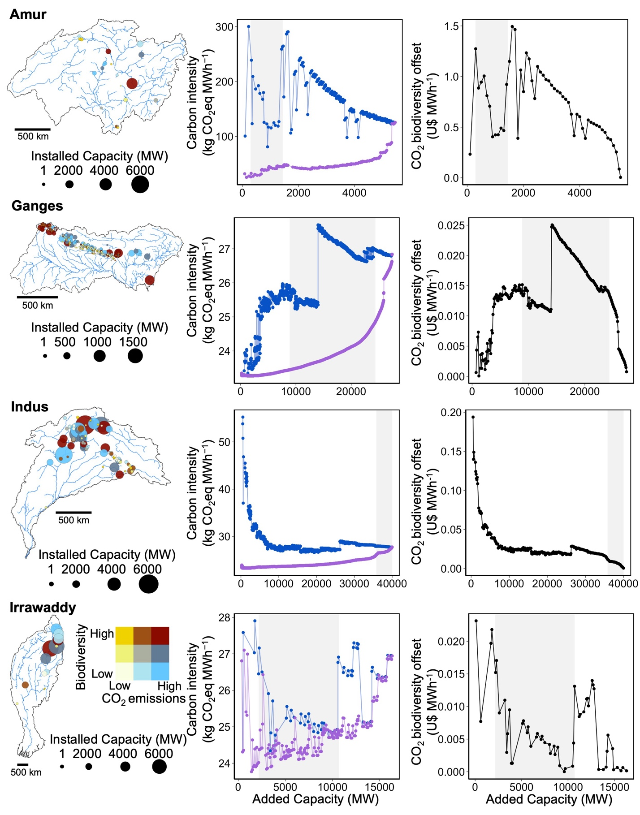

Fig. S8. Biodiversity-centered hydropower planning can more than triple carbon intensities in comparison to low-carbon planning in a subset of Asian basins. First column: Dams vary in their biodiversity impacts, carbon emissions and energy capacity. Second column: Thus, basin-wide Pareto optimal solutions for low-carbon hydropower planning (purple) have lower carbon intensities than Pareto optimal solutions for biodiversity-centered planning (blue). Third column: Offsetting carbon emissions from biodiversity-centered planning to levels equivalent to those associated with lowest-carbon dam portfolios depends on the additional capacity installed, and varies across basins. The grey shaded area represents the potential range of future hydropower expansion for each basin from ref. (10).

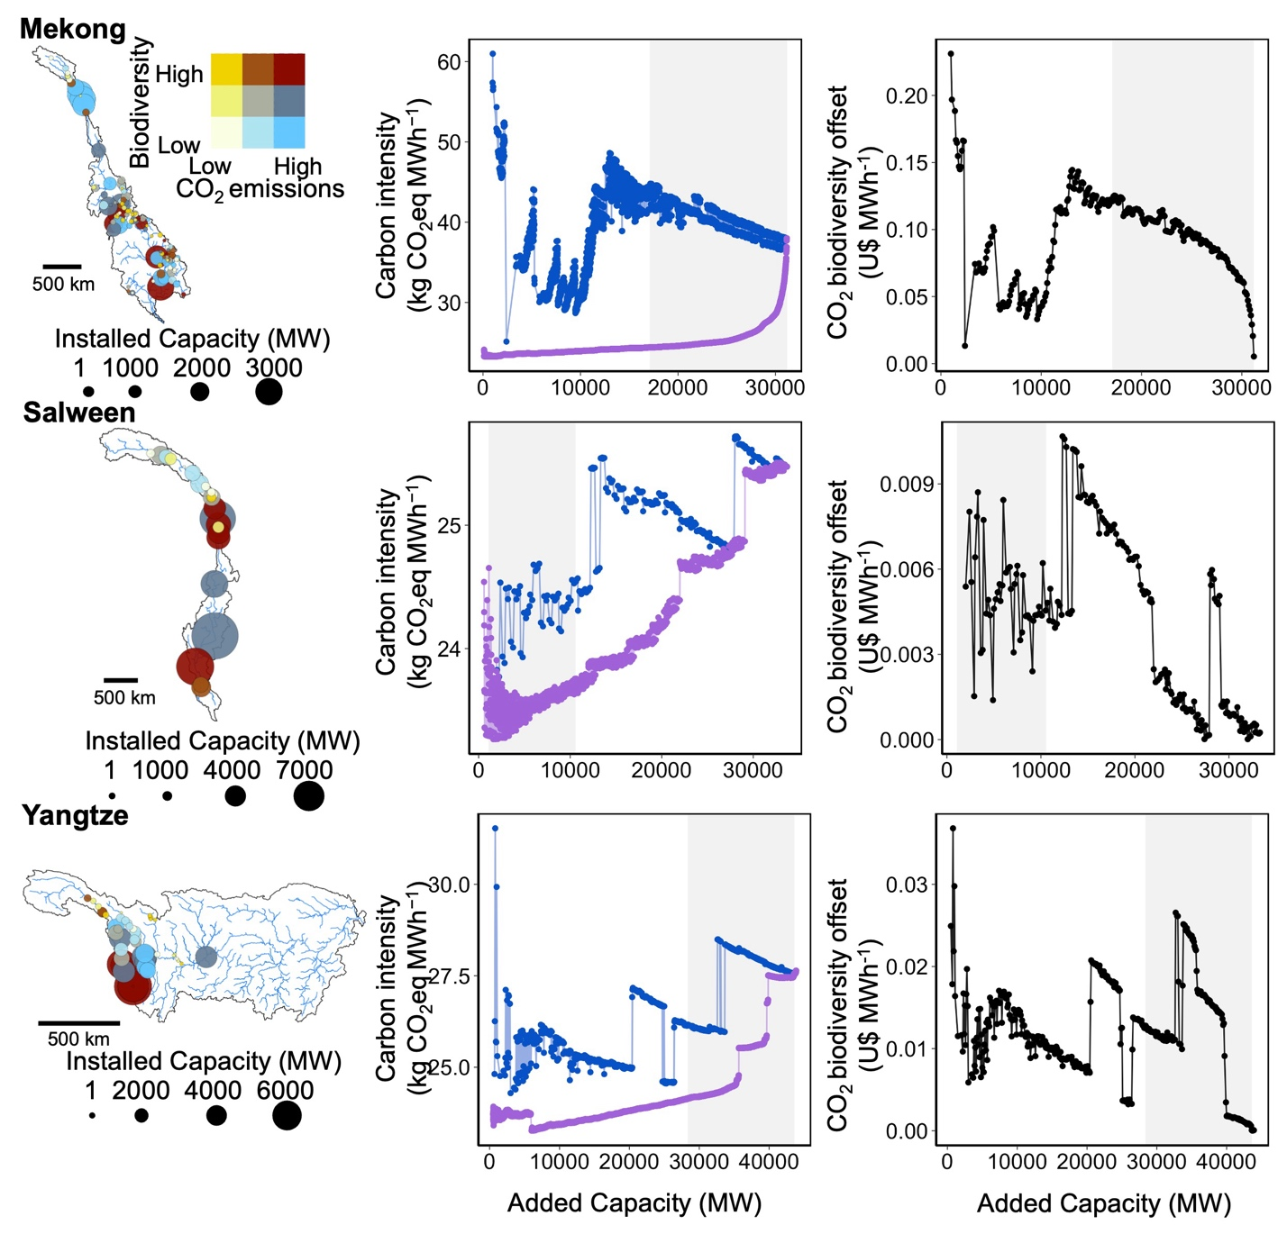

Fig. S9. Biodiversity-centered hydropower planning can more than triple carbon intensities in comparison to low-carbon planning in a second subset of Asian basins. First column: Dams vary in their biodiversity impacts, carbon emissions and energy capacity. Second column: Thus, basin-wide Pareto optimal solutions for low-carbon hydropower planning (purple) have lower carbon intensities than Pareto optimal solutions for biodiversity-centered planning (blue). Third column: Offsetting carbon emissions from biodiversity-centered planning to levels equivalent to those associated with lowest-carbon dam portfolios depends on the additional capacity installed, and varies across basins. The grey shaded area represents the potential range of future hydropower expansion for each basin from ref. (10).

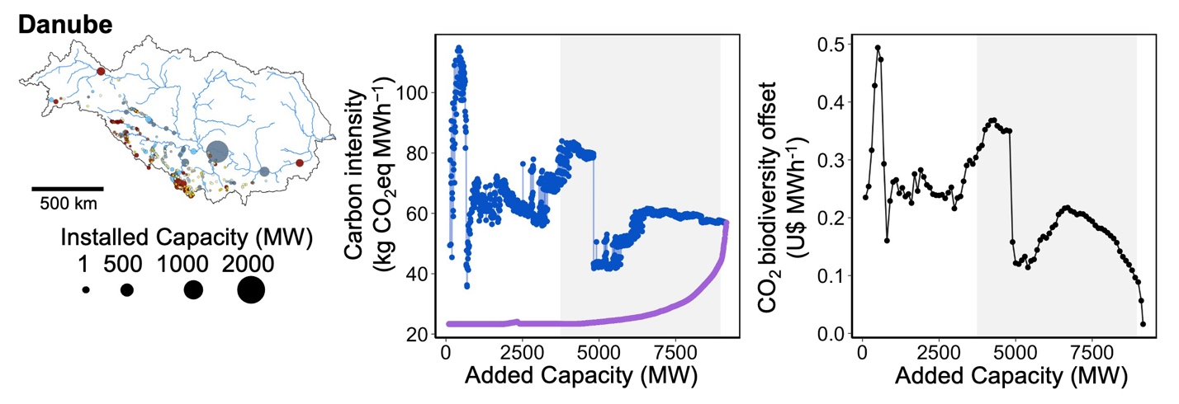Fig. S10. Biodiversity-centered hydropower planning can more than triple carbon intensities in comparison to low-carbon planning in a second subset of Asian basins. First column: Dams vary in their biodiversity impacts, carbon emissions and energy capacity. Second column: Thus, basin-wide Pareto optimal solutions for low-carbon hydropower planning (purple) have lower carbon intensities than Pareto optimal solutions for biodiversity-centered planning (blue). Third column: Offsetting carbon emissions from biodiversity-centered planning to levels equivalent to those associated with lowest-carbon dam portfolios depends on the additional capacity installed, and varies across basins. The grey shaded area represents the potential range of future hydropower expansion for each basin from ref. (10).

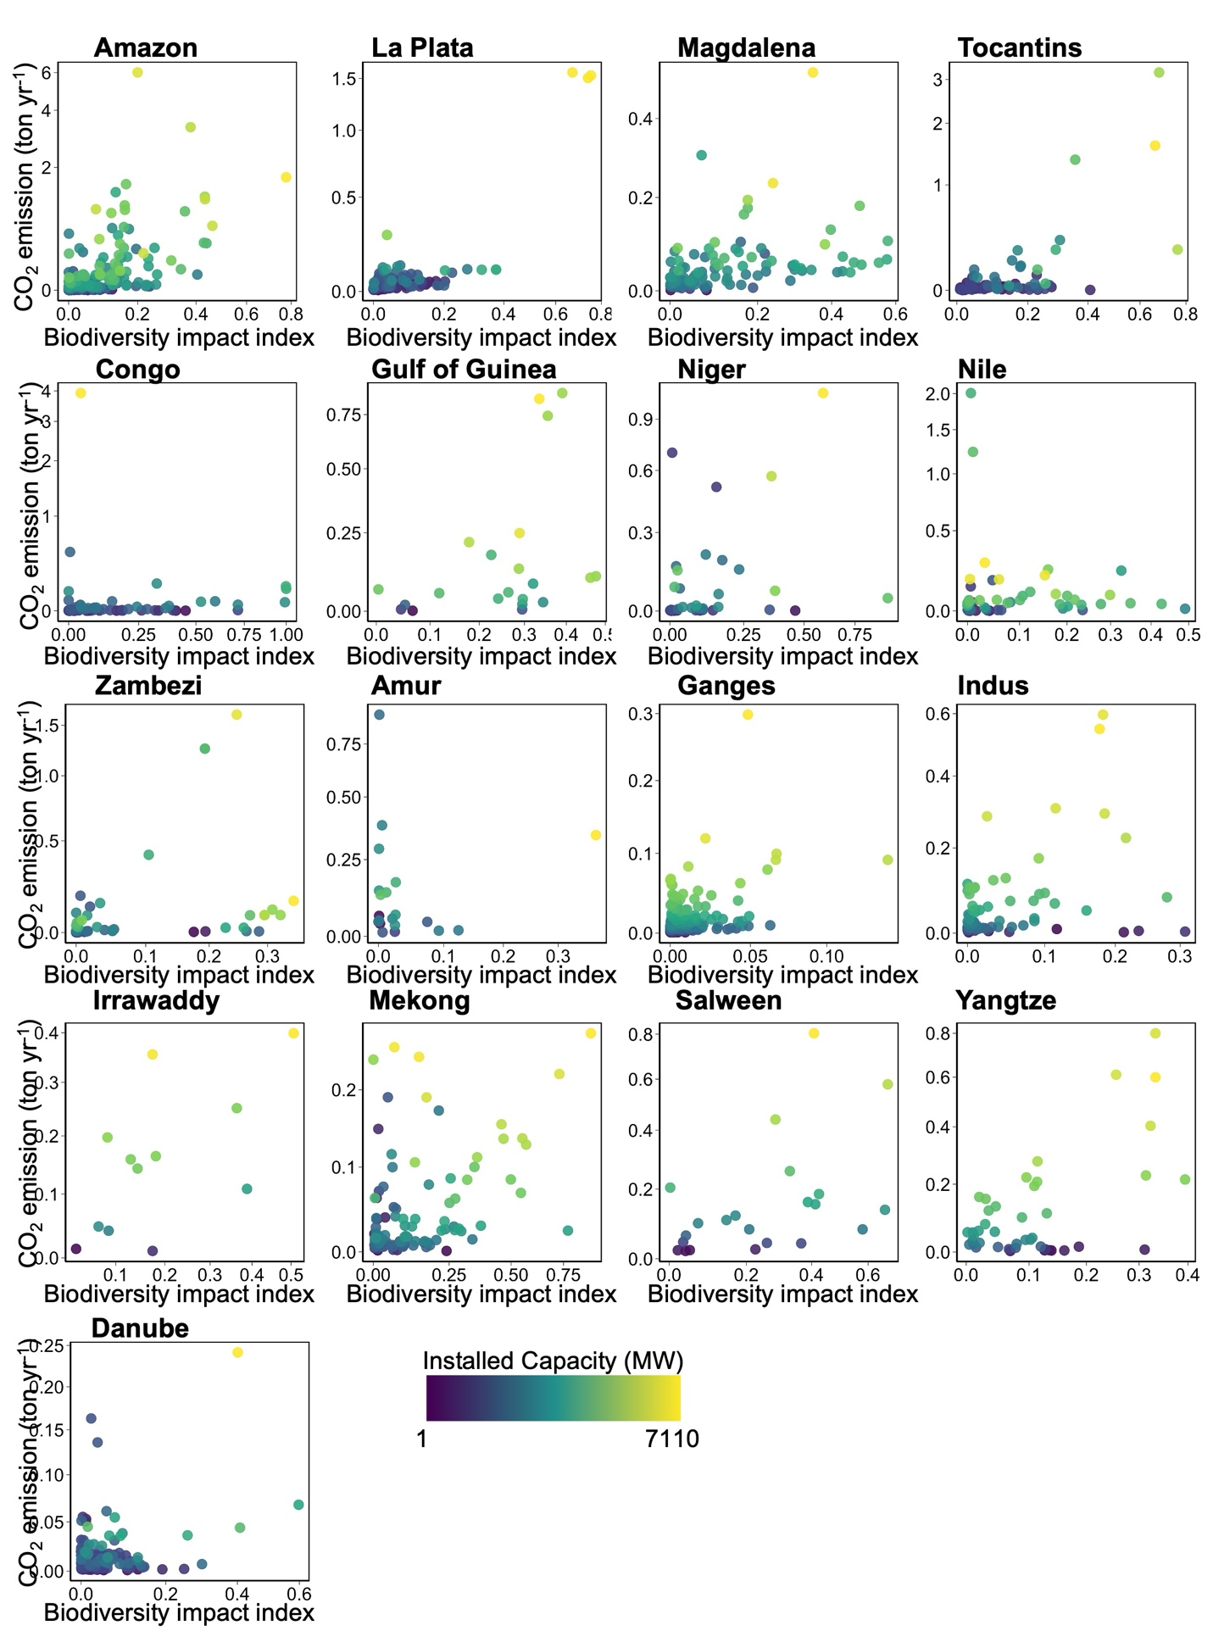
Fig. S11. Dams vary in their potential impacts on fish diversity, carbon emissions and installed capacities. Importantly, these three objectives are effectively decoupled across all river basins, and thus tradeoffs are prevalent. Each point corresponds to an individual dam colored by its installed capacity, as indicated in the legend.

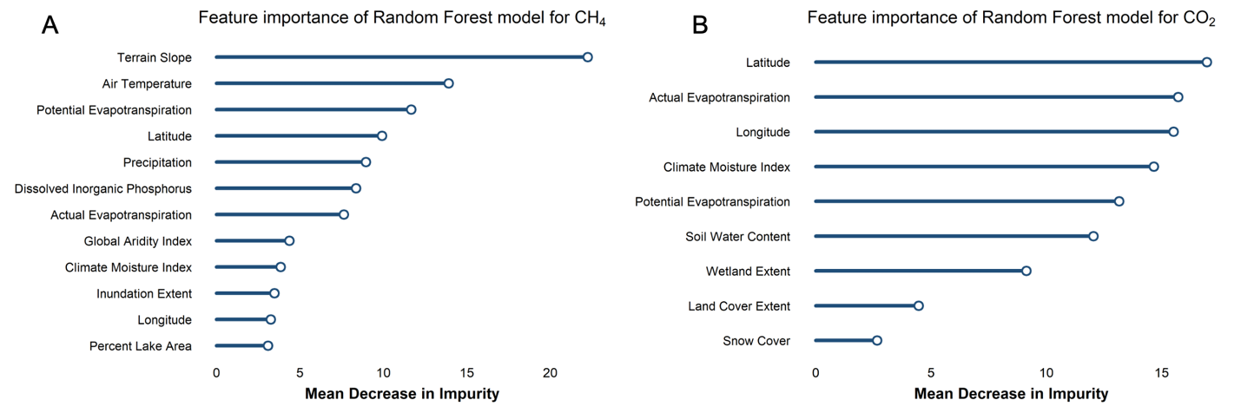
Fig. S12. Feature importance for final random forest models for (A) CH₄ and (B) CO₂. For variable descriptions see tables S1 and S2.

Table S1. Final predictors included in the random forest model for CH₄.
Predictors | Description | Unit | Category
Potential Evapotranspiration | April through September in the sub-basin. | mm | Climate
Actual Evapotranspiration | April through December in the sub-basin. | mm | Climate
Precipitation | February through December in the sub-basin. | mm | Climate
The Climate Moisture Index | In sub-basin and upstream | Index | Climate
Global Aridity Index | In sub-basin and upstream | Index | Climate
Air Temperature | Temperatures for May and July | Degrees Celsius | Climate
Terrain Slope | In sub-basin | Degree | Physiography
Inundation Extent | Annual minimum inundation (smn) Long-term maximum inundation (ult) | % cover | Hydrology
Percent Lake Area | Upstream lake area extent (use) | % cover | Hydrology
Latitude | Geographic Coordinates | Degree | Other
Longitude | Geographic Coordinates | Degree | Other
Dissolved Inorganic Phosphorus | In sub-basin Dissolved inorganic phosphorus | kg P km⁻² yr⁻¹ | Other

Table S2. Final predictors included in the random forest model for CO₂.
Predictors | Description | Unit | Category
Potential Evapotranspiration | July and August in the sub-basin | mm | Climate
Actual Evapotranspiration | October and September in the sub-basin | mm | Climate
Snow Cover Extent | July in the sub-basin. | % | Climate
The Climate Moisture Index | June in the sub-basin | Index | Climate
Wetland Extent | Lakes/reservoirs, in the upstream watershed | % | Landcover
Land Cover Extent | Class 2 upstream | % | Landcover
Soil Water Content | August in the sub-basin | % | Soils/Geology
Latitude | Geographic Coordinates | Degree | Other
Longitude | Geographic Coordinates | Degree | Other

