Appendix A

Appendix A.1 Soft tissue tumors referral pathways

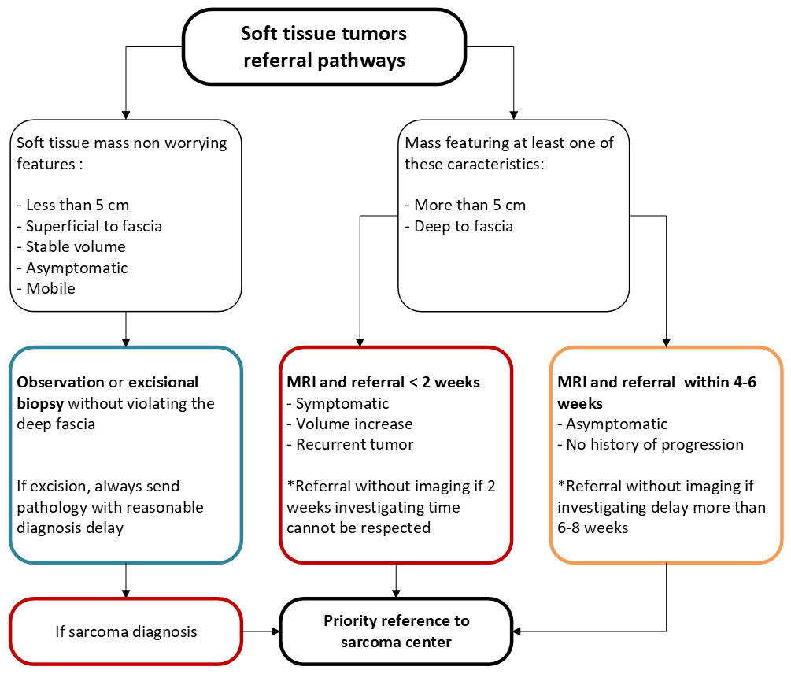

Appendix A.2 Bone tumors referral pathways