Supporting Information
Table S1 Species discrimination of DNA barcodes, plastome, nrDNA, and their combinations as well as ten selected hypervariable plastome loci based on genetic distance (barcoding gap) analyses across Amentotaxus. “Y” indicates successful identification of the corresponding species, whereas “N” indicates failure to discriminate the species.

DNA barcode | A. yunnanensis | A. argotaenia | A. poilanei | A. assamica | A. formosana | A. hekouensis | discrimination rate
ITS | Y | N | N | Y | Y | N | 3 (50%)
rbcL+matK+trnH-psbA | Y | N | N | N | Y | N | 2 (33.3%)
rbcL+matK+trnH-psbA+ITS | Y | Y | N | Y | Y | N | 4 (66.7%)
nrDNA | Y | N | N | Y | Y | N | 3 (50%)
Plastome | Y | Y | Y | N | Y | N | 4 (66.7%)
plastome+nrDNA | Y | Y | Y | N | Y | N | 4 (66.7%)
rrn16-trnV | N | Y | N | N | Y | N | 2 (33.3%)
trnL-F | Y | Y | N | N | Y | N | 3 (50%)
trnR-ndhF | N | N | N | N | Y | N | 1 (16.7%)
clpP-rps12 | Y | Y | Y | N | Y | N | 4 (66.7%)
accD | N | Y | Y | N | Y | N | 3 (50%)
trnL-UAA | Y | N | N | N | Y | N | 2 (33.3%)
ycf1-chlN | Y | N | N | N | Y | N | 2 (33.3%)
accD-rbcL | Y | N | N | N | Y | N | 2 (33.3%)
psbM-trnD | N | Y | Y | N | Y | N | 3 (50%)
ndhC-trnV | N | N | N | N | Y | N | 1 (16.7%)

Figure S1 The Distribution of the 23 Amentotaxus samples used in this study.
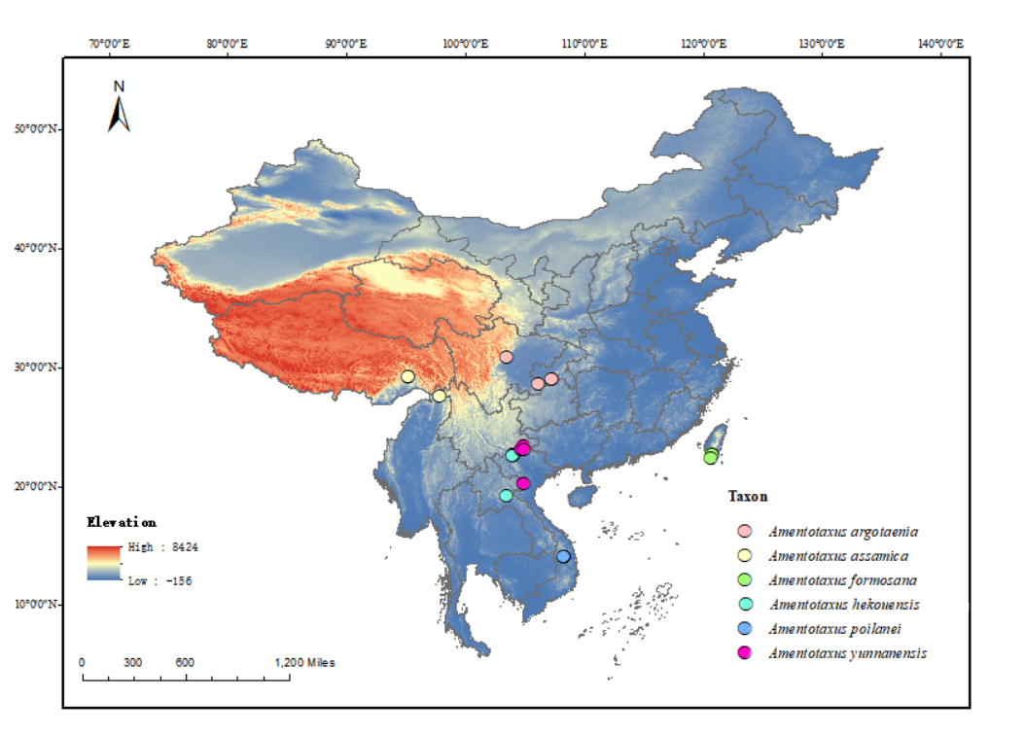

Figure S2 Sequence alignment of 23 Amentotaxus chloroplast genomes using mVISTA program. The top line shows genes in order (transcriptional direction indicated with arrow). A cut-off of 70 % identity was used for the plots, and the Y-scale represents the percent identity between 50 and 100 %. Genome regions are color coded as exon, t/rRNA, and conserved non-coding sequences (CNS).

Figure S3 Maximum likelihood tree constructed based on ITS. Bootstrap support (BS) values are given for each taxon node, with “*” indicating BS = 100%.

Figure S4 Maximum likelihood tree constructed based on the combination of rbcL+matK+trnH-psbA. Bootstrap support (BS) values are given for each taxon node, with “*” indicating BS = 100%.

Figure S5 Maximum likelihood tree constructed based on the combination of rbcL+matK+trnH-psbA+ITS. Bootstrap support (BS) values are given for each taxon node, with “*” indicating BS = 100%.

Figure S6 Maximum likelihood tree constructed based on the next generation barcode (plastome + nrDNA). Bootstrap support (BS) values are given for each taxon node, with “*” indicating BS = 100%.

Figure S7 Maximum likelihood tree constructed based on the plastid clpP-rps12 region. Bootstrap support (BS) values are given for each taxon node, with “*” indicating BS = 100%.

Figure S8 Photograph of type specimen of Amentotaxus poilanei (left) and A. hekouensis (right), respectively.
