Supplementary
Table S1. Lignocellulose composition (cellulose, hemicellulose, and lignin) in the experimental diet on a dry-weight basis.
Lignocellulose | Content (g/kg)
Cellulose | 130 ± 3
Hemicellulose | 191 ± 6
Lignin | 56.7 ± 2.6
Total | 378 ± 7

Table S2. Target genes and primer sequences used for quantitative real-time PCR (qPCR) analysis.
Gene ID | Primer name | Sequence (5′–3′)
LOC119653270 | cecropin1-F | GCTTTGCTTGTCATTGCTGGA
LOC119653270 | cecropin1-R | AGCTCCTTTTTCGATTCCGCT
LOC119657650 | cecropin2-F | AAGCCCGGTGGTACAAAAAGA
LOC119657650 | cecropin2-R | GCATGTCTTTGCTGTTGTGC
LOC119661210 | cecropin3-F | AAGCCCGGTGGTACAAAAAGA
LOC119661210 | cecropin3-R | GCATGTCTTTGCTGTTGTGC
LOC119653991 | defensin1-F | ATGGTCTCGATCAGGCAGTG
LOC119653991 | defensin1-R | CGTTTCGCACGGTAATGCTG
LOC119654016 | defensin2-F | ATGGTCTCGATCAGGCAGTG
LOC119654016 | defensin2-R | CGTTTCGCACGGTAATGCTG
LOC119648896 | LC-F | TCCTGCCTTTGATGGAAGTGAT
LOC119648896 | LC-R | CACCAGTTATTGTCACCGCC
LOC119656959 | LE-F | CGTTGGCGCACACACTTAC
LOC119656959 | LE-R | AACTCGACACCTCTTTTTATGAGT
LOC119649357 | LA-F | AAAAGCCCTGGGGCAAACAT
LOC119649357 | LA-R | TTCCAACCTCTTCTCCGCAC
LOC119659319 | LB1-F | TGCCAAGAACTTCATTGCCTC
LOC119659319 | LB1-R | GGTTAGCAGTGTAACGAGCC
LOC119659450 | LB2-F | TTCCCCAAACTTTCGCTGCC
LOC119659450 | LB2-R | CCAGGTGATACGGAGTGATGG
LOC119660570 | LB3-F | AACTAGCAGTTGTCCTTGTCCT
LOC119660570 | LB3-R | GAGACGAAGTTTGGTGCCCG
LOC119660572/  LOC119660573/  LOC119660576 | LB4-F | TTTCAGGACTGCCTTGCCAC
LOC119660572/  LOC119660573/  LOC119660576 | LB4-R | CCAGGGCATTCAGTAGCGTA
LOC119655118 | Galnt1-F | TCTAGCGAAGCAACGACCTG
LOC119655118 | Galnt1-R | CGTCTGCAACTTGGCTTCAC
LOC119648187 | Galnt2-F | TAAACCGCACACCACCTGAA
LOC119648187 | Galnt2-R | AGGCCTGATCTCTCGGGTAA
LOC119656721 | Galnt3-F | ATGGCATGAACATCGCTTGC
LOC119656721 | Galnt3-R | TCCCAGTGTTGGCACTCTTC
LOC119653512 | Galnt4-F | CGGACGGGAGTGAATGTTCT
LOC119653512 | Galnt4-R | CTCGCCGATTCGCTGATAGT
LOC119658335 | Galnt5-F | TCTTGAAGCGAACGCCTCTT
LOC119658335 | Glant5-R | ATAAGTCCTTCGCGCCTCTG
LOC119650994 | C1GALT1-1-F | TGGCTTTTGTATGGCCGAGT
LOC119650994 | C1GALT1-1-R | TCAACCAGCGCACGACTATT
LOC119651883 | C1GALT1-2-F | ACCCCAGCTCCAGTAGTCAA
LOC119651883 | C1GALT1-2-R | CGTTTCCTTGACGGCCTTTG
LOC119647883 | GlcAT-P-F | GGCGGACGTAAATATCCCGT
LOC119647883 | GlcAT-P-R | GAAGCCATCCTCCTCGTAGC
LOC119656872 | STT3A-F | TGTTGCGGTTCGAGAGTGTT
LOC119656872 | STT3A-R | GGTAGATTGTGCCGCCGATA
LOC119650710 | STT3B-F | TATCATGGGACGCTACACGC
LOC119650710 | STT3B-R | ACGGCCATAAGGAGTGCAAA
LOC119654286 | MOGS-F | GCGGTGAAAACCCCAAGAAG
LOC119654286 | MOGS-R | CCATCCTCCACTGCGTCATT
LOC119656786 | GANAB-F | GCGAGAGTCGGGCTATTTCT
LOC119656786 | GANAB-R | TTTCCGCGCTTCAGGATTGA
LOC119651345 | MAN1B-F | CGACAACAATGCCCCCAAAG
LOC119651345 | MAN1B-R | CACGAATGACGGAACGCATC
LOC119656554 | MAN1A-F | TCCCCTTGACGAGTGGGTAT
LOC119656554 | MAN1A-R | AGGTAGCGATGAAGGCACAG
LOC119651272 | MAN2A-F | GGGAGTCGCAACGGAAAAAC
LOC119651272 | MAN2A-R | CGCTCAAAGACGGGAACTCT
LOC119658825 | MAN2B-F | GCAATGGTTCGCTCGTCATC
LOC119658825 | MAN2B-R | ATGGATGGGCTTTGTTGCCT
LOC119651345 | MGAT1-F | TTACCTTTGAGGAGCTGCGG
LOC119651345 | MGAT1-R | GCCGGTTCTAGGTACACCAC
LOC119654267 | FUT8-F | ACGACGTGTCTTTCTGGCAT
LOC119654267 | FUT8-R | GTTGAAACAGCCGCCATACG
LOC119648244 | FUT11-F | ATGAGTTCGCCTCACCCAAG
LOC119648244 | FUT11-R | CACACGCGGCACCAAAAATA
LOC119648203 | FDL-F | ACGCCAAAGTCCGTGGTATT
LOC119648203 | FDL-R | CGCCTAGACCTCGTTTTGGT
 | TBP-F | ACTCCCTTACATCAGCCTGA
 | TBP-R | TGCCCAGCCATTTGGTTCAT
 | RP49-F | CCCACTGGCTTCAAGAAGTT
 | RP49-R | CGAAACTCCATGTGCGATCT

Table S3. Quality and taxonomic summary of MAGs reconstructed from BSFL gut metagenomes.
MAG Id | Taxonomy | Genome size (bp) | N50 (bp) | Completeness (%) | Contamination(%)
MAG3 | Klebsiella grimontii | 5633724 | 232358 | 94.1 | 0.58
MAG8 | Caproicibacterium amylolyticum | 1368294 | 1717 | 55.08 | 0.08
MAG9 | unclassified_f_Vagococcaceae | 2815131 | 94081 | 96.13 | 1.52
MAG6 | Anaerocolumna jejuensis | 2802275 | 1653 | 52.19 | 2.01
MAG11 | Novisyntrophococcus sp. | 3357936 | 14461 | 94.46 | 0
MAG7 | Weissella paramesenteroides | 1852361 | 268188 | 99.39 | 0
MAG2 | Caproiciproducens sp. | 2250808 | 48125 | 96.64 | 0
MAG16 | Klebsiella variicola | 4264372 | 2604 | 81.15 | 7.93
MAG1 | Novisyntrophococcus sp. | 3334296 | 7110 | 95.46 | 2.43
MAG19 | Morganella morganii_B | 3977751 | 152754 | 99.46 | 0.27
MAG5 | Pediococcus pentosaceus | 1739401 | 376558 | 99.38 | 0
MAG10 | Companilactobacillus sp. | 1385408 | 92105 | 65.52 | 0
MAG18 | Anaerocolumna jejuensis | 5696004 | 9114 | 95.02 | 5.7
MAG17 | Lacrimispora xylanolytica_C | 5260346 | 176849 | 99.37 | 0.63
MAG20 | Caproicibacterium amylolyticum | 2124287 | 9613 | 88.14 | 1.4
MAG14 | unclassified_f_Vagococcaceae | 1601907 | 32191 | 53.2 | 2.76
MAG15 | Nitriliruptor sp. | 1786033 | 1716 | 52.52 | 0.66
MAG4 | Enterococcus casseliflavus | 2259060 | 3367 | 70.05 | 1.37
MAG12 | Novisyntrophococcus sp. | 1666630 | 3462 | 50.88 | 4.65
MAG13 | Enterococcus gallinarum | 2973794 | 75076 | 97.44 | 1.48
MAG21 | Enterococcus gallinarum | 2125277 | 2969 | 72.75 | 1.84
MAG22 | Novisyntrophococcus sp. | 2821236 | 5188 | 67.44 | 1.9

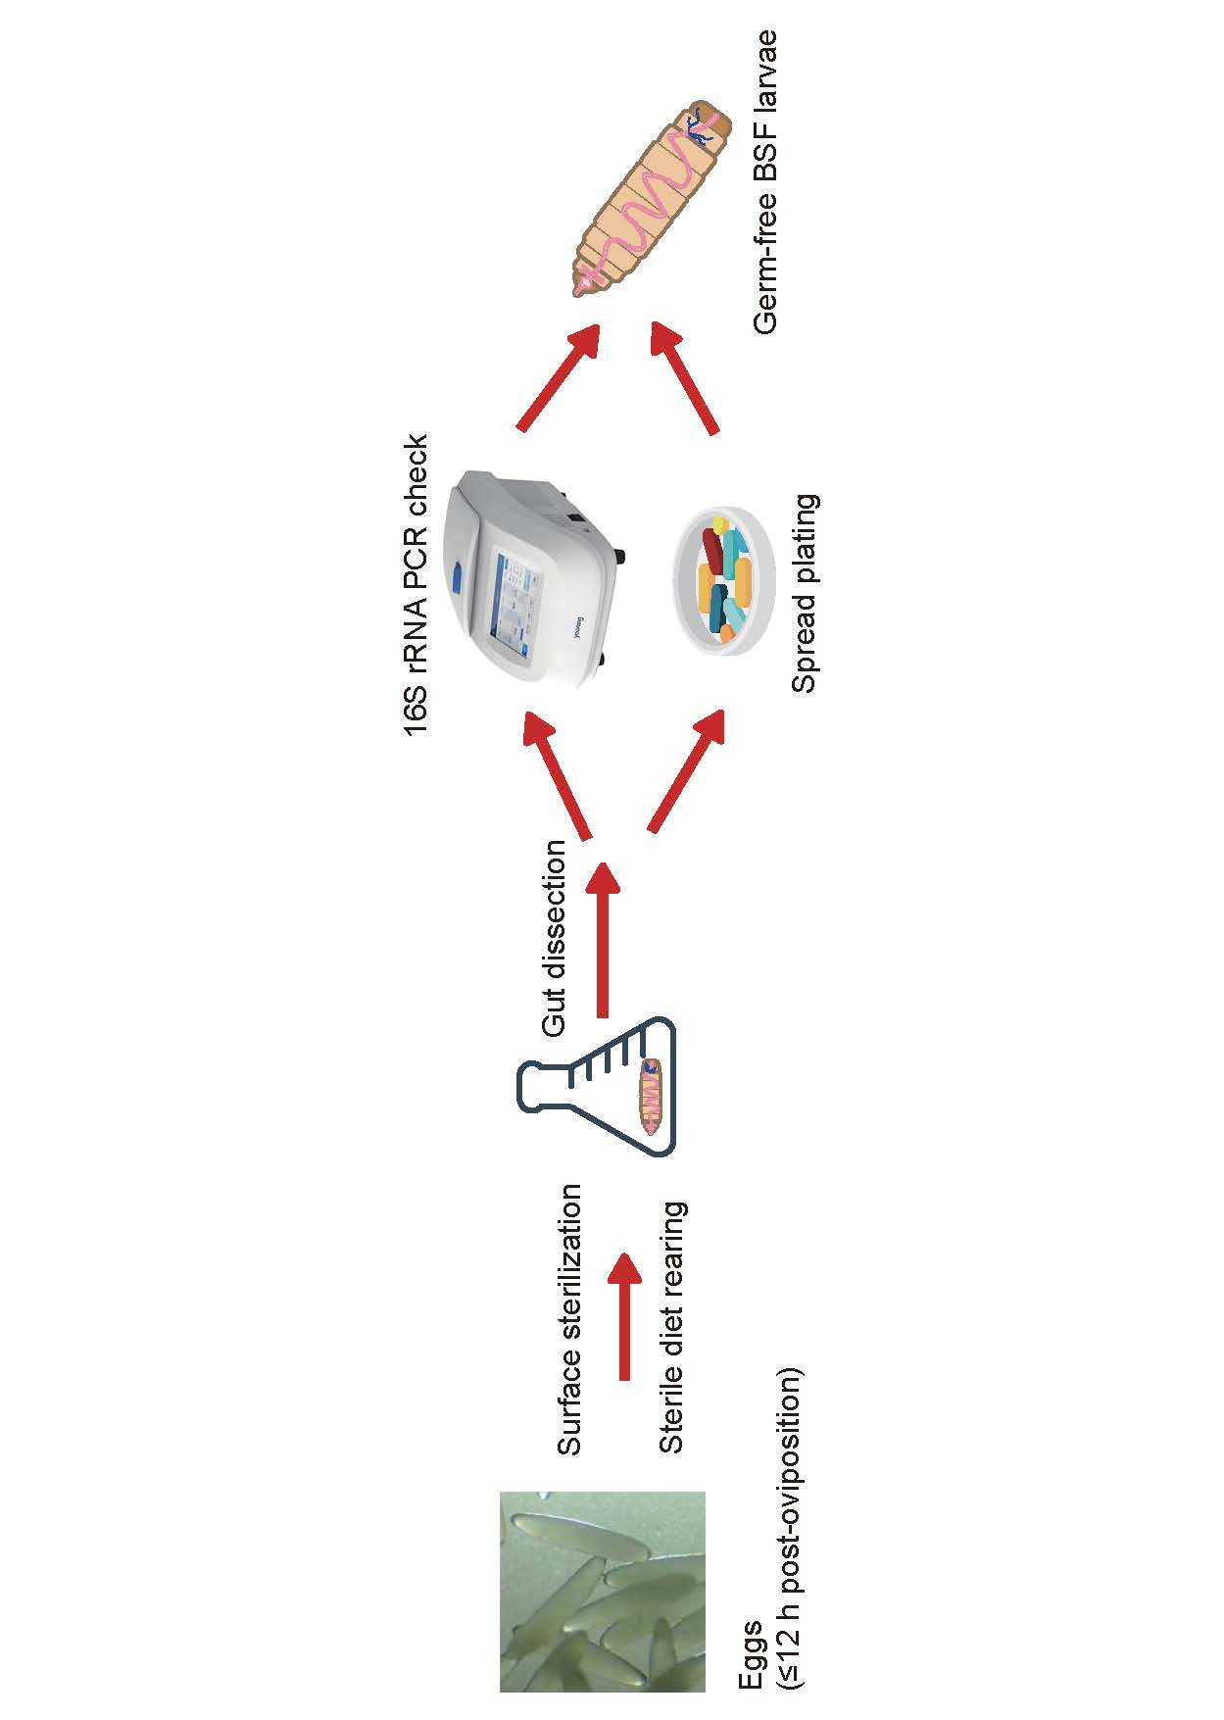
Figure S1. Workflow for the construction and verification of germ-free black soldier fly larvae.
Freshly laid eggs (≤12 h post-oviposition) were surface-sterilized and reared on a sterile diet under aseptic conditions. After hatching, gut dissection was performed, and sterility was verified by 16S rRNA PCR amplification and LB agar spread plating. Larvae showing no detectable bacterial growth or amplification were designated as germ-free and used for subsequent experiments.

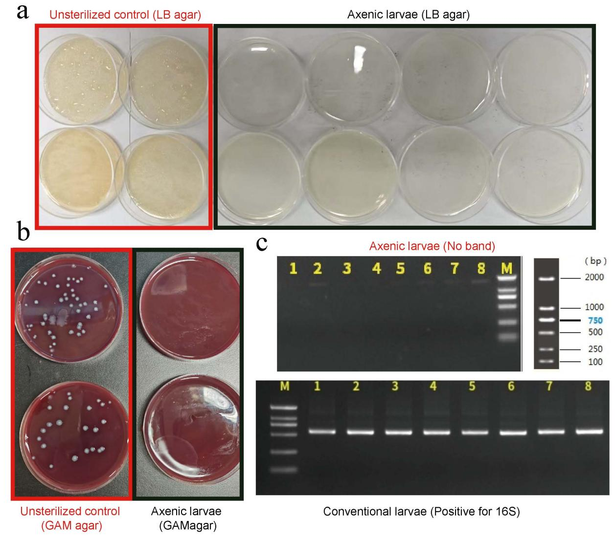
Figure S2. Verification of axenic black soldier fly larvae (BSFL).
(a) Microbial growth on LB agar from homogenates of newly hatched larvae. The left four plates represent homogenates of conventional larvae, and the right eight plates represent homogenates of axenic larvae (one larva per plate). No microbial colonies were observed in axenic larvae after 48 h incubation at 30 °C.(b) Bacterial growth on GAM blood agar from representative larval homogenates: left, conventional larvae; right, axenic larvae (one larva per plate). (c) PCR detection of the bacterial 16S rRNA gene (primers 27F/534R). Lanes 1–8: individual larvae; M: DNA marker. Upper panel, axenic larvae (no amplification); lower panel, conventional larvae (positive bands).

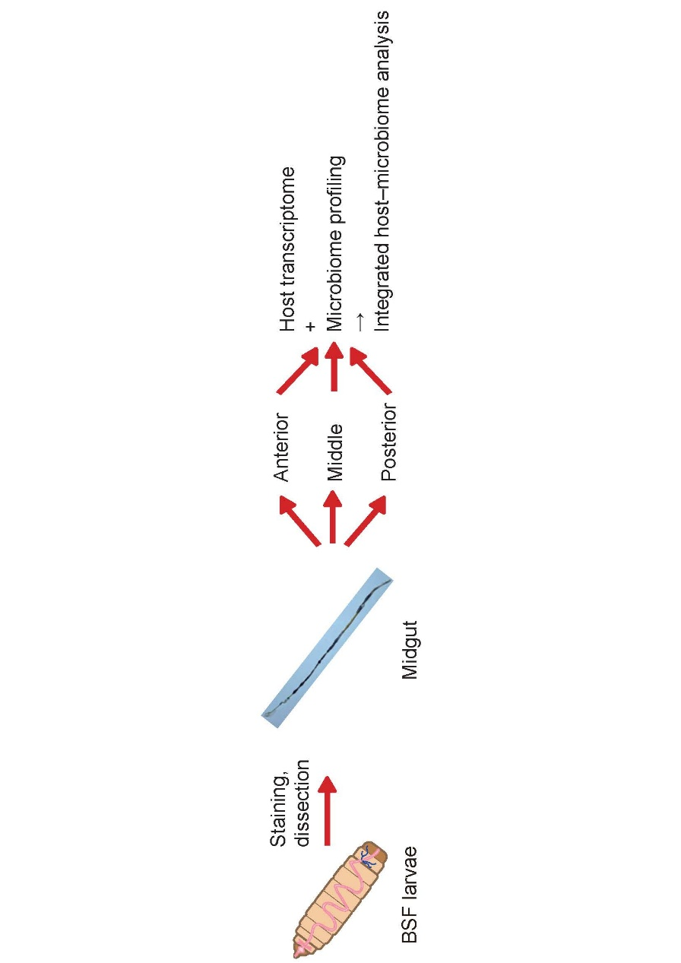
Figure S3. Schematic overview of midgut segmentation and integrated host–microbiome analysis in black soldier fly larvae.
Black soldier fly larvae (BSFL) were stained and dissected to isolate the midgut, which was then divided into anterior, middle, and posterior regions. Each gut segment was subjected to host transcriptome analysis and microbiome profiling. The resulting datasets were integrated for combined host–microbiome analysis.

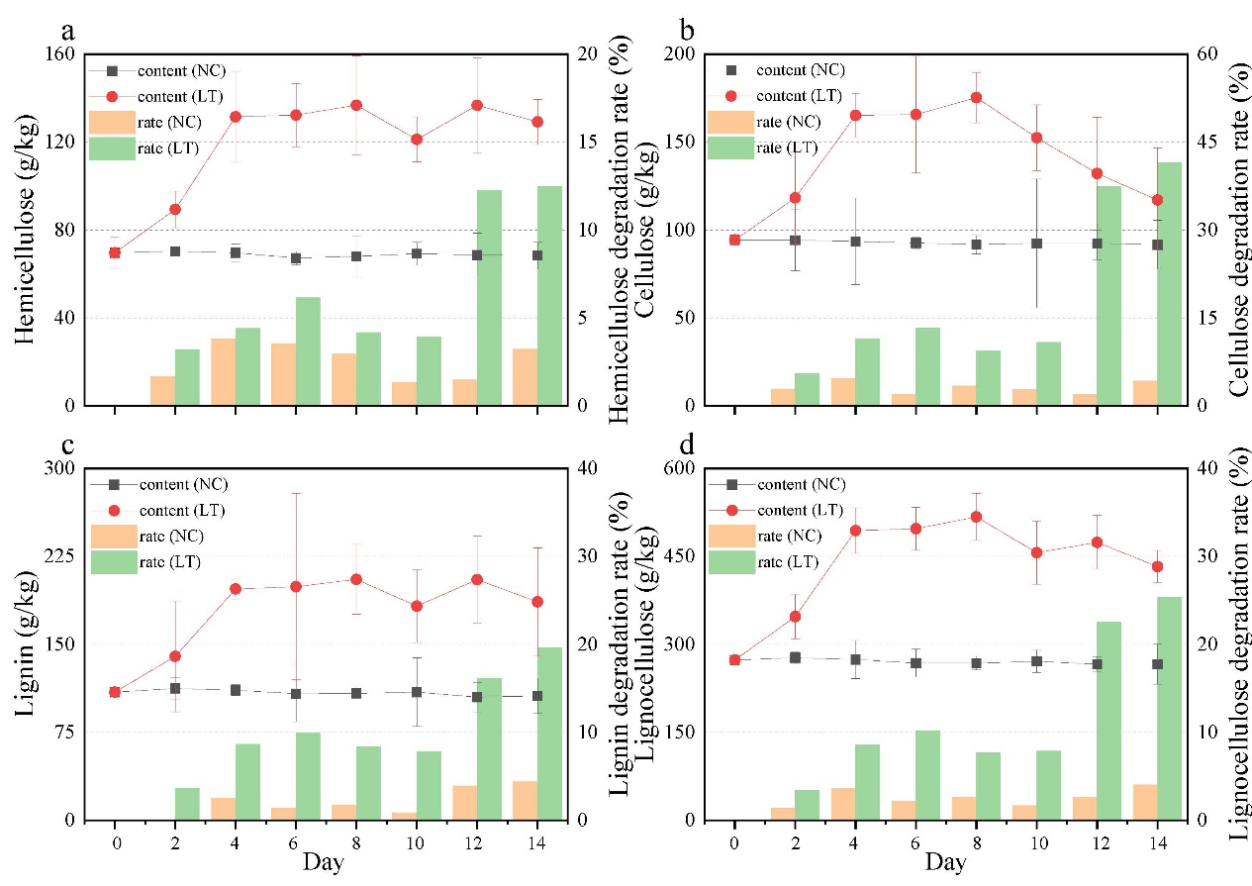
Figure S4. Lignocellulose composition and degradation rates during BSFL bioconversion. (a) Hemicellulose content and degradation rate over time in NC and LT groups. (b) Cellulose content and degradation rate. (c) Lignin content and degradation rate. (d) Total lignocellulose content and cumulative degradation rate. Error bars indicate standard deviations across replicates. LT: larvae treatment; NC: natural compost. The data used in Fig. S2 were previously published in our earlier study [39]. The data are reused here under permission from Elsevier.

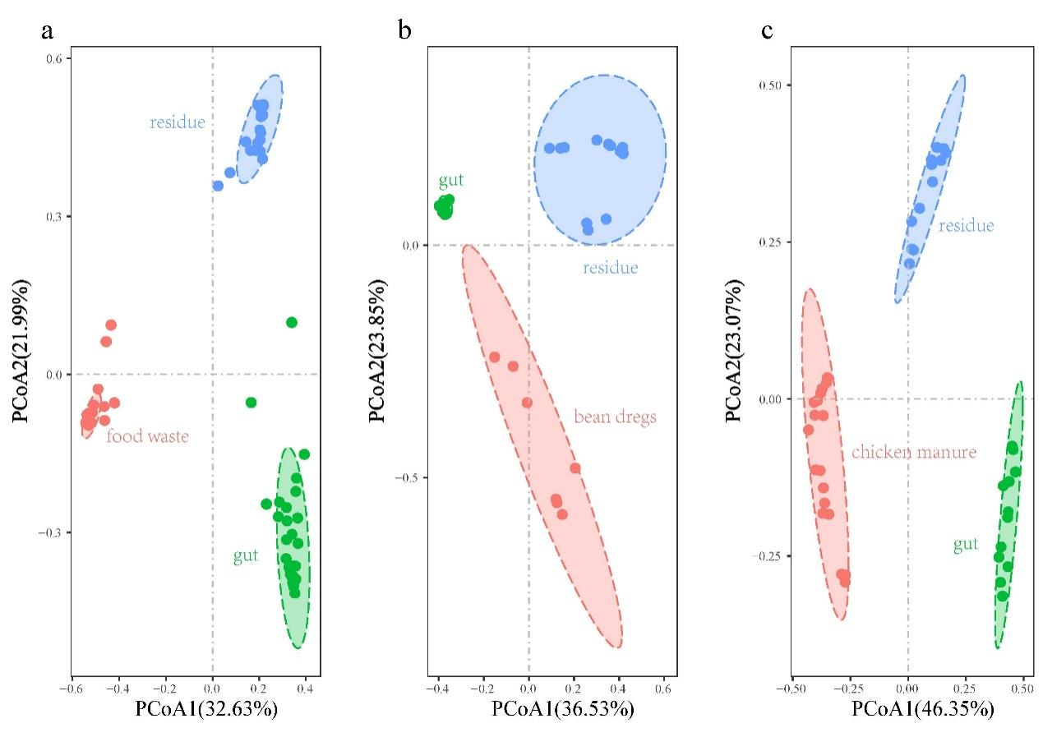
Figure S5. PCoA showing microbial community dissimilarities between larval gut and substrate samples. Principal coordinates analysis (PCoA) plots based on Bray–Curtis distances comparing gut, substrate, and residue microbial communities from three bioconversion groups: (a) food waste, (b) bean dregs, and (c) chicken manure.

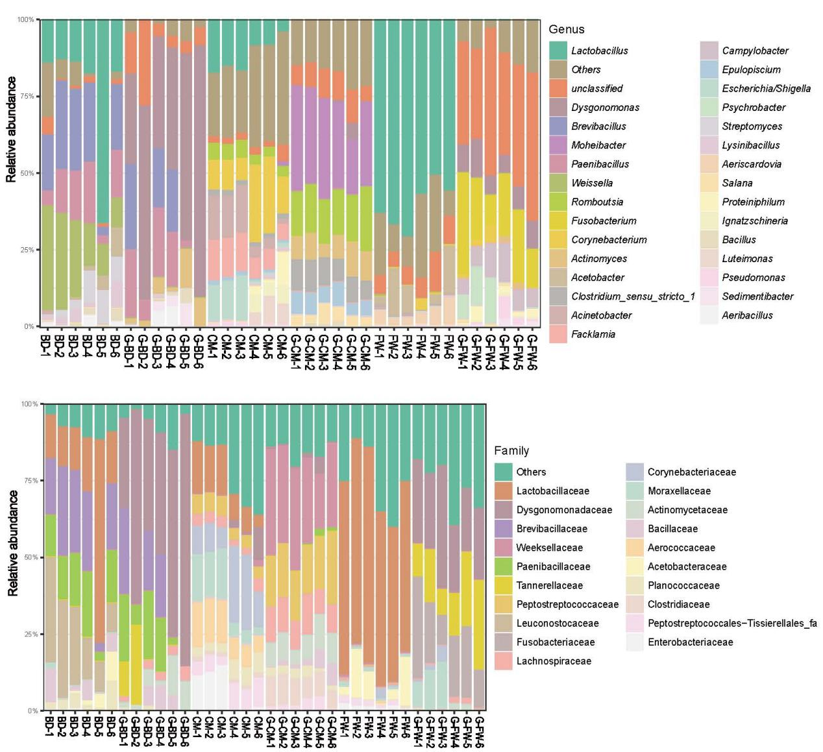
Figure S6. Genus- (top) and family-level (bottom) community compositions of gut and substrate microbiota across diets. (a) Stacked bar plots showing the relative abundance of dominant bacterial phyla in gut (G) and residue (R) samples across three substrate types: bean dregs (BD), food waste (FW), and chicken manure (CM). (b) Boxplots comparing the relative abundance of Firmicutes, Bacteroidetes, Actinobacteria, and Proteobacteria between gut and residue samples. Asterisks indicate significance levels (***p < 0.001; n.s., not significant).

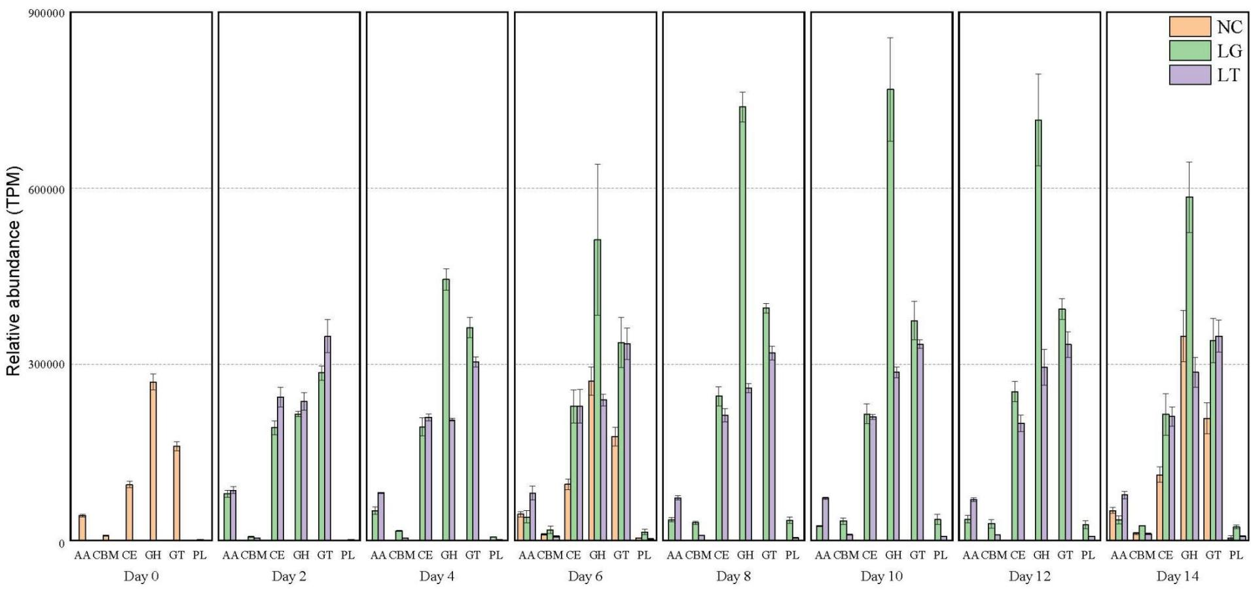
Figure S7. Temporal dynamics of CAZy classes during BSFL bioconversion. Relative abundance (TPM) of genes encoding six CAZy classes: auxiliary activities (AA), carbohydrate-binding modules (CBM), carbohydrate esterases (CE), glycoside hydrolases (GH), glycosyltransferases (GT), and polysaccharide lyases (PL), NC: natural composting, LT: larvae treatment, LG: larvae gut. The data used in Fig. S2 were previously published in our earlier study [39]. The data are reused here under permission from Elsevier.

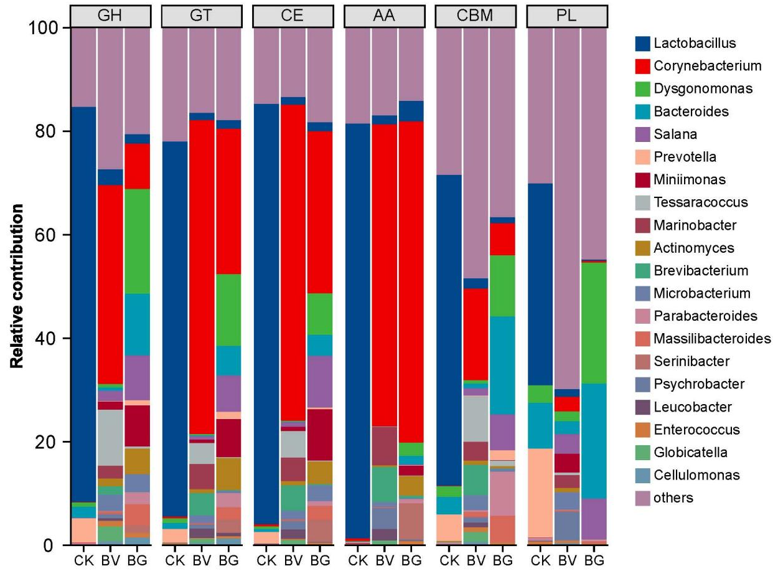
Figure S8. Taxonomic contributions to CAZyme families. Relative abundance of dominant bacterial genera encoding GH, GT, CE, AA, CBM, and PL enzymes in the BSFL gut and substrate microbiomes. GH and AA families were mainly contributed by Dysgonomonas, Corynebacterium, Lactobacillus, and Enterococcus.

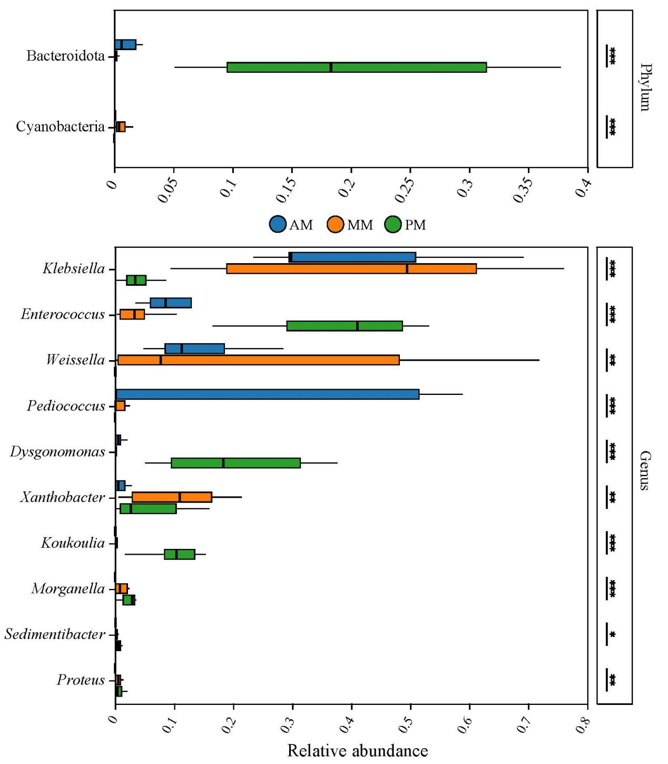
Figure S9. Differential enrichment of microbial taxa across BSFL midgut compartments. Boxplots showing the relative abundances of significantly different bacterial taxa at the phylum (top) and genus (bottom) levels among the anterior (AM), middle (MM), and posterior (PM) midgut regions of black soldier fly larvae. Statistical significance was determined by Kruskal–Wallis tests (*p < 0.05, **p < 0.01, ***p < 0.001).

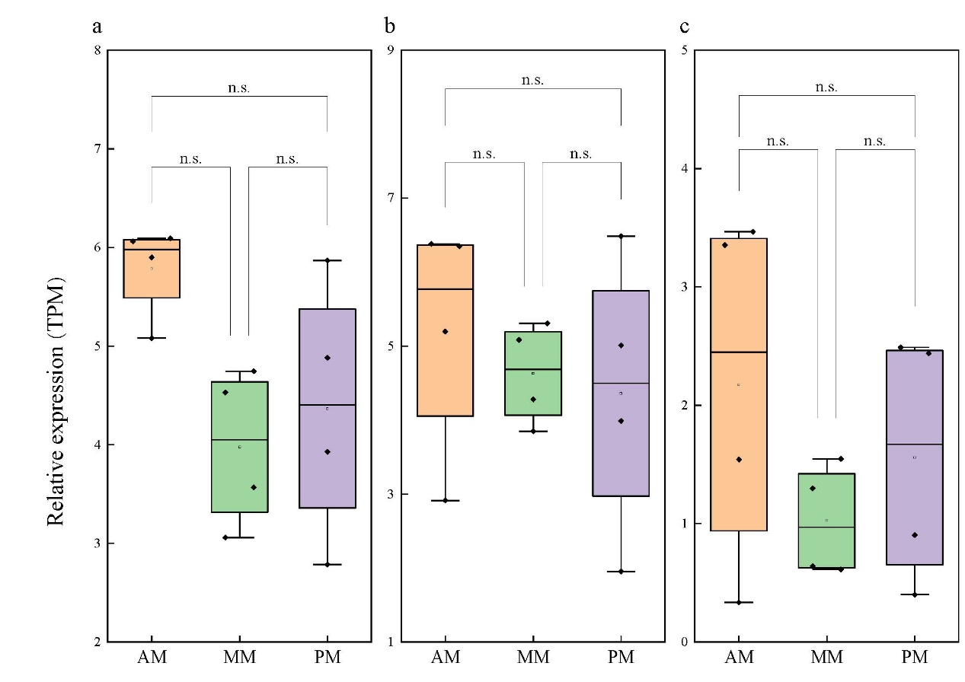
Figure S10. Spatial expression patterns of antimicrobial peptide (AMP) genes in sterile BSFL midgut. Boxplots showing the relative expression levels (TPM) of three representative AMP genes—(a) Cecropin, (b) Defensin-A, and (c) Defensin-B—across the anterior midgut (AM), middle midgut (MM), and posterior midgut (PM) of sterile black soldier fly larvae.

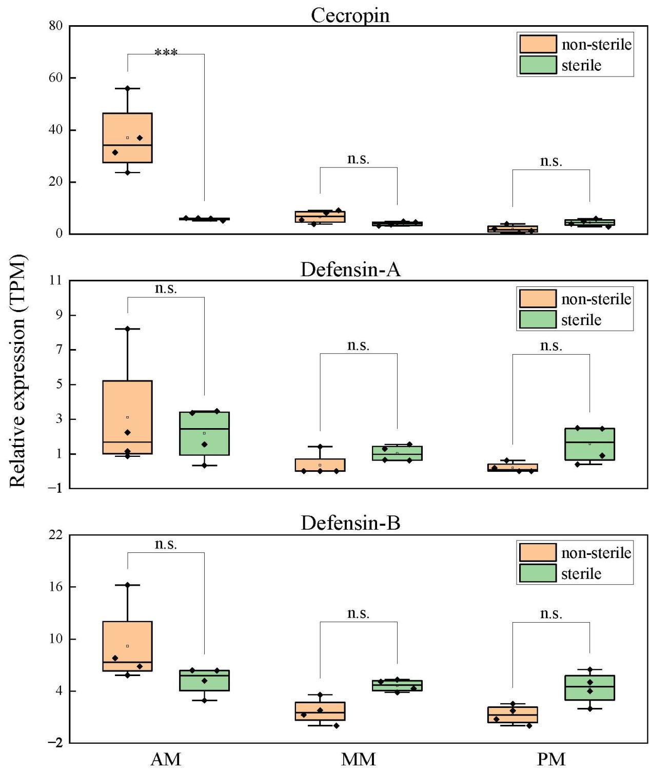
Figure S11. AMP gene expression in sterile and non-sterile BSFL midguts.
Relative expression levels (TPM) of (a) Cecropin, (b) Defensin-A, and (c) Defensin-B in anterior midgut (AM), middle midgut (MM), and posterior midgut (PM) of sterile and non-sterile black soldier fly larvae.

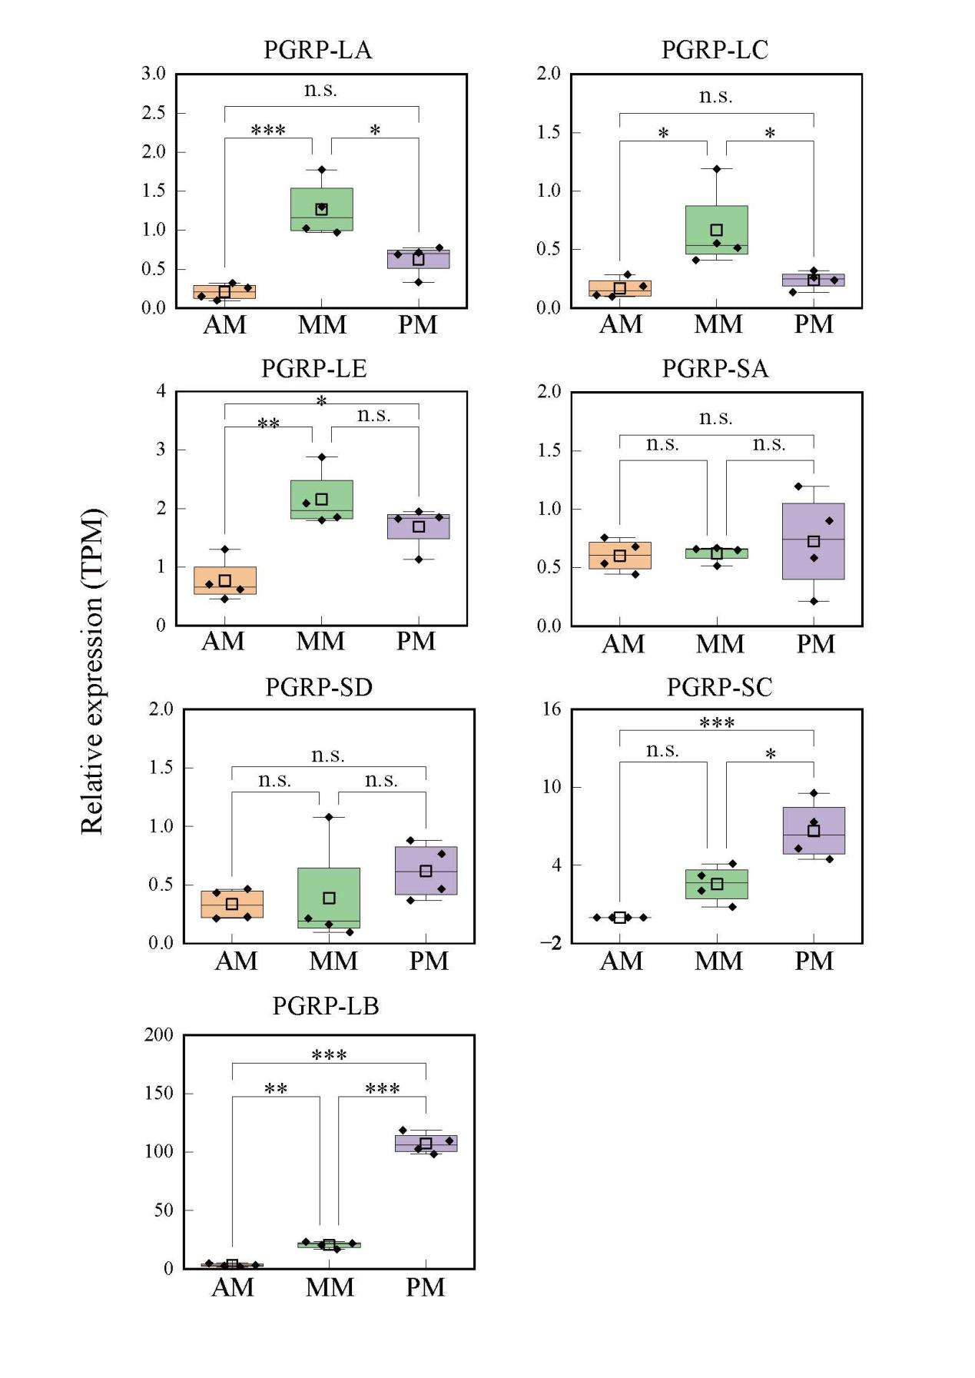
Figure S12. Region-specific expression of PGRP genes in sterile BSFL midgut.
Boxplots show the expression levels of various PGRP genes in the anterior (AM), middle (MM), and posterior midgut (PM) of sterile black soldier fly larvae. Statistical significance is indicated (*n.s., not significant; p < 0.05; *p < 0.01; *p < 0.001).

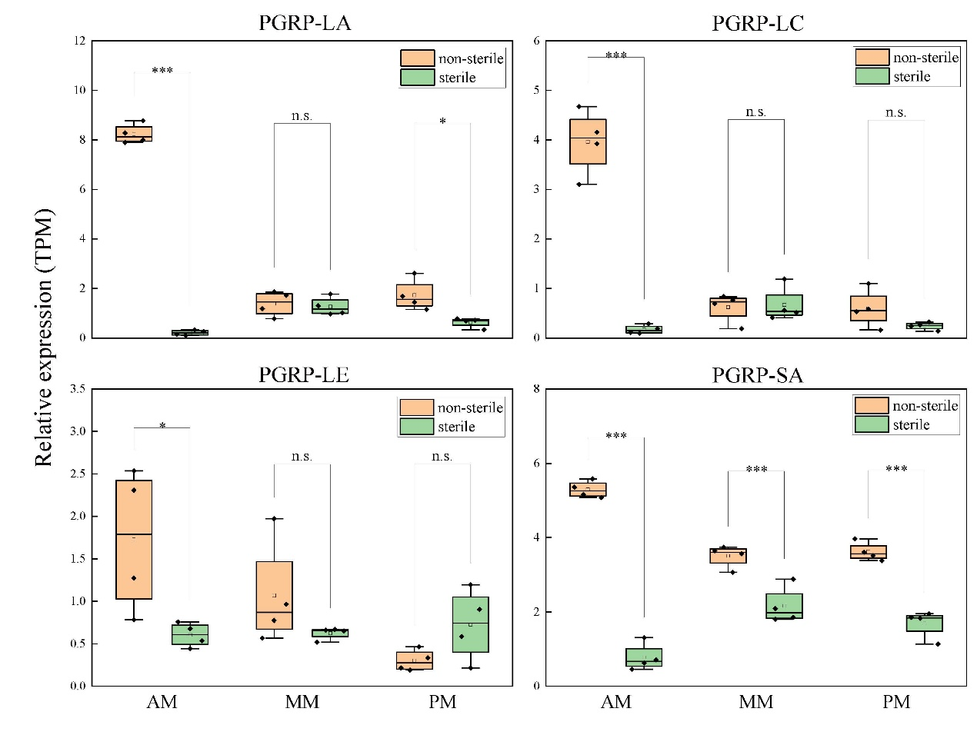
Figure S13. Expression of PGRP genes in sterile and non-sterile BSFL midgut.
Boxplots show the relative expression (TPM) of selected PGRP genes in the anterior (AM), middle (MM), and posterior (PM) midgut of sterile and non-sterile black soldier fly larvae. Statistical significance is indicated (*n.s., not significant; p < 0.05; *p < 0.01; *p < 0.001).

