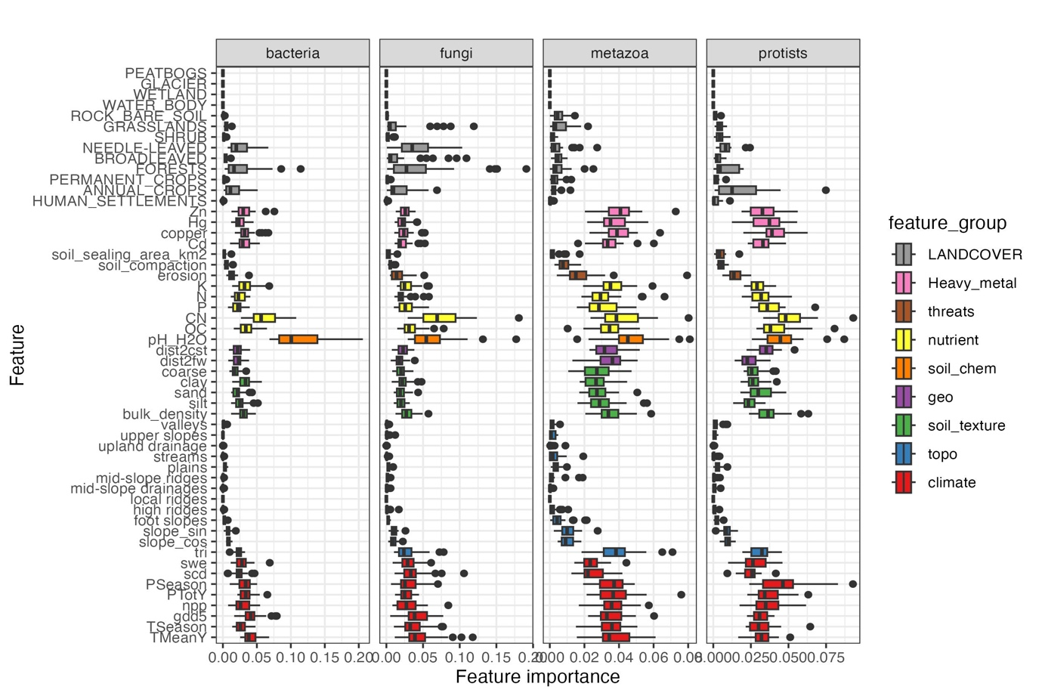
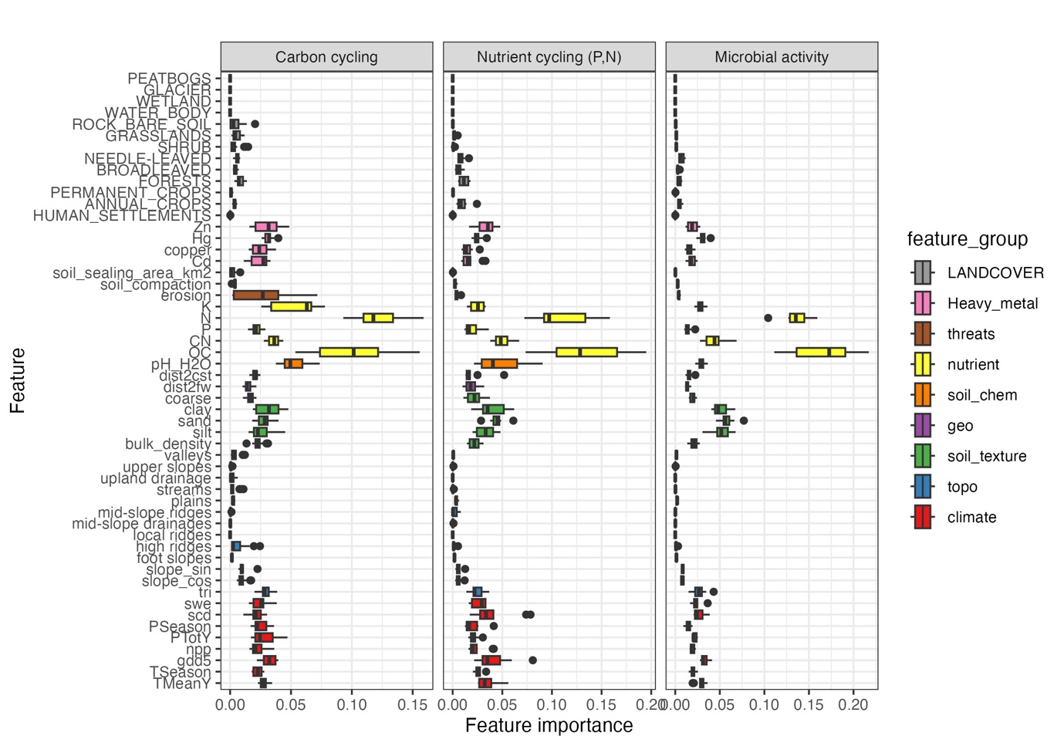
Supplementary Figure 1. Relative importance across biotic indicators related to biodiversity (upper panel) and ecosystem functions (lower panel). Variability across biotic indicators is summarised in one figure for each biotic indicator category (kingdoms and groups of functions). The complete names of the predictors and their description are in Supplementary Table 1.
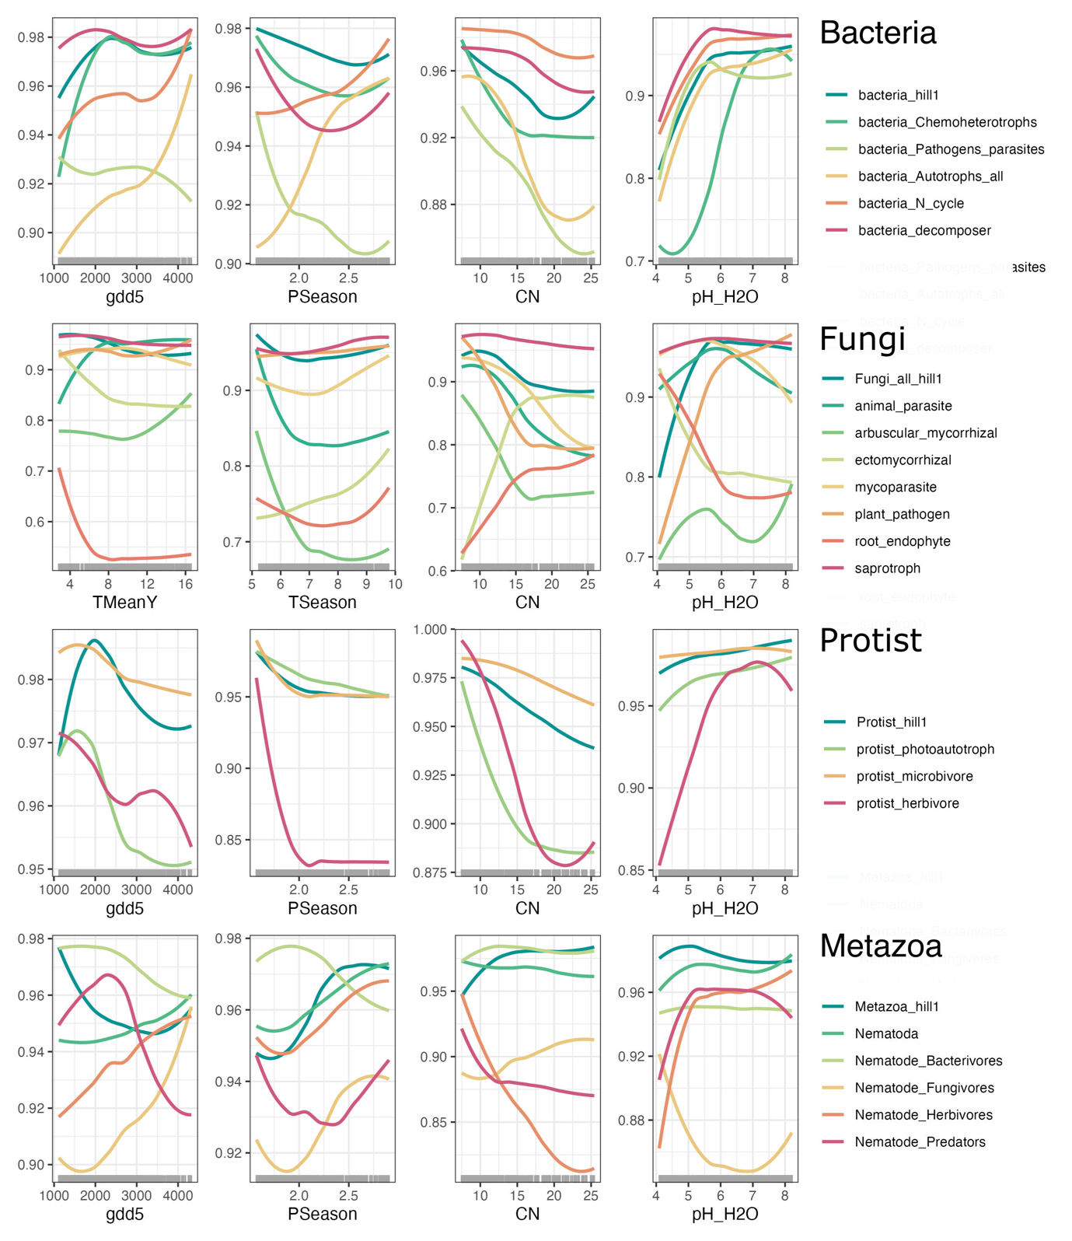

Supplementary Figure 2. Partial dependence plots showing the partial response of the biotic indicators related to biodiversity to different climatic and soil physico-chemical predictors based on the random forest models. The y axis corresponds to the relative diversity obtained by dividing the predicted diversity by the maximum predicted for each feature. The curves were drown as an average across the prediction of the different folds. Abbreviations -ggd5: Growing Degree Days heat sum above 5°C; PSeason: Precipitation seasonality; CN: soil C/N; ph_H2O: soil water pH.

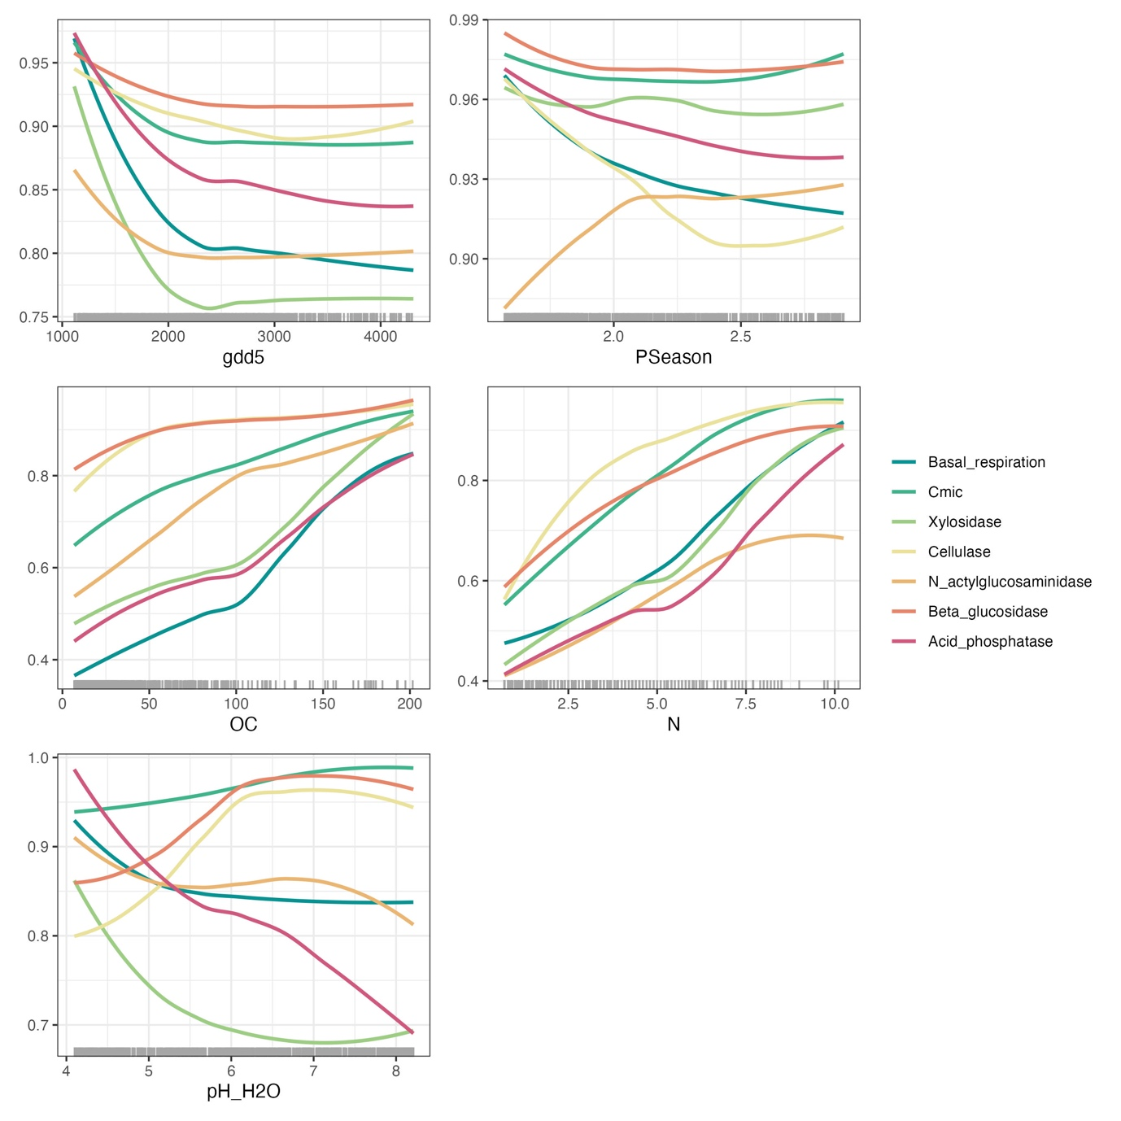

Supplementary Figure 3. Partial dependence plots showing the partial response of the biotic indicators related to ecosystem functions to different climatic and soil physico-chemical predictors based on the random forest models. The y axis corresponds to the relative value obtained by dividing the predicted value by the maximum predicted for each feature. The curves were drown as an average across the prediction of the different folds. Abbreviations -ggd5: Growing Degree Days heat sum above 5°C; PSeason: Precipitation seasonality; OC: soil organic carbon content; N: total soil nitrogen content; ph_H2O: soil water pH.

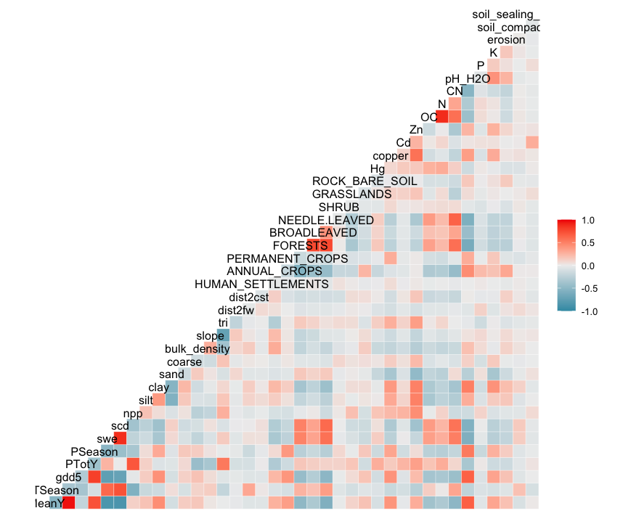
Supplementary Figure 4. Correlation plot between variables included as predictors of the biotic indicator’s values in the modelling framework.

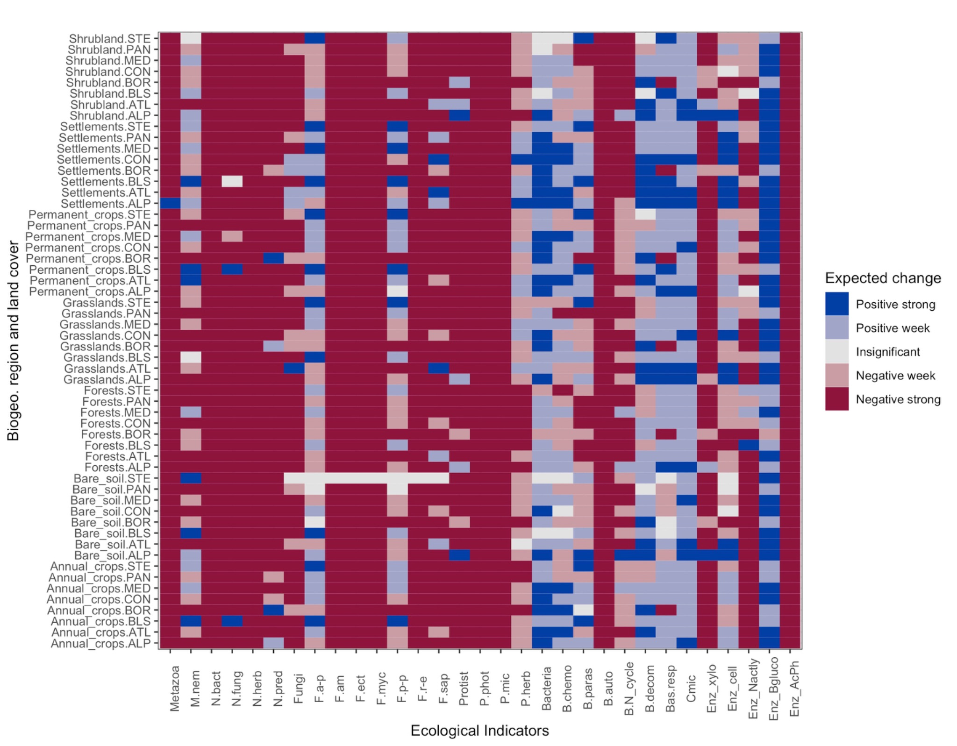
Supplementary Figure 5. Heatmap showing the estimated change on the value of each biotic indicator per land cover and biogeographical region when reducing the soil degradative processes to 0 or to the minimum. The heatmap reflects the differences between the current scenario and the reference scenario.

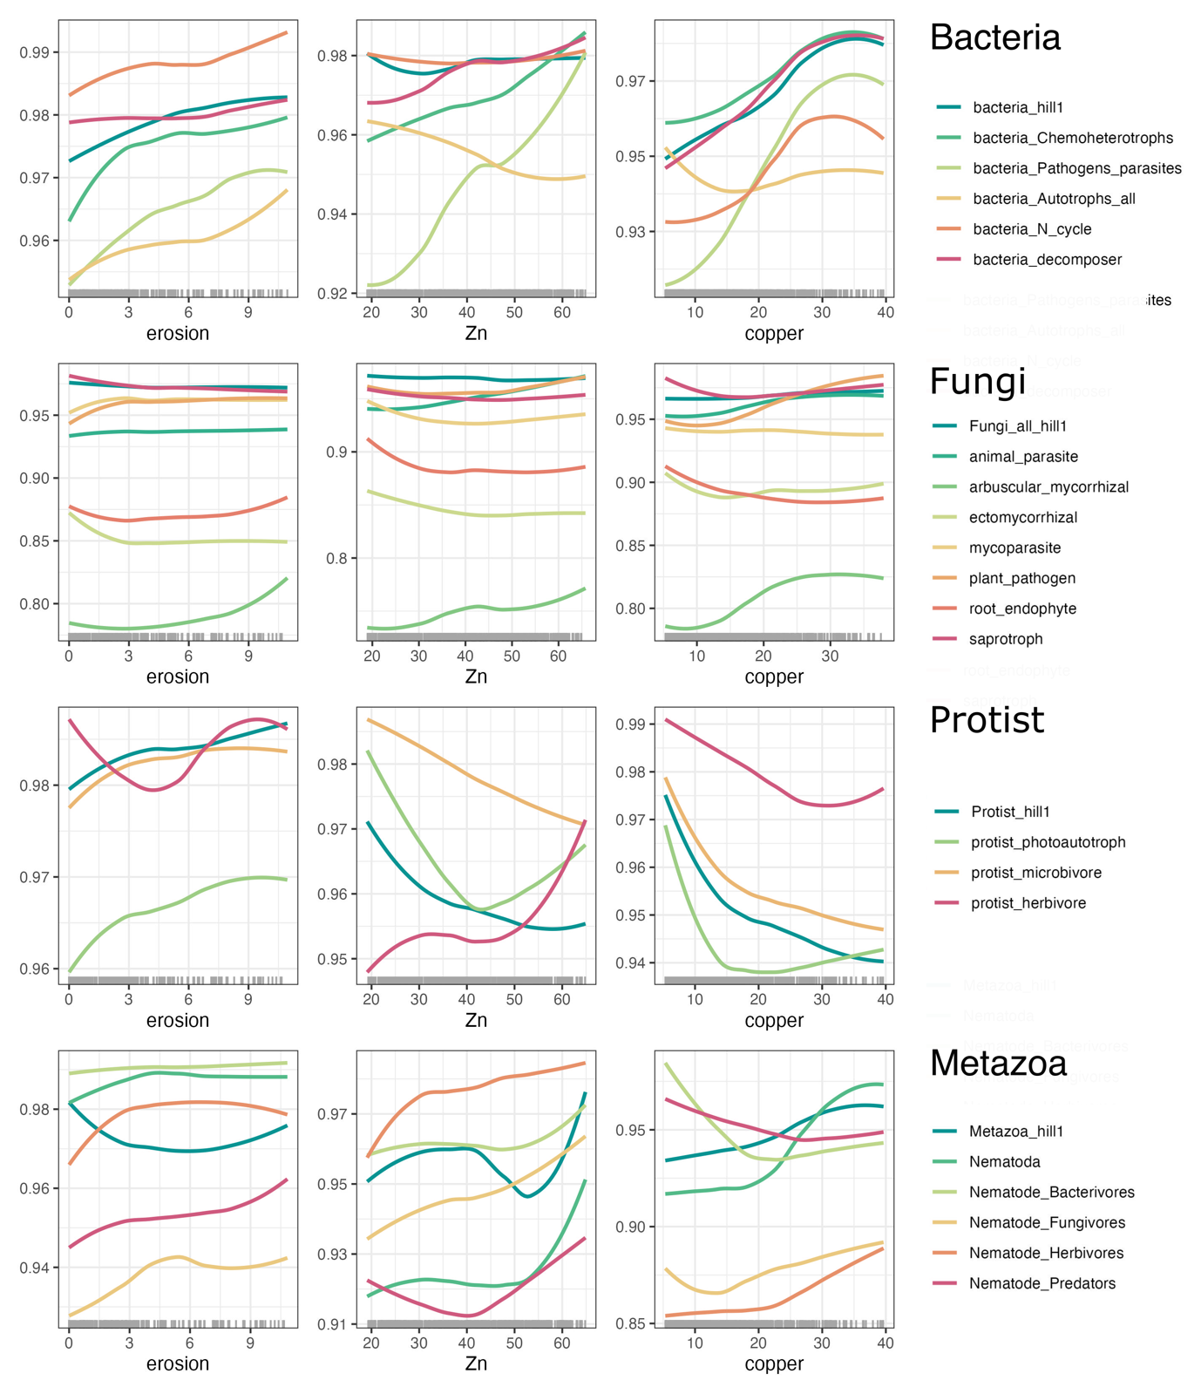
Supplementary Figure 6. Partial dependence plots showing the partial response of the biotic indicators related to biodiversity to erosion and heavy metals concentrations based on the random forest models. The y axis corresponds to the relative diversity obtained by dividing the predicted diversity by the maximum predicted for each feature. The curves were drown as an average across the prediction of the different folds.

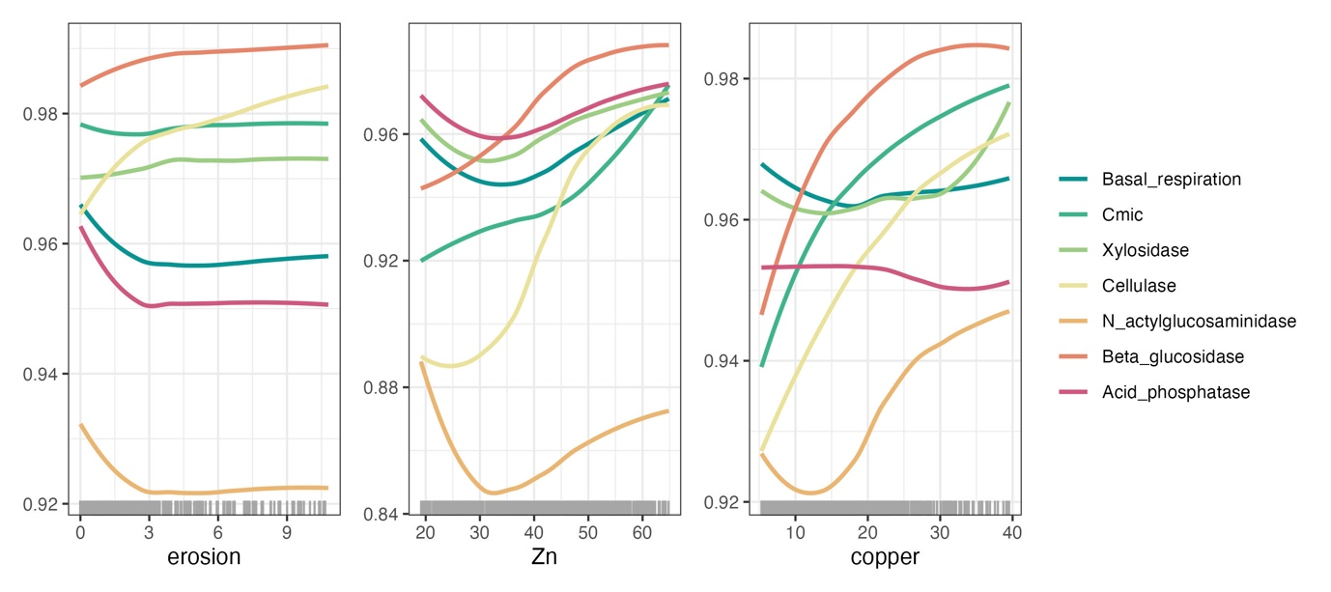
Supplementary Figure 7. Partial dependence plots showing the partial response of the biotic indicators related to ecosystem functions to erosion and heavy metals concentrations based on the random forest models. The y axis corresponds to the relative value obtained by dividing the predicted value by the maximum predicted for each feature. The curves were drown as an average across the prediction of the different folds.

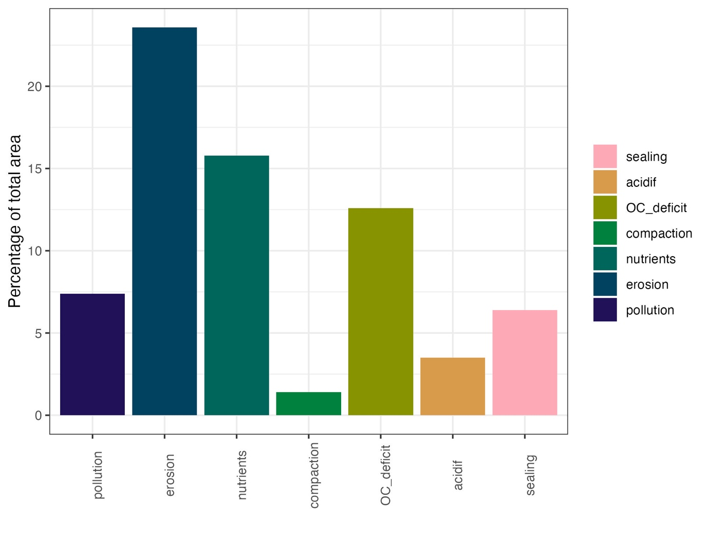
Supplementary Figure 8. Percentage of total area in Europe with soil degradative processes with at least one indicator above (or below) the critical threshold.

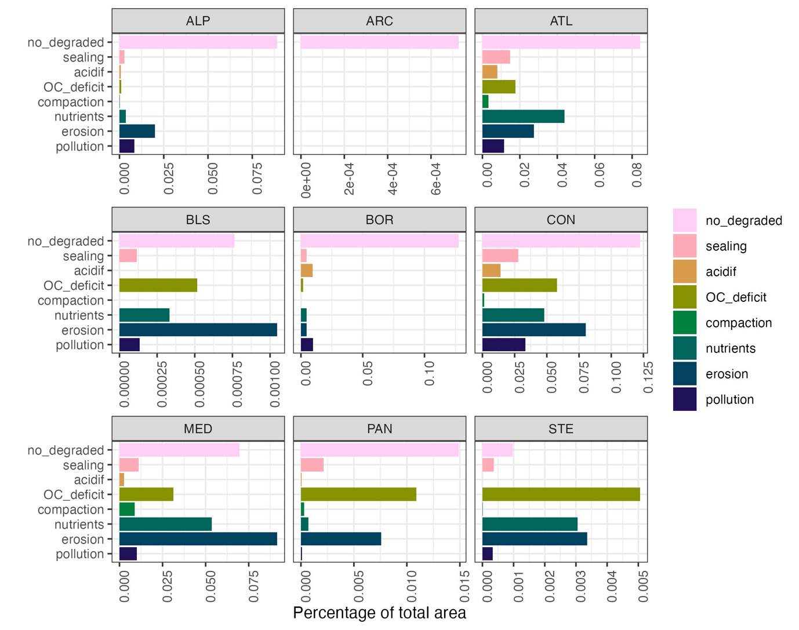

Supplementary Figure 9. Percentage of total area in Europe with soil degradative processes with at least one indicator above (or below) the critical threshold per biogeographical region.

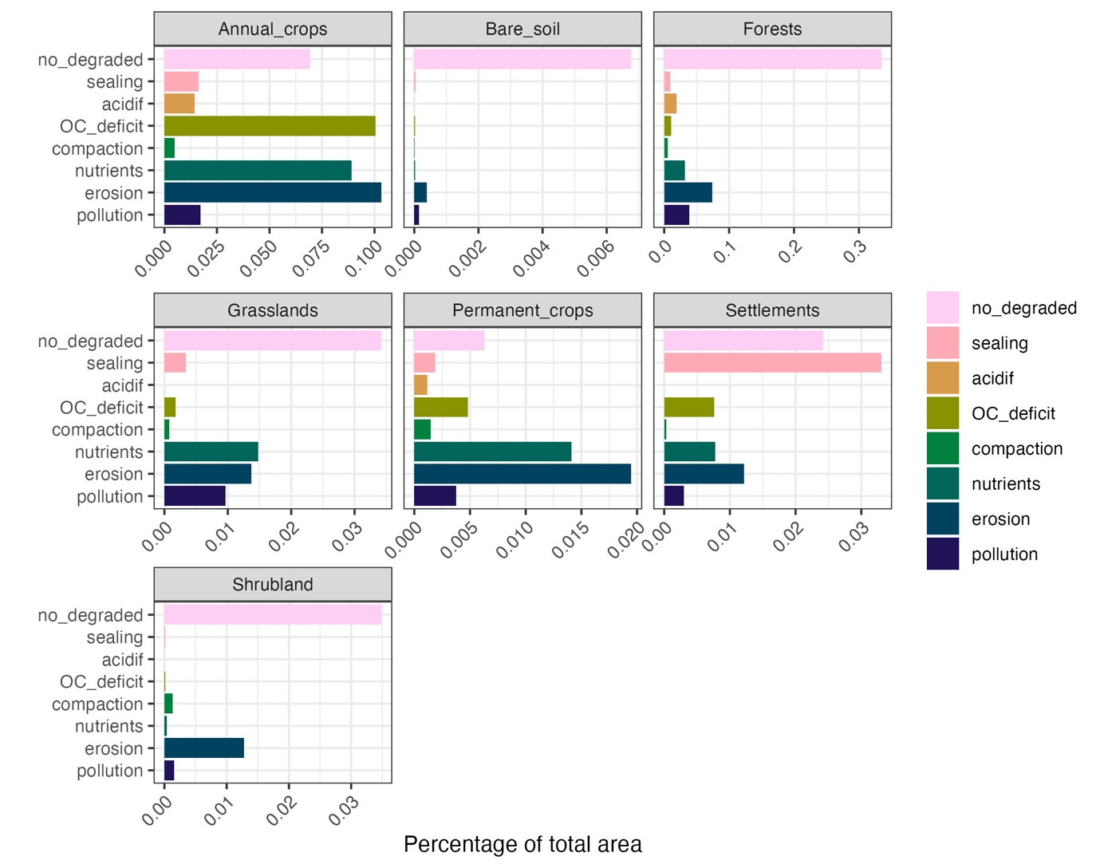
Supplementary Figure 10. Percentage of total area in Europe with soil degradative processes with at least one indicator above (or below) the critical threshold per land cover type.

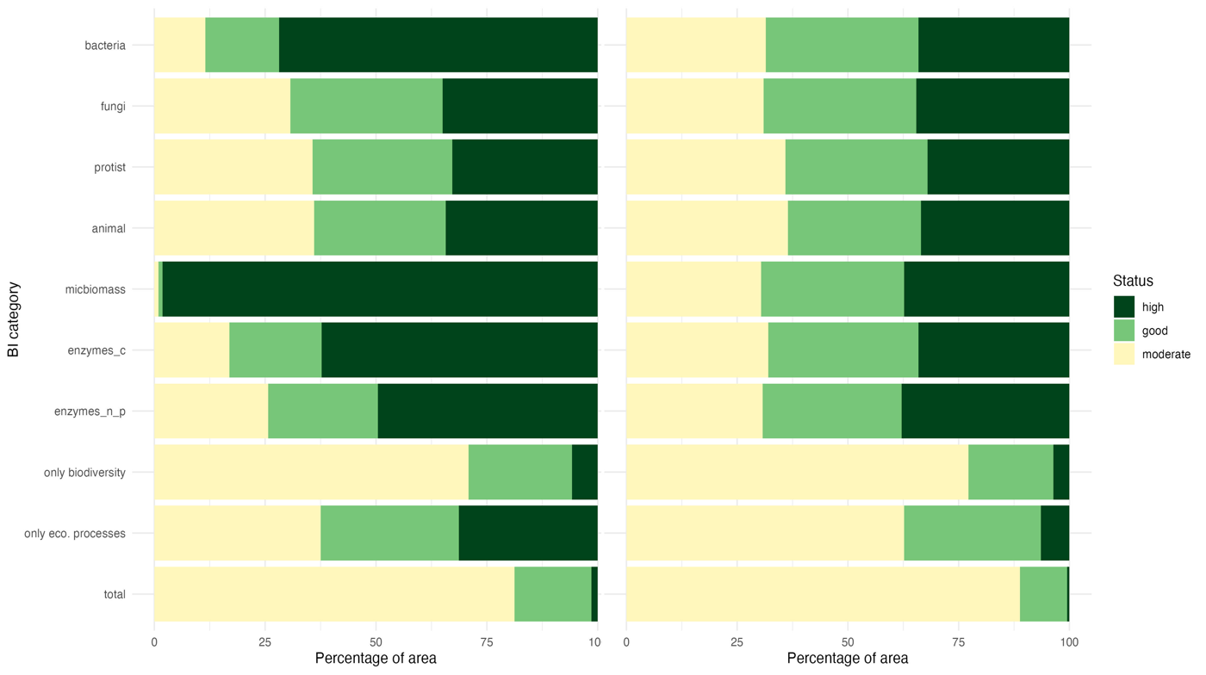

Supplementary Figure 11. Soil health classification per biotic indicator category and in total, when only accounting for biodiversity and functioning losses (left panel) and both gains and losses (right panel).

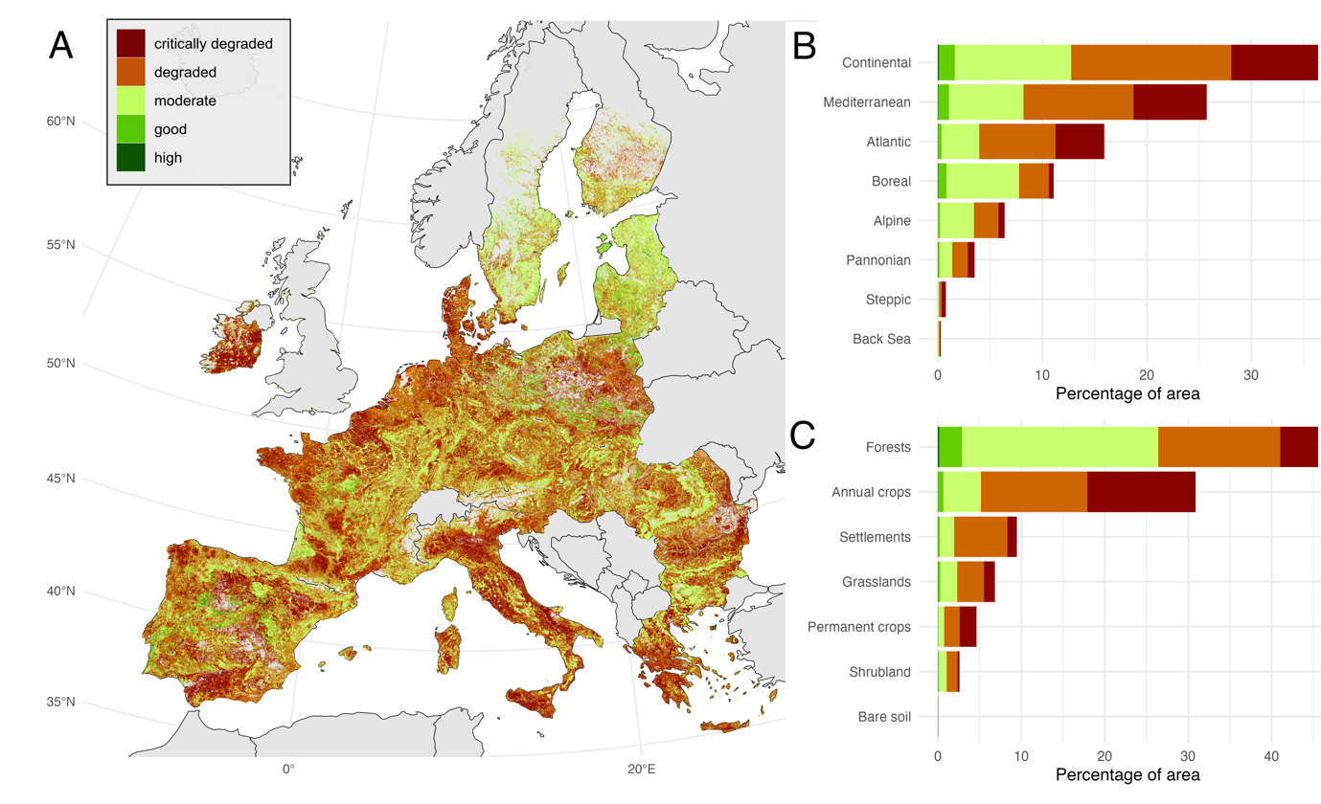

Supplementary Figure 12. Soil health assessment across Europe (A) including the percentage of area in each category by biogeographical region (B) and by land cover type (C). In this analysis, both positive and negative deviations from the undisturbed reference were accounted. Grey areas indicate countries that were not sampled in the LUCAS survey or with missing data for the soil degradation processes evaluated, and regions of low model confidence that were excluded.

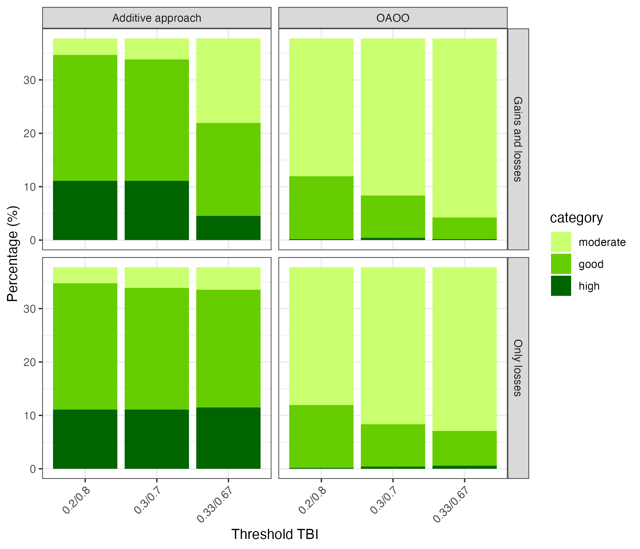
Supplementary Figure 13. Sensitivity of soil health classification to aggregation rules, indicator interpretation, and threshold choices. Proportion of non-degraded soils classified as having moderate, good, or high soil health under alternative classification approaches. The x-axis shows different threshold choices applied to the Total Biodiversity Index (TBI). Columns correspond to the aggregation method used (one-out–all-out, OOAO; additive approach), and rows distinguish between two interpretations of indicator deviations from reference conditions (“losses only” and “gains and losses”). Under the OOAO approach, soils are assigned to a given class only if all indicators meet the corresponding threshold, such that any lower-scoring indicator determines the final classification. In contrast, the additive approach index combines indicator scores additively into a continuous soil-health index, allowing partial contributions from individual indicators. The “losses only” interpretation considers negative deviations from reference conditions as indicators of degradation, whereas the “gains and losses” interpretation accounts for both negative and positive deviations.

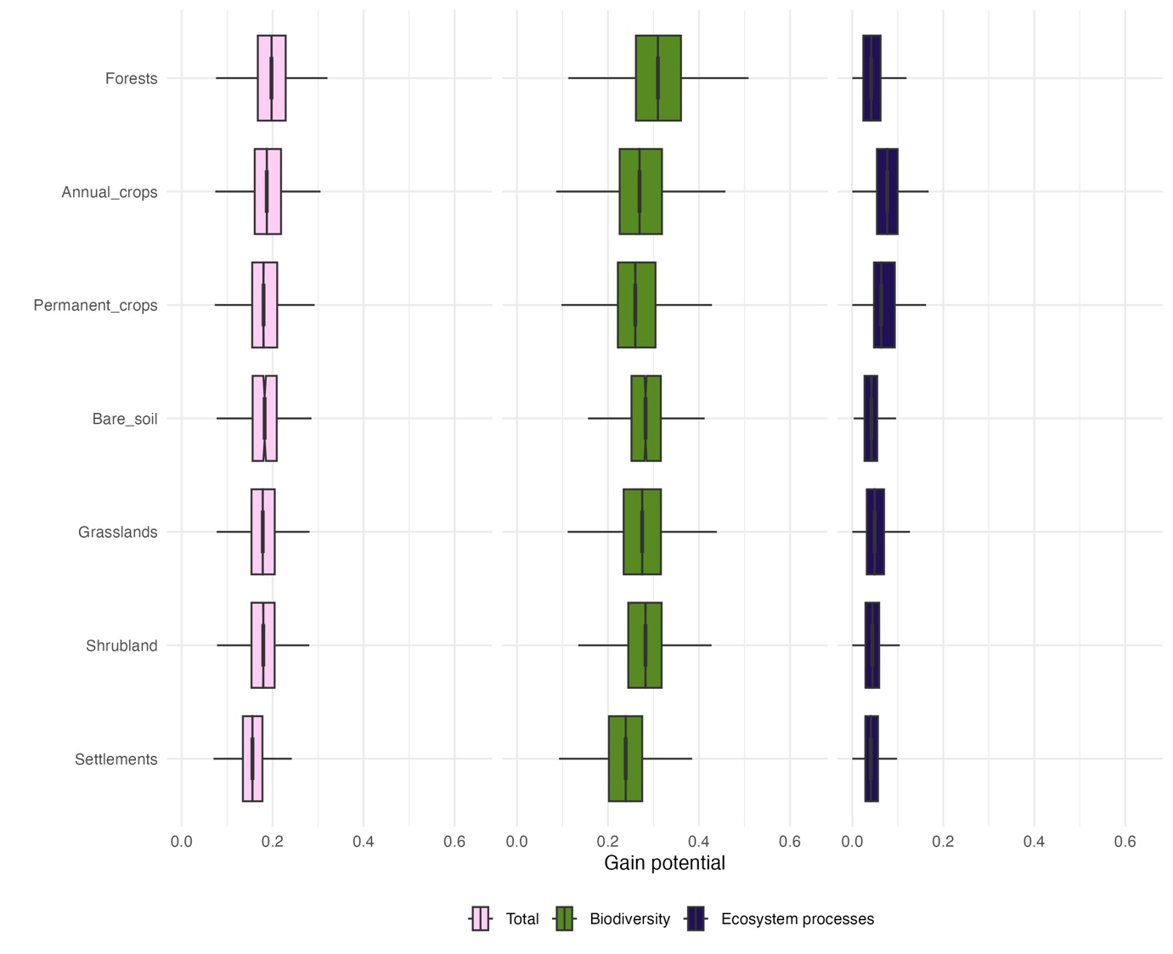
Supplementary Figure 14. Gain potential in biodiversity and ecosystem functioning and in total in degraded soils by land cover. The gain potential represents the average value across biotic indicators in each category or between the 2 categories (for the total), which were previously standardised per biotic indicator by dividing by the maximum value to ensure comparability across the indicators.

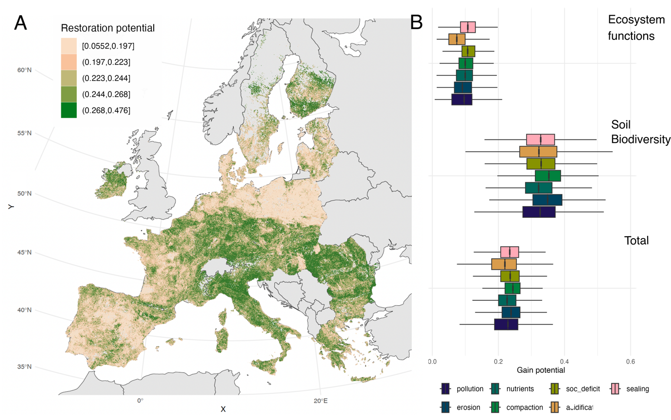
Supplementary Figure 15. Soil restoration potential in Europe (A) and the potential change in in biodiversity and ecosystem functioning (both gains and losses) across soils suffering from different degradation factors (B). The gain potential represents the average value across biotic indicators in each category or between the 2 categories (for the total), which were previously standardised per biotic indicator by dividing by the maximum value to ensure comparability across the indicators. The boxes span the interquartile range (IQR), with the vertical black line indicating the median and whiskers extend 1.5 × IQR from the hinge. Grey areas in A indicate countries that were not sampled in the LUCAS survey or with missing data for the soil degradation processes evaluated, and regions of low model confidence that were excluded. Soc_deficit: Organic Carbon deficit.

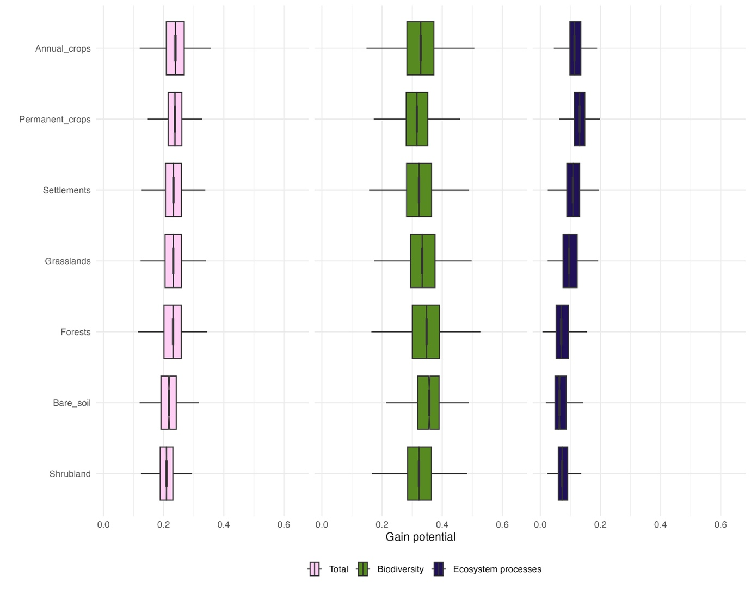

Supplementary Figure 16. Change potential (both gains and losses) in biodiversity and ecosystem functioning and in total in degraded soils by land cover. The change potential represents the average value across biotic indicators in each category or between the 2 categories (for the total), which were previously standardised per biotic indicator by dividing by the maximum value to ensure comparability across the indicators.

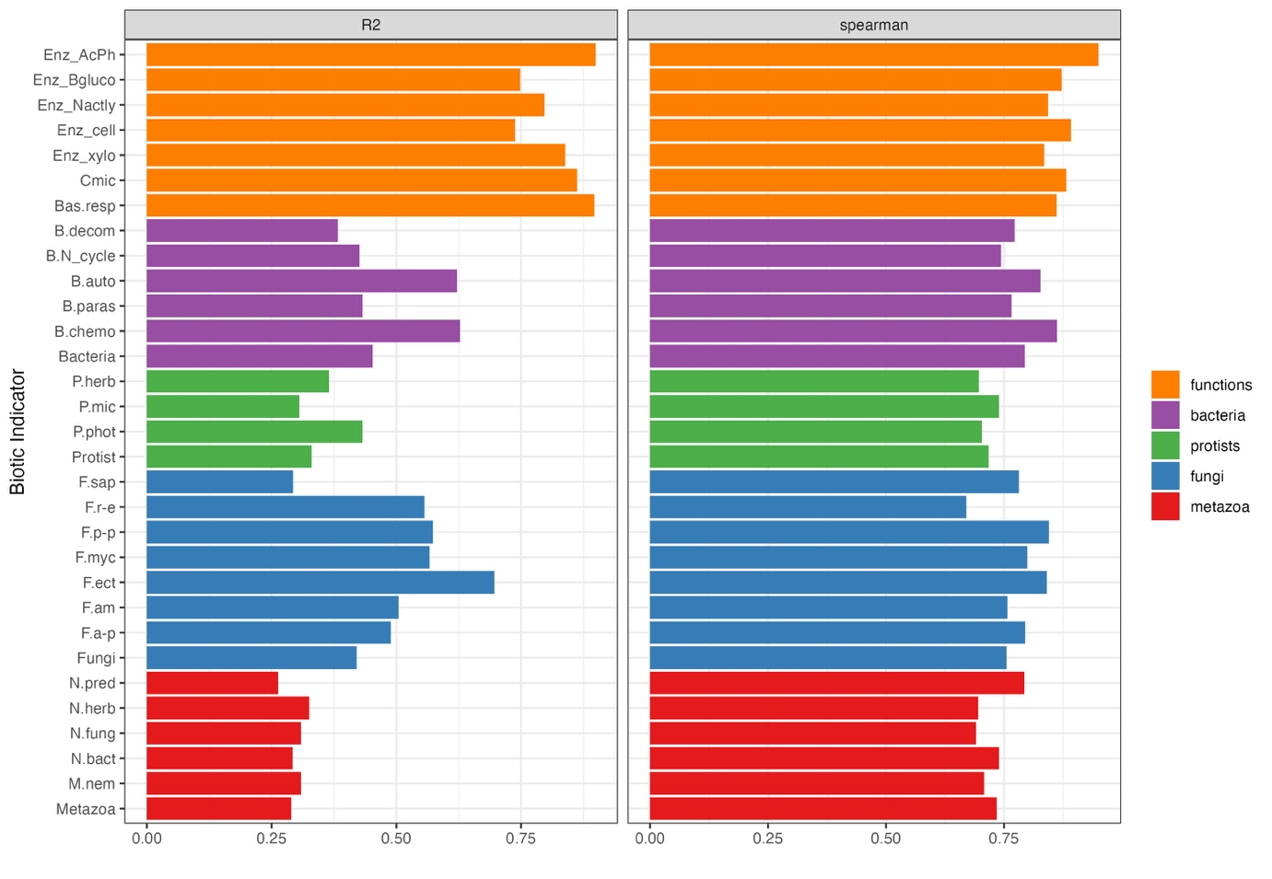
Supplementary Figure 17. Performance metrics of the models for each biotic indicator. The models done for the diversity of the whole kingdoms and the phylum Nematoda are also presented for comparison. Code names: Enz, Enzymatic activity potential; AcPh, Acid phosphatase; Bgluco: Beta-glucosidase; Nactly, N-acetyl-glucosaminidase; cell, Cellulase; xylo, Xylosidase; Cmic, Microbial biomass; Bas.resp, Basal respiration; B, Bacteria; P, Protist; F, Fungi; N, Nematode; auto, autotrophic; paras, parasite; decom, decomposer; chemo, chemoheterotrophic; herb, plant pathogenic; mic, microbivorous; phot, photoautotrophic; sap, saprotrophic, r-e, root endophyte; p-p, plant pathogenic; myc, mycoparasite; ect, ectomycorrhizal; am, arbuscular mycorrhizal; a-p, animal parasite; pred, predator; fung, fungivore; bact, bacterivore, M.nem, Nematoda.

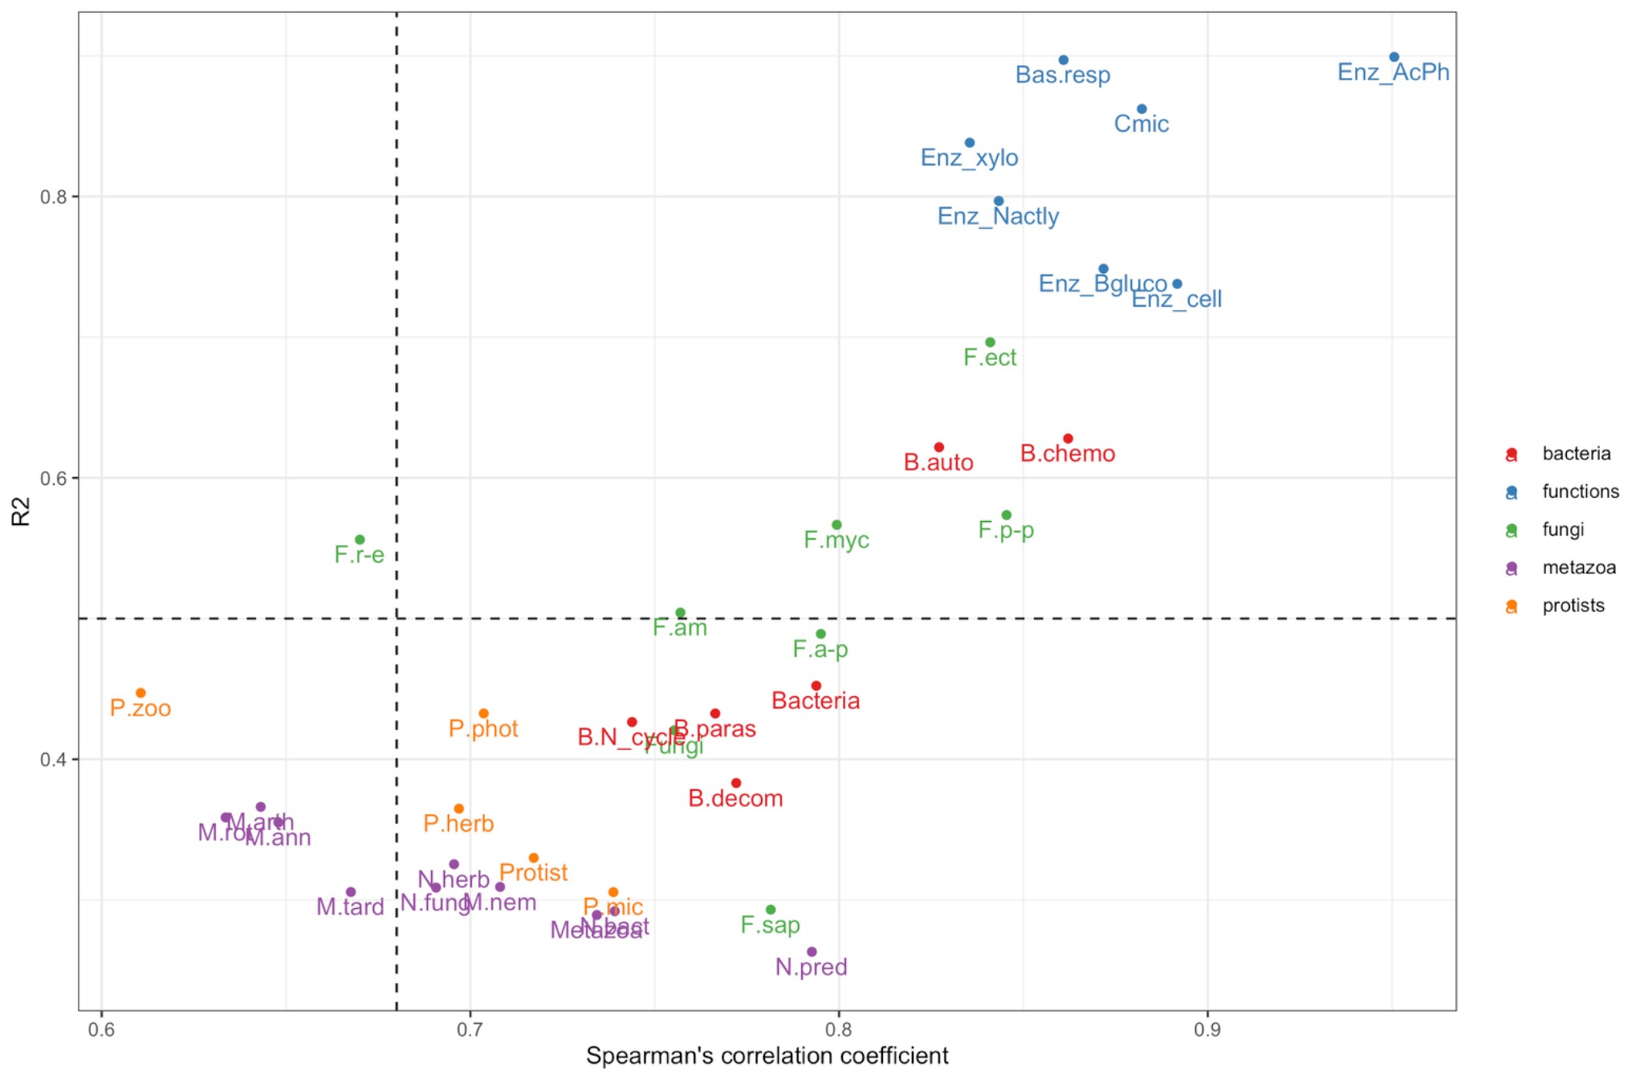

Supplementary Figure 18. Criteria used to select the biotic indicator to be used in the analyses based on the model performance. From the initial list of indicators, those with both an R2 lower than 0.5 and a Spearman's rho2 lower than 0.68 were excluded. The indicators excluded consist mostly of taxonomic groups of animals (i.e., Arthropoda, Tardigrada, Rotifera, Annelida), predator nematodes and zooparasite protists. Code names: Enz, Enzymatic activity potential; AcPh, Acid phosphatase; Bgluco: Beta-glucosidase; Nactly, N-acetyl-glucosaminidase; cell, Cellulase; xylo, Xylosidase; Cmic, Microbial biomass; Bas.resp, Basal respiration; B, Bacteria; P, Protist; F, Fungi; N, Nematode; auto, autotrophic; paras, parasite; decom, decomposer; chemo, chemoheterotrophic; herb, plant pathogenic; mic, microbivorous; phot, photoautotrophic; sap, saprotrophic, r-e, root endophyte; p-p, plant pathogenic; myc, mycoparasite; ect, ectomycorrhizal; am, arbuscular mycorrhizal; a-p, animal parasite; pred, predator; fung, fungivore; bact, bacterivore, M.nem, Nematoda.

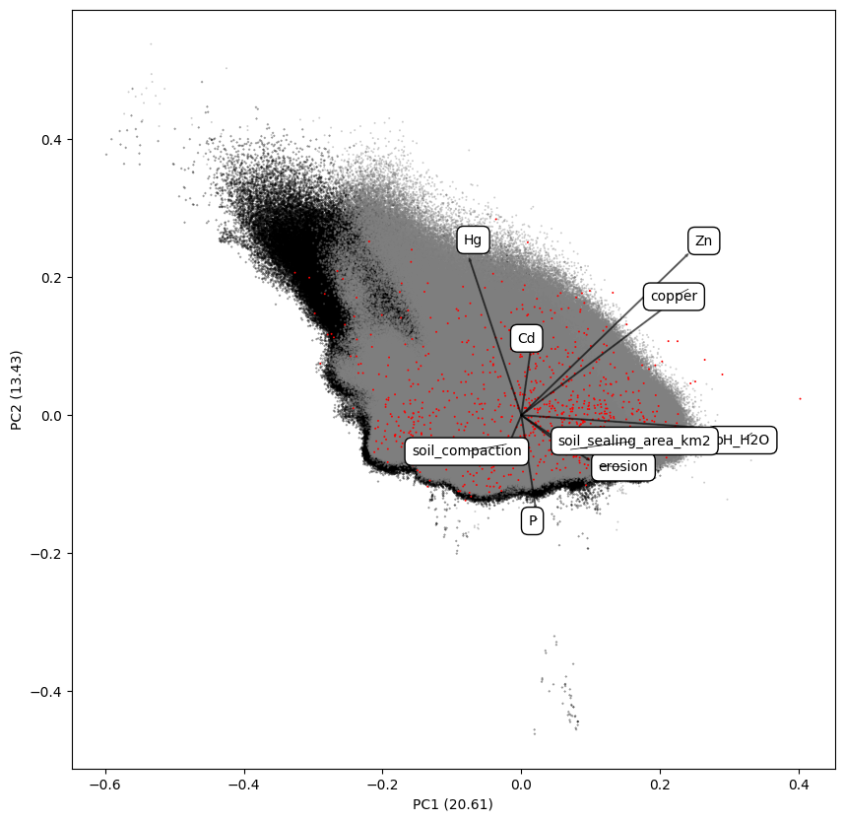

Supplementary Figure 19. PCA of the variables used as predictor in the models of this study (climatic, soil properties, land use, soil degradation processes). Points used for training the model are shown in red. The values used for the projections of the current state and the undisturbed reference are presented in grey and black respectively. For simplification, only the variables that were modified for the undisturbed scenario (representing a soil degradation process) are shown.

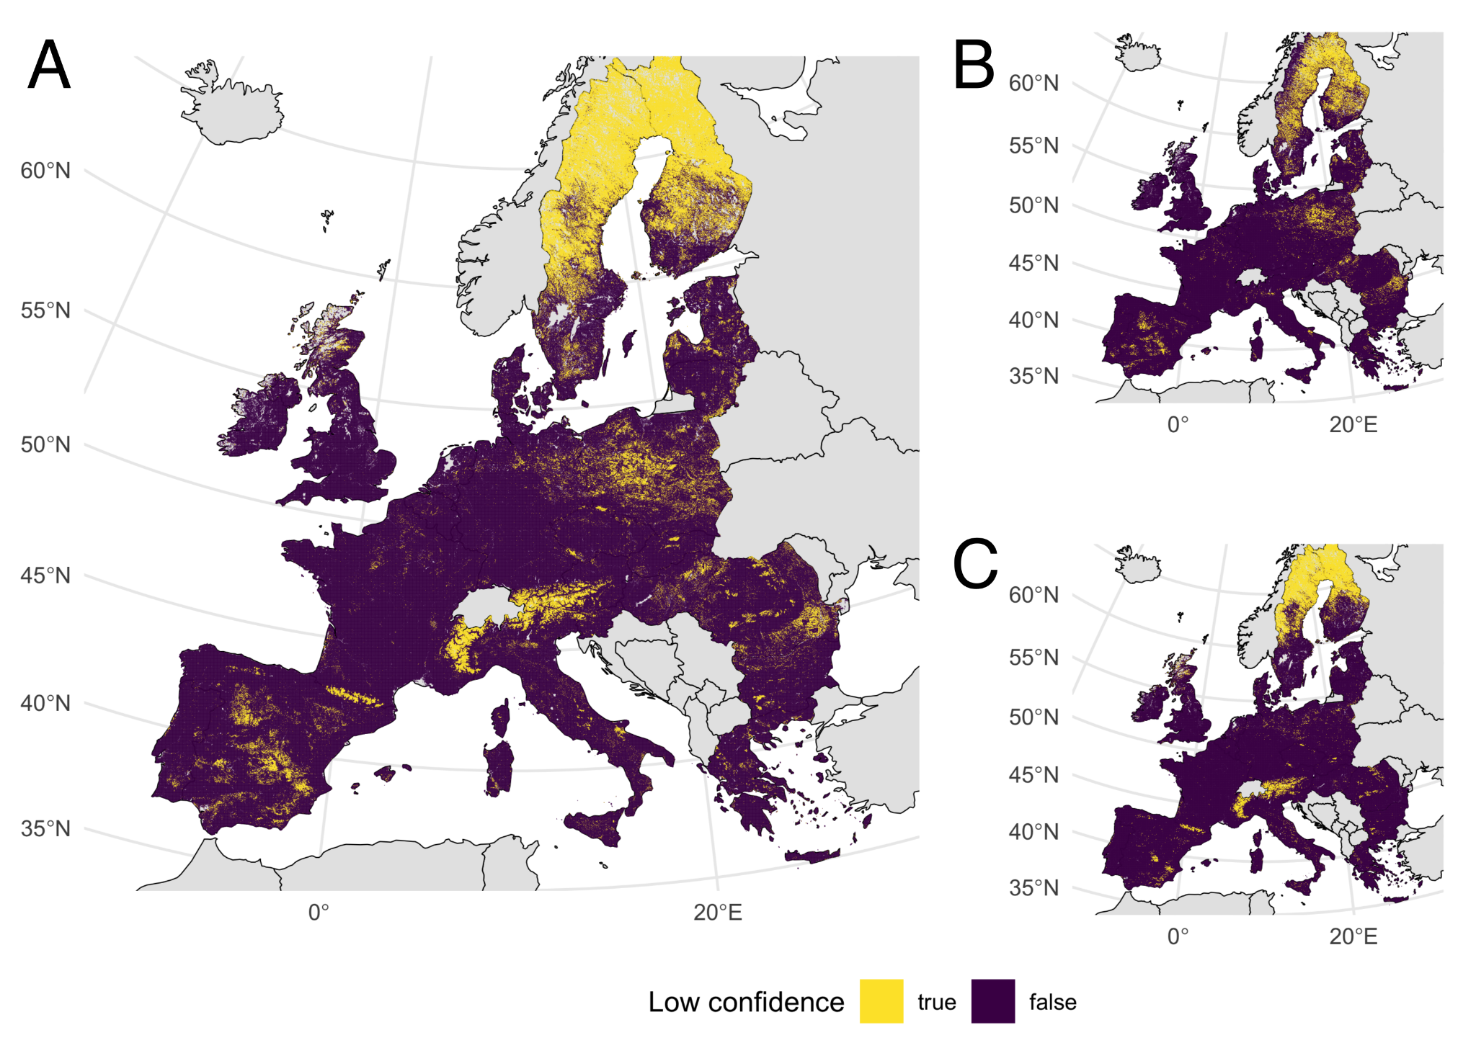
Supplementary Figure 20. Areas of low confidence values for the model in total (A), for biotic indicators related to soil biodiversity (B) and for biotic indicators related to ecosystem functions (C). The uncertainty of the model was evaluated using the coefficient of variation (CV) in the predictions across the folds. Areas with low confidence values correspond to areas where the summed coefficient of variation value is above the 0.9 quantile across all the modelled area.

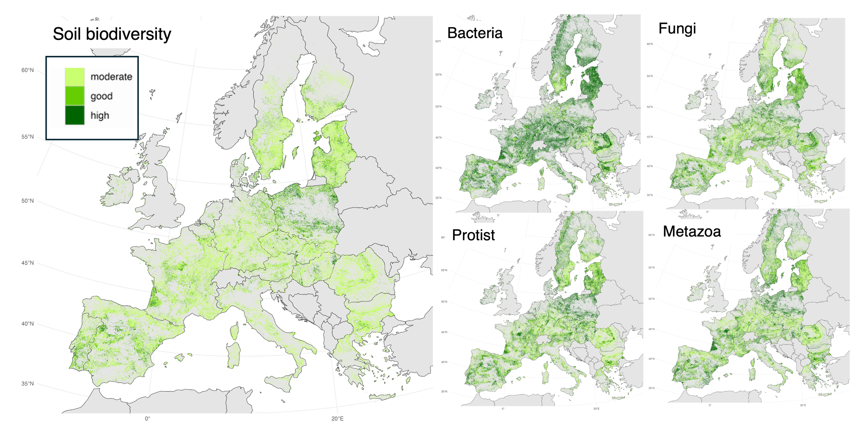
Supplementary Figure 21. Soil health assessment based on biodiversity-related biotic indicators, shown both as a combined assessment and for each category of indicator separately.

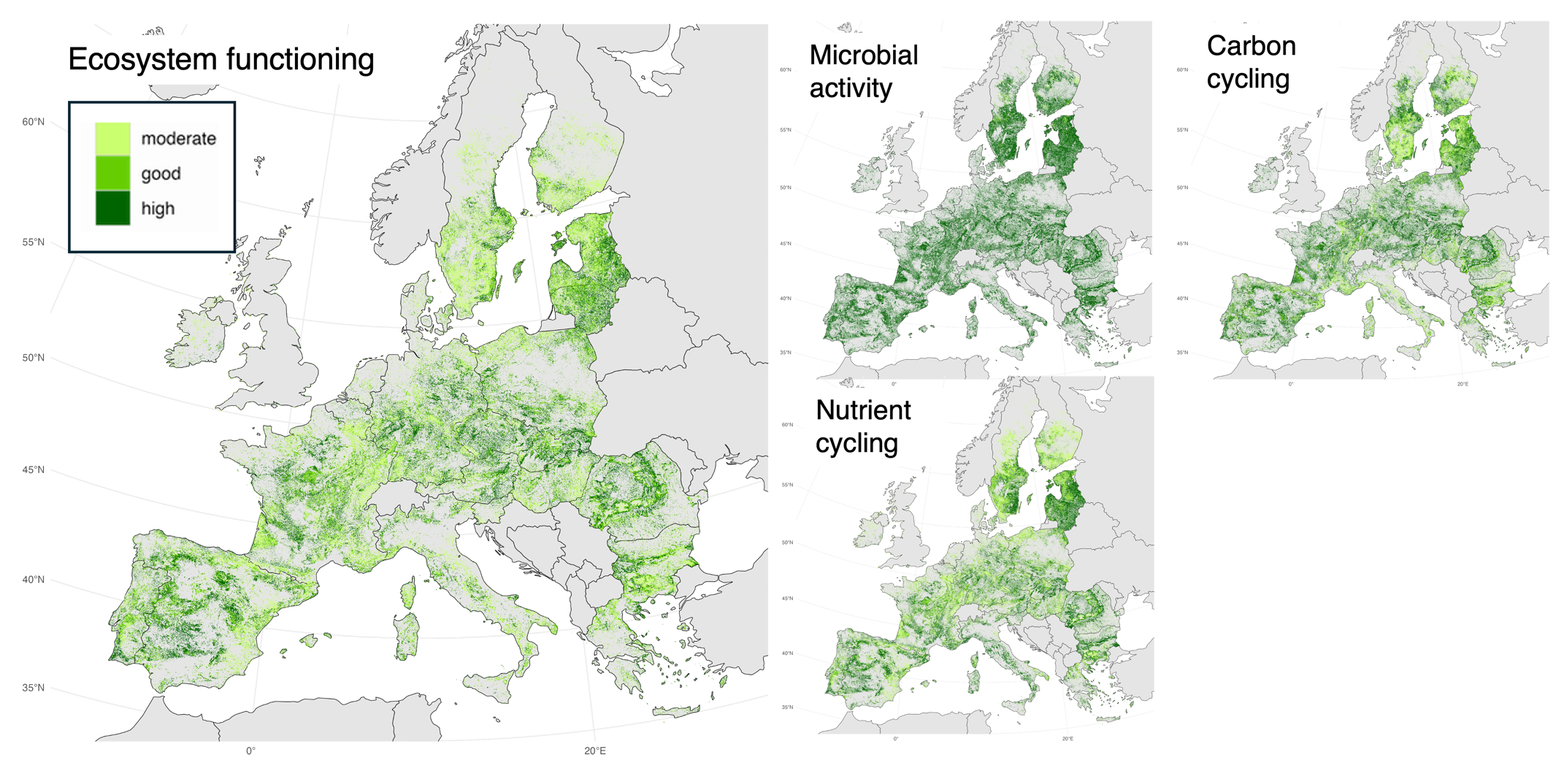
Supplementary Figure 22. Soil health assessment based on ecosystem functioning-related biotic indicators, shown both as a combined assessment and for each category of indicator separately.

Supplementary Table 1. Processes of soil degradation that represent a threat to soil biodiversity and functions, the thresholds use to define exceedance of recommended values, and the value use to create the simulated undisturbed reference scenario assuming complete absence of degradation processes. The source of the data used is listed in the methods section of the main text. NA indicates that the parameter was not used for that specific analysis.

Soil degradation | Indicator | Threshold definition | Undisturbed reference
Soil erosion | Multiple erosion processes (wind, water, tillage, harvesting) | > 2 tonnes ha⁻¹ year⁻¹ | 0
Pollution | Copper excess | [Cu] > 50 mg kg-1 | Min
Pollution | Mercury excess (Hg) | [Hg] > 200 μg kg-1 | min
Pollution | Cadmium excess (Cd) | NA | min
Pollution | Zinc excess (Zn) | NA | min
Soil nutrients | Phosphorus deficiency (in agricultural areas) | P < 20 mg kg-1 | min set to 20 (in annual and permanent crops)
Soil nutrients | Phosphorus excess | P excess > 50 mg kg-1 | max set to 50
Soil nutrients | Nitrogen surplus | Agricultural areas where N surplus > 50 kg ha-1 | NA
Soil compaction | Compaction susceptibility | ≥ High susceptibility to compaction | all set to 1
Soil sealing | Sealing area | NA | 0
SOC deficiency | Soil organic carbon deficit | Intermediate risk: SOC/Clay ratio 10  Critical risk: SOC/Clay ratio 13 | NA
Acidification | Critical pH levels in view of crop production | EEA per country | pH set to 5 in crop areas having critical acidification

Supplementary Table 2. Environmental predictors used to predict the spatial distribution of indicators of soil biodiversity and functions.

Category | Abbreviation | Variable | Description | Unit | Source
Climate | TMeanY | Mean annual temperature (BIO1) | mean annual daily mean air temperatures averaged over 1 year | °C | 1991-2020, EUR11-CORDEX
Climate | TSeason | Temperature Seasonality (BIO4) | standard deviation of the monthly mean temperatures | °C | 1991-2020, EUR11-CORDEX
Climate | gdd5 | Growing degree days heat sum above 5°C | heat sum of all days above the 5°C temperature accumulated over 1 year. | °C | 1991-2020, EUR11-CORDEX
Climate | npp | Net primary productivity | Calculated based on the ‘Miami model’, Lieth, H., 1972. “Modelling the primary productivity of the earth. Nature and resources”, UNESCO, VIII, 2:5-10. | - | 1991-2020, EUR11-CORDEX
Climate | PTotY | Annual Precipitation amount (BIO12) | Accumulated precipitation amount over 1 year | kg m-2 | 1991-2020, EUR11-CORDEX
Climate | PSeason | Precipitation seasonality (BIO15) | The Coefficient of Variation is the standard deviation of the monthly precipitation estimates expressed as a percentage of the mean of those estimates (i.e. the annual mean) | kg m-2 | 1991-2020, EUR11-CORDEX
Climate | scd | Snow cover days | Number of days with snow cover calculated using the snowpack model implementation in from TREELIM (https://doi.org/10.1007/s00035-014-0124-0) | days | 1991-2020, EUR11-CORDEX
Climate | swe | Snow water equivalent | Amount of liquid water if snow is melted | kg m-2 | 1991-2020, EUR11-CORDEX
Topography | tri | Terrain ruggedness index | Elevation differences between adjacent cells in a Digital Elevation Model to describe the ruggedness of the terrain (Riley et al 1999) | m | EU-DEM
Topography | slope | Slope | Slope represents the rate of change of elevation for each digital elevation model (DEM) cell, computed as the first derivative of a DEM, |  | EU-DEM
Topography | tpi_landform | Landform class | Semi-automatic classification of landforms (geomorphologies) based on multi-scale topographic position index | 10 categories | EU-DEM + SAGA-GIS  https://saga-gis.sourceforge.io/saga_tool_doc/6.3.0/ta_morphometry_19.html
Geographic | dist2fw | Distance to fresh water | Distance to the closest fresh water source | km | EU-Hydro
Geographic | dist2cst | Distance to coast | Distance to the closest coast | km | EU-Hydro
Soil physical | sand | Sand content | Sand content in topsoil | % | ESDAC
Soil physical | clay | Clay content | Clay content in topsoil | % | ESDAC
Soil physical | coarse | Coarse fragments | Coarse fragments content in topsoil | % | ESDAC
Soil physical | silt | Silt content | Silt content in topsoil | % | ESDAC
Soil physical | bulk_density | Bulk density | Bulk density derived from soil texture datasets | - | ESDAC
Soil Chemical | pH_H2O | Soil pH | Soil pH measured in H2O | - | ESDAC
Nutrients | OC | Organic Carbon | Soil organic carbon content |  | ESDAC
Nutrients | CN | C:N ratio | Soil carbon to nitrogen ratio | - | ESDAC
Nutrients | P | Phosphorus | Soil phosphorus content | mg_kg-1 | ESDAC
Nutrients | N | Nitrogen | Total soil nitrogen content | g_kg-1 | ESDAC
Nutrients | K | Potassium | Soil potassium content | mg_kg-1 | ESDAC
Land cover | (9 levels) | Land cover type | terrestrial land covers including annual crops, permanent corps, broadleaved forests, needle leaved forests, grasslands, shrublands and human settlements | - | LUCAS (in-situ) for model calibration, Land System Map (Dou et al 2021) for mapping

