EXTENDED DATA

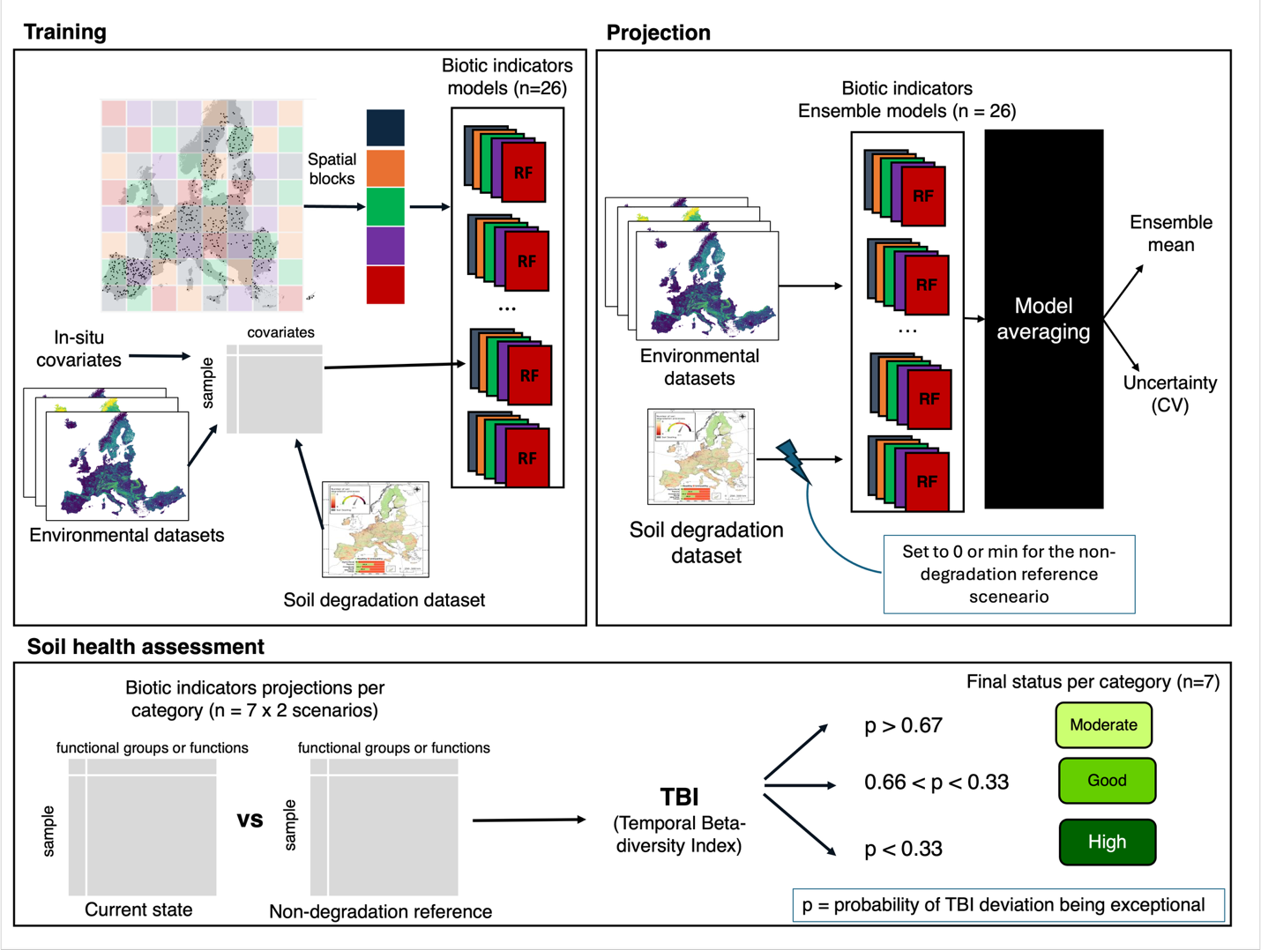
Figure 4. Modelling approach for refining status of non-degraded soils. A stacked ensemble modelling framework using a Random Forest algorithm was implemented to predict biotic indicators across the EU based on environmental variables (including in-situ measurements and extracted variables) and variables representing soil degradation processes (Training panel). The ensemble models for each biotic indicator, obtained after cross-validation, were used to predict both the average and variance of each biotic indicator’s value under current conditions (current state) and a reference baseline (non-degradation reference) (Projections panel). Finally, soils classified as healthy by the EU official framework were further categorized into moderate, good, or high ecological status for each biotic indicator category (n=7). This classification was based on the deviation of biotic indicators in the current state scenario from the non-degradation reference scenario, using the Temporal Beta-Diversity Index and the associated probability of a site experiencing an "exceptional change" (Soil Ecological Status panel).

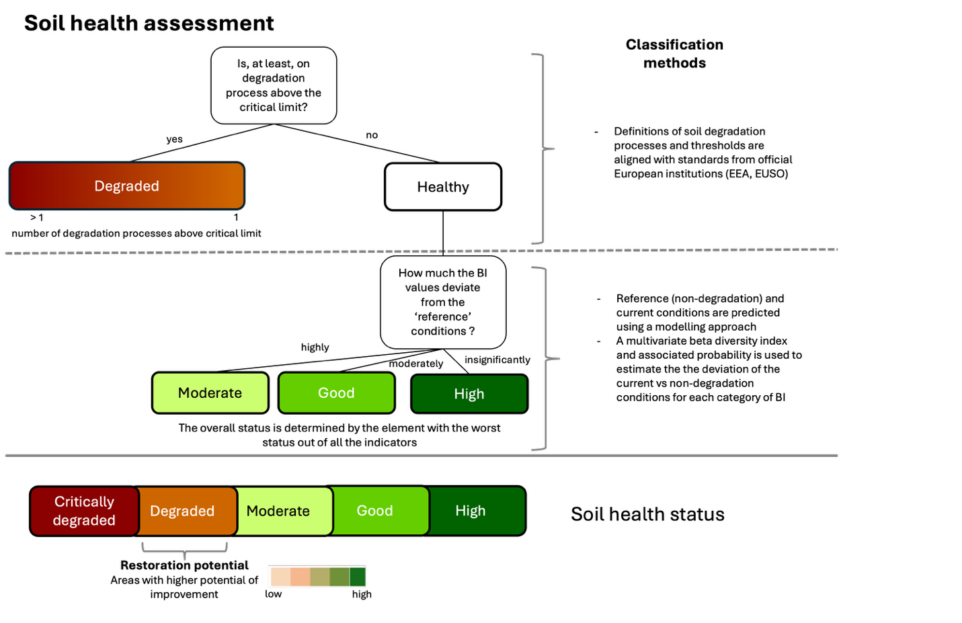
Figure 5. Soil health indicator. We assessed soil health using two complementary and subsequent methods: 1) a first approach that separates degraded soils from healthy soils using soil degradation processes indicators and associated critical thresholds based on standards from official European institutions (EEA, EUSO, Panagos et al. 2024. doi: 10.1111/ejss.13507); 2) a second approach developed in this study to classify soils (‘healthy’ soils in the previous assessment), into moderate, good, or high using biotic indicators. A healthy soil, under our framework, is one where the current biotic communities closely resemble those expected under undisturbed conditions for a specific biogeographic region and land cover type. Conversely, a less healthy soil (moderate status) would exhibit significant biodiversity and functional losses linked to degradation processes. At the end, the information of all the categories of biotic indicators is summarized using the ‘one out all out’ principle.

