Appendix A
Table A1. Manipulating the response scale's polarity (method effects) and direction (acquiescence) in English, Finnish, and Swedish.

Direction | ENG bipolar (original) | ENG unipolar
"Strongly agree" or "Completely agree" response option furthest to the left or right in the matrix | Strongly agree | Completely agree
 | Agree | Strongly agree
 | Neither agree nor disagree | Partially agree
 | Disagree | Slightly agree
 | Strongly disagree | Don't agree at all
 | Don't know | Don't know

Direction | FI bipolar (original) | FI unipolar
"Strongly agree" or "Completely agree" response option furthest to the left or right in the matrix | Täysin samaa mieltä | Täysin samaa mieltä
 | Samaa mieltä | Erittäin samaa mieltä
 | Ei samaa eikä eri mieltä | Osittain samaa mieltä
 | Eri mieltä | Jonkin verran samaa mieltä
 | Täysin eri mieltä | Ei lainkaan samaa mieltä
 | En osaa sanoa | En osaa sanoa

Direction | SV bipolar (original) | SV unipolar
"Strongly agree" or "Completely agree" response option furthest to the left or right in the matrix | Helt av samma åsikt | Instämmer fullkomligt
 | Av samma åsikt | Instämmer mycket
 | Inte av samma eller annan åsikt | Instämmer delvis
 | Av annan åsikt | Instämmer lite
 | Helt av annan åsikt | Instämmer inte alls
 | Kan inte säga | Kan inte säga

Table A2. Manipulating the framing of the statements (ENG, FI, SV) to capture social desirability bias
Statement | Democracy component | ENG original | ENG reversed
1 | Freedom of expression (criticize government) | People should be free to criticize the government even in times of great crisis | Freedom to criticize the government should be restricted during times of great crisis
2 | Freedom of expression (media) | The government should be able to censor media sources that are too critical | Media criticism of the government, even from too critical sources, should not be restricted
3 | Freedom of association | The right to protest should be protected even when protestors inconvenience others | The right to protest should be restricted to avoid causing inconvenience to others
4 | Universal suffrage | The universal right to vote must be questioned when so many voters are poorly informed and easily misled | Ensuring the universal right to vote is essential, even if many voters are poorly informed or misled
5 | Free and fair elections | We should respect the results of elections, no matter the winner | We should not respect the results of elections if the outcome is unacceptable
6 | Judicial constraints on the executive | The government should be able to ignore court rulings that are regarded as politically biased | The government must follow court rulings, even if the rulings are regarded politically biased
7 | Legislative constraints on the executive | MPs should be able to question and oversee political decisions taken by the government, even when this slows down progress | To ensure effective governance, MPs should not question and oversee political decisions taken by the government
8 | Equality before the law (crisis) | The government should be able to bend the law to solve pressing social and political problems | The government should uphold the law even during pressing social and political problems
9 | Equality before the law (beliefs) | All Finns should enjoy the same legal rights, regardless of their political beliefs | Finns should enjoy the same legal rights only conditionally, depending on their political beliefs

Statement | Democracy component | FI original | FI reversed
1 | Freedom of expression (criticize government) | Ihmisten tulisi saada vapaasti arvostella hallitusta myös vakavien kriisien aikana | Hallituksen arvostelua tulisi rajoittaa vakavina kriisiaikoina
2 | Freedom of expression (media) | Hallituksen on voitava sensuroida tiedotusvälineitä, jotka ovat kohtuuttoman kriittisiä hallitusta kohtaan | Hallituksen arvostelua tiedotusvälineissä, jopa kohtuuttoman kriittisissä lähteissä, ei tulisi rajoittaa
3 | Freedom of association | Mielenosoitusoikeutta on suojeltava, vaikka mielenosoitus hankaloittaisi muiden arkea | Mielenosoitusoikeutta tulisi rajoittaa, jotta se ei häiritse muiden arkea
4 | Universal suffrage | Yleinen äänioikeus ei toimi, mikäli monet äänestäjät ovat huonosti perillä asioista ja helposti harhaanjohdettavissa | Yleinen äänioikeus on turvattava, vaikka monet äänestäjät olisivatkin huonosti perillä asioista tai harhaanjohdettavissa
5 | Free and fair elections | Jos vaalit on järjestetty rehellisesti, on tulosta kunnioitettava voittajasta riippumatta | Vaalituloksia ei tarvitse kunnioittaa, jos tulos on epämieluisa
6 | Judicial constraints on the executive | Hallituksen pitäisi voida olla välittämättä sellaisista tuomioistuinten päätöksistä, joita se pitää poliittisesti puolueellisina | Hallituksen on noudatettava tuomioistuinten päätöksiä, vaikka ne vaikuttaisivat poliittisesti puolueellisilta
7 | Legislative constraints on the executive | Kansanedustajien pitäisi voida kyseenalaistaa ja valvoa hallituksen päätöksiä, vaikka se hidastaisi päätösten toimeenpanoa | Tehokkaan hallinnon varmistamiseksi kansanedustajien ei tulisi kyseenalaistaa tai valvoa hallituksen päätöksiä
8 | Equality before the law (crisis) | Hallituksen pitäisi voida venyttää lainsäädännön rajoja ratkaistakseen kiireellisiä yhteiskunnallisia ongelmia | Hallituksen tulisi noudattaa lakia myös kiireellisissä yhteiskunnallisissa ja poliittisissa tilanteissa
9 | Equality before the law (beliefs) | Kaikkien suomalaisten tulisi olla tasavertaisia lain edessä poliittisesta vakaumuksesta riippumatta | Suomalaisten oikeudet lain edessä voivat riippua heidän poliittisista vakaumuksistaan

Statement | Democracy component | SV original | SV reversed
1 | Freedom of expression (criticize government) | Människor borde ha rätt att kritisera regeringen även i tider av allvarlig kris | Kritisering av regeringen borde begränsas i tider av allvarlig kris
2 | Freedom of expression (media) | Regeringen borde kunna censurera mediekällor som är orimligt kritiska mot regeringen | Kritik mot regeringen från medier, även från källor som anses vara för kritiska, bör inte begränsas
3 | Freedom of association | Rätten att protestera bör skyddas även om demonstrationen försvårar vardagen för andra | Rätten att protestera bör begränsas för att undvika att störa andra
4 | Universal suffrage | Den allmänna rösträtten fungerar inte ifall många väljare är dåligt informerade och lätt vilseledda. | Den allmänna rösträtten bör garanteras, även om många väljare är dåligt informerade eller vilseledda
5 | Free and fair elections | Om ett val genomförs på ett lagligt sätt måste resultatet respekteras, oavsett vem som vinner. | Valresultat behöver inte respekteras om utfallet är oacceptabelt
6 | Judicial constraints on the executive | Regeringen bör kunna ignorera domstolsbeslut som den anser vara politiskt partiska. | Regeringen måste följa domstolsbeslut, även om de anses vara politiskt partiska
7 | Legislative constraints on the executive | Riksdagsledamöter bör kunna ifrågasätta och granska regeringsbeslut, även om det fördröjer verkställandet av dem | För att säkerställa en effektiv styrning bör riksdagsledamöter inte ifrågasätta eller granska regeringsbeslut
8 | Equality before the law (crisis) | Regeringen bör kunna tänja på lagens gränser för att lösa angelägna samhällsproblem | Regeringen bör följa lagen även i pressande sociala och politiska situationer
9 | Equality before the law (beliefs) | Alla finländare ska vara jämlika inför lagen, oberoende av politisk övertygelse | Finländares rättigheter inför lagen bör vara beroende av deras politiska övertygelse

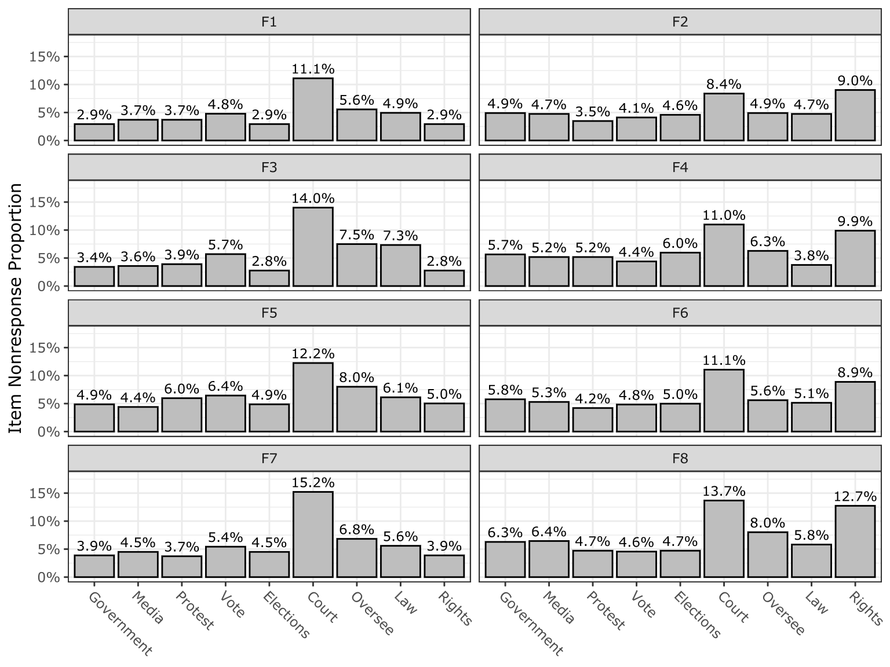
Figure A1. Item nonresponse (“Don’t know” + seen but unanswered) by statement and form.
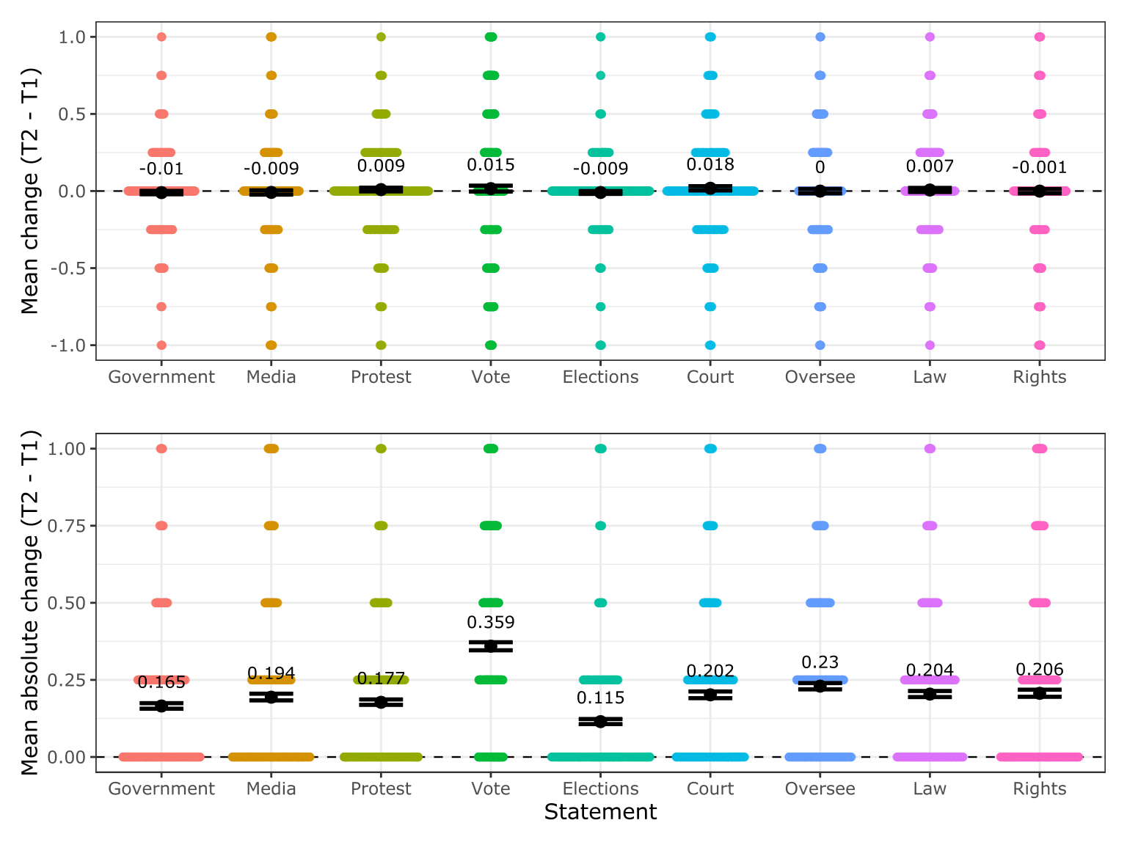
Figure A2. Mean change and mean absolute change in opinion per statement between T1 and T2.

Table A3. Randomized form order combinations across measurement points for the treatment groups (n = 2,545).

Group | T1 form | T2 form | n | Group | T1 form | T2 form | n
1 | F1 | F2 | 48 | 29 | F2 | F1 | 45
2 | F1 | F3 | 42 | 30 | F3 | F1 | 41
3 | F1 | F4 | 35 | 31 | F4 | F1 | 43
4 | F1 | F5 | 47 | 32 | F5 | F1 | 53
5 | F1 | F6 | 56 | 33 | F6 | F1 | 45
6 | F1 | F7 | 49 | 34 | F7 | F1 | 44
7 | F1 | F8 | 43 | 35 | F8 | F1 | 57
8 | F2 | F3 | 47 | 36 | F3 | F2 | 43
9 | F2 | F4 | 39 | 37 | F4 | F2 | 44
10 | F2 | F5 | 40 | 38 | F5 | F2 | 48
11 | F2 | F6 | 42 | 39 | F6 | F2 | 43
12 | F2 | F7 | 53 | 40 | F7 | F2 | 47
13 | F2 | F8 | 53 | 41 | F8 | F2 | 40
14 | F3 | F4 | 50 | 42 | F4 | F3 | 55
15 | F3 | F5 | 43 | 43 | F5 | F3 | 38
16 | F3 | F6 | 48 | 44 | F6 | F3 | 41
17 | F3 | F7 | 42 | 45 | F7 | F3 | 43
18 | F3 | F8 | 45 | 46 | F8 | F3 | 36
19 | F4 | F5 | 54 | 47 | F5 | F4 | 41
20 | F4 | F6 | 46 | 48 | F6 | F4 | 49
21 | F4 | F7 | 46 | 49 | F7 | F4 | 44
22 | F4 | F8 | 41 | 50 | F8 | F4 | 50
23 | F5 | F6 | 42 | 51 | F6 | F5 | 39
24 | F5 | F7 | 43 | 52 | F7 | F5 | 52
25 | F5 | F8 | 50 | 53 | F8 | F5 | 47
26 | F6 | F7 | 49 | 54 | F7 | F6 | 50
27 | F6 | F8 | 48 | 55 | F8 | F6 | 44
28 | F7 | F8 | 40 | 56 | F8 | F7 | 42

Table A4. The treatment groups’ demographic composition.
Variable | N | 1  N = 48 | 2  N = 42 | 3  N = 35 | 4  N = 47 | 5  N = 56 | 6  N = 49 | 7  N = 43 | 8  N = 47 | 9  N = 39 | 10  N = 40 | 11  N = 42 | 12  N = 53 | 13  N = 53 | 14  N = 50
Gender | 2,514
Man |  | 27 (56%) | 24 (59%) | 25 (74%) | 25 (53%) | 32 (57%) | 24 (49%) | 19 (44%) | 19 (40%) | 21 (54%) | 18 (45%) | 21 (54%) | 33 (63%) | 24 (45%) | 28 (56%)
Woman |  | 21 (44%) | 17 (41%) | 9 (26%) | 22 (47%) | 24 (43%) | 25 (51%) | 24 (56%) | 28 (60%) | 18 (46%) | 22 (55%) | 18 (46%) | 19 (37%) | 29 (55%) | 22 (44%)
Age | 2,541 | 57 (45, 71) | 62 (43, 73) | 60 (46, 74) | 66 (50, 73) | 60 (42, 71) | 64 (44, 74) | 61 (47, 72) | 61 (48, 70) | 65 (47, 73) | 65 (52, 73) | 63 (45, 73) | 61 (43, 70) | 58 (39, 71) | 66 (51, 73)
Education | 2,543
No degree |  | 20 (42%) | 19 (45%) | 15 (43%) | 23 (49%) | 21 (38%) | 27 (55%) | 17 (40%) | 22 (47%) | 19 (49%) | 19 (48%) | 24 (57%) | 25 (47%) | 20 (38%) | 17 (34%)
Degree |  | 28 (58%) | 23 (55%) | 20 (57%) | 24 (51%) | 35 (63%) | 22 (45%) | 26 (60%) | 25 (53%) | 20 (51%) | 21 (53%) | 18 (43%) | 28 (53%) | 33 (62%) | 33 (66%)
Variable | N | 15  N = 43 | 16  N = 48 | 17  N = 42 | 18  N = 45 | 19  N = 54 | 20  N = 46 | 21  N = 46 | 22  N = 41 | 23  N = 42 | 24  N = 43 | 25  N = 50 | 26  N = 49 | 27  N = 48 | 28  N = 40
Gender | 2,514
Man |  | 14 (34%) | 27 (56%) | 25 (61%) | 23 (51%) | 32 (59%) | 23 (52%) | 23 (52%) | 20 (49%) | 22 (54%) | 25 (58%) | 29 (58%) | 27 (55%) | 28 (60%) | 24 (60%)
Woman |  | 27 (66%) | 21 (44%) | 16 (39%) | 22 (49%) | 22 (41%) | 21 (48%) | 21 (48%) | 21 (51%) | 19 (46%) | 18 (42%) | 21 (42%) | 22 (45%) | 19 (40%) | 16 (40%)
Age | 2,541 | 64 (48, 68) | 61 (37, 71) | 59 (44, 72) | 63 (48, 72) | 62 (51, 69) | 63 (37, 73) | 66 (52, 73) | 62 (48, 71) | 59 (43, 69) | 58 (41, 72) | 57 (49, 66) | 61 (52, 70) | 60 (45, 69) | 67 (51, 75)
Education | 2,543
No degree |  | 19 (44%) | 24 (50%) | 23 (55%) | 20 (44%) | 29 (54%) | 23 (50%) | 21 (46%) | 22 (54%) | 19 (45%) | 15 (35%) | 25 (50%) | 21 (43%) | 27 (56%) | 23 (59%)
Degree |  | 24 (56%) | 24 (50%) | 19 (45%) | 25 (56%) | 25 (46%) | 23 (50%) | 25 (54%) | 19 (46%) | 23 (55%) | 28 (65%) | 25 (50%) | 28 (57%) | 21 (44%) | 16 (41%)

Variable | N |  | 29  N = 45 |  | 30  N = 41 |  | 31  N = 43 |  | 32  N = 53 |  | 33  N = 45 |  | 34  N = 44 |  | 35  N = 57 |  | 36  N = 43 |  | 37  N = 44 |  | 38  N = 48 |  | 39  N = 43 |  | 40  N = 47 |  | 41  N = 40 |  | 42  N = 55
Gender | 2,514
Man |  |  | 26 (60%) |  | 26 (63%) |  | 26 (60%) |  | 32 (63%) |  | 24 (56%) |  | 24 (56%) |  | 35 (61%) |  | 24 (57%) |  | 22 (51%) |  | 29 (62%) |  | 23 (53%) |  | 31 (66%) |  | 25 (63%) |  | 29 (53%)
Woman |  |  | 17 (40%) |  | 15 (37%) |  | 17 (40%) |  | 19 (37%) |  | 19 (44%) |  | 19 (44%) |  | 22 (39%) |  | 18 (43%) |  | 21 (49%) |  | 18 (38%) |  | 20 (47%) |  | 16 (34%) |  | 15 (38%) |  | 26 (47%)
Age | 2,541 |  | 59 (46, 71) |  | 65 (44, 73) |  | 59 (40, 70) |  | 65 (46, 74) |  | 58 (42, 68) |  | 60 (49, 71) |  | 63 (47, 69) |  | 62 (44, 71) |  | 61 (44, 72) |  | 64 (54, 73) |  | 62 (50, 71) |  | 65 (56, 73) |  | 59 (46, 71) |  | 62 (51, 71)
Education | 2,543
No degree |  |  | 25 (56%) |  | 17 (41%) |  | 20 (47%) |  | 22 (42%) |  | 29 (64%) |  | 22 (50%) |  | 29 (51%) |  | 22 (51%) |  | 21 (48%) |  | 22 (47%) |  | 19 (44%) |  | 22 (47%) |  | 20 (50%) |  | 25 (45%)
Degree |  |  | 20 (44%) |  | 24 (59%) |  | 23 (53%) |  | 31 (58%) |  | 16 (36%) |  | 22 (50%) |  | 28 (49%) |  | 21 (49%) |  | 23 (52%) |  | 25 (53%) |  | 24 (56%) |  | 25 (53%) |  | 20 (50%) |  | 30 (55%)
Variable | N | 43  N = 38 |  | 44  N = 41 |  | 45  N = 43 |  | 46  N = 36 |  | 47  N = 41 |  | 48  N = 49 |  | 49  N = 44 |  | 50  N = 50 |  | 51  N = 39 |  | 52  N = 52 |  | 53  N = 47 |  | 54  N = 50 |  | 55  N = 44 |  | 56  N = 42 |  | p-value
Gender | 2,514 |  |  |  |  |  |  |  |  |  |  |  |  |  |  |  |  |  |  |  |  |  |  |  |  |  |  |  |  | 0.6
Man |  | 23 (62%) |  | 20 (49%) |  | 25 (60%) |  | 17 (47%) |  | 24 (59%) |  | 27 (55%) |  | 27 (61%) |  | 22 (45%) |  | 15 (38%) |  | 27 (52%) |  | 24 (53%) |  | 30 (60%) |  | 19 (43%) |  | 17 (41%)
Woman |  | 14 (38%) |  | 21 (51%) |  | 17 (40%) |  | 19 (53%) |  | 17 (41%) |  | 22 (45%) |  | 17 (39%) |  | 27 (55%) |  | 24 (62%) |  | 25 (48%) |  | 21 (47%) |  | 20 (40%) |  | 25 (57%) |  | 24 (59%)
Age | 2,541 | 63 (47, 73) |  | 67 (47, 73) |  | 61 (47, 73) |  | 62 (41, 74) |  | 64 (44, 73) |  | 62 (52, 71) |  | 55 (36, 73) |  | 61 (43, 72) |  | 65 (47, 71) |  | 66 (54, 77) |  | 64 (45, 76) |  | 68 (56, 74) |  | 65 (42, 72) |  | 60 (40, 69) |  | >0.9
Education | 2,543 |  |  |  |  |  |  |  |  |  |  |  |  |  |  |  |  |  |  |  |  |  |  |  |  |  |  |  |  | 0.8
No degree |  | 15 (39%) |  | 21 (51%) |  | 14 (33%) |  | 21 (58%) |  | 24 (59%) |  | 24 (49%) |  | 20 (45%) |  | 24 (48%) |  | 18 (46%) |  | 28 (54%) |  | 21 (45%) |  | 27 (54%) |  | 26 (59%) |  | 22 (52%)
Degree |  | 23 (61%) |  | 20 (49%) |  | 29 (67%) |  | 15 (42%) |  | 17 (41%) |  | 25 (51%) |  | 24 (55%) |  | 26 (52%) |  | 21 (54%) |  | 24 (46%) |  | 26 (55%) |  | 23 (46%) |  | 18 (41%) |  | 20 (48%)
n (%); Median (Q1, Q3)
Pearson's Chi-squared test; Kruskal-Wallis rank sum test

Table A5. Social desirability latent variable loading per statement form.
Democracy component | Statement versions |  | Social desirability  latent variable
Freedom of expression (criticize government) | 1 original | People should be free to criticize the government even in times of great crisis | S
Freedom of expression (criticize government) | 1 reversed | Freedom to criticize the government should be restricted during times of great crisis
Freedom of expression (media) | 2 original | The government should be able to censor media sources that are too critical
Freedom of expression (media) | 2 reversed | Media criticism of the government, even from too critical sources, should not be restricted | S
Freedom of association | 3 original | The right to protest should be protected even when protestors inconvenience others | S
Freedom of association | 3 reversed | The right to protest should be restricted to avoid causing inconvenience to others
Universal suffrage | 4 original | The universal right to vote must be questioned when so many voters are poorly informed and easily misled
Universal suffrage | 4 reversed | Ensuring the universal right to vote is essential, even if many voters are poorly informed or misled | S
Free and fair elections | 5 original | We should respect the results of elections, no matter the winner | S
Free and fair elections | 5 reversed | We should not respect the results of elections if the outcome is unacceptable
Judicial constraints on the executive | 6 original | The government should be able to ignore court rulings that are regarded as politically biased
Judicial constraints on the executive | 6 reversed | The government must follow court rulings, even if the rulings are regarded politically biased | S
Legislative constraints on the executive | 7 original | MPs should be able to question and oversee political decisions taken by the government, even when this slows down progress | S
Legislative constraints on the executive | 7 reversed | To ensure effective governance, MPs should not question and oversee political decisions taken by the government
Equality before the law (crisis) | 8 original | The government should be able to bend the law to solve pressing social and political problems
Equality before the law (crisis) | 8 reversed | The government should uphold the law even during pressing social and political problems | S
Equality before the law (beliefs) | 9 original | All Finns should enjoy the same legal rights, regardless of their political beliefs | S
Equality before the law (beliefs) | 9 reversed | Finns should enjoy the same legal rights only conditionally, depending on their political beliefs

Variable coding
We calculate three different mean variables related to citizens’ relations to the state:
- Institutional trust (mean: 0.342): a mean variable (0-1) calculated from the respondent’s trust toward the President, Parliament, and Government. A higher value indicates lower trust.
- Internal political efficacy (mean: 0.695): a mean variable (0-1) calculated from the respondent’s assessment of their ability to understand what is going on in politics. A higher value indicates higher efficacy.
- Critical citizen index (mean: 0.518): a mean variable (0-1) calculated from the institutional trust and internal political efficacy mean variables. A higher value indicates being more of a critical citizen.
Using the MC-SDS, we create a mean variable ranging from 0 to 1 of the 13 items, where a higher value indicates being more prone to socially desirable responding. We also calculate a dichotomous variable used in the MTME decomposition, where those scoring under the mean (0.609) are coded as “low scorers” and those scoring over the mean as “high scorers.”
The BFI-2 short form consists of three items per personality domain, for which we create mean variables ranging from 0 to 1, where a higher value indicates more of the respective personality domain:
- Extraversion (mean: 0.515): calculated from statements on sociability, assertiveness, and energy level.
- Agreeableness (mean: 0.650): calculated from statements on compassion, respectfulness, and trust.
- Conscientiousness (mean: 0.720): calculated from statements on organization, productivity, and responsibility.
- Negative emotionality (mean: 0.407): calculated from statements on anxiety, depression, and emotional volatility.
- Open-mindedness (mean: 0.697): calculated from statements on aesthetic sensitivity, intellectual curiosity, and creative imagination.

Table A6a. Main model latent means.
latent_var | est | se | z | pvalue | ci.lower | ci.upper | std.all
T1 | 1.148 | 0.254 | 4.519 | 0.000 | 0.650 | 1.647 | 2.148
T2 | 2.666 | 0.313 | 8.509 | 0.000 | 2.052 | 3.280 | 4.989
T3 | 2.432 | 0.295 | 8.251 | 0.000 | 1.854 | 3.010 | 2.074
T4 | 4.075 | 0.462 | 8.826 | 0.000 | 3.170 | 4.980 | 5.688
T5 | 1.860 | 0.306 | 6.074 | 0.000 | 1.260 | 2.460 | 6.215
T6 | 2.732 | 0.382 | 7.156 | 0.000 | 1.984 | 3.480 | 2.947
T7 | 2.343 | 0.319 | 7.343 | 0.000 | 1.717 | 2.968 | 3.458
T8 | 3.180 | 0.384 | 8.276 | 0.000 | 2.427 | 3.933 | 2.957
T9 | 0.262 | 0.137 | 1.908 | 0.056 | -0.007 | 0.531 | 3.304
M1 | 1.503 | 0.442 | 3.402 | 0.001 | 0.637 | 2.369 | 7.058
M2 | 3.649 | 0.439 | 8.316 | 0.000 | 2.789 | 4.509 | 10.527
A | 1.758 | 0.410 | 4.292 | 0.000 | 0.955 | 2.561 | 8.501
S1 | -0.080 | 0.069 | -1.169 | 0.242 | -0.215 | 0.054 | -1.128

Table A6b. Main model loadings and residuals.
latent_var | observed_var | loading_unstd | se | z | pvalue | ci.lower | ci.upper | loading_std | resid_var_unstd | resid_var_std
T1 | f1_1 | 1.000 | 0.000 |  |  | 1.000 | 1.000 | 0.622 | 0.360 | 0.487
T1 | f2_1 | 1.415 | 0.130 | 10.867 | 0.000 | 1.160 | 1.671 | 0.740 | 0.425 | 0.406
T1 | f3_1 | 1.134 | 0.114 | 9.961 | 0.000 | 0.911 | 1.357 | 0.607 | 0.491 | 0.492
T1 | f4_1 | 1.373 | 0.128 | 10.766 | 0.000 | 1.123 | 1.623 | 0.712 | 0.453 | 0.427
T1 | f5_1 | 0.848 | 0.101 | 8.375 | 0.000 | 0.650 | 1.047 | 0.472 | 0.503 | 0.546
T1 | f6_1 | 1.342 | 0.130 | 10.342 | 0.000 | 1.088 | 1.596 | 0.685 | 0.460 | 0.419
T1 | f7_1 | 1.105 | 0.127 | 8.704 | 0.000 | 0.856 | 1.354 | 0.516 | 0.715 | 0.546
T1 | f8_1 | 1.110 | 0.119 | 9.340 | 0.000 | 0.877 | 1.343 | 0.602 | 0.535 | 0.549
T2 | f1_2 | 1.000 | 0.000 |  |  | 1.000 | 1.000 | 0.710 | 0.249 | 0.440
T2 | f2_2 | 1.047 | 0.130 | 8.052 | 0.000 | 0.792 | 1.302 | 0.519 | 0.825 | 0.710
T2 | f3_2 | 0.616 | 0.065 | 9.494 | 0.000 | 0.489 | 0.743 | 0.557 | 0.149 | 0.427
T2 | f4_2 | 1.447 | 0.147 | 9.860 | 0.000 | 1.159 | 1.734 | 0.604 | 0.917 | 0.560
T2 | f5_2 | 0.913 | 0.093 | 9.829 | 0.000 | 0.731 | 1.095 | 0.557 | 0.441 | 0.576
T2 | f6_2 | 0.871 | 0.125 | 6.993 | 0.000 | 0.627 | 1.115 | 0.392 | 1.100 | 0.779
T2 | f7_2 | 0.463 | 0.074 | 6.258 | 0.000 | 0.318 | 0.608 | 0.350 | 0.323 | 0.649
T2 | f8_2 | 1.155 | 0.153 | 7.527 | 0.000 | 0.855 | 1.456 | 0.452 | 1.338 | 0.716
T3 | f1_3 | 1.000 | 0.000 |  |  | 1.000 | 1.000 | 0.864 | 0.377 | 0.204
T3 | f2_3 | 1.096 | 0.051 | 21.392 | 0.000 | 0.996 | 1.196 | 0.914 | 0.254 | 0.128
T3 | f3_3 | 1.128 | 0.055 | 20.697 | 0.000 | 1.021 | 1.235 | 0.870 | 0.404 | 0.175
T3 | f4_3 | 0.970 | 0.049 | 19.591 | 0.000 | 0.873 | 1.067 | 0.846 | 0.466 | 0.258
T3 | f5_3 | 0.914 | 0.051 | 17.911 | 0.000 | 0.814 | 1.014 | 0.789 | 0.664 | 0.360
T3 | f6_3 | 0.930 | 0.049 | 19.070 | 0.000 | 0.835 | 1.026 | 0.793 | 0.666 | 0.351
T3 | f7_3 | 1.042 | 0.054 | 19.368 | 0.000 | 0.936 | 1.147 | 0.808 | 0.715 | 0.313
T3 | f8_3 | 0.847 | 0.048 | 17.491 | 0.000 | 0.752 | 0.942 | 0.765 | 0.664 | 0.394
T4 | f1_4 | 1.000 | 0.000 |  |  | 1.000 | 1.000 | 0.622 | 0.790 | 0.595
T4 | f2_4 | 0.417 | 0.094 | 4.431 | 0.000 | 0.233 | 0.602 | 0.381 | 0.304 | 0.492
T4 | f3_4 | 1.100 | 0.161 | 6.840 | 0.000 | 0.785 | 1.416 | 0.620 | 0.969 | 0.599
T4 | f4_4 | 0.547 | 0.117 | 4.667 | 0.000 | 0.317 | 0.776 | 0.408 | 0.609 | 0.660
T4 | f5_4 | 0.841 | 0.116 | 7.244 | 0.000 | 0.614 | 1.069 | 0.543 | 0.845 | 0.687
T4 | f6_4 | 0.424 | 0.090 | 4.722 | 0.000 | 0.248 | 0.599 | 0.300 | 0.648 | 0.634
T4 | f7_4 | 1.071 | 0.140 | 7.658 | 0.000 | 0.797 | 1.345 | 0.599 | 1.031 | 0.628
T4 | f8_4 | 0.724 | 0.134 | 5.406 | 0.000 | 0.462 | 0.987 | 0.477 | 0.691 | 0.585
T5 | f1_5 | 1.000 | 0.000 |  |  | 1.000 | 1.000 | 0.441 | 0.225 | 0.487
T5 | f2_5 | 0.985 | 0.207 | 4.756 | 0.000 | 0.579 | 1.391 | 0.396 | 0.390 | 0.706
T5 | f3_5 | 0.960 | 0.189 | 5.079 | 0.000 | 0.590 | 1.331 | 0.399 | 0.356 | 0.687
T5 | f4_5 | 1.359 | 0.328 | 4.139 | 0.000 | 0.716 | 2.003 | 0.725 | 0.118 | 0.374
T5 | f5_5 | 0.533 | 0.171 | 3.124 | 0.002 | 0.199 | 0.868 | 0.175 | 0.557 | 0.669
T5 | f6_5 | 1.371 | 0.260 | 5.278 | 0.000 | 0.862 | 1.881 | 0.494 | 0.436 | 0.633
T5 | f7_5 | 0.662 | 0.206 | 3.216 | 0.001 | 0.258 | 1.065 | 0.210 | 0.554 | 0.626
T5 | f8_5 | 1.908 | 0.389 | 4.909 | 0.000 | 1.146 | 2.670 | 0.831 | 0.132 | 0.279
T6 | f1_6 | 1.000 | 0.000 |  |  | 1.000 | 1.000 | 0.765 | 0.591 | 0.403
T6 | f2_6 | 0.599 | 0.064 | 9.321 | 0.000 | 0.473 | 0.724 | 0.546 | 0.578 | 0.560
T6 | f3_6 | 0.896 | 0.076 | 11.789 | 0.000 | 0.747 | 1.045 | 0.717 | 0.563 | 0.419
T6 | f4_6 | 0.624 | 0.074 | 8.462 | 0.000 | 0.480 | 0.769 | 0.472 | 0.932 | 0.621
T6 | f5_6 | 0.996 | 0.082 | 12.197 | 0.000 | 0.836 | 1.156 | 0.724 | 0.746 | 0.459
T6 | f6_6 | 0.523 | 0.062 | 8.386 | 0.000 | 0.401 | 0.646 | 0.443 | 0.650 | 0.543
T6 | f7_6 | 0.998 | 0.084 | 11.836 | 0.000 | 0.833 | 1.164 | 0.720 | 0.778 | 0.471
T6 | f8_6 | 0.827 | 0.081 | 10.197 | 0.000 | 0.668 | 0.986 | 0.586 | 0.965 | 0.565
T7 | f1_7 | 1.000 | 0.000 |  |  | 1.000 | 1.000 | 0.625 | 0.633 | 0.539
T7 | f2_7 | 0.802 | 0.086 | 9.274 | 0.000 | 0.633 | 0.972 | 0.608 | 0.443 | 0.554
T7 | f3_7 | 1.300 | 0.126 | 10.299 | 0.000 | 1.053 | 1.547 | 0.686 | 0.679 | 0.412
T7 | f4_7 | 0.692 | 0.084 | 8.198 | 0.000 | 0.527 | 0.858 | 0.516 | 0.470 | 0.570
T7 | f5_7 | 0.890 | 0.104 | 8.553 | 0.000 | 0.686 | 1.094 | 0.546 | 0.801 | 0.657
T7 | f6_7 | 0.876 | 0.092 | 9.542 | 0.000 | 0.696 | 1.056 | 0.594 | 0.545 | 0.546
T7 | f7_7 | 1.263 | 0.127 | 9.928 | 0.000 | 1.014 | 1.512 | 0.675 | 0.569 | 0.355
T7 | f8_7 | 0.562 | 0.089 | 6.341 | 0.000 | 0.388 | 0.736 | 0.379 | 0.772 | 0.764
T8 | f1_8 | 1.000 | 0.000 |  |  | 1.000 | 1.000 | 0.839 | 0.485 | 0.295
T8 | f2_8 | 0.579 | 0.045 | 12.753 | 0.000 | 0.490 | 0.668 | 0.650 | 0.370 | 0.403
T8 | f3_8 | 0.925 | 0.063 | 14.695 | 0.000 | 0.802 | 1.048 | 0.799 | 0.556 | 0.358
T8 | f4_8 | 0.621 | 0.050 | 12.418 | 0.000 | 0.523 | 0.720 | 0.616 | 0.503 | 0.428
T8 | f5_8 | 0.856 | 0.058 | 14.750 | 0.000 | 0.742 | 0.970 | 0.735 | 0.712 | 0.454
T8 | f6_8 | 0.365 | 0.047 | 7.733 | 0.000 | 0.273 | 0.458 | 0.372 | 0.598 | 0.535
T8 | f7_8 | 0.904 | 0.061 | 14.874 | 0.000 | 0.785 | 1.024 | 0.774 | 0.624 | 0.395
T8 | f8_8 | 0.683 | 0.057 | 12.080 | 0.000 | 0.572 | 0.794 | 0.615 | 0.603 | 0.423
T9 | f1_9 | 1.000 | 0.000 |  |  | 1.000 | 1.000 | 0.127 | 0.134 | 0.343
T9 | f2_9 | 10.647 | 5.092 | 2.091 | 0.037 | 0.667 | 20.626 | 0.680 | 0.680 | 0.440
T9 | f3_9 | 1.801 | 0.898 | 2.004 | 0.045 | 0.040 | 3.562 | 0.272 | 0.098 | 0.355
T9 | f4_9 | 10.957 | 5.254 | 2.085 | 0.037 | 0.658 | 21.255 | 0.726 | 0.630 | 0.440
T9 | f5_9 | 0.412 | 0.717 | 0.574 | 0.566 | -0.994 | 1.817 | 0.033 | 0.574 | 0.594
T9 | f6_9 | 11.625 | 5.525 | 2.104 | 0.035 | 0.796 | 22.454 | 0.734 | 0.715 | 0.454
T9 | f7_9 | 1.660 | 0.937 | 1.771 | 0.077 | -0.177 | 3.497 | 0.169 | 0.337 | 0.551
T9 | f8_9 | 9.776 | 4.682 | 2.088 | 0.037 | 0.600 | 18.952 | 0.641 | 0.841 | 0.574
M1 | f1_1 | 1.000 | 0.000 |  |  | 1.000 | 1.000 | 0.248 | 0.360 | 0.487
M1 | f1_2 | 0.536 | 0.287 | 1.870 | 0.061 | -0.026 | 1.098 | 0.152 | 0.249 | 0.440
M1 | f1_3 | 0.245 | 0.369 | 0.666 | 0.505 | -0.477 | 0.968 | 0.038 | 0.377 | 0.204
M1 | f1_4 | -0.231 | 0.362 | -0.640 | 0.522 | -0.941 | 0.478 | -0.043 | 0.790 | 0.595
M1 | f1_5 | 0.143 | 0.249 | 0.573 | 0.566 | -0.345 | 0.630 | 0.045 | 0.225 | 0.487
M1 | f1_6 | 0.058 | 0.367 | 0.159 | 0.874 | -0.660 | 0.777 | 0.010 | 0.591 | 0.403
M1 | f1_7 | 0.303 | 0.389 | 0.780 | 0.435 | -0.459 | 1.065 | 0.060 | 0.633 | 0.539
M1 | f1_8 | 0.187 | 0.324 | 0.577 | 0.564 | -0.448 | 0.821 | 0.031 | 0.485 | 0.295
M1 | f1_9 | 0.822 | 0.264 | 3.113 | 0.002 | 0.304 | 1.339 | 0.280 | 0.134 | 0.343
M1 | f2_1 | 0.690 | 0.269 | 2.571 | 0.010 | 0.164 | 1.217 | 0.144 | 0.425 | 0.406
M1 | f2_2 | 0.133 | 0.285 | 0.466 | 0.641 | -0.426 | 0.692 | 0.026 | 0.825 | 0.710
M1 | f2_3 | -0.649 | 0.387 | -1.678 | 0.093 | -1.408 | 0.109 | -0.098 | 0.254 | 0.128
M1 | f2_4 | -0.531 | 0.364 | -1.457 | 0.145 | -1.245 | 0.183 | -0.144 | 0.304 | 0.492
M1 | f2_5 | 0.349 | 0.243 | 1.434 | 0.152 | -0.128 | 0.826 | 0.100 | 0.390 | 0.706
M1 | f2_6 | 0.086 | 0.299 | 0.288 | 0.773 | -0.500 | 0.672 | 0.018 | 0.578 | 0.560
M1 | f2_7 | 0.304 | 0.236 | 1.285 | 0.199 | -0.160 | 0.767 | 0.072 | 0.443 | 0.554
M1 | f2_8 | 0.749 | 0.291 | 2.569 | 0.010 | 0.178 | 1.320 | 0.166 | 0.370 | 0.403
M1 | f2_9 | -1.082 | 0.519 | -2.085 | 0.037 | -2.100 | -0.065 | -0.186 | 0.680 | 0.440
M1 | f5_1 | 2.100 | 0.604 | 3.476 | 0.001 | 0.916 | 3.285 | 0.466 | 0.503 | 0.546
M1 | f5_2 | 1.385 | 0.416 | 3.330 | 0.001 | 0.570 | 2.201 | 0.337 | 0.441 | 0.576
M1 | f5_3 | 0.737 | 0.313 | 2.357 | 0.018 | 0.124 | 1.350 | 0.116 | 0.664 | 0.360
M1 | f5_4 | -0.698 | 0.320 | -2.178 | 0.029 | -1.326 | -0.070 | -0.134 | 0.845 | 0.687
M1 | f5_5 | 2.165 | 0.666 | 3.253 | 0.001 | 0.861 | 3.470 | 0.505 | 0.557 | 0.669
M1 | f5_6 | 0.800 | 0.311 | 2.569 | 0.010 | 0.190 | 1.410 | 0.134 | 0.746 | 0.459
M1 | f5_7 | 1.089 | 0.395 | 2.756 | 0.006 | 0.315 | 1.864 | 0.210 | 0.801 | 0.657
M1 | f5_8 | 0.459 | 0.236 | 1.946 | 0.052 | -0.003 | 0.921 | 0.078 | 0.712 | 0.454
M1 | f5_9 | 2.833 | 0.867 | 3.270 | 0.001 | 1.135 | 4.532 | 0.614 | 0.574 | 0.594
M1 | f6_1 | 1.642 | 0.448 | 3.663 | 0.000 | 0.763 | 2.520 | 0.334 | 0.460 | 0.419
M1 | f6_2 | 1.224 | 0.388 | 3.153 | 0.002 | 0.463 | 1.985 | 0.219 | 1.100 | 0.779
M1 | f6_3 | 0.923 | 0.301 | 3.064 | 0.002 | 0.332 | 1.513 | 0.143 | 0.666 | 0.351
M1 | f6_4 | 2.001 | 0.596 | 3.356 | 0.001 | 0.832 | 3.169 | 0.421 | 0.648 | 0.634
M1 | f6_5 | 1.364 | 0.441 | 3.093 | 0.002 | 0.500 | 2.228 | 0.350 | 0.436 | 0.633
M1 | f6_6 | 1.970 | 0.580 | 3.393 | 0.001 | 0.832 | 3.107 | 0.383 | 0.650 | 0.543
M1 | f6_7 | 1.486 | 0.441 | 3.371 | 0.001 | 0.622 | 2.349 | 0.317 | 0.545 | 0.546
M1 | f6_8 | 2.256 | 0.664 | 3.398 | 0.001 | 0.955 | 3.557 | 0.454 | 0.598 | 0.535
M1 | f6_9 | 0.486 | 0.329 | 1.478 | 0.139 | -0.158 | 1.131 | 0.082 | 0.715 | 0.454
M2 | f3_1 | 1.000 | 0.000 |  |  | 1.000 | 1.000 | 0.347 | 0.491 | 0.492
M2 | f3_2 | 0.181 | 0.085 | 2.123 | 0.034 | 0.014 | 0.347 | 0.106 | 0.149 | 0.427
M2 | f3_3 | 0.707 | 0.136 | 5.184 | 0.000 | 0.439 | 0.974 | 0.161 | 0.404 | 0.175
M2 | f3_4 | -0.478 | 0.160 | -2.993 | 0.003 | -0.792 | -0.165 | -0.130 | 0.969 | 0.599
M2 | f3_5 | 0.808 | 0.117 | 6.911 | 0.000 | 0.579 | 1.037 | 0.389 | 0.356 | 0.687
M2 | f3_6 | -0.178 | 0.140 | -1.275 | 0.202 | -0.452 | 0.096 | -0.053 | 0.563 | 0.419
M2 | f3_7 | 0.652 | 0.152 | 4.301 | 0.000 | 0.355 | 0.949 | 0.176 | 0.679 | 0.412
M2 | f3_8 | 0.100 | 0.126 | 0.798 | 0.425 | -0.146 | 0.346 | 0.028 | 0.556 | 0.358
M2 | f3_9 | 1.137 | 0.152 | 7.471 | 0.000 | 0.839 | 1.435 | 0.751 | 0.098 | 0.355
M2 | f4_1 | 0.156 | 0.117 | 1.333 | 0.183 | -0.073 | 0.385 | 0.052 | 0.453 | 0.427
M2 | f4_2 | 0.135 | 0.171 | 0.790 | 0.430 | -0.200 | 0.470 | 0.037 | 0.917 | 0.560
M2 | f4_3 | -0.049 | 0.141 | -0.350 | 0.727 | -0.325 | 0.227 | -0.013 | 0.466 | 0.258
M2 | f4_4 | 0.398 | 0.138 | 2.890 | 0.004 | 0.128 | 0.668 | 0.144 | 0.609 | 0.660
M2 | f4_5 | 0.312 | 0.109 | 2.857 | 0.004 | 0.098 | 0.526 | 0.193 | 0.118 | 0.374
M2 | f4_6 | 0.725 | 0.163 | 4.441 | 0.000 | 0.405 | 1.045 | 0.205 | 0.932 | 0.621
M2 | f4_7 | -0.038 | 0.131 | -0.290 | 0.772 | -0.295 | 0.219 | -0.014 | 0.470 | 0.570
M2 | f4_8 | 0.658 | 0.134 | 4.924 | 0.000 | 0.396 | 0.920 | 0.210 | 0.503 | 0.428
M2 | f4_9 | -0.121 | 0.172 | -0.704 | 0.482 | -0.459 | 0.216 | -0.035 | 0.630 | 0.440
M2 | f7_1 | 0.895 | 0.112 | 7.967 | 0.000 | 0.675 | 1.115 | 0.271 | 0.715 | 0.546
M2 | f7_2 | 0.972 | 0.120 | 8.130 | 0.000 | 0.738 | 1.207 | 0.478 | 0.323 | 0.649
M2 | f7_3 | 0.301 | 0.096 | 3.153 | 0.002 | 0.114 | 0.489 | 0.069 | 0.715 | 0.313
M2 | f7_4 | -0.430 | 0.148 | -2.900 | 0.004 | -0.720 | -0.139 | -0.116 | 1.031 | 0.628
M2 | f7_5 | 1.023 | 0.151 | 6.781 | 0.000 | 0.727 | 1.319 | 0.377 | 0.554 | 0.626
M2 | f7_6 | 0.388 | 0.112 | 3.478 | 0.001 | 0.170 | 0.607 | 0.105 | 0.778 | 0.471
M2 | f7_7 | 0.323 | 0.125 | 2.592 | 0.010 | 0.079 | 0.567 | 0.088 | 0.569 | 0.355
M2 | f7_8 | 0.289 | 0.097 | 2.979 | 0.003 | 0.099 | 0.480 | 0.080 | 0.624 | 0.395
M2 | f7_9 | 1.250 | 0.148 | 8.468 | 0.000 | 0.961 | 1.539 | 0.554 | 0.337 | 0.551
M2 | f8_1 | 0.847 | 0.095 | 8.891 | 0.000 | 0.660 | 1.034 | 0.298 | 0.535 | 0.549
M2 | f8_2 | 0.343 | 0.135 | 2.536 | 0.011 | 0.078 | 0.609 | 0.087 | 1.338 | 0.716
M2 | f8_3 | 0.539 | 0.088 | 6.122 | 0.000 | 0.367 | 0.712 | 0.144 | 0.664 | 0.394
M2 | f8_4 | 0.526 | 0.156 | 3.373 | 0.001 | 0.221 | 0.832 | 0.168 | 0.691 | 0.585
M2 | f8_5 | 0.344 | 0.136 | 2.536 | 0.011 | 0.078 | 0.610 | 0.174 | 0.132 | 0.279
M2 | f8_6 | 0.550 | 0.112 | 4.929 | 0.000 | 0.331 | 0.769 | 0.146 | 0.965 | 0.565
M2 | f8_7 | 0.885 | 0.121 | 7.332 | 0.000 | 0.648 | 1.121 | 0.305 | 0.772 | 0.764
M2 | f8_8 | 0.654 | 0.118 | 5.531 | 0.000 | 0.422 | 0.886 | 0.190 | 0.603 | 0.423
M2 | f8_9 | 0.440 | 0.133 | 3.296 | 0.001 | 0.178 | 0.701 | 0.126 | 0.841 | 0.574
A | f1_1 | 1.000 | 0.000 |  |  | 1.000 | 1.000 | 0.240 | 0.360 | 0.487
A | f1_2 | 0.655 | 0.239 | 2.736 | 0.006 | 0.186 | 1.124 | 0.180 | 0.249 | 0.440
A | f1_3 | 0.610 | 0.271 | 2.252 | 0.024 | 0.079 | 1.141 | 0.093 | 0.377 | 0.204
A | f1_4 | -0.725 | 0.331 | -2.192 | 0.028 | -1.374 | -0.077 | -0.130 | 0.790 | 0.595
A | f1_5 | 1.573 | 0.338 | 4.660 | 0.000 | 0.911 | 2.234 | 0.479 | 0.225 | 0.487
A | f1_6 | 0.649 | 0.306 | 2.120 | 0.034 | 0.049 | 1.249 | 0.111 | 0.591 | 0.403
A | f1_7 | 0.719 | 0.298 | 2.409 | 0.016 | 0.134 | 1.303 | 0.137 | 0.633 | 0.539
A | f1_8 | 0.032 | 0.256 | 0.124 | 0.901 | -0.469 | 0.532 | 0.005 | 0.485 | 0.295
A | f1_9 | 2.004 | 0.392 | 5.114 | 0.000 | 1.236 | 2.772 | 0.663 | 0.134 | 0.343
A | f2_1 | 0.794 | 0.232 | 3.426 | 0.001 | 0.340 | 1.248 | 0.161 | 0.425 | 0.406
A | f2_2 | 0.664 | 0.266 | 2.493 | 0.013 | 0.142 | 1.185 | 0.127 | 0.825 | 0.710
A | f2_3 | 1.111 | 0.305 | 3.643 | 0.000 | 0.513 | 1.708 | 0.163 | 0.254 | 0.128
A | f2_4 | 2.102 | 0.490 | 4.291 | 0.000 | 1.142 | 3.062 | 0.553 | 0.304 | 0.492
A | f2_5 | 1.283 | 0.325 | 3.951 | 0.000 | 0.646 | 1.919 | 0.357 | 0.390 | 0.706
A | f2_6 | 1.441 | 0.349 | 4.132 | 0.000 | 0.758 | 2.125 | 0.293 | 0.578 | 0.560
A | f2_7 | 1.156 | 0.288 | 4.018 | 0.000 | 0.592 | 1.720 | 0.267 | 0.443 | 0.554
A | f2_8 | 0.889 | 0.256 | 3.479 | 0.001 | 0.388 | 1.390 | 0.192 | 0.370 | 0.403
A | f2_9 | 1.506 | 0.437 | 3.447 | 0.001 | 0.650 | 2.363 | 0.251 | 0.680 | 0.440
A | f3_1 | -0.322 | 0.247 | -1.305 | 0.192 | -0.805 | 0.162 | -0.067 | 0.491 | 0.492
A | f3_2 | 1.433 | 0.335 | 4.272 | 0.000 | 0.775 | 2.090 | 0.502 | 0.149 | 0.427
A | f3_3 | -0.987 | 0.344 | -2.868 | 0.004 | -1.662 | -0.313 | -0.134 | 0.404 | 0.175
A | f3_4 | 0.032 | 0.343 | 0.094 | 0.925 | -0.640 | 0.704 | 0.005 | 0.969 | 0.599
A | f3_5 | -0.031 | 0.203 | -0.155 | 0.877 | -0.430 | 0.367 | -0.009 | 0.356 | 0.687
A | f3_6 | 1.413 | 0.395 | 3.580 | 0.000 | 0.639 | 2.186 | 0.252 | 0.563 | 0.419
A | f3_7 | -0.851 | 0.351 | -2.423 | 0.015 | -1.540 | -0.163 | -0.137 | 0.679 | 0.412
A | f3_8 | 0.346 | 0.261 | 1.326 | 0.185 | -0.165 | 0.857 | 0.057 | 0.556 | 0.358
A | f3_9 | 0.080 | 0.164 | 0.491 | 0.624 | -0.241 | 0.401 | 0.032 | 0.098 | 0.355
A | f4_1 | 1.251 | 0.331 | 3.780 | 0.000 | 0.602 | 1.900 | 0.251 | 0.453 | 0.427
A | f4_2 | 0.024 | 0.338 | 0.071 | 0.943 | -0.638 | 0.687 | 0.004 | 0.917 | 0.560
A | f4_3 | 1.038 | 0.337 | 3.078 | 0.002 | 0.377 | 1.699 | 0.160 | 0.466 | 0.258
A | f4_4 | 0.669 | 0.309 | 2.162 | 0.031 | 0.062 | 1.275 | 0.144 | 0.609 | 0.660
A | f4_5 | 0.680 | 0.210 | 3.239 | 0.001 | 0.268 | 1.091 | 0.251 | 0.118 | 0.374
A | f4_6 | 0.071 | 0.335 | 0.212 | 0.832 | -0.585 | 0.727 | 0.012 | 0.932 | 0.621
A | f4_7 | 1.775 | 0.450 | 3.945 | 0.000 | 0.893 | 2.656 | 0.404 | 0.470 | 0.570
A | f4_8 | 0.141 | 0.258 | 0.548 | 0.584 | -0.364 | 0.646 | 0.027 | 0.503 | 0.428
A | f4_9 | 1.032 | 0.391 | 2.639 | 0.008 | 0.266 | 1.799 | 0.178 | 0.630 | 0.440
S1 | f1_1 | 1.000 | 0.000 |  |  | 1.000 | 1.000 | 0.083 | 0.360 | 0.487
S1 | f3_1 | 1.677 | 1.437 | 1.167 | 0.243 | -1.139 | 4.493 | 0.119 | 0.491 | 0.492
S1 | f5_1 | -1.593 | 1.605 | -0.993 | 0.321 | -4.739 | 1.553 | -0.118 | 0.503 | 0.546
S1 | f7_1 | 5.434 | 3.952 | 1.375 | 0.169 | -2.311 | 13.179 | 0.337 | 0.715 | 0.546
S1 | f2_2 | 0.849 | 1.182 | 0.719 | 0.472 | -1.467 | 3.165 | 0.056 | 0.825 | 0.710
S1 | f4_2 | 4.874 | 3.687 | 1.322 | 0.186 | -2.352 | 12.100 | 0.271 | 0.917 | 0.560
S1 | f6_2 | 2.314 | 1.916 | 1.208 | 0.227 | -1.440 | 6.069 | 0.138 | 1.100 | 0.779
S1 | f8_2 | 5.168 | 3.960 | 1.305 | 0.192 | -2.594 | 12.931 | 0.269 | 1.338 | 0.716
S1 | f1_3 | 3.798 | 2.593 | 1.465 | 0.143 | -1.283 | 8.880 | 0.199 | 0.377 | 0.204
S1 | f3_3 | 3.314 | 2.551 | 1.299 | 0.194 | -1.686 | 8.314 | 0.155 | 0.404 | 0.175
S1 | f5_3 | -1.220 | 1.760 | -0.693 | 0.488 | -4.669 | 2.230 | -0.064 | 0.664 | 0.360
S1 | f7_3 | 3.672 | 2.733 | 1.344 | 0.179 | -1.684 | 9.028 | 0.173 | 0.715 | 0.313
S1 | f2_4 | 2.085 | 1.745 | 1.195 | 0.232 | -1.336 | 5.506 | 0.189 | 0.304 | 0.492
S1 | f4_4 | 4.909 | 3.608 | 1.361 | 0.174 | -2.163 | 11.980 | 0.363 | 0.609 | 0.660
S1 | f6_4 | 4.472 | 3.304 | 1.353 | 0.176 | -2.004 | 10.947 | 0.314 | 0.648 | 0.634
S1 | f8_4 | 6.095 | 4.533 | 1.344 | 0.179 | -2.790 | 14.979 | 0.399 | 0.691 | 0.585
S1 | f1_5 | 2.817 | 2.090 | 1.348 | 0.178 | -1.279 | 6.914 | 0.295 | 0.225 | 0.487
S1 | f3_5 | 0.508 | 0.838 | 0.607 | 0.544 | -1.134 | 2.151 | 0.050 | 0.356 | 0.687
S1 | f5_5 | -2.721 | 2.196 | -1.239 | 0.215 | -7.026 | 1.583 | -0.212 | 0.557 | 0.669
S1 | f7_5 | 5.740 | 4.222 | 1.360 | 0.174 | -2.535 | 14.016 | 0.434 | 0.554 | 0.626
S1 | f2_6 | 3.372 | 2.606 | 1.294 | 0.196 | -1.735 | 8.479 | 0.236 | 0.578 | 0.560
S1 | f4_6 | 5.822 | 4.373 | 1.331 | 0.183 | -2.750 | 14.394 | 0.338 | 0.932 | 0.621
S1 | f6_6 | 5.172 | 3.819 | 1.354 | 0.176 | -2.313 | 12.657 | 0.336 | 0.650 | 0.543
S1 | f8_6 | 4.876 | 3.713 | 1.313 | 0.189 | -2.402 | 12.154 | 0.265 | 0.965 | 0.565
S1 | f1_7 | 3.379 | 2.508 | 1.347 | 0.178 | -1.536 | 8.294 | 0.221 | 0.633 | 0.539
S1 | f3_7 | 4.718 | 3.577 | 1.319 | 0.187 | -2.294 | 11.730 | 0.261 | 0.679 | 0.412
S1 | f5_7 | -0.326 | 1.762 | -0.185 | 0.853 | -3.780 | 3.129 | -0.021 | 0.801 | 0.657
S1 | f7_7 | 7.584 | 5.581 | 1.359 | 0.174 | -3.354 | 18.523 | 0.426 | 0.569 | 0.355
S1 | f2_8 | 4.457 | 3.411 | 1.307 | 0.191 | -2.228 | 11.143 | 0.331 | 0.370 | 0.403
S1 | f4_8 | 5.844 | 4.370 | 1.337 | 0.181 | -2.722 | 14.410 | 0.383 | 0.503 | 0.428
S1 | f6_8 | 5.157 | 3.795 | 1.359 | 0.174 | -2.280 | 12.594 | 0.347 | 0.598 | 0.535
S1 | f8_8 | 6.782 | 5.043 | 1.345 | 0.179 | -3.103 | 16.666 | 0.404 | 0.603 | 0.423
S1 | f1_9 | 3.080 | 2.175 | 1.416 | 0.157 | -1.182 | 7.342 | 0.350 | 0.134 | 0.343
S1 | f3_9 | -0.520 | 0.802 | -0.648 | 0.517 | -2.092 | 1.052 | -0.070 | 0.098 | 0.355
S1 | f5_9 | -2.347 | 2.199 | -1.067 | 0.286 | -6.656 | 1.963 | -0.170 | 0.574 | 0.594
S1 | f7_9 | 3.693 | 2.714 | 1.361 | 0.174 | -1.626 | 9.012 | 0.336 | 0.337 | 0.551

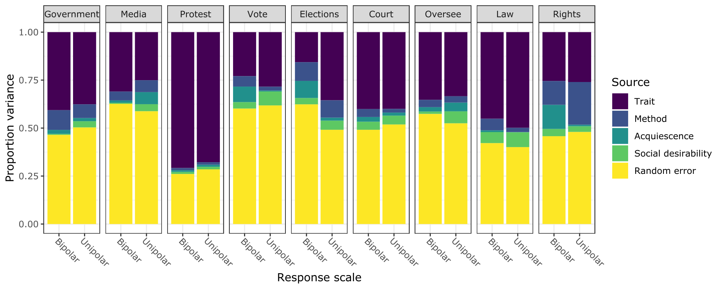
Figure A3. Variance decomposition based on MTME by statement and polarity.
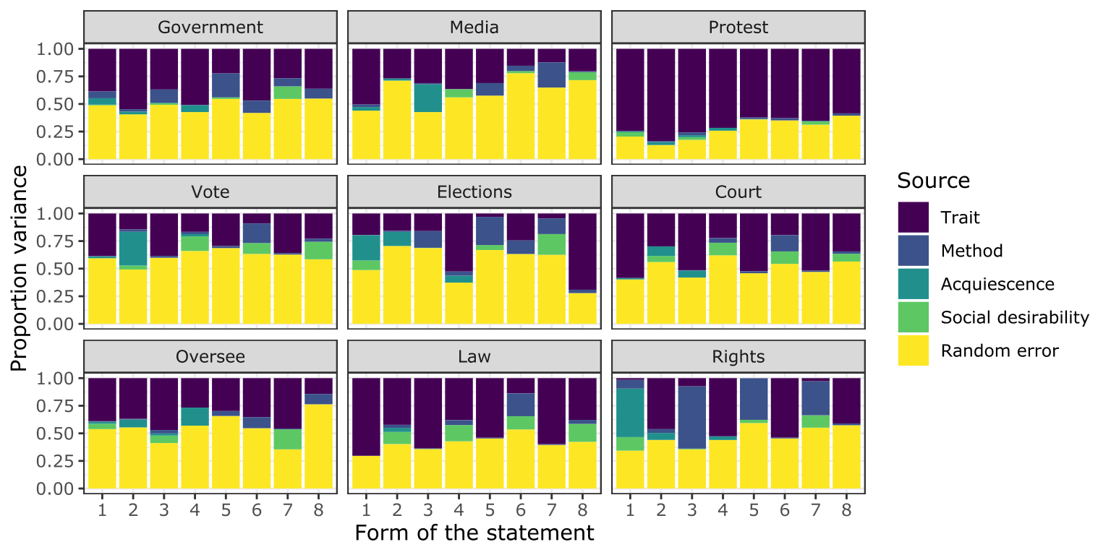
Figure A4. Variance decomposition based on MTME by statement and form.
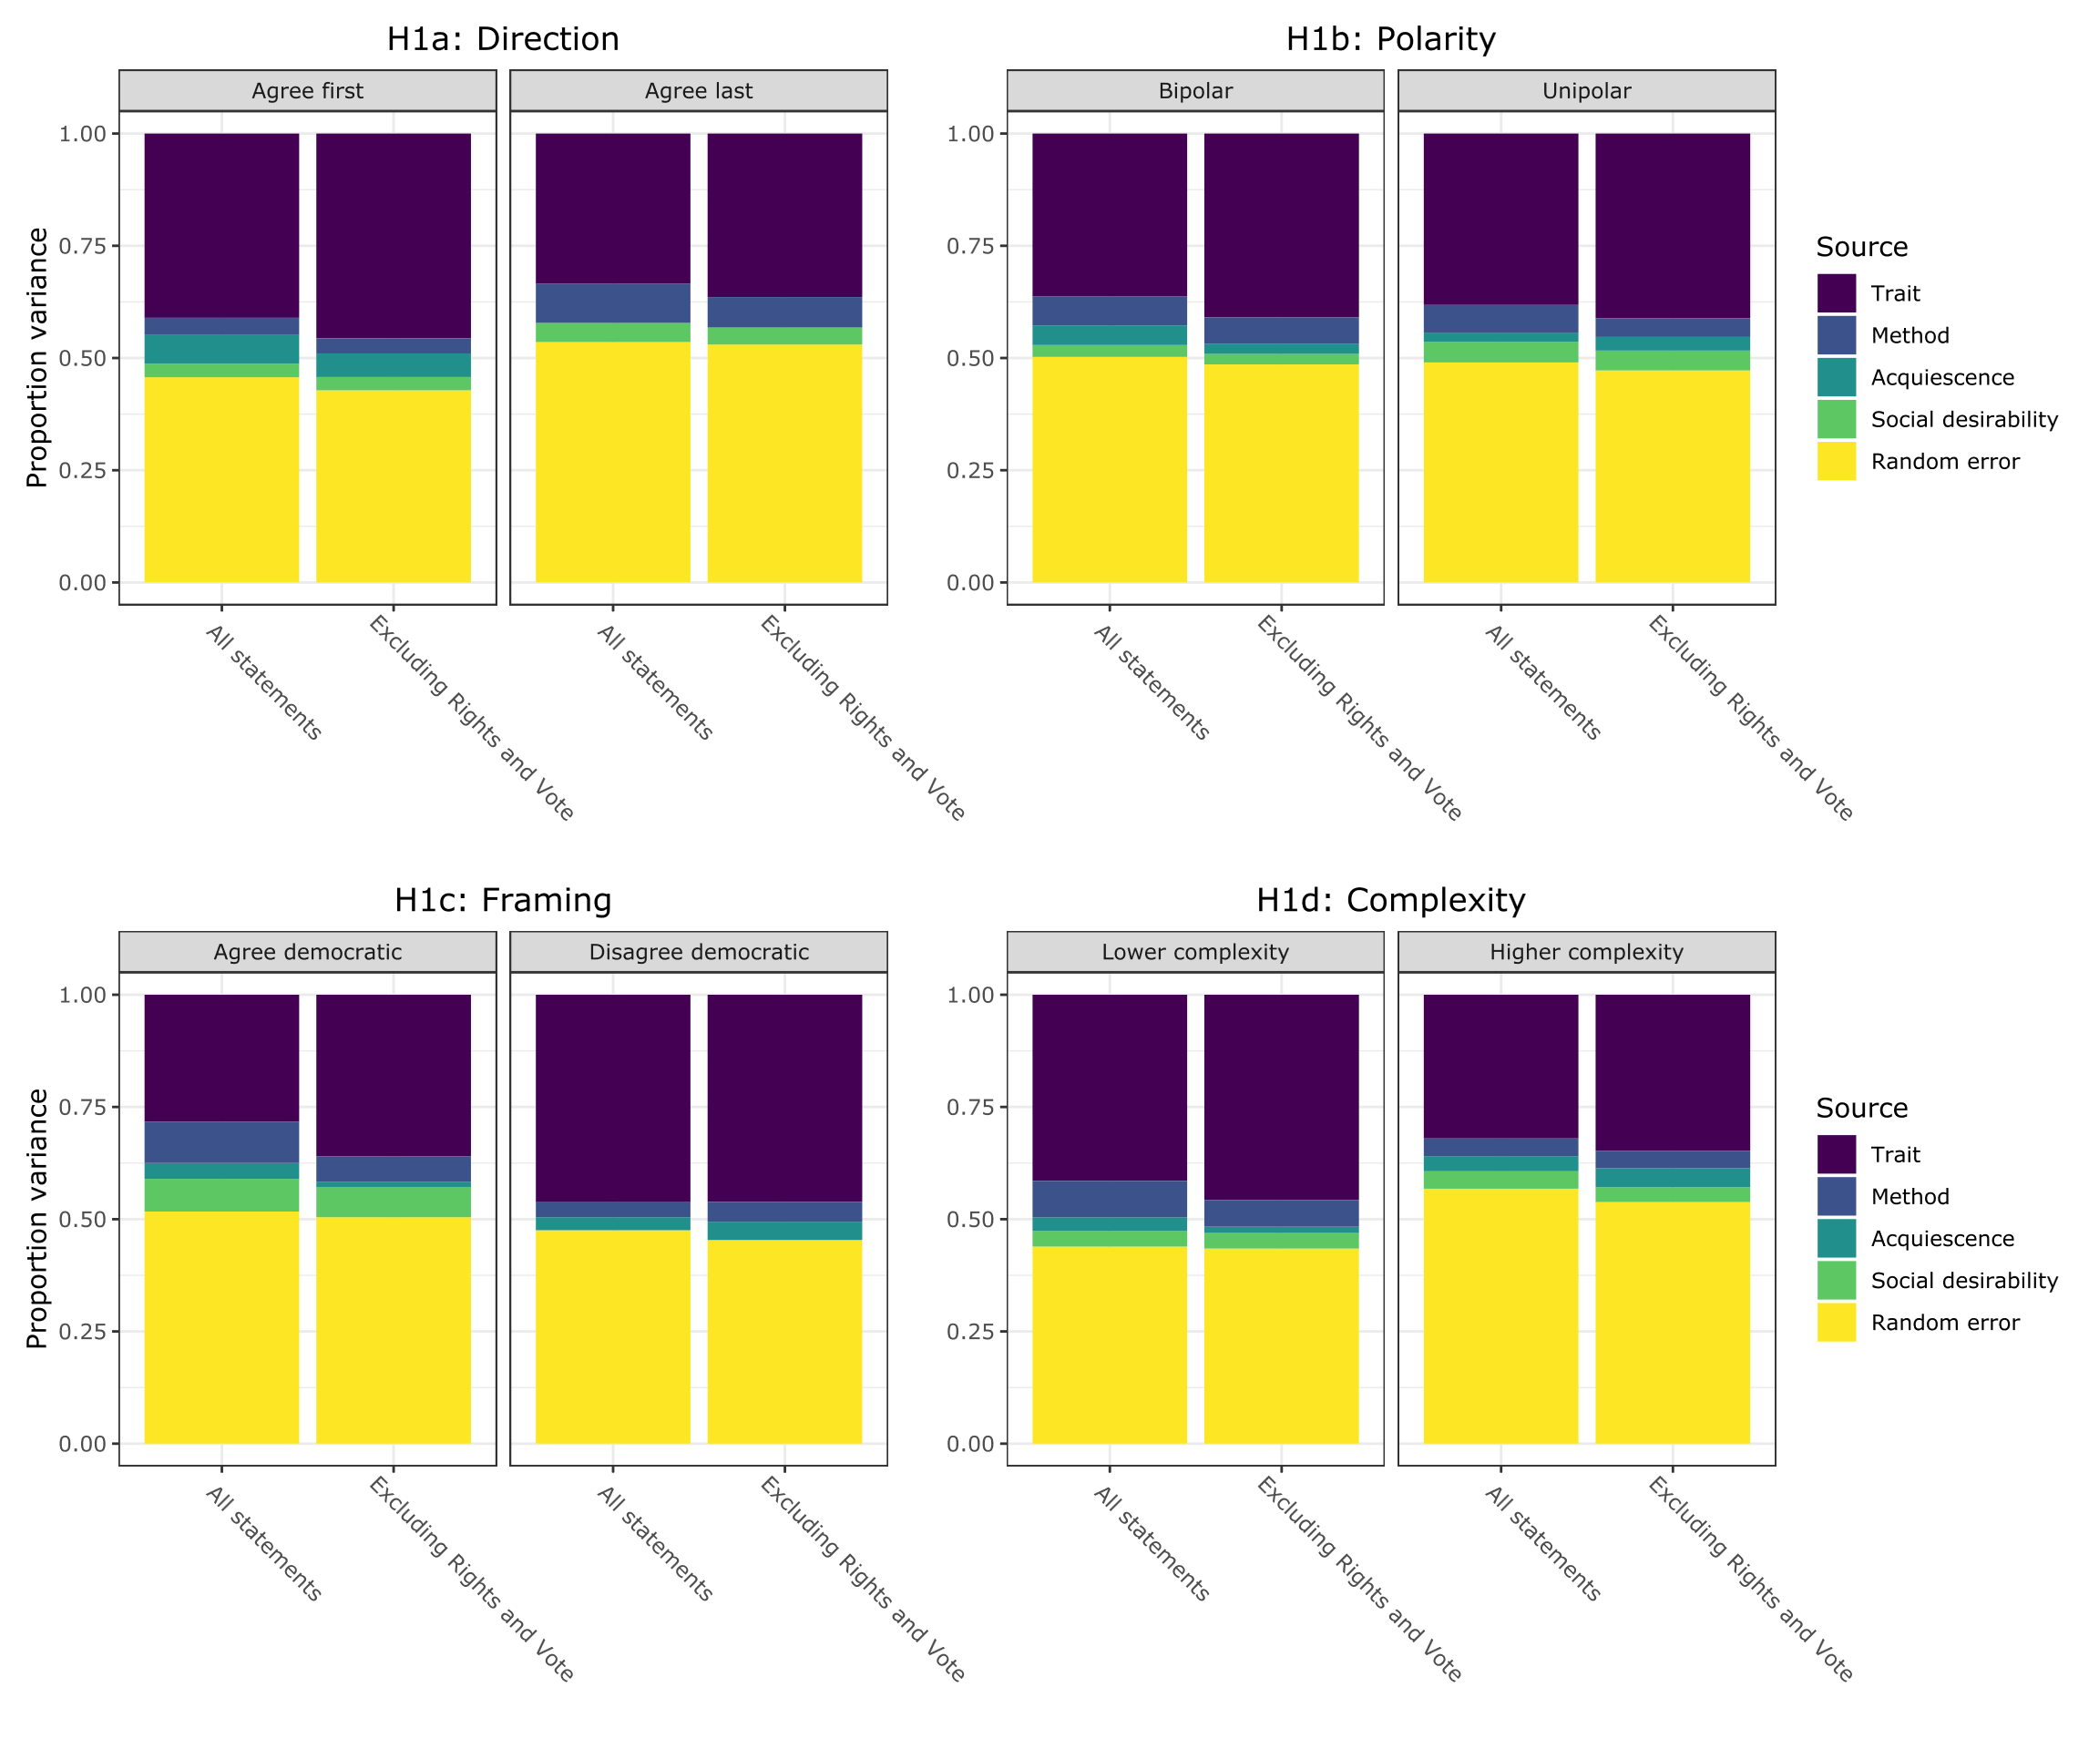
Figure A5. Robustness check comparing estimates with all statements and when excluding Rights and Vote.
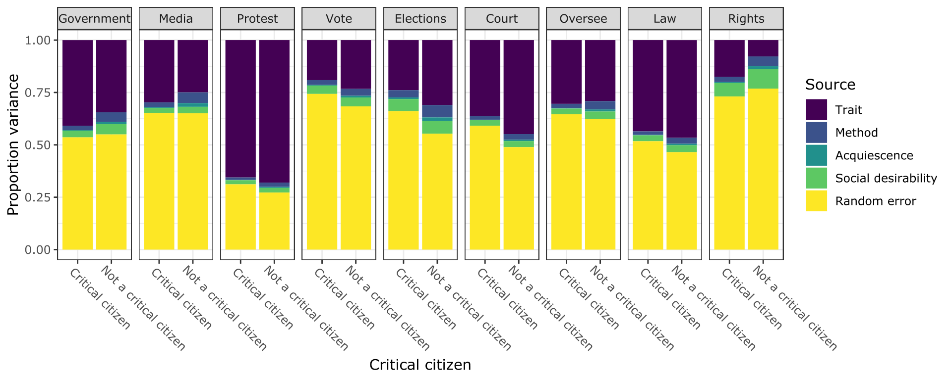
Figure A6. Variance decomposition based on MTME by statement and critical citizen classification.

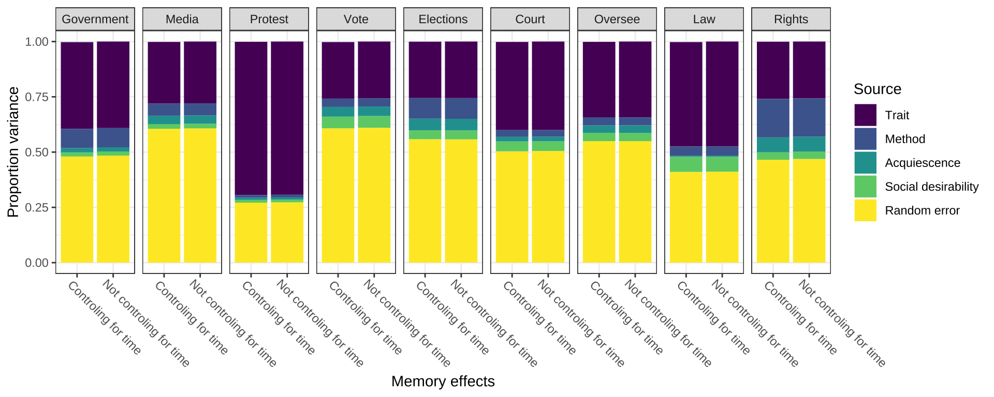
Figure A7. Sensitivity analysis: controlling for the number of days between interviews.

Table A7. Sensitivity analysis: correlating the social desirability latent variable with the MC-SDS and BFI-2 SF variables.
Measure | se | z | pvalue | std.all
Marlowe-Crowne SDS | 0.001 | -0.653 | 0.514 | -0.127
BFI: Extraversion | 0.001 | 0.613 | 0.540 | 0.054
BFI: Agreeableness | 0.001 | 0.675 | 0.499 | 0.131
BFI: Conscientiousness | 0.001 | -0.648 | 0.517 | -0.113
BFI: Negative emotionality | 0.000 | 0.476 | 0.634 | 0.028
BFI: Open-mindedness | 0.001 | 0.593 | 0.553 | 0.060

