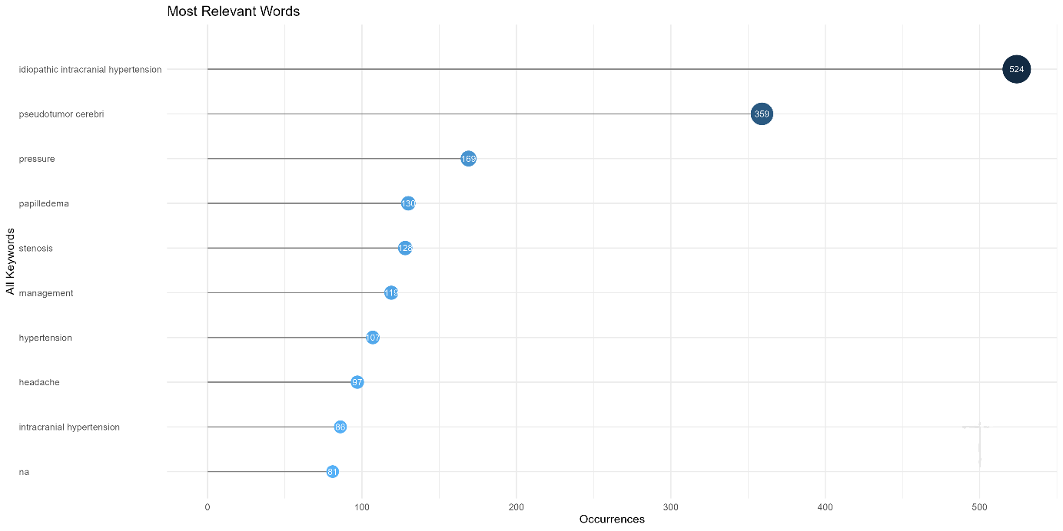
Figure S1a. Keyword Occurrences (2000–2024) Idiopathic intracranial hypertension' (n=524) and 'pseudotumor cerebri' (n=359) were the terms with the highest frequency. These were followed by clinical features (pressure, papilledema, headache) and pathophysiologic terms (stenosis, venous).
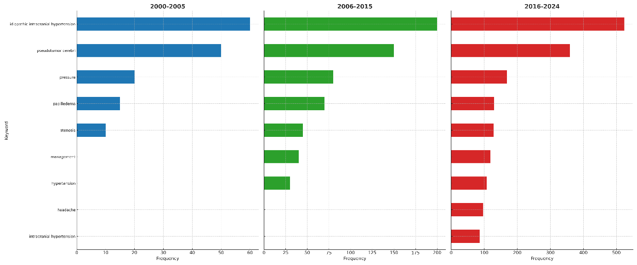
Figure S1b. Keyword frequency timeline (2000–2005, 2006–2015, 2016–2024).
Idiopathic intracranial hypertension' and 'pseudotumor cerebri' were the dominant terms in all periods. While only five terms were listed in the 2000-2005 period, nine terms appeared in the 2006-2015 and 2016-2024 periods. The terms 'management', 'hypertension' and 'headache' appeared in the middle period, while the term 'intracranial hypertension' became prominent in the last period.

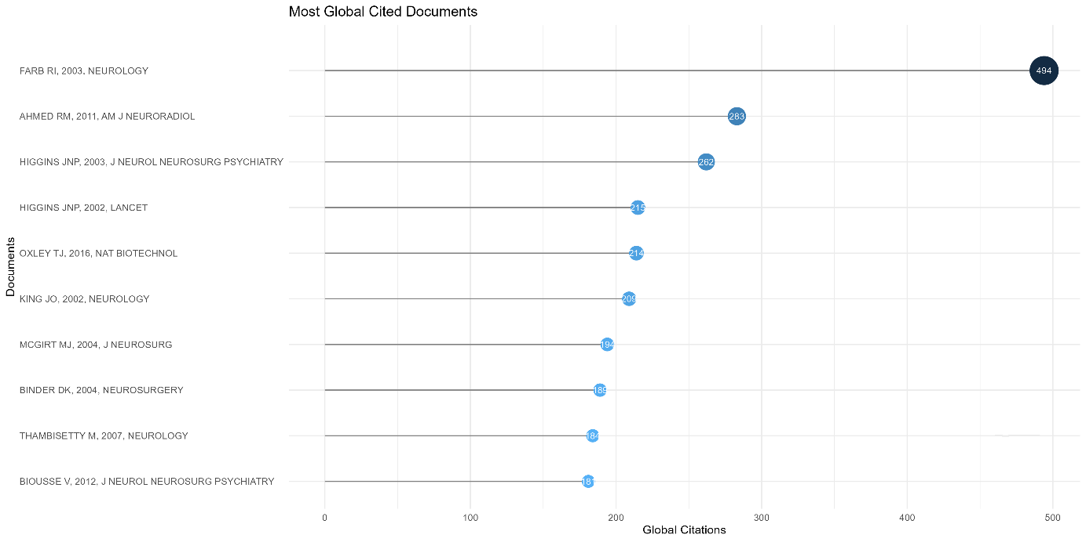

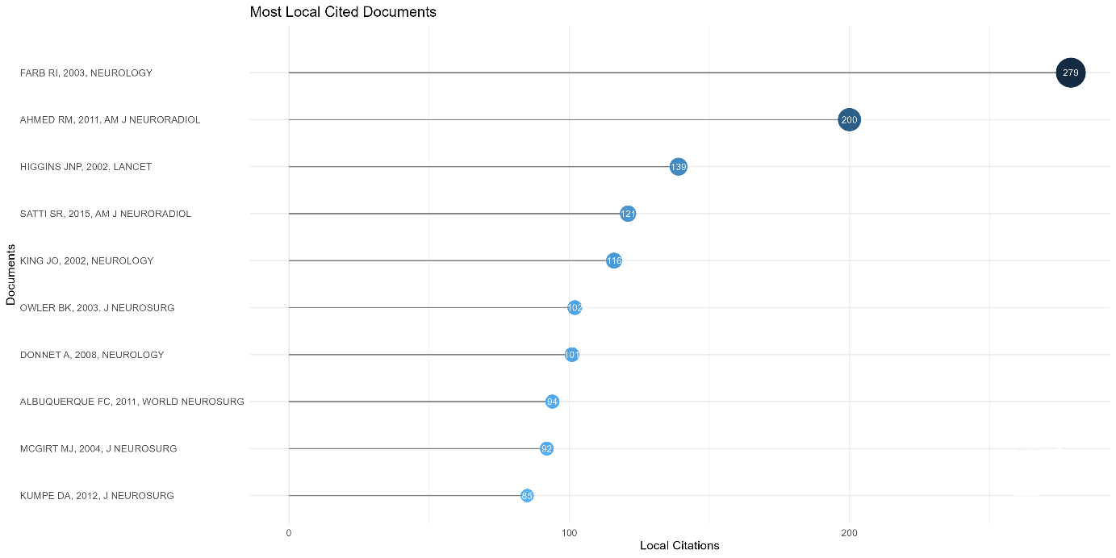
Figure S2. Most cited articles.
(a) Global citations: Total number of citations in all academic literature.
(b) Local citations: Citation counts in IIH literature (2000-2024).
Farb et al. (2003, Neurology) ranked first in both lists (global: 494 citations, local: 279 citations). Ahmed et al. (2011, AJNR) and Higgins et al. (2003, J Neurol Neurosurg Psychiatry) followed in global citations, while Friedman and Wall (2013, Neurology) and Digre et al. (2009, Neurology) stood out in local citations.
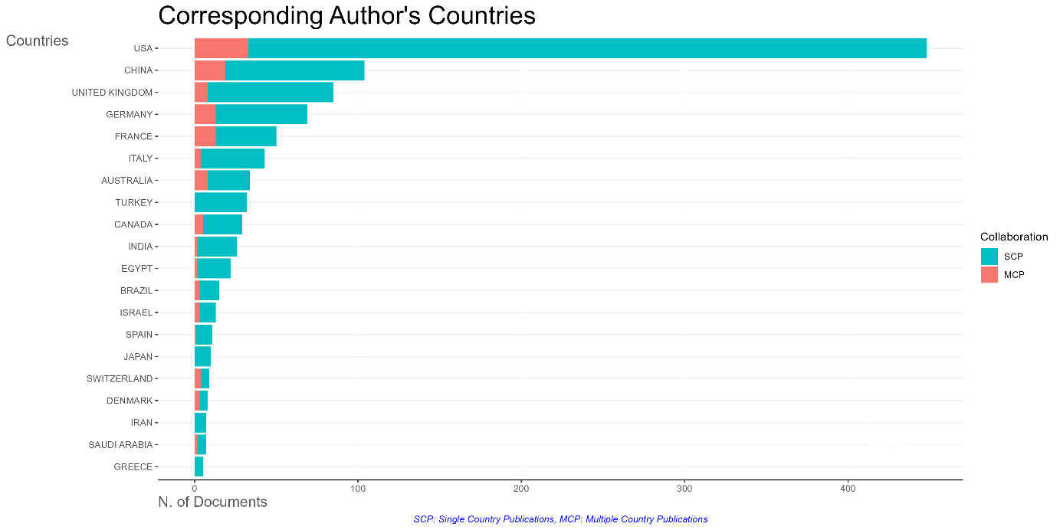
Figure S3. Country distribution of corresponding authors.
The number of publications and collaboration types by country are shown (SCP: single country publications, Single Country Publications; MCP: multi-country publications, Multiple Country Publications). The USA (n≈450), China (n≈100) and the UK (n≈80) had the highest number of publications. The US was dominated by SCP, while China and the UK had a higher proportion of MCP. Turkey ranked 7th in the number of publications
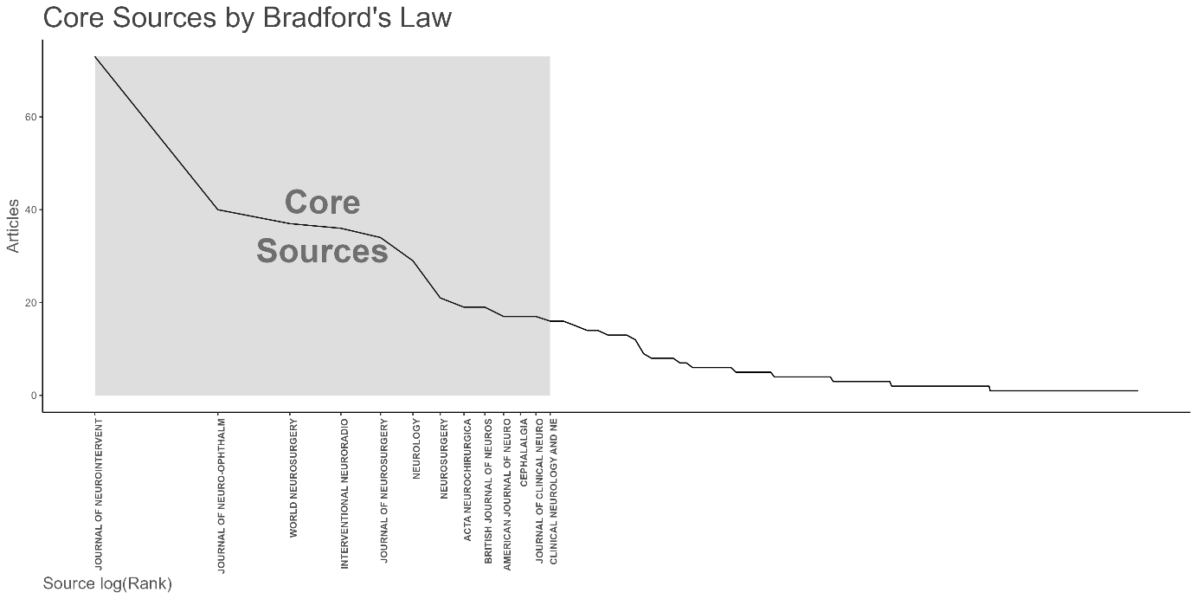
Figure S4. Bradford analysis of journal distribution. The Y-axis shows the number of articles and the X-axis shows the journals (sorted by number of publications). The core region (gray area) represents the most productive journals. The top 5-6 journals account for about one third (33%) of total publications.

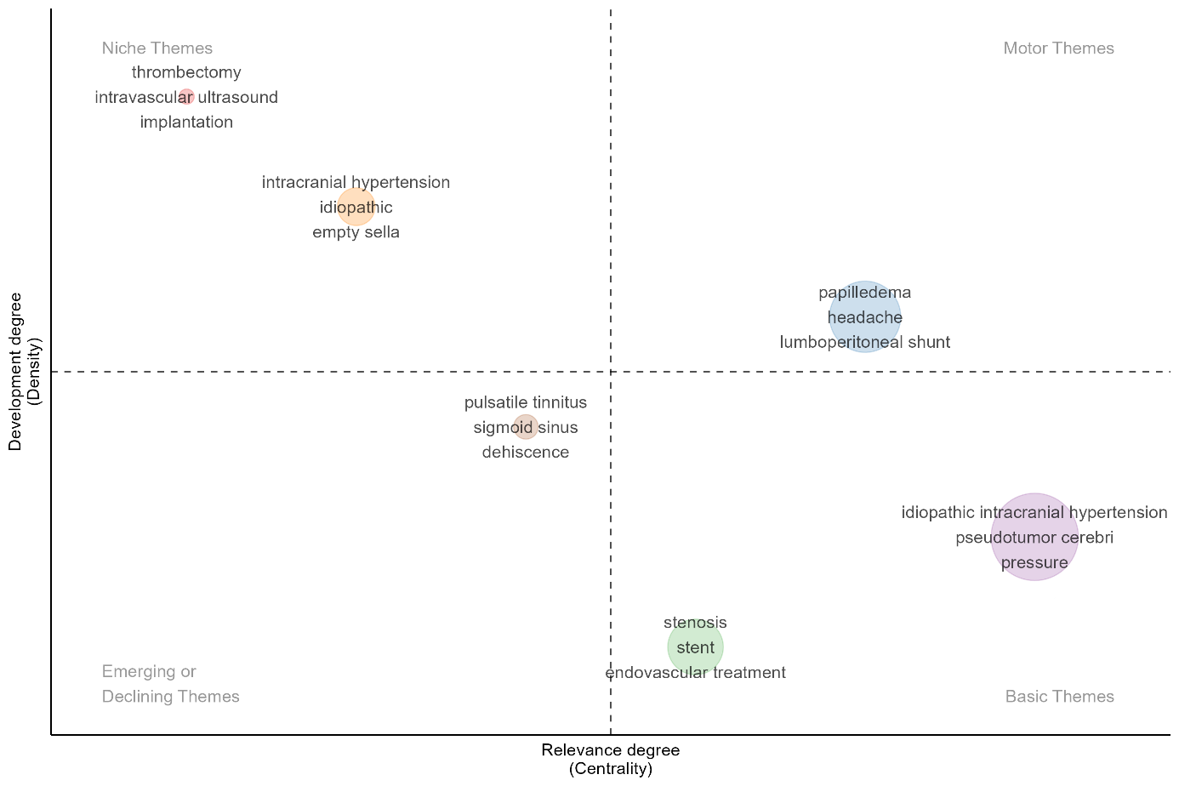
Figure S5. Temporal distribution of treatment approaches (2000–2024). The stacked area chart shows the proportional distribution of treatment modalities across five-year periods. In the 2000–2005 period, the ‘Other/mixed’ category constituted approximately 40%, while venous sinus stenting was seen at 30%, optic nerve sheath fenestration (ONSF) at 15%, cerebrospinal fluid (CSF) shunting at 10%, and medical treatment at 5%. By 2021–2024, venous sinus stenting had increased to its highest level at 45–50%, while CSF shunting remained stable at 10–15%, ONSF at 5–10%, and medical treatment at 3–5%.

