Supporting
Room Temperature long-wavelength infrared Sensitive Imaging Photodetection based on topological insulator Bi₂Te₃ nanoflakes
Sihang Liu¹, Dongbo Wang^{1, ✉} lijuan Liang^{7, ✉}, Chenchen Zhao^{2, ✉}, Donghao Liu¹, Bingke Zhang³, Jingwen Pan⁹, Xiangqun Chen¹, Xuxuan Yang¹, Hao Dang¹, Dong Li¹, Gang Liu^{4, ✉}, Dengkui Wang⁵, Dan Fang⁵, Fujun Liu^{5,✉}, Jiamu cao¹⁰, Ling Li¹⁰, Yufeng Zhang¹⁰, Dongwei Jiang^{6,✉}, Xuan Fang^{5, ✉}, Jiehe Sui¹, Liancheng Zhao¹, Zhichuan Niu⁶, Jiaqi Zhu^{8, ✉}

¹School of Materials Science and Engineering, Harbin Institute of Technology, Harbin 150001, China.
²School of Chemistry and Chemical Engineering, Henan University of Science and Technology, Luoyang, Henan 471023,China
³School of Materials Science and Engineering, University of Jinan, Jinan 250000, China.
⁴Center for High Pressure Science and Technology Advanced Research Shanghai 201203, China
⁵Changchun University Science and Technology, Sch Sci, State Key Lab High Power Semicond Lasers, Changchun 130022, People’s Republic of China
⁶Key Laboratory of Optoelectronic Materials and Devices, Chinese Academy of Sciences, institute of semiconductors, Beijing 100083, China
⁷Shanghai Institute of Microsystem and Information Technology, Chinese Academy of Sciences, Shanghai 200050, China
⁸Harbin Inst Technol, Ctr Composite Mat & Struct, Harbin 150080, Peoples R China
⁹School of Materials Science and Engineering, Henan University of Technology, Zhengzhou 450001, China
¹⁰Harbin Inst Technol, Sch Astronaut, Harbin 150001, Heilongjiang, Peoples R China
✉e-mail: wangdongbo@hit.edu.cn; llj@mail.sim.ac.cn; cczhaophd@haust.edu.cn; liugang@hpstar.ac.cn; fjliu@cust.edu.cn; jdw@semi.ac.cn; fangx@cust.edu.cn; zhujq@hit.edu.cn
Appendix 1: Calculation of single-particle eigen-energy and eigen-wavefunction from a tight-binding model
With the energies and wavefunctions obtained from DFT calculation, we develop a tight-binding (TB) model using the Wannier90 package [Mostofi A A, Yates J R, Pizzi G, Lee Y-S, Souza I, Vanderbilt D and Marzari N 2014 Computer Physics Communications 185 2309-10]. This maps the ground-state wave functions from the plane wave basis set onto a maximally localized Wannier function basis $\left|W_{ik}\right\rangle$, where $i=\left(I,α\right)$ is the composite index of the atomic orbit $α$ of an atom with atom site R. R = R_{a}a + R_{b}b + R_{c}c is the Bravais lattice vector with Ra/b/c being the Bravais lattice vector component in the direction of the unit cell lattice vector a/b/c. The Bloch function of TB model is thus given by:
$\left|ϕ_{ik}\right\rangle =\frac{1}{\sqrt{N}}\sum_{R}{e^{-ik⋅R}}\left|W_{ik}(r)\right\rangle$ (A1)
and elements of the TB Hamiltonian H^{TB} are given by:
$H_{ij}^{TB}\left(k\right)=\sum_{R}{e^{-ik⋅R}}t_{ij}\left(R\right)$ (A2)
where $t_{ij}\left(R\right)=\left\langle W_{i0}\left|H_{KS}\right|W_{jk}\right\rangle$ are the matrix element extracted from the Wannier90 output file, with H_{KS} being the Hamiltonian of the Kohn-Sham equation.

Appendix 2: Calculation of excitonic bandstructure
With single-particle eigenvalues and wavefunctions of the single particle from TB model, we calculate excitonic states through many-body problem using Bethe–Salpeter equation (BSE) [Cutkosky R E 1954 Phys Rev 96 1135-41; Carbonell J and Karmanov V A 2010 The European Physical Journal A 46 387-97]. An exciton state$|Ψ_{s}\left(Q\right)$ is a coherent superposition of hole (with crystal momentum k) and electron (with crystal momentum $k+Q$) states from band-pairs (υ, c) in the reciprocal space and can be written as:
$|Ψ_{s}\left(Q\right)=\sum_{c,υ,k}{A_{c,υ,k,Q}^{S}\left|ϕ_{c,k+Q}\right\rangle |ϕ_{υ,k}⟩}$ (A3)
where S and Q are the exciton band index and the center-of-mass momentum, respectively, and $A_{c,υ,k,Q}^{S}$ is the coordinate. The exciton eigenvalue problem in the basis displayed in Eq. (A3) leads to the following BSE:
$E_{S}(Q)=(E_{c,k,+Q}-E_{υ,k}){}_{\left(k,υ,c\right)\left(k^{'},υ^{'},c^{'}\right)}+\frac{1}{A}\sum_{k^{'},υ^{'},c^{'}}{W_{\left(k,υ,c\right)\left(k^{'},υ^{'},c^{'}\right),Q}A_{c^{'},υ^{'},k^{'},Q}^{S}}$ (A4)
where ${A=A}_{c}N_{k}^{2}$ is the total area of the crystal, with $A_{c}={\sqrt{3}a^{2}}/2$ and $a$ being the lattice constant, $E_{c/v,k}$ is the eigenvalue of TB model with the momentum $k$, $W_{\left(k,υ,c\right)\left(k^{'},υ^{'},c^{'}\right),Q}$ represents the matrix element of the many-body Coulomb potential including direct $W_{ }^{d}$and $W_{ }^{x}$ exchange terms, and $E_{S}(Q)$ is the exciton energy of the S^{th} state with the center-of-mass momentum Q.
To simplify the calculation, we apply the Tamm-Dancoff approximation [ So Hirata and Head-Gordon M 1999 Chem Phys Lett 314 291-299] to the many-body Coulomb potential, which neglects the orbital character of the Coulomb interaction. In this case $W_{\left(k,υ,c\right)\left(k^{'},υ^{'},c^{'}\right),Q}^{d}$ and $W_{\left(k,υ,c\right)\left(k^{'},υ^{'},c^{'}\right),Q}^{x}$ are given by
$W_{\left(k,υ,c\right)\left(k^{'},υ^{'},c^{'}\right),Q}^{d}=V_{k-k^{'}}c,k+Q\left|c^{'},k^{'}+Qυ,k\right|υ^{'},k^{'}$ (A5)
and
$W_{\left(k,υ,c\right)\left(k^{'},υ^{'},c^{'}\right),Q}^{x}=V_{Q}c,k+Q\left|υ,kυ^{'},k^{'}\right|υ^{'},k^{'}+Q$ (A6)
with
$V_{Q}=-\frac{e^{2}}{2ε_{0}ε_{d}\left|Q\right|\left(1+r_{0}\left|Q\right|\right)}$ (A7)
where $ε_{0/d}$ is the vacuum/effective dielectric constant, and $r_{0}$represents a characteristic length.

Appendix 3: Calculations of the surface local density of states.(LDOS) of related energy spectrum
To investigate the superconducting or magnetic proximity effects in Bi₂Te₃ crystals, it is necessary to adopt open boundary conditions to model the material’s surface or interface. For convenience, the three-dimensional vector R is decomposed into a longitudinal component $R_{⊥}$, perpendicular to the material surface, and a transverse component $R_{∥}$, parallel to the surface. After applying open boundary conditions along the $R_{⊥}$ direction, a two-dimensional thin-film system is formed, in which only the in-plane $R_{⊥}$ direction remains periodic.
In general, experimentally cleavable planes often conflict with the primitive lattice vectors obtained from first-principles calculations. Therefore, it becomes necessary to redefine the basis vectors R′₁, R′₂, and R′₃ as follows:

R′₁ = U₁₁R₁ + U₁₂R₂ + U₁₃R₃
R′₂ = U₂₁R₁ + U₂₂R₂ + U₂₃R₃
R′₃ = U₃₁R₁ + U₃₂R₂ + U₃₃R₃ (A8)
where R′₁ and R′₂ form the transverse vector $R_{⊥}$, while R′₃ corresponds to $R_{⊥}$. Using the basis vector transformation matrix U, the physical properties of arbitrary cleavage surfaces can be systematically studied.
In this project, the Hamiltonian of the resulting two-dimensional Bi₂Te₃ crystal is obtained by imposing open boundary conditions along the R′₃ direction and performing a Fourier transform along the periodic directions:

$H_{ij}^{2D}\left(k_{‖}\right)=\sum_{R^{'}}{H_{ij}^{TB}\left(R^{'}\right)e^{-ik_{‖}R^{'}}}$ (A9)

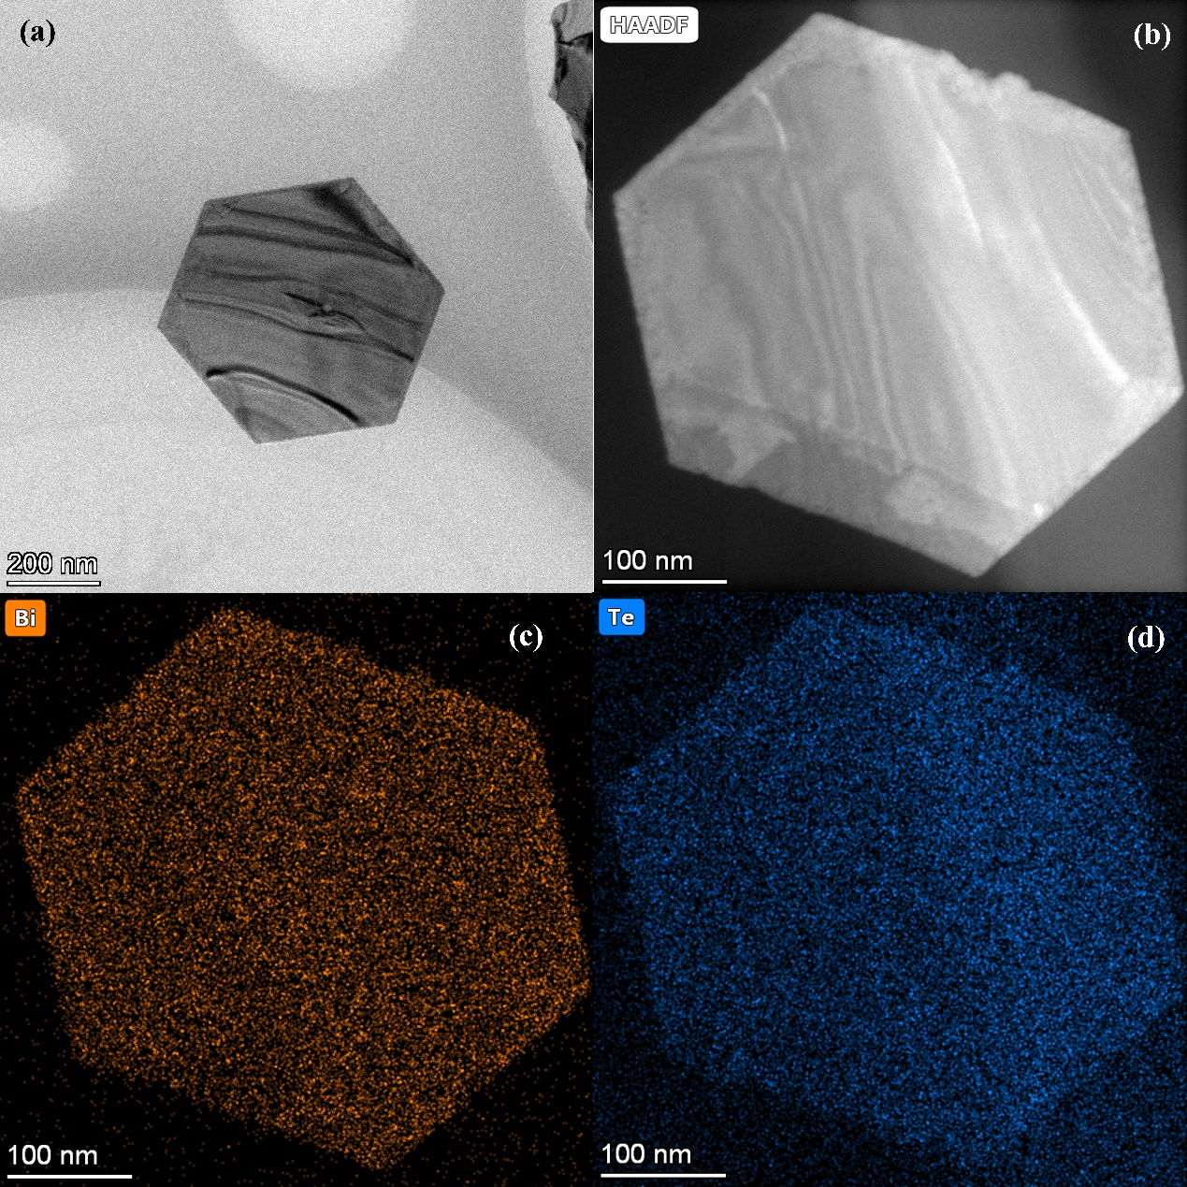
Figure S1 (a, b)TEM and (c, d) multi-element mappings of the synthesis samples of Bi₂Te₃.

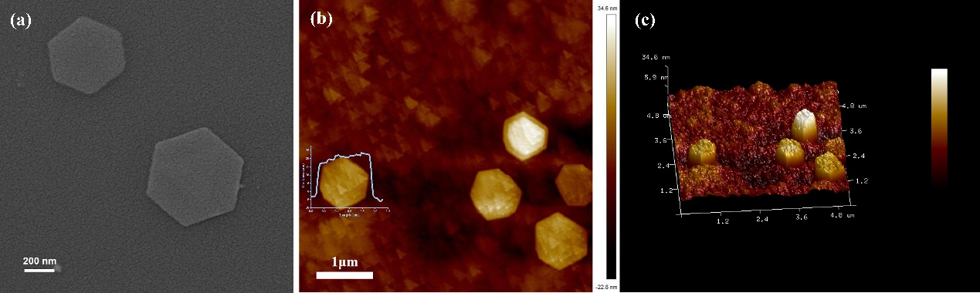
Figure S2 (a)SEM and (b, c) AFM of the synthesis samples of Bi₂Te₃.

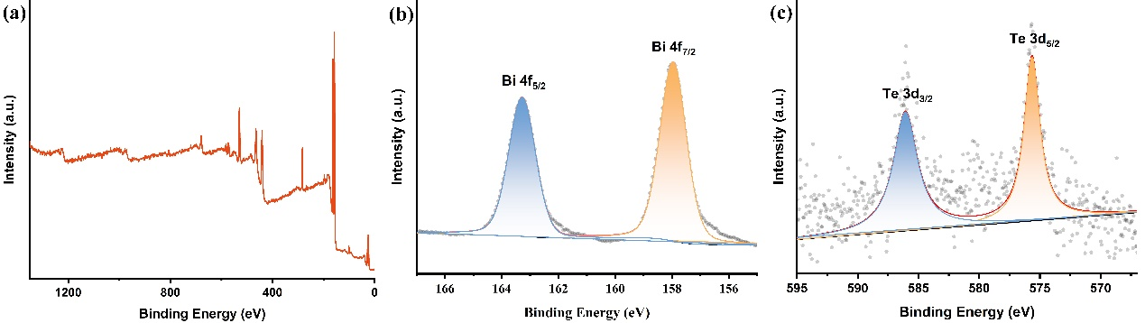
Figure S3 (a) XPS survey of Bi₂Te₃. (b, c) XPS fine spectra of elemental Bi and Te in Bi₂Te₃.
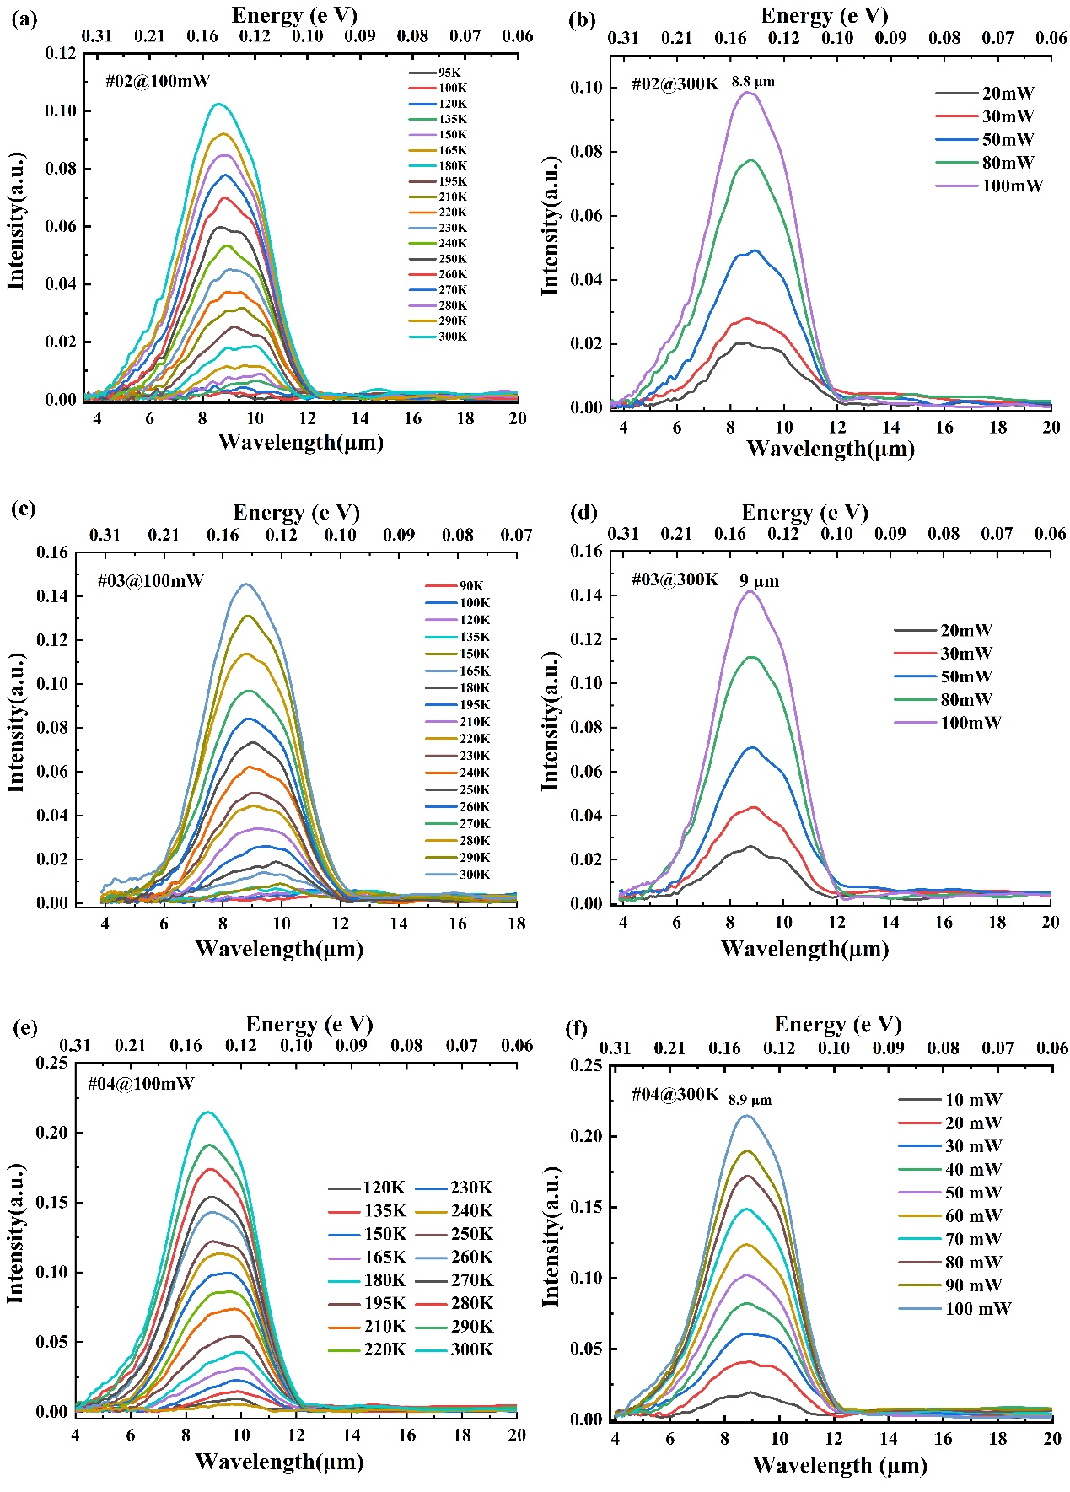
Figure S4 (a, c, e) Variable temperature PL of Bi₂Te₃ and (b, d, f) Variable power PL of Bi₂Te₃ which be prepared in different batches.
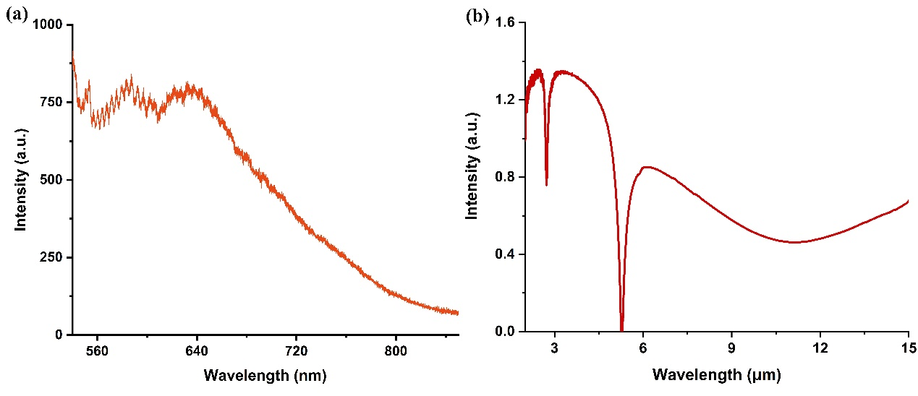
Figure S5 Absorption spectra of Bi₂Te₃ (a) in the visible light and (b) in the infrared light.

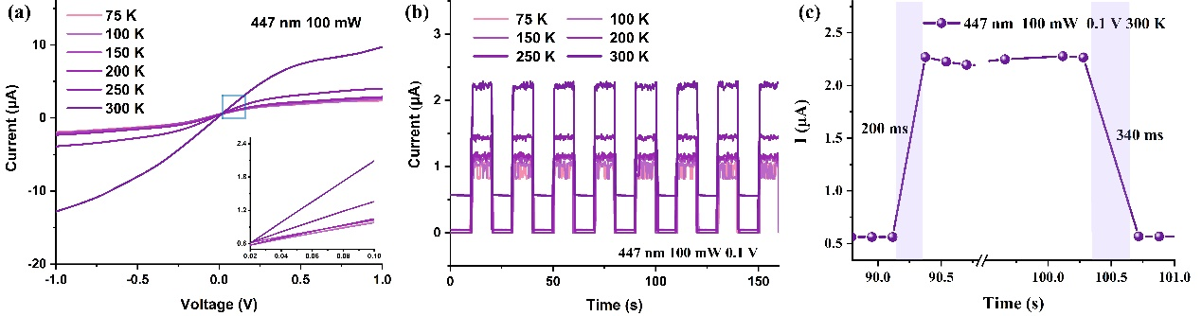
Figure S6 Under the excitation of a 447 nm laser (a) I-V characteristics. (b) photocurrent response of the Bi₂Te₃-based device. (c) Response time characteristics of the device.

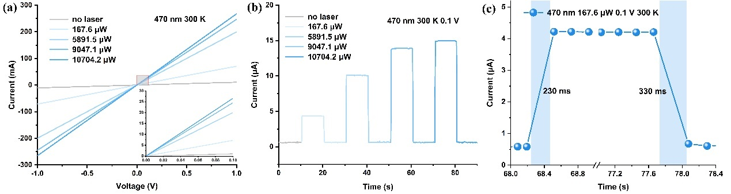
Figure S7 Under the excitation of a 470 nm laser (a) I-V characteristics. (b) photocurrent response of the Bi₂Te₃-based device. (c) Response time characteristics of the device.

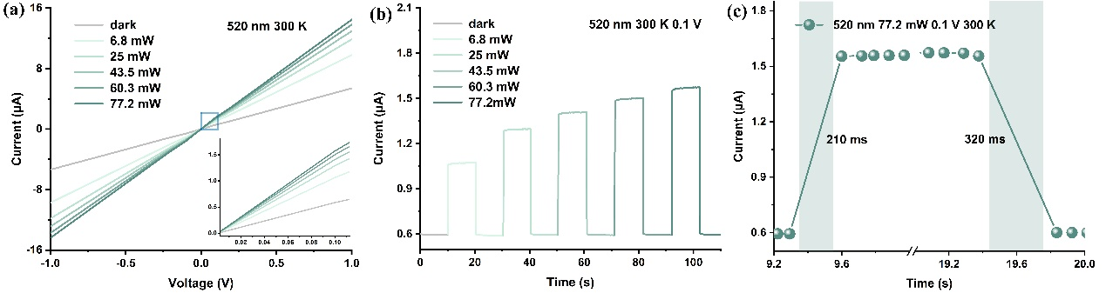
Figure S8 Under the excitation of a 520 nm laser (a) I-V characteristics. (b) photocurrent response of the Bi₂Te₃-based device. (c) Response time characteristics of the device.
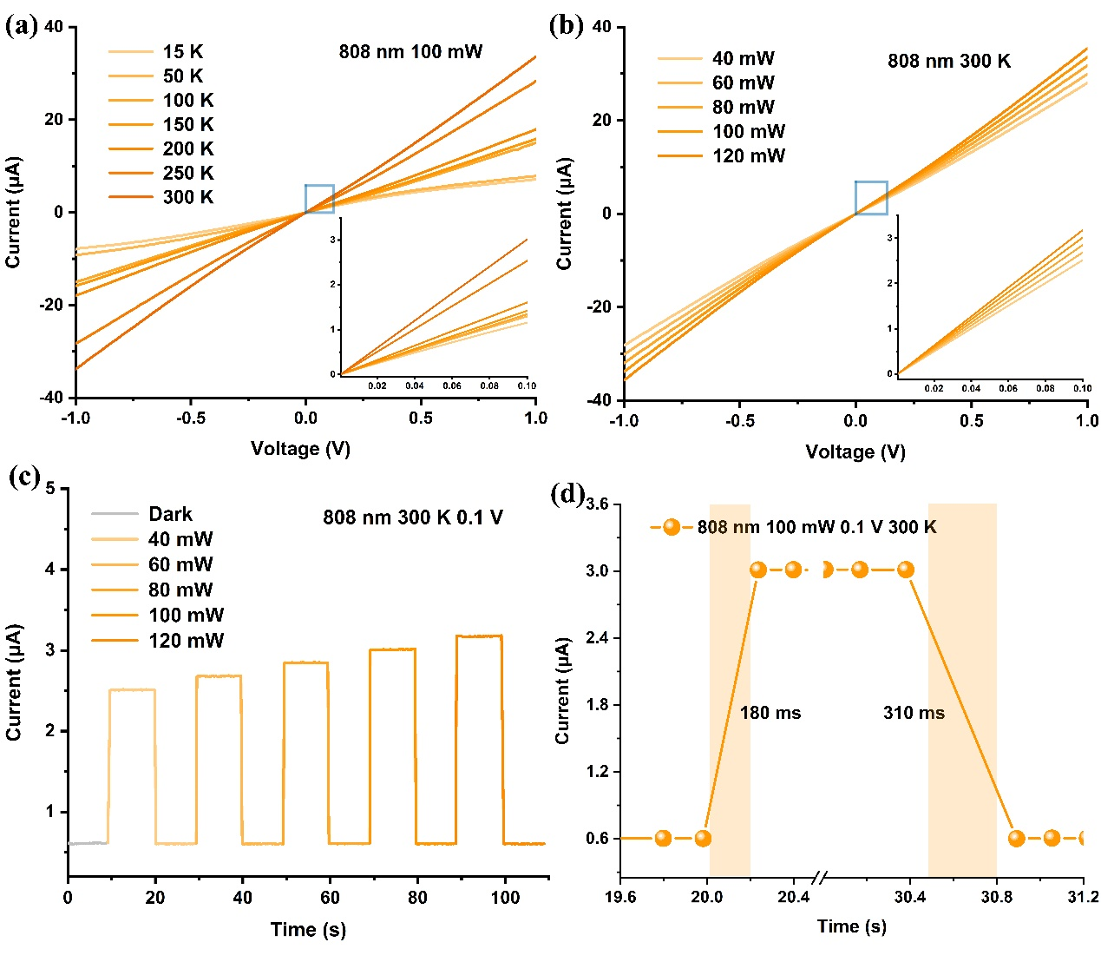
Figure S9 Under the excitation of a 808 nm laser (a) I-V characteristics at different temperature. (b) I-V characteristics at different power. (c) Photocurrent response of the Bi₂Te₃-based device. (d) Response time characteristics of the device.
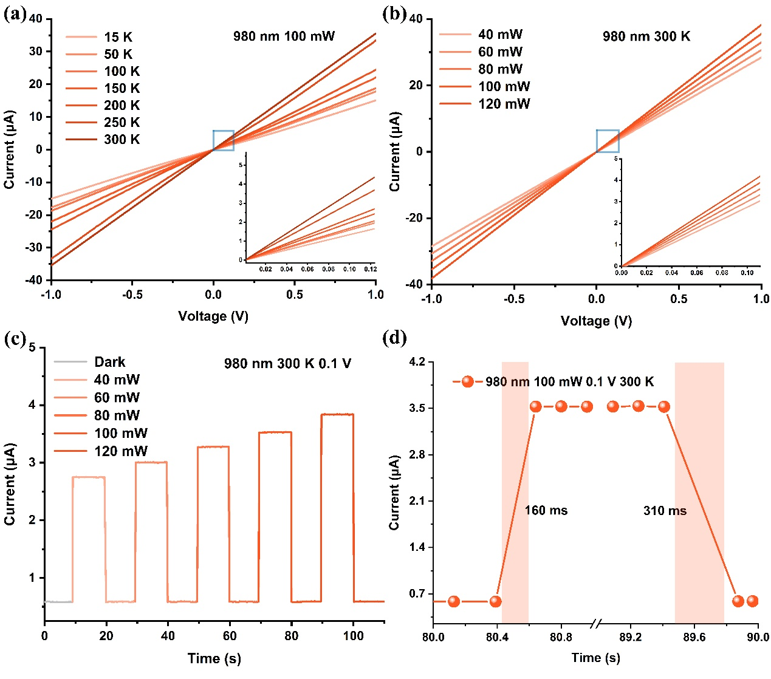
Figure S10 Under the excitation of a 980 nm laser (a) I-V characteristics at different temperature. (b) I-V characteristics at different power. (c) Photocurrent response of the Bi₂Te₃-based device. (d) Response time characteristics of the device.
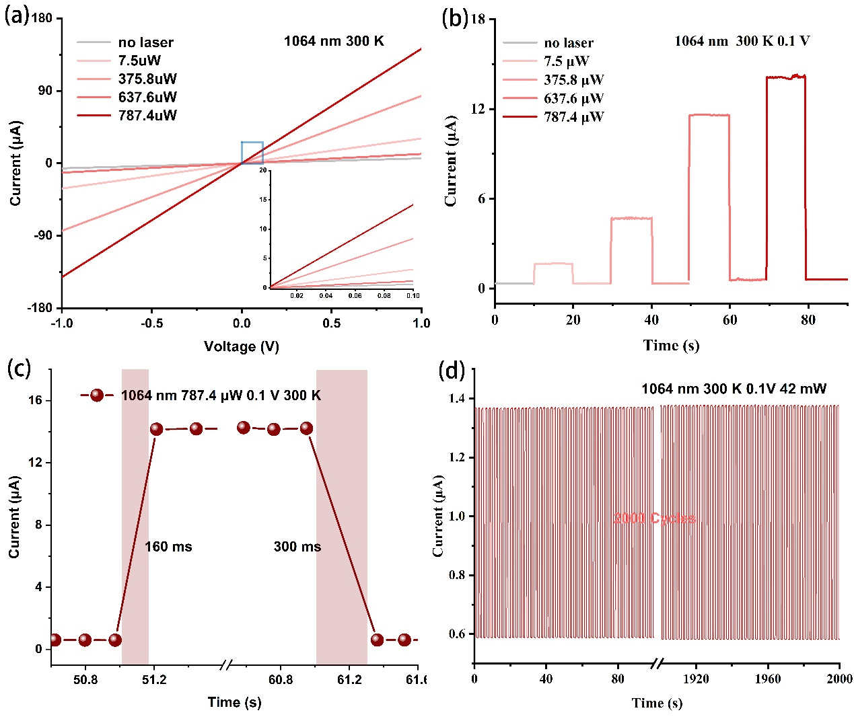
Figure S11 Under the excitation of a 1064 nm laser (a) I-V characteristics. (b) Photocurrent response of the Bi₂Te₃-based device. (c) Response time characteristics of the device. (d) Cycling test of photocurrent response.

Table S1 The on/off ratio, R_{i}, D* and EQE values of each laser at different temperatures.
Laser | Temperature (K) | on/off ratio | R_{i} (mA/W) | D* (Jones) | EQE (%)
447 nm  100 mW  0.1 V | 75 | 1844 | 5.75938E-5 | 1.82127E9 | 6.75029E-4
447 nm  100 mW  0.1 V | 100 | 2060 | 6.43438E-5 | 2.03473E9 | 7.54142E-4
447 nm  100 mW  0.1 V | 150 | 2280 | 7.12188E-5 | 2.25213E9 | 8.34721E-4
447 nm  100 mW  0.1 V | 200 | 236 | 7.34375E-5 | 7.34375E8 | 8.60726E-4
447 nm  100 mW  0.1 V | 250 | 30.20833 | 8.7625E-5 | 2.82808E8 | 1.02701E-3
447 nm  100 mW  0.1 V | 300 | 3.98214 | 1.04375E-4 | 9.86251E7 | 1.22333E-3
808 nm  100 mW  0.1 V | 15 | 13008.13008 | 9.99923E-5 | 6.37528E9 | 1.17196E-3
808 nm  100 mW  0.1 V | 50 | 9847.32824 | 8.06168E-5 | 4.98052E9 | 9.44871E-4
808 nm  100 mW  0.1 V | 100 | 9310.34483 | 8.43659E-5 | 4.95414E9 | 9.88813E-4
808 nm  100 mW  0.1 V | 150 | 2572.46377 | 8.87155E-5 | 2.67002E9 | 1.03979E-3
808 nm  100 mW  0.1 V | 200 | 309.61538 | 1.003E-4 | 9.83522E8 | 1.17557E-3
808 nm  100 mW  0.1 V | 250 | 27.74123 | 1.52425E-4 | 3.56898E8 | 1.7865E-3
808 nm  100 mW  0.1 V | 300 | 5.01661 | 1.51125E-4 | 1.37728E8 | 1.77126E-3
980 nm  100 mW  0.1 V | 15 | 12053.57143 | 8.4368E-5 | 5.63707E9 | 9.88837E-4
980 nm  100 mW  0.1 V | 50 | 12248.06202 | 9.87419E-5 | 6.1474E9 | 1.15731E-3
980 nm  100 mW  0.1 V | 100 | 11586.2069 | 1.04991E-4 | 6.16528E9 | 1.23055E-3
980 nm  100 mW  0.1 V | 150 | 3955.82329 | 1.23094E-4 | 3.90038E9 | 1.44272E-3
980 nm  100 mW  0.1 V | 200 | 479.21225 | 1.36589E-4 | 1.42871E9 | 1.6009E-3
980 nm  100 mW  0.1 V | 250 | 34.97653 | 1.80925E-4 | 4.38292E8 | 2.12053E-3
980 nm  100 mW  0.1 V | 300 | 6.05128 | 1.84688E-4 | 1.70744E8 | 2.16463E-3

Table S2 The on/off ratio, R_{i}, D* and EQE values of each laser at different power.
Laser | Power density | on/off ratio | R_{i} (mA/W) | D* (Jones) | EQE (%)
470 nm  300 K  0.1 V | 167.6 μW | 7.21667 | 0.1391 | 1.26977E11 | 1.63
470 nm  300 K  0.1 V | 5891.5 μW | 16.71667 | 0.01 | 9.1322E9 | 0.117
470 nm  300 K  0.1 V | 9047.1 μW | 23.15 | 0.00918 | 8.38118E9 | 0.108
470 nm  300 K  0.1 V | 10704.2 μW | 24.91667 | 0.00838 | 7.64869E9 | 9.8203E-2
520 nm  300 K  0.1 V | 6.8 mW | 1.78333 | 4.31985E-4 | 3.94347E8 | 5.06309E-3
520 nm  300 K  0.1 V | 25 mW | 2.16667 | 1.75E-4 | 1.59752E8 | 2.05109E-3
520 nm  300 K  0.1 V | 43.5 mW | 2.35 | 1.16379E-4 | 1.06239E8 | 1.36403E-3
520 nm  300 K  0.1 V | 60.3 mW | 2.5 | 9.32836E-5 | 8.51559E7 | 1.09333E-3
520 nm  300 K  0.1 V | 77.2 mW | 2.61667 | 7.85298E-5 | 7.16876E7 | 9.2041E-4
808 nm  300 K  0.1 V | 40 mW | 4.16667 | 2.96875E-4 | 2.71009E8 | 3.47953E-3
808 nm  300 K  0.1 V | 60 mW | 4.46667 | 2.16667E-4 | 1.97789E8 | 2.53945E-3
808 nm  300 K  0.1 V | 80 mW | 4.73333 | 1.75E-4 | 1.59752E8 | 2.05109E-3
808 nm  300 K  0.1 V | 100 mW | 5.01667 | 1.50625E-4 | 1.37501E8 | 1.7654E-3
808 nm  300 K  0.1 V | 120 mW | 5.3 | 1.34375E-4 | 1.22667E8 | 1.57494E-3
980 nm  300 K  0.1 V | 40 mW | 4.58333 | 3.35937E-4 | 3.06668E8 | 3.93736E-3
980 nm  300 K  0.1 V | 60 mW | 5 | 2.5E-4 | 2.28218E8 | 2.93013E-3
980 nm  300 K  0.1 V | 80 mW | 5.46667 | 2.09375E-4 | 1.91132E8 | 2.45398E-3
980 nm  300 K  0.1 V | 100 mW | 5.88333 | 1.83125E-4 | 1.67169E8 | 2.14632E-3
980 nm  300 K  0.1 V | 120 mW | 6.41667 | 1.69271E-4 | 1.54522E8 | 1.98394E-3
1064 nm  300 K  0.1 V | 7.5 μW | 4.1 | 3.35937E-4 | 1.1553E12 | 12.111
1064 nm  300 K  0.1 V | 375.8μW | 11.75 | 2.5E-4 | 7.99552E10 | 0.838
1064 nm  300 K  0.1 V | 637.6μW | 19.33333 | 2.09375E-4 | 9.84314E10 | 1.264
1064 nm  300 K  0.1 V | 787.4μW | 23.66667 | 1.83125E-4 | 9.85446E10 | 1.265
10.6 μm  300 K  1 V | 60 mW | 1.86408 | 0.00221 | 3.1503E8 | 2.58462E-2
10.6 μm  300 K  1 V | 80 mW | 1.89879 | 0.00173 | 2.46763E8 | 2.03278E-2
10.6 μm  300 K  1 V | 100 mW | 1.93952 | 0.00146 | 2.07612E8 | 1.7068E-2
10.6 μm  300 K  1 V | 120 mW | 1.94444 | 0.00124 | 1.74607E8 | 1.45286E-2
10.6 μm  300 K  1 V | 140 mW | 1.95402 | 0.00111 | 1.53857E8 | 1.30286E-2
10.6 μm  300 K  1 V | 160 mW | 2.04183 | 0.00107 | 1.47577E8 | 1.25446E-2
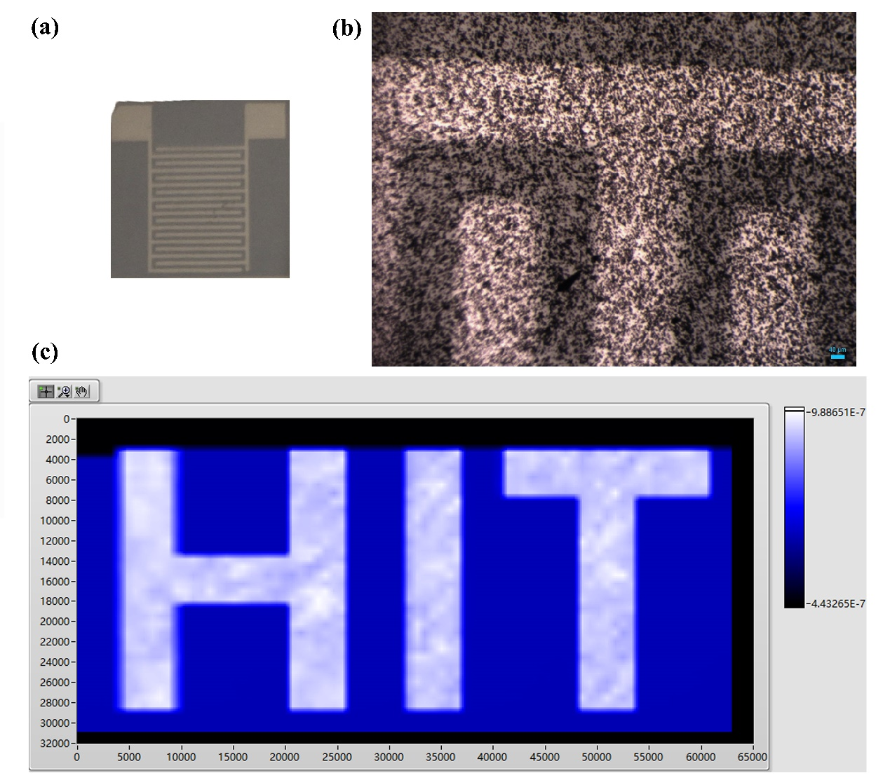
Figure S11 Picture of the Bi₂Te₃-based device. (b) Optical photograph of the electrode. (c) “HIT” pixel images under the excitation of a 1064 nm laser.

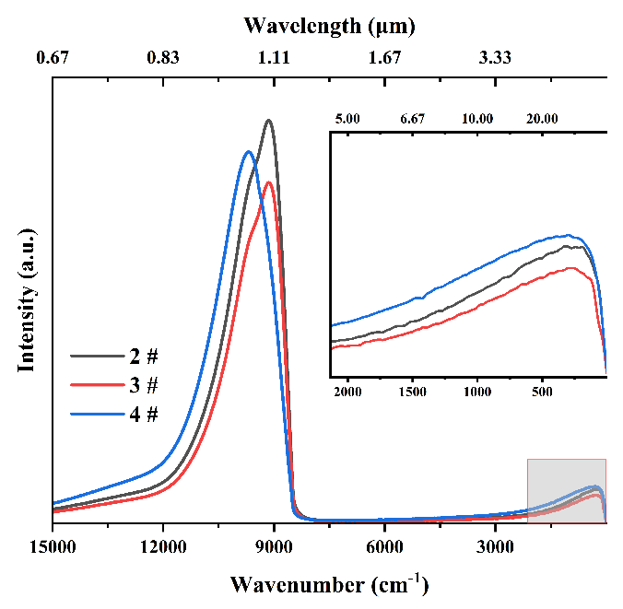
Figure S12 Response spectrum.
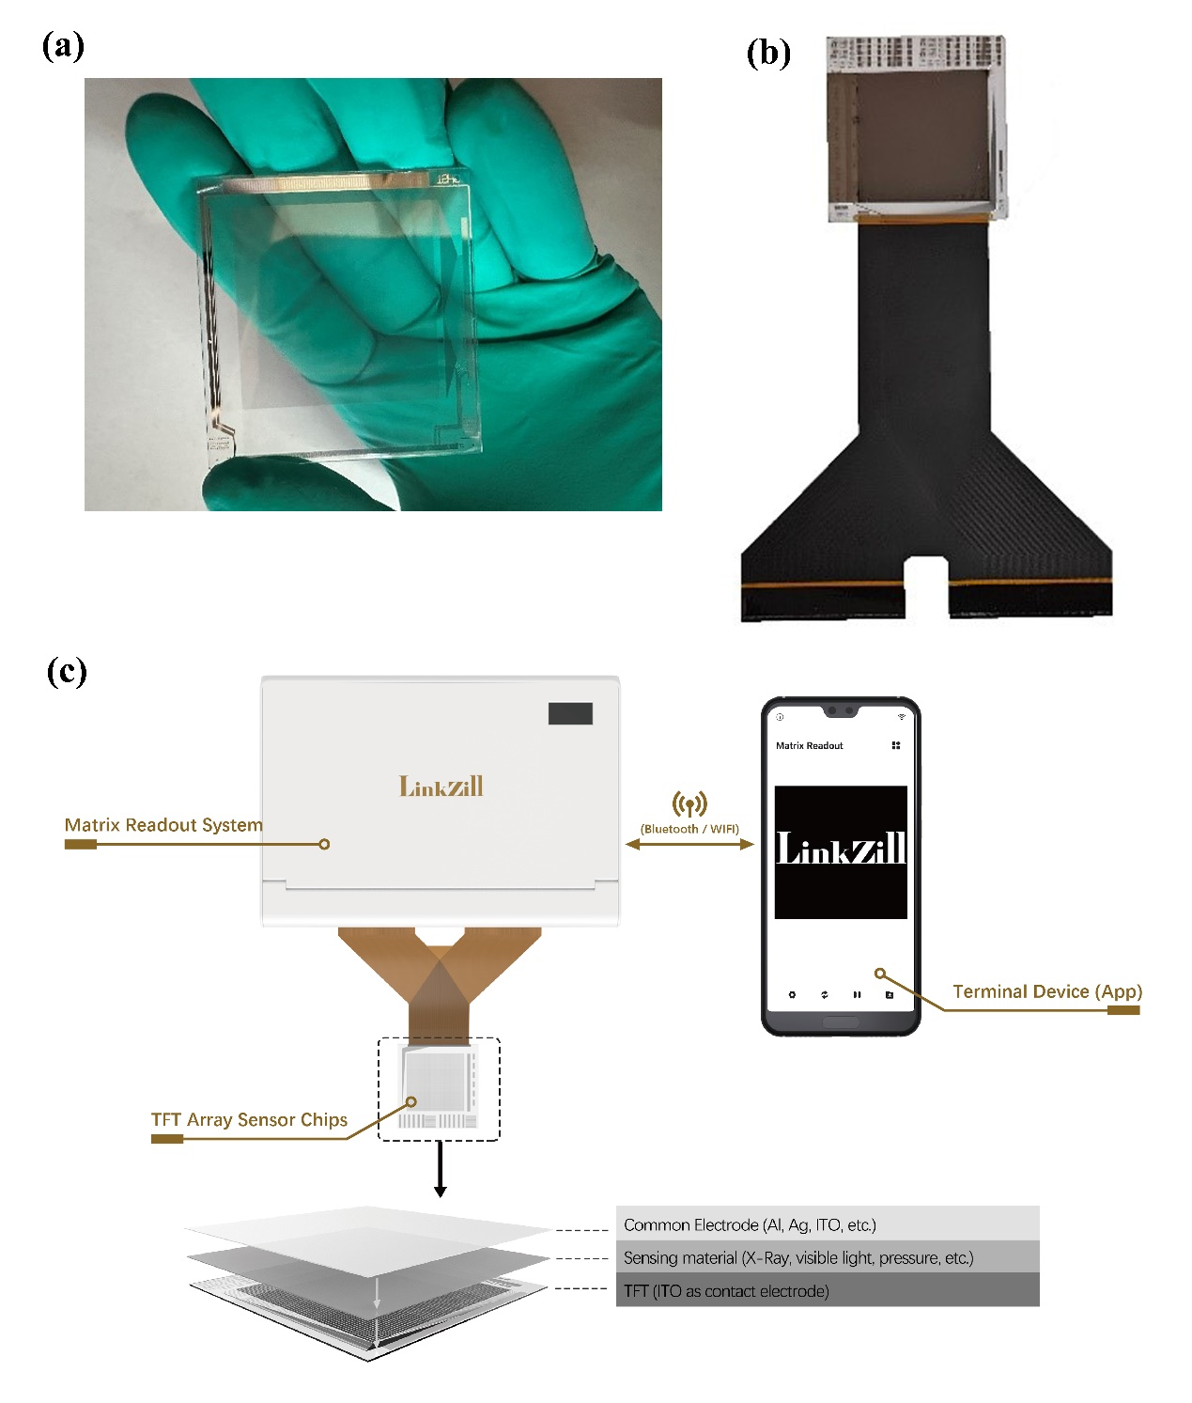
Figure S13 (a) Picture of the Bi₂Te₃-based 64×64 focal plane array. (b) Picture of the Bi₂Te₃-based 64×64 focal plane device. (c) Imaging system under the excitation of visible light.

Video S1 Imaging process under the excitation of visible light.

